 | Jefferson County, New York
2025 Hazard Mitigation Plan
Volume I—Basic Plan
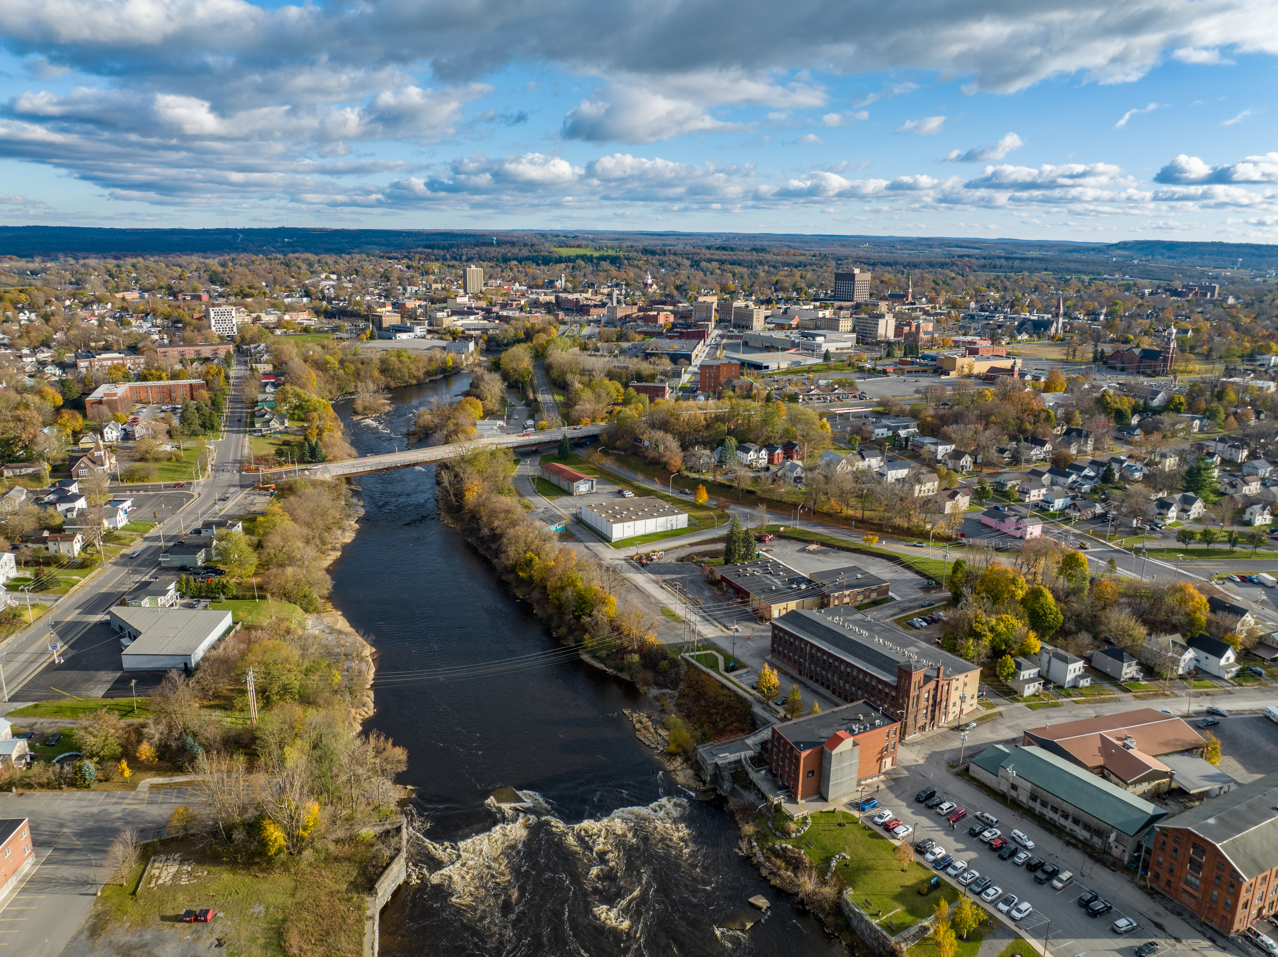
June 2025


Jefferson County 2025 Hazard Mitigation Plan

June 2025
#105s039574
Prepared For |  | Prepared BY
Jefferson County, New York  195 Arsenal Street  Watertown, New York 13601 |  | Tetra Tech  8 Southwoods Blvd. 3rd Fl  Albany, NY 12211 | P +1-321-441-8500  tetratech.com

Executive Summary

Table of Contents
Executive Summary iii
Part 1: The Planning Process and Planning Area
1. Introduction 1-1
1.1 Overview to Hazard Mitigation Planning 1-1
1.2 History of Hazard Mitigation Planning in Jefferson County 1-4
1.3 Plan Organization 1-5
2. Planning Process 2-1
2.1 Alignment with Federal and State Hazard mitigation planning frameworks 2-1
2.2 Planning Process Participants 2-2
2.3 Planning Activities 2-9
2.4 Incorporation of Existing Plans, Studies, Reports and Technical Information 2-17
2.5 Integration with Existing Planning Mechanisms and Programs 2-18
2.6 Plan Adoption 2-18
3. County Profile 3-1
3.1 Location 3-1
3.2 History 3-1
3.3 Jurisdictions Within the County 3-3
3.4 Physical Setting 3-3
3.5 Land Use 3-13
3.6 Demographics and The Economy 3-18
3.7 General Building Stock 3-30
Part 2: Risk Assessment
4. Risk Assessment Methodology and Tools 4-1
4.1 Development of Asset Inventories 4-2
4.2 Vulnerability Assessment Methodology 4-5
4.3 Rating Probability of Occurrence 4-11
4.4 Data Source Summary 4-11
4.5 Limitations 4-11
5. Identification of Hazards of Concern 5-1
6. Dam Failure 6-1
6.1 Hazard Profile 6-1
6.2 Vulnerability and Impact Assessment 6-13
6.3 Future Occurrences and Projected Changes In Risk 6-15
7. Drought 7-1
7.1 Hazard Profile 7-1
7.2 Vulnerability and Impact Assessment 7-6
7.3 Future Occurrences and Projected Changes in Risk 7-10
8. Extreme Temperatures 8-1
8.1 Hazard Profile 8-1
8.2 Vulnerability and Impact Assessment 8-10
8.3 Future Occurrences and Projected Changes in Risk 8-19
9. Flood 9-1
9.1 Hazard Profile 9-1
9.2 Vulnerability and Impact Assessment 9-14
9.3 Future Occurrences and Projected Changes in Risk 9-38
10. Geologic Hazards 10-1
10.1 Hazard Profile 10-1
10.2 Vulnerability and Impact Assessment 10-16
10.3 Future Occurrences and Projected Changes In Risk 10-43
11. Severe Storm 11-1
11.1 Hazard Profile 11-1
11.2 Vulnerability and Impact Assessment 11-16
11.3 Future Occurrences and Projected Changes in Risk 11-23
12. Severe Winter Storm 12-1
12.1 Hazard Profile 12-1
12.2 Vulnerability and Impact Assessment 12-11
12.3 Future Occurrences and Projected Changes in Risk 12-14
13. Wildfire 13-1
13.1 Hazard Profile 13-1
13.2 Vulnerability and Impact Assessment 13-10
13.3 Future Occurrences and Projected Changes In Risk 13-27
14. Hazard Ranking 14-1
Part 3: Capability Assessment
15. Capability Assessment 15-1
15.1 Capability Assessment Process 15-1
15.2 Planning and Regulatory Capabilities 15-1
15.3 Administrative and Technical Capabilities 15-10
15.4 Fiscal Capabilities 15-19
Part 4: Mitigation Strategy
16. Mitigation Strategy 16-1
16.1 Past Mitigation Accomplishments 16-1
16.2 Review and Update of Mitigation Goals and Objectives 16-1
16.3 Mitigation Strategy Development and Update 16-4
Part 5: Plan Maintenance
17. Plan Maintenance and Implementation Procedures 17-1
17.1 HMP Coordinator and Jurisdiction Points of Contact 17-1
17.2 Maintenance and Implementation Tasks 17-1
References 1
Acronyms and Definitions 1

List of Tables
Table 1-1. FEMA Local Mitigation Plan Review Crosswalk 1-2
Table 2-1. Jefferson County Hazard Mitigation Steering Committee Members 2-3
Table 2-2. Jefferson County Hazard Mitigation Planning Partnership Members 2-5
Table 2-3. Participation of Federal, State, Regional, County and Local Stakeholders 2-7
Table 3-1. Jefferson County Municipalities 3-3
Table 3-2. Jefferson County 2024 Land Use Classification 3-13
Table 3-3. Historical Population Change in Jefferson County 3-20
Table 3-4. Historical and Projected Population Change in Jefferson County 3-20
Table 3-5. Jefferson County Demographics, 2020 Census and 2022 ACS 5-Year Estimates 3-23
Table 3-6. Jefferson County Area Labor Force Estimates, April 2020 – April 2024 3-29
Table 3-7. Jefferson County Median Household Income, 2018-2022 3-29
Table 3-8. Building Stock Count and RCV 3-31
Table 3-9. Building Stock Count and RCV by Occupancy Class 3-33
Table 4-1. Zip-Code Based Regional Location Factor for Replacement Cost 4-3
Table 4-2. Summary of Risk Assessment Analyses 4-5
Table 4-3. Summary of Hazus Analysis Levels 4-6
Table 4-4. FEMA Flood Data 4-7
Table 4-5. Risk Assessment Data Documentation 4-12
Table 5-1. Identification of Hazards of Concern for Jefferson County 5-1
Table 6-1. U.S. Army Corps of Engineers Hazard Potential Classification 6-4
Table 6-2. Dams Located In Jefferson County 6-6
Table 6-3. Probability of Future Dam Failure Events in Jefferson County 6-15
Table 7-1. USDA Declarations for Drought Events in Jefferson County (2012 to 2024) 7-4
Table 7-2. Drought Events in Jefferson County (2009 to 2024) 7-5
Table 7-3. Jefferson County Farmland, Total and Irrigated 7-8
Table 7-4. Probability of Future Drought Events in Jefferson County 7-10
Table 8-1. National Weather Service Alerts 8-6
Table 8-2. USDA Declarations for Extreme Temperature Events in Jefferson County (2012 to 2024) 8-8
Table 8-3. Extreme Temperature Events in Jefferson County (2011 to 2023) 8-8
Table 8-4 Harmful Algal Blooms in Jefferson County 2012-2024 8-18
Table 8-5. Probability of Future Extreme Temperature Events in Jefferson County 8-20
Table 8-6. Changes in Extreme Events in the Great Lakes Region 8-21
Table 9-1. Flood Map Terms 9-3
Table 9-2. Land Area in the Flood Hazard Areas by Jurisdictions 9-7
Table 9-3. FEMA Declarations for Flood Events in Jefferson County (1954 to 2025) 9-12
Table 9-4. USDA Declarations for Flood Events in Jefferson County (2012 to 2025) 9-12
Table 9-5. Flood Events in Jefferson County (2009 to 2025) 9-12
Table 9-6. Population in the Special Flood Hazard Area 9-14
Table 9-7. Vulnerable Populations Living in the 1 Percent Annual Chance Flood Hazard Area 9-17
Table 9-8. Vulnerable Populations Living in the 0.2 Percent Annual Chance Flood Hazard Area 9-19
Table 9-9. Buildings Located in the 1% Annual Chance Flood Hazard Area 9-22
Table 9-10. Buildings Located in the 0.2% Annual Chance Flood Hazard Area 9-24
Table 9-11. Buildings in the Flood Hazard Areas by General Occupancy Classes 9-26
Table 9-12. Estimated Building Loss Value Due to 1 Percent Annual Chance Flood 9-28
Table 9-13. Buildings Located in the Extreme Coastal Erosion Hazard Area 9-31
Table 9-14. Buildings Located in the Extreme Coastal Erosion Hazard Area by General Occupancy Class 9-33
Table 9-15. Estimated Debris Created During the One Percent Annual Flood Hazard Event 9-2
Table 9-16. Probability of Future Flood Events in Jefferson County 9-4
Table 10-1. Richter Magnitude Scale 10-8
Table 10-2. Modified Mercalli Intensity Scale 10-9
Table 10-3. Damage Levels Experienced in Earthquakes (PGA) 10-9
Table 10-4. Modified Mercalli Intensity and PGA Equivalents 10-10
Table 10-5. NEHRP Soil Classifications 10-14
Table 10-6. Degrees of Landslide Incidence and Susceptibility 10-14
Table 10-7. Geologic Events in Jefferson County (2009 to 2025) 10-16
Table 10-8. Displaced Households and Persons Requiring Shelter Due to Evaluated Earthquake Events 10-18
Table 10-9. Casualties Caused by the Evaluated Earthquake Event 10-20
Table 10-10. Population Exposed to the Landslide Hazard by Municipality 10-21
Table 10-11. Vulnerable Persons in the Low Incidence Landslide Hazard Area 10-23
Table 10-12. Vulnerable Persons in the Moderate Susceptibility/Low Incidence Landslide Hazard Area 10-25
Table 10-13. Building Damage from the 500-Year MRP Earthquake Event 10-28
Table 10-14. Building Damage from the 2,500-Year MRP Earthquake Event 10-30
Table 10-15. Debris Generated by the 500-Year and 2,500-Year MRP Earthquake Events 10-32
Table 10-16. Severity of Expected Damage for the 500-Year MRP Earthquake Events 10-33
Table 10-17. Severity of Expected Damage for the 2,500-Year MRP Earthquake Events 10-34
Table 10-18. Buildings in the Low Incidence Landslide Hazard Area 10-35
Table 10-19. Buildings in the Low Incidence Landslide Hazard Area by Occupancy Class 10-36
Table 10-20. Buildings in the Moderate Susceptibility / Low Incidence Landslide Hazard Area 10-38
Table 10-21. Buildings in the Moderate Susceptibility / Low Incidence Landslide Hazard Area by Occupancy Class 10-39
Table 10-22. Average Impacts on Community Lifelines for the 500-Year MRP Earthquake 10-41
Table 10-23. Average Impacts on Community Lifelines for the 2,500-Year MRP Earthquake 10-41
Table 10-24. Probability of Future Geologic Events in Jefferson County 10-44
Table 11-1. Regional Snowfall Index Ranking Categories 11-8
Table 11-2. FEMA Declarations for Severe Storm Events in Jefferson County (1954 to 2024) 11-12
Table 11-3. USDA Declarations for Severe Storm Events in Jefferson County (2012 to 2024) 11-12
Table 11-4. Severe Storm Events in Jefferson County (2009 to 2024) 11-13
Table 11-5. Example of Structural Damage State Definitions for a Light Wood Framed Building 11-17
Table 11-6. Building Loss for the 500-Year MRP Hurricane Event by Jurisdiction 11-17
Table 11-7. 500-Year Hurricane MRP Building Damages by Occupancy Class 11-19
Table 11-8. 500-Year Hurricane MRP Damages 11-20
Table 11-9. Estimated Debris Created During the 500-Year MRP Hurricane Event 11-21
Table 11-10. Probability of Future Severe Storm Events in Jefferson County 11-23
Table 12-1. RSI Ranking Categories 12-6
Table 12-2. Winter Storm Category Thresholds 12-6
Table 12-3. FEMA Declarations for Winter Storm Events in Jefferson County (1954 to 2024) 12-7
Table 12-4. USDA Declarations for Winter Storm Events in Jefferson County (2012 to 2024) 12-8
Table 12-5. Winter Storm Events in Jefferson County (2009 to 2024) 12-8
Table 12-6. Probability of Future Winter Storm Events in Jefferson County 12-14
Table 13-1. Description of Fire Danger Ratings in the State of New York 13-6
Table 13-2. Fuel Moisture Classifications 13-6
Table 13-3. Haines Index 13-7
Table 13-4. Wildfire Events in Jefferson County (2009 to 2024) 13-9
Table 13-5. Estimated Population in the WUI Hazard Areas in Jefferson County 13-11
Table 13-6. Estimated Number of Vulnerable Persons in the WUI Intermix Hazard Area 13-14
Table 13-7. Estimated Number of Vulnerable Persons in the WUI Interface Hazard Area 13-16
Table 13-8. Buildings in the WUI Intermix Hazard Area 13-18
Table 13-9. Buildings in the WUI Interface Hazard Area 13-20
Table 13-10. Critical Facilities in the WUI Interface Hazard Area 13-23
Table 13-11. Critical Facilities in the WUI Intermix Hazard Area 13-25
Table 13-12. Probability of Future Wildfire Events in Jefferson County 13-28
Table 15-1. FEMA HMA Grant Cost Share Requirements 15-20
Table 16-1 Qualitative Cost and Benefit Ratings 16-9
Table 17-1. Plan Maintenance Matrix 17-2
Table 17-2. Safe Growth Check List 17-4

List of Figures
Figure 2-1. Jefferson County HMP Webpage and Local On-Line Outreach 2-12
Figure 2-2. Most Frequently Experienced Natural Hazard Events in Jefferson County 2-15
Figure 3-1. Jefferson County Hazard Mitigation Plan Area 3-2
Figure 3-2. Watershed 3-4
Figure 3-3. Lake Ontario and Minor Tributaries Watershed 3-6
Figure 3-4. Saint Lawrence Watershed 3-7
Figure 3-5. Black River Watershed 3-8
Figure 3-6. Regions of Jefferson County 3-9
Figure 3-7. County Climate Summary 3-12
Figure 3-8. Jefferson County Land Use 3-14
Figure 3-9. Watertown-Fort Drum Metropolitan Statistical Area 3-16
Figure 3-10. Jefferson County Agricultural Districts 3-17
Figure 3-11. Population Per Square Mile By Census Tract 3-19
Figure 3-12. Socially Vulnerability Populations in Jefferson County 3-22
Figure 3-13. Social Vulnerability Index 3-25
Figure 3-14. SVI in Jefferson County 3-26
Figure 3-15. Replacement Cost v. Actual Cash Value 3-30
Figure 3-16. Residential Building Stock Value Density in Jefferson County 3-35
Figure 3-17. Commercial Building Stock Value Density in Jefferson County 3-36
Figure 3-18. Industrial Building Stock Value Density in Jefferson County 3-37
Figure 6-1. Dam Failure Causes 6-2
Figure 6-2. Location of Dams in Jefferson County 6-12
Figure 7-1. New York State Drought Regions 7-2
Figure 7-2. Drought Conditions 2000-2023 7-4
Figure 8-1. Average Number of Weather-Related Fatalities in the U.S. 8-2
Figure 8-2. National Risk Index, Cold Wave Risk Index Score by Census Tract 8-3
Figure 8-3. National Risk Index, Heat Wave Risk Index Score by Census Tract 8-4
Figure 8-4. Wind Chill Index 8-5
Figure 8-5. NWS Heat Index 8-6
Figure 8-6. Urban Heat Island Profile 8-7
Figure 8-7. National Risk Index, Extreme Cold Expected Annual Loss Score 8-11
Figure 8-8. Annual Loss to Property - Extreme Cold 8-14
Figure 8-9. Annual Loss to Crops - Extreme Cold 8-16
Figure 8-10. Projected Annual Average Temperature in New York State 8-21
Figure 9-1. Characteristics of a Floodplain 9-2
Figure 9-2. Jefferson County Designated Special Flood Hazard Areas 9-6
Figure 10-1. Earthquake Epicenters in Jefferson County, 2000-2024 10-4
Figure 10-2. National Risk Index, Earthquake Risk Index Score by Census Tract 10-5
Figure 10-3. National Risk Index, Landslide Risk Index Score by Census Tracct 10-6
Figure 10-4. Landslide Susceptibility Hazard Area 10-7
Figure 10-5. 500-Year Earthquake PGA (%g) 10-11
Figure 10-6. 2,500-Year Earthquake PGA (%g) 10-12
Figure 10-7. USGS National Seismic Hazard Mapping for New York State 10-13
Figure 10-8. Landslide Susceptibility in New York State 10-15
Figure 11-1. Historical Tropical Storm and Hurricane Tracks 1950 to 2023 11-5
Figure 11-2. Hail Size Chart 11-6
Figure 11-3. Explanation of EF-Scale Ratings 11-7
Figure 11-4. Thunderstorm Risk 11-8
Figure 11-5. Saffir-Simpson Hurricane Wind Scale 11-9
Figure 11-6. 100-Year MRP Hurricane Event Impacts to Jefferson County 11-10
Figure 11-7. 500-Year MRP Hurricane Event Impacts to Jefferson County 11-11
Figure 12-1. Snow Creation 12-2
Figure 12-2. Sleet Creation 12-2
Figure 12-3. Freezing Rain Creation 12-3
Figure 12-4. National Risk Index, Winter Weather Risk Index Score Using the Census Tract Scale 12-4
Figure 12-5. National Risk Index, Ice Storm Risk Index Score Using the Census Tract Scale 12-5
Figure 12-6. Winter Storm Warning Thresholds 12-7
Figure 13-1. Wildfire-Urban Interface Hazard Areas in Jefferson County 13-4
Figure 13-2. The State of New York FDRAs 13-8
Figure 13-3. Wildfire Events (2008 – 2024) 13-9

Appendices
Appendix A: Resolutions
Appendix B: Outreach, Participation and Meeting Documentation
Appendix C: Action Worksheet Template and Instructions
Appendix D: Plan Maintenance Tools
Appendix E: Critical Facility and Community Lifeline Inventory
Appendix F: Linkage Procedures

Part 1: The Planning Process and Planning Area

Introduction
Jefferson County has developed a hazard mitigation plan (HMP) to reduce risks from disasters to the people, property, economy, and environment within the County. Developed by the County and the participating local jurisdictions (the Planning Partners), this HMP updates the 2011 Jefferson County HMP. The updated 2025 HMP (also referred to as “the plan”) includes countywide analysis and assessment of hazards, risk, and capabilities.

Overview to Hazard Mitigation Planning

What Is Hazard Mitigation?
Hazard mitigation is any sustained action taken to reduce or eliminate the long-term risk and effects that can result from hazards. The Federal Emergency Management Agency (FEMA) defines a hazard mitigation plan (HMP) as the documentation of a state or local government’s evaluation of natural hazards and strategies to mitigate them.
Effective mitigation planning helps people, organizations, and government agencies to better prepare for and respond when disasters occur. It also allows local governments to remain eligible for FEMA grant funding for mitigation projects that will reduce the impact of future disaster events. The long-term benefits of mitigation planning and implementation include the following:
The Federal Emergency Management Agency (FEMA) estimates that for every dollar spent on hazard mitigation, an estimated $6 is saved in future disaster costs.
This savings is achieved by reducing damage to property, injuries, and other economic losses associated with disasters.
- An increased understanding of hazards faced by local communities
- A more sustainable and disaster-resistant community
- Financial savings through partnerships that support planning and mitigation efforts
- Focused use of limited resources on hazards that have the biggest impact on the community
- Reduced long-term impacts and damage to human health and structures
- Reduced costs associated with response and recovery efforts, including repairs

Regulatory Framework
In the early 1990s, a new federal policy regarding disasters began to evolve. Rather than simply reacting whenever disasters strike communities, the federal government began encouraging communities to assess their vulnerability to various hazards before disaster strikes and then take actions to reduce or eliminate potential risks. The policy is based on the logic that a disaster-resistant community can rebound from a natural disaster with less loss of property or human injury, at much lower cost and, consequently, more quickly. Moreover, other costs associated with disasters are minimized, such as the time lost from productive activity by businesses and industries.
The federal Disaster Mitigation Act of 2000 (DMA 2000) encouraged states, tribes, and local governments to take a new and revitalized approach to mitigation planning. DMA 2000 amended the Robert T. Stafford Disaster Relief and Emergency Assistance Act by repealing the previous law’s mitigation planning provisions (Section 409) and replacing them with a new set of requirements (Section 322). Under the new Section 322, communities seeking certain hazard-related federal funding must have a plan that identifies actions to mitigate hazards, risks, and vulnerabilities and establishes a strategy to implement those actions.
Regulations implementing the intent and requirements of DMA 2000 are included in Title 44 of the Code of Federal Regulations, Section 201 (44 CFR 201). In New York, responsibility for fulfilling the requirements of DMA 2000 and 44 CFR 201 and administering the FEMA Hazard Mitigation Program has been delegated to the New York State Division of Homeland Security and Emergency Services (NYS DHSES).
The federal regulations require that states and local governmental agencies update HMPs on a 5-year basis to prepare for and reduce the potential impacts of natural hazards. Each local jurisdiction must identify potential natural hazards to the health, safety, and well-being of its residents, and identify and prioritize actions that can be taken by the community to mitigate those hazards before disaster strikes. To be eligible for hazard mitigation assistance from the federal government, communities must prepare, maintain, and update an HMP.
One goal of the federal regulations is to facilitate cooperation between state and local authorities, prompting them to work together. This enhanced planning process enables local and state governments to better articulate accurate needs for mitigation, resulting in faster allocation of funding and more effective risk reduction projects.
Table 1-1 summarizes the 44 CFR 201 requirements and where each is addressed in this hazard mitigation plan.
Table 1-1. FEMA Local Mitigation Plan Review Crosswalk
Plan Criteria | Primary Location in Plan
Prerequisites
Adoption by the Local Governing Body: §201.6(c)(5) | Chapter 2.0; Appendix A
Planning Process
Documentation of the Planning Process: §201.6(b) and §201.6(c)(1) | Chapter 2.0
Risk Assessment
Identifying Hazards: §201.6(c)(2)(i) | Chapter 5.0
Profiling Hazards: §201.6(c)(2)(i) | Chapters 6.0 – 13.0
Assessing Vulnerability: Overview: §201.6(c)(2)(ii) | Chapter 3.0; Chapters 6.0 – 13.0
Assessing Vulnerability: Identifying Structures: §201.6(c)(2)(ii)(A) | Chapter 3.0; Chapters 6.0 – 13.0
Assessing Vulnerability: Estimating Potential Losses: §201.6(c)(2)(ii)(B) | Chapter 3.0; Chapters 6.0 – 13.0
Assessing Vulnerability: Analyzing Development Trends: §201.6(c)(2)(ii)(C) | Chapter 3.0; Chapters 6.0 – 13.0; Volume II Annexes
Mitigation Strategy
Local Hazard Mitigation Goals: §201.6(c)(3)(i) | Chapter 15.0; Volume II Annexes
Identification and Analysis of Mitigation Actions: §201.6(c)(3)(ii) | Chapter 15.0; Volume II Annexes
Implementation of Mitigation Actions: §201.6(c)(3)(iii) | Chapter 15.0; Volume II Annexes
Multi-Jurisdictional Mitigation Actions: §201.6(c)(3)(iv) | Chapter 15.0; Volume II Annexes
Plan Maintenance Process
Monitoring, Evaluating, and Updating the Plan: §201.6(c)(4)(i) | Chapter 16.0
Incorporation into Existing Planning Mechanisms: §201.6(c)(4)(ii) | Chapter 16.0; Volume II Annexes
Continued Public Involvement: §201.6(c)(4)(iii) | Chapter 16.0

Specialized Terms and Concepts
Like any technical field, hazard mitigation has developed over the years its own set of terms and concepts with particular meanings within the hazard mitigation practice. A full glossary and list of acronyms is provided in Acronyms and Definitions. The list below provides a quick reference for specialized terms whose use is especially prominent in this hazard mitigation plan:
- Adaptive capacity—the ability of a human or natural system to adjust to climate change by moderating potential damage, taking advantage of opportunities, or coping with the consequences (EPA 2023)
- Asset—anything that is important to the character and function of a community (e.g., people, structures, community lifelines, the economy, and natural, historic, and cultural resources) (FEMA 2023)
- Capability assessment—an evaluation of which authorities, policies, programs, funding and resources a participant has to accomplish hazard mitigation (FEMA 2023)
- Cascading hazards—a primary event, such as heavy rainfall, seismic activity, or rapid snowmelt, followed by a chain of consequences that may range from modest (lesser than the original event) to substantial (National Academies of Sciences, Engineering, and Medicine 2022)
- Community lifelines—the most fundamental services in a community that, when stabilized, enable all other aspects of society to function (FEMA 2023)
- Extent—the range of anticipated intensities of the identified hazards within a community, most commonly expressed using various scientific scales (FEMA 2022)
- Hazard profile—a description of a hazard’s location, extent, previous occurrences and probability of future events within a community (FEMA 2023)
- Hazard ranking—the process of identifying the hazards that pose the greatest risk to a community, based on how likely the hazard is to occur, the potential consequences if the hazard does occur, and other relevant local factors
- Impact—the consequences or effects of a hazard on a community’s assets identified in the vulnerability assessment. (FEMA 2023)
- Integration—the inclusion of hazard mitigation principles, vulnerability information and mitigation actions into other existing community planning to leverage activities that have co-benefits, reduce risk and increase resilience (FEMA 2022)
- Mitigation action—measures, projects, plans or activities proposed to reduce the current and future vulnerabilities identified in the risk assessment (FEMA 2023)
- Mitigation strategy— the long-term blueprint for reducing the potential hazard-related losses identified in the risk assessment; the strategy consists of mitigation goals, mitigation actions, and a plan for implementing the actions (FEMA 2023)
- Natural hazard—a source of harm or difficulty created by a meteorological, environmental or geological event (FEMA 2023)
- Plan maintenance—monitoring and updating a hazard mitigation plan as warranted by changing conditions, availability of new information, and progress on the proposed mitigation actions (FEMA 2023)
- Planning process—the procedures used to develop a hazard mitigation plan with broad acceptance across the community
- Risk—the potential for damage or loss when natural hazards interact with people or assets (FEMA 2023)
- Risk assessment—a data-driven analysis to find where a local jurisdiction is vulnerable to hazards (FEMA 2023)
- Social vulnerability—the potential for loss within an individual or social group, as affected by traits that influence an individual’s or group’s resilience, which is their ability to prepare, respond, cope or recover from an event (FEMA 2023)
- Stakeholder—individuals or groups that a mitigation action or policy affects, including businesses, private organizations and residents (FEMA 2023)
- Vulnerability—a description of which assets within locations identified to be hazard prone are at risk from the effects of the hazard (FEMA 2023)

History of Hazard Mitigation Planning in Jefferson County

Previous Jefferson County HMPs
Jefferson County has been included in 20 federal hazard-related declarations (major disaster, fire management, and emergency) since 1954. Following the adoption of DMA 2000 and the new national focus on mitigating hazards through advance planning, the County prepared and adopted its first hazard mitigation plan in 2011. The plan identified the following as the greatest hazards of concern in Jefferson County:
- Dam Failure
- Drought
- Extreme Temperatures
- Flood (including Coastal Erosion and Ice Jam)
- Geologic (Earthquake and Landslide)
- Severe Storm (Windstorm, Thunderstorm, Hail, Hurricane, Lightning, and Tornado)
- Severe Winter Storm (Heavy Snow, Blizzard, Ice Storm)
- Wildfire

Key Changes in the Current Update
The following are the most significant changes made between the previous County HMP (2011) and the current (2025) update:
- The Steering Committee re-evaluated the inclusion of coastal erosion, extreme winds, ice jams, landslides, lightning, and tornado as stand-alone hazards, as was done in the 2011 plan. Members of the Steering Committee and Planning Partnership opted to regroup many of these hazards:
  - The coastal erosion and ice jam hazards align with the flood hazard and was reassigned to this hazard grouping in the 2025 HMP update.
  - The extreme wind, lightning, and tornado hazards were grouped to create the severe storm hazard and were reassigned to this hazard grouping in the 2025 HMP update.
  - The landslide hazard was reassigned to a geologic hazards grouping in the 2025 HMP update.

Plan Organization
The Jefferson County HMP provides a detailed review and analysis of each hazard of concern, resources, and relevant statistical information for the Planning Partners. The plan is organized into two volumes: Volume I includes all information that applies to the entire planning area (Jefferson County); and Volume II includes specific information for each participating jurisdiction.
Volume I is a resource for ongoing mitigation analysis. It includes a description of the County and its jurisdictions as well as information on mitigation planning and how the risk assessment and capability assessment were performed. Volume I of the plan includes the following chapters:
- Part 1: The Planning Process and Planning Area
  - Chapter 1: Introduction
  - Chapter 2: Planning Process: A description of the plan methodology and development process, committee and stakeholder roles and activities, and how the plan will be incorporated into existing programs. Information regarding the adoption of the plan by each participating jurisdiction.
  - Chapter 3: County Profile: An overview of Jefferson County, including: general information and physical conditions, land use patterns and trends, population and demographics, economy, general building stock inventory, community lifelines, and natural, historic, and cultural resources
- Part 2: Risk Assessment
  - Chapter 4: Methodology: Description of the methodology used to assess hazard risk and the status of local data.
  - Chapter 5: Hazards of Concern Identification: Documentation of the process of identifying the natural hazards of concern for further profiling and evaluation.
  - Chapters 6 – 13: Hazard profiles and findings of the risk assessment (estimates of the impact of hazard events on life, safety, and health; general building stock; critical facilities; the economy, and natural, historic, and cultural resources).
- Part 3: Capability Assessment
  - Chapter 14: Capability Assessment: A summary and description of the existing plans, programs, and regulatory mechanisms at all levels of government (federal, state, county, local) that support hazard mitigation within the County.
- Part 4: Mitigation Strategy
  - Chapter 15: Mitigation Strategy: Information regarding the mitigation goals and objectives identified by the Steering Committee in response to priority hazards of concern, and the process by which County and local mitigation strategies have been developed or updated.
- Part 5: Plan Maintenance
  - Chapter 16: Plan Maintenance Procedures: A system to continue to monitor, evaluate, maintain, and update the plan.
Volume II consists of annexes for each participating jurisdiction. Each annex summarizes the jurisdiction’s planning, regulatory, and fiscal capabilities; evaluates vulnerabilities to hazards; describes the status of past mitigation actions; and provides a specific mitigation strategy. The annexes provide each jurisdiction with an expedient resource for implementing mitigation projects and maximizing future grant opportunities.
Appendices include the following:
- Appendix A: Resolutions
- Appendix B: Outreach, Participation and Meeting Documentation
- Appendix C: Action Worksheet Template and Instructions
- Appendix D: Plan Maintenance Tools
- Appendix E: Critical Facility and Community Lifeline Inventory
- Appendix F: Linkage Procedures

Planning Process
This chapter documents how the plan was developed, who was involved and what data and information were used to update the plan. The National Mitigation Framework emphasizes the valuable role of collaboration among various sectors to ensure that mitigation capabilities continue to grow, and that comprehensive mitigation includes strategies for a wide variety of community sectors. This planning effort included active participation and buy-in from community leaders, stakeholders and the public. Government and nonprofit personnel represented emergency management, economic development, land use and development, housing, health and social services, infrastructure and natural resources agencies and organizations, among others.
Jefferson County invited all jurisdictions in the County to join in the planning process. 40 planning teams including a team representing the County-level of government participated in the 2025 plan update process:
- County of Jefferson  - Town of Adams  - Village of Adams  - Town of Alexandria  - Village of Alexandria Bay  - Town of Antwerp  - Village of Antwerp  - Village of Black River  - Town of Brownville  - Village of Brownville  - Village of Cape Vincent  - Village of Carthage  - Town of Champion  - Village of Chaumont | - Town of Clayton  - Village of Clayton  - Village of Deferiet  - Village of Dexter  - Town of Ellisburg  - Village of Evans Mills  - Village of Glen Park  - Town of Henderson  - Town of Hounsfield  - Town of LeRay  - Town of Lorraine  - Town of Lyme  - Village of Mannsville  - Town of Orleans | - Town of Pamelia  - Town of Philadelphia  - Village of Philadelphia  - Town of Rodman  - Town of Rutland  - Village of Sackets Harbor  - Town of Theresa  - Village of Theresa  - City of Watertown  - Town of Watertown  - Village of West Carthage  - Town of Wilna  - Town of Worth

Alignment with Federal and State Hazard mitigation planning frameworks
The plan was developed following FEMA regulations and prevailing FEMA and state guidance. This ensures that all federal and state requirements were met and supports plan review. In addition, this plan will meet criteria for the National Flood Insurance Program (NFIP) and Hazard Mitigation Assistance (HMA) Grant Programs. The Jefferson County 2025 HMP was prepared in accordance with the following regulations and guidance:
- FEMA Mitigation Planning How-to Series (FEMA 386-1 through 4, 2002)
- FEMA How-To Guide for Using Hazus for Risk Assessment FEMA Document No. 433, February 2004.
- FEMA Local Mitigation Plan Review Guide, October 1, 2011.
- FEMA Mitigation Ideas: A Resource for Reducing Risk to Natural Hazards, January 2013.
- FEMA Integrating Hazard Mitigation into Local Planning, March 1, 2013.
- FEMA Plan Integration: Linking Local Planning Efforts, July 2015.
- FEMA Local Mitigation Planning Policy Guide, April 11, 2025.
- FEMA Local Mitigation Planning Handbook, May 2023.
- DMA 2000 (Public Law 106-390, October 30, 2000).
- 44 CFR 201 and 206 (including: Feb. 26, 2002, Oct. 1, 2002, Oct. 28, 2003, and Sept. 13, 2004, Interim Final Rules).
- NYS DHSES Hazard Mitigation Planning Standards, 2022
- NYS DHSES State Hazard Mitigation Plan, 2023

Planning Process Participants
The Jefferson County HMP update was written using the best available information from a wide variety of quantitative and qualitative sources. Efforts were made to solicit broad regional, county, and local representation in this planning process. A comprehensive list of stakeholders was developed with the support of the Steering Committee and Planning Partnership. Stakeholder outreach was performed early and throughout the planning process. Information and input provided by all of the planning participants are foundational to this update and have been integrated throughout.
This section details the outreach to, and involvement of, the many agencies, departments, organizations, non-profits, districts, authorities, and other entities that have a stake in managing hazard risk and mitigation. Beyond those described here, many stakeholders were aware of and/or contributed to this plan through formal and informal outreach efforts by the Planning Partners involved in the plan update.

Project Management
Jefferson County applied for and was awarded a multi-jurisdictional hazard mitigation planning grant under FEMA’s Hazard Mitigation Grant Program which has supported the development of this HMP. Grant administration was the responsibility of the Jefferson County Office of Fire & Emergency Management and was supported by NYS DHSES and Tetra Tech.
Project management and local planning coordination was the responsibility of the Jefferson County Office of Fire & Emergency Management. Fire and Emergency Management personnel worked with hazard mitigation planning subject matter experts at Tetra Tech (the planning consultant) to accomplish the following:
- Assisting with the organization of a Steering Committee and the Planning Partnership
- Assisting with the development and implementation of a public and stakeholder outreach program
- Data collection
- Facilitation and attendance at meetings (Steering Committee, municipal, stakeholder, public and other)
- Review and update of the hazards of concern, and hazard profiling and risk assessment
- Assistance with the review and update of mitigation planning goals and objectives
- Assistance with Jurisdictional Annex development
- Assistance with the review of past mitigation strategy progress
- Assistance with the screening of mitigation actions and the identification of appropriate actions
- Assistance with the prioritization of mitigation actions
- Authoring of the draft and final plan documents

Steering Committee
Jefferson County developed a Steering Committee to provide guidance and direction to the HMP update effort. Steering Committee members were charged with the following:
- Providing guidance and oversight of the planning process on behalf of the general planning partnership
- Attending and participating in Steering Committee meetings
- Assisting with the development and completion of certain planning elements, including:
  - Reviewing and updating the hazards of concern
  - Developing a public and stakeholder outreach program
  - Ensuring that the data and information used in the plan update process is the best available
  - Reviewing and updating the hazard mitigation goals
  - Identifying and screening appropriate mitigation strategies and activities
- Reviewing and commenting on plan documents prior to submission to NYS DHSES and FEMA.
The Steering Committee provided guidance, leadership, and oversight of the planning process and acted as the point of contact for all participating jurisdictions and various interest groups in the planning area. Table 2-1 lists the members of the Steering Committee.
Table 2-1. Jefferson County Hazard Mitigation Steering Committee Members
Affiliation | Name | Title
Community Action Planning Council (CAPC) | Craig Cashman | Chief Executive Officer
Cornell Cooperative Extension | Amanda Root | Executive Director
Cornell Cooperative Extension | Lauren Darcy | Great Lakes Coastal Resilience Specialist
Development Authority of the North Country (DANC) | Andrea Marra | Executive Assistant
Development Authority of the North Country (DANC) | Brian Nutting | Director of Water Quality Management
Development Authority of the North Country (DANC) | Carl Farone | Executive Director
Disabled Persons Assistance Organization (DPAO) | Tina Cummings | Executive Director
Fort Drum Regional Health Planning Organization | Jonathan Cole | EMS Emergency Agency Director
Fort Drum Regional Liaison Organization | David Zembiec | Organization Chair
Jefferson County Highway Department | James Lawrance
Jefferson County Economic Development | Marshall Weir | Chief Executive Officer
Jefferson County Information Technology | Sean Vincent | Director
Jefferson County Planning | Michael Bourcy | Director
Jefferson County Planning | Samuel Wilson | Assistant Planner
Jefferson County Public Health | Stephen Jennings
Jefferson County Public Health | Jeff Leiendecker | Emergency Preparedness and Response Coordinator
Jefferson County Real Property Tax Services | Roxanne Burns | Director
Jefferson County Social Services | Karen Marcum | Commissioner
Jefferson County Soil & Water Conservation District | George Birth | Stormwater Program Coordinator
Jefferson County Administration | Ryan Piche | County Administrator
Jefferson County Administration | Dylan Soper | Deputy County Administrator
Jefferson County Code Enforcement | Jason Crump | Director
Jefferson County Economic Development | Jay Matteson | Deputy Chief Executive Officer
Jefferson County Soil & Water Conservation District | Patrick Crast | Trail Coordinator
Jefferson County Office of Fire & Emergency Management | Megan Jones | Planner
Jefferson County Office of Fire & Emergency Management | Joseph Plummer | Director
Jefferson County Office of Fire & Emergency Management | Niel Rivenburgh | Deputy Director
Jefferson County Office of Fire & Emergency Management | Ryan McIntosh | Planner
North Country Regional Economic Development Council | Steve Hunt | Regional Director
NYSDHSES | Gerald Pederson | NY State DHSES OEM Region 4
NYSDHSES | Jennifer Romano | NY State DHSES OEM Region 4
NYSDHSES | Kevin Clapp | Supervisor, Hazard Mitigation Planning
Rutland, Town of | Logan Eddy | Town Supervisor
Sackets Harbor, Village of | Alex Morgia | Mayor
TI Bridge Authority | Pat Labiendo | Manager, Safety & Security
Tug Hill Commission | Katie Malinowski | Executive Director
Tug Hill Commission | Christopher Barboza | Planner
US Army at Fort Drum Emergency Management | Richard Hughes | Emergency Management Division
Watertown Jefferson County Transportation Council (MPO) | Barbara Caldwell | Highway Technical Committee
Watertown Jefferson County Transportation Council (MPO) | Kristopher Reff | Acting Planning and Program Manager
Watertown, City of | Eric Wagenear | City Manager
Watertown, City of | Matt Timerman | Fire Department

Planning Partnership (Jurisdictional Participation)
All participating jurisdictions, including the County, are recognized as Planning Partners and belong to the Planning Partnership for this HMP. Jefferson County’s encouraged participation by all jurisdictions. The various jurisdictions in Jefferson County have differing levels of capabilities and resources available to their ability to participate in the plan update process, as well as differing levels of vulnerability to and impacts from the natural hazards considered in this plan. Ultimately, jurisdictional participation is evidenced by a completed annex of the HMP, wherein jurisdictions individually identify their planning points of contact, evaluate their risk from the hazards of concern, identify their capabilities to effect mitigation in their community, identify and prioritize a suite of actions to mitigate their hazard risk, and adopt the updated plan via resolution. Annexes are included in Volume II of this HMP.
After completion of the plan, implementation and ongoing maintenance will become a function of the Planning Partnership as described in Chapter 17 (Plan Maintenance). The Planning Partnership will be responsible for reviewing the draft plan and soliciting public comment as part of an annual review and as part of the five-year mitigation plan updates.
The Planning Partnership was charged with the following:
- Representing their jurisdiction throughout the planning process
- Ensuring participation of all departments and functions within their jurisdiction that have a stake in mitigation (e.g., planning, engineering, code enforcement, police and emergency services, public works)
- Assisting in gathering information for inclusion in the HMP update, including the use of previously developed reports and data
- Supporting and promoting the public involvement process
- Reporting on progress of mitigation actions identified in prior or existing HMPs, as applicable
- Identifying, developing, and prioritizing appropriate mitigation actions
- Reporting on progress of integration of prior or existing HMPs into other planning processes and municipal operations
- Supporting and developing a jurisdictional annex
- Reviewing, amending, and approving all sections of the plan update
- Adopting, implementing, and maintaining the plan update
Table 2-2 shows the current members of the Planning Partnership as of the time of publication of this plan update. Each jurisdictional annex and Appendix B identify all planning participants that contributed to this update.
Table 2-2. Jefferson County Hazard Mitigation Planning Partnership Members
Jurisdiction | Primary Point of Contact | Title | Alternate Point of Contact | Title
County of Jefferson | Niel Rivenburgh | Deputy Director, Jefferson Co. Fire & Emergency Management | Ryan McIntosh | Emergency Management Planner, Jefferson Co. Fire & Emergency Management
Town of Adams | David Kellogg | Town Supervisor | Jennifer Burt | Town Clerk
Village of Adams | Kreg Davis | Mayor | Tricia Beutel | Village Clerk
Town of Alexandria | Brent Sweet | Town Supervisor | Sandra Caputo | Town Clerk
Village of Alexandria Bay | Michael Putnam | Mayor | Erica Dest | Village Deputy Clerk
Town of Antwerp | Elizabeth Lynch | Town Supervisor | Barbara Mitchell | Town Clerk
Village of Antwerp | Daniel Munroe | Mayor | Amy Cole | Village Clerk
Village of Black River | David Leonard | Mayor | Abigail Simpson | Village Clerk
Town of Brownville | Richard Lane | Supervisor | Novina Green | Town Clerk
Village of Brownville | Patrick Conner | Mayor | Amber Klusacek | Village Clerk
Village of Cape Vincent | Jerry Golden | Mayor | Mary Rupp | Village Clerk
Village of Carthage | Michael Astfin | Mayor | Rachael Vary | Village Clerk
Town of Champion | John Peck | Town Supervisor | Christina Vargulick | Town Clerk
Village of Chaumont | James Morrow | Mayor | Erin Fulton | Village Clerk
Town of Clayton | Steve Dorr | Highway Superintendent | Megan Badour | Town Clerk
Village of Clayton | Nancy Hyde | Mayor | Joanne Lenhard-Boye | Village Clerk
Village of Deferiet | Joe Cook | Mayor | Lyda Schneider | Village Clerk
Village of Dexter | James Eves | Mayor | Michelle McGrann | Village Clerk
Town of Ellisburg | Douglas Shelmadine | Town Supervisor | Debbie Payne | Town Clerk
Village of Evans Mills | Robert Boucher | Mayor | David Edwards | DPW Superintendent
Village of Glen Park | Stephen Macaulay | Mayor | Renee Kolb | Clerk/Treasurer
Town of Henderson | Karen Richmond | Town Supervisor | Wendy Flagg | Town Clerk
Town of Hounsfield | Beth Arthur | Town Supervisor | Brenda Bockus | Town Clerk
Town of LeRay | Leland Carpenter | Town Supervisor | Melissa Verne | Town Clerk
Town of Lorraine | Sandra Clark | Town Supervisor | Sarah Edington | Town Clerk
Town of Lyme | James Millington | Town Supervisor | Ariana Henderson | Town Clerk
Village of Mannsville | Jon LaLone | Mayor | Paula Easton | Village Clerk
Town of Orleans | Kevin Rarick | Town Supervisor | Tammy Donnelly | Town Clerk
Town of Pamelia | Scott Allen | Town Supervisor | Gwen Call | Town Clerk
Town of Philadelphia | Jeffery Sands | Town Supervisor | Brenda Brown | Town Clerk
Village of Philadelphia | John Moran | Mayor | Jennifer LaMora | Town Clerk
Town of Rodman | Lisa Worden | Town Supervisor | Jamie Ackley | Town Clerk
Town of Rutland | Logan Eddy | Town Supervisor | Samatha Sawyer | Town Clerk
Village of Sackets Harbor | Alex Morgia | Mayor | Peggy Kelly | Village Clerk
Town of Theresa | Steven Marcinkowski | Town Supervisor | Vickie Colvard | Town Clerk
Village of Theresa | Scott McConnell | Mayor | Tara Leeson | Village Clerk
City of Watertown | Eric Wagenaar | City Manager | Matt Timerman | Fire Department
Town of Watertown | Joel Bartlett | Town Supervisor | Pamela Desormo | Town Clerk
Village of West Carthage | Tiffany Queary | Village Clerk | Scott Burto | Mayor
Town of Wilna | Paul Smith | Town Supervisor | Lori Borland | Town Clerk
Town of Worth | Donald Holman | Town Supervisor | Katelyn Macklen | Town Clerk

Federal, State, Regional, County and Local Stakeholders
Table 2-3 shows the agency stakeholders contacted about this plan update and their participation in the process.
Table 2-3. Participation of Federal, State, Regional, County and Local Stakeholders
Agency | Participation
FEMA Region 2 | Provided updated planning guidance; provided summary and detailed NFIP data for planning area; presented preliminary regulatory flood products to municipalities and the public; conducted plan review.
- National Centers for Environmental Information (NCEI)  - National Hurricane Center (NHC)  - National Oceanic and Atmospheric Administration (NOAA)  - National Weather Service (NWS)  - Storm Prediction Center (SPC)  - U.S. Army Corps of Engineers (USACE)  - U.S. Census Bureau  - U.S. Geological Survey (USGS) | Information regarding hazard identification and the risk assessment for this HMP update was requested and received or incorporated by reference.
New York State Department of Homeland Security and Emergency Services | Administered planning grant and facilitated FEMA review; provided updated planning guidance; attended meetings; participated in the Mitigation Strategy Workshop, provided review of Draft and Final Plan.
New York State Department of Environmental Conservation (NYSDEC) | Provided data and information on the number, locations and classification of dams.
New York State Department of Transportation | Submitted a Stakeholder Organization Survey
- Oswego County  - Lewis County  - St. Lawrence County | The County kept surrounding jurisdictions apprised of the project, invited them to complete a neighboring community survey, and requested their review of the draft plan. The representatives from the following adjoining counties and jurisdictions were contacted to inform them about the availability of the project website, draft plan documents, and surveys and to invite them to provide input to the planning process. Representatives of Oswego, Lewis and St. Lawrence county’s Offices of Emergency Management/Services completed the Neighboring Communities Survey.
- Community Action Planning Council (CAPC)  - Cornell Cooperative Extension  - Development Authority of the North Country (DANC)  - Disabled Persons Assistance Organization (DPAO)  - Fort Drum Regional Health Planning Organization  - Fort Drum Regional Liaison Organization  - Jefferson County Highway Department  - Jefferson County Economic Development  - Jefferson County Information Technology  - Jefferson County Planning  - Jefferson County Public Health  - Jefferson County Real Property Tax Services  - Jefferson County Social Services  - Jefferson County Soil & Water Conservation District  - Jefferson County Administration  - Jefferson County Code Enforcement  - Jefferson County Economic Development  - Jefferson County Office of Fire & Emergency Management  - Jefferson County Community Services  - Jefferson County Local Development Corporation (JCLDC)  - North Country Regional Economic Development Council  - Thousand Island Bridge Authority  - Tug Hill Commission  - US Army at Fort Drum Emergency Management  - Watertown Jefferson County Transportation Council (MPO)  - Watertown International Airport | Served on steering committee, attended meetings, completed hazard of concern exercise and goals and objectives exercise, completed surveys, developed mitigation actions, reviewed draft plan.
- Alexandria Central School District  - Belleville Henderson Central School  - Carthage Central School District  - Copenhagen Central School District  - General Brown Central School District  - Immaculate Heart Central School  - Indian River Central School District  - LaFargeville Central School District  - Lyme Central School  - Sackets Harbor Central  - South Jefferson Central School District  - Thousand Islands Central School District  - Watertown City School District  - Board of Cooperative Educational Services (BOCES)  - Jefferson Community College | Jurisdictions were asked to invite representatives of their local schools to complete a stakeholder survey. These academic institutions were invited to complete a stakeholder survey and review the draft plan.
- Mental Health Association in Jefferson County  - Anchor Recovery Center  - Transitional Living Services of NNY  - Disabled Persons Action Organization (DPAO)  - Credo Community Center for Treatment of Addictions | The following non-governmental groups and agencies that provide support to and work with socially vulnerable populations and underserved communities were invited to complete a stakeholder survey and review the draft

Planning Activities
Members of the Planning Partnership, as well as key stakeholders, met and communicated as needed to share information. This included workshops to identify hazards, assess risks and impacts, update inventories of critical facilities, and assist in updating mitigation goals and strategies. All members of the Planning Partnership had the opportunity to review the draft plan, support interaction with other stakeholders, and assist with public involvement efforts. These activities provided continuity through the process to ensure that natural hazard vulnerability information and appropriate mitigation strategies were incorporated. There was a great deal of communication between the Jefferson County Office Fire & Emergency Management, Planning Partnership members and the consultant through virtual and in-person meetings, phone calls, and email. Documentation of meetings (agendas, sign-in sheets, minutes, etc.) may be found in Appendix B: Outreach, Participation and Meeting Documentation.

Stakeholder Survey Summary
The stakeholder survey was designed to identify general needs for hazard mitigation and resiliency within Jefferson County from the perspective of stakeholders, as well as to identify specific projects that may be included in the mitigation plan. It was distributed to identified stakeholders, including county and municipal departments and agencies. Respondents identified that they represent the following sectors:
- Municipal Government
- Infrastructure
- Economic Development
- Land Use and Development
- Health and Social Services
- Housing, Food, Water, Shelter
When asked if the organization maintains or manages anything within their designated service area, 29 percent said they do not manage any facilities. For those that did answer, they indicated the following facilities: buildings, stormwater infrastructure, roads, bridges, or water/sewer plants.
57 percent of respondents noted that they work with socially vulnerable populations. Examples of this work included:
- Housing and services to the homeless population
- Temporary sheltering services
- Transportation services
- Low interest loans for affordable housing
- Working as a Regional Local Project Liaison where projects located in Environmental Justice Areas and low income areas are more frequently considered

Hazard and Damage Identification
80 percent of respondents indicated that wind damage to utilities and trees resulting in power outages, building closures, and travel restrictions from the pandemic have impacted buildings and facilities related to their organization’s work. Respondents said the following areas are the most vulnerable to natural hazards impacts:
- Closed roads and water damage to roads due to flooding, severe storms and severe winter storms
- Power outages due to severe winds, severe storms and severe winter storms
- Aging culverts and bridges that may not have ample freeboard for the frequency and size of current storms
A quarter of the respondents are unsure if their facilities are in a flood prone area, while 75 percent of respondents know that their facilities are not in a flood prone area.

Community Preparedness
67 percent of respondents noted they are aware of the location and number of socially vulnerable populations in their community/operating area. 50 percent of these stakeholders stated that they provide services during times of disaster.
67 percent percent of total respondents being part of an Emergency Operations Plan and a Business Continuity Plan.

Project Identification
Respondents identified the following projects or programs that could reduce their organization’s vulnerability to damage, including operation of service:
- WJCTC Resiliency Study is currently underway
- Emergency Response Plans that deal with reacting to climate related incidents. The ERP also discusses response and containment of hazardous materials releases

Neighboring Community Survey Summary
The neighboring community survey was sent to the county and municipal governments that border Jefferson County. All three neighboring counties submitted the survey (Oswego County, Lewis County and St. Lawrence County).
The Neighboring County Survey was broken down into 5 sections: Emergency Operations and Continuity of Operations Planning, Risk and Vulnerability, Evacuation and Sheltering, Information Sharing, and Projects, Grants, Education and Outreach, each detailed below.

Emergency Operations and Continuity of Operations Planning
Two respondents answered survey questions regarding if any shared service or mutual aid agreements are in place between their county and Jefferson County. Both respondents indicated that they have shared services for emergency staffing for evacuations and disaster response. One respondent indicated that they have shared services for equipment and staff for debris cleanup and removal and another respondent indicated that they have shared services with sheltering.
Two respondents noted that Jefferson County is involved in their county’s emergency operations planning by participating on a planning team or providing resources during an emergency. One respondent indicated that they are involved in Jefferson County’s comprehensive emergency operations planning. Oswego County stated that both County EMO’s collaborate on emergency management and emergency operations during regional meetings and assist when needed and stated that the fire service collaborates and provides mutual aid across the county line on a regular basis.

Risk and Vulnerability
St. Lawrence County noted that they share risk and vulnerability assessments with Jefferson County, including flood mapping, GIS or Hazus.

Evacuation and Sheltering
Oswego County also indicated that they would consult with Jefferson County before making evacuation decisions that would impact the County, and they indicated that fire departments along the county’s border would work together on evacuation and sheltering incidents that may involve travel between counties.
Oswego County indicated that they do not consult with Jefferson County prior to making a sheltering decision that would impact one another, as the Red Cross has some shelters established that could accommodate people from more than one County. Similarly, Oswego also indicated that they do not share any spaces for temporary housing with Jefferson County.

Information Sharing
All three respondents noted they have contact information for Jefferson County’s emergency operations centers at the county level.

Projects, Grants, Education, and Outreach
All three respondents indicated that information regarding mitigation is shared during the planning and implementation phases of projects, including sharing information from municipalities along the border of each county. Oswego County noted that Lake Ontario flooding has impacted both counties in 2017 and 2019, as well as Lake effect snow that impacts municipalities located along county borders. Lewis County indicated that flooding from the Black River impacts both Counties, as well as snowfall events. St. Lawrence County also indicated flooding as a hazard that impacts both counties.
Oswego County EMO will share information on mitigation projects for the county and municipalities that border Jefferson (Towns of Sandy Creek, Boylston and Redfield) as they impact Jefferson County, and Jefferson County does the same. The Counties also are in communication via radio or other direct communication methods on an as needed basis.
All the respondents identify projects as requiring cross-collaboration between county boundaries, including watershed planning/projects, floodplain planning/projects, and outreach. Lewis County indicated that they have collaborated on a grant application in relation to hazardous materials. Oswego County noted that Fire departments along the border between counties may provide education to residents of both counties.

Public Survey Summary
The public survey was developed to assess the level of knowledge of tools and techniques to assist in reducing risk and loss associated with hazards. It asked quantifiable questions about citizen perception of risk, knowledge of mitigation, and support of community programs. The County advertised the survey on their website (see Figure 2-1) and social media accounts. As of March 31, 2025, the survey received 324 responses.
Most residents receive information concerning natural hazards through the internet (75.%) or TV News (67%).
Figure 2-1. Jefferson County HMP Webpage and Local On-Line Outreach
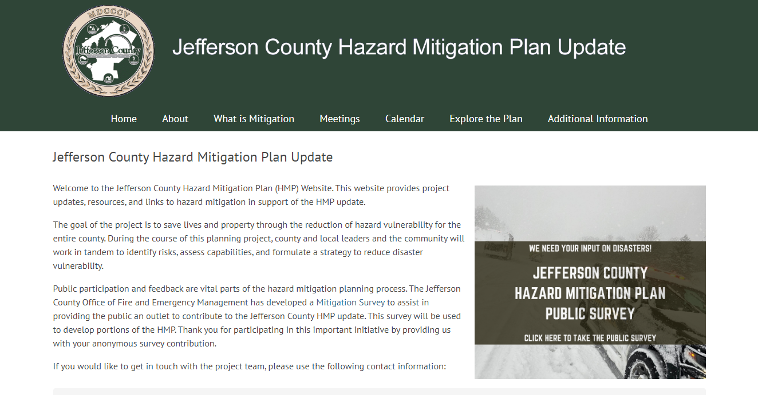
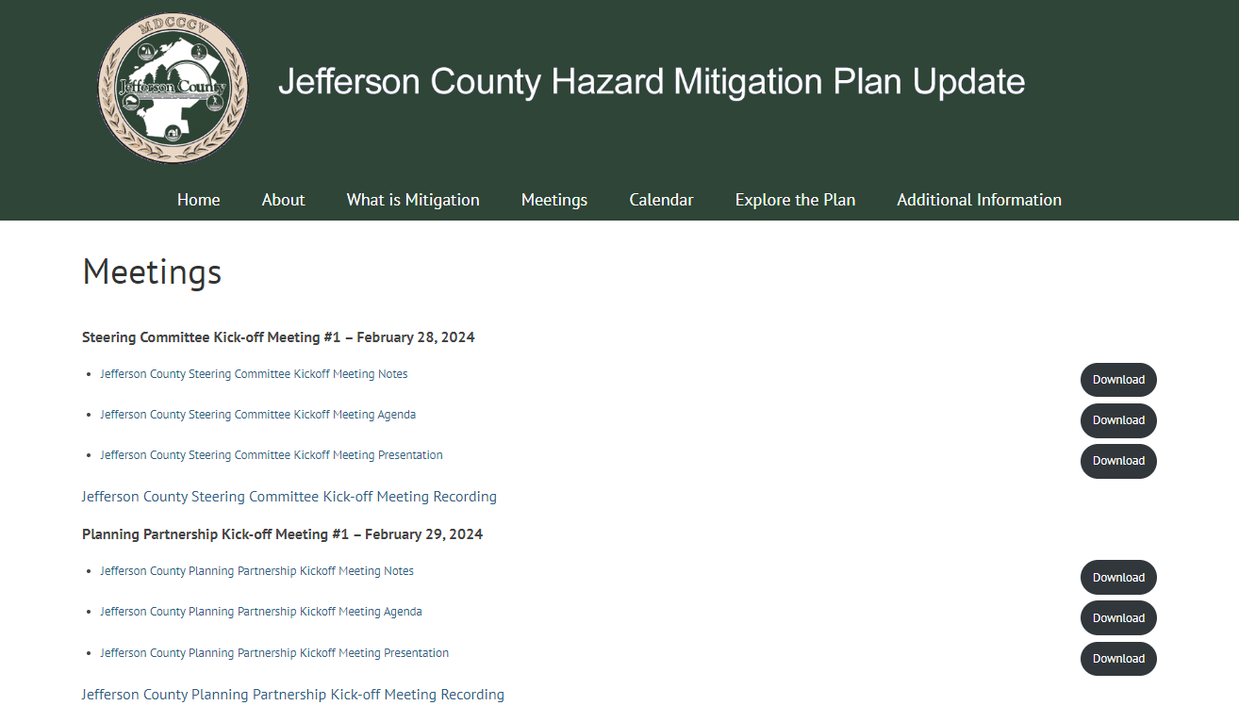
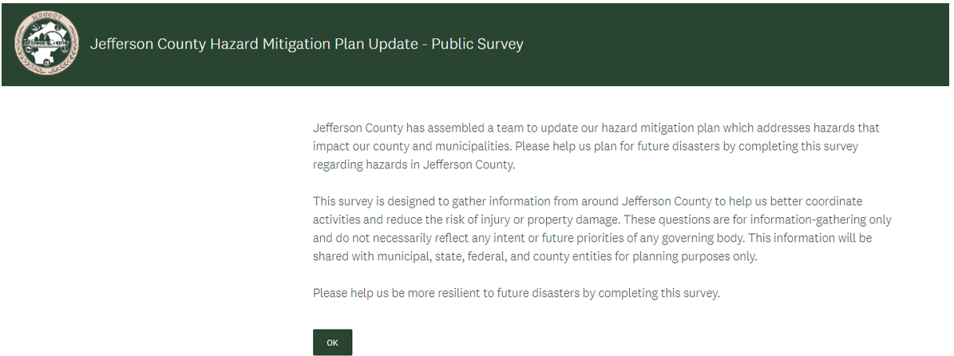
Demographically, survey respondents were from 41 municipalities within Jefferson County, with 48 percent having lived in the County for 20 years or more. The most common age of respondents was between 41 and 50. The majority (75 percent) of residents receive information concerning a natural hazard through the internet. Over half (67 percent) receive information through TV news or via mass notification system (64 percent).
Survey respondents identified the following as the top 5 most frequently occurring natural hazard events within Jefferson County in the past 10 years, as shown in Figure 2-2:
- Winter Storm (79 percent)
- Disease/Pandemic Outbreak (70 percent)
- Extreme Wind (70 percent)
- Severe Storm (59 percent)
- Extreme Temperature (49 percent)
In addition, respondents also expressed concern for high lake water levels, water main breaks, power outages, and air pollution in relation to solar fires and wildfire smoke.
Respondents also identified the following projects to reduce damages due to natural hazards in Jefferson County:
- Work on reducing drifting/blowing snow that leads to traffic accidents on accident prone patches on Route 12-E and 12-F
- Improve and strengthen infrastructure, such as elevating roadways and improving drainage systems
- Replace inadequate or vulnerable bridges and culverts
- Ensure access to redundant water sources
- Provide better information about hazard risks and high-hazard areas
- Assist vulnerable property owners and municipalities with securing funding to mitigate vulnerable infrastructure and properties
Respondents were given the opportunity to propose projects they would like to see implemented in Jefferson County. Suggestions included improving regulations related to building solar and battery storage, upgrading water lines to prevent/reduce water leakage, flooding improvements to roadways, improving storm drains and electrical utility improvements.
Respondents were asked if they owned or rented their place of residence, where 248 elected to provide a response to the question, and 86 percent stated that they owned their residence and 14 percent stated that they rented their residence. Of 249 responses, 85 percent stated that they lived in a single-family, detached, home; 5 percent stated that they resided in a multi-family, detached, home; and 4 percent stated that they live in an apartment complex.
Please list any additional types of projects you believe local, county, state or federal government agencies could be doing to reduce the damage and disruption of natural disasters in Jefferson County.
“Hazardous materials improvements to prevent water supplies from being contaminated.”
“Communication improvements in relation to impacted areas that do not include the City of Watertown”
Figure 2-2. Most Frequently Experienced Natural Hazard Events in Jefferson County
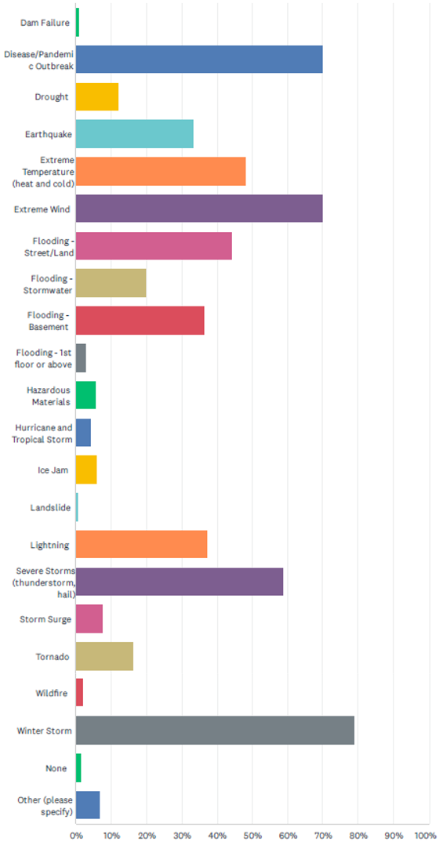
Respondents were also asked about activities that they have done in their homes or plan to do in the future. 41 percent of respondents indicated they have attended meetings or received information on natural disasters or emergency preparedness; 71 percent of respondents indicated that they have talked with members in their home about a natural disaster; 60 percent of respondents have an emergency plan for their home established; 35 percent of respondents have prepared a disaster supply kit; 62 percent of respondents have become trained in first aid and/or CPR; 96 percent of respondents have installed smoke detectors throughout the home; and 29 percent percent of respondents have discussed or created a utility shutoff procedure in the event of a natural disaster.
Respondents were also asked about their property’s location within the floodplain, and if they have flood insurance. Of the 76 respondents who answered this question, only eight indicated that their property is in a designated floodplain, and they have insurance, and the other 68 respondents indicated that their property is not located in the floodplain and that they do not have flood insurance. 22 respondents indicated that they have a property outside of the floodplain that has flood insurance.
Most respondents live in the City of Watertown, the Town of Watertown, and the Town of Brownville.

Continued Public Involvement
The Planning Partners are committed to the continued involvement of the public in the hazard miti gation process. This Plan update will be posted on-line (currently at www.jeffersoncountynyhmp.com), and jurisdictions will be encouraged to maintain links to the plan website. Further, the County will make hard copies of the Plan available for review at public locations as identified on the public plan website.
A notice regarding annual updates of the plan and the location of plan copies will be publicized annually after the Planning Partnership’s annual evaluation and posted on the public website (currently at www.jeffersoncountynyhmp.com).
Each jurisdiction’s governing body shall be responsible for receiving, tracking, and filing public comments regarding this plan.
The public will have an opportunity to comment on the plan as a part of the annual mitigation planning evaluation process and the next five-year mitigation plan update. The HMP Coordinator is responsible for coordinating the plan evaluation portion of the meeting, soliciting feedback, collecting, and reviewing the comments, and ensuring their incorporation in the 5-year plan update as appropriate; however, members of the Planning Partnership will assist the HMP Coordinator. Additional meetings may also be held as deemed necessary by the Planning Partnership. The purpose of these meetings would be to provide the public an opportunity to express concerns, opinions, and ideas about the plan.
After completion of this plan, implementation and ongoing maintenance will continue to be a function of the Planning Partnership. The Planning Partnership will review the plan and accept public comment as part of an annual review and as part of five-year mitigation plan updates.
A notice regarding annual updates of the plan and the location of plan copies will be publicized annually after the HMP Committee’s annual evaluation and posted on the public web site.
Niel S. Rivenburgh of the Jefferson County Office of Fire & Emergency Management has been identified as the ongoing County HMP Coordinator (see Chapter 17), and is responsible for receiving, tracking, and filing public comments regarding this Plan Update. Contact information is:
Mailing Address: | Jefferson County Public Safety Department  Office of Fire & Emergency Management  753 Waterman Dr  Watertown, NY 13601
Contact Name: | Niel S. Rivenburgh
Email Address: | nrivenburgh@co.jefferson.ny.us
Telephone: | (315) 786-2765
Further details regarding continued public involvement are provided in Chapter 17.

Incorporation of Existing Plans, Studies, Reports and Technical Information
The Jefferson County HMP uses the best available information to support hazard profiling, risk assessment, review and evaluation of mitigation capabilities, and the development and prioritization of County and local mitigation strategies. Plans, reports, and other technical information were identified and accessed online through independent research by the planning consultant or provided directly by the County, participating jurisdictions, and stakeholders involved in the planning effort. Detailed sources of technical data and information used are listed in the References section.
The asset inventory data used for the risk assessment is presented in the County Profile (Chapter 3). Details of the source of this data, along with technical information on how the data was used to develop the risk assessment, are presented in Chapter 4, as well as throughout the hazard profiles in this HMP. The County and participating jurisdictions provided relevant jurisdiction-specific planning and regulatory documents, which were reviewed to identify:
- Existing jurisdictional capabilities
- Needs and opportunities to develop or enhance capabilities, which may be identified in the County or local mitigation strategies
- Mitigation-related goals or objectives, considered in the review and update of the overall Goals and Objectives (see Chapter 15)
- Proposed, in-progress, or potential mitigation actions to be incorporated into the updated County and local mitigation strategies
The following regulations, codes, ordinances, and plans were reviewed to develop mitigation planning goals and objectives and mitigation strategies that are consistent across local and regional planning and regulatory mechanisms:
- Comprehensive/master plans
- Building codes
- Zoning and subdivision ordinances
- Flood insurance studies
- Flood insurance rate maps
- NFIP flood damage prevention ordinances
- Site plan requirements
- Local waterfront revitalization plans
- Stormwater management plans
- Emergency management and response plans
- Land use and open space plans
- Capital plans
- Climate smart community program
- Community rating system
- New York State standard multi-hazard mitigation plan, 2023
The County and participating jurisdictions were tasked with updating the assessment of their planning and regulatory capabilities (see capability assessment section of each jurisdictional annex in Volume II). They reviewed relevant plans contributing to the capability of the County and each jurisdiction to integrate effective mitigation efforts into their daily activities. This review is reflected in the capability assessment table in each of the municipal annexes. These tables list plan types, names, and dates, as well as a summary of how each plan supports mitigation and resilience.

Integration with Existing Planning Mechanisms and Programs
Effective mitigation is achieved when hazard awareness and risk management approaches and strategies become an integral part of public activities and decision-making. Many existing plans and programs support hazard mitigation in the County. It is critical that this HMP integrate, coordinate with, and complement, those existing plans and programs.
The capability assessment presented in Chapter 14 provides a summary and description of the existing plans, programs, and regulatory mechanisms at all levels of government (federal, state, county and local) that support hazard mitigation in the County. In the jurisdictional annexes in Volume II, each participating jurisdiction identifies how it has already integrated hazard mitigation into its planning, regulatory and administrative framework (“integration capabilities”) and how it intends to promote this integration (“integration actions”).

Plan Adoption
Adoption by the local governing bodies of each participating jurisdiction demonstrates the commitment of the Planning Partners to fulfill the mitigation goals and strategies outlined in this HMP. Adoption via a municipal resolution legitimizes the HMP and authorizes responsible agencies to execute their responsibilities.
All participating jurisdictions will proceed with formal adoption proceedings. Each jurisdiction must submit a copy of its formal adoption resolution or other legal instrument to the Jefferson County HMP Coordinator in the Jefferson County Office of Fire & Emergency Management. Jefferson County will forward the executed resolutions to the New York State Division of Homeland Security and Emergency Services (NYS DHSES), after which they will be forwarded to FEMA for the record. FEMA allows two options for submitting adoption resolutions:
- Submittal of adoption resolutions with plan—All participating jurisdictions provide documentation of plan adoption when the plan is initially submitted to the state for review. After receiving the draft plan from the state, FEMA conducts its review and will approve the plan if it meets all requirements.
- Approvable pending adoption—A draft HMP is submitted to the state and FEMA for approval prior to adoption by the jurisdictions. When FEMA determines that the plan as a whole and each participating jurisdiction have met all the requirements except adoption, FEMA will inform the state that the plan is “approvable pending adoption” (APA). After that, once FEMA receives documentation of adoption resolutions from at least one jurisdiction, the status is changed from APA to approved for the entire plan and for that jurisdiction. Other jurisdictions that participated in the planning process then receive approval once they pass their own adoption resolutions. A jurisdiction with a plan in APA status does not meet the requirement for an approved mitigation plan to apply for and receive funding assistance.
FEMA will transmit acknowledgement of verification of formal plan adoption and the official approval of the plan to the Jefferson County HMP Coordinator. The plan approval date begins the five-year approval period and sets the expiration date for the plan. All participating jurisdictions will have the same expiration date regardless of their own jurisdiction’s adoption date. The date indicated on FEMA’s approval letter is the official approval date.
The resolutions issued by each jurisdiction to support adoption of this HMP are included in Appendix A.

County Profile
The planning area for this HMP is comprised of the entirety of Jefferson County. This chapter presents general information about the land, people, and assets of Jefferson County. This information provides a baseline for understanding the economic, structural, and population at risk from the hazards addressed in this HMP.

Location
Jefferson County is in the northern part of Northern New York State. It is bounded to the west by Lake Ontario and to the north by the Saint Lawrence River, which forms the border with Canada. It is bounded by Lewis County to the east and St. Lawrence County to the north. The County also includes several islands in the St. Lawrence River, including such large islands as Carleton Island, Grindstone Island, and Wellesley Island. Part of Jefferson County is in the famous “Thousand Islands Region,” an international tourist destination shared between New York State and Canada. The County is 1,857 square miles (Jefferson County 2011) making it fourth-largest County in New York State by total area. Figure 3-1 show Jefferson County and its municipalities.

History
Jefferson County’s vast wilderness was once home to the thriving Oneida Indian Nation, who relied on the region’s abundant natural resources. While French colonial influences are present, the area wasn’t developed until after the American Revolution. That’s when Alexander Macomb acquired the land from the Oneidas in what became known as “Macomb’s Purchase.” This large tract was soon divided into smaller parcels, encouraging settlers to move in. Established in 1805 from part of Oneida County, Jefferson County was named after President Thomas Jefferson. Settlement began as early as 1794, and the local economy quickly grew, thanks to a strong agricultural base—especially dairy farming—and some of the oldest paper mills in New York State.
Drawn by the power of the Black River, industrious pioneers from New England set up a manufacturing and trade hub in the center of the county. Jefferson County soon gained fame for producing a wide range of goods, including cotton and wool yarn, carriages, sewing machines, oil lamps, steam engines, railroad brakes, and even high-pressure hydraulic pumps. Watertown emerged as the heart of the county and became its official seat.
Today, Jefferson County is rich in history and filled with attractions. The Thousand Islands Region and Sackets Harbor, where two War of 1812 battles were fought, are popular destinations. Fort Drum, a major military installation, has been part of the region since 1908, originally known as Pine Camp. On February 13, 1985, the 10th Mountain Division (Light Infantry) was reactivated there, making it the first new Army division created since 1975 and the first stationed in the Northeast since World War II. Known for its versatility, the 10th Mountain Division has been one of the most frequently deployed units in the U.S. Army, ready to handle a variety of missions worldwide (Jefferson County 2016).

Figure 3-1. Jefferson County Hazard Mitigation Plan Area
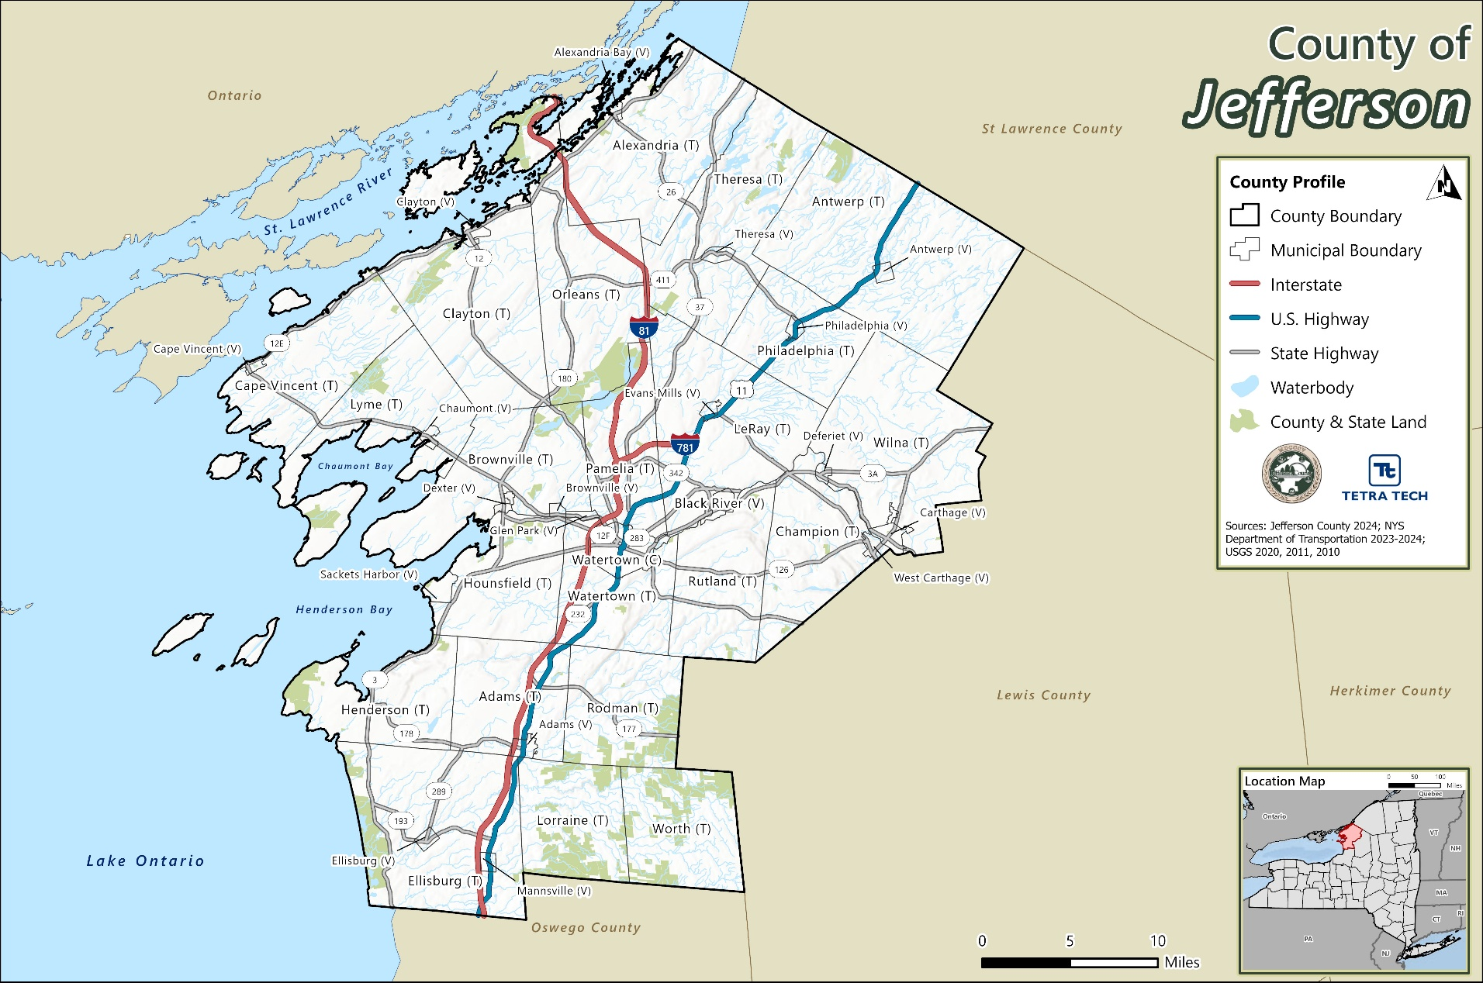

Jurisdictions Within the County
Today, the County consists of 43 municipalities – one city, 23 towns, and 19 villages as listed in Table 3-1.
Table 3-1. Jefferson County Municipalities
City | Villages
City of Watertown | Village of Adams  Village of Alexandria Bay  Village of Antwerp  Village of Black River  Village of Brownville  Village of Cape Vincent  Village of Carthage  Village of Chaumont  Village of Clayton  Village of Deferiet | Village of Dexter  Village of Ellisburg  Village of Evans Mills  Village of Glen Park  Village of Mannsville  Village of Philadelphia  Village of Sackets Harbor  Village of Theresa  Village of West Carthage
Towns
Town of Adams  Town of Alexandria  Town of Antwerp  Town of Brownville  Town of Cape Vincent  Town of Champion  Town of Clayton  Town of Ellisburg | Town of Henderson  Town of Herrings  Town of Hounsfield  Town of LeRay  Town of Lorraine  Town of Lyme  Town of Orleans  Town of Pamelia | Town of Philadelphia  Town of Rodman  Town of Rutland  Town of Theresa  Town of Watertown  Town of Wilna  Town of Worth

Physical Setting

Hydrography and Hydrology
Jefferson County is defined by its abundant and diverse water resources, which play a critical role in shaping the region’s geography, economy, and hazard exposure. The county is bordered by two major water bodies—Lake Ontario to the west and the St. Lawrence River to the north—both of which are significant for transportation, recreation, and ecological health.
Key embayments along the Lake Ontario shoreline include Black River Bay (formerly known as Hungry Bay), Chaumont Bay, Henderson Bay, and Guffin’s Bay. These inlets are important for fisheries, boating, and shoreline development, but also present flood and erosion risks.
In addition to its major water bodies, Jefferson County contains approximately 20 small lakes, primarily located in the Towns of Theresa and Alexandria, with others in Ellisburg, Antwerp, Henderson, Orleans, Pamelia, Champion, and Rutland. Notable among these are:
- Butterfield Lake (Theresa and Alexandria) – the largest, approximately four miles long
- Perch Lake (Orleans and Pamelia) – nearly three miles long
- Pleasant Lake (Champion) – about two miles long
The county is entirely drained by Lake Ontario and the St. Lawrence River. The most significant interior waterway is the Black River, which drains roughly one-quarter of the county. Flowing westward from Carthage to Lake Ontario, the river descends approximately 480 feet, forming a series of rapids and cascades that historically powered local industry and continue to influence land use and flood risk.
Other important waterways include:
- Indian River, a tributary of the Oswegatchie River
- Chaumont River, which flows into Chaumont Bay
- Perch River, draining Perch Lake into Black River Bay
- Sandy Creek (two branches), located in the southern part of the county
- Stony Creek, flowing through Henderson and Adams
- Mill Creek, located in Hounsfield
These water systems are integral to the county’s natural landscape and are key considerations in floodplain management, water quality protection, and hazard mitigation planning.

Watersheds
A watershed is a geographic area of land where all precipitation and surface water drains into a common outlet, such as a river, lake, stream, or bay. Watersheds are defined by natural topographic features like ridges and hills that separate one drainage area from another. They include not only the water bodies themselves but also the surrounding land that contributes runoff to those systems. For example, a lake’s watershed encompasses both the streams that feed into it and the land areas that drain into those streams. Figure 3-2 depicts the hydrologic system of a typical watershed.
Figure 3-2. Watershed
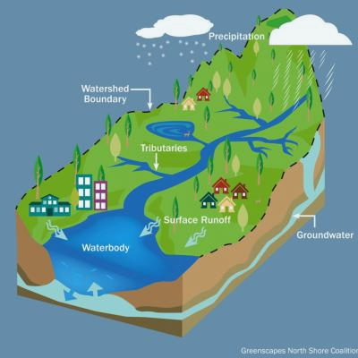
Source: (NOAA 2022)
Watersheds often cross municipal and county boundaries, making regional coordination essential for effective water resource and hazard management. In New York State, all surface waters fall within one of 17 major drainage basins. Jefferson County is located within three major watersheds:

Lake Ontario and Minor Tributaries Watershed
This watershed includes the smaller drainage areas that lie between the major rivers flowing into Lake Ontario, such as the Niagara, Genesee, Oswego, and Black Rivers. It is divided into western, central, and eastern sections that span the Lake Ontario shoreline. The watershed covers approximately 2,460 square miles in New York State and includes most of Jefferson and Orleans Counties, as well as parts of Oswego, Wayne, Monroe, Niagara, Cayuga, and Lewis Counties. This watershed plays a key role in managing stormwater, agricultural runoff, and shoreline erosion. Figure 3-3 shows a map of the Lake Ontario and Minor Tributaries Watershed.

Saint Lawrence Watershed
Located along the northern border of New York State, the Saint Lawrence Watershed is defined by the Saint Lawrence River, which serves as the outflow for the entire Great Lakes system and a vital international waterway. Within New York, this watershed drains the northern and western Adirondack Mountains and the Saint Lawrence Valley. It encompasses approximately 5,600 square miles, including all of Saint Lawrence County, most of Franklin County, and parts of Jefferson, Lewis, Herkimer, Hamilton, Essex, and Clinton Counties. The watershed is critical for navigation, water quality, and binational water management. Figure 3-4 shows a map of the Saint Lawrence Watershed.

Black River Watershed
The Black River originates in the western Adirondacks and flows northwest through the Tug Hill Plateau before emptying into Lake Ontario. This watershed is largely forested and sparsely populated, with Watertown serving as the primary population center. It spans about 1,920 square miles and includes significant portions of Jefferson, Lewis, and Herkimer Counties, as well as parts of Hamilton and Oneida Counties. The Black River is a key resource for hydropower, recreation, and flood management (NYSDEC 2014). Figure 3-5 shows a map of the Black River Watershed.

Topography and Geology
Jefferson County’s physical geography carves the County into five natural regions, each with its own unique character and offerings. These regions include the Indian River Lakes, Black River Valley, Tug Hill Uplands, Thousand Islands, and Lake Ontario Lowlands (refer to Figure 3-6).

Figure 3-3. Lake Ontario and Minor Tributaries Watershed
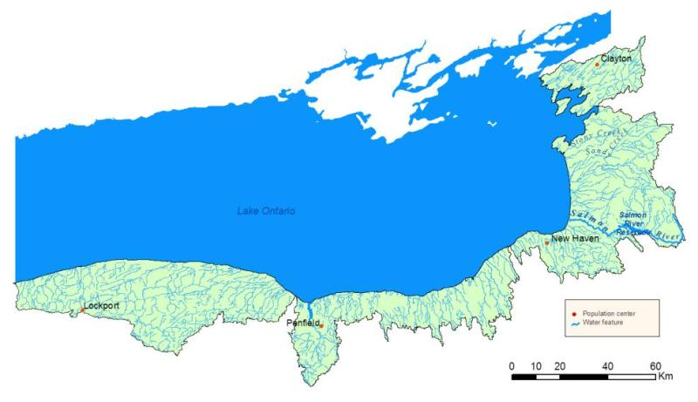
Source: (NYSDEC 2014)

Figure 3-4. Saint Lawrence Watershed
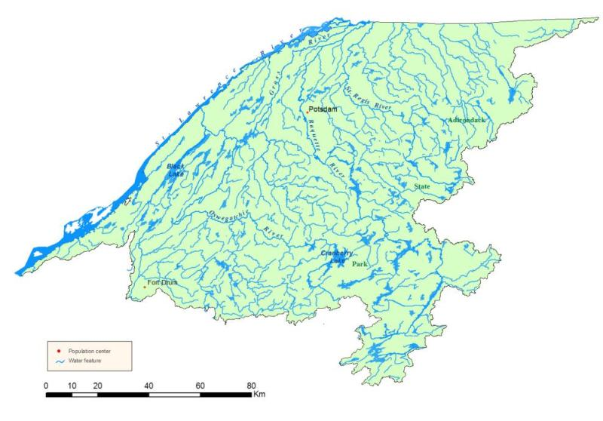
Source: (NYSDEC 2014)
Figure 3-5. Black River Watershed
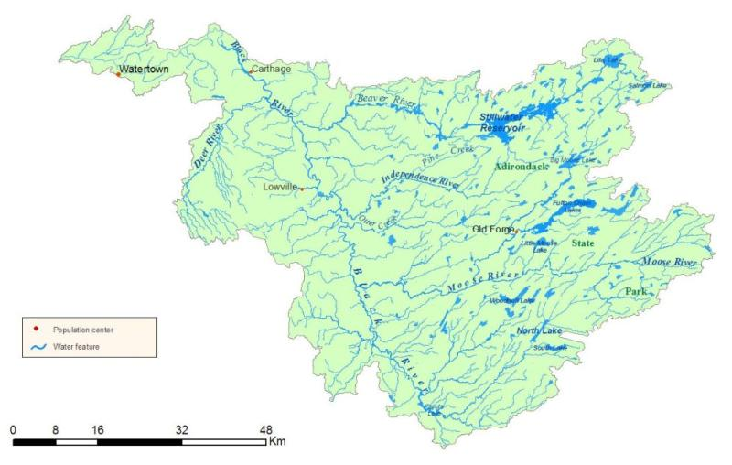
Source: (NYSDEC 2014)
Figure 3-6. Regions of Jefferson County
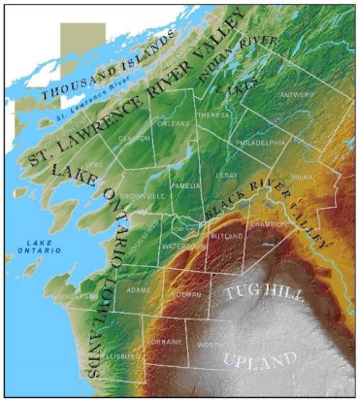
Source: (Jefferson County 2016)

Indian River Lakes
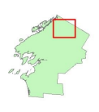
The Indian River Lakes region consists mainly of small, rural communities in the interior portion of Northern Jefferson County, nestled between the St. Lawrence River and Fort Drum. The Indian River Lakes system consists of 18 natural lakes spread throughout the northern portion of Jefferson County, the southern portion of St. Lawrence County, and the westernmost tip of Lewis County. They range from shallow, highly productive warm water lakes to deep, cold-water lakes. The system provides a unique opportunity to fish for a variety of species in a relatively small geographic area. There are 15 lakes open to the public, with seven located in Jefferson County. Flowing from Indian River Village in Lewis County to Black Lake in St. Lawrence County, the Indian River offers over 100 miles of excellent fishing and canoeing opportunities. Seventy-five miles of the river is readily canoeable, and fishing is good through its length, making it an extremely appealing area to the outdoor enthusiast. The Indian is a picturesque mostly slow-moving river. Its channel varies greatly in width, from 25 to 200 feet, and is best described as moderately wide with narrow sections. Water depths are generally shallow (less than 10 feet) with numerous deeper holes (Jefferson County 2016).

Black River Valley
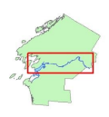
The Black River basin area covers nearly two-thousand square miles and receives the highest annual precipitation of any watershed in New York State. Hydropower afforded by the Black River was an important attraction for settlements in the early days of the County’s development. Industries sprang up along the River, many surviving today in the Villages of Brownville, Carthage, and West Carthage, along with the City of Watertown. The tradition of harnessing the Black River’s force for power is centuries old – in 1795, the first mill in Carthage was constructed. The Black River guided early settlement in the region and flows through the most populated areas of the County (Jefferson County 2016).

Tug Hill Uplands
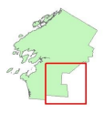
East of Lake Ontario, the land rises steadily to form the Tug Hill Uplands, a relatively flat, rocky area separated from the Adirondack Mountains by the Black River Valley. The plateau stands in the path of prevailing winds that pick-up moisture from Lake Ontario. The annual snowfall averages 20 feet, making the region one of the snowiest areas east of the Rocky Mountains. Because of the heavy snow cover that this area endures for nearly half of the year, it is no surprise that winter sports such as snowmobiling, snowshoeing, dog sledding, and cross-country skiing dominate the local recreational scene. Tug Hill has an elevation of about 350 feet in the west and 2,000 feet in the east. Due to this, the plateau has generated interest from snow kiting (an outdoor winter sport where people use kite power to glide on snow or ice) enthusiasts from across the east coast (Jefferson County 2016).

Thousand Islands
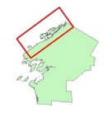
The St. Lawrence River is one of the longest rivers in North America. It is also the outflow for the entire Great Lakes system. The Great Lakes hold nearly 20 percent of the world’s fresh water. The River flows 744 miles from Lake Ontario into the world’s largest freshwater estuary, the Gulf of St. Lawrence. Only 114 miles of the River are in New York State. There are exactly 1,864 islands in the Thousand Islands Region. The islands range in size from over 40 square miles to smaller islands occupied by a single residence, or uninhabited outcroppings of rocks that are only home to migratory waterfowl. To be counted as an island, the piece of land must be surrounded by water, above water all year long, and support at least one tree. Approximately 381 islands and shoals of the Thousand Islands are within Jefferson County. The River is 250 feet at its deepest point. The St. Lawrence River is the world’s longest deep-draft inland waterway. The St. Lawrence Seaway took 15,000 people and 4 years to build, beginning in 1955 and completed in 1959. Parts of the River are so clear in some areas that the bottom can be observed in 80 feet of water. The Thousand Islands International Bridge consists of one American span, three Canadian spans and one International span. The American span is 800 feet between towers, 150 feet above water and has two 1,500-foot viaducts. The Canadian spans includes a suspension span, 750 feet between towers, 120 feet above water and a 1,500-foot viaduct, a steal arch span that is 348 feet long and a Warren Truss span that is 600 feet long. The International span across the border is 90 feet long and the shortest international vehicular bridge in the world (Jefferson County 2016).

Lake Ontario Lowlands
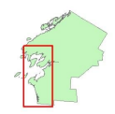
This region is mostly low and flat, with hills of unsorted glacial till and sorted melted water deposits. Lake Ontario is one of the five Great Lakes of North America. It is the easternmost lake, and the smallest in surface area but it has greater volume than Lake Erie. Lake Ontario is 193 miles long and 53 miles wide. The elevation is 244 feet above mean sea level along the Lake Ontario shoreline. This region includes large sand dunes, expansive backwater areas and many bays along the lakeshore. The region includes the Chaumont Barrens; a 1,600-acre alvar forest in the Northern portion of the County, one of the few alvar forests left in the world. The 526-acre Black Pond Wildlife Management Area is also located in this region, in the southern portion of the County. Much of the barrier beach in Black Pond WMA has forested sand dunes that are as much as 60 feet high. Henderson Shores Unique Area This 1,160-acre reforestation area is classified as a “Unique Area” for good reason. The underlying limestone, sometimes right at the surface, often with a shallow layer of wet soil, provides an unusual habitat for a variety of very specialized plants (Jefferson County 2016).

Climate
A climate profile is essential for understanding the county’s exposure to seasonal hazards and for planning infrastructure, emergency response, and community resilience strategies.
Jefferson County, New York, experiences a humid continental climate, characterized by four distinct seasons and significant seasonal variability in temperature and precipitation. The county’s location along the eastern shore of Lake Ontario plays a major role in shaping its weather patterns, particularly through lake-effect snow and enhanced precipitation.
Winters in Jefferson County are long, cold, and snowy. Average high temperatures range from 29°F to 31°F, while lows typically fall between 12°F and 13°F. The county receives an average of 110 inches of snow annually, with some areas—especially those downwind of Lake Ontario—experiencing even higher totals due to lake-effect snow. These conditions can lead to hazardous travel, infrastructure stress, and increased heating demands.
Spring brings a gradual warming trend. Average high temperatures increase from 41°F in March to 67°F in May, while lows rise from 22°F to 46°F. Precipitation is steady, averaging 3 to 4 inches per month, often in the form of rain and melting snow, which can contribute to localized flooding and high streamflows.
Summers are warm and relatively humid, with average highs between 76°F and 80°F and lows ranging from 55°F to 60°F. Rainfall is slightly higher during this season, averaging about 4 inches per month, often from thunderstorms. While severe heat is uncommon, occasional heatwaves can pose health risks, particularly for vulnerable populations.
Autumn is marked by cooling temperatures and vibrant foliage. Highs drop from 72°F in September to 47°F in November, with lows falling from 51°F to 31°F. Rainfall remains consistent, and early snowfall is common by late November, signaling the transition into winter (NOAA, Climate Data for Counties 2025).
Figure 3-7 shows Jefferson County monthly averages for temperature and precipitation. Annual averages for the county are as follows (NOAA, Climate Data Online 2025):
- Average annual precipitation: 40 inches
- Average annual snowfall: 110 inches
- Average number of sunny days: 161 days
Figure 3-7. County Climate Summary
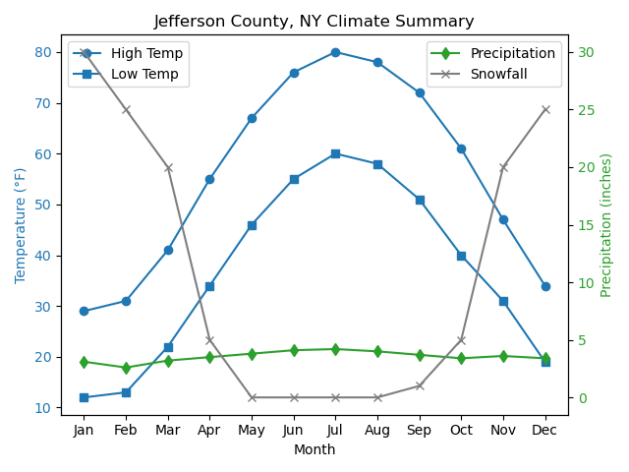

Land Use

Current Land Use
The greatest share of land use in Jefferson County is agriculture, with 33 percent of all land cover categorized as one of many agricultural land use categories (in terms of acreage). The next largest shares are residential with 24.2 percent, followed by vacant land and community services, with 19 percent and 12 percent, respectively. Table 3-2 and Figure 3-8 summarize the land use categories.
Table 3-2. Jefferson County 2024 Land Use Classification
 | Total Area in Category
Category Description | Acres | % of Total
Agricultural | 267,260 | 33.4%
Commercial | 10,225 | 1.3%
Community Services | 91,766 | 11.5%
Industrial | 4,531 | 0.6%
Public Services | 8,711 | 1.1%
Recreation & Entertainment | 8,860 | 1.1%
Residential | 193,633 | 24.2%
Vacant | 148,323 | 18.6%
Wild, Forest, Conservation, Public Parks | 66,010 | 8.3%
Jefferson County (Total) | 799,320 | 100.0%
Source: Jefferson County 2024, City of Watertown 2024

Land Use Trends

Land Use and Development Patterns
In New York State, land use regulatory authority is decentralized, with towns, villages, and cities responsible for zoning and development decisions. However, many land use issues—such as infrastructure planning, environmental protection, and hazard mitigation—extend beyond municipal boundaries. As such, regional coordination is essential to ensure that development patterns do not increase vulnerability to natural hazards.
Land use practices directly influence a community’s exposure to risk. For example, intensive development in flood-prone areas increases the number of people and structures at risk during extreme weather events. Conversely, preserving open space and agricultural land can reduce runoff, protect water quality, and serve as natural buffers during floods.

Figure 3-8. Jefferson County Land Use
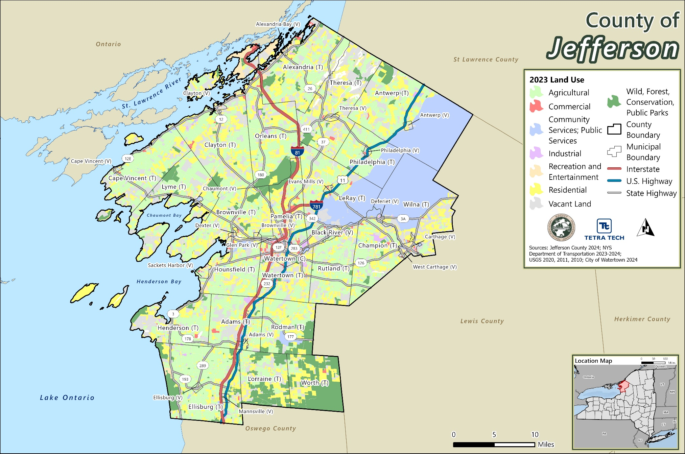

Urban and Metropolitan Development
Jefferson County includes one of New York’s smallest metropolitan areas, centered around the City of Watertown, which serves as the county seat. The broader Watertown-Fort Drum Metropolitan Statistical Area (see Figure 3-9) has a population of approximately 117,000. The presence of Fort Drum, a major U.S. Army installation, significantly shapes the region’s economy, infrastructure, and land use.
While the manufacturing sector has declined in recent decades—mirroring trends across upstate New York—growth in the healthcare, education, and professional services sectors has helped stabilize the local economy. Development in and around Watertown is primarily suburban in character, with commercial corridors along major routes such as Interstate 81 and U.S. Route 11.

Agricultural Land Use and Economic Role
Agriculture remains a cornerstone of Jefferson County’s land use and economy. According to the 2022 Census of Agriculture (USDA 2024):
- The number of farms declined slightly (from 754 in 2017 to 749 in 2022), a 5 percent decrease.
- Total farmland increased by 1 percent, reaching 249,497 acres.
- The average farm size grew by 7 percent, reflecting consolidation trends.
- The market value of agricultural products sold rose by 45 percent, with a 53 percent increase in average value per farm.
Jefferson County ranks:
- 1st in New York State for value of sales in the crops and hay sector
- 10th in the state and 133rd nationally for fruits, tree nuts, and berries
- 9th in the state and 85th nationally for milk production
These figures highlight the county’s strong agricultural productivity and its importance to the regional food system.

Agricultural Districts and Land Protection
Under Article 25-AA of the New York State Agriculture and Markets Law, counties can establish agricultural districts to protect farmland and promote agricultural viability. Jefferson County has three such districts, reviewed every eight years (see Figure 3-10) (Markets 2024):
- Southeast Agricultural District (#1) – Includes the Towns of Champion, Rodman, Rutland, Wilna, Worth, and parts of Adams, Hounsfield, Watertown, Lorraine, and the Village of Adams.
- North Agricultural District (#2) – Covers the Towns of Brownville, Pamelia, LeRay, Lyme, Orleans, Philadelphia, Antwerp, Cape Vincent, Clayton, Theresa, and Alexandria.
- Southwest Agricultural District (#3) – Encompasses the Towns of Henderson and Ellisburg, the Villages of Sackets Harbor, Mannsville, Adams, and Ellisburg, and parts of Hounsfield, Watertown, Adams, and Lorraine.
Together, these districts protect over 200,000 acres of farmland, helping to preserve the county’s rural character and reduce development pressure in hazard-prone areas.

Figure 3-9. Watertown-Fort Drum Metropolitan Statistical Area
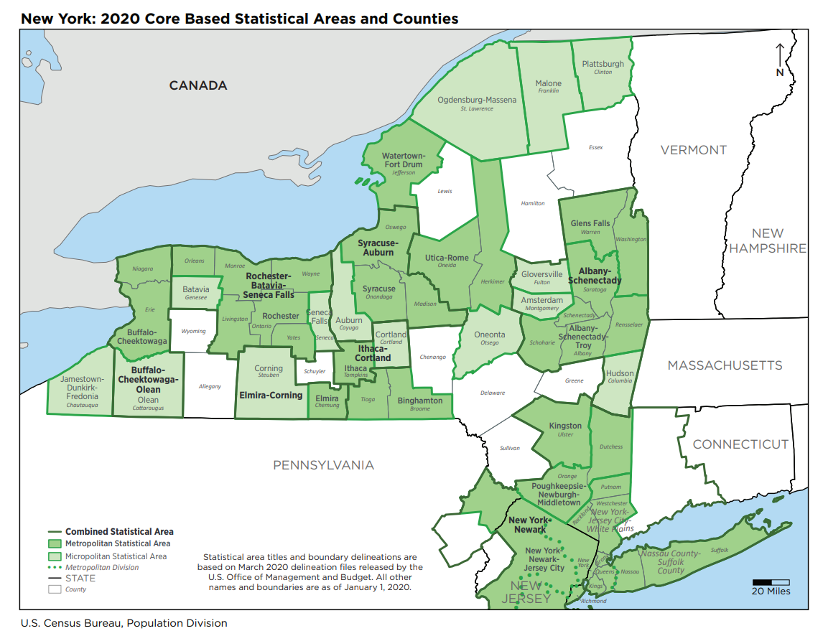
Source: (U.S. Census 2021)
Note: Jefferson County is located within the red circle
Figure 3-10. Jefferson County Agricultural Districts
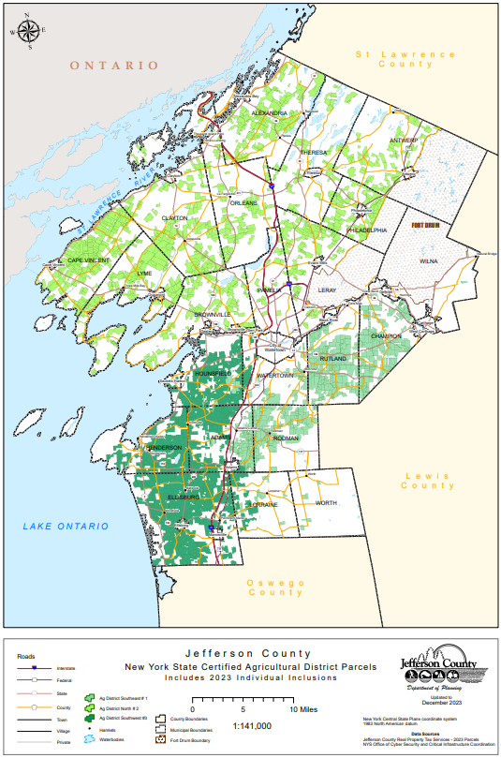
Source: Jefferson County Department of Planning 2023

Demographics and The Economy

Current Population and Changes Over Time
Jefferson County is the most populated County in the six-county North Country region. According to the 2020 U.S. Census, Jefferson County has a population of 116,721 people which is depicted in Figure 3-11.
The largest population center is in the City of Watertown, which also serves the seat of government. Fort Drum U.S Army military reservation is in Jefferson County. There is a growing Amish population in the northern part of the County. There is a higher concentration of elderly and vulnerable population in the City of Watertown and other population centers. There is a notable swell in population during the summer months with seasonal visitors and tourists. The recent reduction in population is largely explained by changes to the Fort Drum population and changes to the census counting procedures (NYS Homeland Security and Emergency Services 2021).
Population trend information was evaluated to estimate future shifts that could significantly change the character of the area. Population trends can provide a basis for making decisions on the type of mitigation approaches to consider and the locations in which these approaches should be applied. This information can also be used to support planning decisions regarding future development in vulnerable areas.
As seen in Table 3-3, Jefferson County’s population has increased over the decades since 1960. There was a peak in total population in the year 2010, followed by a plateau in 2020. The population projections for Jefferson County from Cornell University for the next two decades anticipate a population decline in the mid-2020s, followed by a steady growth back to around 2020 levels by 2040 as seen in Table 3-4.
While the overall population of Jefferson County has increased by 0.40 percent since 2010, this growth is not geographically uniform throughout the County, with some areas having experienced a decline in population. However, the 2020 U.S. Census data for Hazards-U.S. Multi-Hazard (Hazus) is believed to be sufficient and appropriate to support the risk assessment and mitigation planning efforts of this project.
According to the most recent data from the U.S. Census Bureau (2019–2023 American Community Survey), Jefferson County, New York, has an estimated 9,485 veterans. The veteran population in Jefferson County, NY, has shown a gradual decline over the past decade. Here’s a snapshot based on U.S. Census Bureau data:
- 2010–2014 ACS: ~10,800 veterans
- 2015–2019 ACS: ~10,100 veterans
- 2019–2023 ACS: 9,485 veterans
This represents a decrease of approximately 12 percent over the past decade. The decline is consistent with national trends, largely due to the aging of veterans from earlier service eras (e.g., Vietnam and Gulf War I) and fewer new veterans entering the population relative to those aging out or passing away.

Figure 3-11. Population Per Square Mile By Census Tract
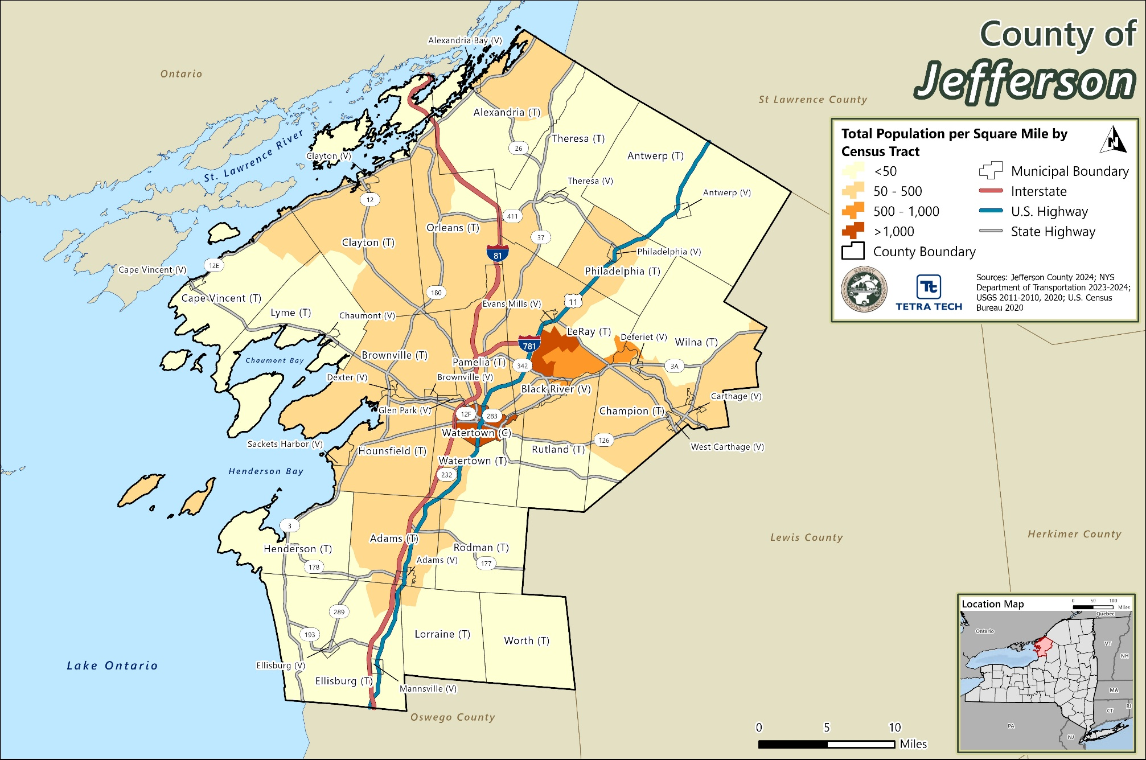

Table 3-3. Historical Population Change in Jefferson County
Jurisdiction* | Population
 | 1960 | 1970 | 1980 | 1990 | 2000 | 2010 | 2020
County of Jefferson | 87,835 | 88,508 | 88,151 | 110,943 | 111,738 | 116,229 | 116,721
City of Watertown | 33,306 | 30,787 | 27,861 | 29,429 | 26,705 | 27,023 | 24,685
Town of Adams | 3,964 | 4,381 | 4,390 | 4,977 | 4,782 | 5,143 | 4,943
Town of Alexandria | 3,574 | 3,515 | 3,587 | 3,949 | 4,097 | 4,061 | 3,741
Town of Antwerp | 1,905 | 1,794 | 1,859 | 1,856 | 1,793 | 1,846 | 1,683
Town of Brownville | 3,985 | 4,321 | 5,113 | 5,604 | 5,843 | 6,263 | 5,842
Town of Cape Vincent | 1,756 | 1,748 | 1,823 | 2,768 | 3,345 | 2,777 | 2,765
Town of Champion | 3,878 | 4,371 | 4,056 | 4,574 | 4,361 | 4,494 | 4,562
Town of Clayton | 3,753 | 4,021 | 4,028 | 4,629 | 4,817 | 5,153 | 4,770
Town of Ellisburg | 3,285 | 3,385 | 3,312 | 3,386 | 3,541 | 3,474 | 3,352
Town of Henderson | 1,207 | 1,364 | 1,330 | 1,268 | 1,377 | 1,360 | 1,438
Town of Hounsfield | 2,722 | 2,771 | 2,645 | 3,089 | 3,323 | 3,466 | 3,281
Town of LeRay | 3,627 | 3,973 | 5,039 | 17,973 | 19,836 | 21,782 | 25,574
Town of Lorraine | 609 | 628 | 720 | 766 | 930 | 1,037 | 924
Town of Lyme | 1,448 | 1,550 | 1,695 | 1,701 | 2,015 | 2,185 | 2,299
Town of Orleans | 1,982 | 1,927 | 2,007 | 2,248 | 2,465 | 2,789 | 2,788
Town of Pamelia | 1,414 | 1,894 | 2,417 | 2,811 | 2,897 | 3,160 | 3,343
Town of Philadelphia | 1,297 | 1,355 | 1,417 | 2,136 | 2,140 | 1,947 | 1,975
Town of Rodman | 765 | 772 | 836 | 1,016 | 1,147 | 1,176 | 1,197
Town of Rutland | 2,229 | 2,448 | 2,685 | 3,023 | 2,959 | 3,060 | 3,038
Town of Theresa | 1,635 | 1,754 | 1,853 | 2,281 | 2,414 | 2,905 | 2,648
Town of Watertown | 2,492 | 3,026 | 3,098 | 4,341 | 4,482 | 4,470 | 5,913
Town of Wilna | 6,809 | 6,538 | 6,227 | 6,899 | 6,235 | 6,427 | 5,732
Town of Worth | 193 | 185 | 153 | 219 | 234 | 231 | 198
Source: (Jefferson County Planning Department 2011); (NYS Office of the Comptroller 2021)
* Town data includes Villages and Census Designated Places (CDPs) within the Town
Table 3-4. Historical and Projected Population Change in Jefferson County
Historical Jefferson County Population |  |  |  |  |  |  | Projected Jefferson County Population
1960 | 1970 | 1980 | 1990 | 2000 | 2010 | 2020 | 2030 | 2040
87,835 | 88,508 | 88,151 | 110,943 | 111,738 | 116,229 | 116,721 | 114,290 | 115,693
Source: (Jefferson County Planning Department 2011); (Cornell University 2018); (NYS Office of the Comptroller 2021)

Socially Vulnerable Populations
These populations can be more susceptible to hazard events based on several factors including their physical and financial ability to react or respond during a hazard, and the location and construction quality of their housing. This HMP considers several socially vulnerable population groups: the elderly (persons over the age of 65), the young (persons under the age of 5), non-English speaking households, those with disabilities, and those living below the poverty level (as defined by the U.S. Census Bureau). Additionally, the County is concerned with the homeless population, those dependent on substances, and the Amish and Mennonite families that do not use technology and therefore do not receive hazard event and warnings.
In Jefferson County, 14 percent of the population is over the age of 65 and 8 percent of the population is under the age of 5. Additionally, 12 percent of the County population is below the poverty level, 1 percent of the County’s residents live in non-English speaking households, and 13 percent of the County population is disabled. Figure 3-12 shows the distribution of these groups across the county and Table 3-5 shows the breakdown by jurisdiction
The Centers for Disease Control and Prevention and Agency for Toxic Substances and Disease Registry Social Vulnerability Index (CDC/ATSDR SVI or SVI) is a place-based index, database, and mapping application designed to identify and quantify communities experiencing social vulnerability. The Geospatial Research, Analysis & Services Program (GRASP) maintains the CDC/ATSDR SVI to help public health officials and local planners better prepare for and respond to emergency events with the goal of decreasing human suffering, economic loss, and health inequities. The current CDC/ATSDR Social Vulnerability Index uses 16 U.S. Census variables from the 5-year American Community Survey (ACS) to identify communities that may need support before, during, or after disasters. These variables are grouped into four themes that cover four major areas of social vulnerability as seen in Figure 3-13 ( Agency for Toxic Substances and Disease Registry 2024). Scores for the major areas are combined into a single measure of overall social vulnerability. Figure 3-14 shows the overall SVI scores across Jefferson County.
While veterans are not automatically considered socially vulnerable as a group, certain subgroups of veterans may experience heightened vulnerability depending on factors such as:
- Disability status—Many veterans live with service-connected disabilities, including physical injuries, PTSD, or other mental health conditions.
- Age—Older veterans, especially those from the Vietnam or Korean War eras, may face challenges related to aging, healthcare access, and fixed incomes.
- Economic hardship—Some veterans experience poverty, unemployment, or housing instability, particularly after transitioning out of active duty.
- Rural isolation—In counties like Jefferson, rural veterans may face barriers to healthcare, transportation, and social services.
- Homelessness—Veterans are overrepresented in the homeless population nationally.
- Mental health and substance abuse.

Figure 3-12. Socially Vulnerability Populations in Jefferson County
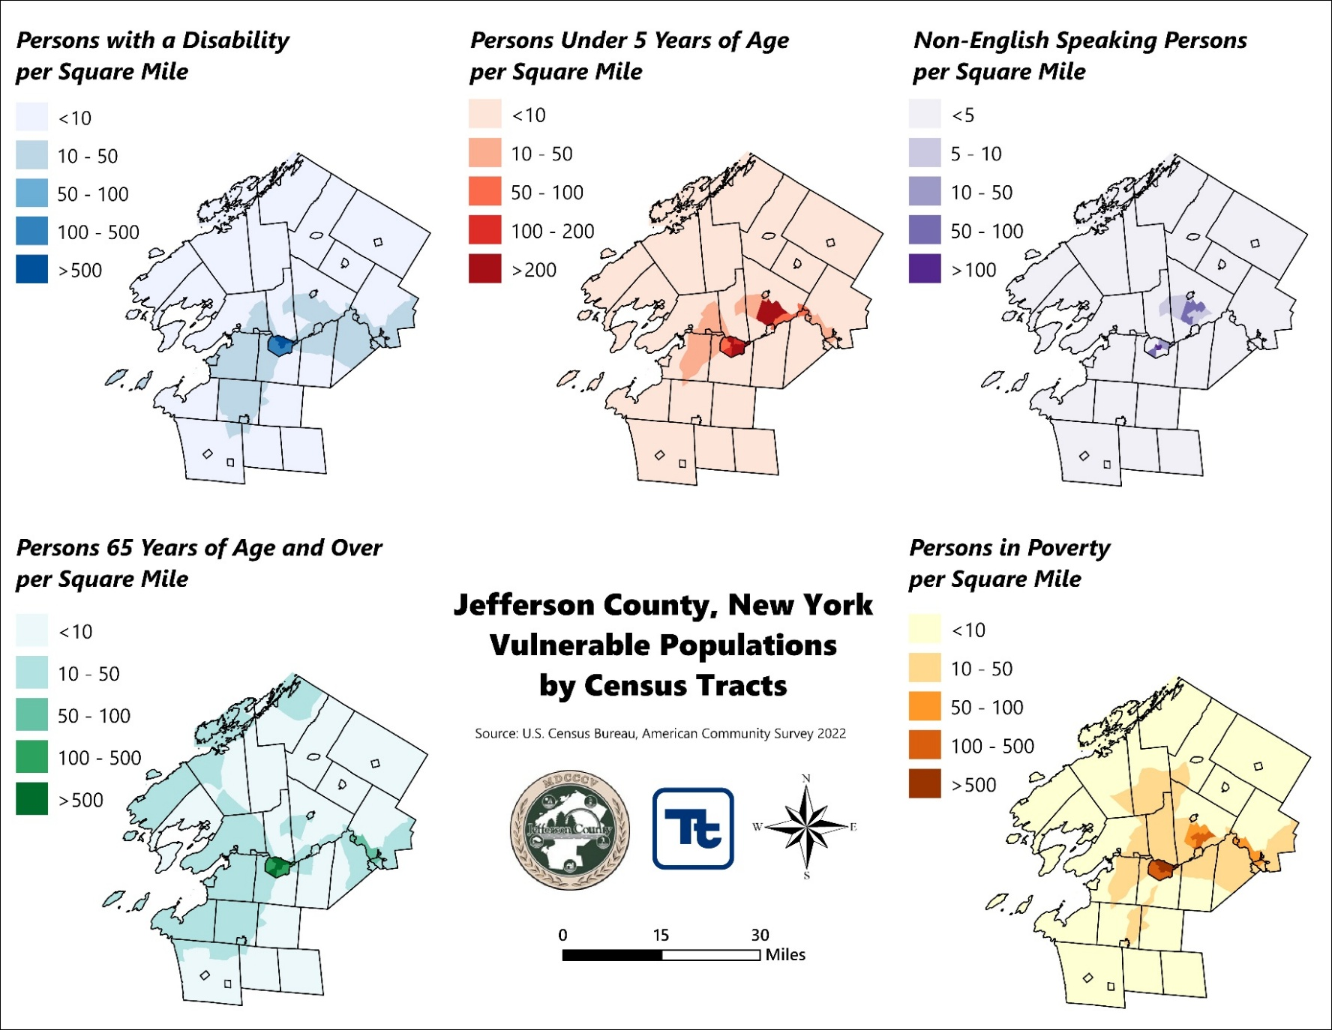
Table 3-5. Jefferson County Demographics, 2020 Census and 2022 ACS 5-Year Estimates
 | 2020 | ACS 5-Year Population Estimates (2022)
 |  | 65 and Older |  | 5 and Younger |  | Non-English-Speaking |  | Disability |  | Below Poverty Level
 | Census Population | Population | % of Total | Population | % of Total | Households | % of Total | Population | % of Total | Population | % of Total
Adams (T) | 3,340 | 491 | 14.7% | 56 | 1.7% | 10 | 0.3% | 455 | 13.6% | 250 | 7.5%
Adams (V) | 1,633 | 358 | 21.9% | 136 | 8.3% | 5 | 0.3% | 403 | 24.7% | 218 | 13.3%
Alexandria (T) | 2,817 | 483 | 17.1% | 182 | 6.5% | 0 | 0.0% | 316 | 11.2% | 152 | 5.4%
Alexandria Bay (V) | 924 | 378 | 40.9% | 32 | 3.5% | 10 | 1.1% | 227 | 24.6% | 105 | 11.4%
Antwerp (T) | 1,177 | 209 | 17.8% | 52 | 4.4% | 0 | 0.0% | 234 | 19.9% | 135 | 11.5%
Antwerp (V) | 506 | 129 | 25.5% | 57 | 11.3% | 0 | 0.0% | 178 | 35.2% | 85 | 16.8%
Black River (V) | 1,232 | 255 | 20.7% | 74 | 6.0% | 5 | 0.4% | 152 | 12.3% | 250 | 20.3%
Brownville (T) | 3,456 | 764 | 22.1% | 253 | 7.3% | 0 | 0.0% | 652 | 18.9% | 355 | 10.3%
Brownville (V) | 930 | 115 | 12.4% | 12 | 1.3% | 0 | 0.0% | 108 | 11.6% | 18 | 1.9%
Cape Vincent (T) | 2,066 | 545 | 26.4% | 60 | 2.9% | 0 | 0.0% | 220 | 10.6% | 129 | 6.2%
Cape Vincent (V) | 699 | 129 | 18.5% | 39 | 5.6% | 0 | 0.0% | 109 | 15.6% | 77 | 11.0%
Carthage (V) | 3,236 | 514 | 15.9% | 314 | 9.7% | 0 | 0.0% | 588 | 18.2% | 616 | 19.0%
Champion (T) | 2,537 | 310 | 12.2% | 78 | 3.1% | 41 | 1.6% | 573 | 22.6% | 508 | 20.0%
Chaumont (V) | 615 | 139 | 22.6% | 54 | 8.8% | 0 | 0.0% | 98 | 15.9% | 90 | 14.6%
Clayton (T) | 3,065 | 541 | 17.7% | 147 | 4.8% | 63 | 2.1% | 251 | 8.2% | 584 | 19.1%
Clayton (V) | 1,705 | 523 | 30.7% | 99 | 5.8% | 54 | 3.2% | 345 | 20.2% | 271 | 15.9%
Deferiet (V) | 245 | 14 | 5.7% | 48 | 19.6% | 0 | 0.0% | 20 | 8.2% | 42 | 17.1%
Dexter (V) | 1,004 | 156 | 15.5% | 35 | 3.5% | 0 | 0.0% | 165 | 16.4% | 130 | 12.9%
Ellisburg (T) | 2,869 | 515 | 18.0% | 149 | 5.2% | 0 | 0.0% | 217 | 7.6% | 215 | 7.5%
Ellisburg (V) | 186 | 36 | 19.4% | 17 | 9.1% | 0 | 0.0% | 57 | 30.6% | 38 | 20.4%
Evans Mills (V) | 678 | 107 | 15.8% | 35 | 5.2% | 0 | 0.0% | 167 | 24.6% | 96 | 14.2%
Glen Park (V) | 452 | 48 | 10.6% | 77 | 17.0% | 0 | 0.0% | 85 | 18.8% | 269 | 59.5%
Henderson (T) | 1,438 | 643 | 44.7% | 48 | 3.3% | 7 | 0.5% | 282 | 19.6% | 264 | 18.4%
Hounsfield (T) | 1,930 | 350 | 18.1% | 165 | 8.5% | 0 | 0.0% | 191 | 9.9% | 109 | 5.6%
LeRay (T) | 24,280 | 585 | 2.4% | 3,289 | 13.5% | 805 | 3.3% | 1,346 | 5.5% | 1,922 | 7.9%
Lorraine (T) | 924 | 156 | 16.9% | 21 | 2.3% | 0 | 0.0% | 139 | 15.0% | 126 | 13.6%
Lyme (T) | 1,684 | 453 | 26.9% | 45 | 2.7% | 0 | 0.0% | 224 | 13.3% | 124 | 7.4%
Mannsville (V) | 297 | 45 | 15.2% | 28 | 9.4% | 0 | 0.0% | 21 | 7.1% | 24 | 8.1%
Orleans (T) | 2,788 | 543 | 19.5% | 144 | 5.2% | 39 | 1.4% | 314 | 11.3% | 403 | 14.5%
Pamelia (T) | 3,343 | 484 | 14.5% | 138 | 4.1% | 0 | 0.0% | 364 | 10.9% | 130 | 3.9%
Philadelphia (T) | 877 | 88 | 10.0% | 129 | 14.7% | 0 | 0.0% | 51 | 5.8% | 15 | 1.7%
Philadelphia (V) | 1,098 | 124 | 11.3% | 62 | 5.6% | 0 | 0.0% | 150 | 13.7% | 268 | 24.4%
Rodman (T) | 1,197 | 158 | 13.2% | 46 | 3.8% | 0 | 0.0% | 172 | 14.4% | 185 | 15.5%
Rutland (T) | 2,422 | 423 | 17.5% | 96 | 4.0% | 81 | 3.3% | 303 | 12.5% | 267 | 11.0%
Sackets Harbor (V) | 1,351 | 302 | 22.4% | 42 | 3.1% | 5 | 0.4% | 150 | 11.1% | 144 | 10.7%
Theresa (T) | 1,896 | 179 | 9.4% | 155 | 8.2% | 0 | 0.0% | 210 | 11.1% | 235 | 12.4%
Theresa (V) | 752 | 71 | 9.4% | 28 | 3.7% | 0 | 0.0% | 88 | 11.7% | 106 | 14.1%
Watertown (C) | 24,685 | 3,531 | 14.3% | 1,805 | 7.3% | 359 | 1.5% | 4,263 | 17.3% | 4,724 | 19.1%
Watertown (T) | 5,913 | 1,133 | 19.2% | 318 | 5.4% | 0 | 0.0% | 811 | 13.7% | 247 | 4.2%
West Carthage (V) | 1,780 | 305 | 17.1% | 102 | 5.7% | 27 | 1.5% | 234 | 13.1% | 189 | 10.6%
Wilna (T) | 2,496 | 304 | 12.2% | 88 | 3.5% | 0 | 0.0% | 298 | 11.9% | 175 | 7.0%
Worth (T) | 198 | 31 | 15.7% | 4 | 2.0% | 0 | 0.0% | 24 | 12.1% | 20 | 10.1%
Jefferson County (Total) | 116,721 | 16,667 | 14.3% | 8,759 | 7.5% | 1,511 | 1.3% | 15,255 | 13.1% | 14,310 | 12.3%
Note: Adams (V) is 100% within Adams (T); Alexandria Bay (V) is 100% within Alexandria (T); Antwerp (V) is 100% within Antwerp (T); Brownville (V), Dexter (V), and Glen Park (V) are 100% within Brownville (T); Cape Vincent (V) is 100% within Cape Vincent (T); Deferiet (V) and West Carthage (V) are 100% within Champion (T); Clayton (V) is 100% within Clayton (T); Ellisburg (V) and Mannsville (V) are 100% within Ellisburg (T); Sackets Harbor (V) is 100% within Hounsfield (T); Black River (V) is 50% within Le Ray (T) and 50% within Ruthland (T); Evans Mills (V) is 100% within Le Ray (T); Chaumont (V) is 100% within Lyme (T); Philadelphia (V) is 100% within Philadelphia (T); Theresa (V) is 100% within Theresa (T); Herrings (V), Deferiet (V), and Carthage (V) are 100% within Wilna (T).
Note: 2.44 persons per household. This number was used to calculate the Non-English-Speaking Populations. U.S. Census Bureau 2018-2022
Note: % = Percent
Source: U.S. Census Bureau 2022 ACS Vulnerable Population Totals

Figure 3-13. Social Vulnerability Index
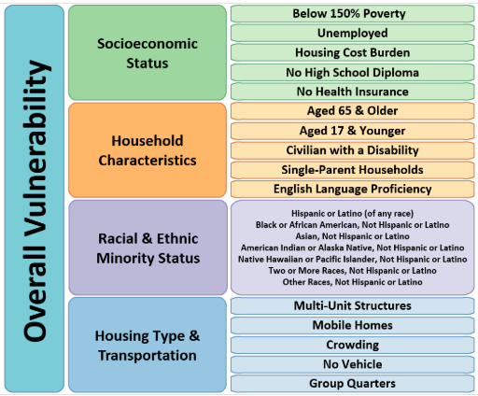
Figure 3-14. SVI in Jefferson County
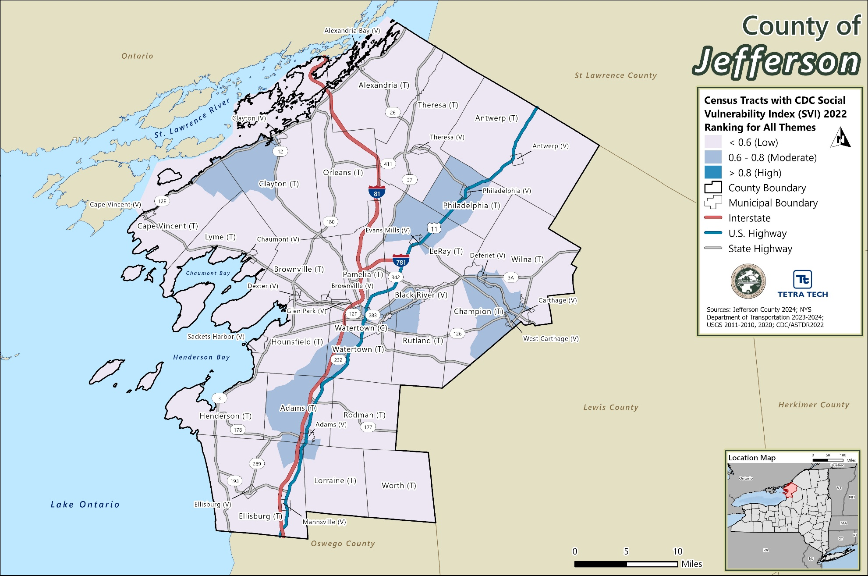

Major Institutions and Economic Trends
Jefferson County, New York, has a diverse and evolving economy shaped by its strategic location, natural resources, and institutional anchors. The county’s economic base is supported by a mix of military operations, agriculture, tourism, manufacturing, and small business activity, each contributing uniquely to the region’s resilience and vulnerability to hazards.

Military and Defense Sector
The most significant economic driver in Jefferson County is Fort Drum, home to the U.S. Army’s 10th Mountain Division. As the only cold-weather Army installation in the continental United States, Fort Drum plays a critical role in national defense and emergency preparedness. In 2020, the installation supported a workforce of approximately 18,910 personnel, including 15,000 active-duty soldiers and nearly 4,000 civilian employees.
Fort Drum’s presence has a profound impact on the local economy, contributing billions of dollars annually through direct employment, defense contracts, and consumer spending by military families. The base also supports a robust retail and service sector, particularly in the City of Watertown, which serves as the county’s commercial hub.
However, the region’s extreme winter weather, including heavy lake-effect snow, places significant stress on local infrastructure—particularly roads, bridges, culverts, and stormwater systems. Maintaining this infrastructure is essential to ensuring the mobility and readiness of military personnel and equipment. The 10th Mountain Division is one of the most frequently deployed units in the U.S. Army, and its ability to mobilize rapidly in all conditions is vital to national security.
The county’s demographics are also shaped by Fort Drum, resulting in a younger population profile and a higher-than-average proportion of veterans compared to other counties in New York’s North Country.

Agriculture and Land-Based Economy
Agriculture remains a foundational component of Jefferson County’s economy and cultural identity. According to the 2022 Census of Agriculture:
- The number of farms declined slightly (from 754 in 2017 to 749 in 2022), a 5 percent decrease.
- Total farmland increased by 1 percent, reaching 249,497 acres.
- The average farm size grew by 7 percent, reflecting ongoing consolidation.
- The market value of agricultural products sold rose by 45 percent, with a 53 percent increase in average value per farm.
Jefferson County ranks:
- 1st in New York State for value of sales in the crops and hay sector
- 10th in the state and 133rd nationally for fruits, tree nuts, and berries
- 9th in the state and 85th nationally for milk production
Agriculture contributes to the county’s economy in multiple ways:
- Supports employment and income across sectors
- Preserves open space and rural character
- Provides fresh, local food to residents and regional markets
- Enhances tourism and recreation, including farm tours, hunting, and fishing
Despite its importance, the sector faces demographic challenges: nearly one-third of producers are over age 65, while only 7 percent are under 35, raising concerns about long-term sustainability.

Tourism and Recreation
Jefferson County is a gateway to the Thousand Islands region, a nationally recognized destination for boating, fishing, and outdoor recreation. Its location along the St. Lawrence River and Lake Ontario makes it a hub for water-based tourism, which supports seasonal businesses such as hotels, marinas, restaurants, and tour operators.
Key attractions include:
- Boldt Castle on Heart Island
- Antique Boat Museum in Clayton
- Jefferson County Historical Society
- Wellesley Island and Southwick Beach State Parks
The county also hosts the Jefferson County Fair, the oldest continuously operating fair in the United States, drawing thousands of visitors annually.

Manufacturing and Industry
Jefferson County’s industrial base includes light manufacturing, food processing, and metal fabrication. While traditional manufacturing has declined, the county is actively working to expand advanced manufacturing and technology-driven industries. Notable employers include:
- New York Air Brake
- Car-Freshner Corporation
- Knowlton Technologies LLC
These firms contribute to economic diversification and provide stable employment opportunities.

Infrastructure and Development
The county’s transportation and utility infrastructure supports both economic activity and emergency response. Key assets include:
- Interstate 81, a major north-south corridor
- Watertown International Airport
- Ongoing investments in broadband expansion, especially in rural areas
These systems are critical for trade, logistics, and hazard mitigation, particularly in supporting evacuation routes, supply chains, and communication during emergencies.

Employment and Income Statistics
The U.S. Census Bureau’s County Business Pattern provides an annual series of sub-national economic data by industry covering most of the country’s economic activity. According to the 2021 Jefferson County Business Pattern, the county had a total of 2,352 business establishments. These businesses provided more than $1.2 million in payroll. Three industries dominate private employment in the County: Health Care and Social Assistance (6,075 people), Retail Trade (6,057 people), and Accommodations and Food Services (3,364 people) (U.S. Census Bureau 2021). Table 3-6 displays the labor force, employment, unemployment, and unemployment rate for Jefferson County between 2020 and 2024.
Table 3-6. Jefferson County Area Labor Force Estimates, April 2020 – April 2024
 | Jefferson County Area |  |  |  | New York Unemployment Rate
Year | Labor Force | Employment | Unemployment | Unemployment Rate
2020 | 44,548 | 36,300 | 7,400 | 16.9% | 14.5%
2021 | 43,235 | 40,000 | 2,500 | 5.8% | 8.2%
2022 | 43,550 | 41,800 | 1,700 | 3.8% | 4.5%
2023 | 43,139 | 41,800 | 1,400 | 3.3% | 4.0%
2024 | 44,207 | 41,300 | 2,100 | 4.8% | 4.2%
Source: (NYS DOL 2024)
Note: The COVID-19 Pandemic reached its height in 2020, which impacted the unemployment rates in the County, State, and Nationwide.
The median household income in the County, according to the 2022 ACS 1-year estimates, was $56,423, which is below the state ($79,557) and national ($74,755) figures (U.S. Census 2022). Table 3-7 shows the median household income in Jefferson County between 2018 and 2022, as calculated by the United States Census Bureau.
Table 3-7. Jefferson County Median Household Income, 2018-2022
Year | Jefferson County Median Household Income | New York Median Household Income | National Median Household Income
2018 | $52,798 | $67,648 | $61,937
2019 | $53,829 | $72,038 | $65,712
2020 | $57,570 | $73,354 | $67,340
2021 | $59,430 | $74,230 | $69,717
2022 | $58,763 | $79,463 | $74,755
Source: (U.S. Census 2023)

General Building Stock

Existing Development
For the purposes of this plan, approximately 50,185 structures were identified by the tax data and spatial data available. 44,821 of these buildings are residential, 2,462 building are commercial, 976 are industrial, and 1,926 are classified as other building types. These structures account for a total replacement cost value (RCV) of approximately $117 billion. Replacement cost value differs from actual cash value, as summarized in Figure 3-15.
Figure 3-15. Replacement Cost v. Actual Cash Value
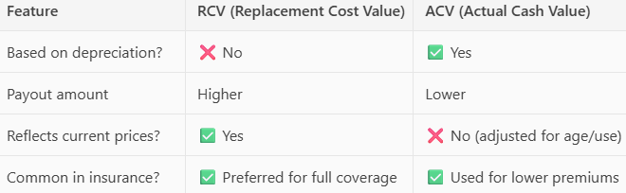
The two components of RCV are Structural RCV and Contents RCV. Structure RCV are the costs to rebuild or repair the physical structure of a building (walls, roof, foundation, etc.) using modern materials and labor rates. Contents RCV are the costs to replace everything inside the building (furniture, equipment, inventory, appliances, etc.) with new items of similar quality. Total RCV = Structure RCV + Contents RCV.
Table 3-8 and Table 3-9 present building stock statistics by occupancy class for Jefferson County. RCV is the estimated cost to replace an asset—in this case, a building or its contents—with a new one of similar kind and quality, at current market prices, without deducting for depreciation.
According to 2022 5-year ACS data, 46,099 households are in Jefferson County. A household includes all the people who occupy a housing unit as their usual residence. The data identified 62,014 housing units in the county. A housing unit is a house, apartment, mobile home or trailer, a group of rooms, or a single room occupied as separate living quarters (or if vacant, intended for occupancy as separate living quarters). According to the 2022 5-year ACS, there are 15,474 vacant housing units in the County (U.S. Census 2023).
Figure 3-16 through Figure 3-18 shows the distribution and value density of residential, commercial, and industrial buildings in Jefferson County. Value density is the dollar value of structures per unit area, including building content value. The densities are shown in units of $1,000 ($K) per square mile. Viewing value distribution maps, can assist communities in visualizing areas of high loss potential and in evaluating aspects of the study area in relation to the specific hazard risks.
The City of Watertown alone accounts for 19 percent of all buildings and 19 percent of the county’s total RCV. Villages generally have fewer buildings but can have high RCVs (e.g., Alexandria Bay (V): $3.21 billion). Smaller towns like Worth and Lorraine have the lowest total RCVs, under $800 million.

Table 3-8. Building Stock Count and RCV
 |  | RCV
Jurisdiction | Number of Buildings | Structure Only | Contents Only | Total (Structure + Contents)
Adams (T) | 1,518 | $2,035,012,049 | $2,017,057,154 | $4,052,069,203
Adams (V) | 661 | $886,603,392 | $887,785,233 | $1,774,388,625
Alexandria (T) | 2,668 | $2,500,592,385 | $1,931,597,756 | $4,432,190,141
Alexandria Bay (V) | 595 | $1,735,446,254 | $1,471,241,579 | $3,206,687,833
Antwerp (T) | 588 | $903,142,559 | $886,772,056 | $1,789,914,615
Antwerp (V) | 261 | $311,476,036 | $302,226,338 | $613,702,374
Black River (V) | 500 | $533,428,129 | $513,152,709 | $1,046,580,838
Brownville (T) | 2,040 | $998,719,331 | $776,376,167 | $1,775,095,498
Brownville (V) | 403 | $502,522,852 | $479,545,419 | $982,068,271
Cape Vincent (T) | 1,970 | $1,587,328,377 | $1,241,881,546 | $2,829,209,923
Cape Vincent (V) | 475 | $908,796,433 | $819,200,154 | $1,727,996,587
Carthage (V) | 1,119 | $1,866,423,150 | $1,853,679,765 | $3,720,102,915
Champion (T) | 1,213 | $1,386,050,367 | $1,301,485,329 | $2,687,535,696
Chaumont (V) | 283 | $440,138,649 | $402,355,601 | $842,494,250
Clayton (T) | 2,359 | $3,069,088,566 | $2,370,208,193 | $5,439,296,759
Clayton (V) | 948 | $2,247,682,329 | $1,942,714,131 | $4,190,396,460
Deferiet (V) | 136 | $157,486,492 | $166,735,780 | $324,222,272
Dexter (V) | 379 | $421,092,428 | $407,920,863 | $829,013,291
Ellisburg (T) | 1,920 | $2,249,380,581 | $2,084,459,758 | $4,333,840,339
Ellisburg (V) | 113 | $138,801,518 | $130,772,132 | $269,573,650
Evans Mills (V) | 246 | $282,560,214 | $263,732,972 | $546,293,186
Glen Park (V) | 208 | $198,300,699 | $208,845,964 | $407,146,663
Henderson (T) | 1,669 | $1,149,076,652 | $944,746,090 | $2,093,822,742
Hounsfield (T) | 1,313 | $1,457,770,013 | $1,313,460,740 | $2,771,230,753
LeRay (T) | 3,255 | $4,231,025,467 | $3,683,313,350 | $7,914,338,817
Lorraine (T) | 551 | $411,454,496 | $352,679,988 | $764,134,484
Lyme (T) | 2,077 | $824,991,534 | $595,474,556 | $1,420,466,090
Mannsville (V) | 173 | $181,996,267 | $184,232,786 | $366,229,053
Orleans (T) | 2,073 | $2,856,766,428 | $2,622,992,167 | $5,479,758,595
Pamelia (T) | 1,456 | $2,788,966,625 | $2,808,799,859 | $5,597,766,484
Philadelphia (T) | 391 | $909,274,104 | $860,494,742 | $1,769,768,846
Philadelphia (V) | 383 | $481,059,842 | $470,146,741 | $951,206,583
Rodman (T) | 590 | $701,937,773 | $656,395,001 | $1,358,332,774
Rutland (T) | 1,097 | $1,279,570,995 | $1,191,849,510 | $2,471,420,505
Sackets Harbor (V) | 628 | $828,861,159 | $701,258,106 | $1,530,119,265
Theresa (T) | 1,304 | $765,366,037 | $629,472,302 | $1,394,838,339
Theresa (V) | 352 | $402,458,667 | $371,694,086 | $774,152,753
Watertown (C) | 8,309 | $11,641,929,562 | $10,945,447,584 | $22,587,377,146
Watertown (T) | 2,033 | $3,788,496,664 | $3,466,518,856 | $7,255,015,520
West Carthage (V) | 652 | $856,591,376 | $837,334,904 | $1,693,926,280
Wilna (T) | 989 | $646,897,373 | $544,207,162 | $1,191,104,535
Worth (T) | 287 | $181,863,773 | $148,290,355 | $330,154,128
Jefferson County (Total) | 50,185 | $61,746,427,597 | $55,788,555,484 | $117,534,983,081
Source: Jefferson County 2024; City of Watertown 2024; USACE 2022; RS Means 2024
Note: C = City; T = Town; V = Village

Table 3-9. Building Stock Count and RCV by Occupancy Class
 | Residential |  | Commercial |  | Industrial |  | Othera
Jurisdiction | Building Count | Total RCV | Building Count | Total RCV | Building Count | Total RCV | Building Count | Total RCV
Adams (T) | 1,294 | $492,428,674 | 82 | $1,628,496,017 | 48 | $757,274,910 | 94 | $1,173,869,602
Adams (V) | 582 | $258,554,593 | 43 | $1,027,570,592 | 23 | $377,588,610 | 13 | $110,674,830
Alexandria (T) | 2,492 | $1,982,999,611 | 73 | $1,253,863,166 | 27 | $451,428,180 | 76 | $743,899,184
Alexandria Bay (V) | 501 | $976,779,301 | 73 | $1,889,989,702 | 10 | $138,868,695 | 11 | $201,050,135
Antwerp (T) | 451 | $165,698,753 | 13 | $233,961,280 | 7 | $185,605,875 | 117 | $1,204,648,707
Antwerp (V) | 237 | $99,299,360 | 14 | $311,705,866 | 6 | $115,961,685 | 4 | $86,735,463
Black River (V) | 459 | $182,335,136 | 24 | $548,681,832 | 9 | $195,507,060 | 8 | $120,056,810
Brownville (T) | 1,958 | $730,474,175 | 21 | $316,430,240 | 5 | $92,047,725 | 56 | $636,143,358
Brownville (V) | 361 | $150,563,751 | 19 | $497,987,000 | 8 | $131,065,200 | 15 | $202,452,320
Cape Vincent (T) | 1,848 | $1,191,341,044 | 23 | $411,912,620 | 16 | $270,437,370 | 83 | $955,518,889
Cape Vincent (V) | 422 | $416,398,446 | 34 | $976,129,980 | 12 | $223,616,400 | 7 | $111,851,761
Carthage (V) | 963 | $459,254,693 | 97 | $2,489,853,582 | 36 | $471,314,340 | 23 | $299,680,300
Champion (T) | 1,045 | $410,124,942 | 31 | $545,696,340 | 14 | $266,241,990 | 123 | $1,465,472,424
Chaumont (V) | 245 | $142,285,431 | 30 | $553,575,952 | 2 | $39,520,950 | 6 | $107,111,917
Clayton (T) | 2,173 | $2,454,671,528 | 63 | $1,467,046,280 | 33 | $610,518,930 | 90 | $907,060,021
Clayton (V) | 813 | $1,096,307,959 | 109 | $2,673,283,043 | 19 | $309,454,845 | 7 | $111,350,613
Deferiet (V) | 120 | $47,707,309 | 4 | $134,346,240 | 9 | $117,052,425 | 3 | $25,116,298
Dexter (V) | 340 | $142,684,662 | 24 | $410,555,526 | 9 | $168,661,185 | 6 | $107,111,918
Ellisburg (T) | 1,612 | $715,374,922 | 46 | $671,620,460 | 25 | $409,306,065 | 237 | $2,537,538,892
Ellisburg (V) | 94 | $37,115,371 | 8 | $127,669,500 | 1 | $13,005,825 | 10 | $91,782,954
Evans Mills (V) | 219 | $101,025,007 | 16 | $268,384,966 | 4 | $65,532,600 | 7 | $111,350,613
Glen Park (V) | 190 | $75,939,615 | 7 | $151,914,700 | 10 | $170,586,150 | 1 | $8,706,198
Henderson (T) | 1,560 | $740,793,631 | 32 | $518,106,400 | 16 | $216,400,170 | 61 | $618,522,541
Hounsfield (T) | 1,165 | $614,607,620 | 55 | $1,144,279,605 | 22 | $335,135,745 | 71 | $677,207,783
LeRay (T) | 2,925 | $2,543,263,141 | 168 | $3,169,390,330 | 84 | $1,401,608,985 | 78 | $800,076,361
Lorraine (T) | 493 | $181,547,245 | 10 | $99,393,560 | 3 | $31,213,980 | 45 | $451,979,699
Lyme (T) | 2,035 | $772,715,858 | 19 | $360,203,900 | 8 | $141,973,335 | 15 | $145,572,997
Mannsville (V) | 154 | $58,664,432 | 7 | $112,373,660 | 6 | $91,544,250 | 6 | $103,646,711
Orleans (T) | 1,832 | $1,128,248,857 | 95 | $2,626,007,226 | 45 | $685,533,030 | 101 | $1,039,969,482
Pamelia (T) | 1,167 | $1,144,746,272 | 115 | $1,898,574,580 | 120 | $1,982,764,665 | 54 | $571,680,967
Philadelphia (T) | 277 | $191,944,396 | 24 | $447,206,340 | 4 | $76,440,735 | 86 | $1,054,177,375
Philadelphia (V) | 344 | $146,142,600 | 21 | $496,571,106 | 10 | $192,402,420 | 8 | $116,090,457
Rodman (T) | 494 | $225,715,169 | 9 | $185,178,473 | 3 | $79,545,375 | 84 | $867,893,757
Rutland (T) | 959 | $462,470,363 | 40 | $892,618,300 | 21 | $330,264,165 | 77 | $786,067,677
Sackets Harbor (V) | 563 | $449,199,870 | 39 | $737,510,956 | 3 | $79,545,375 | 23 | $263,863,064
Theresa (T) | 1,237 | $510,032,893 | 17 | $304,198,860 | 14 | $212,204,790 | 36 | $368,401,796
Theresa (V) | 324 | $131,915,388 | 19 | $469,590,520 | 3 | $66,036,075 | 6 | $106,610,770
Watertown (C) | 7,450 | $3,805,254,923 | 605 | $14,260,498,802 | 169 | $2,803,736,145 | 85 | $1,717,887,276
Watertown (T) | 1,651 | $1,709,542,038 | 260 | $3,858,458,166 | 75 | $1,210,800,780 | 47 | $476,214,536
West Carthage (V) | 576 | $297,340,608 | 43 | $926,876,572 | 20 | $381,872,925 | 13 | $87,836,175
Wilna (T) | 928 | $413,066,267 | 23 | $441,905,520 | 10 | $167,984,985 | 28 | $168,147,763
Worth (T) | 268 | $100,720,252 | 7 | $110,743,920 | 7 | $72,832,620 | 5 | $45,857,336
Jefferson County (Total) | 44,821 | $27,957,296,106 | 2,462 | $51,650,361,680 | 976 | $16,140,437,565 | 1,926 | $21,786,887,730
Source: Jefferson County 2024; City of Watertown 2024; USACE 2022; RS Means 2024
Note: C = City; T = Town; V = Village
a. Other = Government, Religion, Agricultural, and Education

Figure 3-16. Residential Building Stock Value Density in Jefferson County
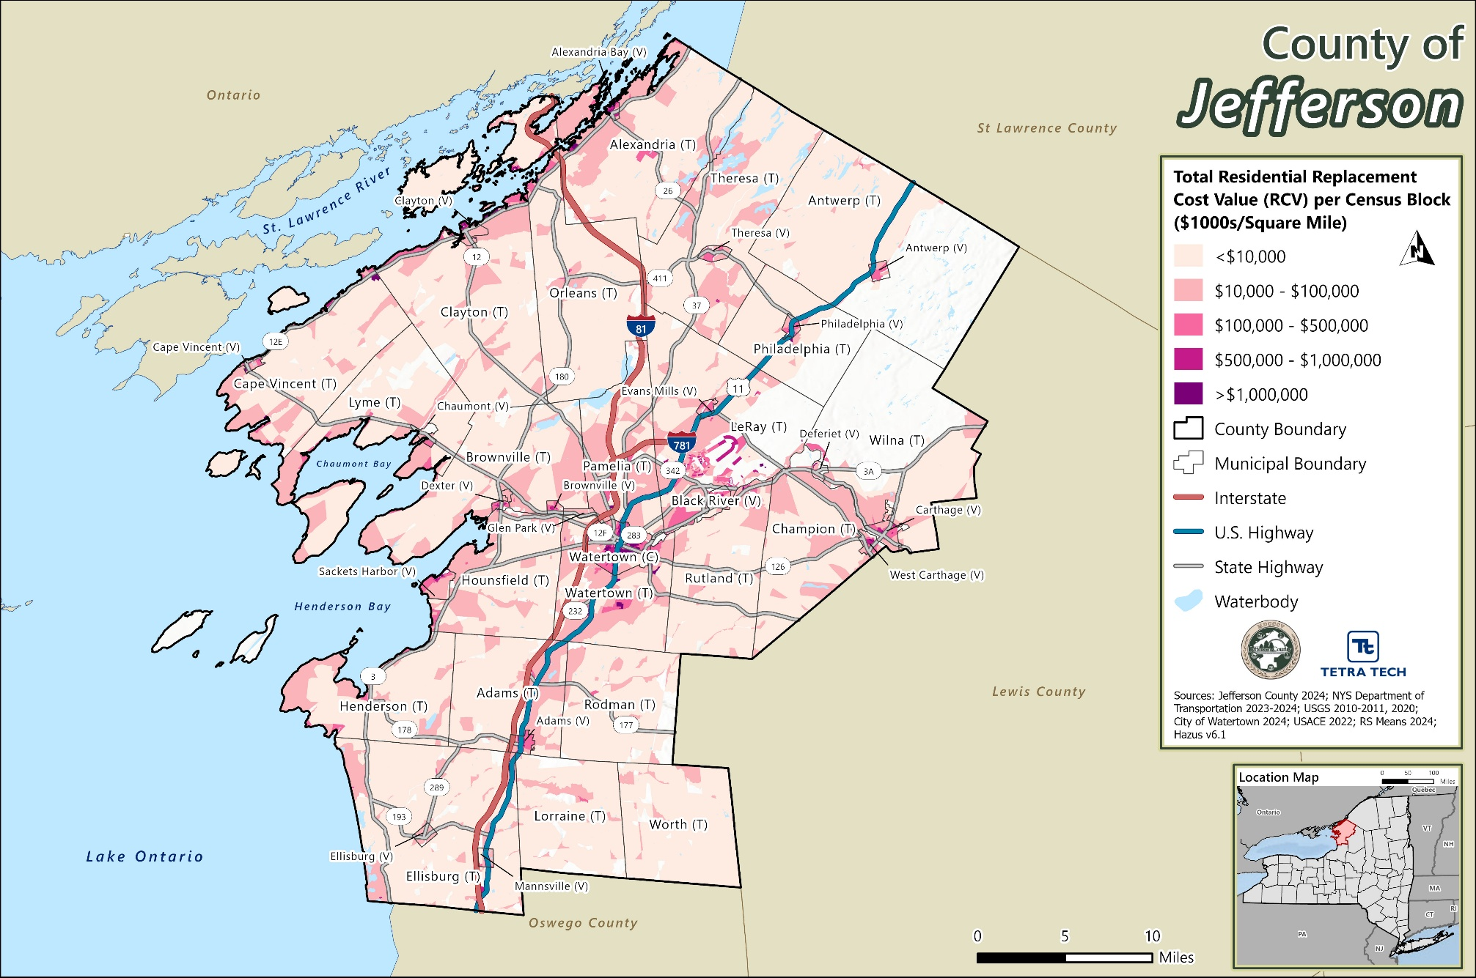
Figure 3-17. Commercial Building Stock Value Density in Jefferson County
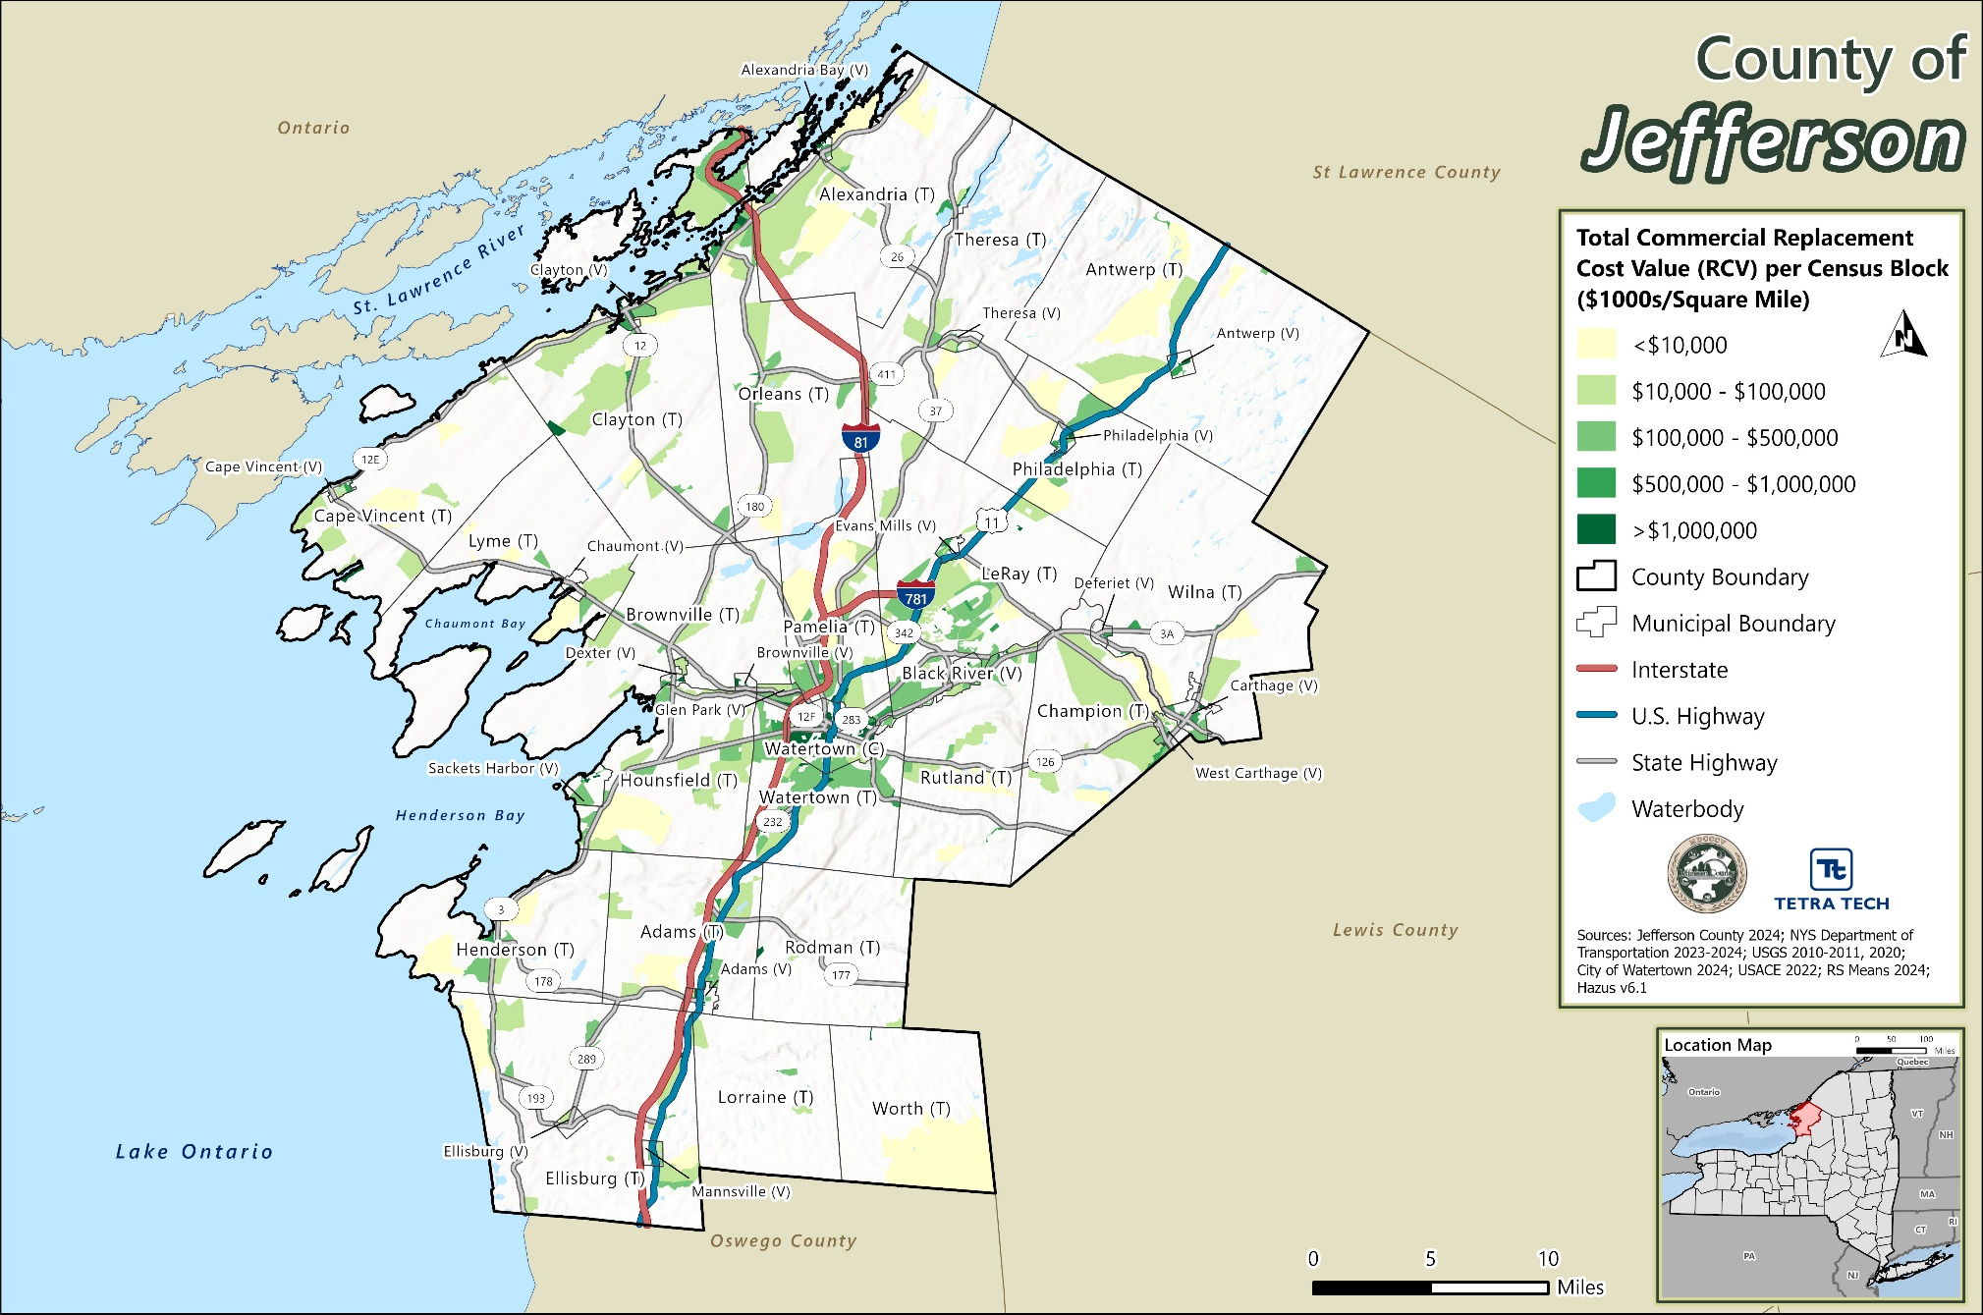
Figure 3-18. Industrial Building Stock Value Density in Jefferson County
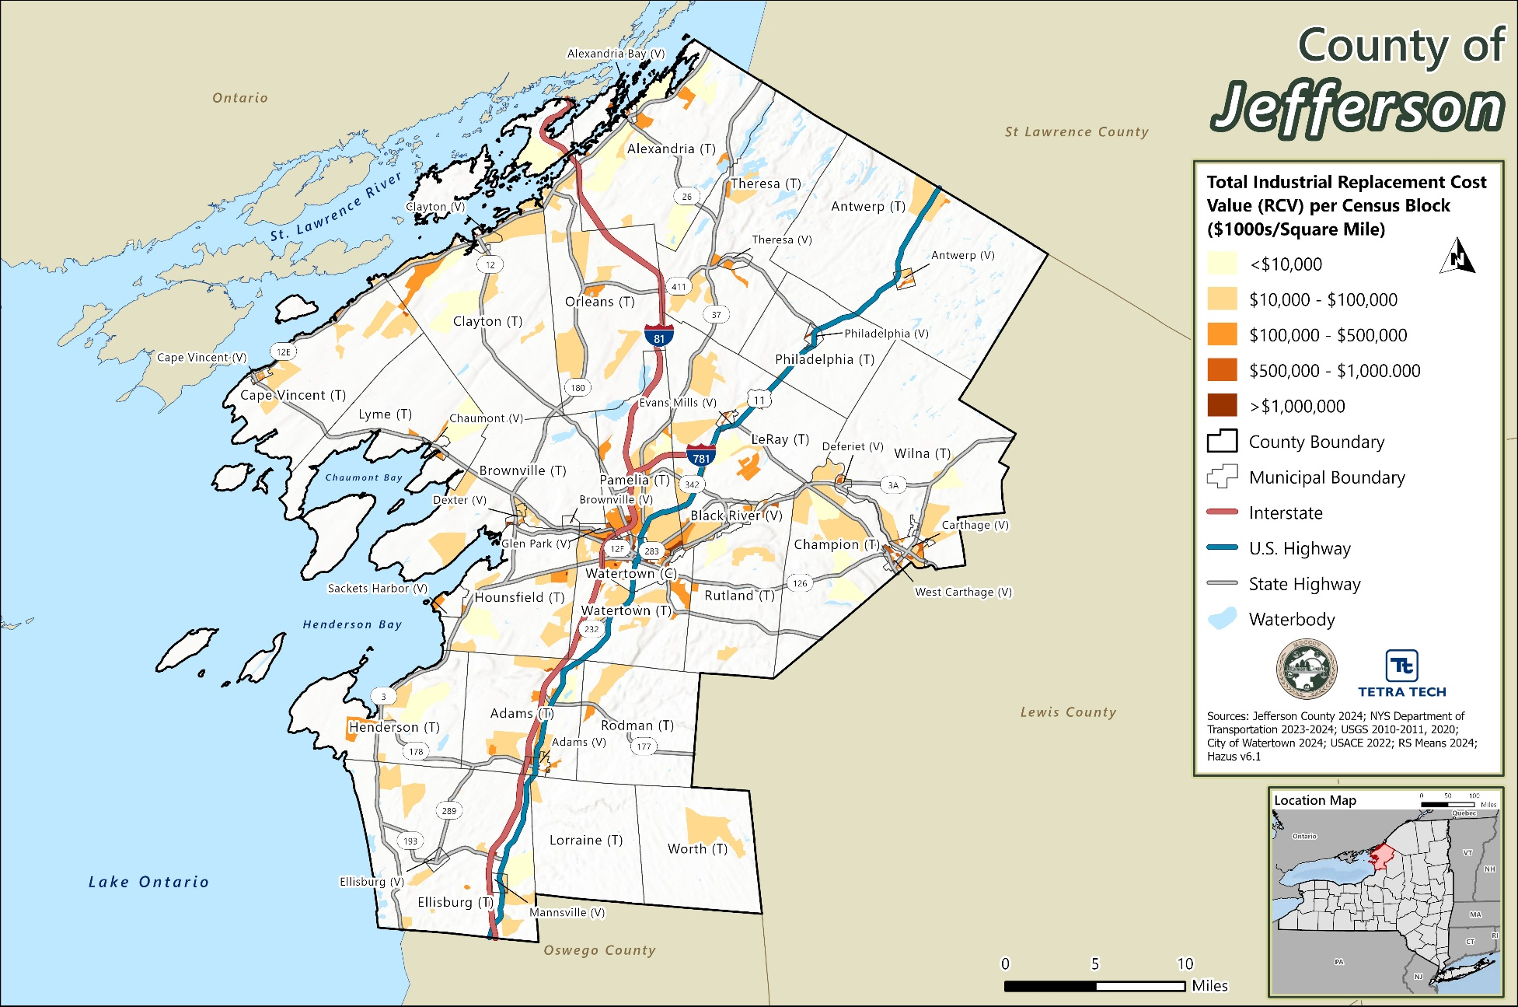

The following are the jurisdictions in Jefferson County with the most buildings:
- Watertown (C): 8,309
- LeRay (T): 3,255
- Alexandria (T): 2,668
- Clayton (T): 2,359
- Brownville (T): 2,040
The following are the jurisdictions in Jefferson County with the highest total replacement cost value:
- Watertown (C):
  - Buildings: 8,309
  - Total RCV: $22.59 billion
- LeRay (T):
  - Buildings: 3,255
  - Total RCV: $7.91 billion
- Watertown (T):
  - Buildings: 2,033
  - Total RCV: $7.26 billion
- Pamelia (T):
  - Buildings: 1,456
  - Total RCV: $5.60 billion
- Orleans (T):
  - Buildings: 2,073
  - Total RCV: $5.48 billion

New Development
For new development, the County uses best available data to avoid potential exposure of development to hazard events where possible. Additionally, the County intends to discourage development in vulnerable areas and the Special Flood Hazard Area, and encourage higher regulatory standards at the local level. Details regarding development specific to each participating municipality are provided in the jurisdictional annexes in Volume II.

Part 2: Risk Assessment

Risk Assessment Methodology and Tools
A risk assessment is the process of evaluating the potential loss of life, personal injury, and economic and property damage that could result from identified hazards. Identifying potential hazards and vulnerable assets allows planning personnel to address and reduce hazard impacts and allows emergency management personnel to establish early response priorities. Results of the risk assessment are used in subsequent mitigation planning processes, including determining and prioritizing mitigation actions that reduce each jurisdiction’s risk from each hazard. Past, present, and future conditions must be evaluated to assess risk most accurately for the county and participating jurisdictions. The process focuses on the following elements:
- Identify and Profile Hazards of Concern—Use best-available quantitative information, as well as input from the Steering Committee, Planning Partnership, stakeholders and the public to determine what types of hazards may affect the entire county and each jurisdiction.
Evaluate where each hazard can happen, how impactful it might be, what’s happened before, and how often and with what intensity it may occur again by describing:
  - Extent—The potential severity of each hazard
  - Location—Geographic area most likely to be affected by the hazard
  - Historical analyses using data on the impacts and losses from previous hazard events, including to the built environment, people and communities, natural and resources and the economy.
  - Probability of future hazard events, including projected impacts of climate change on frequency and intensity of events
- Identify Community Assets—Determine which assets, which include anything that is important to the character and function of a community, are vulnerable to loss during a hazard event by:
  - People, including underserved communities and socially vulnerable populations.
  - Structures, including new and existing buildings and other changes in development.
  - Community lifelines and other critical facilities. Beyond just buildings, identify the community lifelines and other critical facilities that are critical for life safety and the economy. The operation of these lifelines and facilities during and after a disaster is crucial. Their ability to keep functioning affects both the severity of the impacts and the speed of recovery. When possible, list their construction standards, age and life expectancy or other factors that will increase or decrease their vulnerability.
  - Natural, historic and cultural resources.
  - The economy and other activities that have value to the community.
- Assess Risk—Use all available information to estimate to what extent populations and assets may be impacted by a hazard:
  - Determine vulnerability using exposure analysis—Estimate the total number of assets in the jurisdiction that are likely to experience a hazard event if it occurs by overlaying hazard maps with the asset inventories.
  - Estimate potential impacts—Assess the impact of hazard events on the people, property, economy, and lands of the region, including estimates of the cost of potential damage or cost that can be avoided by mitigation.
  - Evaluate future changes that may affect vulnerability and impacts—Analyze how demographic changes, projected development and climate change impacts can alter current vulnerability and potential impacts.
The Jefferson County risk assessment was updated using the following best-available information:
- A new building stock inventory was generated using the 2022 U.S. Army Corps of Engineers (USACE) National Structure Inventory (NSI) dataset, parcel data provided by Jefferson County & the City of Watertown; and 2024 RS Means cost adjustment values.
- 2020 Decennial Census Population data and 2018–2022 American Community Survey (ACS) 5-year Population Estimates were utilized.
- Critical facility inventories were updated, merged, vetted and approved by the County and county jurisdictions.
  - FEMA’s community lifeline categories associated with the new critical facilities inventory.
- FEMA’s Hazus program was used to estimate potential impacts from the flood, wind, and seismic hazards.
  - Hazus identifies areas with high risk for natural hazards and estimates physical, economic, and social impacts of earthquakes, hurricanes, floods, and tsunamis as well as cost-effectiveness of common mitigation strategies. Hazus supports the risk assessment requirement in the mitigation planning process. Hazus is a nationally standardized risk modeling methodology that is distributed by FEMA as free GIS-based desktop software with a collection of inventory databases for every U.S. state and territory.
- Best-available hazard data were used, as described in this section.

Development of Asset Inventories
Jefferson County assets were identified to assess potential vulnerability and impacts associated with the hazards of concern. For the HMP update, Jefferson County assessed vulnerability and potential hazard impacts for the following types of assets: population, buildings, critical facilities, community lifelines, the environment, and new development. Some assets may be more susceptible to impacts because of their physical characteristics or socio-economic uses. Each asset type is described below. To protect individual privacy and the security of critical facilities, information on properties assessed is presented in aggregate, without details about specific individual personal or public properties.

Population
Statistics from the 2020 Decennial Census Population estimate and 2022 ACS 5-year estimate were used to estimate the vulnerability of and potential impacts on the County’s population.
The risk assessment included the collection and use of an expanded and enhanced asset inventory to estimate hazard vulnerability and impacts.
To determine population statistics for villages and towns, village population totals were subtracted from the total town population. Where villages were split between towns, the percentage of the geographic area of the village within each town was calculated and applied to the total population of the village to estimate the population that would be subtracted from each respective town.
Population counts at the jurisdictional level were averaged among the residential structures in the county to estimate the population at the structure level. This estimate provides a more precise distribution of population across the county compared to only using the Census block or Census tract boundaries. Limitations of these analyses are recognized, and thus the results are used only to provide a general estimate for planning purposes.
FEMA’s Hazus program was used to model estimated potential losses to flood, seismic and wind hazards, and is described later in this section. Hazus still contains 2020 U.S. Census data and was used to estimate sheltering and injuries as part of the hazard analysis.
As discussed in Chapter 3, County Profile, research has shown that some populations are at greater risk from hazard events because of decreased resources or physical abilities. Vulnerable populations in Jefferson County included in the risk assessment are children, elderly, population below the poverty level, non-English speaking individuals, and persons institutionalized with a disability.

Buildings
A custom general building stock dataset was created countywide. The general building stock was updated with a custom-building inventory using 2022 U.S. Army Corps of Engineers (USACE), National Structure Inventory database (NSI). The National Structure Inventory Base layer is created by the U. S. Army Corps of Engineers (USACE). The National Structure Inventory (NSI) is a system of databases containing structure inventories of varying quality and spatial coverage. In 2018 and 2019 the NSI team created the data using the following inputs from numerous input data sources. The two main sources of data are CoreLogic parcel files for residential structures and ESRI business layer for non-residential structures. Each data file used contains data on the type of development that exists at a given location. Attributes provided in the associated files were used to further define each structure, such as year built, number of stories, occupancy class, and square footage. The centroid of each building footprint was used to estimate the building location.
Structural and content replacement cost values (RCV) were calculated for each building using the available assessor data, the building footprint, and RSMeans 2024 values.
A regional location factor for Jefferson County was applied based on the individual building stock’s zip code location, as listed in Table 4-1. The location factor is used to adjust costs based to a specific location. The specific location is represented only by the first 3 digits of the zip code, this represents a broad geographic area. The location factor is multiplied by the base cost for that city/zip code.
Table 4-1. Zip-Code Based Regional Location Factor for Replacement Cost
Zip Code | City | Residential | Non-Residential
130xx | Syracuse | 0.98 | 0.99
136xx | Watertown | 0.94 | 0.98

RCV is the current cost of returning an asset to its pre-damaged condition using present-day cost of labor and materials. Total RCV consists of both the structural cost to replace a building and the estimate value of contents of a building. The occupancy classes available in Hazus were condensed into the categories of residential, commercial, industrial, agricultural, religious, governmental, and educational to facilitate analysis and presentation of results. Residential loss estimates addressed both multi-family and single-family dwellings.

Critical Facilities and Community Lifelines
A critical facility inventory, which includes essential facilities, utilities, transportation features and user-defined facilities, was provided by the County for the analyses conducted as part of this risk assessment.
A lifeline provides indispensable service that enables the continuous operation of critical business and government functions, and is critical to human health and safety, or economic security (FEMA).
Other essential facility features were sourced from the New York State Department of Environmental Conservation 2023, 2024; Federal Communications Commission 2024; HIFLD 2023, 2024; NYS Department of Health 2024; National Plan and Provider Enumeration System 2023; USACE 2024; and NYS Department of Transportation 2023. The development involved a review for accuracy, additions, or deletions of new or moved critical assets, identification of backup power for each asset (if known) and whether the critical facility is considered a lifeline in accordance with FEMA’s definition. To protect individual privacy and the security of assets, information is presented in aggregate, without details about specific individual properties or facilities.

Environment and Land Use
The 2024 Land Use Land Cover dataset was created by Jefferson County & the City of Watertown was used to assess land use characteristics of the county. The built land use areas were defined as residential areas and non-residential areas. Non-residential areas include agricultural, commercial, community services/public services, industrial, recreation & entertainment, and wild, forest, conservation, public parks.

New Development
In addition to assessing the vulnerability of the built environment, Jefferson County examined recent development and anticipated new development in the next 5 years. Each jurisdiction was asked to provide a list of major development that has taken place within these timeframes. The location of new development projects was submitted via ArcGIS Survey123.
New development was identified as (1) anticipated in the next 5 years and (2) recently developed over the last 5 years. An analysis was conducted in geographic information system (GIS) to determine hazard exposure of these development sites. Projects built on multiple parcels were assessed as one unit. If one parcel identified within the project boundary intersected a spatial hazard layer, the entire project was considered “exposed” to the hazard area of concern.
Identifying these changes and integrating new development into the risk assessment provides communities information to consider when developing the mitigation strategy to reduce these vulnerabilities in the future (one tool in the Mitigation Toolbox discussed in Chapter 16, Mitigation Strategy. Recent and anticipated development and hazard vulnerability analysis results are presented as a table in each annex in Volume II.

Vulnerability Assessment Methodology
Jefferson County used standardized tools, combined with local, state, and federal data and expertise to assess potential vulnerability and losses associated with hazards of concern. Three levels of analysis were used, depending upon the data available for each hazard:
- Historical Impacts and Qualitative Analysis (Q) – This analysis includes an examination of historical impacts to understand potential impacts of future events of similar size. Potential impacts and losses are discussed qualitatively using best-available data and professional judgment.
- Risk-area Vulnerability Analysis (V) – This analysis involves overlaying available spatial hazard layers, for hazards with defined extent and locations, on asset mapping in GIS to determine which assets are in the impact area of the hazard.
- Hazus Loss Estimation (H) — The FEMA Hazus modeling software was used to estimate potential losses for the following hazards: flood, earthquake, and hurricane.
Table 4-2 summarizes the type of analysis conducted by hazard of concern.
Table 4-2. Summary of Risk Assessment Analyses
Hazard | Population | General Building Stock | Critical Facilities | New Development
Dam Failure | Q | Q | Q | Q
Drought | Q | Q | Q | Q
Extreme Temperature | Q | Q | Q | Q
Flood, Riverine | V, H | V, H | V, H | V
Flood, Coastal Erosion | V | V | V | V
Geologic Hazard, Earthquake | H | H | H | Q
Geologic Hazard, Landslide | V | V | V | V
Severe Storm | H | H | H | Q
Severe Winter Storm | Q | Q | Q | Q
Wildfire | V | V | V | V
Note: V = Risk-area Vulnerability analysis; H = Hazus analysis; Q = Qualitative analysis

Hazus
Hazus is a GIS-based software tool developed by FEMA that applies engineering and scientific risk calculations, which have been developed by hazard and information technology experts, to provide defensible damage and loss estimates. These methodologies are accepted by FEMA and provide a consistent framework for assessing risk across a variety of hazards. The GIS framework also supports the evaluation of hazards and assessment of inventory and loss estimates for these hazards.
Hazus uses GIS technology to estimate a community’s direct physical damage to building stock, critical facilities, transportation systems and utility systems. To generate this information, Hazus uses default data for inventory, vulnerability, and hazards; this default data can be supplemented with local data to provide a more refined analysis. Damage reports can include induced damage (inundation, fire, threats posed by hazardous materials and debris) and direct economic and social losses (casualties, shelter requirements, and economic impact) depending on the hazard and available local data. Hazus’ open data architecture can be used to manage community GIS data in a central location. The use of this software also promotes consistency of data output now and in the future and standardization of data collection and storage.
In general, modeled losses were estimated in the program using depth grids for the flood analysis and probabilistic analyses were performed to develop expected or estimated distribution of losses (mean return period losses) for hurricane wind and seismic hazards. The probabilistic model generates estimated damages and losses for specified return periods (e.g., 100- and 500-year). Table 4-3 displays the levels of analysis that can be conducted using the Hazus software.
Table 4-3. Summary of Hazus Analysis Levels
Level 1 | Hazus provides hazard and inventory data with minimal outside data collection or mapping.
Level 2 | Analysis involves augmenting the Hazus provided hazard and inventory data with more recent or detailed data for the study region, referred to as “local data”
Level 3 | Analysis involves adjusting the built-in loss estimation models used for the hazard loss analyses. This Level is typical done in conjunction with the use of local data.

Hazard-Specific Methodologies

Dam Failure
To assess the vulnerability of Jefferson County to dam failure and its associated impacts, a qualitative review was conducted since there are no High Hazard Potential Dams located within the County.

Drought
All of Jefferson County is at risk from the impacts of drought events. A qualitative analysis was conducted to assess the County’s vulnerability to this hazard of concern.

Extreme Temperature
All of Jefferson County is at risk from the impacts of extreme temperature events. A qualitative analysis was conducted to assess the County’s vulnerability to this hazard of concern.

Flood

Flood Inundation Hazard Areas
The 1-percent and 0.2-percent annual chance flood event was examined to evaluate the county’s risk from the flood hazard. This flood event boundary is generally considered by planners and evaluated under federal programs such as the National Flood Insurance Program (NFIP). Table 4-4 lists the data used to evaluate exposure and determine potential future losses for this plan update, which can be summarized as follows:
- Jefferson County Q3 data from FEMA, dated from the 1970s through the 1990s.
- FEMA’s Effective Digital Flood Insurance Rate Map (DFIRM) dated January 1, 2014 for Le Ray (Town) and Black River (Village).
- A 1-percent annual chance flood depth grid generated using the Q3 data, the effective DFIRM data, and a 1-meter digital elevation model (DEM) from USGS.
Table 4-4. FEMA Flood Data
Jurisdiction | FEMA Data | Date
Adams (T) | Q3 | 6/5/1985
Adams (V) | Q3 | 6/19/1985
Alexandria (T) | Q3 | 10/15/1985
Alexandria Bay (V) | Q3 | 4/3/1978
Antwerp (T) | Q3 | 4/15/1986
Antwerp (V) | NSFHA | —
Black River (V) | Effective DFIRM | 1/8/2014
Brownville (T) | Q3 | 6/2/1992
Brownville (V) | Q3 | 3/18/1986
Cape Vincent (T) | Q3 | 6/2/1992
Cape Vincent (V) | Q3 | 4/17/1984
Carthage (V) | Q3 | 6/17/1991
Champion (T) | Q3 | 6/2/1993
Chaumont (V) | Q3 | 9/8/1999
Clayton (T) | Q3 | 4/2/1986
Clayton (V) | Q3 | 12/1/1977
Deferiet (V) | NSFHA | —
Dexter (V) | Q3 | 6/15/1994
Ellisburg (T) | Q3 | 5/18/1992
Ellisburg (V) | Q3 | 6/19/1985
Evans Mills (V) | Q3 | 1/2/1992
Glen Park (V) | NSFHA | —
Henderson (T) | Q3 | 5/18/1992
Hounsfield (T) | Q3 | 5/18/1992
LeRay (T) | Effective DFIRM | 1/8/2014
Lorraine (T) | NSFHA | —
Lyme (T) | Q3 | 9/2/1993
Mannsville (V) | NSFHA | —
Orleans (T) | Q3 | 3/1/1978
Pamelia (T) | Q3 | 1/2/1992
Philadelphia (T) | Q3 | 6/5/1989
Philadelphia (V) | Q3 | 9/15/1993
Rodman (T) | Q3 | 7/3/1985
Rutland (T) | Q3 | 8/18/1992
Sackets Harbor (V) | Q3 | 5/2/1994
Theresa (T) | Q3 | 10/15/1985
Theresa (V) | Q3 | 10/15/1985
Watertown (C) | Q3 | 8/2/1993
Watertown (T) | Q3 | 8/2/1993
West Carthage (V) | Q3 | 9/28/1990
Wilna (T) | Q3 | 1/16/1992
Worth (T) | NSFHA | —
Note: Non-Special Flood Hazard Area (NSFHA) is an area that is in a moderate- to low-risk flood zone.
The Q3 data and effective FIRM data was used to evaluate exposure for both the 1- and 0.2-percent annual chance flood events; and determine potential future losses for the 1-percent annual chance flood event. The depth grid generated using the Q3 & Effective FIRM and 1-meter DEM was integrated into the Hazus riverine flood model and used to estimate potential losses for the 1-percent annual chance flood event.
To estimate exposure to the 1- and 0.2-percent annual chance flood events, the DFIRM flood boundaries were overlaid on the centroids of updated assets (population, building stock, and critical facilities); as well as the DFIRM flood boundaries being overlaid on the polygons provided for anticipated new development. Centroids or polygons that intersected the flood boundaries were totaled to estimate the building RCV and population vulnerable to the flood inundation areas. A Level 2 Hazus riverine flood analysis was performed. Both the critical facility and building inventories were formatted to be compatible with Hazus and its Comprehensive Data Management System (CDMS).
Once updated with the inventories, the Hazus riverine flood model was run to estimate potential losses in Jefferson County for the 1-percent annual chance flood event. A user-defined analysis was also performed for the building stock. Buildings located within the floodplain were imported as user-defined facilities to estimate potential losses to the building stock at the structural level. Hazus calculated the estimated potential losses to the population (default 2020 U.S. Census data across dasymetric blocks), potential damages to the general building stock, and potential damages to critical facility inventories based on the depth grids generated and the default Hazus damage functions in the flood model.

Coastal Erosion
The New York State Department of State, provided data to delineate coastal erosion hazard areas (CEHAs). The hazard risk layer depicts areas of extreme, high and moderate risk for areas within 1-mile of the New York State Coastal Boundary which includes Jefferson County. These risk areas include:
- Extreme Risk Areas—Areas at greatest risk of frequent inundation or vulnerable to erosion: Area at or below the Ordinary High Water Elevation (247.3ft IGLD) Coastal areas with greater than 1-percent chance of flooding that are also susceptible to hazards associated with storm waves. Soils in which the likelihood of flooding is likely to occur often under usual weather conditions or is expected infrequently under usual weather conditions (approximately 5 to 50 times in 100 years). Dynamic natural shoreline feature areas susceptible to flooding and erosion. The result is an area depicting the maximum extent of the above areas was compiled.
- High Risk Areas—Areas outside the Extreme Risk Area that are at a less frequent, but high risk of inundation: Area bounded by the 1-percent annual flood risk zone (FEMA A zones). Riparian Buffer Area. The result is an area depicting the maximum extent of the above areas upland of the boundary of the Extreme Risk Area was compiled.
- Moderate Risk Areas—Areas outside the Extreme and High Risk Areas but currently at moderate risk of inundation from infrequent events. Area bounded by the 0.2 percent annual risk (500 year) flood zone, where available. Area bounded by the base flood elevation plus 2 feet of vertical elevation. Soils dominated by running water or formed by water-deposited sediments. The result is an area depicting the maximum extent of the above areas upland of the boundary of the High Risk Area was compiled.
To determine what assets are exposed to coastal erosion, Jefferson County GIS data were overlaid with the hazard area. Assets with their centroid located in the hazard area were totaled to estimate the totals and values at risk from the impacts of a coastal erosion event.

Geologic Hazards

Earthquake
A probabilistic assessment was conducted for Jefferson County for the 500-year and 2,500-year through a Level 2 analysis in HAZUS-MH v6.1 to analyze the earthquake hazard and provide a range of loss estimates. The probabilistic method uses information from historical earthquakes and inferred faults, locations, and magnitudes and computes the probable ground shaking levels that might be experienced during a recurrence period by Census tract.
As noted in the HAZUS-MH Earthquake User Manual, “Uncertainties are inherent in any loss estimation methodology. They arise in part from incomplete scientific knowledge concerning earthquakes and their effects upon buildings and facilities. They also result from the approximations and simplifications that are necessary for comprehensive analyses. Incomplete or inaccurate inventories of the built environment, demographics and economic parameters add to the uncertainty. These factors can result in a range of uncertainty in loss estimates produced by the HAZUS Earthquake Model, possibly at best by a factor of two or more” (FEMA 2015). However, HAZUS’ potential loss estimates are acceptable for the purposes of this HMP.
Ground shaking is the primary cause of earthquake damage to man-made structures, and soft soils amplify ground shaking. One contributor to the site amplification is the velocity at which the rock or soil transmits shear waves (S-waves). The National Earthquake Hazard Reductions Program (NEHRP) has developed five soil classifications defined by their shear-wave velocity that impact the severity of an earthquake. The soil classification system ranges from A to E, where A represents hard rock that reduces ground motions from an earthquake and E represents soft soils that amplify and magnify ground shaking and increase building damage and losses.
NEHRP soil classifications were not available for Jefferson County at the time of this analysis. Soils were estimated as NEHRP soil Type D across Jefferson County, as a conservative approach to this risk assessment. Groundwater was set at a depth of 5 feet (default setting). Damages and losses due to liquefaction, landslide, or surface fault rupture were not included in this analysis. Although damages are estimated at the Census tract level, results were presented at the municipal level. For Census tracts encompassing multiple municipalities, the default general building stock inventory was used to calculate the percent of the total Census tract replacement cost value in each municipality. This percentage was applied to the Census tract losses to estimate the municipal level losses. For example, the Census blocks from two municipalities are located within one Census tract. The total replacement cost value of Municipality A is 60 percent of the total Census tract replacement cost value, while Municipality B is 40 percent of the total value. Therefore, 60 percent of the losses for the Census tract will be applied to Municipality A, and 40 percent will be applied to Municipality B.

Landslide
The 2011 Landslide Incidence and Susceptibility geographic information system (GIS) layer from the U.S. Geological Survey was used to coarsely define the general area susceptible to landslide. According to Radbruch-Hall and others, as stated below, the Landslide Incidence and Susceptibility GIS layer from the National Atlas applies to the U.S. Geological Survey layer as well:
“….was prepared by evaluating formations or groups of formations shown on the geologic map of the United States (King and Beikman 1974) and classifying them as having high, medium, or low landslide incidence (number of landslides) and being of high, medium, or low susceptibility to landsliding. Thus, those map units or parts of units with more than 15 percent of their area involved in landsliding were classified as having high incidence; those with 1.5 to 15 percent of their area involved in landsliding, as having medium incidence; and those with less than 1.5 percent of their area involved, as having low incidence. This classification scheme was modified where particular lithofacies are known to have variable landslide incidence or susceptibility. In continental glaciated areas, additional data were used to identify surficial deposits that are susceptible to slope movement. Susceptibility to landsliding was defined as the probable degree of response of the areal rocks and soils to natural or artificial cutting or loading of slopes or to anomalously high precipitation. High, medium, and low susceptibility are delimited by the same percentages used in classifying the incidence of landsliding. For example, it was estimated that a rock or soil unit characterized by high landslide susceptibility would respond to widespread artificial cutting by some movement in 15 percent or more of the affected area. We did not evaluate the effect of earthquakes on slope stability, although many catastrophic landslides have been generated by ground shaking during earthquakes. Areas susceptible to ground failure under static conditions would probably also be susceptible to failure during earthquakes” (Radbruch-Hall 1982).
The asset data (population, building stock, critical facilities, new development) were used to support an evaluation of assets exposed and potential impacts and losses associated with this hazard. As an example, to identify assets exposed to landslides, available and appropriate GIS data were overlaid upon the hazard area.

Severe Storm
A Hazus probabilistic analysis was performed to analyze the wind hazard losses for Jefferson County for the 100- and 500-year mean return period events. The probabilistic Hazus hurricane model activates a database of thousands of potential storms that have tracks and intensities reflecting the full spectrum of Atlantic hurricanes observed since 1886 and identifies those with tracks associated with Jefferson County. Hazus contains data on historical hurricane events and wind speeds. It also includes surface roughness and vegetation (tree coverage) maps for the area. Surface roughness and vegetation data support the modeling of wind force across various types of land surfaces. Default demographic and updated building and critical facility inventories in Hazus were used for the analysis. Although damages are estimated at the census tract level, results were presented at the municipal level. Because there are multiple census tracts that contain more than one jurisdiction, a density analysis was used to extract the percent of building structures that fall within each tract and jurisdiction. The percentage was multiplied against the results calculated for each tract and summed for each jurisdiction.

Severe Winter Storm
All of Jefferson County is exposed and vulnerable to the winter storm hazard. In general, structural impacts include damage to roofs and building frames, rather than building content. Current modeling tools are not available to estimate specific losses for this hazard. A qualitative analysis was conducted to assess the County’s vulnerability to this hazard of concern.

Wildfire
Wildland-urban interface mapping (Interface and Intermix) from the SILVIS Laboratory at the University of Wisconsin – Madison was used to delineate wildfire hazard areas. These wildfire hazard areas are based on the 2020 Census, 2021 National Land Cover Dataset, and the Protected Areas Database. For this risk assessment, the high-, medium-, and low-density interface areas were combined and used as the “Interface” hazard area, and the high, medium-, and low-density intermix areas were combined and used as the “Intermix” hazard areas.
To determine what assets are exposed to wildfire, available and appropriate GIS data were overlaid with the hazard area. Assets with their centroid located in the hazard area were totaled to estimate the totals and values at risk from the impacts of a wildfire event.

Rating Probability of Occurrence
Based on records of previous hazard events and consideration of potential future changes that could affect the frequency of future events, the risk assessment for each hazard assigns a rating for the probability of occurrence of that hazard in the future. These ratings were assigned as follows:
- Unlikely—not likely to occur or less than 1 percent annual chance of occurring
- Rare—between 1 and 10 percent annual chance of occurring
- Occasional—between 10 and 100 percent annual chance of occurring
- Frequent—100 percent chance occurring; occurs multiple times a year

Data Source Summary
Table 4-5 summarizes the data sources used for the risk assessment for this plan.

Limitations
Loss estimates, vulnerability analyses, and hazard-specific impact evaluations rely on the best-available data and methodologies. Uncertainties are inherent in any loss estimation methodology and arise in part from incomplete scientific knowledge concerning natural hazards and their effects on the built environment. Uncertainties also result from the following:
- Approximations and simplifications necessary to conduct such a study
- Incomplete or dated inventory, demographic, or economic parameter data
- The unique nature, geographic extent, and severity of each hazard
- Mitigation measures already employed by the participating jurisdictions
- The amount of advance notice residents have to prepare for a specific hazard event
- Uncertainty of climate change projections
These factors can result in a range of uncertainty in loss estimates, possibly by a factor of two or more. Therefore, potential vulnerability and loss estimates are approximate. These results do not predict precise results and should be used to understand relative risk. Additionally, economic impacts to industry such as tourism and the real-estate market were not analyzed quantitatively.
Table 4-5. Risk Assessment Data Documentation
Data | Source | Format
Population Data | U.S. Census Bureau 2020; American Community Survey 5-Year Estimates 2018-2022 | Digital (GIS)
Building Inventory | Jefferson County 2024; City of Watertown 2024; USACE 2022; RS Means 2024 | Digital (GIS)
Critical Facilities and Lifelines | Jefferson County 2024; New York State Department of Environmental Conservation 2023, 2024; Federal Communications Commission 2024; HIFLD 2023, 2024; NYS Department of Health 2024; National Plan and Provider Enumeration System 2023; USACE 2024; NYS Department of Transportation 2023 | Digital (GIS)
Digitized Effective FIRM maps | FEMA (Effective DFIRMs & Q3 data) | Digital (GIS)
1-Meter Digital Elevation Model | USGS 2023 | Tag Image File (TIFF)
Flood Depth Grid | Tetra Tech 2024 | TIFF
Land Use | Jefferson County 2024; City of Watertown 2024 | Digital (GIS)
Coastal Erosion Hazard Data | New York Department of State 2020 | Digital (GIS)
Landslide Incidence & Susceptibility Hazard Data | USGS 2011 | Digital (GIS)
Wildland-Urban Interface (WUI) Hazard Data | University of Wisconsin-Madison 2023, MRLC Consortium 2021, U.S. Census Bureau 2020 | Digital (GIS)
New Development Data | Participating Jefferson County Jurisdictions | Digital (GIS)
Note: FEMA = Federal Emergency Management Agency, HIFLD = Homeland Infrastructure Foundation-Level Data, MRLC = Multi-Resolution Land Characteristics, TIFF = Tag Image File Format, USACE = U.S. Army Corps of Engineers, USGS = U.S. Geological Survey

Identification of Hazards of Concern
To provide a strong foundation for mitigation actions in this plan, Jefferson County considered a full range of hazards that could impact the area and then identified and ranked those that present the greatest concern. These hazards of concern were identified based on the following:
Hazards of Concern are those hazards that are considered most likely to impact a community. These are identified using available data and local knowledge.
Natural Hazards are those hazards that are a source of harm or difficultly created by a meteorological, environmental, or geological events.
- Input from all Planning Partners
- Review of the New York State Hazard Mitigation Plan
- Review of the 2011 Jefferson County HMP
- Research on the frequency, magnitude, and costs associated with hazards that have previously or could feasibly impact the region.
- Qualitative information regarding natural (not human-caused) hazards and the perceived vulnerability of the study area’s assets to them.
Table 5-1 documents the process of identifying the hazards of concern for further profiling and evaluation.
Table 5-1. Identification of Hazards of Concern for Jefferson County
Hazard | May Occur in the County? | Significant Threat to the County? | Why was this determination made? | Sources
Avalanche | No | No | The 2023 New York State Hazard Mitigation Plan (NYS HMP) identifies avalanche as a hazard of concern. Avalanche was identified as a hazard in the NYS HMP, and there have been occurrences in the state; however, there were no occurrences in Jefferson County.  The topography and climate of Jefferson County does not support the occurrence of an avalanche. The Steering Committee and Planning Partnership do not consider the hazard to be a significant concern. | NYS DHSES  Input from Steering Committee and Planning Partnership
Coastal Hazards | Yes | No | The NYS HMP identifies coastal hazards as a hazard of concern for New York State. Coastal hazards can impact all the state’s coastal counties along Lake Erie and the Niagara River, Lake Ontario and the St. Lawrence River, Atlantic Ocean and Long Island Sound, Hudson River south of the federal dam in Troy, the East River, the Harlem River, the Kill van Kull, and Arthur Kill, and all connecting waterbodies, bays, harbors, shallows, and wetlands.  Although Jefferson County has a coastline along Lake Ontario, coastal hazards was not identified as a significant enough concern by the Planning Committee to have its own hazard profile. Coastal hazards and Coastal Hazard Erosion data is included in the “Flood” profile. | NYS DHSES  Input from Steering Committee and Planning Partnership
Dam Failure | Yes | Yes | The 2023 NYS HMP does not identify dam failure as a hazard of concern for New York State, though it is included in the Flood hazard profile.  According to the NYSDEC, there are 80 dams within Jefferson County, as shown in Section 3. Of these 80 dams in Jefferson County: 66 low hazard, 14 intermediate hazard, 0 high hazard, and 0 negligible or no hazard classification code (NYSDEC 2022).  Dam failure is presented in an individual hazard profile. | NYS DHSES  NYSDEC  NYS GIS  Input from Steering Committee and Planning Partnership
Drought | Yes | Yes | The NYS HMP identifies drought as a hazard of concern for the state. Jefferson County has been impacted by several drought events that have occurred in New York State. Agriculture is a substantial industry in Jefferson County. Drought conditions would severely impact the county’s economy. Jefferson County was included in three recent drought-related U.S. Department of Agriculture (USDA) disaster declarations:  - S3427—2012 Drought and Excessive Heat  - S3441—2012 Drought  - S4062—2016 Drought  The Steering Committee and Planning Partnership has identified drought as a hazard of concern for Jefferson County. | NYS DHSES  FEMA  USDA  NOAA-NCEI  NRCC  Input from Steering Committee and Planning Partnership
Earthquake | Yes | Yes | The NYS HMP identified earthquake as a hazard of concern for New York State. New York State was included in one FEMA earthquake-related disaster declaration (DR-1415); Jefferson County was not included in this declaration. From 2015 to 2024, there have been no significant earthquakes with epicenters in Jefferson County.  Based on input from the Steering Committee and Planning Partnership, earthquake has been identified as a hazard of concern for Jefferson County in the geologic hazards grouping. | NYS DHSES  U.S. Geological Survey (USGS) – Earthquake Hazards Program, Review of USGS Seismic Maps  Input from Steering Committee and Planning Partnership
Extreme Temperature | Yes | Yes | The NYS HMP identifies Extreme Cold and Extreme Heat as hazards of concern for New York State. Jefferson County was included in ten recent USDA disaster declarations related to extreme temperature events:  - S3249—2012 Frost and Freeze  - S3427—2012 Drought and Excessive Heat  - S3594—2013 Freeze and Frost  - S3666—2014 Freeze  - S3696—2014 Freeze  - S3886—2015 Frost, Freeze, and Excessive Snow  - S4903—2020 Frost, Freeze  - S4904—2020 Freeze  - S5485—2023 Frost, Freeze  - S5698—2024 Frost, Freeze  The Steering Committee and Planning Partnership identified extreme temperature as a hazard of concern for Jefferson County. | NYS DHSES  NOAA-NCEI  USDA  Input from Steering Committee and Planning Partnership
Flood  (riverine, lakeshore, ice jam, urban flooding, and flash flooding) | Yes | Yes | The NYS HMP identifies flooding as a hazard of concern for New York State.  Between 1956 and 2024, Jefferson County was included in nine FEMA flood-related declarations.  - FEMA DR-367; March 21, 1973; High Winds, Wave Action, Flooding  - FEMA-DR-1095; January 19-30, 1996; Severe Storms and Flooding  - FEMA DR-1534; May 13 – June 17, 2004; Severe Storms and Flooding  - FEMA EM-3262; August 29 – October 1, 2005; Hurricane Katrina Evacuation  - FEMA EM-3351; October 27 – November 8, 2012; Hurricane Sandy  - FEMA DR-4204; November 17-26, 2014; Severe Winter Storm, Snowstorm, and Flooding  - FEMA DR-4348; May 2 – August 6, 2017; Flooding  - FEMA DR-4472; October 31 – November 1, 2019; Severe Storms, Straight-line Winds, and Flooding  - FEMA DR-4825; August 8-10, 2024; Remnants of Tropical Storm Debby  Jefferson County was included in 11 recent USDA disaster declarations related to flood events:  - S3593—2013, Excessive Rain and Related Flooding, High Winds, and Hail  - S3747—2014, Excessive Rain, Flash Flooding, Flooding, High Winds, and Hail  - S3885—2015, Excessive Rain, High Winds, Hail, Lightning, and Tornado  - S4265—2017, Excessive Rain  - S4274—2017, Flooding  - S4479—2018, Excessive Precipitation  - S4622—2019, Excessive Rain  - S4623—2019, Excessive Rain, Flash Flooding, Flooding  - S5640—2023, Tornado and Excessive Rain  - S5739—2024, Tornado, Hurricane, High Wind, Flash Flood, Excessive Rain, Hail  - S5875—2024, Hurricane Debby  Based on the history of flooding and its impacts on Jefferson County and input from the Steering Committee and Planning Partnership, flooding has been identified as a hazard of concern for the County. | NYS DHSES  FEMA  NOAA-NCEI  USACE CRREL Ice Jam Database  USDA  Input from Steering Committee and Planning Partnership
Geologic Hazards | Yes | Yes | Please see Earthquake and Landslide.
Hailstorm | Yes | Yes | Please see Severe Storm Profile
Hurricane  (tropical cyclones, including tropical storms and tropical depressions) | Yes | Yes | See Severe Storm Profile
Ice Jams | Yes | Yes | See Flood Profile
Ice Storm | Yes | Yes | See Severe Winter Storm Profile
Landslide | Yes | Yes | The 2023 NYS HMP includes landslide as a hazard of concern for New York State.  Between 1954 and 2024, New York State was not included in any landslide-related disaster declarations; however, there were 6 occurrences according to NOAA’s NCEI Storm Events Database. None of these events occurred in Jefferson County.  USGS indicates within the National Atlas Map Maker program that Jefferson County is identified as having low landslide incidence, with pockets of moderate incidence.  Based on input from the Steering Committee and Planning Partnership, landslide has been identified as a hazard of concern for Jefferson County within the Geologic Hazards grouping. | NYS DHSES  FEMA  Input from Steering Committee and Planning Partnership
Lightning | Yes | Yes | Please see Severe Storm Profile
Severe Storm  (windstorms, thunderstorms, hail, hurricanes, lightning, and tornadoes) | Yes | Yes | The NYS HMP identifies severe storm as a hazard of concern for New York State; however, for the state HMP, the hazards were profiled in individual sections coastal hazards, hail, hurricane, lightning, tornado, and high winds. For the Jefferson County HMP, the hazards were combined into one profile. Between 1954 and 2024, Jefferson County was included in seven FEMA severe storm-related declarations:  - FEMA DR-367; March 21, 1973; High Winds, Wave Action, Flooding  - FEMA-DR-1095; January 19-30, 1996; Severe Storms and Flooding  - FEMA DR-1534; May 13 – June 17, 2004; Severe Storms and Flooding  - FEMA EM-3262; August 29 – October 1, 2005; Hurricane Katrina Evacuation  - FEMA EM-3351; October 27 – November 8, 2012; Hurricane Sandy  - FEMA DR-4472; October 31 – November 1, 2019; Severe Storms, Straight-line Winds, and Flooding  - FEMA DR-4825; August 8-10, 2024; Remnants of Tropical Storm Debby  Jefferson County was included in 11 recent USDA disaster declarations related to severe storm events:  - S3593—2013, Excessive Rain and Related Flooding, High Winds, and Hail  - S3747—2014, Excessive Rain, Flash Flooding, Flooding, High Winds, and Hail  - S3885—2015, Excessive Rain, High Winds, Hail, Lightning, and Tornado  - S4265—2017, Excessive Rain  - S4274—2017, Flooding  - S4479—2018, Excessive Precipitation  - S4622—2019, Excessive Rain  - S4623—2019, Excessive Rain, Flash Flooding, Flooding  - S5640—2023, Tornado and Excessive Rain  - S5739—2024, Tornado, Hurricane, High Wind, Flash Flood, Excessive Rain, Hail  - S5875—2024, Hurricane Debby  Based on previous occurrences and input from the Steering Committee and Planning Partnership, severe storms are identified as a hazard of concern for Jefferson County. | NYS DHSES  FEMA  NOAA-NCEI  SPC  USDA  Input from Steering Committee and Planning Partnership
Severe Winter Storm  (heavy snow, blizzards, ice storms) | Yes | Yes | The NYS HMP identifies ice storms and snowstorms as hazards of concern for New York State. According to the 2023 NYS HMP, Jefferson County experienced three ice storm events with losses of $465,000 and nine snowstorm events with losses of $450,795,000.  - FEMA included Jefferson County in eight winter storm-related disaster declarations:  - FEMA EM-3027; January 29, 1977; New York Snowstorms  - FEMA DR-527; February 5, 1977; New York Snowstorms  - FEMA DR-898; March 3-4, 1990; New York Severe Storm, Winter Storm  - FEMA DR-3107; March 13-17, 1993; New York Severe Blizzard  - FEMA DR-1196; January 5-17, 1998; New York Severe Winter Storms  - FEMA EM-3136; January 1-19, 1999; New York Winter Storm  - FEMA DR-4204; November 17-26, 2014; New York Severe Winter Storm, Snowstorm, and Flooding  - FEMA DR-3589; November 18-21, 2022; New York Severe Winter Storm and Snowstorm  Jefferson County was included in one recent USDA disaster declarations related to extreme temperature events:  - S3886—2015, Frost, Freeze, and Excessive Snow  Based on previous occurrences and input from the Steering Committee and Planning Partnership, severe winter storms are identified as a hazard of concern for Jefferson County. | NYS DHSES  FEMA  NOAA-NCEI  USDA  Input from Steering Committee and Planning Partnership
Tornado | Yes | Yes | Please see Severe Storm
Wildfire | Yes | Yes | The NYS HMP identifies wildfire as a hazard of concern for New York State.  Jefferson County was not included in any FEMA wildfire-related disaster declarations. Wildfires have occurred within Jefferson County. The county’s agriculture industry could be severely impacted by a large wildfire.  Despite based on available data and the nature of the county, the Steering Committee and Planning Partnership elected to not choose Wildfire as a hazard of concern. | NYS DHSES  FEMA  Input from Steering Committee and Planning Partnership
Windstorm | Yes | Yes | Please see Severe Storm
CRREL = Cold Regions Research and Engineering Laboratory, DR = Presidential Disaster Declaration Number, EM = Presidential Disaster Emergency Number, FEMA = Federal Emergency Management Agency, NCEI = National Centers for Environmental Information, NOAA = National Oceanic and Atmospheric Administration, NRCC = Northeast Regional Climate Center, NYSDEC = New York State Department of Environmental Conservation, NYS DHSES = New York State Division of Homeland Security and Emergency Services, NYS HMP = New York State Hazard Mitigation Plan, SPC = Storm Prediction Center, USDA = U.S. Department of Agriculture, USGS = U.S. Geologic Survey
Based on the review of potential hazards of concern, eight hazards of concern were identified as significant hazards affecting the entire County, to be addressed at the County level in this plan (shown here in alphabetical order):
- Dam Failure
- Drought
- Extreme Temperatures
- Flood
- Geologic Hazards (Earthquake and Landslide)
- Severe Storm
- Severe Winter Storm
- Wildfire
Other natural and human-caused hazards of concern have occurred within Jefferson County, but have a low potential to occur, are addressed by other planning mechanisms, and/or do not result in significant impacts within the County. Therefore, these hazards are not addressed in this update. If deemed necessary by the County, these hazards may be considered in future plan updates.
The Steering Committee approved use of the following hazard event groupings:
- The dam failure hazard includes the impacts of the unintended release of impounded water from dams including inundation and debris flows.
- A drought is a period characterized by long durations of below normal precipitation. Drought is a temporary irregularity that can affect agriculture, water supply, aquatic ecology, wildlife, and plant life.
- The extreme temperature hazard includes both heat and cold events, which can have a significant impact to human health, commercial/agricultural businesses, and primary and secondary effects on infrastructure (e.g., burst pipes and power failure). What constitutes “extreme cold” or “extreme heat” can vary across different areas of the country based on what the population is accustomed to. The 2024 HMP considers the heat island effect that occurs within developed areas.
- The flood hazard includes riverine flooding, lakeshore, flash flooding, shallow flooding, ice jam flooding, and stormwater/urban drainage flooding. Inclusion of the various forms of flooding under a general Flood hazard is consistent with that used in FEMA’s Multi-Hazard Identification and Risk Assessment guidance and the NYS HMP. Coastal erosion is discussed as a cascading impact of lakeshore flooding.
- The geologic hazard includes earthquakes and landslides including rock falls, rock topples, rotational slump, transitional slide, earth flows, creep, block slides, debris avalanche, and debris flows.
- The severe storm hazard includes windstorms that often entail a variety of other influencing weather conditions, including thunderstorms, hail, lightning, and tornadoes. Tropical disturbances (hurricanes, tropical storms, and tropical depressions) are often identified as a type of severe storm. For this HMP update, Severe Storm includes thunderstorms, hail, lightning, extreme wind, and tornadoes.
- The severe winter storm hazard includes blizzards, ice storms, snowstorms, and sleet.
- The wildfire hazard can be defined as any non-structural fire that occurs in the wildland. Three distinct types of wildfires have been defined and include naturally occurring wildfire, human-caused wildfire, and prescribed fire. They may be highly destructive and become difficult to control. Wildfires result in the disturbance of forest and brush and destruction of real estate and personal property and have secondary impacts on other hazards, such as flooding, by removing vegetation and disturbing watersheds.
These groupings are the same as those provided by FEMA (FEMA 386-2 Understanding Your Risks, Identifying Hazards and Estimating Losses; Multi-Hazard Identification and Risk Assessment – The Cornerstone of the National Mitigation Strategy; Local Mitigation Planning Handbook) and take into consideration the hazard grouping in the NYS HMP.

Dam Failure

Hazard Profile
The following section provides the hazard profile (hazard description, location, extent, previous occurrences and losses, probability of future occurrences, and impact of climate change) and vulnerability assessment for the dam failure hazard in Jefferson County.

Hazard Description
A dam is an artificial barrier allowing storage of water, wastewater, or liquid-borne materials for many reasons (flood control, human water supply, irrigation, livestock water supply, energy generation, containment of mine tailings, recreation, or pollution control). Many dams fulfill a combination of these stated functions (ASDSO 2023). Dam failure is any malfunction or abnormality outside of the design that adversely affects a dam’s primary function of impounding water and potentially leads to a sudden, rapid, and uncontrolled release of water (USSD 2023). The risks that are associated with dams must always be minimized and maintained properly, including safety inspections, technical review of a proposed new dam, monitoring and enforcement of dam safety criteria and emergency preparedness (NYS DEC n.d.).
Man-made dams can be classified by the type of construction material used, methods applied in construction, slope, or cross-section of the dam, how a dam resists forces of water pressure behind it, means used to control seepage, and occasionally, purpose of the dam. Materials used for construction of dams include earth, rock, tailings from mining or milling, concrete, masonry, steel, timber, miscellaneous materials (plastic or rubber), and any combination of these materials (ASDSO 2023). Dams are built for the purpose of power production, agriculture, water supply, recreation, and flood protection.
More than a third of the nation’s dams are at least 50 years old. Approximately 15,000 of those dams pose a significant hazard to life and property if failure occurs. About 2,000 unsafe dams are dispersed throughout the United States in almost every state.

Dam Failure Causes
Dams typically fail when spillway capacity is inadequate, and excess flow overtops the dam or when internal erosion (piping) through the dam or foundation occurs. Complete failure occurs if internal erosion or overtopping results in a complete structural breach, releasing a high-velocity wall of debris-filled water that rushes downstream, damaging or destroying anything in its path (FEMA 2016).
Figure 6-1 visualizes the primary causes of dam failures, nationally. Dam failures can result from one or a combination of the following (ASDSO n.d.):
- Overtopping caused by floods that exceed capacity of the dam  - Deliberate acts of sabotage  - Structural failure of materials used in dam construction  - Movement or failure of the foundation supporting the dam | - Settling and cracking of concrete or embankment dams  - Piping and internal erosion of soil in embankment dams  - Inadequate maintenance and upkeep
Figure 6-1. Dam Failure Causes
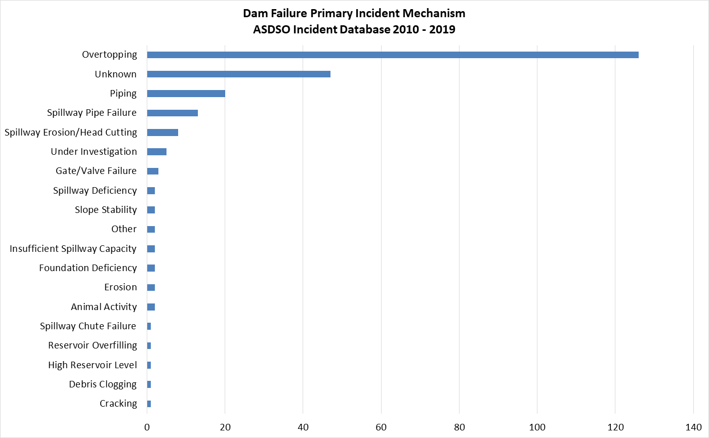
Source: (ASDSO n.d.)

Regulatory Oversight of Dams
Potential for catastrophic flooding caused by dam failures led to passage of the NDSP (Public Law 92-367). For 30 years, the NDSP has protected Americans from dam failure. NDSP is a partnership among the states, federal agencies, and other stakeholders that encourages individual and community responsibility for dam safety. Under FEMA’s leadership, state assistance funds have allowed all participating states to improve their programs through increased inspections, emergency action planning, and purchase of needed equipment. FEMA has also expanded existing training programs and initiated new training programs (FEMA 2022). Grant assistance from FEMA provides support for improvement of dam safety programs that regulate most dams in the United States (FEMA 2023).
The State of New York has a comprehensive dam safety program through which three governmental authorities regulate dam safety throughout the state:
- NYSDEC – Environmental Conservation Law (ECL) Article 15, Part 673
- FERC – 18 Code of Federal Regulations (CFR) 12.22-24
- USACE – EP 1110-2-13, Dam Safety Preparedness
Dam safety EAPs are formal dam failure procedures written by the dam owner/operator. EAPs are site-specific plans and relate only to the facility’s procedures to prevent/mitigate occurrence of a catastrophic dam failure. USACE is responsible for submitting an EAP for each dam it owns, operates, and maintains. EAPs for hydroelectric dams fall under the purview of FERC, and NYSDEC regulates dam safety and EAPs for all dams in New York.

New York State Department of Environmental Conservation
The New York State Department of Environmental Conservation’s (NYSDEC) Dam Safety Section is responsible for safety inspection of dams, technical review of proposed dam construction or modification, monitoring of remedial work for compliance with dam safety criteria, and emergency preparedness for all dams in the state. NYSDEC is responsible for more than 100 flood control projects throughout the state, most of which were constructed by U.S. Army Corps of Engineers (USACE) and are operated and maintained by NYSDEC (in some cases with local municipal partners) (NYSDEC 2014).
The State inspects high hazard dams every two years and moderate hazard dams every four years. To support emergency planning efforts and raise awareness among local officials and emergency managers, a copy of each inspection report is sent to the chief executive of the community in which the dam is located. Municipal officials or emergency managers from any municipality in the dam’s inundation area may receive a copy of the inspection report upon request (NYSDEC 2023).
U.S. According to the NYSDEC Division of Water Bureau of Flood Protection and Dam Safety, the hazard classification of a dam is assigned according to the potential impacts of a dam failure pursuant to 6 New York Codes Rules and Regulations (NYCRR) Part 673.3 (NYSDEC date unknown) (N.Y. Comp. Codes R. & Regs. Tit. 6 § 673.3 - General provisions n.d.). Dams are classified in terms of potential for downstream damage if the dam were to fail. These hazard classifications are identified and defined below (NYS DEC n.d.):
- Low Hazard (Class A) is a dam located in an area where failure will damage nothing more than isolated buildings, undeveloped lands, or township or county roads; and/or will cause no significant economic loss or serious environmental damage. Failure or mis-operation would result in no probable loss of human life. Losses are principally limited to the owner’s property.
- Intermediate Hazard (Class B) is a dam located in an area where failure may damage isolated homes, main highways, and minor railroads; interrupt the use of relatively important public utilities; and/or cause significant economic loss or serious environmental damage. Failure or mis-operation would result in no probable loss of human life, but may cause economic loss, environment damage, disruption of lifeline facilities, or impact other concerns. Dams classified as intermediate hazard dams are often located in predominantly rural or agricultural areas but could be in areas with population and significant infrastructure.
- High Hazard (Class C) is a dam located in an area where failure may cause loss of human life, serious damage to homes, industrial or commercial buildings, important public utilities, main highways, or railroads, and/or will cause extensive economic loss. This hazard classification is for dams in which excessive economic loss (urban area including extensive community, industry, agriculture, or outstanding natural resources) would occur as a direct result of dam failure.
- Negligible or No Hazard (Class D) is a dam that has been breached or removed, or has failed or otherwise no longer materially impounds waters, or a dam that was planned but never constructed. These dams are defunct dams posing negligible or no hazard to downstream areas. NYSDEC may retain pertinent records regarding such dams.
All Class B and C dams are subject to periodic safety inspections, and owners are required to submit Annual Certification Forms and Emergency Action Plans (EAPs). The DEC also conducts engineering assessments and may issue enforcement actions if deficiencies are found (Safety n.d.).

Army Corps of Engineers Dam Safety Program
USACE is responsible for safety inspections of some federal and non-federal dams that meet size and storage limitations specified in the National Dam Safety Act, including the 80 dams identified in the USACE National Inventory of Dams (NID). USACE has inventoried dams and has surveyed each state and federal agency’s capabilities, practices, and regulations regarding design, construction, operation, and maintenance of dams. USACE has also developed guidelines for inspection and evaluation of dam safety (USACE 2014). Table 6-1 outlines USACE hazard potential classification system.
Table 6-1. U.S. Army Corps of Engineers Hazard Potential Classification
Hazard Categorya | Direct Loss of Lifeb | Lifeline Lossesc | Property Lossesd | Environmental Lossese
Low | None (rural location, no permanent structures for human habitation) | No disruption of services (cosmetic or rapidly repairable damage) | Private agricultural lands, equipment, and isolated buildings | Minimal incremental damage
Significant | Rural location, only transient or day-use facilities | Disruption of essential facilities and access | Major public and private facilities | Major mitigation required
High | Certain (one or more) extensive residential, commercial, or industrial development | Disruption of essential facilities and access | Extensive public and private facilities | Extensive mitigation cost or impossible to mitigate
Source: (USACE 2014)
a. Categories are assigned to overall projects, not individual structures at a project.
b. Loss-of-life potential is based on inundation mapping of area downstream of the project. Analyses of loss-of-life potential should consider the population at risk, time of flood wave travel, and warning time.
c. Lifeline losses include indirect threats to life caused by the interruption of lifeline services from project failure or operational disruption; for example, loss of critical medical facilities or access to them.
d. Property losses include damage to project facilities and downstream property and indirect impact from loss of project services, such as impact from loss of a dam and navigation pool, or impact from loss of water or power supply.
e. Environmental impact downstream caused by the incremental flood wave produced by the project failure, beyond what would normally be expected for the magnitude flood event under which the failure occurs.

Federal Energy Regulatory Commission Dam Safety Program
The Federal Energy Regulatory Commission (FERC) cooperates with many federal and state agencies to ensure and promote dam safety and, more recently, homeland security. Every five years, an independent FERC-approved consulting engineer must inspect and evaluate projects with dams higher than 32.8 feet (10 meters) or with total storage capacity of more than 2,000 acre-feet (FERC 2020).FERC staff inspect hydroelectric projects on an unscheduled basis to investigate the following (FERC 2020):
- Potential dam safety problems
- Complaints about constructing and operating a project
- Safety concerns related to natural disasters
- Issues concerning compliance with terms and conditions of a license
FERC staff also evaluates effects of potential and actual large floods on safety of dams. FERC staff visit dams and licensed projects during and after floods, assess extents of damage, and direct any studies or remedial measures the licensee must undertake. FERC’s Engineering Guidelines for the Evaluation of Hydropower Projects guides its engineering staff and licensees in evaluations of dam safety. The publication is frequently revised to reflect current information and methodologies (FERC 2020).
FERC requires licensees to prepare emergency action plans (EAP) and provides training on doing so. The plans outline an early warning system in the event of an actual or potential sudden release of water from a dam failure. The plans include operational procedures that may be implemented during regulatory measures, such as reducing reservoir levels and downstream flows, as well as procedures for notifying affected residents and agencies responsible for emergency management. These plans are frequently updated and tested to ensure that all applicable parties are informed of the proper procedures in emergencies (FERC 2020).

Location
In the State of New York, there are over 400 high hazard dams and over 500 moderate hazard dams that pose a threat to jurisdictions in the event of a dam failure. There are 80 dams are present throughout Jefferson County. Most of these dams pose little risk, as Jefferson County has no high hazard dams located within the County, however, there are 14 dams with an intermediate hazard classification. Table 6-2 is a complete list of the dams in Jefferson County (NYS DHSES n.d.). Figure 6-2 shows the locations of dams in Jefferson County.

Extent
Dam failures can occur without warning during normal operating conditions. This is referred to as a “sunny day” failure. Dam failures may also occur during a large storm event. Significant rainfall can quickly inundate an area and cause floodwaters to overwhelm a reservoir. If the spillway of the dam cannot safely pass the resulting flows, water will begin flowing in areas not designed for such flows, and a failure may occur.
The hazard classification of a dam can be used as a measure of the extent of the dam’s failure, as the classification indicates the potential impact of a failure. The level of impact due to a failure can be estimated using the USACE hazard potential classification system presented in Table 6-1 (USACE 2014). The classification of each dam in Jefferson County is included in Table 6-2. New York has seen significant property damage including damage or loss of dams, bridges, roads, and buildings because of storm events and dam failures.

Previous Occurrences

FEMA Major Disaster and Emergency Declarations
Between 1954 and 2024, Jefferson County was not included in any major disaster (DR) or emergency (EM) declarations for dam failure-related events (FEMA 2024).

USDA Declarations
The Secretary of Agriculture is authorized to designate counties as disaster areas to make emergency loans to producers suffering losses in those counties and in contiguous counties. Between 2012 and 2024, Jefferson County was not included in any USDA dam failure-related agricultural disaster declarations.

Previous Events
There are no known dam failure-related events that impacted Jefferson County between January 2012 and December 2024. For events prior to 2012, refer to the previous Jefferson County HMP (ASDSO n.d.).

Table 6-2. Dams Located In Jefferson County
State ID | Dam Name | Municipality | Stream | Owners | Owner Type | Purposes | Class
068-3127 | Robert W Purcell Dam | Town of Cape Vincent | TR- Lake Ontario | ROBERT W PURCELL | Private | Fire Protection, Stock, Or Small Farm Pond | Low Hazard Dam
078-0016 | Dexter North Channel Dam | Village of Dexter | Black River | Central Rivers Power, LLC | Private | Hydroelectric | Low Hazard Dam
078-0017 | Dexter Middle Channel Dam | Village of Dexter | Black River | Central Rivers Power, LLC | Private | Hydroelectric | Low Hazard Dam
078-0018 | Dexter South Channel Dam | Village of Dexter | Black River | Central Rivers Power, LLC | Private | Hydroelectric | Intermediate Hazard Dam
078-1500 | Lucky Star Lake Dam | Town of Clayton | TR- Chaumont River | LUCKY STAR RANCH CORPORATION | Private | Recreation | Low Hazard Dam
078-3015 | May Rod & Gun Club Pond Dam | Town of Cape Vincent | Mud Creek | A F STEINMAN JR | Private | Other | Low Hazard Dam
099-0385 | Philadelphia Dam | Village of Philadelphia | Indian River | EONY GENERATION LTD. | Private | Hydroelectric | Low Hazard Dam
099-0397 | Sandy Hollow Dam | Town of Philadelphia | Indian River | SANDY HOLLOW POWER CO. INC. | Private | Hydroelectric | Intermediate Hazard Dam
068-5390 | Wilson Creek Water Control Structure Dam | Town of Cape Vincent | Wilson Bay | DARREN MALONEY | Private | Fish and Wildlife Pond | Low Hazard Dam
098-5439 | Hunneyman Dam | Town of Theresa | TR-Indian River | GUY E. HUNNEYMAN | Private | Recreation | Low Hazard Dam
099-1114 | Pine Camp Artillery Range Dam Site #1 | Town of Wilna | Buck Creek | UNITED STATES DEPARTMENT OF AGRICULTURE | Federal | Recreation | Low Hazard Dam
099-4913 | Gardner Park Dam | Town of Le Ray | Trout Brook | RAY BAER GARDNER PARK COMMUNITY | Private | Recreation | Low Hazard Dam
099-5109 | Philadelphia Village Reservoir Dam | Town of Le Ray | Trout Brook | VILLAGE OF PHILADELPHIA | Local Government | Water Supply - Primary | Low Hazard Dam
100-0227 | West End Dam | Town of Wilna | Black River | Carthage Industrial Development Corporation | Private | Hydroelectric, Other | Low Hazard Dam
100-0229 | Tannery Island Dam | Town of Wilna | Black River | TANNERY ISLAND POWER COMPANY | Private | Hydroelectric | Low Hazard Dam
100-0231 | Carthage State Dam | Town of Wilna | Black River | New York State Office of General Services | State | Navigation | Low Hazard Dam
100-1564 | Village Of Carthage Pool Dam | Town of Champion | Lake Creek | VILLAGE OF CARTHAGE | Local Government | Recreation | Low Hazard Dam
099-0165 | Lefebvre Mill Dam | Town of Le Ray | Black River | A H LEFEBVRE | Private | Hydroelectric | Low Hazard Dam
099-0195 | Deferiet Dam | Village of Deferiet | Black River | Erie Boulevard Hydropower, LP/Brookfield Renewable | Private | Hydroelectric | Intermediate Hazard Dam
099-0206 | Herrings Dam | Town of Wilna | Black River | Erie Boulevard Hydropower, LP/Brookfield Renewable | Private | Hydroelectric | Intermediate Hazard Dam
099-0345 | Antwerp Dam #2 | Town of Antwerp | Indian River | VILLAGE OF ANTWERP | Local Government | Water Supply - Secondary | Low Hazard Dam
099-0350 | Antwerp Village Dam | Village of Antwerp | Indian River | VILLAGE OF ANTWERP | Local Government | Water Supply - Secondary | Low Hazard Dam
088-0369 | Village Power House Dam | Town of Theresa | Indian River | KINETIC ENERGY, LLC | Private | Hydroelectric | Intermediate Hazard Dam
088-0455 | Frank Hubbard Dam | Town of Le Ray | Pleasant Creek | FRANK HUBBARD | Private | Fire Protection, Stock, Or Small Farm Pond | Low Hazard Dam
088-4579 | La Fargeville Dam | Town of Orleans | Chaumont River | ELMER HEYL & CARY STEEL | Private | Other | Low Hazard Dam
088-4667 | St James Lake Dam | Town of Le Ray | Pleasant Creek | UNITED STATES ARMY | Federal | Recreation | Low Hazard Dam
088-0832 | Theresa Dam | Village of Theresa | Indian River | Central Rivers Power, LLC | Private | Hydroelectric | Low Hazard Dam
088-1715 | Mary T Gibson Marsh #6 Dam | Town of Le Ray | TR-Hyde Creek | MARY T GIBSON | Private | Fire Protection, Stock, Or Small Farm Pond | Low Hazard Dam
088-1716 | Mary T Gibson Marsh #7 Dam | Town of Orleans | TR-Hyde Creek | MARY T GIBSON | Private | Fire Protection, Stock, Or Small Farm Pond | Low Hazard Dam
088-2522 | Upper Perch River Dam | Town of Brownville, Town of Pamelia | TR-Perch River | NYSDEC | State | Fish and Wildlife Pond, Other | Low Hazard Dam
088-2847 | Perch River Gma Feeding Area #925 Dam | Town of Brownville | TR-Perch River | NYSDEC | State | Other | Low Hazard Dam
088-4187 | Stafford Dam | Town of Alexandria | TR-Jewette Creek | SIDNEY STAFFORD | Private | Other | Low Hazard Dam
088-4883 | Fourth Street East Impoundment Dam | Town of Le Ray | Pleasant Creek | UNITED STATES ARMY - FORT DRUM DPW | Federal | Flood Control and Storm Water Management | Low Hazard Dam
088-4965 | Stone Mills Dam 2 | Town of Brownville, Town of Orleans | Perch River | NYSDEC | State | Other | Low Hazard Dam
088-5005 | 801 Housing Phase 3 Mid Det Basin Dam | Town of Le Ray | - | DOF DEVELOPMENT CORPORATION | Private | Flood Control and Storm Water Management | Low Hazard Dam
088-5381 | Hyde Lake Outlet Control Structures | Town of Theresa | Hyde Creek | SAVE HYDE LAKE ASSOCIATION | Private | Other | Low Hazard Dam
089-0086 | Factory Square Dam | City of Watertown | Black River | BLACK CLAWSON COMPANY | Private | Hydroelectric | Low Hazard Dam
089-0087 | Sewalls South Channel Dam | City of Watertown | Black River | Erie Boulevard Hydropower, LP/Brookfield Renewable | Private | Hydroelectric | Intermediate Hazard Dam
089-0095 | Diamond Island Diversion Dam | City of Watertown | Black River | Central Rivers Power, LLC | Private | Hydroelectric | Low Hazard Dam
089-0106 | Watertown Municipal Power Dam | Town of Pamelia | Black River | CITY OF WATERTOWN | Local Government | Hydroelectric | Intermediate Hazard Dam
089-0106A | Delano Island Diversion Dam | Town of Watertown | Black River | CITY OF WATERTOWN | Local Government | Hydroelectric | Low Hazard Dam
089-0106B | Pump House Dam | Town of Watertown | Black River | CITY OF WATERTOWN | Local Government | Other | Low Hazard Dam
089-0107 | Watertown Settling Basin Dam | Town of Pamelia | Black River | CITY OF WATERTOWN | Local Government | Other | Low Hazard Dam
098-1791 | Howard Ward Pond Dam | Town of Theresa | TR-Lake of the Woods | HOWARD WARD | Private | Recreation | Low Hazard Dam
098-2548 | Beartown Marsh Dam | Town of Antwerp | TR-Vrooman Creek | ESTATE OF JANET C AUSTIN | Private | Recreation | Low Hazard Dam
088-0128 | Black River Power Dam | Village of Black River | Black River | Erie Boulevard Hydropower, LP/Brookfield Renewable | Private | Hydroelectric | Intermediate Hazard Dam
087-4718 | Mud Lake Dam | Town of Alexandria | TR-Butterfield Lake | REDWOOD FIRE DISTRICT | Private | Recreation | Low Hazard Dam
088-0133 | Kamargo Dam | Village of Black River | Black River | Erie Boulevard Hydropower, LP/Brookfield Renewable | Private | Hydroelectric | Intermediate Hazard Dam
080-0089 | Bear Creek Dam | Town of Ellisburg | Bear Creek | REBECCA ELLIS | Private | Other | Intermediate Hazard Dam
089-3266 | Beebee Island Main Dam | City of Watertown | Black River | Erie Boulevard Hydropower, LP/Brookfield Renewable | Private | Hydroelectric | Intermediate Hazard Dam
078-5693 | Swamp Road Dike | Town of Lyme | TR-Shaver Creek | RICHARD EDSALL | Private | Fish and Wildlife Pond | Low Hazard Dam
089-3814 | Brookside Cemetery Dams A,b,c,d | Town of Watertown | Mill Brook | WATERTOWN CEMETERY ASSOCIATION | Private | Other | Low Hazard Dam
089-5119 | Robert Freeman Dam | Town of Rutland | Jacobs Creek | ROBERT FREEMAN | Private | Fish and Wildlife Pond, Recreation | Low Hazard Dam
079-5421 | Saiff Marsh Dam | Town of Brownville | - | WILLIAM J SAIFF III | Private | Fish and Wildlife Pond | Low Hazard Dam
080-0043 | Monitor Mills Dam | Town of Ellisburg | Sandy Creek | MANFORD LEE | Private | Other | Low Hazard Dam
079-0077 | Eureka Mills Dam | Town of Henderson | Stony Creek | E C SAWYER | Private | Other | Low Hazard Dam
079-0109 | Webster Dam | Village of Adams | Sandy Creek | F E WRIGHT | Private | Other | Low Hazard Dam
079-0111A | Taft Hydro Dam | Village of Adams | Sandy Creek | ECOsponsible, LLC | Private | Hydroelectric | Low Hazard Dam
079-0112 | Smithville Dam | Town of Adams | Stoney Creek | SMITHVILLE FIRE DISTRICT | Private | Recreation | Low Hazard Dam
079-2520 | Northern Ny Trust Co Dam | Town of Lorraine | TR-Totman Gulf | N N Y TRUST COMPANY | Private | Other | Low Hazard Dam
080-0073 | Kellers Dam | Village of Mannsville | Skinner Creek | C A KELLER | Private | Other | Low Hazard Dam
100-4580 | Pleasant Lake Dam | Town of Champion | TR-Black River | VILLAGE OF WEST CARTHAGE | Local Government | Water Supply - Primary | Low Hazard Dam
100-4632 | Long Falls Dam | Town of Champion | Black River | FOURTH BRANCH ASSOCIATES | Private | Hydroelectric | Low Hazard Dam
089-0108 | Watertown Dosing Station Dam | Town of Pamelia | Black River | CITY OF WATERTOWN | Local Government | Water Supply - Primary | Low Hazard Dam
089-1303 | Upper North Channel Dam | City of Watertown | Black River | Erie Boulevard Hydropower, LP/Brookfield Renewable | Private | Hydroelectric | Intermediate Hazard Dam
089-1317 | Beebee Island Diversion Dam | City of Watertown | Black River | Erie Boulevard Hydropower, LP/Brookfield Renewable | Private | Hydroelectric, Other | Intermediate Hazard Dam
080-1583 | Martinet Marsh Dam | Town of Ellisburg | TR-Lake Ontario | HENRY MARTINET | Private | Recreation | Low Hazard Dam
089-1714 | Lloyd & Gordon Fassett Marsh Dam | Town of Rodman | TR-N. Branch Sandy Creek | LLOYD AND GORDON FASSETT | Private | Fire Protection, Stock, Or Small Farm Pond | Low Hazard Dam
078-3250 | Perch River Wildlife Refuge Dam | Town of Brownville | Perch River | NYSDEC | State | Other | Low Hazard Dam
089-1871 | Harold L Scriven Wildlife Pond Dam | Town of Watertown | TR-Stony Creek | HAROLD L SCRIVEN | Private | Fire Protection, Stock, Or Small Farm Pond | Low Hazard Dam
089-2119 | Nys Dec Marsh Dam #1 | Town of Rodman | TR-South Sandy Creek | NYSDEC | State | Fire Protection, Stock, Or Small Farm Pond | Low Hazard Dam
089-2195 | Martin Wildlife Pond Dam | Town of Rutland | TR-Boynton Creek | ERNEST B & GLADYS L MARTIN | Private | Fire Protection, Stock, Or Small Farm Pond | Low Hazard Dam
089-2535 | Loomis Marsh Dam | Town of Rodman | TR-South Sandy Creek | EUGENE AND GRACE LOOMIS | Private | Fire Protection, Stock, Or Small Farm Pond | Low Hazard Dam
089-2598 | Honeyville Marsh Dam | Town of Adams | TR-Stony Creek | NYSDEC DIVISION OF FISH AND WILDLIFE | State | Recreation | Intermediate Hazard Dam
077-5945 | Wellesly Island State Park Dam | Town of Orleans | TR-St.Lawrence | NYSOPRHP THOUSAND ISLANDS REGION | State | Fish and Wildlife Pond | Low Hazard Dam
087-1584 | Wesley Bullard Marsh Dam | Town of Alexandria | TR-Jewett Creek | WESLEY BULLARD | Private | Fire Protection, Stock, Or Small Farm Pond | Low Hazard Dam
089-5114 | DANC Detention Basin Dam | Town of Rodman | TR-Fish Creek | Development Auth North Country | State | Flood Control and Storm Water Management, Other | Low Hazard Dam
100-4958 | Spicer Dam (Big) | Village of Carthage | Black River | TANNERY ISLAND POWER COMPANY | Private | Hydroelectric | Low Hazard Dam
100-4959 | Spicer Dam (Little) | Village of Carthage | Black River | TANNERY ISLAND POWER COMPANY | Private | Hydroelectric | Low Hazard Dam
099-5784 | Elmer Hoover Dam | Town of Philadelphia | TR-Oswegatchie | ELMER HOOVER | Private | Recreation | Low Hazard Dam
Source: NYS DHSES
Figure 6-2. Location of Dams in Jefferson County
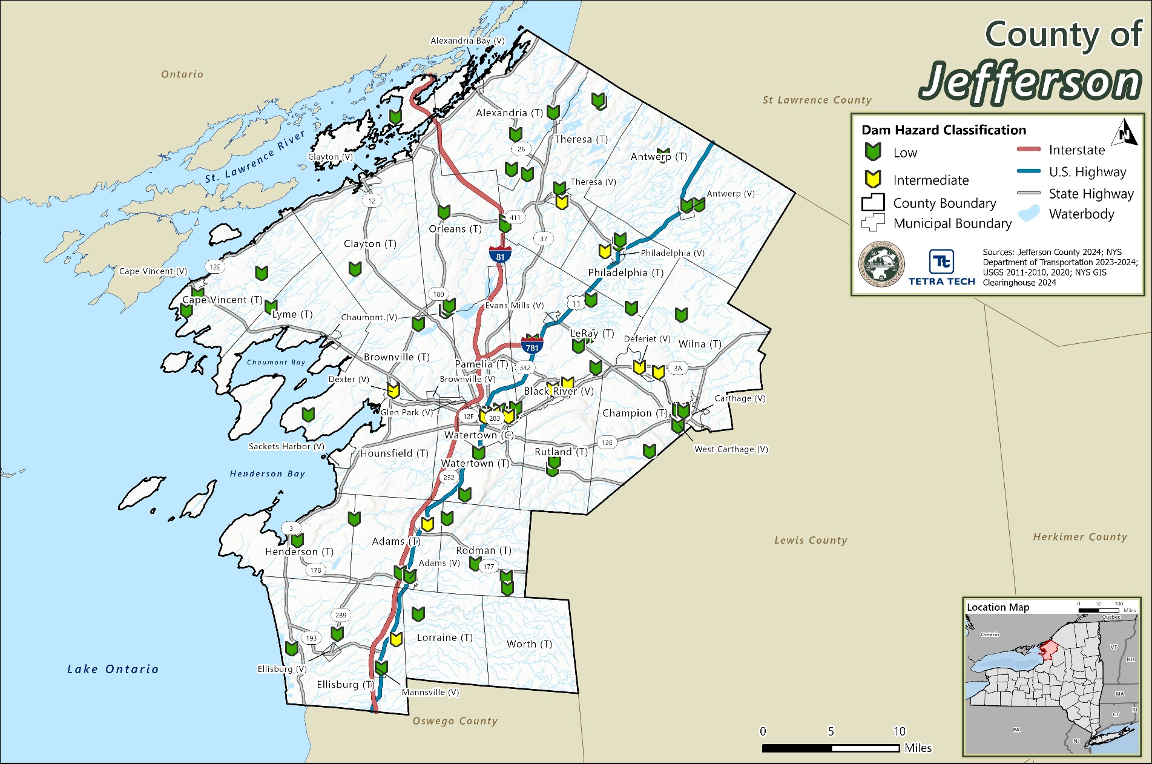

Cascading Impacts on Other Hazards
Dam failure can cause severe downstream flooding, depending on the magnitude of the failure. Other potential secondary hazards of dam failure are landslides around the reservoir perimeter, bank erosion on the rivers, and destruction of downstream habitat (FEMA 2013).

Vulnerability and Impact Assessment

Life, Health, and Safety
The impact of dam failure on life, health, and safety depends on several factors such as the class of dam, the area being protected, the location, and the proximity of structures, infrastructure, and critical facilities to the dam.

Overall Population
The entire population residing within a dam failure inundation zone is considered exposed and vulnerable to an event. The potential for loss of life is affected by the capacity and number of evacuation routes available to populations living within these areas.
Dam failure can displace persons in the area if flooding of structures occurs. Dam failure may mimic flood events, depending on the size of the dam reservoir and breach. Understanding potential outcomes of flooding for each dam in Jefferson County would require intensive hydraulic modeling.

Socially Vulnerable Population
According to Census data, there are 14,310 total persons living below the poverty level, 16,667 persons over the age of 65 years, 8,759 persons under the age of 5 years, 1,511 non-English speakers, 15,255 persons with a disability in Jefferson County. Figure 3-14 shows SVI scores across Jefferson County.
These populations are more at risk during a dam failure event because economically disadvantaged populations are more likely to make the decision to evacuate based upon the net economic impact to their family, while elderly populations are likely to seek or need medical attention. The availability of medical attention may be limited due to isolation during a flood event and other difficulties in evacuating. There is often limited warning time for a dam failure event. Populations without adequate warning of the event are highly vulnerable. Individuals who may not receive adequate warning may include those that are lack internet connection, do not speak English proficiently, and/or do not regularly use the communication tool used for warnings, like a cellphone or social media account.

General Building Stock
Buildings located downstream of a dam are at risk to damages should there be a failure. Properties located closest to the dam inundation area have the greatest potential to experience the largest, most destructive surge of water. The overall impact of flooding damages caused by dam failure will vary depending on the depth of flooding and velocity of the surge.

Community Lifelines and Other Critical Facilities
Dam failures may also impact critical facilities and lifelines located in the downstream inundation zone. Consequentially, dam failure can cut evacuation routes, limit emergency access, and/or create isolation issues. Dam failure can cause severe downstream flooding and may transport large volumes of sediment and debris, depending on the magnitude of the event. Widespread damage to buildings and infrastructure affected by an event would result in large costs to repair these locations. In addition to physical damage costs, businesses can be closed while flood waters retreat, and utilities are returned to a functioning state. Further, utilities such as overhead power lines, cable and phone lines could also be vulnerable. Loss of these utilities could create additional isolation issues for the inundation areas.

Economy
Severe flooding that follows an event like a dam failure can cause extensive structural damage and withhold essential services. The cost to recover from flood damages after a surge will vary depending on the hazard risk of each dam.
Severe flooding that follows an event like a dam failure can cause extensive damage to public utilities and disruptions to delivery of services. Loss of power and communications may occur and drinking water and wastewater treatment facilities can become temporarily out of operation. Debris from surrounding buildings can accumulate should the dam mimic major flood events, such as the 1-percent annual chance flood event that is discussed in Chapter 9 (Flood).

Natural, Historic and Cultural Resources

Natural
The environmental impacts of a dam failure can include significant water-quality and debris-disposal issues or severe erosion that can impact local ecosystems. Flood waters can back up sanitary sewer systems and inundate wastewater treatment plants, causing raw sewage to contaminate residential and commercial buildings and the flooded waterway. The contents of unsecured containers of oil, fertilizers, pesticides, and other chemicals may get added to flood waters. Hazardous materials may be released and distributed widely across the floodplain. Water supply and wastewater treatment facilities could be offline for weeks. After the flood waters subside, contaminated and flood-damaged building materials and contents must be properly disposed of. Contaminated sediment must be removed from buildings, yards, and properties (NOAA, Contaminants in the Environment n.d.).

Historic
Dam failures may impact historic resources by the resulting flood waters. Historic buildings and structures, sites, monuments, districts, and historic documents are often irreplaceable, and may become damaged or destroyed in the flood waters following a dam failure. The loss of these resources is all the more painful as residents rely on the presence of these resources to reinforce connections with neighbors and the larger community, and to seek comfort in the aftermath of a disaster.

Cultural
Cultural resources include “moveable heritage,” such as collections of artifacts, statuary, artwork, and important documents or repositories. These resources are housed in libraries, museums, archives, historical repositories, or historic properties. Flood waters following a dam failure creates the largest risk to these resources. Similar to historic resources, residents may rely on the presence of cultural resources to reinforce connections with neighbors and the larger community, and to seek comfort in the aftermath of a disaster.

Future Occurrences and Projected Changes In Risk
Understanding future changes that affect vulnerability can assist in planning for future development and ensure establishment of appropriate mitigation, planning, and preparedness measures. The following sections examine potential conditions that may affect hazard vulnerability.

Probability of Future Events
Dam failure events are infrequent and usually coincide with trigger events, such as earthquakes, landslides, and excessive rainfall and snowmelt. However, the risk of such an event increase for each dam as the dam’s age increases or the frequency of maintenance decreases. “Residual risk” to dams remains after the implementation of safeguards. Residual risk to dams is associated with events beyond those that the facility was designed to withstand. The probability of any type of dam or levee failure is low in today’s dam safety regulatory and oversight environment.
There are no publicly documented major dam failures in Jefferson County, New York, according to the most recent data from the National Inventory of Dams (NID) and FEMA disaster declarations. While Jefferson County does have several dams—many of which are classified as low or significant hazard potential—there have been no recorded catastrophic failures that resulted in federal disaster declarations or widespread damage. However, it’s important to note that routine maintenance issues and minor structural concerns may still occur and are typically addressed by local or state agencies.
The New York State Department of Environmental Conservation (DEC) oversees dam safety inspections and maintains records of dam conditions, including any enforcement actions or repair mandates.
Table 6-3 shows the future occurrence of dam and levee failure events in Jefferson County, based on historical information. Jefferson County has a 0 percent probability of dam failure events occurring in any given year.
Table 6-3. Probability of Future Dam Failure Events in Jefferson County
Hazard Type | Number of Occurrences Between 1996 and 2023 | Percent Chance of Occurring in Any Given Year
Dam Failure | 0 | 0
Note: Due to limitations in data, not all dam failure events occurring between 1954 and 1996 are accounted for in the tally of occurrences. The number of hazard occurrences is calculated using the number of occurrences between 1996 and 2023.

Climate Change Projections and Likely Impacts
Climate change can impact stored water systems as increased rainfall accumulations can cause dams to overtop. Dams are designed partly based on assumptions about a river’s flow behavior, expressed as hydrographs. Increased precipitation may result in overtopping, as the hydrographs are based off historical events. The overtopping of a dam can lead to areas downstream to become inundated with flood waters that would otherwise be safely stored.
Warming atmospheric temperatures influence ocean temperatures. With the projected increase in temperature, it is anticipated that ocean waters will increase as well due to thermal expansion, which is where ocean temperatures rise, and water expands. Additionally, this is causing ice sheets and glaciers to melt, further increasing the level of the ocean’s waters. Sea level rise can impact the amount of water in the county lakes and rivers, impacting not only bordering communities, but inland communities as well (NASA n.d.).
In Jefferson County, and the Great Lakes region, temperatures are estimated to increase by 3.5 ºF to 7.4 ºF by the 2050s, 5.1 ºF to 12.4 ºF by the 2080s, and 5.6 ºF to 14.5 ºF by 2100, relative to the 1981-2010 base period. Precipitation totals are estimated to decrease by one or can increase by up to eleven the 2050s, increase by two to 17 percent by the 2080s, and decrease by four percent or increase by up to 23 percent by 2100, relative to the 1981-2010 base period (Stevens & Lamie 2024).

Projected Changes in Development and Population
As discussed, and illustrated in Chapter 3 (County Profile), areas targeted for future growth and development have been identified across the County. Any areas of growth could be potentially impacted by a dam failure event if the structures are located within the flood protection area and mitigation measures are not considered. Therefore, it is the intention of the County and all participating municipalities to discourage development in vulnerable areas or to encourage higher regulatory standards at the local level. Due to the sensitive nature of dam locations and downstream inundation zones, an assessment to determine the proximity of these new development sites to potential dam inundation cannot be performed at this time.
Jefferson County has experienced a decrease in its population since 2010. Cornell University’s Program on Applied Demographics produced populations projections by County from 2016 to 2040. According to these projections, Jefferson County is projected to have a population of 114,290 by 2030 and 115,693 by 2040 (Cornell University 2018).
As the population increases any changes in the density of population can impact the number of persons exposed to the probable maximum flood inundation hazard areas. Higher density can not only create issues for residents during evacuation of a dam failure event but can also have an effect on commuters that travel into and out of the County for work, particularly during a flood event that may impact transportation corridors, which are also major commuter roads. Refer to Chapter 3 (County Profile) for more information about population trends in the County.

Drought

Hazard Profile
The following section provides the hazard profile (hazard description, location, extent, previous occurrences and losses, probability of future occurrences, and impact of climate change) and vulnerability assessment for the drought hazard in Jefferson County.

Hazard Description
A drought is a period of unusually constant dry weather that persists long enough to cause deficiencies in water supply (surface or underground) that can last a short period or for many years. Droughts are slow-onset hazards, but, over time, they can severely affect crops, municipal water supplies, recreational resources, and wildlife. If drought conditions extend over several years, the direct and indirect economic impacts can be significant. High temperatures, high winds, and low humidity can worsen drought conditions and make areas more susceptible to wildfire. In addition, human actions and demands for water resources can accelerate drought-related impacts (MitigateNY 2023).
Droughts can be categorized as one or more of the following four types (National Drought Mitigation Center 2023):
- Meteorological drought is a measure of departure of precipitation from normal. It is defined solely on the relative degree of dryness. Due to climatic differences, what might be considered a drought in one location of the country may not be a drought in another location.
- Agricultural drought links various characteristics of meteorological (or hydrological) drought to agricultural impacts, focusing on precipitation shortages, differences between actual and potential evapotranspiration, soil water deficits, reduced ground water or reservoir levels, and other parameters. It occurs when there is not enough water available for a particular crop to grow at a particular time. Agricultural drought is defined in terms of soil moisture deficiencies relative to water demands of plant life, primarily crops.
- Hydrological drought is associated with the effects of periods of precipitation shortfalls (including snowfall) on surface or subsurface water supply. It occurs when these water supplies are below normal. It is related to the effects of precipitation shortfalls on stream flows and reservoirs, lakes, and groundwater levels.
- Socioeconomic drought is associated with the supply and demand of an economic good with elements of meteorological, hydrological, and agricultural drought. This differs from other drought categories because its occurrence depends on current economic trends of supply and demand to identify or classify droughts. Socioeconomic drought occurs when the demand for an economic good exceeds supply because of a weather-related shortfall in water supply.

Location
New York is rich with water resources. Our celebrated streams, lakes, and coasts are fed by an average annual precipitation that ranges from 60 inches in the Catskills to 28 inches in the Lake Champlain Valley. But even here, in our “continental” climate, normal fluctuations in regional weather patterns can lead to periods of dry weather. Occasional drought is a normal, recurrent feature of virtually every climate in the United States.
New York is divided into drought management regions based roughly on drainage basin (watershed) and county lines, as shown in Figure 7-1. DEC monitors precipitation, lake and reservoir levels, stream flow, and groundwater level at least monthly in each region and more frequently during periods of drought. DEC uses this data to assess the condition of each region, which can range from “normal” to “drought disaster.” Jefferson County is in Drought Region VI Great Lakes.
Figure 7-1. New York State Drought Regions
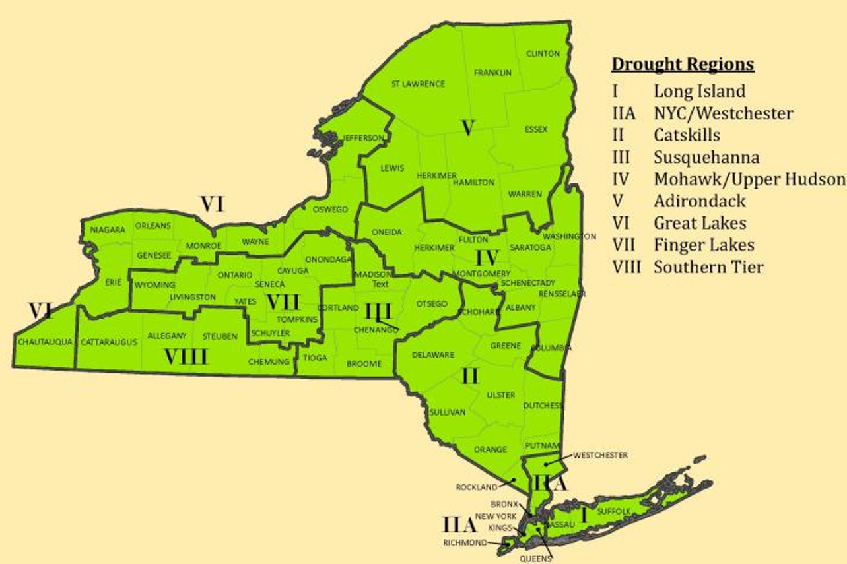
Source: NYSDEC

Extent
The severity of a drought depends on the degree of moisture deficiency, the duration, and the size and location of the affected area. The longer the duration of the drought and the larger the area impacted, the more severe the potential impacts (USDA 2023).
In NYS drought status determinations are based on a NYSDEC State Drought Index that uses New York State specific attributes, so it may differ somewhat from national drought assessments. In addition, local conditions may vary, so some areas of the state may make their own terminations of drought stage using locally-focused criteria.
NYSDEC monitors precipitation, lake and reservoir levels, stream flow, and groundwater level at least monthly in each region and more frequently during periods of drought. NYSDEC and the New York State Drought Management Task Force use this data to assign each region one of the following four drought stages (NYSDEC 2023):
- Normal is considered the standard moisture soil levels found throughout the State.
- Drought Watch is the first stage of drought. This stage is declared by the NYSDEC and is intended to give advance notice of a developing drought. As this stage, the public is urged to conserve water. Public water purveyors and industries are urged to update and begin to implement individual drought contingency plans.
- Drought Warning is the second stage of drought. This stage is also declared by the NYSDEC and is a notice of impending and imminent severe drought conditions. A warning declaration includes stepping up public awareness and increasing voluntary conservation. Public water supply purveyors and industries are urged to continue to implement local drought contingency plans. Federal, state, and local water resources agencies are notified to prepare for emergency response measures.
- Drought Emergency is the third stage of drought. This stage is declared by the NYSDHSES, based upon recommendation of the New York State Drought Management Task Force. It is a notice of existing severe and persistent drought conditions. An emergency declaration is a notice for local water resources agencies to mandate conservation and implement other emergency response measures. A continuing and worsening drought emergency may result in the the State governor declaring a drought disaster. It is a notice of the most severe and persistent drought conditions. At this stage, a significant proportion of communities in the impacted area may lack the capabilities to respond to a drought of this scale.
The State of New York uses two primary methodologies to determine the various drought stages. The Palmer Drought Severity Index (PDSI) is a commonly used drought indicator and is primarily based on soil conditions. These are typically the first indicators that a moisture deficit is present. These values range from negative five to positive five, where positive values indicate wetter conditions and negative values represent drier conditions (NYSDEC 2023).
The second methodology used by the State was developed by the NYSDEC and is referred to as the State Drought Index (SDI). The SDI evaluates drought conditions on a more comprehensive basis by measuring whether numerous indicators reach dire thresholds. The data collected is compared against critical threshold values to show a normal or changeable drought condition. The indicators are weighted on a regional basis to reflect the unique circumstances of each drought management region (NYSDEC 2023). It is through this SDI that New York State determines if various regions are experiencing the various levels of drought conditions detailed above.
The State of New York also tracks the Standardized Precipitation Evapotranspiration Index (SPEI) as an additional drought measurement tool. The SPEI, along with the PDSI, can be used to evaluate the levels of soil moisture and forecast potential impacts to agriculture within the State (NYSDEC 2023).
The PDSI and SPEI are monitored to help the State understand potential impacts of drought on agricultural conditions (NYSDEC 2023).

Previous Occurrences
Figure 7-2 shows how drought conditions varied across the county from January 2000 to July 2023. Jefferson County has experienced varying levels of drought over the years, with some periods showing significant portions of the county affected. The most frequently observed drought categories are D0 (Abnormally Dry) and D1 (Moderate Drought), indicated by yellow and light orange bars. These more intense drought categories (D2-D4) appear less frequently and affect smaller portions of the county when they do occur. There are noticeable spikes in drought coverage during certain years, suggesting episodic drought events rather than a consistent trend.
Figure 7-2. Drought Conditions 2000-2023
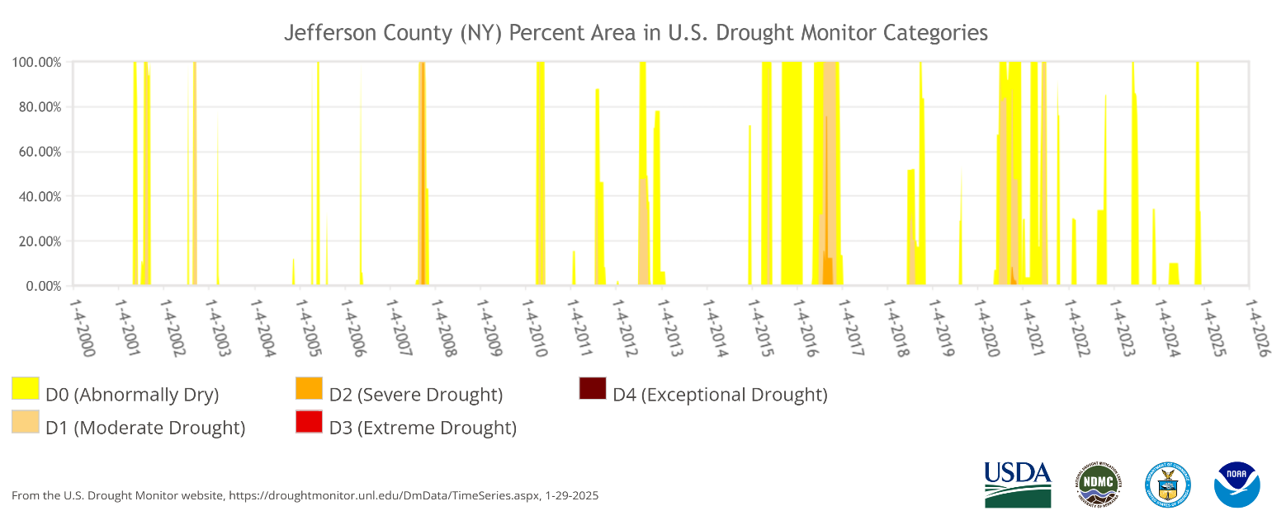
Source: U.S Drought Monitor

FEMA Major Disaster and Emergency Declarations
There have been no presidential disaster declarations in New York State related to drought.

USDA Declarations
The Secretary of Agriculture from the U.S. Department of Agriculture (USDA) is authorized to designate counties as disaster areas to make emergency loans to producers suffering losses in those counties and in contiguous counties. Between 2012 and 2024, Jefferson County was included in three USDA drought-related agricultural disaster declarations. For declarations that occurred between 2012, and December 2024 refer to Table 7-1.
Table 7-1. USDA Declarations for Drought Events in Jefferson County (2012 to 2024)
Event Date | USDA Declaration Number | Description
October 24-June 2, 2012 | S3427 | Drought, Excessive Heat
November 26-June 26, 2012 | S3441 | Drought
September 28-April 1, 2016 | S4062 | Drought
Source: USDA 2024

Previous Events below Declaration Thresholds
Known hazard events that impacted Jefferson County between January 2009 and December 2024 are discussed in Table 7-2. For events prior to 2009, refer to the 2011 Jefferson County HMP.

Table 7-2. Drought Events in Jefferson County (2009 to 2024)
Event Date | Location Impacted | Description
August 18- September 30, 2016 | County-wide | The USGS ground water level network showed that numerous wells were in the driest 10th percentile. The dry conditions started to have an impact on crops.
July 12, 2016 | County-wide | USDM D1, two weeks, Corn rolling in southern Jefferson County, New York: Corn in southern Jefferson County, New York, was rolling its leaves in an effort to conserve moisture. Hay has taken a bigger hit than corn, at this point, and could mean farmers will be short on hay if rain does not return soon. North Country Public Radio (Canton, N.Y.), July 12, 2016
July 15, 2016 | County-wide | USDM DO Drought watch, warning for New York: A drought warning was issued for a large part of western New York including Jefferson County.
July 6, 2020 | County-wide | USDM D1, two weeks, Brown, brittle lawns in northern New York: Hot, dry weather turned lawns brown and brittle in Jefferson and St. Lawrence counties. Even weeds were struggling. WWNY-TV 7 FOX 28 (Watertown, N.Y.), July 6, 2020
Source: NOAA 2025, U.S. Drought Monitor

Cascading Impacts on Other Hazards
Drought in New York State, including Jefferson County, can create a range of cascading impacts that affect water availability, ecosystems, agriculture, infrastructure, and public health. Some of the potential cascading impacts of drought in the region include:
- Water Shortages and Restrictions—Prolonged droughts reduce water availability in reservoirs, rivers, and aquifers, leading to restrictions on water use for households, businesses, and agriculture. This can affect daily life, reduce agricultural output, and hinder industrial processes that rely on large water supplies.
- Increased Wildfire Risk—Dry conditions increase the likelihood of wildfires, especially in forested or rural areas. While wildfires are less common in New York than in other parts of the U.S., drought can heighten this risk. Fires also endanger wildlife, degrade air quality, and strain emergency services.
- Agricultural Losses and Food Price Increases—Drought stresses crops and livestock, reducing yields and increasing the risk of crop failure. This can lead to financial losses for farmers, disruptions in food supply, and higher prices for consumers. Jefferson County’s dairy farms and crop producers may face significant challenges during drought conditions.
- Ecosystem Disruption and Loss of Biodiversity—Reduced water flow in rivers, streams, and wetlands can harm fish and wildlife, disrupt migration patterns, and damage habitats. Aquatic species in the Black River and other local waterways may experience population declines due to low water levels and poor water quality.
- Increased Energy Costs and Strain on Power Systems—Drought affects hydroelectric power generation, which is an important energy source in New York. With lower water levels, hydroelectric plants may produce less electricity, potentially increasing reliance on other sources and driving up energy costs. Additionally, water is needed for cooling in fossil fuel and nuclear power plants, which may also face operational constraints during droughts.
- Soil Degradation and Reduced Land Productivity—Drought depletes soil moisture, making it more susceptible to erosion and reducing its fertility. Over time, this can lead to lower land productivity, especially for crops requiring high moisture. Soil degradation may also contribute to dust storms, which can further reduce air quality.
- Economic Impacts on Water-Dependent Industries—Industries such as tourism, recreation, and hydroelectric power generation may face setbacks. Reduced water levels impact activities like fishing, boating, and hiking, affecting tourism in areas like the Thousand Islands and Tug Hill Plateau.
- Public Health Concerns—Drought can reduce the availability of clean drinking water, leading to reliance on alternative sources that may be less safe. Additionally, poor air quality from wildfires or dust storms can exacerbate respiratory conditions. Lower water availability can also reduce sanitation and hygiene standards, increasing the risk of disease.
- Pressure on Municipal Water Systems—Lower water levels can concentrate pollutants in drinking water supplies, increasing treatment costs and putting pressure on municipal water systems. Aging infrastructure may be strained as cities and towns attempt to meet water demand, which can further reduce water quality or increase the risk of water shortages.
- Long-Term Forest and Vegetation Loss—Drought can cause long-term damage to forests and green spaces, weakening trees and vegetation and making them more susceptible to disease and pests. This can affect biodiversity, reduce carbon sequestration, and change the landscape over time.

Vulnerability and Impact Assessment
To understand risk, a community must evaluate what assets are exposed or vulnerable in the identified hazard area. For the extreme temperature hazard, all of Jefferson County has been identified as the hazard area. Therefore, all assets in the County (population, structures, critical facilities, and lifelines), as described in the County Profile (Chapter 3), are vulnerable to the extreme temperature hazard.

Life, Health, and Safety

Overall Population
The entire population of Jefferson County (116,721) is exposed to this hazard. Drought conditions can affect people’s health and safety, including health problems related to low water flows and poor water quality, and health problems related to dust. Droughts also can lead to loss of human life. Other possible impacts on health from drought include increased recreational risks; effects on air quality; diminished living conditions related to energy, air quality, and sanitation and hygiene; compromised food and nutrition; and increased incidence of illness and disease. Health implications of drought are numerous. Some drought-related health effects are short-term while others can be long-term (CDC 2024).

Socially Vulnerable Population
Vulnerable populations include homeless people, elderly (over 65 years old), low income or linguistically isolated populations, people with life-threatening illnesses, and residents that may have limited access to water as is. They may require extra water supplies or need assistance to obtain water and are more likely to seek or need medical attention. According to the 2022 five-year ACS population estimate, there are 14,310 total persons living below the poverty level, 16,667 persons over the age of 65 years, 8,759 persons under the age of five years, 1,511 non-English speakers, and 15,255 persons with a disability living in Jefferson County. Figure 3-14 shows the SVI for Jefferson County, which is identified as “relatively high.” Socially vulnerable populations are most susceptible to drought events based on several factors, including the following:
- Economic Hardship—Low-income households may struggle to afford increased water and energy costs during droughts. Rural residents, who make up a significant portion of the county, may rely on private wells or small water systems that are more susceptible to drought-related shortages.
- Agricultural Dependence—Jefferson County has a strong agricultural base, including dairy, hay, and corn production. Drought can reduce crop yields and livestock productivity, directly impacting farm income and food security for those dependent on local agriculture.
- Health and Infrastructure Challenges—Vulnerable populations, such as the elderly or those with pre-existing health conditions, may be more affected by poor air quality from dust or wildfire smoke. Aging infrastructure in rural areas may be less resilient to drought-related stress, such as increased demand on water systems or contamination risks from low water levels.
- Limited Access to Resources—Some communities may have limited access to emergency services or drought relief programs, especially in more isolated parts of the county. Public health services may be strained if drought leads to water quality issues or sanitation challenges.

General Building Stock
A drought event is not expected to directly affect any structures. However, droughts contribute to conditions conducive to wildfires and reduce fire-fighting capabilities. Risk to life and property is greatest within those areas where forested areas adjoin urbanized areas (high-density residential, commercial, and industrial) or wildland urban interface (WUI).

Community Lifelines and Other Critical Facilities
While droughts typically do not cause direct structural damage to buildings, they can significantly impact critical infrastructure and community lifelines, particularly those tied to water supply, agriculture, and emergency services in Jefferson County.
- Water Supply and Firefighting Services—Jefferson County relies on a combination of surface water and groundwater sources for municipal and rural water supply. During drought conditions, surface water bodies such as the Black River and Lake Ontario tributaries may experience reduced flow, affecting water intake for treatment plants and limiting availability for firefighting operations. Groundwater wells, especially shallow private wells common in rural areas like Adams, Lorraine, and Ellisburg, are particularly vulnerable to drought. These wells may experience reduced pumping capacity or go dry entirely, requiring emergency water deliveries or costly well deepening.
- Groundwater Depletion and Streamflow Reduction—Drought reduces precipitation and snowmelt, which are critical for recharging aquifers in Jefferson County’s glacial and fractured bedrock geology. As groundwater levels drop, baseflow contributions to streams decline, leading to lower stream levels during the summer months. This affects not only water availability but also aquatic ecosystems and recreational uses of water bodies like Sandy Creek and the Chaumont River. According to the U.S. Geological Survey (USGS), groundwater recovery after drought can take months or even years, especially in areas with limited recharge capacity (Conservation n.d.).
- Agricultural and Food Supply Infrastructure—Jefferson County is a major agricultural hub in northern New York, with over 1,000 farms producing dairy, hay, corn, and vegetables. Drought can severely impact irrigation systems, livestock watering, and crop storage facilities, leading to reduced yields and economic losses. Facilities such as grain silos, feedlots, and milk processing plants may face operational disruptions due to water scarcity or increased energy costs for pumping and cooling.
- Public Health and Sanitation—Reduced water availability can strain healthcare facilities, schools, and elder care centers, particularly in smaller towns like Carthage and Clayton. These institutions depend on reliable water for sanitation, cooling, and food preparation. In drought conditions, water quality may also deteriorate, increasing the risk of contamination from concentrated pollutants or failing septic systems.

Economy
Water is an essential part of the production of many goods and services. Business reliant on water, such as farming, fisheries, timber, and tourism, can suffer substantially during drought events. Impacts from a drought can “include job losses, business failures, and lost investments”. Droughts can destroy crops, leading to increased costs for food and food shortages. Depending on the duration of the drought, some farmers could even be driven out of business due to crop damage.
The greatest share of land use in Jefferson County is agriculture, with 33.4 percent of all land cover categorized as one of many agricultural land use categories (in terms of acreage). Jefferson County, New York had 749 farms in 2022, according to the USDA NASS. The average farm size was 333 acres. The market value of products sold from farms in Jefferson County in 2022 was $238,933,000.
The County has a well-developed crops and hay sector and is ranked first in the State in terms of value of sales by this commodity group. Additionally, Jefferson County ranks tenth in the state, and 133rd in the nation, for the value of its fruits, tree nuts, and berries sector; the County ranks ninth in the state, and 85th in the nation for the value of its milk produced by cows (USDA 2024).
Many farms do not have irrigation systems and rely on rain to sustain their crops. Only 800 acres of approximately 250,000 acres farmed are irrigated in Jefferson County (see Table 7-3. If there is not enough precipitation and a drought occurs, substantial crop loss is possible (USDA 2024).
Table 7-3. Jefferson County Farmland, Total and Irrigated
 | Area (acres)
Area Farmed
Cropland | 174,537
Pastureland | 16,038
Woodland | 43,254
Other | 15,668
Total | 249,497
Farmland Irrigated | 800
Source: (USDA 2024)
Drought can produce a range of impacts that span many economic sectors and can reach beyond an area experiencing physical drought. As previously discussed, water withdrawals are not only used for potable water but for use in the commercial/industrial/mining sectors and power generation.
Increased demand for water and electricity can also result in shortages and higher costs for these resources. Industries that rely on water for business could be impacted the most (e.g., landscaping businesses). Although most businesses will still be operational, they may be impacted aesthetically. These aesthetic impacts are most significant within the recreation and tourism industry. Moreover, droughts within another area could impact the food supply and price of food for residents within the county.

Natural, Historic and Cultural Resources

Natural
Drought conditions in Jefferson County can significantly impact the region’s natural ecosystems, particularly those dependent on consistent water availability. The county is home to numerous wetlands, forested areas, and freshwater systems, including the Chaumont River, Sandy Creek, and tributaries feeding into Lake Ontario. These ecosystems are highly sensitive to prolonged dry periods.
Wetlands in areas like Perch Lake Wildlife Management Area and Lakeview Wildlife Management Area rely on stable groundwater and surface water levels. Drought reduces soil moisture and water table levels, threatening the survival of wetland vegetation and aquatic species (USGS, Droughts and Climate Change n.d.). This can lead to habitat degradation, loss of biodiversity, and increased vulnerability to invasive species.
Drought increases the risk of wildfires, particularly in forested and brush-heavy areas such as the Tug Hill Plateau. Dry vegetation becomes more flammable, and firefighting efforts may be hampered by limited water availability (USGS, Droughts and Climate Change n.d.). Additionally, drought-stressed trees are more susceptible to insect infestations (e.g., bark beetles) and disease outbreaks, which can lead to long-term forest health decline.
With reduced precipitation soil in Jefferson County, especially in agricultural zones, can become dry and compact. This leads to loss of topsoil, reduced fertility, and increased erosion, particularly on sloped terrain near the Black River Valley (EPA n.d.). These effects are exacerbated by the county’s glacial soils, which are prone to runoff when vegetation cover is lost.
Drought reduces streamflow and dilutes pollutants less effectively, increasing the concentration of nutrients, pathogens, and agricultural runoff in water bodies. This can lead to algal blooms and degraded water quality in recreational and drinking water sources (EPA n.d.). Droughts also have the potential to lead to water pollution due to the lack of rainwater to dilute any chemicals in water sources. Contaminated water supplies may be harmful to plants and animals. If water is not getting into the soils, the ground will dry up and become unstable. Unstable soils increase the risk of erosion and loss of topsoil (EPA 2025).

Historic and Cultural
Jefferson County’s historic and cultural assets, including 19th-century architecture in Sackets Harbor, military heritage sites, and historic farms, may also be indirectly affected by drought. Sites such as the Sackets Harbor Battlefield State Historic Site and historic homesteads often include heritage gardens and landscapes that require irrigation. Water restrictions during drought may limit maintenance, leading to deterioration of these cultural features. While drought does not typically damage buildings directly, soil shrinkage from prolonged dryness can affect foundations, especially in older structures with shallow footings.
Drought can disrupt agricultural fairs, reenactments, and outdoor festivals that are central to Jefferson County’s cultural identity. Reduced water availability may limit livestock participation, crop displays, and public attendance due to heat and dust.

Future Occurrences and Projected Changes in Risk
Understanding future changes that affect vulnerability can assist in planning for future development and ensure establishment of appropriate mitigation, planning, and preparedness measures. The following sections examine potential conditions that may affect hazard vulnerability.

Probability of Future Events
Information on previous drought occurrences in the County was used to calculate the probability of future occurrence of such events, as summarized in Table 7-4. Based on historical records and input from the Steering Committee, the probability of occurrence for drought in the County is considered “rare.” FEMA’s National Risk Index evaluates Drought risk based on Expected Annual Loss as “very low” when compared to the rest of the U.S.
Table 7-4. Probability of Future Drought Events in Jefferson County
Hazard Type | Occurrences Between 1996 and 2023 | Percent Chance of Occurring in Any Given Year
Drought | 3 | 10.71%
Source: NOAA 2025
Note: Due to limitations in data, not all drought events occurring between 1954 and 1996 are accounted for in the tally of occurrences. The number of hazard occurrences is calculated using the number of occurrences between 1996 and 2023

Climate Change Projections and Likely Impacts
It is anticipated that climate change may increase the frequency and intensity of droughts in New York State. Warmer temperatures will increase evaporation and reduce surface water levels, leading to drier soil. Additionally, the variability of precipitation may increase, meaning there will be more periods of extreme precipitation and more periods of little-to-no precipitation, the latter of which can spur a drought. Some studies project that late-summer, short-duration droughts will become more common due to climate change (NYSDHSES 2023).
In Jefferson County, and the Great Lakes region, temperatures are estimated to increase by 3.5 ºF to 7.4 ºF by the 2050s, 5.1 ºF to 12.4 ºF by the 2080s, and 5.6 ºF to 14.5 ºF by 2100, relative to the 1981-2010 base period. Precipitation totals are estimated to decrease by one or can increase by up to eleven the 2050s, increase by two to 17 percent by the 2080s, and decrease by four percent or increase by up to 23 percent by 2100, relative to the 1981-2010 base period (Stevens & Lamie 2024).
Overall, from 1895 to 2022, the state has become slightly wetter, but has continued to experience short term droughts, especially in the summer months. Long, multiyear droughts are not expected to increase in New York State, however, short term seasonal droughts lasting weeks or months could increase, especially in the summer. This is because of precipitation falling in more intense bursts with longer dry spells in between, as well as higher temperatures in the summer causing more water to evaporate. Reduced snow cover may also play a role, as soil dries out sooner because snow is melting earlier. The potential increase of short-term droughts may impact water systems with less storage, resulting in water shortages which will impact crop yields (Stevens & Lamie 2024).
In the Great Lakes region, the number of days per year with maximum temperatures over 90 to 95° Fahrenheit and the total number of heat waves per year are expected to increase into the 2070s. These increases in temperature have the potential to worsen drought conditions, elevating the risk for adverse impacts for the County (Stevens & Lamie 2024).

Projected Changes in Development and Population
Any areas of growth located in the County could be susceptible to drought. Specific areas of recent and new development are indicated in tabular form and/or on the hazard maps included in Volume II (Annexes) of this plan.
Jefferson County has experienced a decrease in its population since 2010. Cornell University’s Program on Applied Demographics produced populations projections by County from 2016 to 2040. According to these projections, Jefferson County is projected to have a population of 114,290 by 2030 and 115,693 by 2040 (Cornell University 2018). Changes in the density of the population can impact the number of people exposed to drought and the draw upon water resources.

Extreme Temperatures

Hazard Profile
The following section provides the hazard profile (hazard description, location, extent, previous occurrences and losses, probability of future occurrences, and impact of climate change) and vulnerability assessment for the extreme temperature hazard in Jefferson County.

Hazard Description
Extreme temperature includes both heat and cold events, which can adversely affect human health and the economy, as well as cause primary and secondary effects on infrastructure (such as burst pipes and power failure). What constitutes “extreme cold” or “extreme heat” can vary across different areas of the country, based on the typical climate and seasonal patterns.

Extreme Cold
Extreme cold events occur when temperatures drop well below normal in an area. For example, near-freezing temperatures are considered “extreme cold” in regions relatively unaccustomed to winter weather. Conversely, “extreme cold” might be used to describe temperatures below 0° F in regions that are subjected to temperatures below freezing on more of a regular basis.
Extreme cold in New York can encompass frigid temperatures, heavy snowfall, ice storms, and bitter wind chills. The northeastern location of the state makes it highly susceptible to extreme cold. Varying land elevations, character of the landscape, and large bodies of water play a significant role in the state’s temperatures. It is common for large portions or the entire state to experience extreme cold. In the face of extreme cold events, schools may close to prevent students, teachers, and staff from commuting to and from school, and there may be risks to public health, infrastructure, and daily life across the state.
For the purposes of this HMP, extreme cold temperatures refer to when the ambient air temperature drops to approximately 0 degrees Fahrenheit (°F) or below (NWS n.d.). Prolonged exposure to extreme cold temperatures can cause frostbite or hypothermia and become life-threatening. These conditions are described as the following:
- Frostbite is damage to body tissue caused by extreme cold. A wind chill of negative 20°F will cause frostbite in just 30 minutes. Frostbite can cause a loss of feeling and a white or pale appearance in extremities.
- Hypothermia is a condition brought on when the body temperature drops to less than 95°F, and it can be deadly. Warning signs of hypothermia include uncontrollable shivering, memory loss, disorientation, incoherence, slurred speech, drowsiness, and apparent exhaustion.
Extreme cold can adversely affect susceptible populations, such as those without shelter or a vehicle, or those who live in a home that is poorly insulated or without heat (such as mobile homes). Infants and the elderly are most susceptible to the effects of extreme changes in temperatures and are particularly at risk, but anyone can be affected (National Center for Healthy Housing 2022).

Extreme Heat
Extreme heat is defined as temperatures that are at least 10 degrees above the average high temperature for a region and that last for several weeks. Humid or muggy conditions occur when a high atmospheric pressure effectively forms a dome near the ground that traps hazy, damp air. A heat wave is a period of abnormally hot and humid weather. A heat wave will typically last two or more days (EPA 2025).
Depending on severity, duration, and location, extreme heat events can trigger secondary hazards including, but not limited to, dust storms, droughts, wildfires, water shortages, and power outages. These secondary hazards could result in broad and far-reaching impacts throughout an entire region. Impacts could include significant loss of life and illness; economic costs in transportation, agriculture, production, energy, and infrastructure; and losses of ecosystems, wildlife habitats, and water resources (CDC 2024).
Figure 8-1 shows the number of weather fatalities based on a 10-year average and a 30-year average. Extreme heat caused the highest average of weather-related fatalities between 1994 and 2023 (NWS 2023).
Figure 8-1. Average Number of Weather-Related Fatalities in the U.S.
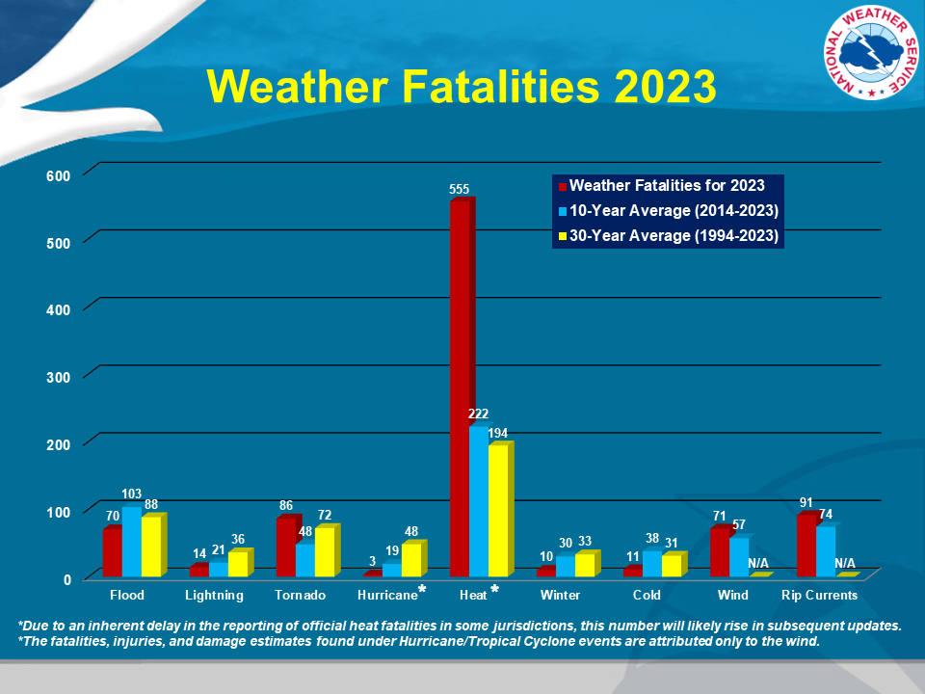
Source: NWS 2023

Location
Jefferson County is susceptible to both extreme cold and extreme heat temperature events. Extreme temperatures are a function of varying land elevation, topography, and proximity to water bodies, among other factors.

Extreme Cold
Jefferson County, located in the Tug Hill Plateau region of Northern New York, is particularly vulnerable to extreme cold events due to its geographic and climatic characteristics. The county experiences prolonged periods of sub-zero temperatures, intensified by lake-effect snow and wind chills originating from Lake Ontario. Historically, the most severe impacts of extreme cold in New York State have been concentrated in the Western and Adirondack regions. However, Jefferson County shares many of the same vulnerabilities due to its proximity to Lake Ontario and its exposure to intense lake-effect weather systems. These systems can rapidly drop temperatures and increase wind chill.
Extreme cold temperatures occur throughout most of the winter season and generally accompany most winter storm events throughout the state. Extensive periods of extreme cold result when great high-pressure systems move into and through the eastern United States. Combined with the presence of Arctic air masses, high atmospheric pressure can cause extreme cold conditions to over the State of New York. These conditions typically manifest when arctic air masses under high atmospheric pressure move southward from central Canada or the Hudson Bay, making the State’s location in the northeast highly susceptible to extreme cold (NYS DHSES 2023, Cornell University n.d.).
Figure 8-2 shows the cold wave risk index for Jefferson County by census tract across the county. This index helps to understand the susceptibility of the County to cold temperatures. According to the National Risk Index, the County overall has a relatively high risk from cold temperatures and ranks in the 85th percentile nationally (FEMA 2019).
Figure 8-2. National Risk Index, Cold Wave Risk Index Score by Census Tract
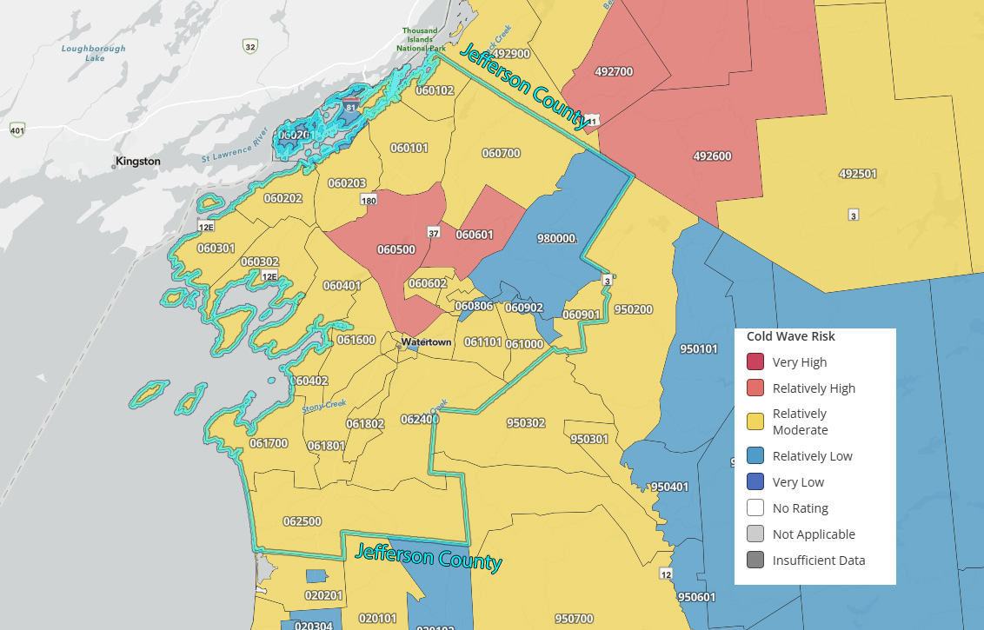
Source: (FEMA 2019)

Extreme Heat
Extreme heat events can occur anywhere in New York State. Risk to extreme heat is based on a combination of sensitivity, exposure, and ability to adapt to extreme heat. These events usually cover a large area, such as an entire county. However, there can be spot locations that are somewhat cooler (e.g., a shady park near a stream) or hotter (e.g., urban areas because of their built environment holds the heat) (NYS DHSES 2023).
Figure 8-3 shows the heat wave risk index for Jefferson County by census tract across the county. This index helps to understand the susceptibility of the County to extreme heat. According to the National Risk Index, the County overall has a relatively low risk from cold temperatures and ranks in the 42nd percentile nationally (FEMA 2019).
Figure 8-3. National Risk Index, Heat Wave Risk Index Score by Census Tract
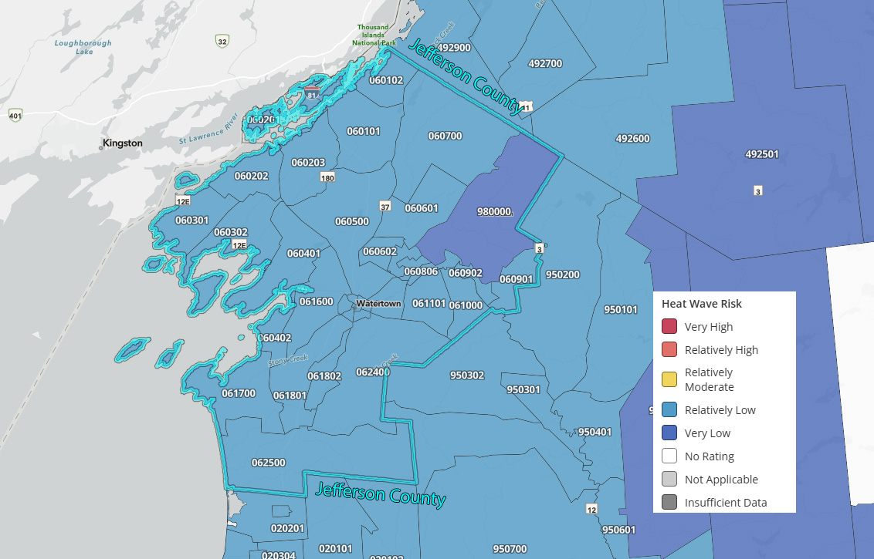
Source: (FEMA 2019)

Extent

Extreme Cold
The extent (severity or magnitude) of extreme cold temperatures is generally measured through the Wind Chill Temperature (WCT) Index. Wind Chill is a term used to describe what the air temperature feels like to the human skin due to the combination of cold temperatures and winds blowing on exposed skin. In simple terms, the colder the air temperature and the higher the wind speeds the colder it will feel on your skin if you’re outside (NOAA n.d.).The index approximates the dangers from wind chill. The WCT is presented in Figure 8-4.
Figure 8-4. Wind Chill Index
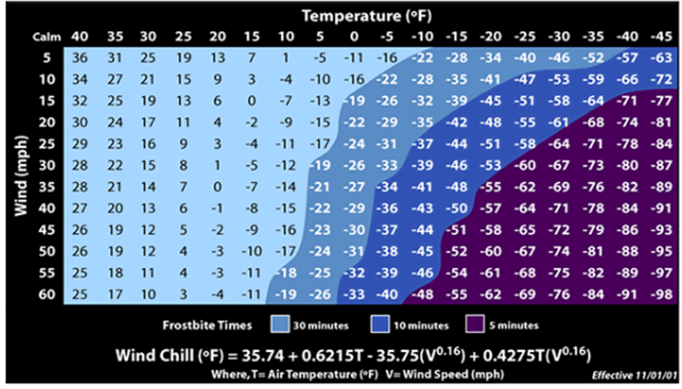
Source: NWS 2001

Extreme Heat
The extent of extreme heat temperatures is generally measured through the heat index. Created by the National Weather Service (NWS), the heat index measures apparent air temperature as it increases with the relative humidity. The temperature and relative humidity are needed to determine the Heat Index. Once both values have been identified, the heat index is the corresponding number of both values (as seen in Figure 8-5). This index provides a measure of how temperatures feel; however, the values are devised for shady, light wind conditions. Figure 8-5 shows the heat index value for shaded areas. Exposure to full sun can increase the index by up to 15 °F (NWS n.d.).
The NWS provides alerts when heat indices approach hazardous levels. Table 8-1 explains these alerts. In the event of an extreme heat advisory, the NWS issues special weather statements, including who is most at risk, safety rules for reducing risk, and the extent of the hazard and Heat Index values. Additionally, the NWS includes heat index values in weather forecasts and provides assistance to the state and local health officials in preparing Civil Emergency Messages during severe heat waves (NYSDHSES n.d.).
Urbanized areas face elevated risks during an extreme heat event, compared to rural and suburban areas. When natural areas are developed, open land and vegetation is replaced with buildings, roads, and other infrastructure which absorb more solar radiation than the natural land. Additionally, surfaces that were once permeable and moist are now impermeable and dry. These changes cause urban areas to become warmer than the surrounding areas. This forms an island of higher temperatures (EPA 2023). Jefferson County is a coastal community which can experience warmer water with fish kills or harmful algae blooms in relation to extreme heat events.
Figure 8-5. NWS Heat Index
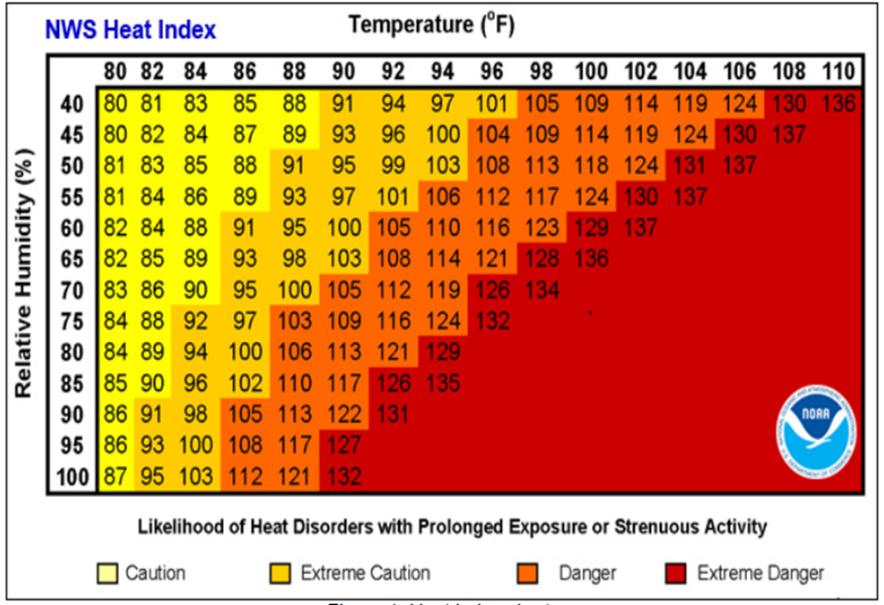
Source: NWS n.d.
Table 8-1. National Weather Service Alerts
Alert | Criteria
Heat Advisory | Issued 12 hours of the onset of the following conditions: maximum daytime heat index values are to reach between 100°F to 104°F for at least 2 consecutive hours
Excessive Heat Watch | Issued when conditions are favorable for excessive heat in the next 24 to 72 hours
Excessive Heat Warning | Issued within 12 hours of the onset of the following conditions: maximum heat index temperature is expected to be 105°F or higher for at least 2 days and nighttime air temperatures will not drop below 75°F
Source: NWS n.d.
A heat island refers to built-up areas that are hotter than nearby outlying areas. The annual mean air temperature of a city with more than 1 million people can be between 1.8 ⁰F and 5.4⁰F warmer than surrounding areas. In the evening, the difference in air temperatures can be as high as 22⁰F. Heat islands occur on the earth’s surface and in the atmosphere. On a hot, sunny day, the sun can heat dry, exposed urban surfaces to temperatures 50⁰F to 90⁰F hotter than the air. Heat islands can affect communities by increasing peak energy demand during the summer, thereby escalating air conditioning costs, air pollution and greenhouse gas emissions, heat-related illness and death, and rates of water quality degradation (EPA 2023).
Figure 8-6 illustrates an urban heat island profile. The graphic demonstrates that heat islands are typically most intense over dense urban areas and are less prevalent in vegetated areas (EAP 2023).
Figure 8-6. Urban Heat Island Profile
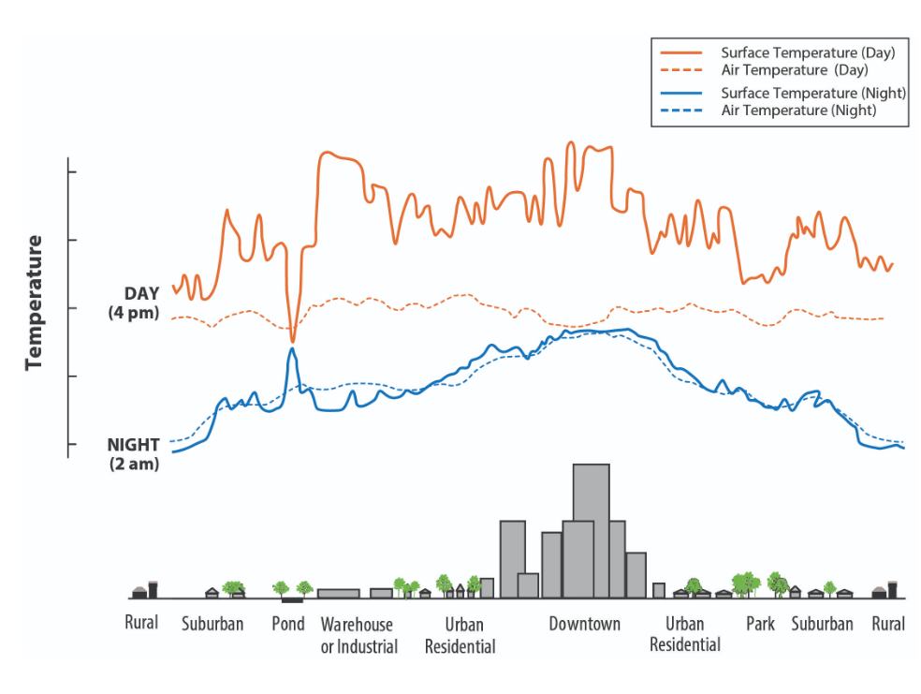
Source: EPA 2023

Previous Occurrences
FEMA’s National Risk Index reports that in Jefferson County the Expected Annual Loss (EAL) associated with extreme cold events is $485,101, and for extreme heat events it is $55,667 (Zuzak 2023).

FEMA Major Disaster and Emergency Declarations
Between 1954 and December 2024, Jefferson County was not included in any major disaster (DR) or emergency (EM) declarations for extreme temperature-related events (FEMA 2025).

USDA Declarations
The Secretary of Agriculture is authorized to designate counties as disaster areas to make emergency loans to producers suffering losses in those counties and in contiguous counties. Between 2012 and December 2024, Jefferson County was included in five USDA extreme temperature-related agricultural disaster declarations. For declarations that occurred between 2012 and December 2024, refer to Table 8-2
Table 8-2. USDA Declarations for Extreme Temperature Events in Jefferson County (2012 to 2024)
Event Date | USDA Declaration Number | Description
June 2, 2012 | S3427 | Drought and excessive heat
January 1-May 24, 2015 | S3886 | Frost, Freeze, and Excessive Snow
April 1-June 1, 2020 | S4903 | Freeze and Frost
April 15- June 1, 2020 | S4904 | Freeze
May 14-May 25, 2023 | S5485 | Freeze and Frost
April 22-27, 2024 | S5698 | Frost and Freeze
Source: USDA 2024

Previous Events below Declaration Thresholds
Known hazard events that impacted Jefferson County between January 2011 and December 2024 are discussed in Table 8-3. This table only includes extreme cold events. The NOAA NCEI Storm Events database have zero reported events of extreme heat during this period. For events prior to 2011, refer to the 2011 Jefferson County HMP.
Table 8-3. Extreme Temperature Events in Jefferson County (2011 to 2023)
Event Date | Location Impacted | Description
January 24, 2011 | County-wide | Bitter cold temperatures affected the eastern Lake Ontario region with some records of negative. No crop or property damages were reported.
October 6, 2011 | County-wide | Cold temperatures resulted in temperatures below freezing. No crop or property damages were reported.
April 18, 2012 | County-wide | Temperatures fell below zero which resulted in damage to stone fruits with estimates of 60 percent of the yield being lost. No crop or property damages were reported.
April 28-30, 2012 | County-wide | Temperatures fell below freezing which resulted in damage to stone fruits with estimates of 80 percent of the yield being lost. No crop or property damages were reported.
October 12-13, 2012 | County-wide | The freeze brought an end to the 2012 growing season. No crop or property damages were reported.
September 17, 2013 | County-wide | Temperatures fell below freezing with a low of 30 degrees being reported in Watertown. No crop or property damages were reported.
September 19, 2014 | County-wide | Overnight temperatures led to a frost and freeze. No crop or property damages were reported.
October 12, 2014 | County-wide | Temperatures fell below freezing. No crop or property damages were reported.
February 13-14, 2016 | County-wide | Wind chills of negative 30 degrees were documented, and warming shelters were opened. No crop or property damages were reported.
December 28, 2017 | County-wide | Temperatures dropped to 20 below zero and wind chills of negative 30 were documented in Watertown. No crop or property damages were reported.
January 1, 2018 | County-wide | Temperatures of negative 20 were documented. No crop or property damages were reported.
January 5-6, 2018 | County-wide | Temperatures of negative 20 were documented. No crop or property damages were reported.
October 17, 2018 | County-wide | Freezing temperatures resulted in a killing freeze that signified the end of the growing season. No crop or property damages were reported.
January 30-31, 2019 | County-wide | Temperatures dipped below zero. One homeless man died of exposure. No crop or property damages were reported.
May 12-14, 2020 | County-wide | A cold pattern persisted through the growing season which impacted the beginning of the growing season. No crop or property damages were reported.
September 21, 2020 | County-wide | Unseasonably cold air led to killing freezes in the County. No crop or property damages were reported.
January 11, 2022 | County-wide | The County experiences nearly nightly sub-zero temperatures with wind chill values of negative 30 degrees. No crop or property damages were reported.
January 15, 2022 | County-wide | The County experiences nearly nightly sub-zero temperatures with wind chill values of negative 30 degrees. No crop or property damages were reported.
January 21-30, 2022 | County-wide | The County experiences nearly nightly sub-zero temperatures with wind chill values of negative 30 degrees. No crop or property damages were reported.
October 2, 2022 | County-wide | The remnants of Hurricane Ian led to frost widespread across the region. No crop or property damages were reported.
February 3-4, 2023 | County-wide | Extreme could lead to wind chills as low as negative 43 at Watertown. No crop or property damages were reported.
May 17, 2023 | County-wide | Freezing temperatures damaged many apple orchards and grape vineyards. Damage to crops and buds is estimated to be at least 50 percent. No crop or property damages were reported.
Source: NOAA 2024

Cascading Impacts on Other Hazards
Extreme temperature events—both heat and cold—can significantly exacerbate other natural hazards in Jefferson County, NY, due to the region’s unique geography, agricultural economy, and climate vulnerabilities.
Prolonged periods of extreme heat can accelerate soil moisture loss and reduce surface water availability, contributing to drought conditions. Jefferson County, located in the eastern Lake Ontario snowbelt, is not traditionally drought-prone, but recent climate trends show increasing variability in precipitation and temperature patterns 1. As drought conditions intensify, vegetation becomes desiccated, creating ideal fuel for wildfires. While wildfires are historically rare in Jefferson County, the New York State Department of Environmental Conservation (NYSDEC) has noted that climate change is increasing the risk of wildfires in previously low-risk areas (Office of Climate Change n.d.).
The Tug Hill Plateau and the Fort Drum Military Installation, both within or adjacent to Jefferson County, contain large tracts of forest and grassland that could become ignition points under extreme heat and drought conditions. Human activities, such as military training exercises or recreational fires, could further elevate wildfire risk during these periods.
Conversely extreme cold events, especially those occurring outside the typical winter season, can lead to damaging frosts and freezes. These events are particularly harmful in early spring or late fall when crops and vegetation are vulnerable. Jefferson County’s agricultural sector, which includes dairy, corn, soybeans, and fruit crops, is highly susceptible to such temperature anomalies. A late spring frost following an unseasonably warm period can damage budding plants, reducing yields and economic returns for farmers (Office of Climate Change n.d.).
Extreme temperature fluctuations can also disrupt the phenological cycles of crops and pests. Warmer winters may fail to kill off overwintering insect populations, leading to earlier and more severe infestations in the growing season. For example, pests like the corn earworm and soybean aphid, which are sensitive to winter temperatures, may become more prevalent in Jefferson County as winters warm (Office of Climate Change n.d.). Additionally, extreme heat during the growing season can cause heat stress in crops, reducing pollination success and grain fill in crops like corn. Similarly, extreme cold snaps can damage perennial crops such as apples and grapes, which are increasingly being cultivated in northern New York.

Vulnerability and Impact Assessment
To understand risk, a community must evaluate what assets are exposed or vulnerable in the identified hazard area. For the extreme temperature hazard, all of Jefferson County has been identified as the hazard area. Therefore, all assets in the County (population, structures, critical facilities, and lifelines), as described in the County Profile (Chapter 3), are vulnerable to the extreme temperature hazard.

Life, Health, and Safety

Overall Population
Extreme temperature events have potential health impacts including injury and death. More mild winters resulting from a warming climate can reduce illness and injuries associated with extreme cold temperatures and reallocate them to extreme heat events. The entire population of Jefferson County (116,721) is exposed to the extreme temperature hazard.
Several health hazards are related to extreme cold temperatures and include wind chill, frostbite, and hypothermia, which are defined as the following:
- Wind chill is not the actual temperature but rather how wind and cold feel on exposed skin. As the wind increases, heat is carried away from the body at an accelerated rate, driving down the body temperature.
- Frostbite is damage to body tissue caused by extreme cold. A wind chill of negative 20°F will cause frostbite in just 30 minutes. Frostbite can cause a loss of feeling and a white or pale appearance in extremities.
- Hypothermia is a condition brought on when the body temperature drops to less than 95°F, and it can be deadly. Warning signs of hypothermia include uncontrollable shivering, memory loss, disorientation, incoherence, slurred speech, drowsiness, and apparent exhaustion (NWS 2022).
Several health hazards are related to extreme heat temperatures and include heat exhaustion and heat stroke, which are defined as the following:
- Heat exhaustion is the body’s response to an excessive loss of water and salt, usually through excessive sweating. Symptoms can include headache, cramping, dizziness, and weakness.
- Heat stroke is the most serious heat-related illness. It occurs when the body can no longer control its temperature. The body’s temperature rises rapidly, the sweating mechanism fails, and the body is unable to cool down. When heat stroke occurs, the body temperature can rise to 106°F or higher within 10 to 15 minutes. Heat stroke can cause permanent disability or death if the person does not receive emergency treatment (CDC 2022).

Socially Vulnerable Populations
According to FEMA’s National Risk Index the risk for extreme cold in Jefferson County is relatively high (see Figure 8-2), as is the expected annual loss (see Figure 8-7).
Figure 8-7. National Risk Index, Extreme Cold Expected Annual Loss Score
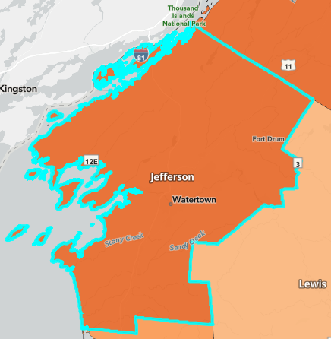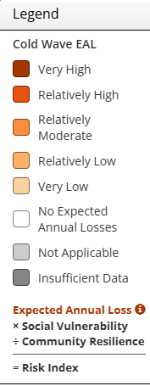

Extreme cold disasters in New York State can have significant and wide-ranging impacts on communities and people. Health risks due to extreme cold can include hypothermia and frost bite, which can result in tissue damage and be life threatening. Cold air can also exacerbate respiratory conditions like asthma, bronchitis, and pneumonia, leading to increased hospitalizations. Cold weather can also strain the cardiovascular systems, leading to increased risk to those who have related health issues. Public safety issues are also a risk during extreme cold events. Slippery roads and sidewalks increase the risk of accidents, including car crashes and falls. Individuals who are experiencing homelessness are particularly vulnerable during extreme cold events as they may lack adequate shelter and warmth.
Most impact to people and communities from extreme cold has occurred in the rural parts of Western New York. Rural areas are most likely to suffer from long power outages because utilities prioritize areas with greater numbers of customers, and because fallen trees may limit accessibility. Extended periods of cold weather drive up heating costs, which can strain household budgets and increase energy poverty. This is particularly challenging for low-income residents, who may struggle to afford adequate heating, leading to health risks or reduced spending on other essentials. Extreme cold also increases the risk of house fires. Many people use alternative heat sources like space heaters or fireplaces during extreme cold, which can increase the risk of house fires. Power outages also encourage candle use, which can lead to accidental fires. Fire departments may be strained in responding due to icy conditions and increased call volumes (NYS DHSES 2023).
Across the state, New Yorkers are already experiencing increasingly common and severe effects of extreme heat events, and these events are projected to become widespread, more frequent, severe and prolonged as climate change progresses. Extreme heat impacts unfold unevenly across New York’s communities. Heat deaths occur primarily among communities of color, Indigenous Peoples, low-income communities, the rural poor, and people living in isolation. Additionally, exposed indoor and outdoor workers, people experiencing homelessness and housing insecurity, seniors, young children, and pregnant women are particularly vulnerable to impacts.
Extreme heat does not impact everyone in the same ways. High-risk factors correlated with adverse health outcomes include socioeconomic vulnerabilities; race and ethnicity; age; preexisting medical conditions; limited access to transportation; physiological mobility; limited linguistic capabilities; marital status; mental, physical, or cognitive impairments; and being homebound. Individuals living in settings that reduce physical mobility, such as incarcerated people, are also at greater risk of extreme heat impacts. Extreme heat events may cause additional isolation for vulnerable individuals living alone, as visitations may be reduced or prevented, which increases their risk of death.
Extreme heat can cause psychological stress and anxiety over a changing climate and associated natural disasters. Individuals living with mental health challenges may be at increased risk of heat-related morbidity and mortality. An increased risk of concurrent heat-related illness with behavioral health disorder hospitalizations was observed in individuals with dementia and schizophrenia in a recent New York State study. Some studies link elevated temperatures to violence and other mental health problems; the strongest association is an elevated suicide risk. Medications used to help with mental health, including antidepressants, antianxiety medications, stimulants, antipsychotics, and mood stabilizers, can interfere with body temperature regulation and make staying cool difficult.
Outdoor workers and some indoor workers are at a high risk of heat-related illness. As New York State experiences more frequent extreme heat days due to climate change, outdoor workers, such as those in construction, agriculture, and transportation, are at greater risk for heat illnesses. Outdoor workers are at heightened risk of heat exposure, which can lead to dehydration, kidney damage, or renal failure when combined with strenuous physical activity. Additionally, exposure to fumes and exhaust in extreme heat can have negative health impacts. For example, higher temperatures can cause an increase in pesticide evaporation and lead to increased toxin exposure and potential health impacts for farm workers. Commuting workers may face exposure risks during their commute.
Climate-sensitive health problems, including those related to reduced worker productivity, can have broader impacts on the economy. Studies show lower productivity during heat waves. Assuming a pathway toward a 1.5°C rise in global temperature by the end of the twenty-first century, the International Labor Organization “projected that 2.2 percent of total working hours will be lost to high temperatures globally in 2030—a productivity loss equivalent to 80 million full-time jobs.” When temperatures are high, industries may cut labor hours and pay, which requires some workers to put their health at risk by choosing or being pressured to work on extremely hot days to avoid decreasing family earnings; this is a significant challenge given rural poverty in New York State.
People exposed to extreme heat throughout the day with no relief at night are at higher risk of hospitalization or death from hyperthermia. Additionally, higher temperatures can cause poor sleep and have been linked to poor educational outcomes. When it is too cold or hot, individuals are less likely to engage in physical activity, which is a health behavior that reduces the risk of all-cause mortality, cardiovascular disease, type 2 diabetes, and several cancers.
Extreme heat events can cause energy insecurity, particularly the cost of and access to cooling in homes, leading to increased health risks. Lack of access to necessary energy can cause health risks by impeding in-home care and at-home medical devices and can prevent people from going to the hospital. People may experience dehydration and heat-related illness in homes without air conditioning. Low-income residents may not be able to afford energy efficiency upgrades or air conditioners. Energy insecure renters may be at an added disadvantage as they may lack the ability to make decisions about energy efficiency in their homes and landlords may lack sufficient incentives to make energy efficiency improvements to units that would help lower renters’ bills related to increased temperatures. Many Indigenous communities are already burdened with low energy access, and affordability will be further impacted by extreme heat. The results of energy insecurity include extreme home temperatures, and potential utility shutoffs or mounting charges in utility bills due to nonpayment. Power outages can impact the ability to keep food fresh and properly stored, which leads to bacterial growth and may have a disproportionate effect on lower income residents who cannot afford to waste the food or go out to eat.
Extreme heat can have second-order effects that exacerbate other problems. An increase in ground level ozone and particulate matter, i.e., smog, exacerbated by extreme heat, can cause premature deaths, hospital visits, lost school days, and acute respiratory symptoms. Higher temperatures may also contribute to increased risk for food-borne, water-borne, and vector-borne illness.
Additionally, the risk of transmission of airborne diseases, including the risk of COVID-19 transmission, has been found to be elevated indoors compared to outdoors, which may be a concern when using indoor spaces for refuge from high temperatures. Public cooling centers may not have adequate space to maintain adequate separation. During heat waves, New Yorkers may remain in overheated homes—or for unhoused individuals, remain outdoors—for a variety of reasons, even as temperatures impact health (New York State 2024).
Overall, heat-related death rates correlate with a range of environmental and social factors including a prevalence of poor housing conditions, poverty, impervious land cover, high land-surface temperatures, and lower access to air conditioning.
Disproportionate exposure to heat occurs in the state’s urban areas due to overall higher temperatures, physical microenvironments such as apartments, and high nighttime temperatures brought about by the urban heat island effect, which prevents the physical environment from sufficiently cooling off overnight. In New York State, urban heat islands can disproportionately impact neighborhoods that are home to lower-income populations and higher concentrations of older adults.
People living in rural areas of the state face similar health outcomes, but the causes for their vulnerability are not always the same. Adverse heat-health outcomes are reported for rural and urban communities alike, with similar overall heat-health outcomes. The factors which exacerbate heat-health impacts in rural communities may more likely relate to distance and access to health care and other important services, aging infrastructure, perceptions of risk, social and physical isolation, and other drivers. Residents in rural areas are more likely to work outdoors and perform strenuous tasks related to farming, logging, and raising livestock. Agricultural workers in the U.S. are among the populations most vulnerable to the health impacts of extreme heat. Rural poverty, an aging population, and overall poorer health compound impacts in rural communities. In New York State, approximately 20 percent of the surveyed households overall, and more than 30 percent in households earning less than $35,000, were estimate not to have air conditioning.

General Building Stock
Extreme cold poses significant risks to the built environment, especially in urban centers like Watertown and densely populated areas along the Black River and Fort Drum. The County’s proximity to Lake Ontario and its exposure to intense lake-effect weather systems can rapidly drop temperatures and increase wind chill, exacerbating the risk of infrastructure failure and structural damage.
The Expected Annual Loss (EAL) metric, as calculated by FEMA’s National Risk Index using the HAZUS model, incorporates both the frequency and severity of hazards and the value of exposed assets. In Jefferson County, EAL is notably higher in urbanized areas such as Watertown, where the concentration of residential, commercial, and critical infrastructure increases the potential for economic loss. The county’s exposure is further heightened by the presence of Fort Drum, a major military installation with extensive built infrastructure. Figure 8-8 shows estimates of annual loss to property due to extreme cold in New York State.
Figure 8-8. Annual Loss to Property - Extreme Cold
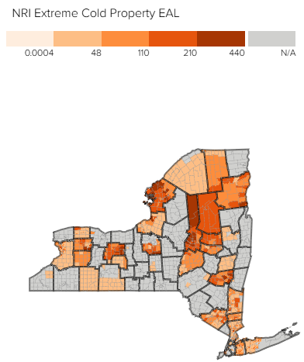
Source: (Zuzak 2023)
Extreme cold can damage buildings and infrastructure in several ways, due to a variety of factors:
- Freeze/Thaw Cycles—Repeated freezing and thawing can cause expansion and contraction in building materials, leading to cracks in foundations, walls, and roadways.
- Frozen Pipes—Prolonged cold can freeze water pipes, leading to bursts and water damage, particularly in older homes or buildings with inadequate insulation.
- Power Outages—Ice accumulation on power lines and poles can lead to widespread outages. Jefferson County’s rural areas are especially vulnerable due to longer distances between service points and slower restoration times.
- Fire Risk—The use of alternative heating sources during power outages increases the risk of residential fires, especially in mobile homes and older structures with outdated electrical systems (NYSDOS n.d.).
- Manufactured and Mobile Homes—These structures are more prevalent in rural parts of Jefferson County and are particularly susceptible to extreme cold due to poor insulation and lightweight construction.
- Aging Housing Stock—Many homes in Jefferson County were built before modern energy codes were adopted. These structures often lack adequate insulation and weatherproofing, increasing heating demands and vulnerability to cold-related damage (NYSDOS n.d.).
All the building stock in the County is exposed to the extreme temperature hazard. Refer to Chapter 3 (County Profile), which summarizes the building inventory in Jefferson County.
Extreme heat generally does not impact buildings; however, elevated summer temperatures increase the energy demand for cooling. Losses can be associated with the overheating of heating, ventilation, and air conditioning (HVAC) systems.

Community Lifelines and Other Critical Facilities
All critical facilities in Jefferson County—including hospitals, emergency shelters, fire and police stations, water and wastewater treatment plants, and Fort Drum—are exposed to extreme cold hazards. While direct structural damage from cold temperatures is typically minimal, the operational impacts can be severe and wide-reaching.
Urban areas like Watertown face higher economic and service disruption risks due to the concentration of infrastructure and population, while rural areas may struggle with limited redundancy, aging infrastructure, and longer emergency response times. Extreme cold events can trigger a series of cascading impacts that compromise the functionality of critical infrastructure:
- Power Outages and Energy Demand Surges—Heating demand spikes during extreme cold can strain the electrical grid. Ice accumulation on power lines and transformers can lead to outages, which are particularly dangerous for critical facilities like hospitals and emergency shelters. Backup generators are essential to maintain operations during these events (NYS DHSES 2023).
- Water and Wastewater System Failures—Freezing temperatures can cause water mains and service lines to burst, disrupting water supply and sanitation services. This is especially concerning for healthcare facilities and long-term care homes, where water access is vital for hygiene and patient care.
- Transportation Network Disruptions—Icy roads, frozen rail switches, and snow-covered runways can delay emergency response, disrupt supply chains, and isolate rural communities. Jefferson County’s reliance on a mix of state highways and rural roads makes it particularly vulnerable to transportation disruptions during prolonged cold spells.
- Emergency and Health Services Strain—Hospitals and EMS providers face increased demand for cold-related illnesses such as hypothermia, frostbite, and respiratory issues. Simultaneously, icy conditions increase the risk of vehicular accidents and fire incidents due to alternative heating methods.
- Communication and Coordination Challenges—Power outages and weather-related damage to communication infrastructure can hinder coordination among emergency services, especially in remote areas of the county.

Economy
Jefferson County’s natural and cultural landscape is deeply intertwined with its agricultural economy, historical heritage, and ecological diversity. Extreme cold events pose a significant threat to these resources, with impacts that ripple across the environment, economy, and community identity.
The agricultural sector is among the most vulnerable to extreme cold in Jefferson County. The county is home to over 1,000 farms and more than 250,000 acres of farmland, much of which is dedicated to dairy, hay, corn, and livestock production 1. Extreme cold events can disrupt this sector in several ways:
- Crop Damage and Delayed Planting—Frost and prolonged cold can damage overwintering crops and delay spring planting due to frozen soil. This is particularly problematic for hay and corn, which are essential for livestock feed.
- Livestock Stress—Cold stress in cattle and other livestock can lead to reduced weight gain, lower milk production, and increased mortality. Water sources may freeze, requiring additional labor and equipment to maintain hydration.
- Infrastructure Damage—Farm buildings, irrigation systems, and equipment are susceptible to damage from freezing temperatures, especially if not winterized. Burst pipes and frozen machinery can lead to costly repairs and operational delays.
According to FEMA’s National Risk Index, Jefferson County’s Expected Annual Loss (EAL) from extreme cold for crops is estimated at $295,603, significantly higher than the EAL from extreme heat ($1,175), underscoring the disproportionate risk posed by cold weather to local agriculture. Figure 8-9 shows estimates of annual loss to crops due to extreme cold in New York State.
Figure 8-9. Annual Loss to Crops - Extreme Cold
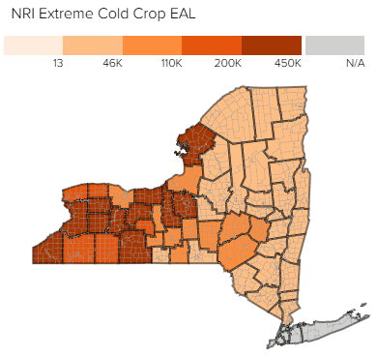
Source: (Zuzak 2023)
The USDA Plant Hardiness Zone Map places Jefferson County in Zone 5a to 5b, indicating average annual minimum temperatures between -20°F and -10°F 2. These conditions limit the types of crops and native plants that can thrive and increase the risk of cold-related damage.
Extreme temperature events also have impacts on the economy, including loss of business function and damage and loss of inventory. Business owners may be faced with increased financial burdens due to unexpected repairs caused to the building (pipes bursting), higher than normal utility bills, or business interruption caused by power failure (loss of electricity and telecommunications).
Extreme heat events can result in drought and dry conditions and directly affect livestock and crop production. Heat stress can damage crops, reduce yields, and increase water needs, impacting local agriculture and leading to potential losses for farmers. Livestock may also suffer from heat stress, impacting milk production, weight gain, and reproductive health. This can drive up food prices and affect the local economy. In Jefferson County Expected Annual Loss due to extreme hear for crops is $1,175 – significantly less than the extreme cold risk to agriculture.

Natural, Historic and Cultural Resources
Jefferson County’s diverse natural environment, rich historical heritage, and cultural assets are all vulnerable to the impacts of extreme cold events. These hazards can disrupt ecological processes, damage sensitive ecosystems, and threaten the preservation of historic structures and cultural landmarks. Extreme cold events, particularly when combined with fluctuating freeze-thaw cycles and heavy snowfall, can significantly alter natural processes and stress local ecosystems. Jefferson County’s location makes it especially prone to lake-effect snow and prolonged cold spells.
Excessive snowfall followed by early warming can lead to rapid snowmelt, increasing runoff and altering streamflow patterns. This can affect aquatic habitats and water quality in rivers such as the Black River and Indian River, which are vital to the region’s ecology and recreation. Prolonged freezing of lakes, ponds, and streams can reduce oxygen levels, threatening fish populations such as trout and bass, which are important to both biodiversity and local fishing economies. Sudden or prolonged cold snaps can disrupt the feeding and migration patterns of birds and mammals. Species unaccustomed to extreme cold may experience increased mortality or be forced to relocate, reducing local biodiversity. For example, white-tailed deer, common in Jefferson County, may struggle to find food under deep snowpack, leading to population stress. Freeze-thaw cycles can damage tree bark and root systems, particularly in younger or shallow-rooted species. This weakens forest resilience and increases susceptibility to pests and disease. The USGS notes that climate-induced changes in temperature and precipitation patterns are already shifting the composition and health of northeastern forests (USGS, Climate Impacts on Plants and Animals n.d.).
Heat can increase water temperatures, reducing oxygen levels in rivers and lakes, which harms fish and aquatic life. Prolonged heat also stresses trees and plants, which can lead to die-off, reducing biodiversity and impacting natural landscapes. Extreme heat increases the likelihood of harmful algal blooms. Harmful algal blooms (HABs) in freshwater (lakes, ponds, rivers, and streams) generally consist of visible patches of cyanobacteria, also called blue-green algae. Cyanobacteria are naturally present in low numbers in most aquatic (freshwater and/or marine) systems. Under certain conditions, including adequate nutrient (e.g., phosphorus) availability, warm temperatures, and calm winds, cyanobacteria may multiply rapidly and form blooms that are visible on the surface of the affected waterbody. Several types of cyanobacteria can produce toxins and other harmful compounds that can pose health risks to people and animals through ingestion, skin contact, or inhalation (NYSDEC n.d.). Algal blooms can be dangerous to people and animals and contact should be avoided.
Table 8-4 includes harmful algal bloom incident data, for Jefferson County, documented by NYSDEC over a 12-year period. The letter codes refer to maximum bloom status that was documented by the DEC HABs Program in each waterbody in each year. S (Suspicious Bloom): DEC staff determined that conditions fit the description of a cyanobacteria HAB based on visual observations and/or digital photographs; C (Confirmed Bloom): DEC staff determined that conditions fit the description of a cyanobacteria HAB based on visual observations and/or digital photographs or water sampling results have confirmed the presence of a cyanobacteria HAB which may produce toxins or other harmful compounds; HT (Confirmed with High Toxins Bloom): Water sampling results confirmed that there were toxins present in quantities to potentially cause health effects if people or animals came in contact with the water (NYSDEC n.d.).
Table 8-4 Harmful Algal Blooms in Jefferson County 2012-2024
Waterbody Name | Year | Bloom Type | Date of First Listing | Date of Last Listing | Number of Weeks on DEC Notification List
Boyd Lake | 2015 | HT | 9/18/2015 | 10/20/2015 | 5
Boyd Lake | 2014 | HT | 6/19/2014 | 10/16/2014 | 17
Butterfield Lake | 2018 | C | 9/21/2018 | 10/2/2018 | 2
Butterfield Lake | 2017 | C | 9/29/2017 | 10/13/2017 | 2
Butterfield Lake | 2014 | C | 8/6/2014 | 10/27/2014 | 12
Butterfield Lake | 2013 | C | 7/3/2013 | 10/20/2013 | 16
Butterfield Lake | 2024 | C | 8/8/2024 | 8/8/2024 | 1
Butterfield Lake | 2023 | C | 9/5/2023 | 9/5/2023 | 1
Butterfield Lake | 2022 | C | 9/8/2022 | 9/8/2022 | 1
Butterfield Lake | 2020 | C | 8/31/2020 | 8/31/2020 | 1
Butterfield Lake | 2019 | C | 9/8/2019 | 9/8/2019 | 1
Grass Lake | 2014 | C | 9/25/2014 | 9/29/2014 | 1
Grass Lake | 2013 | C | 9/10/2013 | 10/13/2013 | 5
Greenwood Lake | 2023 | C | 8/14/2023 | 8/14/2023 | 1
Hyde Lake | 2018 | S | 8/17/2018 | 10/20/2018 | 9
Hyde Lake | 2017 | S | 8/19/2017 | 8/25/2017 | 1
Hyde Lake | 2024 | C | 10/1/2024 | 9/9/2024 | 63
Hyde Lake | 2023 | C | 4/26/2023 | 11/5/2023 | 69
Hyde Lake | 2022 | C | 7/27/2022 | 11/11/2022 | 52
Hyde Lake | 2021 | C | 7/10/2021 | 9/3/2021 | 10
Hyde Lake | 2020 | C | 8/19/2020 | 8/19/2020 | 1
Lake Of the Woods | 2015 | C | 8/14/2015 | 10/20/2015 | 10
Lake Ontario | 2018 | S | 9/14/2018 | 10/5/2018 | 3
Lake Ontario | 2016 | S | 8/19/2016 | 10/13/2016 | 8
Lake Ontario | 2024 | C | 7/24/2024 | 9/10/2024 | 24
Lake Ontario | 2020 | C | 8/22/2020 | 9/6/2020 | 5
Lake Ontario | 2019 | S | 7/5/2019 | 7/15/2019 | 3
Lake Ontario (Sackett) | 2018 | S | 9/21/2018 | 10/20/2018 | 4
Lake Ontario (Westcott) | 2018 | S | 8/17/2018 | 10/20/2018 | 9
Lakeview Pond | 2019 | S | 8/3/2019 | 8/3/2019 | 1
Millsite Lake | 2018 | S | 6/7/2018 | 10/27/2018 | 20
Millsite Lake | 2017 | S | 4/8/2017 | 10/13/2017 | 27
Moon Lake | 2018 | S | 8/31/2018 | 10/12/2018 | 6
Moon Lake | 2017 | S | 8/25/2017 | 9/29/2017 | 5
Moon Lake | 2016 | S | 6/24/2016 | 10/27/2016 | 18
Moon Lake | 2015 | HT | 7/31/2015 | 10/13/2015 | 11
Moon Lake | 2023 | C | 8/13/2023 | 10/4/2023 | 6
Moon Lake | 2022 | C | 7/23/2022 | 9/17/2022 | 7
Muskellunge Lake | 2020 | C | 9/22/2020 | 9/22/2020 | 1
North Sandy Pond | 2018 | C | 8/24/2018 | 9/29/2018 | 5
North Sandy Pond | 2016 | HT | 5/8/2016 | 10/2/2016 | 21
North Sandy Pond | 2015 | C | 9/25/2015 | 10/13/2015 | 3
North Sandy Pond | 2023 | C | 6/2/2023 | 10/3/2023 | 6
North Sandy Pond | 2022 | C | 8/4/2022 | 9/17/2022 | 6
North Sandy Pond | 2021 | C | 8/6/2021 | 10/8/2021 | 3
Payne Lake | 2015 | S | 8/28/2015 | 10/2/2015 | 5
Payne Lake | 2021 | C | 10/6/2021 | 10/6/2021 | 1
Red Lake | 2021 | C | 4/14/2021 | 4/14/2021 | 1
Sixberry Lake | 2015 | C | 7/8/2015 | 10/2/2015 | 12
Sixtown Pond | 2015 | S | 8/28/2015 | 10/27/2015 | 9
Sixtown Pond | 2024 | C | 10/5/2024 | 10/5/2024 | 1
Sixtown Pond/Crystal Lake | 2016 | C | 5/8/2016 | 10/13/2016 | 23
Source: (NYSDEC n.d.), (NYSDEC, DATA.NY.GOV 2024)

Future Occurrences and Projected Changes in Risk
Understanding future changes that affect vulnerability can assist in planning for future development and ensure establishment of appropriate mitigation, planning, and preparedness measures. The following sections examine potential conditions that may affect hazard vulnerability.

Probability of Future Events
Information on previous extreme temperature occurrences in the County was used to calculate the probability of future occurrence of such events, as summarized in Table 8-5. Based on historical records and input from the Steering Committee, the probability of occurrence for extreme temperatures in the County is considered “frequent.”
Table 8-5. Probability of Future Extreme Temperature Events in Jefferson County
Hazard Type | Occurrences Between 1996 and 2024 | Percent Chance of Occurring in Any Given Year
Excessive Heat | 0 | 0
Extreme Cold/Wind Chill | 13 | 46.43%
Cold/Wind Chill | 1 | 3.57%
Frost/Freeze | 20 | 71.43%
Total | 34 | 100%
Source: NOAA 2024
Note: Due to limitations in data, not all extreme temperatures events occurring between 1954 and 1996 are accounted for in the tally of occurrences. The number of hazard occurrences is calculated using the number of occurrences between 1996 and 2023.

Climate Change Projections and Likely Impacts
Climate change is expected to significantly alter temperature and precipitation patterns across New York State, including Jefferson County. While average annual temperatures are projected to rise, the nature of extreme cold events is also expected to shift, becoming less frequent but potentially more intense when they do occur. These changes will have wide-ranging implications for public health, infrastructure, agriculture, and emergency preparedness.
According to the Northeast Regional Climate Center (NRCC) and Cornell University’s Climate Smart Farming Program, the Great Lakes region, including Jefferson County, is projected to experience the following changes relative to the 1981–2010 baseline (Northeast Regional Climate Center n.d.):
Temperature Increases:
- By the 2050s: +3.5°F to +7.4°F
- By the 2080s: +5.1°F to +12.4°F
- By 2100: +5.6°F to +14.5°F
Precipitation Changes:
- By the 2050s: -1 percent to +11 percent
- By the 2080s: +2 percent to +17 percent
- By 2100: -4 percent to +23 percent
These projections suggest that winters will continue to warm faster than other seasons, a trend already observed in New York State, which has warmed more rapidly than the national average.
Figure 8-10 shows statewide projections for future average annual temperature. While the number of extremely cold days (below 0°F) is expected to decline, the severity of cold snaps may increase due to greater variability in atmospheric patterns. This means that Jefferson County could still experience dangerous cold outbreaks, even as the overall climate warms (Northeast Regional Climate Center n.d.). These events may be shorter in duration but more intense, placing sudden stress on infrastructure and vulnerable populations.
Figure 8-10. Projected Annual Average Temperature in New York State
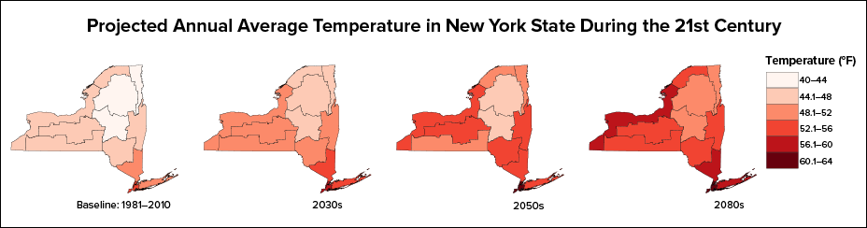
Source: Stevens & Lamie 2024 2023

Table 8-6 looks further at the prediction of extreme heat and cold days in upcoming decades.
Table 8-6. Changes in Extreme Events in the Great Lakes Region
# Days Per Year | Baseline | 10th Percentile | 50th Percentile | 90th Percentile
2030s
Days over 90°F | 3 | 7 | 10 | 27
Days over 95°F | 0.3 | 0.8 | 2 | 7
Days below 32°F | 126 | 76 | 102 | 110
Days below 0°F | 3 | 0 | 102 | 110
Number of Heat Waves | 0.2 | 0.6 | 0.9 | 3
Average Length of Heat Waves | 4 | 4 | 4 | 5
Maximum Heat Index | 95 | 101 | 103 | 108
Days Heat Index is over 85°F | 19 | 33 | 43 | 57
Days Heat Index is over 95°F | 2 | 8 | 10 | 16
2050s
Days over 90°F | 3 | 10 | 19 | 54
Days over 95°F | 0.3 | 1 | 5 | 24
Days below 32°F | 126 | 57 | 95 | 102
Days below 0°F | 3 | 0 | 0 | 0.4
Number of Heat Waves | 0.2 | 0.9 | 2 | 7
Average Length of Heat Waves | 4 | 4 | 4 | 6
Maximum Heat Index | 95 | 104 | 109 | 115
Days Heat Index is over 85°F | 19 | 42 | 60 | 81
Days Heat Index is over 95°F | 2 | 10 | 18 | 32
2080’s
Days over 90°F | 3 | 16 | 37 | 89
Days over 95°F | 0.3 | 3 | 19 | 54
Days below 32°F | 126 | 5 | 71 | 99
Days below 0°F | 3 | 0 | 0 | 0
Number of Heat Waves | 0.2 | 2 | 5 | 9
Average Length of Heat Waves | 4 | 4 | 5 | 8
Maximum Heat Index | 95 | 108 | 116 | 132
Days Heat Index is over 85°F | 19 | 54 | 77 | 118
Days Heat Index is over 95°F | 2 | 16 | 32 | 74
Source: Stevens & Lamie 2024 2023

Projected Changes in Development and Population
Jefferson County has experienced a gradual population decline since 2010, largely influenced by demographic shifts, economic changes, and fluctuations in the military population at Fort Drum, one of the county’s largest employers. According to projections from Cornell University’s Program on Applied Demographics (PAD), the county’s population is expected to stabilize and slightly increase over the next two decades, from approximately 114,290 in 2030 to 115,693 by 2040 (Cornell University 2018).
While this modest growth is not expected to significantly alter the county’s overall vulnerability to extreme cold events, localized development in less densely populated areas, such as the towns of LeRay, Rutland, and Pamelia, could introduce new challenges. These include:
- Increased demand on utility infrastructure (e.g., electricity, water, and telecommunications), which may already be limited in rural areas.
- Greater exposure to cold-related hazards in newly developed areas that may lack robust emergency services or infrastructure redundancy.
- Strain on emergency response systems, particularly during widespread power outages or transportation disruptions caused by snow and ice.
As development expands into previously undeveloped or agricultural areas, the transformation of pervious surfaces (e.g., forests, fields) into impervious surfaces (e.g., roads, rooftops) can alter local microclimates and increase vulnerability to both extreme cold and heat. While heat island effects are more commonly associated with urbanization, impervious surfaces can also exacerbate freeze/thaw cycles, leading to increased road and infrastructure damage and greater runoff during snowmelt, which can overwhelm stormwater systems and affect water quality in local rivers and streams.
Specific areas of recent and new development are indicated in tabular form and/or on the hazard maps included in the jurisdictional annexes in Volume II of this plan.

Flood

Hazard Profile
This section provides information regarding the description, extent, location, previous occurrences and losses, climate change projections, and the probability of future occurrences of the flood hazard, which includes a vulnerability assessment for the flood hazard and impacts in Jefferson County.

Hazard Description
Flooding is the temporary inundation of normally dry land resulting from the overflow of inland or tidal waters, the rapid accumulation of surface runoff, or the collapse or failure of water control infrastructure. Flood events can develop gradually over several days or occur suddenly with little warning, causing devasting impacts. These impacts may be localized effecting individual neighborhoods or communities or widespread, disrupting entire river basins, coastal regions, and multiple counties or states.
Flooding is one of the most frequent and costly natural hazards in New York State, posing significant risks to public safety, property, and infrastructure. Communities located within flood-prone areas – particularly within riverine and coastal lakeshore floodplains – are especially vulnerable. While flooding can occur in any season, it is typically triggered by prolonged rainfall, intense short-duration storms, ice or debris jams, or the failure of dams, levees, or other water control structures. The severity and frequency of floods may also be worsened by related hazards such as increased precipitation trends and severe weather.
Flood events are a common occurrence in Jefferson County. The county is susceptible to multiple types of flooding, including riverine flooding, coastal lakeshore flooding, flash floods, and stormwater or urban flooding. These events can result in extensive property damage, threats to life and safety, injuries, and significant disruption to critical infrastructure. Impacts often include residential and commercial water damage, road and bridge closures, interruptions to transit and emergency services, and damage to electrical and telecommunications networks.
For this HMP and as deemed appropriate by the Steering Committee, the flood types of concern discussed in this section include riverine, lake, flash, stormwater, pluvial (including stormwater and urban flooding), coastal lakeshore, and ice jam.

Floodplains
A floodplain is the land adjoining the channel of a river, stream, ocean, lake, or other watercourse or water body that becomes inundated with water during flooding events. In Jefferson County, floodplains are commonly found along rivers, streams, and the shoreline of Lake Ontario. Floodplain boundaries may change over time due to development, changes in impervious surface area, placement of structures in floodways, altered precipitation and runoff patterns, advancements in topographic measurement, or the use of updated hydrologic and hydraulic modeling techniques. A floodplain is made up of the following components (see Figure 9-1):
- Flood Fringe is the area within the floodplain but outside the floodway. This area extends from the outer banks of a floodway to the river valley, where the elevation begins to rise.
- Floodway is the channel of a river or other waterway and the adjacent land areas that are under water or reserved to carry and discharge the overflow of water caused by flooding.
Figure 9-1. Characteristics of a Floodplain
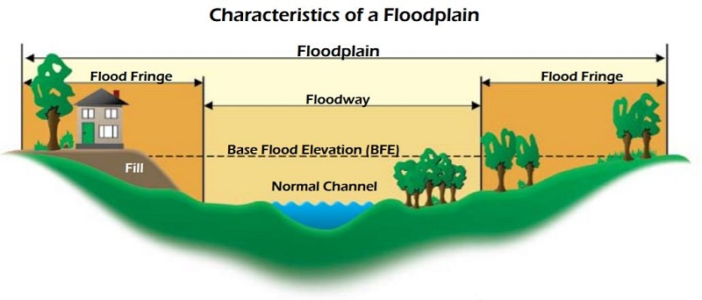
Source: FEMA 2022
The 1-percent annual chance floodplain is the area inundated by a flood that has a 1-percent chance in any given year of being equaled or exceeded. This is the area that has flood insurance and floodplain management requirements (FEMA n.d.) The 1-percent annual chance flood is also referred to as the base flood or 100-year flood. Although the average frequency of this flood is once every 100 years, it is possible for it to occur more than once in a much shorter period of time. Similarly, the are inundated by a flood with a 0.2-percent chance of being equaled or exceeded each year hazard area is sometimes called the 500-year floodplain but can occur more often than once every 500 years (FEMA n.d.)..
In Jefferson County, floodplains line the rivers, streams, lakes, and wetlands of the County. The boundaries of the floodplains can be altered because of changes in land use, the amount of impervious surface, placement of obstructing structures in floodways, changes in precipitation and runoff patterns, improvements in technology for measuring topographic features, and utilization of different hydrologic modeling techniques.
Floodplain mapping is based on riverine and coastal flooding conditions. Urban and stormwater flooding and future conditions (e.g., sea level rise and rainfall areas) are not reflected in FEMA floodplain mapping. As such, FEMA floodplain maps may underestimate flood risk in many areas in the region. As a result, the public may also underestimate risk.
In FEMA maps, floodplains areas are identified as Special Flood Hazard Area (SFHA). SFHAs are defined as the area that will be inundated by the flood event that has a 1-percent chance of being equaled to or exceeded in any given year. It should be noted that areas located outside of the SFHA can be subject to flooding and may even act as an unofficial floodplain. Flooding outside of the SFHA area may include stormwater or urban flooding and flash flooding. Additional definitions relating to flood maps can be seen in Table 9-1.
Table 9-1. Flood Map Terms
Term | Description
Special Hazard Flood Areas (SFHAs) | Labeled as Zone A, Zone AO, Zone AH, Zones A1-A30, Zone AE, Zone A99, Zone AR, Zone AR/AE, Zone AR/AO, Zone AR/A1-A30, Zone AR/A, Zone V, Zone VE, and Zones V1-V30.
Zone B or Zone X (shaded) | Moderate flood hazard areas and are the areas between the limits of the base flood and the 0.2-percent-annual-chance (or 500-year) flood.
Zone C or Zone X (unshaded) | Areas of minimal flood hazard, which are the areas outside the SFHA and higher than the elevation of the 0.2-percent-annual-chance flood, are labeled.
Source: FEMA 2020

Types of Flooding

Riverine Flooding
Riverine flooding is the most common type of flooding in Jefferson County. It occurs when water levels in rivers, streams, creeks, or ditches exceed the capacity of their channels causing water to overflow onto adjacent low-lying land. Riverine flooding includes both overbank flooding, which develops more gradually from prolonged rainfall or snowmelt, and flash flooding, which occurs rapidly due to intense rainfall over a short period.

Flash Flooding
Flash floods are characterized by rapid-onset flooding that occurs within minutes or hours of excessive rainfall. According to the National Weather Service (NWS), flash floods generally result from heavy or excessive precipitation within a six-hour period. They can also occur due to dam or levee failures, sudden releases caused by ice or debris jams, slow-moving or stalled thunderstorms, by thunderstorms repeatedly moving over the same area, or by heavy rains from hurricanes and tropical storms.
Flash floods are characterized by their swift onset and high intensity. The highest number of flood-related fatalities in the U.S. are caused by flash floods. There are rarely any warning signs prior to flash flooding, making it extremely dangerous. As little as six (6) inches of moving water can knock a person down, and two (2) feet of moving water can sweep a vehicle away. A flash flood can wash away stream banks, roads, people, and vehicles, carve out new water channels, rip trees and other vegetation out of the ground, wash out culverts, and destroy buildings and bridges as it sweeps through an area (FEMA, Fact Sheets 2022).

Pluvial Flooding
Pluvial flooding occurs when rainfall overwhelms the capacity of natural or man-made drainage systems, leading to ponding or flowing water in areas not adjacent to waterbodies, rivers or streams. This type of flooding is increasingly common in both urban and rural areas of Jefferson County, particularly during high-intensity rainfall events or when ground conditions prevent adequate infiltration.

Urban Flooding
In urban environments, pluvial flooding, often referred to as urban flooding, is typically caused by impervious surfaces such as roads, sidewalks, rooftops, and parking lots, which reduce the land’s natural ability to absorb water. As a result, rainwater runs off quickly, accumulating in low-lying areas, roadways, and drainage basins. When stormwater systems are undersized, blocked, or otherwise unable to handle the volume of water, localized flooding can occur.
According to the National Weather Service (2009), urban flooding includes inundation of streets, underpasses, and storm drains, and can occur far from mapped floodplains. This flooding may develop quickly during extreme precipitation events and can damage property, block critical roadways, and overwhelm emergency response systems. Unlike riverine flooding, pluvial flooding is often poorly mapped and underrepresented in risk assessments. Urban development compounds these risk by increasing runoff and shortening the time it takes for water to reach nearby streams or storm drains. This accelerated runoff may also contribute to downstream flooding. With climate change contributing to more frequent and intense rainfall events, communities in Jefferson County may face growing challenges related to pluvial flooding.

Stormwater Flooding
Stormwater flooding is a subset of pluvial flooding that stems from blocked, undersized or overwhelmed stormwater management systems (e.g., storm drains, culverts, detention basins). In some areas of Jefferson County, aging infrastructure or limited stormwater controls have contributed to repeated nuisance flooding, especially during heavy downpours or spring thaw. During winter or early spring, frozen or saturated ground conditions further reduce infiltration, increasing the risk of surface water accumulation and basement seepage.

Coastal Lakeshore Flooding and Erosion
Coastal lakeshore erosion in Jefferson County, NY refers to the gradual loss of land along the Lake Ontario shoreline due to natural forces like wave action, fluctuating water levels, and severe weather events. This erosion process has been intensified in recent years by:
- Extreme water level variability: Jefferson County has experienced both record-high and low lake levels, particularly in 2017 and 2019, which led to severe flooding and shoreline damage (CLEAR n.d.).
- Heavy rainfall and storms: These events increase runoff and wave energy, accelerating the erosion of bluffs, beaches, and developed shorelines.
- Shoreline development: Increased construction and infrastructure near the water’s edge can disrupt natural erosion buffers and make the coast more vulnerable.

Ice Jam Flooding
An ice jam occurs when pieces of floating ice are carried with a stream’s current and accumulate behind any obstruction to the stream flow. Obstructions may include river bends, mouths of tributaries, points where the river slope decreases, as well as dams and bridges. The water held back by this obstruction can cause flooding upstream, and if the obstruction suddenly breaks, flash flooding can occur as well. The formation of ice jams depends on the weather and physical condition of the river and stream channels. They are most likely to occur where the channel slope naturally decreases, in culverts, and along shallows where channels may freeze solid.
Ice jams and resulting floods can occur at different times of the year. For example, fall freeze-up from the formation of frazil ice; mid-winter periods when stream channels freeze solid, forming anchor ice; and spring breakup when rising water levels from snowmelt or rainfall break existing ice cover into pieces that accumulate at bridges or other types of obstructions (FEMA 2023).
There are two different types of ice jams: freeze-up and breakup. Freeze-up jams occur in the early to mid-winter when floating ice may slow or stop due to a change in water slope as it reaches an obstruction to movement. Breakup jams occur during periods of thaw, generally in late winter and early spring. The ice cover breakup is usually associated with a rapid increase in runoff and corresponding river discharge due to a heavy rainfall, snowmelt, or warmer temperatures (FEMA 2023). Jefferson County’s cold winters and complex river systems make it vulnerable to both types of ice jam flooding, particularly along the black River and its tributaries.

Location

Jefferson County Watersheds
Jefferson County, NY, is part of several important watersheds that drain into Lake Ontario and the St. Lawrence River. According to the New York State Department of Environmental Conservation (DEC) and regional planning sources, the key watersheds in Jefferson County include:
- Lake Ontario Watershed: This watershed covers the majority of Jefferson County’s western boundary. It includes tributaries like the Black River, Chaumont River, and Sandy Creek and drains directly into Lake Ontario, influencing water quality and erosion patterns along the shoreline.
- St. Lawrence River Watershed: This watershed in northern Jefferson County drains into the St. Lawrence River. It includes smaller tributaries and coastal wetlands that are ecologically significant.
- Black River Watershed: This watershed is one of the largest in the region, flowing through Jefferson, Lewis, and Herkimer counties. It supports agriculture, hydropower, and recreation but is subject to flooding and erosion, especially during spring melt and heavy rainfall.
- Indian River Watershed: This watershed is in the northeastern part of the county and is a sub-watershed of the St. Lawrence River system. It is important for wildlife habitat and water quality.
These watersheds are part of the North Country Resilient NY Program, which aims to assess and improve flood resilience and water quality in the region (NYSDEC 2025).

Riverine Flooding
In Jefferson County, riverine flooding is commonly caused by prolonged rainfall (thunderstorms, heavy rains, tropical storms, and hurricanes), snowmelt, or remnants of tropical storms. While flooding can occur countywide, it is more likely to occur near water bodies such as the Black River, Indian River, Sandy Creek, and their tributaries. River valleys, especially where slopes flatten or human development has encroached on floodplains, are particularly susceptible.
The Black River, which runs from the Adirondacks through the center of the county to Lake Ontario, is a major flood-prone waterway. Communities such as Watertown, Great Bend, Carthage, and Brownville are located along this corridor and have historically experienced flood impacts.
Flooding potential is influenced by a combination of topography, hydrology, land use, and climatology. Development patterns also play a critical role since impervious surfaces like roads, rooftops, and parking lots reduce natural infiltration, increasing the speed and volume of stormwater runoff. This can overwhelm drainage systems, leading to flash and pluvial flooding, and contributes to greater flood extents during storm events. Figure 9-2 shows the areas inundated by the 1 percent and 0.2 percent annual chance floods in Jefferson County, based on FEMA’s flood mapping. Table 9-2 depicts the amount of land area that is located within the flood hazard areas by jurisdictions.

Figure 9-2. Jefferson County Designated Special Flood Hazard Areas
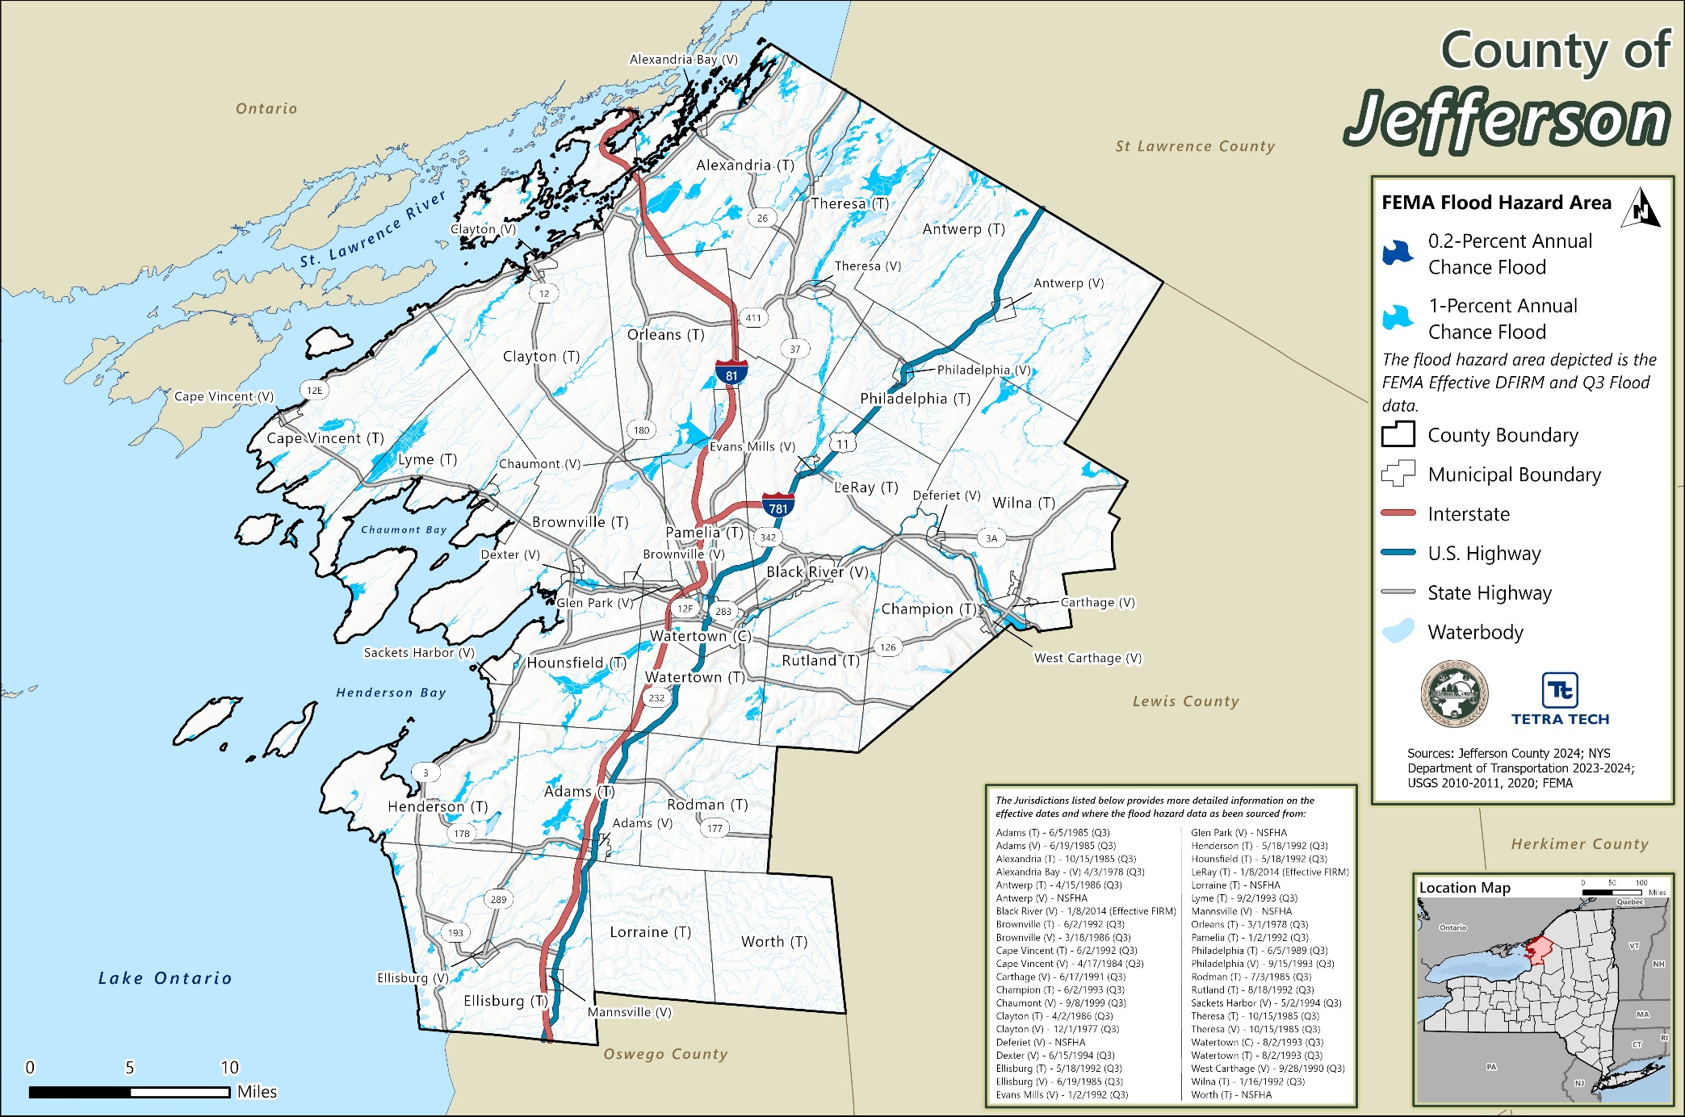

Table 9-2. Land Area in the Flood Hazard Areas by Jurisdictions
 |  | Land Area Excluding Water Bodies in the Hazard Area
Jurisdiction | Total Land Area Excluding Water Bodies (acres) | 1% Annual Chance Flood Hazard Area |  | 0.2% Annual Chance Flood Hazard Area
 |  | Total Area (acres) | % of Jurisdiction Total | Total Area (acres) | % of Jurisdiction Total
Adams (T) | 26,090 | 1,911 | 7.3% | 1,911 | 7.3%
Adams (V) | 927 | 45 | 4.8% | 45 | 4.8%
Alexandria (T) | 46,023 | 5,133 | 11.2% | 5,133 | 11.2%
Alexandria Bay (V) | 474 | 41 | 8.7% | 41 | 8.7%
Antwerp (T) | 67,229 | 2,046 | 3.0% | 2,046 | 3.0%
Antwerp (V) | 660 | 9 | 1.3% | 9 | 1.3%
Black River (V) | 1,190 | 198 | 16.6% | 227 | 19.0%
Brownville (T) | 36,741 | 1,168 | 3.2% | 1,168 | 3.2%
Brownville (V) | 405 | 6 | 1.5% | 6 | 1.5%
Cape Vincent (T) | 35,473 | 1,943 | 5.5% | 1,943 | 5.5%
Cape Vincent (V) | 451 | 11 | 2.4% | 11 | 2.4%
Carthage (V) | 1,654 | 437 | 26.4% | 438 | 26.5%
Champion (T) | 27,667 | 736 | 2.7% | 736 | 2.7%
Chaumont (V) | 621 | 37 | 6.0% | 37 | 6.0%
Clayton (T) | 52,105 | 1,953 | 3.7% | 1,953 | 3.7%
Clayton (V) | 1,022 | 43 | 4.2% | 46 | 4.5%
Deferiet (V) | 477 | 6 | 1.2% | 6 | 1.2%
Dexter (V) | 460 | 46 | 9.9% | 46 | 9.9%
Ellisburg (T) | 53,334 | 1,643 | 3.1% | 1,650 | 3.1%
Ellisburg (V) | 642 | 43 | 6.8% | 43 | 6.8%
Evans Mills (V) | 523 | 64 | 12.3% | 82 | 15.6%
Glen Park (V) | 482 | 8 | 1.7% | 8 | 1.7%
Henderson (T) | 26,291 | 1,426 | 5.4% | 1,479 | 5.6%
Hounsfield (T) | 29,948 | 2,970 | 9.9% | 2,970 | 9.9%
LeRay (T) | 46,198 | 2,329 | 5.0% | 2,394 | 5.2%
Lorraine (T) | 24,973 | 0 | 0.0% | 0 | 0.0%
Lyme (T) | 35,148 | 3,243 | 9.2% | 3,243 | 9.2%
Mannsville (V) | 576 | 0 | 0.0% | 0 | 0.0%
Orleans (T) | 45,347 | 1,778 | 3.9% | 1,789 | 3.9%
Pamelia (T) | 21,726 | 615 | 2.8% | 634 | 2.9%
Philadelphia (T) | 23,470 | 466 | 2.0% | 466 | 2.0%
Philadelphia (V) | 612 | 135 | 22.1% | 135 | 22.1%
Rodman (T) | 27,063 | 508 | 1.9% | 508 | 1.9%
Rutland (T) | 28,323 | 1,092 | 3.9% | 1,092 | 3.9%
Sackets Harbor (V) | 1,462 | 28 | 1.9% | 28 | 1.9%
Theresa (T) | 41,321 | 4,110 | 9.9% | 4,110 | 9.9%
Theresa (V) | 842 | 114 | 13.5% | 114 | 13.5%
Watertown (C) | 6,004 | 570 | 9.5% | 640 | 10.7%
Watertown (T) | 22,887 | 891 | 3.9% | 899 | 3.9%
West Carthage (V) | 897 | 174 | 19.4% | 174 | 19.4%
Wilna (T) | 48,245 | 1,714 | 3.6% | 1,717 | 3.6%
Worth (T) | 27,613 | 0 | 0.0% | 0 | 0.0%
Jefferson County (Total) | 813,593 | 39,689 | 4.9% | 39,976 | 4.9%
Source: Jefferson County 2024; USGS 2020; NYS Geospatial Services 2024; FEMA (Effective DFIRMs & Q3 Data)
Due to the county’s geography the following areas are at higher risk of flooding:
- Low-lying shoreline areas along Lake Ontario and the St. Lawrence River
- Areas with poor drainage or flat terrain
- FEMA-designated Special Flood Hazard Areas (SFHA)
- Urbanized zones with extensive impervious surfaces (e.g. Watertown, Carthage)
- Areas vulnerable to lake level fluctuations, ice jam formation, or coastal erosion

Flash Flooding
Flash flooding can occur anywhere in New York State, but Jefferson County has a moderate to low flash flood risk compared to more mountainous and urbanized counties. However, localized flash floods have occurred in response to heavy rainfall over small watersheds or steep tributaries of the Black River system. Conditions that increase the risk include frozen ground, saturated soils, or culvert/bridge obstructions (NYS DHSES 2023).

Pluvial Flooding (Urban and Stormwater Flooding)
Urban and stormwater (pluvial) flooding occurs in areas where the built environment cannot manage runoff effectively. In Jefferson County, this is most common in urbanized communities such as Watertown, where aging or undersized infrastructure can lead to water accumulation during even moderate rain events. Even small amounts of rain can overwhelm the deteriorated or inadequate infrastructure found in even the small municipalities, especially in impoverished, neglected, and/or socioeconomically isolated urban communities. This flooding typically occurs outside of mapped floodplains and may be exacerbated by debris-clogged storm drains, snowpack, or impervious surfaces (NYS DHSES 2023).

Coastal Lakeshore Flooding and Erosion
Jefferson County shoreline communities consist of six villages and nine townships. The county shoreline follows Lake Ontario on the west, and the St. Lawrence River on the north. The Thousand Islands Bridge system acts as a gateway to the county, spanning the St. Lawrence River at Collins Landing near Alexandria Bay to Wellesley Island and ultimately the Canadian border at Hill Island and the mainland Ontario at Selton. Jefferson County’s 442 miles of shoreline along Lake Ontario and the St. Lawrence River is interspersed with steep bluffs, bays, points, ponds, and islands (e.g., Chaumont Bay, North and South Colwell Pond, Stony Island, and the Thousand Islands). There are numerous tributaries that are also scattered along the shoreline, ranging in sizes from the Black River to Cranberry Creek. The shoreline is characterized by a variety of natural features (e.g., sandy/coarse beaches, bedrock, bluffs, and wetlands) and artificial features (e.g., seawalls, rip rap, and bluff stabilization) (CLEAR n.d.).
These shorelines are vulnerable to flooding and erosion driven by high lake levels, storm surges, seiches, and long-term coastal processes. While much of the bedrock shoreline offers natural resistance to erosion, some of the southern and lower-lying segments are more exposed and prone to bluff recession and flooding during coastal storms.

Ice Jam Flooding
According to the US Army Corps of Engineers (USACE), the State ranks second in the nation for total number of ice jam events, with over 1,600 incidents documented between 1780 and 2024. Jefferson County is vulnerable to ice jam flooding, particularly along the Black River, Indian River, and smaller tributaries. These are most common during late winter and early spring, when warming temperatures and rising water levels cause ice cover to break up and accumulate at bridges, river bends, or constricted channels. The County has experienced several minor to moderate ice jam incidents, although most are undocumented in national summaries. Areas downstream of Watertown and Carthage may be particularly vulnerable due to historical river modifications and channel construction.

Extent
The extent of flooding refers to the anticipated range of intensities and impacts associated with different types of flood events. The severity is influenced by the volume and duration of precipitation or meltwater, the terrain and soil conditions, proximity to water bodies, and the capacity of natural and built drainage systems.
Flood severity is generally assessed using the following criteria:
- Depth and velocity of floodwaters
- Duration of inundation
- Extent of property damage and infrastructure disruption
- Risk to public safety and access to emergency services

Riverine Flooding
The severity of riverine and flash flooding is determined by a combination of factors including stream and river basin topography and physiography; precipitation and weather patterns; recent soil moisture conditions; and degree of vegetative clearing and impervious surface. Generally, floods are long-term events that can last for several days.
The frequency and severity of riverine flooding are measured using a discharge probability, which is the probability that a certain river discharge (flow) level will be equaled or exceeded each year. Flood studies use historical records to determine the probability of occurrence for the different discharge levels.
In the case of riverine or flash flooding, once a river reaches flood stage, the flood extent or severity categories used by the NWS include minor flooding, moderate flooding, and major flooding. Each category has a definition based on property damage and public threat:
- Minor Flooding incurs minimal or no property damage, but possibly some public threat or inconvenience.
- Moderate Flooding incurs some inundation of structures and roads near streams. Some evacuations of people and/or transfer of property to higher elevations are necessary.
- Major Flooding incurs extensive inundation of structures and roads. Significant evacuations of people and/or transfer of property to higher elevations.
Flood frequency and magnitude are also measured using reoccurrence intervals, such as the 10-year, 50-year, 100-year, and 500-year floods, which refer to the statistical probability of an event occurring in any given year.

Flash Flooding
Extent categories follow the same NWS flood severity framework (minor, moderate, major) as riverine but are often more difficult to forecast due to short lead times.

Pluvial Flooding (Urban and Stormwater Flooding)
There are currently no standardized metrics for classifying pluvial flood severity, but extent is typically measured by the following:
- Flood depth (e.g. ponding<6 inches, >12 inches)
- Areal coverage (e.g. multiple streets or blocks affected)
- Infrastructure performance (e.g. capacity exceedance, clogged drains)
- Repetitive Loss Locations
Urban flooding in Jefferson County may be localized (e.g. Watertown, Adams, Carthage) and tends to occur during high-intensity rainfall events or when snowmelt/frozen ground impedes infiltration.

Coastal Lakeshore
The National Weather Service (NWS) categorizes coastal flooding through a tiered alert system:
- Coastal Flood Advisory: Minor or nuisance flooding is occurring or imminent.
- Coastal Flood Watch: Moderate to major flooding is possible.
- Coastal Flood Warning: Moderate to major flooding is occurring or imminent.
Coastal lakeshore flooding along Lake Ontario and the St. Lawrence River in Jefferson County ranges from nuisance flooding during high lake levels to damaging inundation caused by storm surge and seiches—standing waves generated by strong winds and atmospheric pressure changes. The severity of these events is influenced by several factors:
- Wind direction and speed
- Atmospheric pressure systems
- Lake level height, which has shown increasing variability in recent years
- Shoreline topography and development patterns (CLEAR n.d.)
Flooding events in 2017 and 2019 brought record-high water levels to Lake Ontario and the St. Lawrence River, causing millions of dollars in damage to homes, businesses, and public infrastructure (CLEAR n.d.). These events were exacerbated by heavy rainfall, increased impervious surfaces from shoreline development and aging infrastructure not designed for frequent inundation.

Ice Jam Flooding
Ice jam flooding events often occur suddenly and difficult to predict, allowing for little time to prepare for and warn of an event. The size of the snowpack and the rate of snowmelt controls the extent of an ice jam.
Ice Jam extent is influenced by:
- Thickness and duration of river ice cover
- Rate of snowmelt and rainfall
- River geometry (bends, constrictions, bridges)
- Existing obstructions or modifications
Ice jam floods can lead to sudden upstream inundation behind the jam, flash flooding downstream if the jam breaks, property and infrastructure damage in low-lying river corridors.
Although unpredictable, ice jam flood severity often mirrors flash floods in intensity with shorter lead times. The U.S. Army Corps of Engineers (USACE) has recorded over 1,600 ice jam events in New York, making it one of the most frequently impacted states. Jefferson County, particularly along the Black River, is susceptible during late winter and early spring thaws.

Previous Occurrences

FEMA Major Disaster and Emergency Declarations
Between 1954 and 2023, Jefferson County was included in 12 major disaster (DR) or emergency (EM) declarations for flood-related events (FEMA 2023). Table 9-3 lists these declarations.

USDA Declarations
The Secretary of Agriculture from the U.S. Department of Agriculture (USDA) is authorized to designate counties as disaster areas to make emergency loans to producers suffering losses in those counties and in contiguous counties. Between 2012 and 2023, Jefferson County was included in three USDA flood-related agricultural disaster declarations. For declarations that occurred between 2012 and 2023, refer to Table 9-4.

Previous Events
Known hazard events that impacted Jefferson County between January 2009 and June 2025 are discussed in Table 9-5. For events prior to 2009, refer to the 2011 Jefferson County HMP.
Table 9-3. FEMA Declarations for Flood Events in Jefferson County (1954 to 2025)
Event Date | Declaration Date | Declaration Number | Description
April 22, 1955 | April 22, 1955 | DR-45-NY | Hurricane
March 29, 1956 | March 29, 1956 | DR-52-NY | Flood
March 16, 1962 | March 16, 1962 | DR-129-NY | Severe Storm, High Tides, and Flooding
August 23, 1963 | August 23, 1963 | DR-158-NY | Heavy Rains, and Flooding
March 21, 1973 | March 21, 1973 | DR-367-NY | High Winds, Wave Action, and Flooding
January 19- 30, 1996 | January 24, 1996 | DR-1095-NY | Severe Storms and Flooding
January 5-17, 1998 | January 6, 1998 | DR-1196-NY | Severe Storms and Flooding
August 3, 2004 | May 13-June 17, 2004 | DR-1534-NY | Severe Storms and Flooding
November 17-26, 2014 | December 22, 2014 | DR-4204-NY | Severe Winter Storm, Snowstorm, and Flooding
May 2- August 6, 2017 | November 14, 2017 | DR-4348-NY | Flooding
October 31-November 1, 2019 | December 19, 2019 | DR-4472-NY | Severe Storms, Straight-line Winds, and Flooding
August 8-10, 2024 | September 24, 2024 | DR-4825-NY | Remnants of Tropical Storm Debby
Source: FEMA 2025
Table 9-4. USDA Declarations for Flood Events in Jefferson County (2012 to 2025)
Event Date | USDA Declaration Number | Description
May 1, 2013 | S3593 | Excessive Rain and related Flooding, High Winds, and Hail.
April 1-July 8, 2014 | S3747 | Excessive Rain, Flash Flooding, Flooding, High Winds, and Hail
April 15, 2019 | S4623 | Excessive Rain, Flash Flooding, and Flooding
July 10, 2024 | S5739 | Tornado, Hurricane, High Wind, Flash Flood, Excessive Rain, Hail
Source: USDA 2025
Table 9-5. Flood Events in Jefferson County (2009 to 2025)
Event Date | Declaration or Proclamation Number | Location Impacted | Description
September 30, 2010 |  | County Wide | Rainfall amounts of three to four and a half inches were recorded with numerous road closures throughout the County from flooding. $25,000 in property damages were documented.
April 28-30, 2011 |  | County Wide | Two to four inches of rain was documented in the Lake Ontario Region where runoff resulted in numerous road closures due to flooding. The Black River exceeded its flood stage of 10 feet and crested at a height of 12.7 feet. One person drowned in the Back River and $250,000 in property damages were documented.
August 5, 2012 |  | County Wide | A thunderstorm produced rainfall rates of up to two inches per hour which resulted in flash flooding in the Town of Brownville. $15,000 in property damages were reported.
April 13-19, 2014 |  | County Wide | Above normal snowpack was reported in the Black River basin which contributed to flooding after the snow melt and in combination with heavy precipitation events. The Black River exceeded its flood stage of 10 feet and crested at a height of 13.81 feet. Several roads were closed, and damages to farmland and residential structures were also reported. The County had to evacuate several dozen homes and $250,000 in property damages were reported.
April 7-9, 2017 |  | County Wide | The Black River exceeded its flood stage of 10 feet and crested at a height of 10.48 feet. Several creeks also surpassed their flood stage. $20,000 in property damages were reported.
May 2- November 26, 2017 | Yes | Lakeshore Communities | During the first six months of 2017, more than twice the normal amount of water accumulated on Lake Ontario. The lake saw two of the wettest months ever recorded in April and May of 2017. Waves destroyed public and private break walls all along the lake shore. Thousands of homes and buildings were affected flood waters and $10 Million in damages was estimated for Jefferson County.
May 17-August 24, 2019 |  | County Wide | Lake Ontario experienced excessive runoff from the Ottawa River Basin and above normal precipitation which pushed the lake to nearly six feet above low water datum in June. $4,700,000 in property damages were reported.
November 1-3, 2019 | Yes | Lakeshore Communities | Lake Ontario recorded a seiche that brough the lake level up to 4.51 ft above low water datum. The Black River in Watertown rose to 11.24 ft, above the flood stage of 7.9 ft, and cause moderate flooding. This combined with onshore winds and waves exceeding 16 ft allowed for continue beach erosion in the County. $25,000 in property damages were reported.
November 21, 2019 |  | Lakeshore Communities | High wind gusts combined with high lake levels generated waves that eroded the Lake Ontario shoreline.
November 27-28, 2019 |  | Lakeshore Communities | A seiche was noted on Lake Ontario, where flood levels jumped over a foot between one hour. This combined with onshore waves continued beach erosion on the east end of Lake Ontario.
March 28-29, 2021 |  | County Wide | Rapid snowmelt resulted in a rapid rise of Black River’s water levels. The Black River crested at 10.1 feet, which is just slightly above the flood stage of 10 feet.
December 11-12, 2021 |  | Lakeshore Communities | Winds and waves caused significant erosion on the shoreline of Lake Ontario and generated a seiche.
August 8-10, 2024 | DR-4825-NY | County Wide | Remnants of Tropical Storm Debby
Source: NCEI 2024

Cascading Impacts on Other Hazards
Flooding rarely occurs in isolation. As climate change intensifies the frequency and severity of extreme precipitation events, the secondary impacts of flooding are becoming increasingly consequential for Jefferson County and its municipalities. These cascading effects extend across sectors, compounding the direct damage caused by floodwaters.
Flooding can trigger or worsen other hazards:
- Landslides or embankment failures in saturated, particularly along roads or streams.
- Hazardous material releases in flood affects industrial sites, wastewater systems, or farm storage.
- Transportation disruptions due to impassable roads and damaged bridges.
- Power outages and water system contamination if substations, pumps, or treatment facilities are flooded.
- Ice jam flooding, often worsened by sudden snowmelt, can cascade into flash flooding and infrastructure failure.
As climate change accelerates the hydrologic extremes experienced in Jefferson County, these secondary and tertiary impacts of flooding will likely become more frequent and more damaging. Proactive mitigation planning must consider not only direct flooding but broader systems that depend on resilient infrastructure, accessible roads, and protected environmental resources.

Vulnerability and Impact Assessment

Life, Health, and Safety
Population in flood-prone zones-particularly in areas adjacent to the Black River, Indian River, Chaumont River, and Lake Ontario shoreline-face elevated risks during flooding events. Emergency access is a major concern in more rural towns where flooding can isolate homes or prevent first responders from reaching those in need.

Overall Population
Based on 2020 Census data, Jefferson County’s population is approximately 109,834. Of that, an estimated 3.1 percent live within FEMA-designated Special Flood hazard Areas (SFHAs). Table 9-6 presents the distribution of exposed population by jurisdiction. Residents in Watertown, Brownville, Lyme, and Cape Vincent have historically experienced repetitive flooding and property damage (U.S. Census Bureau 2020).
As a result of a significant flood event, residents may be displaced or require temporary to long-term shelter. The number of people requiring shelter is generally less than the number displaced as some displaced persons use hotels or stay with family or friends following a disaster event. Table 9-7 summarizes the estimated number of displaced persons and persons seeking short-term shelter caused by the 1 percent annual chance flood.

Table 9-6. Population in the Special Flood Hazard Area
Jurisdiction | Total Population (2020 Decennial) | Population in the 1% Annual Chance Flood Hazard Area
 |  | Number of Persons | % of Jurisdiction Total
Adams (T) | 3,340 | 20 | 0.6%
Adams (V) | 1,633 | 11 | 0.7%
Alexandria (T) | 2,817 | 501 | 17.8%
Alexandria Bay (V) | 924 | 22 | 2.4%
Antwerp (T) | 1,177 | 36 | 3.1%
Antwerp (V) | 506 | 0 | 0.0%
Black River (V) | 1,232 | 0 | 0.0%
Brownville (T) | 3,456 | 250 | 7.2%
Brownville (V) | 930 | 0 | 0.0%
Cape Vincent (T) | 2,066 | 520 | 25.2%
Cape Vincent (V) | 699 | 11 | 1.6%
Carthage (V) | 3,236 | 342 | 10.6%
Champion (T) | 2,537 | 33 | 1.3%
Chaumont (V) | 615 | 5 | 0.8%
Clayton (T) | 3,065 | 156 | 5.1%
Clayton (V) | 1,705 | 31 | 1.8%
Deferiet (V) | 245 | 0 | 0.0%
Dexter (V) | 1,004 | 2 | 0.2%
Ellisburg (T) | 2,869 | 192 | 6.7%
Ellisburg (V) | 186 | 3 | 1.6%
Evans Mills (V) | 678 | 6 | 0.9%
Glen Park (V) | 452 | 0 | 0.0%
Henderson (T) | 1,438 | 105 | 7.3%
Hounsfield (T) | 1,930 | 82 | 4.2%
LeRay (T) | 24,280 | 124 | 0.5%
Lorraine (T) | 924 | 0 | 0.0%
Lyme (T) | 1,684 | 210 | 12.5%
Mannsville (V) | 297 | 0 | 0.0%
Orleans (T) | 2,788 | 115 | 4.1%
Pamelia (T) | 3,343 | 54 | 1.6%
Philadelphia (T) | 877 | 9 | 1.0%
Philadelphia (V) | 1,098 | 67 | 6.1%
Rodman (T) | 1,197 | 24 | 2.0%
Rutland (T) | 2,422 | 68 | 2.8%
Sackets Harbor (V) | 1,351 | 0 | 0.0%
Theresa (T) | 1,896 | 232 | 12.2%
Theresa (V) | 752 | 4 | 0.5%
Watertown (C) | 24,685 | 311 | 1.3%
Watertown (T) | 5,913 | 17 | 0.3%
West Carthage (V) | 1,780 | 3 | 0.2%
Wilna (T) | 2,496 | 51 | 2.0%
Worth (T) | 198 | 0 | 0.0%
Jefferson County (Total) | 116,721 | 3,617 | 3.1%
Source: U.S. Census Bureau 2020; FEMA (Effective DFIRMs & Q3 Data)
Table 9-7. Impacts on People Due to the 1 Percent Annual Chance Flood
Jurisdiction | Total Population (2020 Decennial) | 1% Annual Chance Flood Impacts on People
 |  | Displaced Population | Persons Seeking Short-Term Shelter
Adams (T) | 3,340 | 23 | 6
Adams (V) | 1,633 | 21 | 8
Alexandria (T) | 2,817 | 164 | 66
Alexandria Bay (V) | 924 | 23 | 15
Antwerp (T) | 1,177 | 23 | 1
Antwerp (V) | 506 | 0 | 0
Black River (V) | 1,232 | 5 | 1
Brownville (T) | 3,456 | 86 | 27
Brownville (V) | 930 | 1 | 0
Cape Vincent (T) | 2,066 | 123 | 58
Cape Vincent (V) | 699 | 6 | 2
Carthage (V) | 3,236 | 334 | 103
Champion (T) | 2,537 | 20 | 13
Chaumont (V) | 615 | 13 | 3
Clayton (T) | 3,065 | 33 | 21
Clayton (V) | 1,705 | 35 | 22
Deferiet (V) | 245 | 0 | 0
Dexter (V) | 1,004 | 8 | 5
Ellisburg (T) | 2,869 | 67 | 27
Ellisburg (V) | 186 | 5 | 0
Evans Mills (V) | 678 | 15 | 3
Glen Park (V) | 452 | 0 | 0
Henderson (T) | 1,438 | 64 | 35
Hounsfield (T) | 1,930 | 46 | 16
LeRay (T) | 24,280 | 48 | 38
Lorraine (T) | 924 | 0 | 0
Lyme (T) | 1,684 | 103 | 70
Mannsville (V) | 297 | 0 | 0
Orleans (T) | 2,788 | 36 | 11
Pamelia (T) | 3,343 | 61 | 15
Philadelphia (T) | 877 | 10 | 3
Philadelphia (V) | 1,098 | 68 | 10
Rodman (T) | 1,197 | 14 | 1
Rutland (T) | 2,422 | 67 | 18
Sackets Harbor (V) | 1,351 | 6 | 3
Theresa (T) | 1,896 | 102 | 37
Theresa (V) | 752 | 12 | 1
Watertown (C) | 24,685 | 380 | 106
Watertown (T) | 5,913 | 21 | 9
West Carthage (V) | 1,780 | 9 | 6
Wilna (T) | 2,496 | 48 | 12
Worth (T) | 198 | 0 | 0
Jefferson County (Total) | 116,721 | 2,100 | 772

Socially Vulnerable Population
Flood hazards have disproportionate effects on socially vulnerable populations-Those who may lack the resources, mobility, or access to information needed to prepare for, respond to, or recover from flood events. In Jefferson County, these populations include low-income households, elderly residents, persons with disabilities, individuals with limited English proficiency, single-parent households, renters, and seasonal or migrant works.
Economically disadvantaged populations including those living below the federal poverty level and those identified under ALICE thresholds, are especially vulnerable. These households are more likely to reside in land areas susceptible to flooding, where housing may be older, poorly elevated, or located inside of the regulated special flood hazard area. Due to limited financial reserves, these households often must weigh net economic impacts on their families when deciding whether to evacuate or shelter in place. This dynamic increases the likelihood of delayed or constrained responses during emergencies.
According to the CDC/ATSDR Social Vulnerability Index and United Way of New York’s ALICE data, parts of Watertown, Carthage, Adams, and LeRay exhibit elevated levels of social vulnerability. In these areas:
- Renter-occupied units exceed 50 percent of housing stock in some tracts.
- Vehicle access may be limited, impacting mobility during evacuation.
- Many homes were built prior to modern floodplain management regulations.
- Residents are more likely to lack access to flood insurance or post-disaster recovery resources.
In rural towns, such as Orleans, Antwerp, and Theresa, vulnerability is compounded by geographic isolation, limited broadband and cellular access, and reliance on a small number of transportation routes that are easily disrupted by flooding.
Moreover, socially vulnerable populations often face challenges in accessing emergency information, resources, or recovery services-especially if they lack a fixed address, formal lease, or are not proficient in English. These barriers are especially pronounced for migrant farmworkers and temporary residents who support the county’s agricultural and tourism economies and may reside in informal or flood-prone housing.
An analysis of American Community Survey (2022) data reveals that across Jefferson County, numerous socially vulnerable populations are located within the 1-percent annual chance flood hazard area. Of the county’s estimated 16,667 residents over age 65, approximately 672 (4 percent) live in mapped flood hazard areas. Similarly, 203 young children under age 5 (2.3 percent) and 463 persons with disabilities (3 percent) are situated in flood-prone areas. Although non-English speakers represent a smaller portion of the at-risk population—only 14 individuals (0.9 percent)—they may face greater challenges in accessing timely warnings and evacuation instructions. Approximately 392 individuals living below the federal poverty level (2.7 percent) are also located within the flood hazard area, underscoring the intersection between economic disadvantage and flood exposure. These findings are presented in Table 9-8 and Table 9-9 and highlight the importance of incorporating social vulnerability data into flood risk reduction strategies, especially in rural and shoreline communities where infrastructure and emergency access may be limited.

General Building Stock
Jefferson County contains over 50,000 structures valued at more than $117 billion in total replacement cost, spanning residential, commercial, industrial, institutional, and agricultural uses. The county’s varied landscape-including river valleys, shorelines, low-lying interior terrain- places many of these buildings at risk of flooding or erosion related hazards.
Buildings exposed to flooding and coastal erosion are vulnerable to:
- Structural damage from inundation, foundation undermining, and wave action
- Interior damage from water infiltration, mold, and prolonged moisture exposure
- Loss of function for critical facilities (e.g. utilities, schools, emergency response buildings)
- Economic disruption, especially for small businesses and agricultural producers in flood-prone valleys
Older housing stock and buildings with basements or slab-on-grade construction are particularly susceptible. Repetitive loss properties and uninsured or underinsured homes in socially vulnerable areas face heightened risk of long-term displacement and disrepair following events.

Table 9-8. Vulnerable Populations Living in the 1 Percent Annual Chance Flood Hazard Area
 | Vulnerable Population Living in the 1 Percent Annual Chance Flood Hazard Area
 | Persons Over 65 |  | Persons Under 5 |  | Non-English Speakers |  | Persons with Disability |  | Persons in Poverty
Jurisdiction | Number | % of Total | Number | % of Total | Number | % of Total | Number | % of Total | Number | % of Total
Adams (T) | 3 | 0.6% | 0 | 0.0% | 0 | 0.0% | 2 | 0.4% | 1 | 0.4%
Adams (V) | 2 | 0.6% | 0 | 0.0% | 0 | 0.0% | 2 | 0.5% | 1 | 0.5%
Alexandria (T) | 86 | 17.8% | 32 | 17.6% | 0 | 0.0% | 56 | 17.7% | 27 | 17.8%
Alexandria Bay (V) | 9 | 2.4% | 0 | 0.0% | 0 | 0.0% | 5 | 2.2% | 2 | 1.9%
Antwerp (T) | 6 | 2.9% | 1 | 1.9% | 0 | 0.0% | 7 | 3.0% | 4 | 3.0%
Antwerp (V) | 0 | 0.0% | 0 | 0.0% | 0 | 0.0% | 0 | 0.0% | 0 | 0.0%
Black River (V) | 0 | 0.0% | 0 | 0.0% | 0 | 0.0% | 0 | 0.0% | 0 | 0.0%
Brownville (T) | 55 | 7.2% | 18 | 7.1% | 0 | 0.0% | 47 | 7.2% | 25 | 7.0%
Brownville (V) | 0 | 0.0% | 0 | 0.0% | 0 | 0.0% | 0 | 0.0% | 0 | 0.0%
Cape Vincent (T) | 137 | 25.1% | 15 | 25.0% | 0 | 0.0% | 55 | 25.0% | 32 | 24.8%
Cape Vincent (V) | 2 | 1.6% | 0 | 0.0% | 0 | 0.0% | 1 | 0.9% | 1 | 1.3%
Carthage (V) | 54 | 10.5% | 33 | 10.5% | 0 | 0.0% | 62 | 10.5% | 65 | 10.6%
Champion (T) | 4 | 1.3% | 1 | 1.3% | 0 | 0.0% | 7 | 1.2% | 6 | 1.2%
Chaumont (V) | 1 | 0.7% | 0 | 0.0% | 0 | 0.0% | 0 | 0.0% | 0 | 0.0%
Clayton (T) | 27 | 5.0% | 7 | 4.8% | 3 | 4.8% | 12 | 4.8% | 29 | 5.0%
Clayton (V) | 9 | 1.7% | 1 | 1.0% | 0 | 0.0% | 6 | 1.7% | 4 | 1.5%
Deferiet (V) | 0 | 0.0% | 0 | 0.0% | 0 | 0.0% | 0 | 0.0% | 0 | 0.0%
Dexter (V) | 0 | 0.0% | 0 | 0.0% | 0 | 0.0% | 0 | 0.0% | 0 | 0.0%
Ellisburg (T) | 34 | 6.6% | 9 | 6.0% | 0 | 0.0% | 14 | 6.5% | 14 | 6.5%
Ellisburg (V) | 0 | 0.0% | 0 | 0.0% | 0 | 0.0% | 1 | 1.8% | 0 | 0.0%
Evans Mills (V) | 0 | 0.0% | 0 | 0.0% | 0 | 0.0% | 1 | 0.6% | 0 | 0.0%
Glen Park (V) | 0 | 0.0% | 0 | 0.0% | 0 | 0.0% | 0 | 0.0% | 0 | 0.0%
Henderson (T) | 46 | 7.2% | 3 | 6.3% | 0 | 0.0% | 20 | 7.1% | 19 | 7.2%
Hounsfield (T) | 15 | 4.3% | 7 | 4.2% | 0 | 0.0% | 8 | 4.2% | 4 | 3.7%
LeRay (T) | 2 | 0.3% | 16 | 0.5% | 4 | 0.5% | 6 | 0.4% | 9 | 0.5%
Lorraine (T) | 0 | 0.0% | 0 | 0.0% | 0 | 0.0% | 0 | 0.0% | 0 | 0.0%
Lyme (T) | 56 | 12.4% | 5 | 11.1% | 0 | 0.0% | 27 | 12.1% | 15 | 12.1%
Mannsville (V) | 0 | 0.0% | 0 | 0.0% | 0 | 0.0% | 0 | 0.0% | 0 | 0.0%
Orleans (T) | 22 | 4.1% | 5 | 3.5% | 1 | 2.6% | 13 | 4.1% | 16 | 4.0%
Pamelia (T) | 7 | 1.4% | 2 | 1.4% | 0 | 0.0% | 5 | 1.4% | 2 | 1.5%
Philadelphia (T) | 0 | 0.0% | 1 | 0.8% | 0 | 0.0% | 0 | 0.0% | 0 | 0.0%
Philadelphia (V) | 7 | 5.6% | 3 | 4.8% | 0 | 0.0% | 9 | 6.0% | 16 | 6.0%
Rodman (T) | 3 | 1.9% | 0 | 0.0% | 0 | 0.0% | 3 | 1.7% | 3 | 1.6%
Rutland (T) | 11 | 2.6% | 2 | 2.1% | 2 | 2.5% | 8 | 2.6% | 7 | 2.6%
Sackets Harbor (V) | 0 | 0.0% | 0 | 0.0% | 0 | 0.0% | 0 | 0.0% | 0 | 0.0%
Theresa (T) | 21 | 11.7% | 19 | 12.3% | 0 | 0.0% | 25 | 11.9% | 28 | 11.9%
Theresa (V) | 0 | 0.0% | 0 | 0.0% | 0 | 0.0% | 0 | 0.0% | 0 | 0.0%
Watertown (C) | 44 | 1.2% | 22 | 1.2% | 4 | 1.1% | 53 | 1.2% | 59 | 1.2%
Watertown (T) | 3 | 0.3% | 0 | 0.0% | 0 | 0.0% | 2 | 0.2% | 0 | 0.0%
West Carthage (V) | 0 | 0.0% | 0 | 0.0% | 0 | 0.0% | 0 | 0.0% | 0 | 0.0%
Wilna (T) | 6 | 2.0% | 1 | 1.1% | 0 | 0.0% | 6 | 2.0% | 3 | 1.7%
Worth (T) | 0 | 0.0% | 0 | 0.0% | 0 | 0.0% | 0 | 0.0% | 0 | 0.0%
Jefferson County (Total) | 672 | 4.0% | 203 | 2.3% | 14 | 0.9% | 463 | 3.0% | 392 | 2.7%
Source: U.S. Census Bureau, American Community Survey 5-Year Estimates 2018-2022; FEMA (Effective DFIRMs & Q3 Data); Hazus v6.1

Table 9-9. Vulnerable Populations Living in the 0.2 Percent Annual Chance Flood Hazard Area
 | Vulnerable Population Living in the 0.2 Percent Annual Chance Flood Hazard Area
 | Persons Over 65 |  | Persons Under 5 |  | Non-English Speakers |  | Persons with Disability |  | Persons in Poverty
Jurisdiction | Number | % of Total | Number | % of Total | Number | % of Total | Number | % of Total | Number | % of Total
Adams (T) | 3 | 0.6% | 0 | 0.0% | 0 | 0.0% | 2 | 0.4% | 1 | 0.4%
Adams (V) | 2 | 0.6% | 0 | 0.0% | 0 | 0.0% | 2 | 0.5% | 1 | 0.5%
Alexandria (T) | 86 | 17.8% | 32 | 17.6% | 0 | 0.0% | 56 | 17.7% | 27 | 17.8%
Alexandria Bay (V) | 9 | 2.4% | 0 | 0.0% | 0 | 0.0% | 5 | 2.2% | 2 | 1.9%
Antwerp (T) | 6 | 2.9% | 1 | 1.9% | 0 | 0.0% | 7 | 3.0% | 4 | 3.0%
Antwerp (V) | 0 | 0.0% | 0 | 0.0% | 0 | 0.0% | 0 | 0.0% | 0 | 0.0%
Black River (V) | 0 | 0.0% | 0 | 0.0% | 0 | 0.0% | 0 | 0.0% | 0 | 0.0%
Brownville (T) | 55 | 7.2% | 18 | 7.1% | 0 | 0.0% | 47 | 7.2% | 25 | 7.0%
Brownville (V) | 0 | 0.0% | 0 | 0.0% | 0 | 0.0% | 0 | 0.0% | 0 | 0.0%
Cape Vincent (T) | 137 | 25.1% | 15 | 25.0% | 0 | 0.0% | 55 | 25.0% | 32 | 24.8%
Cape Vincent (V) | 2 | 1.6% | 0 | 0.0% | 0 | 0.0% | 1 | 0.9% | 1 | 1.3%
Carthage (V) | 54 | 10.5% | 33 | 10.5% | 0 | 0.0% | 62 | 10.5% | 65 | 10.6%
Champion (T) | 4 | 1.3% | 1 | 1.3% | 0 | 0.0% | 7 | 1.2% | 6 | 1.2%
Chaumont (V) | 1 | 0.7% | 0 | 0.0% | 0 | 0.0% | 0 | 0.0% | 0 | 0.0%
Clayton (T) | 27 | 5.0% | 7 | 4.8% | 3 | 4.8% | 12 | 4.8% | 29 | 5.0%
Clayton (V) | 9 | 1.7% | 1 | 1.0% | 0 | 0.0% | 6 | 1.7% | 4 | 1.5%
Deferiet (V) | 0 | 0.0% | 0 | 0.0% | 0 | 0.0% | 0 | 0.0% | 0 | 0.0%
Dexter (V) | 0 | 0.0% | 0 | 0.0% | 0 | 0.0% | 0 | 0.0% | 0 | 0.0%
Ellisburg (T) | 34 | 6.6% | 9 | 6.0% | 0 | 0.0% | 14 | 6.5% | 14 | 6.5%
Ellisburg (V) | 0 | 0.0% | 0 | 0.0% | 0 | 0.0% | 1 | 1.8% | 0 | 0.0%
Evans Mills (V) | 3 | 2.8% | 1 | 2.9% | 0 | 0.0% | 6 | 3.6% | 3 | 3.1%
Glen Park (V) | 0 | 0.0% | 0 | 0.0% | 0 | 0.0% | 0 | 0.0% | 0 | 0.0%
Henderson (T) | 48 | 7.5% | 3 | 6.3% | 0 | 0.0% | 21 | 7.4% | 19 | 7.2%
Hounsfield (T) | 15 | 4.3% | 7 | 4.2% | 0 | 0.0% | 8 | 4.2% | 4 | 3.7%
LeRay (T) | 4 | 0.7% | 24 | 0.7% | 6 | 0.7% | 10 | 0.7% | 14 | 0.7%
Lorraine (T) | 0 | 0.0% | 0 | 0.0% | 0 | 0.0% | 0 | 0.0% | 0 | 0.0%
Lyme (T) | 56 | 12.4% | 5 | 11.1% | 0 | 0.0% | 27 | 12.1% | 15 | 12.1%
Mannsville (V) | 0 | 0.0% | 0 | 0.0% | 0 | 0.0% | 0 | 0.0% | 0 | 0.0%
Orleans (T) | 22 | 4.1% | 6 | 4.2% | 1 | 2.6% | 13 | 4.1% | 16 | 4.0%
Pamelia (T) | 7 | 1.4% | 2 | 1.4% | 0 | 0.0% | 5 | 1.4% | 2 | 1.5%
Philadelphia (T) | 0 | 0.0% | 1 | 0.8% | 0 | 0.0% | 0 | 0.0% | 0 | 0.0%
Philadelphia (V) | 7 | 5.6% | 3 | 4.8% | 0 | 0.0% | 9 | 6.0% | 16 | 6.0%
Rodman (T) | 3 | 1.9% | 0 | 0.0% | 0 | 0.0% | 3 | 1.7% | 3 | 1.6%
Rutland (T) | 11 | 2.6% | 2 | 2.1% | 2 | 2.5% | 8 | 2.6% | 7 | 2.6%
Sackets Harbor (V) | 0 | 0.0% | 0 | 0.0% | 0 | 0.0% | 0 | 0.0% | 0 | 0.0%
Theresa (T) | 21 | 11.7% | 19 | 12.3% | 0 | 0.0% | 25 | 11.9% | 28 | 11.9%
Theresa (V) | 0 | 0.0% | 0 | 0.0% | 0 | 0.0% | 0 | 0.0% | 0 | 0.0%
Watertown (C) | 125 | 3.5% | 63 | 3.5% | 12 | 3.3% | 151 | 3.5% | 167 | 3.5%
Watertown (T) | 4 | 0.4% | 1 | 0.3% | 0 | 0.0% | 2 | 0.2% | 0 | 0.0%
West Carthage (V) | 0 | 0.0% | 0 | 0.0% | 0 | 0.0% | 0 | 0.0% | 0 | 0.0%
Wilna (T) | 6 | 2.0% | 1 | 1.1% | 0 | 0.0% | 6 | 2.0% | 3 | 1.7%
Worth (T) | 0 | 0.0% | 0 | 0.0% | 0 | 0.0% | 0 | 0.0% | 0 | 0.0%
Jefferson County (Total) | 761 | 4.6% | 255 | 2.9% | 24 | 1.6% | 571 | 3.7% | 508 | 3.5%
Source: U.S. Census Bureau, American Community Survey 5-Year Estimates 2018-2022; FEMA (Effective DFIRMs & Q3 Data)

Riverine Flood Vulnerability
Table 9-10 and Table 9-11 list the estimated number and value of buildings located in the 1 percent and 0.2 percent annual chance flood hazard areas. Based on FEMA floodplain mapping and county-level building inventories, 2,459 buildings are located within the 1-percent annual chance flood hazard area, representing approximately 4.9 percent of the county’s total building stock. These structures have a combined replacement value of $4.09 billion, or 3.5 percent of the total structural value countywide.
The jurisdictions with the highest percentage of buildings in the floodplain include:
- Cape Vincent (T): 23.8 percent of the buildings, valued at $328.4 million
- Alexandria (T): 16.9 percent of buildings, valued at $426.3 million
- Carthage (V): 11.6 percent of buildings, valued at $554.8 million
- Lyme (T): 12.4 percent of buildings, valued at $143.2 million
These high-exposure areas are generally located along Lake Ontario, the St. Lawrence River, the Black River, and tributary corridors. Many structures in these areas were built before modern floodplain management standards were adopted and may lack adequate floodproofing or elevation.
The distribution of flood-exposed buildings by occupancy class is listed in Table 9-12. Residential buildings account for most exposed properties-approximately 94 percent (2,3.16 of 2,459 structures). However, critical non-residential facilities are also present in the floodplain, including commercial buildings, schools, and municipal buildings. For example, Watertown alone contains 136 flood-exposed structures with a value exceeding $961 million, including government, industrial, and healthcare facilities.
Hazus estimated the expected building losses due to the 1 percent annual chance flood as listed in Table 9-13.

Coastal Erosion Exposure
In addition to riverine and inland flooding, coastal erosion along the Lake Ontario shoreline presents a growing threat to structures located in extreme and high coastal erosion hazard areas. Across the county:
- 1,318 buildings are in extreme coastal erosion hazard areas, with a replacement value of approximately $2.0 billion
- Jurisdictions with the highest building counts in erosion zones:
- Ellisburg (T): 270 buildings, $146.9 million
- Lyme (T): 217 buildings, $120.2 million
- Brownville (T): 185 buildings, $72.1 million
- Watertown (C): 369 buildings, $1.04 billion
The total exposure to this hazard area by jurisdiction is presented in Table 9-14. The City of Watertown has the largest value of exposed structures in coastal erosion hazard areas, despite being the furthest inland-due to its high total value concentration and inclusion of major public facilities.
Table 9-15 lists exposure to the coastal erosion hazard area by occupancy class. Most exposed buildings in erosion zones are also residential, but there are notable commercial, institutional, and recreational assets, particularly in Clayton, Cape Vincent, and Sackets Harbor, which are critical to the region’s tourism economy and community identity.

Table 9-10. Buildings Located in the 1% Annual Chance Flood Hazard Area
 |  |  | Buildings in the 1% Annual Chance Flood Hazard Area
 | Jurisdiction Total Buildings |  | Number of Buildings |  | Replacement Cost Value
Jurisdiction | Number of Buildings | Replacement Cost Value | Count | % of Jurisdiction Total | Value | % of Jurisdiction Total
Adams (T) | 1,518 | $4,052,069,203 | 12 | 0.8% | $52,590,116 | 1.3%
Adams (V) | 661 | $1,774,388,625 | 7 | 1.1% | $71,980,758 | 4.1%
Alexandria (T) | 2,668 | $4,432,190,141 | 451 | 16.9% | $426,287,828 | 9.6%
Alexandria Bay (V) | 595 | $3,206,687,833 | 19 | 3.2% | $189,009,011 | 5.9%
Antwerp (T) | 588 | $1,789,914,615 | 16 | 2.7% | $51,012,718 | 2.9%
Antwerp (V) | 261 | $613,702,374 | 0 | 0.0% | $0 | 0.0%
Black River (V) | 500 | $1,046,580,838 | 3 | 0.6% | $86,616,810 | 8.3%
Brownville (T) | 2,040 | $1,775,095,498 | 142 | 7.0% | $53,900,296 | 3.0%
Brownville (V) | 403 | $982,068,271 | 0 | 0.0% | $0 | 0.0%
Cape Vincent (T) | 1,970 | $2,829,209,923 | 469 | 23.8% | $328,382,059 | 11.6%
Cape Vincent (V) | 475 | $1,727,996,587 | 10 | 2.1% | $122,414,003 | 7.1%
Carthage (V) | 1,119 | $3,720,102,915 | 130 | 11.6% | $554,813,732 | 14.9%
Champion (T) | 1,213 | $2,687,535,696 | 14 | 1.2% | $5,295,131 | 0.2%
Chaumont (V) | 283 | $842,494,250 | 2 | 0.7% | $750,791 | 0.1%
Clayton (T) | 2,359 | $5,439,296,759 | 115 | 4.9% | $74,408,330 | 1.4%
Clayton (V) | 948 | $4,190,396,460 | 21 | 2.2% | $177,135,258 | 4.2%
Deferiet (V) | 136 | $324,222,272 | 0 | 0.0% | $0 | 0.0%
Dexter (V) | 379 | $829,013,291 | 4 | 1.1% | $45,164,213 | 5.4%
Ellisburg (T) | 1,920 | $4,333,840,339 | 109 | 5.7% | $39,993,733 | 0.9%
Ellisburg (V) | 113 | $269,573,650 | 2 | 1.8% | $770,588 | 0.3%
Evans Mills (V) | 246 | $546,293,186 | 6 | 2.4% | $77,440,201 | 14.2%
Glen Park (V) | 208 | $407,146,663 | 0 | 0.0% | $0 | 0.0%
Henderson (T) | 1,669 | $2,093,822,742 | 116 | 7.0% | $116,575,826 | 5.6%
Hounsfield (T) | 1,313 | $2,771,230,753 | 51 | 3.9% | $21,064,236 | 0.8%
LeRay (T) | 3,255 | $7,914,338,817 | 21 | 0.6% | $144,957,584 | 1.8%
Lorraine (T) | 551 | $764,134,484 | 0 | 0.0% | $0 | 0.0%
Lyme (T) | 2,077 | $1,420,466,090 | 257 | 12.4% | $143,204,171 | 10.1%
Mannsville (V) | 173 | $366,229,053 | 0 | 0.0% | $0 | 0.0%
Orleans (T) | 2,073 | $5,479,758,595 | 79 | 3.8% | $88,647,264 | 1.6%
Pamelia (T) | 1,456 | $5,597,766,484 | 20 | 1.4% | $73,831,261 | 1.3%
Philadelphia (T) | 391 | $1,769,768,846 | 3 | 0.8% | $945,547 | 0.1%
Philadelphia (V) | 383 | $951,206,583 | 23 | 6.0% | $44,427,492 | 4.7%
Rodman (T) | 590 | $1,358,332,774 | 10 | 1.7% | $3,943,291 | 0.3%
Rutland (T) | 1,097 | $2,471,420,505 | 29 | 2.6% | $30,442,334 | 1.2%
Sackets Harbor (V) | 628 | $1,530,119,265 | 0 | 0.0% | $0 | 0.0%
Theresa (T) | 1,304 | $1,394,838,339 | 153 | 11.7% | $83,325,013 | 6.0%
Theresa (V) | 352 | $774,152,753 | 2 | 0.6% | $790,384 | 0.1%
Watertown (C) | 8,309 | $22,587,377,146 | 136 | 1.6% | $961,632,059 | 4.3%
Watertown (T) | 2,033 | $7,255,015,520 | 5 | 0.2% | $2,039,808 | <0.1%
West Carthage (V) | 652 | $1,693,926,280 | 1 | 0.2% | $375,396 | <0.1%
Wilna (T) | 989 | $1,191,104,535 | 21 | 2.1% | $12,472,486 | 1.0%
Worth (T) | 287 | $330,154,128 | 0 | 0.0% | $0 | 0.0%
Jefferson County (Total) | 50,185 | $117,534,983,081 | 2,459 | 4.9% | $4,086,639,726 | 3.5%
Source: Jefferson County 2024; City of Watertown 2024; USACE 2022; RS Means 2024; FEMA (Effective DFIRMs & Q3 Data)
Table 9-11. Buildings Located in the 0.2% Annual Chance Flood Hazard Area
 |  |  | Buildings in the 0.2% Annual Chance Flood Hazard Area
 | Jurisdiction Total Buildings |  | Number of Buildings |  | Replacement Cost Value
Jurisdiction | Number of Buildings | Replacement Cost Value | Count | % of Jurisdiction Total | Value | % of Jurisdiction Total
Adams (T) | 1,518 | $4,052,069,203 | 12 | 0.8% | $52,590,116 | 1.3%
Adams (V) | 661 | $1,774,388,625 | 7 | 1.1% | $71,980,758 | 4.1%
Alexandria (T) | 2,668 | $4,432,190,141 | 451 | 16.9% | $426,287,828 | 9.6%
Alexandria Bay (V) | 595 | $3,206,687,833 | 19 | 3.2% | $189,009,011 | 5.9%
Antwerp (T) | 588 | $1,789,914,615 | 16 | 2.7% | $51,012,718 | 2.9%
Antwerp (V) | 261 | $613,702,374 | 0 | 0.0% | $0 | 0.0%
Black River (V) | 500 | $1,046,580,838 | 3 | 0.6% | $86,616,810 | 8.3%
Brownville (T) | 2,040 | $1,775,095,498 | 142 | 7.0% | $53,900,296 | 3.0%
Brownville (V) | 403 | $982,068,271 | 0 | 0.0% | $0 | 0.0%
Cape Vincent (T) | 1,970 | $2,829,209,923 | 469 | 23.8% | $328,382,059 | 11.6%
Cape Vincent (V) | 475 | $1,727,996,587 | 10 | 2.1% | $122,414,003 | 7.1%
Carthage (V) | 1,119 | $3,720,102,915 | 130 | 11.6% | $554,813,732 | 14.9%
Champion (T) | 1,213 | $2,687,535,696 | 14 | 1.2% | $5,295,131 | 0.2%
Chaumont (V) | 283 | $842,494,250 | 2 | 0.7% | $750,791 | 0.1%
Clayton (T) | 2,359 | $5,439,296,759 | 115 | 4.9% | $74,408,330 | 1.4%
Clayton (V) | 948 | $4,190,396,460 | 21 | 2.2% | $177,135,258 | 4.2%
Deferiet (V) | 136 | $324,222,272 | 0 | 0.0% | $0 | 0.0%
Dexter (V) | 379 | $829,013,291 | 4 | 1.1% | $45,164,213 | 5.4%
Ellisburg (T) | 1,920 | $4,333,840,339 | 109 | 5.7% | $39,993,733 | 0.9%
Ellisburg (V) | 113 | $269,573,650 | 2 | 1.8% | $770,588 | 0.3%
Evans Mills (V) | 246 | $546,293,186 | 13 | 5.3% | $115,784,730 | 21.2%
Glen Park (V) | 208 | $407,146,663 | 0 | 0.0% | $0 | 0.0%
Henderson (T) | 1,669 | $2,093,822,742 | 120 | 7.2% | $118,260,034 | 5.6%
Hounsfield (T) | 1,313 | $2,771,230,753 | 51 | 3.9% | $21,064,236 | 0.8%
LeRay (T) | 3,255 | $7,914,338,817 | 28 | 0.9% | $147,585,353 | 1.9%
Lorraine (T) | 551 | $764,134,484 | 0 | 0.0% | $0 | 0.0%
Lyme (T) | 2,077 | $1,420,466,090 | 257 | 12.4% | $143,204,171 | 10.1%
Mannsville (V) | 173 | $366,229,053 | 0 | 0.0% | $0 | 0.0%
Orleans (T) | 2,073 | $5,479,758,595 | 80 | 3.9% | $89,042,456 | 1.6%
Pamelia (T) | 1,456 | $5,597,766,484 | 21 | 1.4% | $100,346,386 | 1.8%
Philadelphia (T) | 391 | $1,769,768,846 | 3 | 0.8% | $945,547 | 0.1%
Philadelphia (V) | 383 | $951,206,583 | 23 | 6.0% | $44,427,492 | 4.7%
Rodman (T) | 590 | $1,358,332,774 | 10 | 1.7% | $3,943,291 | 0.3%
Rutland (T) | 1,097 | $2,471,420,505 | 29 | 2.6% | $30,442,334 | 1.2%
Sackets Harbor (V) | 628 | $1,530,119,265 | 0 | 0.0% | $0 | 0.0%
Theresa (T) | 1,304 | $1,394,838,339 | 153 | 11.7% | $83,325,013 | 6.0%
Theresa (V) | 352 | $774,152,753 | 2 | 0.6% | $790,384 | 0.1%
Watertown (C) | 8,309 | $22,587,377,146 | 321 | 3.9% | $1,367,778,692 | 6.1%
Watertown (T) | 2,033 | $7,255,015,520 | 6 | 0.3% | $2,415,203 | <0.1%
West Carthage (V) | 652 | $1,693,926,280 | 1 | 0.2% | $375,396 | <0.1%
Wilna (T) | 989 | $1,191,104,535 | 21 | 2.1% | $12,472,486 | 1.0%
Worth (T) | 287 | $330,154,128 | 0 | 0.0% | $0 | 0.0%
Jefferson County (Total) | 50,185 | $117,534,983,081 | 2,665 | 5.3% | $4,562,728,578 | 3.9%
Source: Jefferson County 2024; City of Watertown 2024; USACE 2022; RS Means 2024; FEMA (Effective DFIRMs & Q3 Data)

Table 9-12. Buildings in the Flood Hazard Areas by General Occupancy Classes
Jurisdiction | Buildings in the 1% Annual Chance Flood Hazard Area |  |  |  | Buildings in the 0.2% Annual Chance Flood Hazard Area
 | Residential | Commercial | Industrial | Othera | Residential | Commercial | Industrial | Othera
Adams (T) | 8 | 0 | 3 | 1 | 8 | 0 | 3 | 1
Adams (V) | 4 | 1 | 1 | 1 | 4 | 1 | 1 | 1
Alexandria (T) | 444 | 5 | 2 | 0 | 444 | 5 | 2 | 0
Alexandria Bay (V) | 12 | 4 | 3 | 0 | 12 | 4 | 3 | 0
Antwerp (T) | 14 | 1 | 0 | 1 | 14 | 1 | 0 | 1
Antwerp (V) | 0 | 0 | 0 | 0 | 0 | 0 | 0 | 0
Black River (V) | 0 | 1 | 2 | 0 | 0 | 1 | 2 | 0
Brownville (T) | 142 | 0 | 0 | 0 | 142 | 0 | 0 | 0
Brownville (V) | 0 | 0 | 0 | 0 | 0 | 0 | 0 | 0
Cape Vincent (T) | 466 | 2 | 0 | 1 | 466 | 2 | 0 | 1
Cape Vincent (V) | 7 | 2 | 0 | 1 | 7 | 2 | 0 | 1
Carthage (V) | 102 | 12 | 15 | 1 | 102 | 12 | 15 | 1
Champion (T) | 14 | 0 | 0 | 0 | 14 | 0 | 0 | 0
Chaumont (V) | 2 | 0 | 0 | 0 | 2 | 0 | 0 | 0
Clayton (T) | 111 | 3 | 0 | 1 | 111 | 3 | 0 | 1
Clayton (V) | 15 | 6 | 0 | 0 | 15 | 6 | 0 | 0
Deferiet (V) | 0 | 0 | 0 | 0 | 0 | 0 | 0 | 0
Dexter (V) | 1 | 2 | 0 | 1 | 1 | 2 | 0 | 1
Ellisburg (T) | 108 | 0 | 0 | 1 | 108 | 0 | 0 | 1
Ellisburg (V) | 2 | 0 | 0 | 0 | 2 | 0 | 0 | 0
Evans Mills (V) | 2 | 2 | 2 | 0 | 8 | 3 | 2 | 0
Glen Park (V) | 0 | 0 | 0 | 0 | 0 | 0 | 0 | 0
Henderson (T) | 114 | 2 | 0 | 0 | 118 | 2 | 0 | 0
Hounsfield (T) | 50 | 1 | 0 | 0 | 50 | 1 | 0 | 0
LeRay (T) | 15 | 2 | 2 | 2 | 22 | 2 | 2 | 2
Lorraine (T) | 0 | 0 | 0 | 0 | 0 | 0 | 0 | 0
Lyme (T) | 254 | 2 | 0 | 1 | 254 | 2 | 0 | 1
Mannsville (V) | 0 | 0 | 0 | 0 | 0 | 0 | 0 | 0
Orleans (T) | 76 | 2 | 1 | 0 | 77 | 2 | 1 | 0
Pamelia (T) | 19 | 0 | 0 | 1 | 19 | 0 | 1 | 1
Philadelphia (T) | 3 | 0 | 0 | 0 | 3 | 0 | 0 | 0
Philadelphia (V) | 21 | 2 | 0 | 0 | 21 | 2 | 0 | 0
Rodman (T) | 10 | 0 | 0 | 0 | 10 | 0 | 0 | 0
Rutland (T) | 27 | 1 | 0 | 1 | 27 | 1 | 0 | 1
Sackets Harbor (V) | 0 | 0 | 0 | 0 | 0 | 0 | 0 | 0
Theresa (T) | 152 | 0 | 1 | 0 | 152 | 0 | 1 | 0
Theresa (V) | 2 | 0 | 0 | 0 | 2 | 0 | 0 | 0
Watertown (C) | 94 | 20 | 22 | 0 | 264 | 31 | 26 | 0
Watertown (T) | 5 | 0 | 0 | 0 | 6 | 0 | 0 | 0
West Carthage (V) | 1 | 0 | 0 | 0 | 1 | 0 | 0 | 0
Wilna (T) | 19 | 2 | 0 | 0 | 19 | 2 | 0 | 0
Worth (T) | 0 | 0 | 0 | 0 | 0 | 0 | 0 | 0
Jefferson County (Total) | 2,316 | 75 | 54 | 14 | 2,505 | 87 | 59 | 14
Source: Jefferson County 2024; City of Watertown 2024; USACE 2022; FEMA (Effective DFIRMs & Q3 Data)
a. Other = Government, Religion, Agricultural, and Education
Table 9-13. Estimated Building Loss Value Due to 1 Percent Annual Chance Flood
 | Estimated Loss for All Occupancies |  | Estimated Loss by Occupancy Class
 | Loss Value | Percent of Total Jurisdiction RCV | Residential | Commercial | Othera
Adams (T) | $10,049,905 | 0.2% | $0 | $0 | $10,049,905
Adams (V) | $30,028,960 | 1.7% | $62,785 | $22,715,154 | $7,251,021
Alexandria (T) | $39,208,845 | 0.9% | $9,321,142 | $29,882,653 | $5,050
Alexandria Bay (V) | $2,057,001 | 0.1% | $84,989 | $889,022 | $1,082,990
Antwerp (T) | $5,188,456 | 0.3% | $521,772 | $0 | $4,666,684
Antwerp (V) | $0 | 0.0% | $0 | $0 | $0
Black River (V) | $25,646,631 | 2.5% | $0 | $5,366,347 | $20,280,284
Brownville (T) | $1,027,461 | 0.1% | $1,027,461 | $0 | $0
Brownville (V) | $0 | 0.0% | $0 | $0 | $0
Cape Vincent (T) | $1,396,443 | <0.1% | $1,396,443 | $0 | $0
Cape Vincent (V) | $16,427 | <0.1% | $16,427 | $0 | $0
Carthage (V) | $121,969,290 | 3.3% | $2,594,159 | $73,034,200 | $46,340,931
Champion (T) | $437,477 | <0.1% | $437,477 | $0 | $0
Chaumont (V) | $0 | 0.0% | $0 | $0 | $0
Clayton (T) | $1,057,025 | <0.1% | $537,629 | $519,396 | $0
Clayton (V) | $54,079 | <0.1% | $54,079 | $0 | $0
Deferiet (V) | $0 | 0.0% | $0 | $0 | $0
Dexter (V) | $12,513 | <0.1% | $12,513 | $0 | $0
Ellisburg (T) | $391,605 | <0.1% | $391,605 | $0 | $0
Ellisburg (V) | $0 | 0.0% | $0 | $0 | $0
Evans Mills (V) | $197,541 | <0.1% | $0 | $164,250 | $33,291
Glen Park (V) | $0 | 0.0% | $0 | $0 | $0
Henderson (T) | $3,270,497 | 0.2% | $3,270,497 | $0 | $0
Hounsfield (T) | $765,972 | <0.1% | $412,225 | $353,748 | $0
LeRay (T) | $1,879,018 | <0.1% | $222,902 | $0 | $1,656,116
Lorraine (T) | $0 | 0.0% | $0 | $0 | $0
Lyme (T) | $648,567 | <0.1% | $648,567 | $0 | $0
Mannsville (V) | $0 | 0.0% | $0 | $0 | $0
Orleans (T) | $437,693 | <0.1% | $437,693 | $0 | $0
Pamelia (T) | $71,114 | <0.1% | $71,114 | $0 | $0
Philadelphia (T) | $151,868 | <0.1% | $151,868 | $0 | $0
Philadelphia (V) | $401,240 | <0.1% | $401,240 | $0 | $0
Rodman (T) | $757,766 | 0.1% | $757,766 | $0 | $0
Rutland (T) | $402,180 | <0.1% | $402,180 | $0 | $0
Sackets Harbor (V) | $0 | 0.0% | $0 | $0 | $0
Theresa (T) | $22,330,800 | 1.6% | $7,440,346 | $0 | $14,890,454
Theresa (V) | $332,312 | <0.1% | $332,312 | $0 | $0
Watertown (C) | $290,848,478 | 1.3% | $6,735,636 | $113,709,471 | $170,403,371
Watertown (T) | $157,972 | <0.1% | $157,972 | $0 | $0
West Carthage (V) | $7,870 | <0.1% | $7,870 | $0 | $0
Wilna (T) | $906,370 | 0.1% | $906,370 | $0 | $0
Worth (T) | $0 | 0.0% | $0 | $0 | $0
Jefferson County (Total) | $562,109,376 | 0.5% | $38,815,039 | $246,634,241 | $276,660,096
a. Other = Industrial, Government, Religion, Agricultural, and Education
Table 9-14. Buildings Located in the Extreme Coastal Erosion Hazard Area
Jurisdiction | Jurisdiction Total Buildings |  | Buildings in the Extreme Coastal Erosion Hazard Area
 |  |  | Number of Buildings |  | Replacement Cost Value
 | Count | Replacement Cost Value | Count | % of Jurisdiction Total | Value | % of Jurisdiction Total
Adams (T) | 1,518 | $4,052,069,203 | 0 | 0.0% | $0 | 0.0%
Adams (V) | 661 | $1,774,388,625 | 0 | 0.0% | $0 | 0.0%
Alexandria (T) | 2,668 | $4,432,190,141 | 36 | 1.3% | $15,782,755 | 0.4%
Alexandria Bay (V) | 595 | $3,206,687,833 | 10 | 1.7% | $105,673,442 | 3.3%
Antwerp (T) | 588 | $1,789,914,615 | 0 | 0.0% | $0 | 0.0%
Antwerp (V) | 261 | $613,702,374 | 0 | 0.0% | $0 | 0.0%
Black River (V) | 500 | $1,046,580,838 | 0 | 0.0% | $0 | 0.0%
Brownville (T) | 2,040 | $1,775,095,498 | 185 | 9.1% | $72,127,918 | 4.1%
Brownville (V) | 403 | $982,068,271 | 0 | 0.0% | $0 | 0.0%
Cape Vincent (T) | 1,970 | $2,829,209,923 | 47 | 2.4% | $18,805,122 | 0.7%
Cape Vincent (V) | 475 | $1,727,996,587 | 1 | 0.2% | $410,674 | <0.1%
Carthage (V) | 1,119 | $3,720,102,915 | 0 | 0.0% | $0 | 0.0%
Champion (T) | 1,213 | $2,687,535,696 | 0 | 0.0% | $0 | 0.0%
Chaumont (V) | 283 | $842,494,250 | 4 | 1.4% | $1,521,379 | 0.2%
Clayton (T) | 2,359 | $5,439,296,759 | 14 | 0.6% | $18,341,572 | 0.3%
Clayton (V) | 948 | $4,190,396,460 | 25 | 2.6% | $12,894,802 | 0.3%
Deferiet (V) | 136 | $324,222,272 | 0 | 0.0% | $0 | 0.0%
Dexter (V) | 379 | $829,013,291 | 2 | 0.5% | $770,588 | 0.1%
Ellisburg (T) | 1,920 | $4,333,840,339 | 270 | 14.1% | $146,876,017 | 3.4%
Ellisburg (V) | 113 | $269,573,650 | 1 | 0.9% | $375,396 | 0.1%
Evans Mills (V) | 246 | $546,293,186 | 0 | 0.0% | $0 | 0.0%
Glen Park (V) | 208 | $407,146,663 | 0 | 0.0% | $0 | 0.0%
Henderson (T) | 1,669 | $2,093,822,742 | 49 | 2.9% | $132,654,654 | 6.3%
Hounsfield (T) | 1,313 | $2,771,230,753 | 19 | 1.4% | $20,013,307 | 0.7%
LeRay (T) | 3,255 | $7,914,338,817 | 0 | 0.0% | $0 | 0.0%
Lorraine (T) | 551 | $764,134,484 | 0 | 0.0% | $0 | 0.0%
Lyme (T) | 2,077 | $1,420,466,090 | 217 | 10.4% | $120,155,568 | 8.5%
Mannsville (V) | 173 | $366,229,053 | 6 | 3.5% | $24,894,258 | 6.8%
Orleans (T) | 2,073 | $5,479,758,595 | 11 | 0.5% | $7,701,108 | 0.1%
Pamelia (T) | 1,456 | $5,597,766,484 | 38 | 2.6% | $222,379,350 | 4.0%
Philadelphia (T) | 391 | $1,769,768,846 | 0 | 0.0% | $0 | 0.0%
Philadelphia (V) | 383 | $951,206,583 | 0 | 0.0% | $0 | 0.0%
Rodman (T) | 590 | $1,358,332,774 | 0 | 0.0% | $0 | 0.0%
Rutland (T) | 1,097 | $2,471,420,505 | 0 | 0.0% | $0 | 0.0%
Sackets Harbor (V) | 628 | $1,530,119,265 | 14 | 2.2% | $40,829,382 | 2.7%
Theresa (T) | 1,304 | $1,394,838,339 | 0 | 0.0% | $0 | 0.0%
Theresa (V) | 352 | $774,152,753 | 0 | 0.0% | $0 | 0.0%
Watertown (C) | 8,309 | $22,587,377,146 | 369 | 4.4% | $1,041,079,595 | 4.6%
Watertown (T) | 2,033 | $7,255,015,520 | 0 | 0.0% | $0 | 0.0%
West Carthage (V) | 652 | $1,693,926,280 | 0 | 0.0% | $0 | 0.0%
Wilna (T) | 989 | $1,191,104,535 | 0 | 0.0% | $0 | 0.0%
Worth (T) | 287 | $330,154,128 | 0 | 0.0% | $0 | 0.0%
Jefferson County (Total) | 50,185 | $117,534,983,081 | 1,318 | 2.6% | $2,003,286,885 | 1.7%
Source: Jefferson County 2024; City of Watertown 2024; USACE 2022; RS Means 2024; New York Department of State 2020
Table 9-15. Buildings Located in the Extreme Coastal Erosion Hazard Area by General Occupancy Class
Jurisdiction | Buildings in the Extreme Coastal Erosion Hazard Area by General Occupancy Class
 | Residential | Commercial | Industrial | Othera
Adams (T) | 0 | 0 | 0 | 0
Adams (V) | 0 | 0 | 0 | 0
Alexandria (T) | 36 | 0 | 0 | 0
Alexandria Bay (V) | 6 | 2 | 2 | 0
Antwerp (T) | 0 | 0 | 0 | 0
Antwerp (V) | 0 | 0 | 0 | 0
Black River (V) | 0 | 0 | 0 | 0
Brownville (T) | 185 | 0 | 0 | 0
Brownville (V) | 0 | 0 | 0 | 0
Cape Vincent (T) | 47 | 0 | 0 | 0
Cape Vincent (V) | 1 | 0 | 0 | 0
Carthage (V) | 0 | 0 | 0 | 0
Champion (T) | 0 | 0 | 0 | 0
Chaumont (V) | 4 | 0 | 0 | 0
Clayton (T) | 13 | 0 | 1 | 0
Clayton (V) | 24 | 1 | 0 | 0
Deferiet (V) | 0 | 0 | 0 | 0
Dexter (V) | 2 | 0 | 0 | 0
Ellisburg (T) | 264 | 1 | 0 | 5
Ellisburg (V) | 1 | 0 | 0 | 0
Evans Mills (V) | 0 | 0 | 0 | 0
Glen Park (V) | 0 | 0 | 0 | 0
Henderson (T) | 45 | 3 | 0 | 1
Hounsfield (T) | 17 | 1 | 0 | 1
LeRay (T) | 0 | 0 | 0 | 0
Lorraine (T) | 0 | 0 | 0 | 0
Lyme (T) | 215 | 2 | 0 | 0
Mannsville (V) | 4 | 1 | 1 | 0
Orleans (T) | 10 | 1 | 0 | 0
Pamelia (T) | 32 | 5 | 0 | 1
Philadelphia (T) | 0 | 0 | 0 | 0
Philadelphia (V) | 0 | 0 | 0 | 0
Rodman (T) | 0 | 0 | 0 | 0
Rutland (T) | 0 | 0 | 0 | 0
Sackets Harbor (V) | 12 | 2 | 0 | 0
Theresa (T) | 0 | 0 | 0 | 0
Theresa (V) | 0 | 0 | 0 | 0
Watertown (C) | 328 | 31 | 10 | 0
Watertown (T) | 0 | 0 | 0 | 0
West Carthage (V) | 0 | 0 | 0 | 0
Wilna (T) | 0 | 0 | 0 | 0
Worth (T) | 0 | 0 | 0 | 0
Jefferson County (Total) | 1,246 | 50 | 14 | 8
Source: Jefferson County 2024; City of Watertown 2024; USACE 2022; New York Department of State 2020
a. Other = Government, Religion, Agricultural, and Education

Community Lifelines and Other Critical Facilities
Understanding which critical facilities and infrastructure are vulnerable to flooding in Jefferson County is essential for safeguarding public safety and ensuring continuity of services during and after flood events. The functionality of these assets, ranging from emergency services to utilities and transportation networks, directly influences the county’s ability to respond to and recover from disasters. Damage to these systems or disruption of access routes can delay emergency response, isolate residents, and endanger lives, particularly in remote or low-lying communities such as Henderson, Lyme, and Ellisburg.
In Jefferson County, both structural vulnerabilities (e.g., flood-prone facilities) and access-related vulnerabilities (e.g., roads and bridges) are present. Floodwaters can obstruct or wash out key roadways, hindering the movement of emergency personnel, utility repair crews, and supply distribution networks. Utility infrastructure—such as overhead power lines, telecommunications, and cable systems—is also at risk, especially where poles are located in saturated or eroding soils. Prolonged power outages and communication failures can compound the effects of flooding, leading to isolation, loss of heating or cooling, and breakdowns in emergency alert systems.
Several critical transportation corridors are at risk during a 1-percent annual chance flood event (commonly referred to as the 100-year flood). These include:
- State Route 3, which connects Watertown to coastal communities like Sackets Harbor and Henderson.
- State Route 12, a key north-south route serving Alexandria Bay and Clayton.
- State Route 26, which runs through Carthage and serves Fort Drum.
- State Route 37, which parallels the St. Lawrence River and serves shoreline communities.
Numerous county and local roads that cross the Black River, Indian River, and Chaumont River are also vulnerable. Flood-related transportation challenges may include impassable bridges, debris-blocked culverts, and roadbed erosion, all of which can restrict mobility and delay emergency response.
In addition to transportation, essential utility systems are at risk. Drinking water infrastructure, sanitary sewer systems, and stormwater management facilities may be overwhelmed or damaged during major flood events. Inundation or backup of these systems can lead to public health risks, particularly in more densely developed areas such as Watertown, Carthage, and Adams. For example, combined sewer overflows (CSOs) in Watertown could discharge untreated wastewater into the Black River during extreme rainfall events.
To assess exposure, Jefferson County conducted a spatial overlay analysis of critical facility locations with FEMA’s 1-percent and 0.2-percent annual chance floodplain boundaries. The Hazus-MH modeling tool was used to estimate potential flood-related losses to these assets. Facilities analyzed include hospitals, fire stations, police departments, schools, water treatment plants, and emergency shelters. The results of this analysis are summarized in each community’s jurisdictional annex, including proposed mitigation actions to address these priorities and strengthen service continuity across Jefferson County.
The estimated numbers of critical facilities in the 1 percent and 0.2 percent annual chance flood hazard areas are listed in Table 9-16 and Table 9-17.

Table 9-16. Community Lifelines and Other Critical Facilities Located in the 1 Percent Annual Chance Flood Hazard Area
Jurisdiction | Number of Facilities in the 1% Annual Chance Flood Hazard Area, by Lifeline Category |  |  |  |  |  |  |  |  | Total Facilities in Hazard Area
 | Communications | Energy | Food, Hydration, Shelter | Hazardous Materials | Health & Medical | Safety & Security | Transportation | Water Systems | Other Critical Facilities | Count | % of Jurisdiction Total
Adams (T) | 0 | 0 | 0 | 0 | 0 | 0 | 5 | 1 | 0 | 6 | 11.1%
Adams (V) | 0 | 0 | 0 | 0 | 0 | 0 | 2 | 0 | 0 | 2 | 7.4%
Alexandria (T) | 0 | 0 | 0 | 0 | 0 | 1 | 6 | 9 | 0 | 16 | 17.0%
Alexandria Bay (V) | 0 | 0 | 0 | 0 | 0 | 0 | 0 | 0 | 0 | 0 | 0.0%
Antwerp (T) | 0 | 0 | 0 | 0 | 0 | 0 | 4 | 4 | 0 | 8 | 14.3%
Antwerp (V) | 0 | 0 | 0 | 0 | 0 | 0 | 0 | 0 | 0 | 0 | 0.0%
Black River (V) | 0 | 1 | 0 | 0 | 0 | 1 | 2 | 0 | 0 | 4 | 25.0%
Brownville (T) | 0 | 0 | 0 | 0 | 0 | 3 | 4 | 1 | 0 | 8 | 16.0%
Brownville (V) | 0 | 0 | 0 | 0 | 0 | 0 | 0 | 0 | 0 | 0 | 0.0%
Cape Vincent (T) | 0 | 0 | 0 | 0 | 0 | 0 | 3 | 0 | 0 | 3 | 13.0%
Cape Vincent (V) | 0 | 0 | 0 | 0 | 0 | 0 | 0 | 0 | 0 | 0 | 0.0%
Carthage (V) | 0 | 3 | 0 | 0 | 0 | 2 | 1 | 0 | 0 | 6 | 20.7%
Champion (T) | 0 | 1 | 0 | 0 | 0 | 2 | 3 | 0 | 0 | 6 | 11.1%
Chaumont (V) | 0 | 0 | 0 | 0 | 0 | 0 | 1 | 0 | 0 | 1 | 7.7%
Clayton (T) | 0 | 0 | 0 | 0 | 0 | 0 | 4 | 0 | 0 | 4 | 4.6%
Clayton (V) | 0 | 0 | 0 | 0 | 0 | 0 | 0 | 0 | 0 | 0 | 0.0%
Deferiet (V) | 0 | 0 | 0 | 0 | 0 | 0 | 0 | 0 | 0 | 0 | 0.0%
Dexter (V) | 0 | 1 | 0 | 0 | 0 | 3 | 0 | 0 | 0 | 4 | 28.6%
Ellisburg (T) | 0 | 0 | 0 | 0 | 0 | 1 | 16 | 0 | 1 | 18 | 20.2%
Ellisburg (V) | 0 | 0 | 0 | 0 | 0 | 0 | 4 | 0 | 0 | 4 | 33.3%
Evans Mills (V) | 1 | 0 | 0 | 0 | 0 | 0 | 1 | 0 | 0 | 2 | 13.3%
Glen Park (V) | 0 | 0 | 0 | 0 | 0 | 0 | 0 | 0 | 0 | 0 | 0.0%
Henderson (T) | 0 | 0 | 0 | 0 | 0 | 0 | 5 | 0 | 0 | 5 | 15.2%
Hounsfield (T) | 0 | 0 | 0 | 0 | 0 | 1 | 10 | 0 | 1 | 12 | 30.0%
LeRay (T) | 0 | 1 | 0 | 0 | 0 | 1 | 7 | 0 | 1 | 10 | 10.4%
Lorraine (T) | 0 | 0 | 0 | 0 | 0 | 0 | 0 | 0 | 0 | 0 | 0.0%
Lyme (T) | 0 | 0 | 0 | 0 | 0 | 1 | 3 | 2 | 1 | 7 | 14.0%
Mannsville (V) | 0 | 0 | 0 | 0 | 0 | 0 | 0 | 0 | 0 | 0 | 0.0%
Orleans (T) | 1 | 0 | 0 | 0 | 0 | 1 | 8 | 0 | 0 | 10 | 10.9%
Pamelia (T) | 0 | 0 | 0 | 0 | 0 | 0 | 4 | 0 | 0 | 4 | 6.2%
Philadelphia (T) | 0 | 0 | 0 | 0 | 0 | 0 | 4 | 0 | 0 | 4 | 15.4%
Philadelphia (V) | 0 | 0 | 0 | 0 | 0 | 1 | 4 | 0 | 1 | 6 | 30.0%
Rodman (T) | 0 | 0 | 0 | 0 | 0 | 0 | 13 | 0 | 0 | 13 | 29.5%
Rutland (T) | 0 | 0 | 0 | 0 | 0 | 0 | 8 | 0 | 0 | 8 | 16.3%
Sackets Harbor (V) | 0 | 0 | 0 | 0 | 0 | 0 | 0 | 0 | 0 | 0 | 0.0%
Theresa (T) | 0 | 0 | 0 | 0 | 0 | 1 | 4 | 6 | 0 | 11 | 13.1%
Theresa (V) | 0 | 0 | 0 | 0 | 0 | 0 | 2 | 0 | 0 | 2 | 10.0%
Watertown (C) | 2 | 4 | 0 | 0 | 0 | 8 | 8 | 0 | 0 | 22 | 15.6%
Watertown (T) | 0 | 0 | 0 | 0 | 0 | 0 | 0 | 0 | 0 | 0 | 0.0%
West Carthage (V) | 0 | 0 | 0 | 0 | 0 | 1 | 0 | 0 | 0 | 1 | 9.1%
Wilna (T) | 0 | 0 | 0 | 0 | 0 | 0 | 4 | 0 | 0 | 4 | 11.1%
Worth (T) | 0 | 0 | 0 | 0 | 0 | 0 | 0 | 0 | 0 | 0 | 0.0%
Jefferson County (Total) | 4 | 11 | 0 | 0 | 0 | 28 | 140 | 23 | 5 | 211 | 12.8%
Table 9-17. Community Lifelines and Other Critical Facilities Located in the 0.2 Percent Annual Chance Flood Hazard Area
Jurisdiction | Number of Facilities in the 0.2% Annual Chance Flood Hazard Area, by Lifeline Category |  |  |  |  |  |  |  |  | Total Facilities in Hazard Area
 | Communications | Energy | Food, Hydration, Shelter | Hazardous Materials | Health & Medical | Safety & Security | Transportation | Water Systems | Other Critical Facilities | Count | % of Jurisdiction Total
Adams (T) | 0 | 0 | 0 | 0 | 0 | 0 | 5 | 1 | 0 | 6 | 11.1%
Adams (V) | 0 | 0 | 0 | 0 | 0 | 0 | 2 | 0 | 0 | 2 | 7.4%
Alexandria (T) | 0 | 0 | 0 | 0 | 0 | 1 | 6 | 9 | 0 | 16 | 17.0%
Alexandria Bay (V) | 0 | 0 | 0 | 0 | 0 | 0 | 0 | 0 | 0 | 0 | 0.0%
Antwerp (T) | 0 | 0 | 0 | 0 | 0 | 0 | 4 | 4 | 0 | 8 | 14.3%
Antwerp (V) | 0 | 0 | 0 | 0 | 0 | 0 | 0 | 0 | 0 | 0 | 0.0%
Black River (V) | 0 | 1 | 0 | 0 | 0 | 1 | 2 | 0 | 0 | 4 | 25.0%
Brownville (T) | 0 | 0 | 0 | 0 | 0 | 3 | 4 | 1 | 0 | 8 | 16.0%
Brownville (V) | 0 | 0 | 0 | 0 | 0 | 0 | 0 | 0 | 0 | 0 | 0.0%
Cape Vincent (T) | 0 | 0 | 0 | 0 | 0 | 0 | 3 | 0 | 0 | 3 | 13.0%
Cape Vincent (V) | 0 | 0 | 0 | 0 | 0 | 0 | 0 | 0 | 0 | 0 | 0.0%
Carthage (V) | 0 | 3 | 0 | 0 | 0 | 2 | 1 | 0 | 0 | 6 | 20.7%
Champion (T) | 0 | 1 | 0 | 0 | 0 | 2 | 3 | 0 | 0 | 6 | 11.1%
Chaumont (V) | 0 | 0 | 0 | 0 | 0 | 0 | 1 | 0 | 0 | 1 | 7.7%
Clayton (T) | 0 | 0 | 0 | 0 | 0 | 0 | 4 | 0 | 0 | 4 | 4.6%
Clayton (V) | 0 | 0 | 0 | 0 | 0 | 0 | 0 | 0 | 0 | 0 | 0.0%
Deferiet (V) | 0 | 0 | 0 | 0 | 0 | 0 | 0 | 0 | 0 | 0 | 0.0%
Dexter (V) | 0 | 1 | 0 | 0 | 0 | 3 | 0 | 0 | 0 | 4 | 28.6%
Ellisburg (T) | 0 | 0 | 0 | 0 | 0 | 1 | 16 | 0 | 1 | 18 | 20.2%
Ellisburg (V) | 0 | 0 | 0 | 0 | 0 | 0 | 4 | 0 | 0 | 4 | 33.3%
Evans Mills (V) | 1 | 0 | 0 | 0 | 0 | 0 | 1 | 0 | 0 | 2 | 13.3%
Glen Park (V) | 0 | 0 | 0 | 0 | 0 | 0 | 0 | 0 | 0 | 0 | 0.0%
Henderson (T) | 0 | 0 | 0 | 0 | 0 | 0 | 5 | 1 | 0 | 6 | 18.2%
Hounsfield (T) | 0 | 0 | 0 | 0 | 0 | 1 | 10 | 0 | 1 | 12 | 30.0%
LeRay (T) | 0 | 1 | 0 | 0 | 0 | 1 | 8 | 0 | 1 | 11 | 11.5%
Lorraine (T) | 0 | 0 | 0 | 0 | 0 | 0 | 0 | 0 | 0 | 0 | 0.0%
Lyme (T) | 0 | 0 | 0 | 0 | 0 | 1 | 3 | 2 | 1 | 7 | 14.0%
Mannsville (V) | 0 | 0 | 0 | 0 | 0 | 0 | 0 | 0 | 0 | 0 | 0.0%
Orleans (T) | 1 | 0 | 0 | 0 | 0 | 1 | 8 | 0 | 0 | 10 | 10.9%
Pamelia (T) | 0 | 0 | 0 | 0 | 0 | 0 | 4 | 0 | 0 | 4 | 6.2%
Philadelphia (T) | 0 | 0 | 0 | 0 | 0 | 0 | 4 | 0 | 0 | 4 | 15.4%
Philadelphia (V) | 0 | 0 | 0 | 0 | 0 | 1 | 4 | 0 | 1 | 6 | 30.0%
Rodman (T) | 0 | 0 | 0 | 0 | 0 | 0 | 13 | 0 | 0 | 13 | 29.5%
Rutland (T) | 0 | 0 | 0 | 0 | 0 | 0 | 8 | 0 | 0 | 8 | 16.3%
Sackets Harbor (V) | 0 | 0 | 0 | 0 | 0 | 0 | 0 | 0 | 0 | 0 | 0.0%
Theresa (T) | 0 | 0 | 0 | 0 | 0 | 1 | 4 | 6 | 0 | 11 | 13.1%
Theresa (V) | 0 | 0 | 0 | 0 | 0 | 0 | 2 | 0 | 0 | 2 | 10.0%
Watertown (C) | 2 | 4 | 0 | 0 | 0 | 9 | 8 | 0 | 1 | 24 | 17.0%
Watertown (T) | 0 | 0 | 0 | 0 | 0 | 0 | 1 | 0 | 0 | 1 | 1.6%
West Carthage (V) | 0 | 0 | 0 | 0 | 0 | 1 | 0 | 0 | 0 | 1 | 9.1%
Wilna (T) | 0 | 0 | 0 | 0 | 0 | 0 | 4 | 0 | 0 | 4 | 11.1%
Worth (T) | 0 | 0 | 0 | 0 | 0 | 0 | 0 | 0 | 0 | 0 | 0.0%
Jefferson County (Total) | 4 | 11 | 0 | 0 | 0 | 29 | 142 | 24 | 6 | 216 | 13.1%

Economy
Flooding has the potential to significantly disrupt Jefferson County’s economy, both through immediate physical damage and longer-term losses in productivity, tax revenue, and consumer spending. While the county is predominantly rural, its economic base is diverse, including agriculture, tourism, light manufacturing, retail and services, and the presence of Fort Drum, a major military installation and employer.
Flood events in Jefferson County can cause:
- Structural damage to commercial and industrial buildings
- Loss or spoilage of inventory, equipment, and raw materials
- Damage to utilities, transportation infrastructure, and access routes that delay reopening.
- Physical destruction of farm crops, hay storage, and livestock enclosures in agricultural zones
- Service disruption at public-sector and institutional employers
For example, commercial buildings in Carthage, Watertown, and Alexandria Bay have experienced historic flooding that damaged storefronts, compromised utilities, and required long-term closure or relocation of operations. In low-lying tourism-dependent communities such as Clayton, Sackets Harbor, and Cape Vincent, waterfront flood can interrupt seasonal operations, discourage visitor traffic, and impose costly cleanup efforts.
Floods can result in substantial loss of business function, even for buildings that are not physically damaged. Access limitations due to flooded roads, power outages, or water contamination may prevent employers and customers from reaching business locations. For small and mid-sized enterprises with limited capital reserves, even short periods of closure can lead to layoffs, lost revenue, or permanent closure.
Hazus also estimates the amount of debris that may be generated as a result of an earthquake event to enable the study region to prepare and rapidly and efficiently manage debris removal and disposal. Debris estimates are divided into three categories based on the ease with which it can be removed: building finish materials, structural materials, and foundation materials. Table 9-18 lists the Hazus debris estimates by jurisdiction.
Table 9-18. Estimated Debris Created During the One Percent Annual Flood Hazard Event
Jurisdiction | Estimated Debris Created During the 1-Percent Annual Chance Food Event
 | Total (tons) | Finish (tons) | Structure (tons) | Foundation (tons)
Adams (T) | 15 | 7 | 5 | 4
Adams (V) | 117 | 46 | 40 | 31
Alexandria (T) | 895 | 296 | 366 | 233
Alexandria Bay (V) | 79 | 79 | 0 | 0
Antwerp (T) | 79 | 46 | 18 | 15
Antwerp (V) | 0 | 0 | 0 | 0
Black River (V) | 9 | 9 | 0 | 0
Brownville (T) | 294 | 123 | 73 | 97
Brownville (V) | 2 | 2 | 0 | 0
Cape Vincent (T) | 198 | 108 | 33 | 57
Cape Vincent (V) | 2 | 2 | 0 | 0
Carthage (V) | 651 | 412 | 138 | 102
Champion (T) | 31 | 17 | 7 | 7
Chaumont (V) | 182 | 36 | 91 | 56
Clayton (T) | 71 | 49 | 10 | 12
Clayton (V) | 25 | 25 | 0 | 0
Deferiet (V) | 0 | 0 | 0 | 0
Dexter (V) | 7 | 6 | 0 | 1
Ellisburg (T) | 492 | 145 | 130 | 217
Ellisburg (V) | 440 | 110 | 197 | 133
Evans Mills (V) | 12 | 10 | 1 | 1
Glen Park (V) | 0 | 0 | 0 | 0
Henderson (T) | 327 | 189 | 66 | 73
Hounsfield (T) | 147 | 93 | 21 | 33
LeRay (T) | 177 | 59 | 68 | 50
Lorraine (T) | 0 | 0 | 0 | 0
Lyme (T) | 242 | 139 | 35 | 68
Mannsville (V) | 0 | 0 | 0 | 0
Orleans (T) | 39 | 33 | 3 | 3
Pamelia (T) | 26 | 25 | 0 | 0
Philadelphia (T) | 6 | 3 | 2 | 2
Philadelphia (V) | 100 | 94 | 2 | 4
Rodman (T) | 128 | 38 | 53 | 38
Rutland (T) | 21 | 14 | 3 | 4
Sackets Harbor (V) | 52 | 51 | 1 | 1
Theresa (T) | 767 | 276 | 257 | 235
Theresa (V) | 11 | 7 | 2 | 2
Watertown (C) | 13,071 | 1,722 | 6,235 | 5,114
Watertown (T) | 27 | 18 | 5 | 5
West Carthage (V) | 12 | 3 | 5 | 3
Wilna (T) | 255 | 61 | 111 | 83
Worth (T) | 0 | 0 | 0 | 0
Jefferson County (Total) | 19,010 | 4,352 | 7,977 | 6,681
Source: Hazus v6.1; Jefferson County 2024; City of Watertown 2024; USACE 2022; FEMA (Effective FIRMs & Q3 Data)

Natural, Historic and Cultural Resources

Natural Resources
Jefferson County is home to an expansive network of lakes, rivers, wetlands, forests, and wildlife habitats, many of which are vulnerable to both inland and coastal flooding. Major waterbodies such as Lake Ontario, the St. Lawrence River, the Black River, and Chaumont Bay are surrounded by environmentally sensitive areas that play critical roles in stormwater retention, biodiversity conservation, and water quality regulation.
Key natural areas at risk include:
- Lakeview Wildlife Management Area: A vital coastal wetland complex along Lake Ontario, vulnerable to lake level rise and storm surge.
- Perch River Wildlife Management Area: A large wetland and floodplain system near Brownville and Pamelia, sensitive to changes in snowmelt and riverine flooding.
- Wetlands in Henderson, Lyme, and Ellisburg: These areas provide essential habitat and flood mitigation services but are increasingly threatened by fluctuating lake levels and intense rainfall events.
- Flooding in these areas can lead to habitat degradation, invasive species spread, and loss of ecosystem services that support both wildlife and human communities.

Historic Resources
Jefferson County boasts a rich array of historic structures and districts, including 19th-century homes, churches, military sites, and waterfront commercial buildings. Notable examples include:
- Sackets Harbor Battlefield Historic Site: A War of 1812 site located directly on the Lake Ontario shoreline, vulnerable to coastal flooding and erosion.
- Thousand Island Park Historic District: A Victorian-era resort community on Wellesley Island, where many historic cottages are located within flood-prone zones.
- Downtown Watertown, Clayton, and Cape Vincent: These historic cores contain buildings that are difficult to retrofit for flood resilience due to their age and architectural significance.
Many of these structures are located near rivers, harbors, and lakeshores, making them particularly susceptible to flooding. Retrofitting or elevating them is often challenging without compromising their historical integrity.

Cultural Resources
Cultural assets in Jefferson County include museums, performance venues, heritage centers, historic churches, and archaeological sites, many of which are not formally mapped or protected. These resources foster community cohesion, tourism, education, and intergenerational connection. Examples include:
- Jefferson County Historical Society Museum in Watertown, which houses archives and artifacts vulnerable to basement flooding.
- Cultural festivals and events in Clayton and Cape Vincent rely on waterfront venues and seasonal tourism.

Future Occurrences and Projected Changes in Risk
Understanding future changes that affect vulnerability can assist in planning for future development and ensure establishment of appropriate mitigation, planning, and preparedness measures. The following sections examine potential conditions that may affect hazard vulnerability.

Probability of Future Events
Information on previous flooding occurrences in the County was used to calculate the probability of future occurrences such events, as summarized in Table 9-19. Based on historical records and input from the Steering Committee, the probability of occurrence for flooding in the County is considered “occasional.”
Table 9-19. Probability of Future Flood Events in Jefferson County
Hazard Type | Number of Occurrences Between 1996 and 2023 | Percent Chance of Occurring in Any Given Year
Riverine | 4 | 14.29%
Flash Flooding | 1 | 3.57%
Coastal Erosion | 9 | 32.14%
Ice Jam Flooding | 2 | 7.14%
Note: Due to limitations in data, not all flooding events occurring between 1954 and 1996 are accounted for in the tally of occurrences. As a result, the number of hazard occurrences is calculated using the number of occurrences between 1996 and 2023

Climate Change Projections and Likely Impacts
Climate change is expected to exacerbate flood risk in Jefferson County by increasing the frequency and intensity of extreme precipitation events, as well as contributing to rising Lake Ontario water levels. The New York State Climate Impacts Assessment (2023) projects that by the 2050s, the region could see a 5 to 15 percent increase in annual precipitation, with more precipitation falling as heavy rain events. Seasonal lake level variability and seiche effects along the Lake Ontario shoreline may increase, raising flood potential in communities such as Sackets Harbor, Henderson, and Clayton Country (U.S. Census Bureau 2020).
Climate change is significantly increasing flood risks across New York State, including in Jefferson County, a region particularly vulnerable due to its proximity to Lake Ontario and the St. Lawrence River. Rising temperatures and more intense rainfall events are key drivers of this trend. According to the New York State Climate Impacts Assessment, extreme precipitation is projected to become more frequent, which could exacerbate flooding across the region. Warmer air holds more moisture, leading to sudden, severe downpours that overwhelm local infrastructure and pose serious threats to communities.
In Jefferson County, this is especially concerning for low-lying areas near the Black River and its tributaries, which are already prone to seasonal flooding. The county’s rural infrastructure and limited stormwater management systems make it more susceptible to flash flooding and erosion during extreme weather events. Urban areas like Watertown, the county seat, are particularly vulnerable, as aging drainage systems may struggle to manage the increased runoff, leading to more frequent and severe urban flooding.
Flooding types are influenced by climate change primarily through increased precipitation and sea-level rise. In the Northeast, the Intergovernmental Panel on Climate Change (IPCC) projects more intense, short-duration rainfall events. This raises the risk of flash floods, characterized by higher volumes and peak rainfall rates. The “flashiness” of flash floods, a measure of how quickly and intensely they occur, is also expected to rise. Although the duration of these events in the Northeast may not change significantly, both the volume and peak intensity of rainfall are likely to increase. In the Great Lakes region, which includes Jefferson and surrounding counties, changes in extreme precipitation may be more modest compared to historical baselines. However, the number of days with over one inch of precipitation is projected to rise, suggesting that flash floods could deliver more water in the same or even shorter timeframes, with potentially grave consequences for local communities (NYDHSES n.d.).
Ice jam flooding is affected differently. Warmer winters shorten the duration of ice cover and shift the timing of snowmelt. While this may reduce the frequency of traditional ice jams along rivers like the Indian and Black Rivers, it could increase the likelihood of mid-winter ice breakups, which can be more damaging due to their unpredictability and timing.
These more frequent and intense downpours have wide-ranging implications. In Jefferson County, they can compromise drinking water supplies, increase the risk of riverine flooding, and disrupt critical infrastructure such as Route 3, Route 12, and rail lines that serve Fort Drum and surrounding communities. Additionally, longer dry spells during summer months may reduce potable water availability, especially in rural areas dependent on wells and small reservoirs.
A secondary but important impact of climate-driven flooding is the rise in water temperatures in rivers and streams. This can harm aquatic ecosystems—such as those in the Chaumont River watershed—and reduce the capacity of waterways to assimilate effluent from wastewater treatment plants, a concern for small municipalities like Adams and Clayton.

Projected Changes in Development and Population
Although Jefferson County is largely rural, targeted development is expected near major transportation corridors, along waterfront areas, and in proximity to Watertown and Fort Drum. Ongoing or potential development in Clayton, LeRay, Pamelia, and Watertown includes residential subdivisions, commercial expansions, and supporting infrastructure for growing population centers.
Many of these areas include or border mapped 1-percent annual chance flood hazard zones, and without strong local floodplain management practices, new development could inadvertently increase runoff volumes or introduce new structures into vulnerable areas. Municipalities participating in the National Flood Insurance Program (NFIP) must carefully consider base flood elevations, setbacks, and drainage standards when review new development proposals.
According to the 2020 U.S. Census and subsequent population estimates, Jefferson County has experienced a modest population decline in recent years. The population decreased from approximately 116,721 in 2020 to an estimated 113,140 in 2024, reflecting a 3.1 percent decline 1. This trend is largely due to natural decreases (more deaths than births) and limited immigration, which has not offset the decline.
However, localized growth is anticipated near Fort Drum, a major U.S. Army installation and economic driver in the region. Fort Drum supports thousands of active-duty personnel and their families, and its presence continues to stimulate housing development, retail, and service industries in nearby communities such as Watertown, Evans Mills, and Le Ray. This military-related growth may help stabilize or even reverse population decline in certain areas.
In contrast, shoreline and seasonal communities such as Henderson, Cape Vincent, and Lyme are seeing a different kind of demographic shift. These areas are attracting part-time residents, retirees, and seasonal tourists, many of whom are drawn to the scenic waterfronts of Lake Ontario and the Thousand Islands region. These populations often reside in seasonal or second homes, which may not be built to the same flood-resilient standards as year-round residences.
Any increase in population, particularly in shoreline or low-lying communities, can result in expanded exposure to flood hazards if not carefully managed. Seasonal and tourism-related housing is especially vulnerable due to its proximity to flood-prone areas, construction types not designed for year-round occupancy, and limited elevation or floodproofing standards. Many of these homes are located within FEMA-designated flood zones, where rising lake levels and more intense storms pose growing risks.
Future population shifts also have implications for emergency preparedness. Increased demand for emergency shelters, evacuation routes, and infrastructure capacity during extreme weather events must be anticipated. For example, Route 12E and Route 3, which serve many lakeside communities, could become critical evacuation corridors during flood events. Additionally, the county’s emergency services must plan for the seasonal influx of residents who may be unfamiliar with local hazards or emergency protocols.

Geologic Hazards

Hazard Profile
This section provides information regarding the description, extent, location, previous occurrences and losses, climate change projections, and the probability of future occurrences of the geologic hazard, which includes earthquakes and landslides.

Hazard Description

Earthquake
An earthquake is a shaking of the Earth’s surface by energy waves emitted by slow moving tectonic plates overcoming friction with one another underneath the Earth’s surface, a volcanic eruption, or by a manmade explosion (FEMA 2023). Most destructive quakes are caused by dislocations of the crust. The crust may first bend and then, when the stress exceeds the strength of the rocks, break, and snap to a new position. In the process of breaking, vibrations called “seismic waves” are generated. These waves travel outward from the source of the earthquake at varying speeds. Most earthquakes occur at the boundaries where the Earth’s tectonic plates meet (faults), whereas less than 10 percent occur within plate interiors.

Faults or Fault Line
A fault (also known as a fault line) is a fracture or zone of fractures between two blocks of rock. Faults allow the blocks to move relative to each other. This movement may occur rapidly, in the form of an earthquake - or may occur slowly, in the form of creep (USGS 2023). When a fault experiences an earthquake, there is no guarantee that all the stress has been relieved. Another earthquake can still occur. In fact, relieving stress along one part of a fault may increase it in another part.

Tectonic Plates
The State of New York is in an area where the rarer plate interior-related earthquakes occur. As plates continue to move and plate boundaries shift over time, weakened boundary regions become part of the interiors of the plates. These zones of weakness within the continents can cause earthquakes in response to stresses that originate at the edges of the plate or in the deeper crust (USGS 2016). As mentioned above, seismic waves are produced when some form of energy stored in Earth’s crust is suddenly released. This is usually when rock masses straining against one another suddenly fracture and slip.
Certain saturated soft soil can take on the characteristics of a fluid when shaken by an earthquake, resulting in a state called liquefaction. Amplified shaking also results in areas of “soft soils” which includes fill, loose sand, waterfront, and lakebed clays.

Seismic Zones
The term “Seismic Zone” is used to describe an area where earthquakes tend to focus. Seismic Zones slightly differ from “Seismic Hazard Zones” in that Seismic Hazard Zones describe areas with a particular level of hazard due to earthquakes (USGS n.d.). The U.S. Geological Survey (USGS) creates Seismic Hazard Maps that reflect these Seismic Zones and Seismic Hazard Zone data across the United States.
According to the U.S. Geological Survey (USGS) Earthquake Hazards Program, an earthquake hazard is any disruption associated with an earthquake that affects residents’ normal activities. The program defines seven different types of earthquake hazards (USGS n.d.) (CRMP 2021) (NOAA 2023).:
- Surface faulting—A displacement reaches the Earth’s surface during a slip along a fault. Commonly occurs with shallow earthquakes, which are those with an epicenter less than 20 kilometers.
- Ground motion (shaking)—The movement of the Earth’s surface from earthquakes or explosions. Ground motion or shaking is produced by waves that are generated by a sudden slip on a fault or sudden pressure at the explosive source and travel through the Earth and along its surface.
- Landslide—A movement of surface material down a slope.
- Liquefaction—A process by which water-saturated sediment temporarily loses strength and acts as a fluid, like the wet sand near the water at the beach. Earthquake shaking can cause this effect. Liquefaction susceptibility is determined by the geological history, depositional setting, and topographic position of the soil. Liquefaction effects may occur along the shorelines of the ocean, rivers, and lakes and they can also happen in low-lying areas away from water bodies in locations where the ground water is near the earth’s surface.
- Tectonic Deformation—A change in the original shape of a material caused by stress and strain.
- Tsunami—A sea wave of local or distant origin that results from large-scale seafloor displacements associated with large earthquakes, major sub-marine slides, or exploding volcanic islands.
- Seiche—The sloshing of a closed body of water, such as a lake or bay, from earthquake shaking.

Landslide
According to the U.S. Geological Survey (USGS), the term landslide includes a wide range of ground movement, such as rock falls, deep failure of slopes, and shallow debris flows. Gravity acting on an over-steepened slope is the primary reason for a landslide, but there are other contributing factors that include the following (USGS, Landslide Hazard Program n.d.):
- Erosion by rivers, glaciers, or ocean waves create over steepened slopes
- Rock and soil slopes are weakened through saturation by snowmelt or heavy rains
- Earthquakes create stresses that make weak slopes fail
- Earthquakes of magnitude 4.0 and greater have been known to trigger landslides
- Volcanic eruptions produce loose ash deposits, heavy rain, and debris flows
- Excess weight from accumulation of rain or snow, stockpiling of rock or ore, from waste piles, or from man-made structures may stress weak slopes to failure and other structures
Areas generally prone to landslide hazards include previous landslide areas, bases of steep slopes, bases of drainage channels, developed hillsides, and areas recently burned by forest and brush fires (NYS DHSES n.d.). Landslide materials may be composed of natural rock, soil, artificial fill, or a combination of these materials. These events can transpire quickly with little to no warning. Depending on the location of a landslide, they can pose significant risks to health, safety, transportation, as well as other services. Annually, landslides in the U.S. cause approximately $1 billion in damages and between 25 and 50 fatalities (USGS, Landslide Hazard Program n.d.).
Landslides may be triggered by both natural and human-caused changes in the environment. Natural causes can include heavy rain, rapid snow melt, steepening of slopes caused by erosion, earthquakes, and changes in groundwater levels. Human activities that contribute to slope failure include altering the natural slope gradient, steepening slopes by construction, increasing soil water content, and removing vegetation cover. Warning signs for landslide activity include the following (USGS, Landslide Hazard Program n.d.):
- Springs, seeps, or saturated ground in areas that have not typically been wet before.
- New cracks or unusual bulges in the ground, street pavement, or sidewalk.
- Soil moving away from foundations.
- Ancillary structures, such as decks and patios, tilting and moving relative to the main house.
- Tilting or cracking of concrete floors and foundations.
- Broken water lines and other underground utilities.
- Leaning telephone poles, trees, retaining walls, or fences
- Offset fence lines
- Sunken or down dropped roadbeds
- Rapid increase in creek water levels, possibly accompanied by increased turbidity
- Sudden increase in creek water levels while rain is still falling or just recently ended
- Sticking doors and windows, and visible open spaces indicating jambs and frames out of plumb
- A faint rumbling sound that increases in volume as the landslide nears
- Unusual sounds, such as trees cracking or boulders knocking together

Location

Earthquake
Though less common than other hazards (such as hurricanes or floods), earthquakes can occur throughout the State of New York and the Northeast (MitigateNY 2018). The New York City Area Consortium for Earthquake Loss Mitigation (NYCEM) ranks New York State as having the third highest earthquake activity level east of the Mississippi River (Tantala 2003).
Jefferson County has not been identified as an area with increased risk of earthquake events and according to multiple sources, Jefferson County faces a low risk of earthquake events (ThinkHazard 2024). Jefferson County is not located near any major or active fault lines, contributing to the low threat posed by earthquakes. No significant geological or topographical features of the County play a role in affecting local earthquake vulnerability. However, the Adirondack Mountains in the region do have fault lines.
Figure 10-1 illustrates historic earthquake epicenters across and near Jefferson County. According to this figure, there have been two earthquakes with epicenters in Jefferson County that occurred in 2023. Earthquake epicenters are not the only place at risk to damage during an event. Depending on the scale and type, earthquakes can affect areas far away from their epicenters.
Figure 10-1. Earthquake Epicenters in Jefferson County, 2000-2024
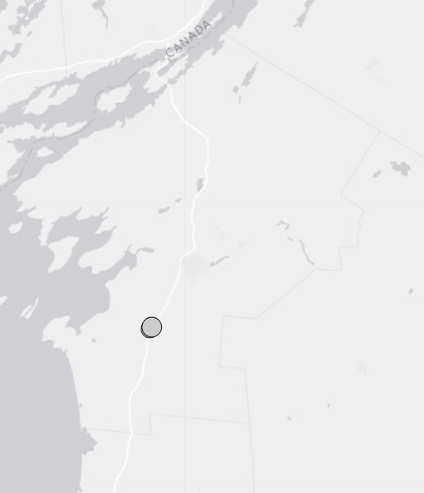
Source: USGS 2024
The St. Lawrence Rift System is a geologically significant and seismically active zone that runs along the St. Lawrence River and has been mapped from northern New York State into Canada and beyond. The rift system is a northeast-southwest trending structure that extends over 620 miles from the Ottawa–Montreal area through eastern Canada and into northern New York. The region was particularly active during the Late Proterozoic-Early Paleozoic periods. These faults are attributed to the opening of the Iapetus Ocean, the precursor of the Atlantic Ocean. The rift system runs parallel to the St. Lawrence River for approximately 620 miles.
The region is seismically active, with notable zones like the Charlevoix Seismic Zone in Quebec experiencing multiple magnitude 6+ earthquakes over the past few centuries. In northern New York, the rift system contributes to moderate earthquake risk, such as the 1944 Cornwall–Massena earthquake near the New York–Ontario border (Tremblay, et al. 2013). The epicenters of earthquakes recorded between 1627 and 2003 have generally tended to be clustered around rift zone, (in which the main faults are shown as black lines) (Jefferson County Office of Fire and Emergency Management 2011).
Figure 10-2 shows the earthquake risk index for Jefferson County by census tract. This index helps to understand the susceptibility of the County to earthquakes. According to the National Risk Index, the County overall has a relatively low risk from earthquakes (FEMA 2025).
Figure 10-2. National Risk Index, Earthquake Risk Index Score by Census Tract
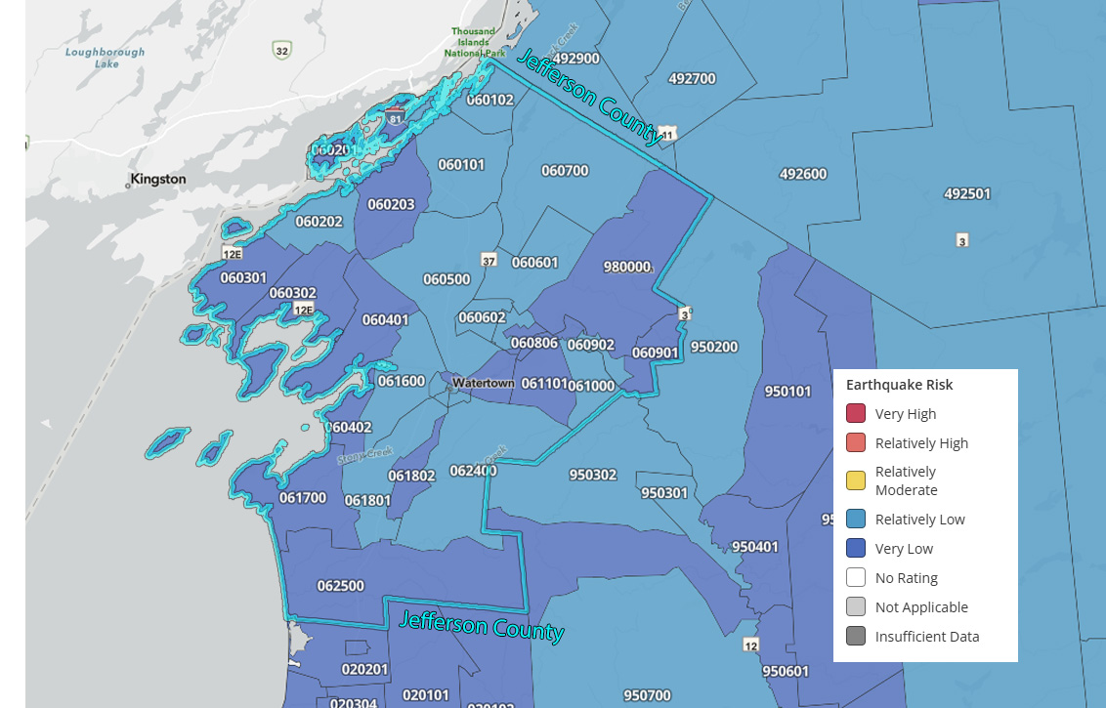
Source: FEMA 2025

Landslide
Variables that contribute to the overall extent of potential landslide activity include soil properties, topographic position and slope, and historical incidence. Predicting a landslide is difficult, even under ideal conditions. As a result, the landslide hazard is often represented by an area’s landslide incidence and/or susceptibility. Areas that are commonly considered to be safe from landslides include areas that have not experienced landslides in the past, areas of minimal slope, and areas set back from the tops of slopes. Conversely, areas that are commonly considered to be more prone to landslides tend to be areas where a landslide has occurred in the past, bases of steep slopes or drainage channels, and developed hillsides where leach field septic systems are used.
Figure 10-3 shows the landslide risk index for Jefferson County on the census tract scale. This index helps to understand the susceptibility of the County to landslides. According to the National Risk Index, the County overall has a relatively moderate risk to landslides (FEMA 2025).
Jefferson County has two landslide susceptibility hazard areas as seen in Figure 10-4. The area of the county located adjacent to Lake Ontario has moderate susceptibility and low incidence for landslides, while the interior areas in the county have a low incidence to landslides. This shows increased susceptibility to the areas located adjacent to Lake Ontario.

Figure 10-3. National Risk Index, Landslide Risk Index Score by Census Tracct
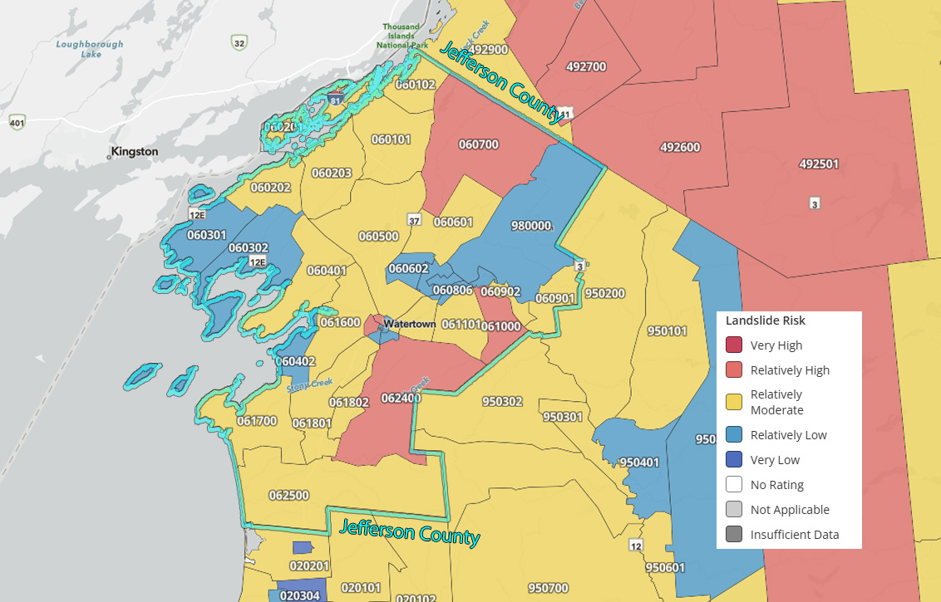
Source: FEMA 2025

Figure 10-4. Landslide Susceptibility Hazard Area
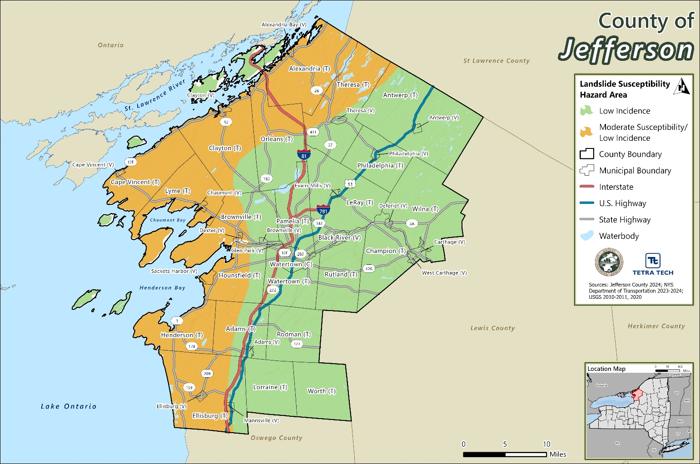

Extent

Earthquake
An earthquake’s magnitude and intensity are used to describe the size and severity of the event. Magnitude describes the size at the focus of an earthquake. Intensity describes the overall severity of shaking felt during the event. The earthquake’s magnitude is a measure of the energy released at the source of the earthquake.
Magnitude is expressed by ratings on the Richter scale and/or the moment magnitude scale (MMS). The Richter Scale conveys the shaking felt by an event but does not measure damage (USGS 2023). Table 10-1 presents the Richter scale magnitudes. The Richter Scale is no longer commonly used but is often referred to when discussed past events.
Table 10-1. Richter Magnitude Scale
Richter Magnitude | Earthquake Effects
2.5 or less | Usually not felt, but can be recorded by seismograph
2.5 or 5.4 | Often felt, but causes only minor damage
5.5 or 6.0 | Slight damage to buildings and other structures
6.1 or 6.9 | May cause a lot of damage in very populated areas
7.0 or 7.9 | Major earthquake; serious damage
8.0 or greater | Great earthquake; can totally destroy communities near the epicenter
Source: Michigan Tech 2023

The MMS has replaced the Richter Scale as a common measure of earthquake severity. The moment magnitude provides an estimate of earthquake size that is valid over the complete range of magnitudes, a characteristic that was lacking in other magnitude scales. For very large earthquakes, moment magnitude gives the most reliable estimate of earthquake size. Moment is a physical quantity proportional to the slip on the fault multiplied by the area of the fault surface that slips; it is related to the total energy released in the earthquake. The moment can be estimated from seismograms (and from geodetic measurements). The moment is then converted into a number like other earthquake magnitudes by a standard formula. The result is called the moment magnitude (USGS n.d.).
Earthquake intensity is based on the observed effects of ground shaking on people, buildings, and natural features, and varies across affected locations. The Modified Mercalli (MMI) scale expresses how strong a shock was felt at a particular location in values. Table 10-2 summarizes earthquake intensity as expressed by the Modified Mercalli scale.
Peak ground elevation (PGA) measures how hard the earth shakes, or accelerates, in each geographic area. PGA is expressed as a percent acceleration force of gravity (%g). For example, 10%g PGA means that the ground is accelerating at a rate that is 10 percent that of gravity (USGS 2019). Damage levels experienced in an earthquake vary with the intensity of ground shaking and with the seismic capacity of structures, as noted in Table 10-3.
Table 10-4 describes the MMI scale alongside PGA equivalents to provide a more holistic picture of earthquake extent as it relates to ground acceleration. Building construction, type of structure, building materials, and other factors will play a role in determining the extent of earthquake damage within the planning area.
Table 10-2. Modified Mercalli Intensity Scale
Mercalli Intensity | Shaking | Description
I | Not Felt | Not felt except by a very few under especially favorable conditions.
II | Weak | Felt only by a few persons at rest, especially on upper floors of buildings.
III | Weak | Felt quite noticeably by persons indoors, especially on upper floors of buildings. Many people do not recognize it as an earthquake. Standing motor cars may rock slightly. Vibrations similar to the passing of a truck. Duration estimated.
IV | Light | Felt indoors by many, outdoors by few during the day. At night, some awakened. Dishes, windows, doors disturbed; walls make cracking sound. Sensation like heavy truck striking building. Standing motor cars rocked noticeably.
V | Moderate | Felt by nearly everyone; many awakened. Some dishes, windows broken. Unstable objects overturned. Pendulum clocks may stop.
VI | Strong | Felt by all, many frightened. Some heavy furniture moved; a few instances of fallen plaster. Damage slight.
VII | Very Strong | Damage negligible in buildings of good design and construction; slight to moderate in well-built ordinary structures; considerable damage in poorly built or badly designed structures; some chimneys broken.
VIII | Severe | Damage slight in specially designed structures; considerable damage in ordinary substantial buildings with partial collapse. Damage great in poorly built structures. Fall of chimneys, factory stacks, columns, monuments, walls. Heavy furniture overturned.
IX | Violent | Damage considerable in specially designed structures; well-designed frame structures thrown out of plumb. Damage great in substantial buildings, with partial collapse. Buildings shifted off foundations.
X | Extreme | Some well-built wooden structures destroyed; most masonry and frame structures destroyed with foundations. Rails bent.
Source: USGS 2023

Table 10-3. Damage Levels Experienced in Earthquakes (PGA)
Ground Motion Percentage | Explanation of Damages
1-2%g | Motions are widely felt by people; hanging plants and lamps swing strongly, but damage levels, if any, are usually very low.
< 10%g | Usually causes only slight damage, except in unusually vulnerable facilities.
10 - 20%g | May cause minor-to-moderate damage in well-designed buildings, with higher levels of damage in poorly designed buildings. At this level of ground shaking, only unusually poor buildings would be subject to potential collapse.
20 - 50%g | May cause significant damage in some modern buildings and very high levels of damage (including collapse) in poorly designed buildings.
≥50%g | May causes higher levels of damage in many buildings, even those designed to resist seismic forces.
Source: USGS 2005
Note: %g: Peak Ground Acceleration (PGA)

Table 10-4. Modified Mercalli Intensity and PGA Equivalents
Modified Mercalli Intensity | Acceleration (%g) (PGA) | Perceived Shaking | Potential Damage
I | <0.17 | Not Felt | None
II | 0.17 – 1.4 | Weak | None
III | 0.17 – 1.4 | Weak | None
IV | 1.4 – 3.9 | Light | None
V | 3.9 – 9.2 | Moderate | Very Light
VI | 9.2 – 18 | Strong | Light
VII | 18 – 34 | Very Strong | Moderate
VIII | 34 – 65 | Severe | Moderate to Heavy
IX | 65-124 | Violent | Heavy
X | >124 | Extreme | Very Heavy
Source: Freeman 2004
Note: PGA: Peak Ground Acceleration
Figure 10-5 and Figure 10-6 show the 500-Year and 2,500 Year Earthquake PGA (%g). For the 500-Year event, most of the county will experience a V – Moderate acceleration with the southern portion of the county including the town of Henderson, the town and village of Ellisburg, the town of Lorraine, and the town of Worth experiencing IV – Light acceleration. For the 2,500 Year Earthquake event, the entire county is projected to experience a VI – Strong acceleration with strong perceived shaking.
National maps of earthquake shaking hazards provide information for creating and updating seismic design requirements for building codes, insurance rate structures, earthquake loss studies, retrofit priorities, and land use planning. After thorough review of the studies, professional organizations of engineers update the seismic-risk maps and seismic design requirements contained in building codes (Brown 2001). The USGS updated the National Seismic Hazard Maps in 2023. New seismic, geologic, and geodetic information on earthquake rates and associated ground shaking were incorporated into these revised maps. Figure 10-7 represents the best available data, as determined by the USGS.
The New York State Geological Survey conducted seismic shear-wave tests of the State’s surficial geology (glacial deposits). Surficial materials are those at or near Earth’s surface and in the case of New York State, these come in the form of sediment (such as rock, soil, gravel, etc.) that are deposited by glaciers (UC Davis n.d.). Based on these test results, the surficial geologic materials of the State of New York were categorized according to the National Earthquake Hazard Reduction Program’s (NEHRP) Soil Site Classifications (Table 10-5). The NEHRP developed five soil classifications defined by their shear-wave velocity that impact the severity of an earthquake.

Figure 10-5. 500-Year Earthquake PGA (%g)
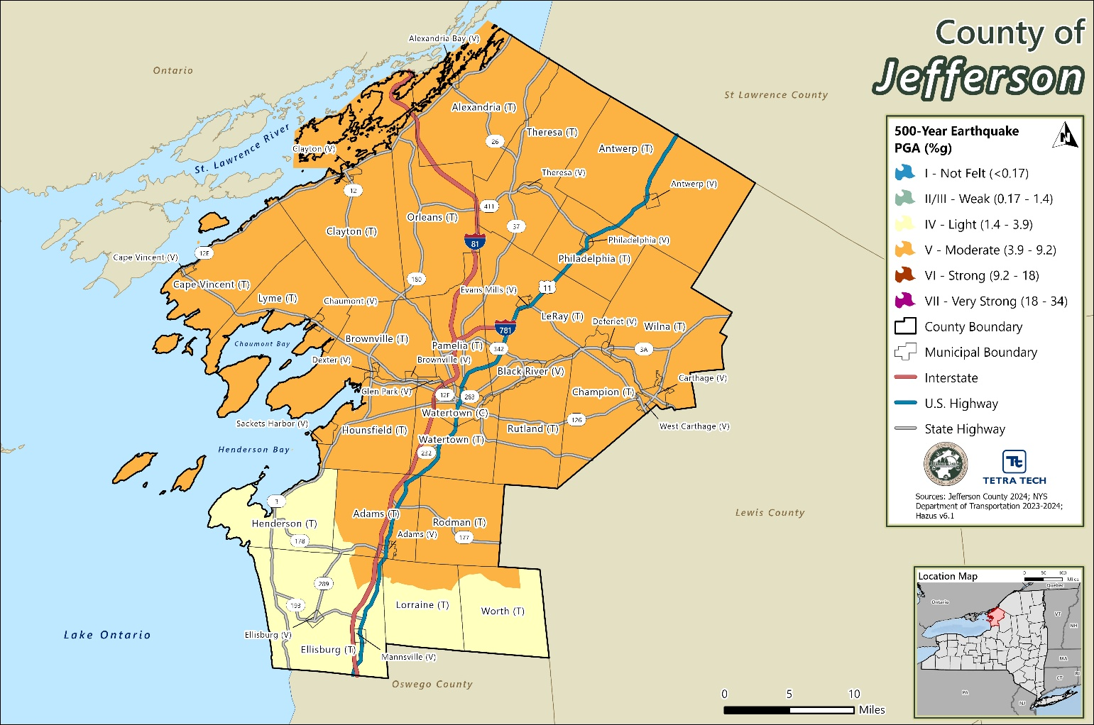
Source: Jefferson County 2024; NYS Department of Transportation 2023-2024; Hazus v6.1
Figure 10-6. 2,500-Year Earthquake PGA (%g)
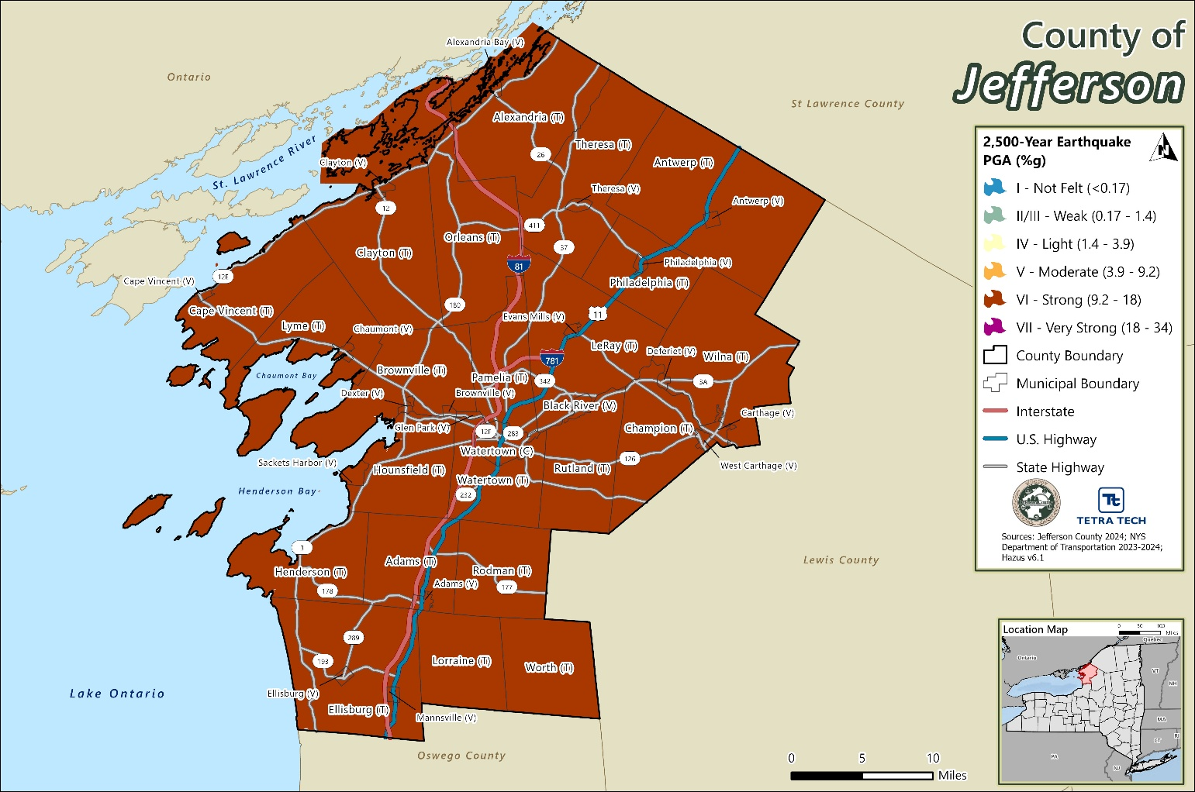
Source: Jefferson County 2024; NYS Department of Transportation 2023-2024; Hazus v6.1
Figure 10-7. USGS National Seismic Hazard Mapping for New York State
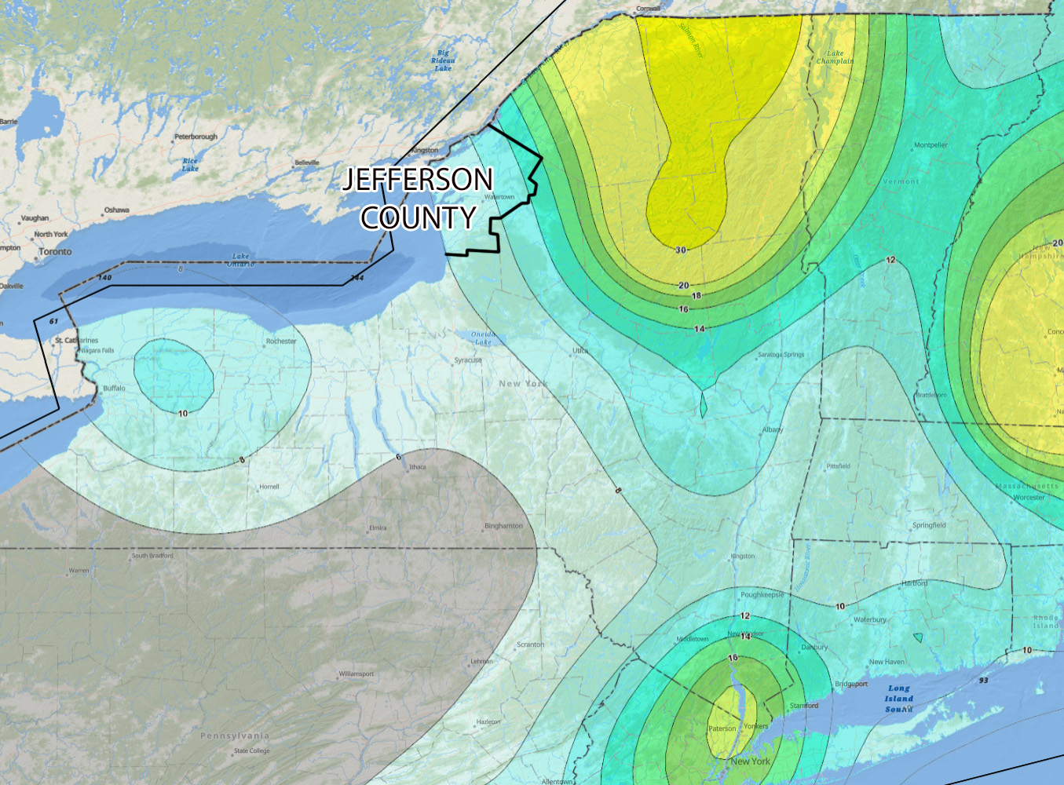
Values shown indicate the PGA, in %g, with a 2 percent chance of happening in 50 years
Source: USGS

The soil classification system ranges from A to E, as noted in Table 10-5, where A represents hard rock that reduces ground motions from an earthquake and E represents soft soils that amplify and magnify ground shaking and increase building damage and losses. Class E soils include water-saturated mud and artificial fill. The strongest amplification of shaking due is expected for this soil type. Seismic waves travel faster through hard rock than through softer rock and sediments. As the waves pass from harder to softer rocks, the waves slow down and their amplitude increases. Shaking tends to be stronger at locations with softer surface layers where seismic waves move more slowly. Ground motion above an unconsolidated landfill or soft soils can be more than 10 times stronger than at neighboring locations on rock for small ground motions (FEMA 2016).
Table 10-5. NEHRP Soil Classifications
Soil Classification | Description
A | Hard Rock
B | Rock
C | Very dense soil and soft rock
D | Stiff soils
E | Soft soils
Source: FEMA 2016

Landslide
The potential for landslides exists across the entire State and the entire northeast region of the United States. Scientific and historical data for the State of New York indicates that some areas of the State have a substantial landslide risk. Landslide incidence is the number of landslides that have occurred in a geographic area (Radbruch-Hall, et al. 1982). Refer to Table 10-6 for the degrees of landslide incidence. It is estimated that 80 percent of the State has a low susceptibility to the landslide hazard. In general, the highest potential for landslides can be found along major rivers and lake valleys that were formerly occupied by glacial lakes resulting in glacial lake deposits and usually associated with steeper slopes (for example, the Hudson and Mohawk River Valleys). Some natural variables, such as soil properties, topographic position and slope, and historical incidence, all contribute to determining the overall risk of landslide activity in any area (NYS 2019).
Table 10-6. Degrees of Landslide Incidence and Susceptibility
Degree of Incidence | Degree of Susceptibility | Total Area of Landslide (%)
High Incidence | High Susceptibility | 15%
Medium Incidence | Medium Susceptibility | 1.5% to 15%
Low Incidence | Low Susceptibility | < 1.5%
Source: Dorothy H. Rudbruch-Hall, 1982
Landslide susceptibility is defined as the probable degree of response of geologic formations to natural or artificial cutting, to loading of slopes, or to unusually high precipitation. Unusually high precipitation or changes in existing conditions can initiate landslide movement in areas where rocks and soils have experienced numerous landslides in the past. Landslide susceptibility depends on slope angle and the geologic material underlying the slope. Landslide susceptibility only identifies areas potentially affected and does not imply a time frame when a landslide might occur. High, medium, and low susceptibility are delimited by the same percentages used for classifying the incidence of land sliding.
As illustrated in Figure 10-8, the lake coast of Jefferson County has a low incidence and moderate susceptibility of landslide events. This area has some slopes and moving groundwater, resulting in bed rock topples and soil slides (also known as debris slides). The remainder of the County has a low landslide incidence.
Figure 10-8. Landslide Susceptibility in New York State
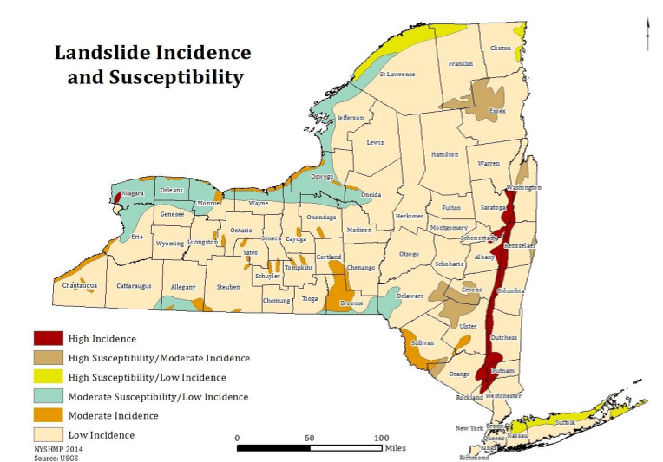
Source: NYS DHSES 2014
The severity of a landslide depends in large part on the degree of development in the area in which it occurs and the geographic area of slide itself. Landslides can result in devastating consequences, but only in very localized areas. A landslide occurring in an undeveloped area would be less severe because lives and property would not be affected; the impacts would be to land, vegetation, and possibly some wildlife. On the contrary, a landslide occurring in a developed area could have devastating effects, ranging from structure and infrastructure damage to injury and/or loss of life. Structures or infrastructure built on susceptible land would likely collapse as their footings slide downhill, while development below the land failure could be crushed. Landslides around roadways could damage or destroy vehicles or cause car accidents.

Previous Occurrences
As noted in the 2023 New York State Hazard Mitigation Plan, although the probability of damaging earthquakes in the State is low, earthquakes do occur on a regular basis in New York. Regarding landslides, NYSGS estimates that 90 percent of landslides that occur are under 2 acres in size.

FEMA Major Disaster and Emergency Declarations
Between 1954 and 2024, Jefferson County was included in no major disaster (DR) or emergency (EM) declarations for geological-related events (FEMA 2024). There has been one federally declared disaster in New York State due to an earthquake, following an event of Magnitude 3.1 that occurred in the far northeastern part of the state in April 2002 (with aftershocks in May 2002). Jefferson County was not affected by this event.

USDA Declarations
The Secretary of Agriculture from the U.S. Department of Agriculture (USDA) is authorized to designate counties as disaster areas to make emergency loans to producers suffering losses in those counties and in contiguous counties. Between 2012 and 2024, Jefferson County was not included in any USDA geologic-related agricultural disaster declarations.

Previous Events
Known hazard events that impacted Jefferson County between January 2009 and April 2025 are discussed in Table 10-7. For events prior to 2009, refer to the 2011 Jefferson County HMP.
Table 10-7. Geologic Events in Jefferson County (2009 to 2025)
Event Date | Declaration or Proclamation Number | Location Impacted | Description
April 14, 2023 | N/A | Adams Center | An earthquake with a magnitude of 2.6 and a depth of 6.4 kilometers.
April 23, 2023 | N/A | New York State | An earthquake with a magnitude of 3.6 and a depth of 8.7 kilometers.
Source: USDA 2024
The New York State Geological Survey records a total of 329 significant landslide events that occurred in New York State between 1837 and 2007. None of these events are recorded as having occurred in Jefferson County, and mapping of the New York State Geological Survey Landslide Inventory in the 2023 New York State Plan HMP does not include any individual landslide events in Jefferson County prior to 1990.

Cascading Impacts on Other Hazards
Secondary impacts of earthquakes and landslides could be magnified by climate change. Soils saturated by repetitive storms could experience liquefaction during seismic activity due to the increased saturation. Dams storing increased volumes of water due to changes in the hydrograph could fail during seismic events. There are currently no models available to estimate these impacts.

Vulnerability and Impact Assessment

Earthquake
A probabilistic assessment was conducted for Jefferson County for the 500-year and 2,500-year through a Level 2 analysis in HAZUS-MH v6.1 to analyze the earthquake hazard and provide a range of loss estimates. The probabilistic method uses information from historical earthquakes and inferred faults, locations, and magnitudes and computes the probable ground shaking levels that might be experienced during a recurrence period by Census tract.
As noted in the HAZUS-MH Earthquake User Manual, “Uncertainties are inherent in any loss estimation methodology. They arise in part from incomplete scientific knowledge concerning earthquakes and their effects upon buildings and facilities. They also result from the approximations and simplifications that are necessary for comprehensive analyses. Incomplete or inaccurate inventories of the built environment, demographics and economic parameters add to the uncertainty. These factors can result in a range of uncertainty in loss estimates produced by the HAZUS Earthquake Model, possibly at best by a factor of two or more” (FEMA 2015). However, HAZUS’ potential loss estimates are acceptable for the purposes of this HMP.
Ground shaking is the primary cause of earthquake damage to man-made structures, and soft soils amplify ground shaking. One contributor to the site amplification is the velocity at which the rock or soil transmits shear waves (S-waves). The National Earthquake Hazard Reductions Program (NEHRP) has developed five soil classifications defined by their shear-wave velocity that impact the severity of an earthquake. The soil classification system ranges from A to E, where A represents hard rock that reduces ground motions from an earthquake and E represents soft soils that amplify and magnify ground shaking and increase building damage and losses.
NEHRP soil classifications were not available for Jefferson County at the time of this analysis. Soils were estimated as NEHRP soil Type D across Jefferson County, as a conservative approach to this risk assessment. Groundwater was set at a depth of 5 feet (default setting). Damages and losses due to liquefaction, landslide, or surface fault rupture were not included in this analysis.

Landslide
To assess Jefferson County’s risk to the landslide hazard, an exposure analysis was conducted for the County’s assets (population, building stock, critical facilities, historic assets, and new development) using the USGS’s Landslide Incidence and Susceptibility data, which approximates areas that are vulnerable to this hazard. For the purposes of this plan, the Vulnerability Assessment defines high landslide incidence hazard area as areas with over 15 percent of the area is involved in land sliding. The asset data (population, building stock, critical facilities, new development) were used to support an evaluation of assets exposed and potential impacts and losses associated with this hazard. As an example, to identify assets exposed to landslides, available and appropriate GIS data were overlaid upon the hazard area.

Life, Health, and Safety
The entire County may experience an earthquake. However, the degree to which Jefferson County residents are affected by potential earthquakes or landslides depends on many factors including the age and type of construction people live in, the soil type homes are located on, and the intensity of the earthquake. Whether directly or indirectly impacted, residents could be faced with business closures, road closures that could isolate populations, and loss of function of critical facilities and utilities.

Overall Population

Earthquake
Overall, the risk to public safety and loss of life from an earthquake in the County is minimal for low magnitude events. However, there is a higher risk to public safety for those inside buildings due to structural damage or people walking below building ornamentations and chimneys that may be shaken loose and fall because of an earthquake.
As a result of a significant earthquake event, residents may be displaced or require temporary to long-term sheltering. The number of people requiring shelter is generally less than the number displaced as some displaced persons use hotels or stay with family or friends following a disaster event. Hazus estimates that there will be zero displaced households and zero people seeking short-term sheltering caused by the 100-year MRP event. Table 10-8 summarizes the estimated number of displaced households and persons seeking short-term sheltering caused by the 500-year and 2,500-year mean return period (MRP) events.
Table 10-8. Displaced Households and Persons Requiring Shelter Due to Evaluated Earthquake Events
Jurisdiction | 500-Year MRP Earthquake Event |  | 2,500-Year MRP Earthquake Event
 | Displaced Households | Persons Seeking Short-Term Shelter | Displaced Households | Persons Seeking Short-Term Shelter
Adams (T) | 0 | 0 | 1 | 0
Adams (V) | 0 | 0 | 0 | 0
Alexandria (T) | 0 | 0 | 1 | 1
Alexandria Bay (V) | 0 | 0 | 0 | 0
Antwerp (T) | 0 | 0 | 0 | 0
Antwerp (V) | 0 | 0 | 0 | 0
Black River (V) | 0 | 0 | 0 | 0
Brownville (T) | 0 | 0 | 1 | 0
Brownville (V) | 0 | 0 | 0 | 0
Cape Vincent (T) | 0 | 0 | 1 | 1
Cape Vincent (V) | 0 | 0 | 0 | 0
Carthage (V) | 0 | 0 | 1 | 0
Champion (T) | 0 | 0 | 1 | 0
Chaumont (V) | 0 | 0 | 0 | 0
Clayton (T) | 0 | 0 | 1 | 0
Clayton (V) | 0 | 0 | 0 | 0
Deferiet (V) | 0 | 0 | 0 | 0
Dexter (V) | 0 | 0 | 0 | 0
Ellisburg (T) | 0 | 0 | 0 | 0
Ellisburg (V) | 0 | 0 | 0 | 0
Evans Mills (V) | 0 | 0 | 0 | 0
Glen Park (V) | 0 | 0 | 0 | 0
Henderson (T) | 0 | 0 | 1 | 0
Hounsfield (T) | 0 | 0 | 2 | 1
LeRay (T) | 0 | 0 | 4 | 2
Lorraine (T) | 0 | 0 | 0 | 0
Lyme (T) | 0 | 0 | 0 | 0
Mannsville (V) | 0 | 0 | 0 | 0
Orleans (T) | 0 | 0 | 1 | 0
Pamelia (T) | 0 | 0 | 1 | 0
Philadelphia (T) | 0 | 0 | 0 | 0
Philadelphia (V) | 0 | 0 | 0 | 0
Rodman (T) | 0 | 0 | 0 | 0
Rutland (T) | 0 | 0 | 1 | 0
Sackets Harbor (V) | 0 | 0 | 1 | 1
Theresa (T) | 0 | 0 | 1 | 0
Theresa (V) | 0 | 0 | 0 | 0
Watertown (C) | 0 | 0 | 7 | 4
Watertown (T) | 0 | 0 | 1 | 0
West Carthage (V) | 0 | 0 | 0 | 0
Wilna (T) | 0 | 0 | 1 | 1
Worth (T) | 0 | 0 | 0 | 0
Jefferson County (Total) | 0 | 0 | 30 | 16
Source: Hazus v6.1; U.S. Census Bureau 2020
According to the 1999-2003 NYCEM Summary Report (Earthquake Risks and Mitigation in the New York / New Jersey / Connecticut Region), a strong correlation exists between structural building damage and number of injuries and casualties from an earthquake event. Further, the time of day also exposes different sectors of the community to the hazard. For example, Hazus considers the residential occupancy at its maximum at 2:00 a.m., where the educational, commercial, and industrial sectors are at their maximum at 2:00 p.m., with peak commute time at 5:00 p.m. Whether directly impacted or indirectly impact, the entire population will have to deal with the consequences of earthquakes to some degree. Business interruption could prevent people from working, road closures could isolate populations, and loss of functions of utilities could impact populations that suffered no direct damage from an event itself. Overall, Hazus estimates that there are no injuries or casualties caused by the 100-year MRP event. Table 10-9 summarizes the estimated number of injuries or casualties caused by the 500-year and 2,500-year MRP events.
Table 10-9. Casualties Caused by the Evaluated Earthquake Event
 | 500-Year MRP Earthquake Event |  |  | 2,500-Year MRP Earthquake Event
 | 2:00 AM | 2:00 PM | 5:00 PM | 2:00 AM | 2:00 PM | 5:00 PM
Non-Hospitalized Injuries | 2 | 5 | 2 | 18 | 34 | 14
Hospitalizations | 0 | 1 | 0 | 2 | 6 | 2
Fatalities | 0 | 0 | 0 | 0 | 1 | 0

Landslide
Generally, a landslide event is an isolated incidence and impacts the populations within the immediate area of the incident. Specifically, the population located downslope of high landslide incidence hazard areas are particularly vulnerable. In addition to causing damage to residential buildings and displacing residents, landslide events can block off or damage major roadways and inhibit travel for emergency responders or populations trying to evacuate the area.
Table 10-10 summarizes the estimated population living in the two mapped landslide hazard areas in Jefferson County. Based on the analysis, an estimated 23,925 residents, or 20.5 percent of the County’s population, are in the moderate susceptibility/low incidence landslide hazard area and 89,686 residents, or 76.8 percent of the County’s population, are in the moderate susceptibility/low incidence landslide hazard area

Socially Vulnerable Population
Economically disadvantaged populations, including those living below the poverty and ALICE thresholds, are more vulnerable to landslides because they are likely to evaluate their risk and make decisions to evacuate based on net economic impacts on their families. Populations considered most vulnerable to earthquake events are those located in/near the built environment, particularly those near unreinforced masonry construction. The population over age 65 and those living with a disability is also more vulnerable because they are more likely to seek or need medical attention that may not be available due to isolation during a landslide or earthquake event, and they may have more difficulty evacuating. Similarly, those under five may be more vulnerable because they are dependent on others for essential needs and mobility. Individuals that are not proficient in English may be unable to interpret emergency warning messages to evacuate or providing resources to protect or mitigate damage to themselves and/or their property. Factors leading to this higher susceptibility include decreased mobility and financial ability to react or respond during a hazard, and the location and construction quality of their housing.

Earthquake
All socially vulnerable populations in the county are considered to be vulnerable to the earthquake hazard. Figure 3-14 shows SVI scores across Jefferson County.

Landslide
Table 10-11 and Table 10-12 present the estimated socially vulnerable populations located in mapped landslide hazard areas
Table 10-10. Population Exposed to the Landslide Hazard by Municipality
 |  | Population in the Landslide Hazard Area
Jurisdiction | Total Population (2020 Decennial) | Moderate Susceptibility/Low Incidence Landslide Hazard Area |  | Low Incidence Landslide Hazard Area
 |  | Number of Persons | % of Jurisdiction Total | Number of Persons | % of Jurisdiction Total
Adams (T) | 3,340 | 575 | 17.2% | 2,764 | 82.8%
Adams (V) | 1,633 | 0 | 0.0% | 1,633 | 100.0%
Alexandria (T) | 2,817 | 2,350 | 83.4% | 167 | 5.9%
Alexandria Bay (V) | 924 | 890 | 96.3% | 0 | 0.0%
Antwerp (T) | 1,177 | 20 | 1.7% | 1,156 | 98.2%
Antwerp (V) | 506 | 0 | 0.0% | 506 | 100.0%
Black River (V) | 1,232 | 0 | 0.0% | 1,232 | 100.0%
Brownville (T) | 3,456 | 2,306 | 66.7% | 953 | 27.6%
Brownville (V) | 930 | 0 | 0.0% | 929 | 99.9%
Cape Vincent (T) | 2,066 | 1,719 | 83.2% | 25 | 1.2%
Cape Vincent (V) | 699 | 698 | 99.9% | 0 | 0.0%
Carthage (V) | 3,236 | 0 | 0.0% | 3,235 | 100.0%
Champion (T) | 2,537 | 0 | 0.0% | 2,537 | 100.0%
Chaumont (V) | 615 | 614 | 99.8% | 0 | 0.0%
Clayton (T) | 3,065 | 2,378 | 77.6% | 269 | 8.8%
Clayton (V) | 1,705 | 1,608 | 94.3% | 0 | 0.0%
Deferiet (V) | 245 | 0 | 0.0% | 244 | 99.6%
Dexter (V) | 1,004 | 673 | 67.0% | 0 | 0.0%
Ellisburg (T) | 2,869 | 2,219 | 77.3% | 610 | 21.3%
Ellisburg (V) | 186 | 185 | 99.5% | 0 | 0.0%
Evans Mills (V) | 678 | 0 | 0.0% | 677 | 99.9%
Glen Park (V) | 452 | 0 | 0.0% | 452 | 100.0%
Henderson (T) | 1,438 | 1,269 | 88.2% | 0 | 0.0%
Hounsfield (T) | 1,930 | 1,472 | 76.3% | 364 | 18.9%
LeRay (T) | 24,280 | 0 | 0.0% | 24,279 | 100.0%
Lorraine (T) | 924 | 0 | 0.0% | 923 | 99.9%
Lyme (T) | 1,684 | 1,052 | 62.5% | 0 | 0.0%
Mannsville (V) | 297 | 53 | 17.8% | 242 | 81.5%
Orleans (T) | 2,788 | 1,515 | 54.3% | 868 | 31.1%
Pamelia (T) | 3,343 | 0 | 0.0% | 3,343 | 100.0%
Philadelphia (T) | 877 | 0 | 0.0% | 877 | 100.0%
Philadelphia (V) | 1,098 | 0 | 0.0% | 1,098 | 100.0%
Rodman (T) | 1,197 | 0 | 0.0% | 1,196 | 99.9%
Rutland (T) | 2,422 | 0 | 0.0% | 2,421 | 100.0%
Sackets Harbor (V) | 1,351 | 1,298 | 96.1% | 0 | 0.0%
Theresa (T) | 1,896 | 1,031 | 54.4% | 864 | 45.6%
Theresa (V) | 752 | 0 | 0.0% | 752 | 100.0%
Watertown (C) | 24,685 | 0 | 0.0% | 24,684 | 100.0%
Watertown (T) | 5,913 | 0 | 0.0% | 5,912 | 100.0%
West Carthage (V) | 1,780 | 0 | 0.0% | 1,780 | 100.0%
Wilna (T) | 2,496 | 0 | 0.0% | 2,496 | 100.0%
Worth (T) | 198 | 0 | 0.0% | 198 | 100.0%
Jefferson County (Total) | 116,721 | 23,925 | 20.5% | 89,686 | 76.8%
Source: U.S. Census Bureau 2020; USGS 2011
.

Table 10-11. Vulnerable Persons in the Low Incidence Landslide Hazard Area
 | Vulnerable Population Living in the Low Incidence Landslide Hazard Area
 | Persons Over 65 |  | Persons Under 5 |  | Non-English Speakers |  | Persons with Disability |  | Persons in Poverty
Jurisdiction | Number | % of Total | Number | % of Total | Number | % of Total | Number | % of Total | Number | % of Total
Adams (T) | 406 | 82.7% | 46 | 82.1% | 8 | 80.0% | 376 | 82.6% | 206 | 82.4%
Adams (V) | 358 | 100.0% | 136 | 100.0% | 4 | 80.0% | 403 | 100.0% | 217 | 99.5%
Alexandria (T) | 28 | 5.8% | 10 | 5.5% | 0 | 0.0% | 18 | 5.7% | 9 | 5.9%
Alexandria Bay (V) | 0 | 0.0% | 0 | 0.0% | 0 | 0.0% | 0 | 0.0% | 0 | 0.0%
Antwerp (T) | 205 | 98.1% | 51 | 98.1% | 0 | 0.0% | 229 | 97.9% | 132 | 97.8%
Antwerp (V) | 129 | 100.0% | 57 | 100.0% | 0 | 0.0% | 178 | 100.0% | 85 | 100.0%
Black River (V) | 254 | 99.6% | 73 | 98.6% | 5 | 100.0% | 152 | 100.0% | 250 | 100.0%
Brownville (T) | 210 | 27.5% | 69 | 27.3% | 0 | 0.0% | 179 | 27.5% | 97 | 27.3%
Brownville (V) | 115 | 100.0% | 12 | 100.0% | 0 | 0.0% | 108 | 100.0% | 17 | 94.4%
Cape Vincent (T) | 6 | 1.1% | 0 | 0.0% | 0 | 0.0% | 2 | 0.9% | 1 | 0.8%
Cape Vincent (V) | 0 | 0.0% | 0 | 0.0% | 0 | 0.0% | 0 | 0.0% | 0 | 0.0%
Carthage (V) | 514 | 100.0% | 313 | 99.7% | 0 | 0.0% | 588 | 100.0% | 615 | 99.8%
Champion (T) | 310 | 100.0% | 78 | 100.0% | 41 | 100.0% | 573 | 100.0% | 507 | 99.8%
Chaumont (V) | 0 | 0.0% | 0 | 0.0% | 0 | 0.0% | 0 | 0.0% | 0 | 0.0%
Clayton (T) | 47 | 8.7% | 12 | 8.2% | 5 | 7.9% | 22 | 8.8% | 51 | 8.7%
Clayton (V) | 0 | 0.0% | 0 | 0.0% | 0 | 0.0% | 0 | 0.0% | 0 | 0.0%
Deferiet (V) | 14 | 100.0% | 47 | 97.9% | 0 | 0.0% | 20 | 100.0% | 42 | 100.0%
Dexter (V) | 0 | 0.0% | 0 | 0.0% | 0 | 0.0% | 0 | 0.0% | 0 | 0.0%
Ellisburg (T) | 109 | 21.2% | 31 | 20.8% | 0 | 0.0% | 46 | 21.2% | 45 | 20.9%
Ellisburg (V) | 0 | 0.0% | 0 | 0.0% | 0 | 0.0% | 0 | 0.0% | 0 | 0.0%
Evans Mills (V) | 107 | 100.0% | 35 | 100.0% | 0 | 0.0% | 167 | 100.0% | 96 | 100.0%
Glen Park (V) | 47 | 97.9% | 77 | 100.0% | 0 | 0.0% | 84 | 98.8% | 269 | 100.0%
Henderson (T) | 0 | 0.0% | 0 | 0.0% | 0 | 0.0% | 0 | 0.0% | 0 | 0.0%
Hounsfield (T) | 66 | 18.9% | 31 | 18.8% | 0 | 0.0% | 36 | 18.8% | 20 | 18.3%
LeRay (T) | 584 | 99.8% | 3,289 | 100.0% | 804 | 99.9% | 1,346 | 100.0% | 1,922 | 100.0%
Lorraine (T) | 155 | 99.4% | 20 | 95.2% | 0 | 0.0% | 139 | 100.0% | 125 | 99.2%
Lyme (T) | 0 | 0.0% | 0 | 0.0% | 0 | 0.0% | 0 | 0.0% | 0 | 0.0%
Mannsville (V) | 36 | 80.0% | 22 | 78.6% | 0 | 0.0% | 17 | 81.0% | 19 | 79.2%
Orleans (T) | 169 | 31.1% | 44 | 30.6% | 12 | 30.8% | 97 | 30.9% | 125 | 31.0%
Pamelia (T) | 484 | 100.0% | 138 | 100.0% | 0 | 0.0% | 364 | 100.0% | 130 | 100.0%
Philadelphia (T) | 88 | 100.0% | 129 | 100.0% | 0 | 0.0% | 51 | 100.0% | 14 | 93.3%
Philadelphia (V) | 124 | 100.0% | 62 | 100.0% | 0 | 0.0% | 149 | 99.3% | 267 | 99.6%
Rodman (T) | 158 | 100.0% | 46 | 100.0% | 0 | 0.0% | 172 | 100.0% | 185 | 100.0%
Rutland (T) | 422 | 99.8% | 95 | 99.0% | 80 | 98.8% | 303 | 100.0% | 266 | 99.6%
Sackets Harbor (V) | 0 | 0.0% | 0 | 0.0% | 0 | 0.0% | 0 | 0.0% | 0 | 0.0%
Theresa (T) | 81 | 45.3% | 70 | 45.2% | 0 | 0.0% | 95 | 45.2% | 107 | 45.5%
Theresa (V) | 70 | 98.6% | 28 | 100.0% | 0 | 0.0% | 88 | 100.0% | 106 | 100.0%
Watertown (C) | 3,531 | 100.0% | 1,805 | 100.0% | 359 | 100.0% | 4,263 | 100.0% | 4,723 | 100.0%
Watertown (T) | 1,133 | 100.0% | 318 | 100.0% | 0 | 0.0% | 811 | 100.0% | 246 | 99.6%
West Carthage (V) | 305 | 100.0% | 101 | 99.0% | 27 | 100.0% | 234 | 100.0% | 189 | 100.0%
Wilna (T) | 303 | 99.7% | 88 | 100.0% | 0 | 0.0% | 298 | 100.0% | 175 | 100.0%
Worth (T) | 31 | 100.0% | 3 | 75.0% | 0 | 0.0% | 24 | 100.0% | 20 | 100.0%
Jefferson County (Total) | 10,599 | 63.6% | 7,336 | 83.8% | 1,345 | 89.0% | 11,632 | 76.3% | 11,278 | 78.8%
Source: U.S. Census Bureau; ACS 5-Year Estimates 2018-2022; USGS 2011
Table 10-12. Vulnerable Persons in the Moderate Susceptibility/Low Incidence Landslide Hazard Area
 | Vulnerable Population Living in the Moderate Susceptibility/Low Incidence Landslide Hazard Area
 | Persons Over 65 |  | Persons Under 5 |  | Non-English Speakers |  | Persons with Disability |  | Persons in Poverty
Jurisdiction | Number | % of Total | Number | % of Total | Number | % of Total | Number | % of Total | Number | % of Total
Adams (T) | 84 | 17.1% | 9 | 16.1% | 1 | 10.0% | 78 | 17.1% | 43 | 17.2%
Adams (V) | 0 | 0.0% | 0 | 0.0% | 0 | 0.0% | 0 | 0.0% | 0 | 0.0%
Alexandria (T) | 402 | 83.2% | 151 | 83.0% | 0 | 0.0% | 263 | 83.2% | 126 | 82.9%
Alexandria Bay (V) | 364 | 96.3% | 30 | 93.8% | 9 | 90.0% | 218 | 96.0% | 101 | 96.2%
Antwerp (T) | 3 | 1.4% | 0 | 0.0% | 0 | 0.0% | 4 | 1.7% | 2 | 1.5%
Antwerp (V) | 0 | 0.0% | 0 | 0.0% | 0 | 0.0% | 0 | 0.0% | 0 | 0.0%
Black River (V) | 0 | 0.0% | 0 | 0.0% | 0 | 0.0% | 0 | 0.0% | 0 | 0.0%
Brownville (T) | 509 | 66.6% | 168 | 66.4% | 0 | 0.0% | 435 | 66.7% | 236 | 66.5%
Brownville (V) | 0 | 0.0% | 0 | 0.0% | 0 | 0.0% | 0 | 0.0% | 0 | 0.0%
Cape Vincent (T) | 453 | 83.1% | 49 | 81.7% | 0 | 0.0% | 183 | 83.2% | 107 | 82.9%
Cape Vincent (V) | 128 | 99.2% | 38 | 97.4% | 0 | 0.0% | 108 | 99.1% | 76 | 98.7%
Carthage (V) | 0 | 0.0% | 0 | 0.0% | 0 | 0.0% | 0 | 0.0% | 0 | 0.0%
Champion (T) | 0 | 0.0% | 0 | 0.0% | 0 | 0.0% | 0 | 0.0% | 0 | 0.0%
Chaumont (V) | 139 | 100.0% | 53 | 98.1% | 0 | 0.0% | 98 | 100.0% | 90 | 100.0%
Clayton (T) | 419 | 77.4% | 114 | 77.6% | 48 | 76.2% | 194 | 77.3% | 453 | 77.6%
Clayton (V) | 493 | 94.3% | 93 | 93.9% | 50 | 92.6% | 325 | 94.2% | 255 | 94.1%
Deferiet (V) | 0 | 0.0% | 0 | 0.0% | 0 | 0.0% | 0 | 0.0% | 0 | 0.0%
Dexter (V) | 104 | 66.7% | 23 | 65.7% | 0 | 0.0% | 110 | 66.7% | 87 | 66.9%
Ellisburg (T) | 398 | 77.3% | 115 | 77.2% | 0 | 0.0% | 167 | 77.0% | 166 | 77.2%
Ellisburg (V) | 35 | 97.2% | 17 | 100.0% | 0 | 0.0% | 56 | 98.2% | 38 | 100.0%
Evans Mills (V) | 0 | 0.0% | 0 | 0.0% | 0 | 0.0% | 0 | 0.0% | 0 | 0.0%
Glen Park (V) | 0 | 0.0% | 0 | 0.0% | 0 | 0.0% | 0 | 0.0% | 0 | 0.0%
Henderson (T) | 567 | 88.2% | 42 | 87.5% | 6 | 85.7% | 248 | 87.9% | 233 | 88.3%
Hounsfield (T) | 267 | 76.3% | 125 | 75.8% | 0 | 0.0% | 145 | 75.9% | 83 | 76.1%
LeRay (T) | 0 | 0.0% | 0 | 0.0% | 0 | 0.0% | 0 | 0.0% | 0 | 0.0%
Lorraine (T) | 0 | 0.0% | 0 | 0.0% | 0 | 0.0% | 0 | 0.0% | 0 | 0.0%
Lyme (T) | 283 | 62.5% | 28 | 62.2% | 0 | 0.0% | 140 | 62.5% | 77 | 62.1%
Mannsville (V) | 8 | 17.8% | 5 | 17.9% | 0 | 0.0% | 3 | 14.3% | 4 | 16.7%
Orleans (T) | 295 | 54.3% | 78 | 54.2% | 21 | 53.8% | 170 | 54.1% | 219 | 54.3%
Pamelia (T) | 0 | 0.0% | 0 | 0.0% | 0 | 0.0% | 0 | 0.0% | 0 | 0.0%
Philadelphia (T) | 0 | 0.0% | 0 | 0.0% | 0 | 0.0% | 0 | 0.0% | 0 | 0.0%
Philadelphia (V) | 0 | 0.0% | 0 | 0.0% | 0 | 0.0% | 0 | 0.0% | 0 | 0.0%
Rodman (T) | 0 | 0.0% | 0 | 0.0% | 0 | 0.0% | 0 | 0.0% | 0 | 0.0%
Rutland (T) | 0 | 0.0% | 0 | 0.0% | 0 | 0.0% | 0 | 0.0% | 0 | 0.0%
Sackets Harbor (V) | 290 | 96.0% | 40 | 95.2% | 4 | 80.0% | 144 | 96.0% | 138 | 95.8%
Theresa (T) | 97 | 54.2% | 84 | 54.2% | 0 | 0.0% | 114 | 54.3% | 127 | 54.0%
Theresa (V) | 0 | 0.0% | 0 | 0.0% | 0 | 0.0% | 0 | 0.0% | 0 | 0.0%
Watertown (C) | 0 | 0.0% | 0 | 0.0% | 0 | 0.0% | 0 | 0.0% | 0 | 0.0%
Watertown (T) | 0 | 0.0% | 0 | 0.0% | 0 | 0.0% | 0 | 0.0% | 0 | 0.0%
West Carthage (V) | 0 | 0.0% | 0 | 0.0% | 0 | 0.0% | 0 | 0.0% | 0 | 0.0%
Wilna (T) | 0 | 0.0% | 0 | 0.0% | 0 | 0.0% | 0 | 0.0% | 0 | 0.0%
Worth (T) | 0 | 0.0% | 0 | 0.0% | 0 | 0.0% | 0 | 0.0% | 0 | 0.0%
Jefferson County (Total) | 5,338 | 32.0% | 1,262 | 14.4% | 139 | 9.2% | 3,203 | 21.0% | 2,661 | 18.6%
Source: U.S. Census Bureau; ACS 5-Year Estimates 2018-2022; USGS 2011

General Building Stock

Earthquake
Building damage because of the 100-year, 500-year, and 2,500-year MRP earthquakes were estimated for each municipality using Hazus. Table 10-13 and Table 10-14 summarize estimated total building and content losses caused by the 500-year and 2,500-year MRP events by jurisdiction, respectively. These tables also summarize losses for structures categorized as residential, commercial, and all other occupancy classes. Total estimated damage to the general building stock from the 500-year MRP event is less than 0.1 percent of the total county replacement cost value (RCV) (approximately $53 million). Damage from the 2,500-year MRP event is about 0.5 percent of the total county RCV ($580 million). The largest amount of damage is estimated to occur in the City of Watertown.
Hazus also estimates the amount of debris that may be generated as a result of an earthquake event to enable the study region to prepare and rapidly and efficiently manage debris removal and disposal. Debris estimates are divided into two categories: reinforced concrete and steel that require special equipment to break it up before it can be transported; and brick, wood, and other debris that can be loaded directly onto trucks with bulldozers (FEMA, Hazus Earthquake Model Technical Manual 2020). For the 500-year and 2,500-year MRP events, Hazus estimates a total of 16,214 tons and 92,729 tons of debris will be generated county-wide, respectively. Table 10-15 summarizes the estimated debris generated as a result of these events by municipality.
Hazus estimates the severity of expected damage per occupancy class type for the 500-year and 2,500-year MRP events. Table 10-16 and Table 10-17 show the respective expected damage counts per each MRP.

Table 10-13. Building Damage from the 500-Year MRP Earthquake Event
Jurisdiction | Total RCV | Estimated Damage (Structure and Contents) Due to 500-Year MRP Earthquake Event
 |  | Total for All Buildings
 |  | Damage | Damage as % of Total RCV | Residential | Commercial | Other
Adams (T) | $4,052,069,203 | $1,577,464 | <0.1% | $203,809 | $714,715 | $658,940
Adams (V) | $1,774,388,625 | $709,177 | <0.1% | $84,675 | $330,310 | $294,192
Alexandria (T) | $4,432,190,141 | $3,034,826 | 0.1% | $1,242,310 | $1,114,875 | $677,641
Alexandria Bay (V) | $3,206,687,833 | $718,620 | <0.1% | $259,196 | $329,993 | $129,430
Antwerp (T) | $1,789,914,615 | $586,199 | <0.1% | $125,688 | $168,032 | $292,479
Antwerp (V) | $613,702,374 | $260,219 | <0.1% | $55,765 | $74,712 | $129,742
Black River (V) | $1,046,580,838 | $348,034 | <0.1% | $126,751 | $96,068 | $125,214
Brownville (T) | $1,775,095,498 | $1,325,412 | 0.1% | $312,978 | $439,120 | $573,313
Brownville (V) | $982,068,271 | $551,336 | 0.1% | $71,606 | $215,699 | $264,032
Cape Vincent (T) | $2,829,209,923 | $1,741,817 | 0.1% | $631,370 | $545,860 | $564,586
Cape Vincent (V) | $1,727,996,587 | $344,940 | <0.1% | $112,329 | $124,332 | $108,279
Carthage (V) | $3,720,102,915 | $1,835,306 | <0.1% | $262,840 | $877,290 | $695,177
Champion (T) | $2,687,535,696 | $1,118,048 | <0.1% | $233,033 | $396,486 | $488,529
Chaumont (V) | $842,494,250 | $123,034 | <0.1% | $45,489 | $43,260 | $34,284
Clayton (T) | $5,439,296,759 | $2,301,014 | <0.1% | $833,321 | $778,991 | $688,702
Clayton (V) | $4,190,396,460 | $847,656 | <0.1% | $354,656 | $330,228 | $162,773
Deferiet (V) | $324,222,272 | $236,081 | 0.1% | $30,097 | $116,530 | $89,453
Dexter (V) | $829,013,291 | $166,399 | <0.1% | $54,341 | $46,667 | $65,391
Ellisburg (T) | $4,333,840,339 | $1,016,359 | <0.1% | $211,288 | $178,168 | $626,903
Ellisburg (V) | $269,573,650 | $58,856 | <0.1% | $11,280 | $7,214 | $40,362
Evans Mills (V) | $546,293,186 | $461,055 | 0.1% | $82,791 | $158,112 | $220,151
Glen Park (V) | $407,146,663 | $284,560 | 0.1% | $36,958 | $111,328 | $136,274
Henderson (T) | $2,093,822,742 | $760,202 | <0.1% | $215,891 | $151,050 | $393,260
Hounsfield (T) | $2,771,230,753 | $1,298,548 | <0.1% | $258,938 | $520,751 | $518,859
LeRay (T) | $7,914,338,817 | $4,415,359 | 0.1% | $1,422,013 | $1,414,011 | $1,579,335
Lorraine (T) | $764,134,484 | $363,933 | <0.1% | $91,487 | $79,202 | $193,244
Lyme (T) | $1,420,466,090 | $906,427 | 0.1% | $335,352 | $318,130 | $252,946
Mannsville (V) | $366,229,053 | $90,106 | <0.1% | $17,269 | $11,044 | $61,793
Orleans (T) | $5,479,758,595 | $2,230,626 | <0.1% | $718,826 | $823,563 | $688,237
Pamelia (T) | $5,597,766,484 | $2,208,082 | <0.1% | $417,179 | $794,538 | $996,365
Philadelphia (T) | $1,769,768,846 | $701,385 | <0.1% | $105,305 | $205,377 | $390,704
Philadelphia (V) | $951,206,583 | $688,604 | 0.1% | $103,260 | $201,645 | $383,698
Rodman (T) | $1,358,332,774 | $476,707 | <0.1% | $210,587 | $97,837 | $168,282
Rutland (T) | $2,471,420,505 | $875,760 | <0.1% | $264,222 | $260,212 | $351,326
Sackets Harbor (V) | $1,530,119,265 | $475,935 | <0.1% | $133,801 | $190,536 | $151,598
Theresa (T) | $1,394,838,339 | $1,357,961 | 0.1% | $345,949 | $401,923 | $610,089
Theresa (V) | $774,152,753 | $350,947 | <0.1% | $75,208 | $100,762 | $174,978
Watertown (C) | $22,587,377,146 | $11,940,729 | 0.1% | $1,620,352 | $6,212,194 | $4,108,184
Watertown (T) | $7,255,015,520 | $1,992,215 | <0.1% | $471,122 | $727,793 | $793,300
West Carthage (V) | $1,693,926,280 | $632,402 | <0.1% | $112,265 | $235,430 | $284,707
Wilna (T) | $1,191,104,535 | $1,540,494 | 0.1% | $248,010 | $710,369 | $582,115
Worth (T) | $330,154,128 | $169,845 | 0.1% | $51,991 | $22,928 | $94,927
Jefferson County (Total) | $117,534,983,081 | $53,122,678 | <0.1% | $12,601,596 | $20,677,287 | $19,843,795
Source: Hazus v6.1; Jefferson County 2024; City of Watertown 2024; USACE 2022; RS Means 2024
Table 10-14. Building Damage from the 2,500-Year MRP Earthquake Event
Jurisdiction | Total RCV | Estimated Damage (Structure and Contents) Due to 2,500-Year MRP Earthquake Event
 |  | Total for All Buildings
 |  | Damage | Damage as % of Total RCV | Residential | Commercial | Other
Adams (T) | $4,052,069,203 | $17,770,109 | 0.4% | $2,231,424 | $8,686,272 | $6,852,413
Adams (V) | $1,774,388,625 | $8,030,800 | 0.5% | $927,059 | $4,007,625 | $3,096,116
Alexandria (T) | $4,432,190,141 | $33,058,100 | 0.7% | $12,852,472 | $12,734,303 | $7,471,325
Alexandria Bay (V) | $3,206,687,833 | $8,371,281 | 0.3% | $2,830,857 | $4,036,319 | $1,504,105
Antwerp (T) | $1,789,914,615 | $6,165,266 | 0.3% | $1,227,015 | $1,799,977 | $3,138,274
Antwerp (V) | $613,702,374 | $2,737,127 | 0.4% | $544,604 | $800,330 | $1,392,193
Black River (V) | $1,046,580,838 | $4,618,780 | 0.4% | $1,433,741 | $1,408,374 | $1,776,665
Brownville (T) | $1,775,095,498 | $14,517,957 | 0.8% | $3,268,861 | $5,203,188 | $6,045,907
Brownville (V) | $982,068,271 | $5,827,333 | 0.6% | $744,138 | $2,541,095 | $2,542,100
Cape Vincent (T) | $2,829,209,923 | $18,956,494 | 0.7% | $6,230,601 | $6,871,524 | $5,854,369
Cape Vincent (V) | $1,727,996,587 | $3,859,019 | 0.2% | $1,195,442 | $1,492,950 | $1,170,627
Carthage (V) | $3,720,102,915 | $18,284,682 | 0.5% | $2,596,209 | $9,847,232 | $5,841,241
Champion (T) | $2,687,535,696 | $13,600,200 | 0.5% | $2,539,277 | $5,224,845 | $5,836,078
Chaumont (V) | $842,494,250 | $1,260,262 | 0.1% | $458,934 | $502,564 | $298,765
Clayton (T) | $5,439,296,759 | $26,649,263 | 0.5% | $8,910,130 | $10,300,899 | $7,438,233
Clayton (V) | $4,190,396,460 | $10,594,144 | 0.3% | $4,118,301 | $4,689,176 | $1,786,667
Deferiet (V) | $324,222,272 | $2,408,260 | 0.7% | $308,156 | $1,346,374 | $753,730
Dexter (V) | $829,013,291 | $1,880,233 | 0.2% | $570,086 | $562,005 | $748,142
Ellisburg (T) | $4,333,840,339 | $12,670,951 | 0.3% | $2,405,995 | $2,435,560 | $7,829,396
Ellisburg (V) | $269,573,650 | $757,920 | 0.3% | $131,150 | $104,591 | $522,179
Evans Mills (V) | $546,293,186 | $4,559,873 | 0.8% | $807,274 | $1,627,679 | $2,124,921
Glen Park (V) | $407,146,663 | $3,007,656 | 0.7% | $384,071 | $1,311,533 | $1,312,052
Henderson (T) | $2,093,822,742 | $8,823,147 | 0.4% | $2,398,018 | $2,068,974 | $4,356,155
Hounsfield (T) | $2,771,230,753 | $14,601,672 | 0.5% | $2,877,250 | $6,399,901 | $5,324,521
LeRay (T) | $7,914,338,817 | $47,860,476 | 0.6% | $14,376,145 | $16,471,393 | $17,012,938
Lorraine (T) | $764,134,484 | $4,553,576 | 0.6% | $954,410 | $1,058,208 | $2,540,958
Lyme (T) | $1,420,466,090 | $9,286,271 | 0.7% | $3,381,015 | $3,698,635 | $2,206,620
Mannsville (V) | $366,229,053 | $1,160,356 | 0.3% | $200,787 | $160,127 | $799,442
Orleans (T) | $5,479,758,595 | $25,708,345 | 0.5% | $7,992,997 | $10,073,997 | $7,641,351
Pamelia (T) | $5,597,766,484 | $23,411,111 | 0.4% | $4,186,264 | $8,711,250 | $10,513,597
Philadelphia (T) | $1,769,768,846 | $6,919,093 | 0.4% | $989,860 | $2,111,014 | $3,818,219
Philadelphia (V) | $951,206,583 | $6,791,721 | 0.7% | $970,483 | $2,072,415 | $3,748,822
Rodman (T) | $1,358,332,774 | $5,776,896 | 0.4% | $2,011,491 | $1,370,833 | $2,394,572
Rutland (T) | $2,471,420,505 | $11,279,050 | 0.5% | $2,781,687 | $3,627,794 | $4,869,568
Sackets Harbor (V) | $1,530,119,265 | $5,647,924 | 0.4% | $1,537,649 | $2,443,269 | $1,667,005
Theresa (T) | $1,394,838,339 | $14,264,485 | 1.0% | $3,411,921 | $4,304,594 | $6,547,969
Theresa (V) | $774,152,753 | $3,691,451 | 0.5% | $734,485 | $1,079,373 | $1,877,594
Watertown (C) | $22,587,377,146 | $122,454,382 | 0.5% | $17,593,821 | $71,022,281 | $33,838,279
Watertown (T) | $7,255,015,520 | $23,613,863 | 0.3% | $4,752,741 | $9,185,628 | $9,675,494
West Carthage (V) | $1,693,926,280 | $7,533,163 | 0.4% | $1,244,146 | $3,057,213 | $3,231,804
Wilna (T) | $1,191,104,535 | $15,144,872 | 1.3% | $2,405,529 | $7,821,999 | $4,917,344
Worth (T) | $330,154,128 | $2,157,422 | 0.7% | $536,818 | $338,332 | $1,282,272
Jefferson County (Total) | $117,534,983,081 | $580,264,986 | 0.5% | $132,053,317 | $244,611,644 | $203,600,025
Source: Hazus v6.1; Jefferson County 2024; City of Watertown 2024; USACE 2022; RS Means 2024

Table 10-15. Debris Generated by the 500-Year and 2,500-Year MRP Earthquake Events
Jurisdiction | Debris Generated by 500-Year MRP Event |  | Debris Generated by 2,500-Year MRP Event
 | Brick/Wood (tons) | Concrete/Steel (tons) | Brick/Wood (tons) | Concrete/Steel (tons)
Adams (T) | 558 | 95 | 2,746 | 881
Adams (V) | 247 | 41 | 1,236 | 388
Alexandria (T) | 397 | 50 | 2,608 | 666
Alexandria Bay (V) | 84 | 10 | 596 | 146
Antwerp (T) | 64 | 9 | 406 | 113
Antwerp (V) | 28 | 4 | 180 | 50
Black River (V) | 67 | 8 | 450 | 113
Brownville (T) | 346 | 58 | 1,768 | 568
Brownville (V) | 210 | 38 | 965 | 343
Cape Vincent (T) | 538 | 90 | 2,762 | 915
Cape Vincent (V) | 81 | 13 | 476 | 169
Carthage (V) | 628 | 123 | 2,684 | 938
Champion (T) | 256 | 41 | 1,398 | 425
Chaumont (V) | 32 | 6 | 160 | 65
Clayton (T) | 572 | 88 | 3,056 | 833
Clayton (V) | 188 | 29 | 1,052 | 277
Deferiet (V) | 92 | 18 | 389 | 138
Dexter (V) | 28 | 4 | 165 | 46
Ellisburg (T) | 339 | 59 | 1,690 | 542
Ellisburg (V) | 20 | 3 | 97 | 31
Evans Mills (V) | 113 | 18 | 601 | 172
Glen Park (V) | 108 | 19 | 498 | 177
Henderson (T) | 268 | 48 | 1,295 | 451
Hounsfield (T) | 397 | 75 | 1,959 | 774
LeRay (T) | 1,110 | 157 | 6,453 | 1,761
Lorraine (T) | 124 | 21 | 626 | 187
Lyme (T) | 239 | 48 | 1,178 | 482
Mannsville (V) | 30 | 5 | 148 | 47
Orleans (T) | 403 | 53 | 2,473 | 632
Pamelia (T) | 571 | 85 | 3,112 | 920
Philadelphia (T) | 134 | 20 | 742 | 200
Philadelphia (V) | 132 | 20 | 729 | 197
Rodman (T) | 192 | 33 | 899 | 259
Rutland (T) | 201 | 30 | 1,136 | 297
Sackets Harbor (V) | 109 | 23 | 587 | 278
Theresa (T) | 167 | 23 | 1,051 | 289
Theresa (V) | 38 | 5 | 243 | 67
Watertown (C) | 3,389 | 644 | 14,964 | 5,638
Watertown (T) | 674 | 110 | 3,430 | 1,030
West Carthage (V) | 148 | 25 | 788 | 255
Wilna (T) | 476 | 92 | 2,075 | 714
Worth (T) | 61 | 10 | 295 | 89
Jefferson County (Total) | 13,859 | 2,355 | 70,168 | 22,561
Source: Hazus v6.1; Jefferson County 2024; City of Watertown 2024; USACE 2022
Table 10-16. Severity of Expected Damage for the 500-Year MRP Earthquake Events
Occupancy Class | Total Number of Buildings in Occupancy | Severity of Expected Damage | Earthquake 500-Year Mean Return Period
 |  |  | Building Count | Percent Buildings in Occupancy Class
Residential Exposure (Single and Multi-Family Dwellings) | 44,821 | NONE | 44,031 | 98.2%
 |  | MINOR | 673 | 1.5%
 |  | MODERATE | 114 | 0.3%
 |  | SEVERE | 2 | <0.1%
 |  | DESTRUCTION | 0 | 0.0%
Commercial Buildings | 2,463 | NONE | 2,392 | 97.1%
 |  | MINOR | 57 | 2.3%
 |  | MODERATE | 11 | 0.4%
 |  | SEVERE | 1 | 0.1%
 |  | DESTRUCTION | 1 | <0.1%
Industrial Buildings | 976 | NONE | 933 | 95.6%
 |  | MINOR | 30 | 3.1%
 |  | MODERATE | 11 | 1.2%
 |  | SEVERE | 2 | 0.2%
 |  | DESTRUCTION | 0 | 0.0%
Government, Religion, Agricultural, and Education Buildings | 1,926 | NONE | 1,888 | 98.0%
 |  | MINOR | 34 | 1.8%
 |  | MODERATE | 4 | 0.2%
 |  | SEVERE | 0 | 0.0%
 |  | DESTRUCTION | 0 | 0.0%
Source: Hazus v6.1; Jefferson County 2024; City of Watertown 2024; USACE 2022
Table 10-17. Severity of Expected Damage for the 2,500-Year MRP Earthquake Events
Occupancy Class | Total Number of Buildings in Occupancy | Severity of Expected Damage | Earthquake 2,500-Year Mean Return Period
 |  |  | Building Count | Percent Buildings in Occupancy Class
Residential Exposure (Single and Multi-Family Dwellings) | 44,821 | NONE | 40,116 | 89.5%
 |  | MINOR | 3,725 | 8.3%
 |  | MODERATE | 915 | 2.0%
 |  | SEVERE | 64 | 0.1%
 |  | DESTRUCTION | 1 | <0.1%
Commercial Buildings | 2,462 | NONE | 2,107 | 85.6%
 |  | MINOR | 270 | 11.0%
 |  | MODERATE | 74 | 3.0%
 |  | SEVERE | 10 | 0.4%
 |  | DESTRUCTION | 1 | 0.1%
Industrial Buildings | 976 | NONE | 804 | 82.4%
 |  | MINOR | 105 | 10.8%
 |  | MODERATE | 55 | 5.6%
 |  | SEVERE | 11 | 1.1%
 |  | DESTRUCTION | 2 | 0.2%
Government, Religion, Agricultural, and Education Buildings | 1,926 | NONE | 1,705 | 88.5%
 |  | MINOR | 186 | 9.6%
 |  | MODERATE | 32 | 1.7%
 |  | SEVERE | 3 | 0.2%
 |  | DESTRUCTION | 0 | 0.0%
Source: Hazus v6.1; Jefferson County 2024; City of Watertown 2024; USACE 2022

Landslide
The potential damage is the modeled loss that could occur to the exposed inventory measured by the structural and content replacement cost value. There are an estimated 17,675 buildings in moderate susceptibility / low landslide incidence hazard area, representing approximately 35.2 percent of the County’s total general building stock inventory replacement cost value. The Town of Alexandria has the greatest number of its buildings located in moderate susceptibility / low landslide incidence hazard area (2,246 buildings or 84.2 percent of its total building stock). Refer to Table 10-18 through Table 10-21 for the estimated exposure of low landslide incidence and the moderate susceptibility/low incidence landslide hazard areas by jurisdiction.
Table 10-18. Buildings in the Low Incidence Landslide Hazard Area
Jurisdiction | Jurisdiction Total Buildings |  | Buildings in the Low Incidence Landslide Hazard Area
 |  |  | Number of Buildings |  | RCV
 | Count | RCV | Count | % of Jurisdiction Total | Value | % of Jurisdiction Total
Adams (T) | 1,518 | $4,052,069,203 | 1,255 | 82.7% | $3,493,086,156 | 86.2%
Adams (V) | 661 | $1,774,388,625 | 661 | 100.0% | $1,774,388,625 | 100.0%
Alexandria (T) | 2,668 | $4,432,190,141 | 152 | 5.7% | $148,194,965 | 3.3%
Alexandria Bay (V) | 595 | $3,206,687,833 | 0 | 0.0% | $0 | 0.0%
Antwerp (T) | 588 | $1,789,914,615 | 580 | 98.6% | $1,786,673,750 | 99.8%
Antwerp (V) | 261 | $613,702,374 | 261 | 100.0% | $613,702,374 | 100.0%
Black River (V) | 500 | $1,046,580,838 | 500 | 100.0% | $1,046,580,838 | 100.0%
Brownville (T) | 2,040 | $1,775,095,498 | 577 | 28.3% | $585,836,278 | 33.0%
Brownville (V) | 403 | $982,068,271 | 403 | 100.0% | $982,068,271 | 100.0%
Cape Vincent (T) | 1,970 | $2,829,209,923 | 23 | 1.2% | $9,849,349 | 0.3%
Cape Vincent (V) | 475 | $1,727,996,587 | 0 | 0.0% | $0 | 0.0%
Carthage (V) | 1,119 | $3,720,102,915 | 1,119 | 100.0% | $3,720,102,915 | 100.0%
Champion (T) | 1,213 | $2,687,535,696 | 1,213 | 100.0% | $2,687,535,696 | 100.0%
Chaumont (V) | 283 | $842,494,250 | 0 | 0.0% | $0 | 0.0%
Clayton (T) | 2,359 | $5,439,296,759 | 227 | 9.6% | $552,305,611 | 10.2%
Clayton (V) | 948 | $4,190,396,460 | 0 | 0.0% | $0 | 0.0%
Deferiet (V) | 136 | $324,222,272 | 136 | 100.0% | $324,222,272 | 100.0%
Dexter (V) | 379 | $829,013,291 | 0 | 0.0% | $0 | 0.0%
Ellisburg (T) | 1,920 | $4,333,840,339 | 415 | 21.6% | $1,021,897,113 | 23.6%
Ellisburg (V) | 113 | $269,573,650 | 0 | 0.0% | $0 | 0.0%
Evans Mills (V) | 246 | $546,293,186 | 246 | 100.0% | $546,293,186 | 100.0%
Glen Park (V) | 208 | $407,146,663 | 208 | 100.0% | $407,146,663 | 100.0%
Henderson (T) | 1,669 | $2,093,822,742 | 0 | 0.0% | $0 | 0.0%
Hounsfield (T) | 1,313 | $2,771,230,753 | 265 | 20.2% | $813,571,608 | 29.4%
LeRay (T) | 3,255 | $7,914,338,817 | 3,255 | 100.0% | $7,914,338,817 | 100.0%
Lorraine (T) | 551 | $764,134,484 | 551 | 100.0% | $764,134,484 | 100.0%
Lyme (T) | 2,077 | $1,420,466,090 | 0 | 0.0% | $0 | 0.0%
Mannsville (V) | 173 | $366,229,053 | 144 | 83.2% | $345,514,237 | 94.3%
Orleans (T) | 2,073 | $5,479,758,595 | 666 | 32.1% | $1,903,142,054 | 34.7%
Pamelia (T) | 1,456 | $5,597,766,484 | 1,456 | 100.0% | $5,597,766,484 | 100.0%
Philadelphia (T) | 391 | $1,769,768,846 | 391 | 100.0% | $1,769,768,847 | 100.0%
Philadelphia (V) | 383 | $951,206,583 | 383 | 100.0% | $951,206,583 | 100.0%
Rodman (T) | 590 | $1,358,332,774 | 590 | 100.0% | $1,358,332,774 | 100.0%
Rutland (T) | 1,097 | $2,471,420,505 | 1,097 | 100.0% | $2,471,420,505 | 100.0%
Sackets Harbor (V) | 628 | $1,530,119,265 | 0 | 0.0% | $0 | 0.0%
Theresa (T) | 1,304 | $1,394,838,339 | 599 | 45.9% | $668,687,634 | 47.9%
Theresa (V) | 352 | $774,152,753 | 352 | 100.0% | $774,152,753 | 100.0%
Watertown (C) | 8,309 | $22,587,377,146 | 8,309 | 100.0% | $22,587,377,147 | 100.0%
Watertown (T) | 2,033 | $7,255,015,520 | 2,033 | 100.0% | $7,255,015,520 | 100.0%
West Carthage (V) | 652 | $1,693,926,280 | 652 | 100.0% | $1,693,926,280 | 100.0%
Wilna (T) | 989 | $1,191,104,535 | 989 | 100.0% | $1,191,104,535 | 100.0%
Worth (T) | 287 | $330,154,128 | 287 | 100.0% | $330,154,128 | 100.0%
Jefferson County (Total) | 50,185 | $117,534,983,081 | 29,995 | 59.8% | $78,089,498,452 | 66.4%
Source: Jefferson County 2024; City of Watertown 2024; USACE 2022; RS Means 2024; USGS 2011
Table 10-19. Buildings in the Low Incidence Landslide Hazard Area by Occupancy Class
Jurisdiction | Buildings in the Low Incidence Landslide Hazard Area by General Occupancy Class
 | Residential | Commercial | Industrial | Othera
Adams (T) | 1,071 | 80 | 47 | 57
Adams (V) | 582 | 43 | 23 | 13
Alexandria (T) | 148 | 2 | 1 | 1
Alexandria Bay (V) | 0 | 0 | 0 | 0
Antwerp (T) | 443 | 13 | 7 | 117
Antwerp (V) | 237 | 14 | 6 | 4
Black River (V) | 459 | 24 | 9 | 8
Brownville (T) | 540 | 5 | 0 | 32
Brownville (V) | 361 | 19 | 8 | 15
Cape Vincent (T) | 23 | 0 | 0 | 0
Cape Vincent (V) | 0 | 0 | 0 | 0
Carthage (V) | 963 | 97 | 36 | 23
Champion (T) | 1,045 | 31 | 14 | 123
Chaumont (V) | 0 | 0 | 0 | 0
Clayton (T) | 191 | 6 | 0 | 30
Clayton (V) | 0 | 0 | 0 | 0
Deferiet (V) | 120 | 4 | 9 | 3
Dexter (V) | 0 | 0 | 0 | 0
Ellisburg (T) | 343 | 25 | 11 | 36
Ellisburg (V) | 0 | 0 | 0 | 0
Evans Mills (V) | 219 | 16 | 4 | 7
Glen Park (V) | 190 | 7 | 10 | 1
Henderson (T) | 0 | 0 | 0 | 0
Hounsfield (T) | 220 | 12 | 12 | 21
LeRay (T) | 2,925 | 168 | 84 | 78
Lorraine (T) | 493 | 10 | 3 | 45
Lyme (T) | 0 | 0 | 0 | 0
Mannsville (V) | 126 | 6 | 6 | 6
Orleans (T) | 571 | 27 | 11 | 57
Pamelia (T) | 1,167 | 115 | 120 | 54
Philadelphia (T) | 277 | 24 | 4 | 86
Philadelphia (V) | 344 | 21 | 10 | 8
Rodman (T) | 494 | 9 | 3 | 84
Rutland (T) | 959 | 40 | 21 | 77
Sackets Harbor (V) | 0 | 0 | 0 | 0
Theresa (T) | 564 | 8 | 3 | 24
Theresa (V) | 324 | 19 | 3 | 6
Watertown (C) | 7,450 | 605 | 169 | 85
Watertown (T) | 1,651 | 260 | 75 | 47
West Carthage (V) | 576 | 43 | 20 | 13
Wilna (T) | 928 | 23 | 10 | 28
Worth (T) | 268 | 7 | 7 | 5
Jefferson County (Total) | 26,272 | 1,783 | 746 | 1,194
Source: Jefferson County 2024; City of Watertown 2024; USACE 2022; USGS 2011
a. Other = Government, Religion, Agricultural, and Education
Table 10-20. Buildings in the Moderate Susceptibility / Low Incidence Landslide Hazard Area
Jurisdiction | Jurisdiction Total Buildings |  | Buildings in the Moderate Susceptibility / Low Incidence Landslide Hazard Area
 |  |  | Number of Buildings |  | RCV
 | Count | RCV | Count | % of Jurisdiction Total | Value | % of Jurisdiction Total
Adams (T) | 1,518 | $4,052,069,203 | 263 | 17.3% | $558,983,047 | 13.8%
Adams (V) | 661 | $1,774,388,625 | 0 | 0.0% | $0 | 0.0%
Alexandria (T) | 2,668 | $4,432,190,141 | 2,246 | 84.2% | $4,150,202,735 | 93.6%
Alexandria Bay (V) | 595 | $3,206,687,833 | 576 | 96.8% | $3,196,939,455 | 99.7%
Antwerp (T) | 588 | $1,789,914,615 | 8 | 1.4% | $3,240,865 | 0.2%
Antwerp (V) | 261 | $613,702,374 | 0 | 0.0% | $0 | 0.0%
Black River (V) | 500 | $1,046,580,838 | 0 | 0.0% | $0 | 0.0%
Brownville (T) | 2,040 | $1,775,095,498 | 1,352 | 66.3% | $1,147,931,800 | 64.7%
Brownville (V) | 403 | $982,068,271 | 0 | 0.0% | $0 | 0.0%
Cape Vincent (T) | 1,970 | $2,829,209,923 | 1,655 | 84.0% | $2,692,572,956 | 95.2%
Cape Vincent (V) | 475 | $1,727,996,587 | 475 | 100.0% | $1,727,996,587 | 100.0%
Carthage (V) | 1,119 | $3,720,102,915 | 0 | 0.0% | $0 | 0.0%
Champion (T) | 1,213 | $2,687,535,696 | 0 | 0.0% | $0 | 0.0%
Chaumont (V) | 283 | $842,494,250 | 283 | 100.0% | $842,494,250 | 100.0%
Clayton (T) | 2,359 | $5,439,296,759 | 1,827 | 77.4% | $4,665,345,596 | 85.8%
Clayton (V) | 948 | $4,190,396,460 | 902 | 95.1% | $4,162,293,178 | 99.3%
Deferiet (V) | 136 | $324,222,272 | 0 | 0.0% | $0 | 0.0%
Dexter (V) | 379 | $829,013,291 | 242 | 63.9% | $335,782,764 | 40.5%
Ellisburg (T) | 1,920 | $4,333,840,339 | 1,483 | 77.2% | $3,303,283,992 | 76.2%
Ellisburg (V) | 113 | $269,573,650 | 113 | 100.0% | $269,573,649 | 100.0%
Evans Mills (V) | 246 | $546,293,186 | 0 | 0.0% | $0 | 0.0%
Glen Park (V) | 208 | $407,146,663 | 0 | 0.0% | $0 | 0.0%
Henderson (T) | 1,669 | $2,093,822,742 | 1,486 | 89.0% | $2,022,067,309 | 96.6%
Hounsfield (T) | 1,313 | $2,771,230,753 | 990 | 75.4% | $1,910,833,830 | 69.0%
LeRay (T) | 3,255 | $7,914,338,817 | 0 | 0.0% | $0 | 0.0%
Lorraine (T) | 551 | $764,134,484 | 0 | 0.0% | $0 | 0.0%
Lyme (T) | 2,077 | $1,420,466,090 | 1,312 | 63.2% | $1,119,225,380 | 78.8%
Mannsville (V) | 173 | $366,229,053 | 29 | 16.8% | $20,714,815 | 5.7%
Orleans (T) | 2,073 | $5,479,758,595 | 1,123 | 54.2% | $2,861,771,110 | 52.2%
Pamelia (T) | 1,456 | $5,597,766,484 | 0 | 0.0% | $0 | 0.0%
Philadelphia (T) | 391 | $1,769,768,846 | 0 | 0.0% | $0 | 0.0%
Philadelphia (V) | 383 | $951,206,583 | 0 | 0.0% | $0 | 0.0%
Rodman (T) | 590 | $1,358,332,774 | 0 | 0.0% | $0 | 0.0%
Rutland (T) | 1,097 | $2,471,420,505 | 0 | 0.0% | $0 | 0.0%
Sackets Harbor (V) | 628 | $1,530,119,265 | 605 | 96.3% | $1,487,666,735 | 97.2%
Theresa (T) | 1,304 | $1,394,838,339 | 705 | 54.1% | $726,150,705 | 52.1%
Theresa (V) | 352 | $774,152,753 | 0 | 0.0% | $0 | 0.0%
Watertown (C) | 8,309 | $22,587,377,146 | 0 | 0.0% | $0 | 0.0%
Watertown (T) | 2,033 | $7,255,015,520 | 0 | 0.0% | $0 | 0.0%
West Carthage (V) | 652 | $1,693,926,280 | 0 | 0.0% | $0 | 0.0%
Wilna (T) | 989 | $1,191,104,535 | 0 | 0.0% | $0 | 0.0%
Worth (T) | 287 | $330,154,128 | 0 | 0.0% | $0 | 0.0%
Jefferson County (Total) | 50,185 | $117,534,983,081 | 17,675 | 35.2% | $37,205,070,759 | 31.7%
Source: Jefferson County 2024; City of Watertown 2024; USACE 2022; RS Means 2024; USGS 2011
Table 10-21. Buildings in the Moderate Susceptibility / Low Incidence Landslide Hazard Area by Occupancy Class
Jurisdiction | Buildings in the Moderate Susceptibility/Low Incidence Landslide Hazard Area by General Occupancy Class
 | Residential | Commercial | Industrial | Othera
Adams (T) | 223 | 2 | 1 | 37
Adams (V) | 0 | 0 | 0 | 0
Alexandria (T) | 2,079 | 71 | 26 | 70
Alexandria Bay (V) | 483 | 72 | 10 | 11
Antwerp (T) | 8 | 0 | 0 | 0
Antwerp (V) | 0 | 0 | 0 | 0
Black River (V) | 0 | 0 | 0 | 0
Brownville (T) | 1,307 | 16 | 5 | 24
Brownville (V) | 0 | 0 | 0 | 0
Cape Vincent (T) | 1,538 | 18 | 16 | 83
Cape Vincent (V) | 422 | 34 | 12 | 7
Carthage (V) | 0 | 0 | 0 | 0
Champion (T) | 0 | 0 | 0 | 0
Chaumont (V) | 245 | 30 | 2 | 6
Clayton (T) | 1,686 | 55 | 33 | 53
Clayton (V) | 767 | 109 | 19 | 7
Deferiet (V) | 0 | 0 | 0 | 0
Dexter (V) | 228 | 8 | 3 | 3
Ellisburg (T) | 1,247 | 21 | 14 | 201
Ellisburg (V) | 94 | 8 | 1 | 10
Evans Mills (V) | 0 | 0 | 0 | 0
Glen Park (V) | 0 | 0 | 0 | 0
Henderson (T) | 1,377 | 32 | 16 | 61
Hounsfield (T) | 889 | 41 | 10 | 50
LeRay (T) | 0 | 0 | 0 | 0
Lorraine (T) | 0 | 0 | 0 | 0
Lyme (T) | 1,272 | 18 | 8 | 14
Mannsville (V) | 28 | 1 | 0 | 0
Orleans (T) | 996 | 54 | 32 | 41
Pamelia (T) | 0 | 0 | 0 | 0
Philadelphia (T) | 0 | 0 | 0 | 0
Philadelphia (V) | 0 | 0 | 0 | 0
Rodman (T) | 0 | 0 | 0 | 0
Rutland (T) | 0 | 0 | 0 | 0
Sackets Harbor (V) | 541 | 38 | 3 | 23
Theresa (T) | 673 | 9 | 11 | 12
Theresa (V) | 0 | 0 | 0 | 0
Watertown (C) | 0 | 0 | 0 | 0
Watertown (T) | 0 | 0 | 0 | 0
West Carthage (V) | 0 | 0 | 0 | 0
Wilna (T) | 0 | 0 | 0 | 0
Worth (T) | 0 | 0 | 0 | 0
Jefferson County (Total) | 16,103 | 637 | 222 | 713
Source: Jefferson County 2024; City of Watertown 2024; USACE 2022; USGS 2011
a. Other = Government, Religion, Agricultural, and Education

Community Lifelines and Other Critical Facilities

Earthquake
Hazus was used to estimate the average probability of each damage category to critical facilities in Jefferson County for the 500-year and 2,500-year MRP events. Hazus also estimates the time to restore critical facilities to fully functional use, presented as a probability of being functional at specified time increments (days after the event). For example, a facility may have a 5 percent chance of being fully functional at Day 3, and a 95 percent chance of being fully functional at Day 90. Table 10-22 and Table 10-23 present the results.
Table 10-22. Average Impacts on Community Lifelines for the 500-Year MRP Earthquake
Name | Average % Probability of Sustaining Damage |  |  |  |  | Average Percent Functionality
 | None | Slight | Moderate | Extensive | Complete | Day 1 | Day 7 | Day 30 | Day 90
Communications | 94.7% | 3.5% | 1.7% | 0.2% | 0.0% | 98.9% | 99.8% | 99.9% | 99.9%
Energy | 96.3% | 2.1% | 1.3% | 0.2% | 0.0% | 98.8% | 99.5% | 99.9% | 99.9%
Food, Hydration, Shelter | 0.0% | 0.0% | 0.0% | 0.0% | 0.0% | 0.0% | 0.0% | 0.0% | 0.0%
Hazardous Materials | 95.7% | 3.2% | 1.0% | 0.1% | 0.0% | 95.6% | 98.8% | 99.8% | 99.9%
Health and Medical | 99.6% | 0.3% | 0.1% | 0.0% | 0.0% | 99.6% | 99.9% | 99.9% | 99.9%
Safety and Security | 95.4% | 3.4% | 1.1% | 0.1% | 0.0% | 95.4% | 98.7% | 99.8% | 99.9%
Transportation | 100.0% | <0.1% | 0.0% | 0.0% | 0.0% | 99.9% | 99.9% | 99.9% | 99.9%
Water Systems | 96.4% | 2.1% | 1.3% | 0.2% | 0.0% | 98.5% | 99.8% | 99.9% | 99.9%
Source: Hazus v6.1; Jefferson County 2024; New York State Department of Environmental Conservation 2023, 2024; Federal Communications Commission 2024; HIFLD 2023, 2024; NYS Department of Health 2024; National Plan and Provider Enumeration System 2023; USACE 2024; NYS Department of Transportation 2023
Table 10-23. Average Impacts on Community Lifelines for the 2,500-Year MRP Earthquake
Name | Average % Probability of Sustaining Damage |  |  |  |  | Average Percent Functionality
 | None | Slight | Moderate | Extensive | Complete | Day 1 | Day 7 | Day 30 | Day 90
Communications | 75.4% | 12.2% | 10.2% | 2.1% | <0.1% | 93.0% | 98.8% | 99.9% | 99.9%
Energy | 83.3% | 8.2% | 6.7% | 1.8% | <0.1% | 93.2% | 97.4% | 99.3% | 99.9%
Food, Hydration, Shelter | 0.0% | 0.0% | 0.0% | 0.0% | 0.0% | 0.0% | 0.0% | 0.0% | 0.0%
Hazardous Materials | 81.3% | 11.9% | 5.7% | 1.0% | 0.1% | 81.2% | 93.1% | 98.8% | 99.8%
Health and Medical | 93.4% | 4.8% | 1.7% | 0.1% | <0.1% | 93.3% | 98.0% | 99.8% | 99.9%
Safety and Security | 80.8% | 12.1% | 5.9% | 1.1% | 0.1% | 80.7% | 92.7% | 98.7% | 99.6%
Transportation | 99.9% | 0.1% | <0.1% | 0.0% | 0.0% | 99.9% | 99.9% | 99.9% | 99.9%
Water Systems | 83.3% | 8.1% | 6.7% | 1.8% | <0.1% | 92.6% | 98.7% | 99.9% | 99.9%
Source: Hazus v6.1; Jefferson County 2024; New York State Department of Environmental Conservation 2023, 2024; Federal Communications Commission 2024; HIFLD 2023, 2024; NYS Department of Health 2024; National Plan and Provider Enumeration System 2023; USACE 2024; NYS Department of Transportation 2023

Landslide
Landslides pose a localized but potentially serious hazard in Jefferson County, NY, particularly in areas with steep slopes, glacial till soils, and along the Lake Ontario shoreline and river valleys. While large-scale landslides are relatively rare, smaller mass movements such as soil slumps, debris flows, and rockfalls can cause significant damage to infrastructure and disrupt essential services.
In Jefferson County, landslides can threaten critical facilities and community lifelines, including transportation corridors, utilities, and emergency services. For example, landslides along State Route 12E or Route 3, which run near steep lakefront bluffs or through hilly terrain, could block access to and from communities like Cape Vincent, Henderson, or Watertown. This could delay emergency response, isolate neighborhoods, and disrupt supply chains for health care, food, and public safety services.
Utility infrastructure is also at risk. Power transmission lines that cross elevated terrain or are anchored in unstable soils could be compromised by slope failures. A landslide could undermine a transmission tower, leading to widespread power outages. This is particularly concerning for vulnerable populations, such as elderly residents or those dependent on medical equipment. Similarly, landslides can damage water supply lines or contaminate surface water sources, especially in rural areas that rely on wells or small-scale water systems.
The Lake Ontario shoreline, which forms the county’s western boundary, is subject to coastal erosion and bluff instability, particularly during periods of high-water levels and storm events. These processes can trigger landslides or exacerbate existing slope instability, threatening homes, roads, and recreational areas (New York Sea Grant n.d.).
Of the 1,643 critical facilities identified across the county, and included in the risk assessment, 574 are in the Moderate Susceptibility/Low Incidence Landslide hazard area and 1,030 are in the Low Incidence Landslide hazard area. Risk assessment findings related to all critical facilities have been submitted to the Jefferson County Department of Fire and Emergency Management and have been redacted for this public document.

Economy
Transportation infrastructure in Jefferson County is particularly vulnerable to geologic hazards, including landslides and, to a lesser extent, earthquakes. The county’s road network includes several state and county highways that traverse hilly terrain, glacial till soils, and areas adjacent to water bodies such as the Black River and Lake Ontario. These conditions increase the risk of slope instability and ground failure, especially during or after heavy precipitation or seismic activity.
Landslides can damage or block critical roadways and bridges, leading to traffic disruptions and economic losses. In Jefferson County, where seasonal tourism, agriculture, and military operations (e.g., Fort Drum) are key economic drivers, such disruptions could have cascading impacts on local businesses, emergency response, and employment1. For example, State Routes 3, 12, and 12E, which serve as major transportation corridors, pass through areas with moderate to steep slopes and could be affected by slope failures.
Rail infrastructure, such as the CSX lines that run through the county, is also at risk. These lines are vital for freight movement and economic activity. Landslides or earthquake-induced ground deformation near embankments or cut slopes could block or damage rail lines. Unlike roads, rail lines are more difficult to reroute, making such closures particularly disruptive.
Geologic hazards also have broader economic impacts, including loss of business function, damage to inventory, relocation costs, wage loss, and rental loss due to the repair or replacement of buildings. According to FEMA’s Hazus modeling, building-related economic losses include both income losses (wage, rental, relocation, and capital-related losses) and capital stock losses (structural, non-structural, content, and inventory losses). While this analysis does not include damage estimates for individual roadway segments or rail lines, it is assumed that these features would sustain damage due to ground failure, resulting in interruptions to regional transportation and distribution networks.
Bridges in Jefferson County are particularly vulnerable, especially those crossing watercourses such as the Black River, Indian River, and Chaumont River. These structures are often located in floodplains with softer soils, which are more susceptible to liquefaction and lateral spreading during seismic events. Additionally, many bridges and transportation facilities in the county were constructed before modern seismic design standards were adopted, increasing their vulnerability to earthquake damage (U.S. National Science Foundation n.d.).

Natural, Historic and Cultural Resources

Natural
According to USGS, earthquakes and landslides can cause damage to the surface of the Earth in various forms depending on the magnitude and distribution of the event. Surface faulting is one of the major seismic components to earthquakes that can create wide ruptures in the ground. Ruptures and slides can have a direct impact on the landscape and natural environment because they can disconnect habitats for miles isolating animal species or tear apart plant roots (USGS n.d.).
Furthermore, ground failure and slides as a result of soil liquefaction can have an impact on soil pores and retention of water resources The greater the seismic activity and liquefaction properties of the soil, the more likely drainage of groundwater can occur which depletes groundwater resources. In areas where there is higher pressure of groundwater retention, the pores can build up more pressure and make soil behave more like a fluid rather than a solid increasing risk of localized flooding and deposition or accumulation of silt (USGS n.d.).

Historic
Depending on the magnitude and distribution, events affecting the County could bring devastating loss of life and property to the area in and around historical landmarks.

Cultural
Depending on the magnitude and distribution, events affecting the County could bring devastating loss of life and property to the area in and around cultural landmarks.

Future Occurrences and Projected Changes In Risk
Understanding future changes that affect vulnerability can assist in planning for future development and ensure establishment of appropriate mitigation, planning, and preparedness measures. The following sections examine potential conditions that may affect hazard vulnerability.

Probability of Future Events
The 2023 State Hazard Mitigation Plan indicates that the earthquake hazard in New York State is often understated because other natural hazards occur more frequently (such as hurricanes, tornadoes, and flooding) and are much more visible. However, the potential for earthquakes does exist across the entire northeastern United States, including New York State and Jefferson County (NYS DHSES 2023).
While it is certainly possible for landslides to occur within Jefferson County, the current readily available data regarding historic occurrences does not permit any estimation of the frequency of future occurrences. While the overall probability of future occurrence is assumed to be low for most of the County, there are portions (including some developed areas) of the Towns of Adams, Alexandria, Brownville, Clayton, Cape Vincent, Ellisburg, Henderson, Hounsfield, Lyme, Orleans, and Theresa and the Villages of Alexandria Bay, Clayton, Cape Vincent, Chaumont, Dexter, Ellisburg, and Sackets Harbor located within moderate susceptibility, low incidence landslide risk areas.
Information on previous geological occurrences in the County was used to calculate the probability of future occurrence of such events, as summarized in Table 10-24. Based on historical records and input from the Steering Committee, the probability of occurrence for geologic hazards in the County is considered “rare.”
Table 10-24. Probability of Future Geologic Events in Jefferson County
Hazard Type | Number of Occurrences Between 1996 and 2023 | Percent Chance of Occurring in Any Given Year
Earthquake | 2 | 7.14%
Landslide | 0 | 0%
Total | 2 | 7.14%
Source: USDA 2024,
Note: Due to limitations in data, not all geologic events occurring between 1954 and 1996 are accounted for in the tally of occurrences. The number of hazard occurrences is calculated using the number of occurrences between 1996 and 2023

Climate Change Projections and Likely Impacts
The impacts of global climate change on earthquake probability are unknown. Some scientists say that melting glaciers could induce tectonic activity. As ice melts and water runs off, tremendous amounts of weight are shifted on the earth’s crust. As newly freed crust returns to its original, pre-glacier shape, it could cause seismic plates to slip and stimulate volcanic activity according to research into prehistoric earthquakes and volcanic activity. NASA and USGS scientists found that retreating glaciers in southern Alaska may be opening the way for future geologic hazards (NASA 2004). The 2023 New York State Hazard Mitigation Plan notes that earthquakes are unlikely to be affected by climate change as the causes of earthquakes are largely unaffected by atmospheric changes brought on by climate change.
Because the impacts of climate change on earthquakes are not well understood, a change in the County’s vulnerability as the climate continues to change is difficult to determine. However, climate change has the potential to magnify secondary impacts of earthquakes and landslides. The County is expected to see an increase in average annual temperatures and precipitation due to climate change. Increased severe storm and heavy rainfall events may elevate the likelihood of a landslide occurring in steep sloped areas because precipitation may fall faster or in larger quantities than the soil can absorb in a given timeframe. However, these changes depend on to what degree steep sloped areas are developed and other climate trends, such as seasonal precipitation and drought, which affect vegetation growth. As a result of the climate change projections discussed above, County’s assets located on areas of saturated soils and on or at the base of steep slopes, are at a higher risk of landslides/mudslides because of seismic activity.
The 2023 New York State Hazard Mitigation Plan states that as of spring 2023, there was not any research showing a direct link between climate change and current or historic landslide events in New York State. Landslides may be impacted by climate change in the future, however. The underlying conditions and causes of landslides, such as bedrock stability and heavy rain events, are influenced by climate-related trends like temperature increases, sea level rise, and extreme precipitation events. Unseasonably warm days leading to rapid snowmelt, or extreme precipitation events, can make the ground overly saturated. This in turn creates an unstable environment on steep slopes, which can cause landslides. Warming trends and increasingly frequent and intense extreme precipitation events will only continue to become more common due to climate change.
The location of climate-influenced landslide events remains difficult to model. However, modern, detailed geological mapping at the quadrangle or county scales over a LiDAR terrain base map may provide the best predictive tool to identify areas susceptible to future landslide hazards.

Projected Changes in Development and Population
As discussed, and illustrated in Section 3 (County Profile), areas targeted for future growth and development have been identified across the County. Development built in areas with softer NEHRP soil classes, liquefaction, and landslide-susceptible areas may experience shifting or cracking in the foundation during earthquakes because of the loose soil characteristics of these soil classes. However, current building codes require seismic provisions that should render new construction less vulnerable to seismic impacts than older, existing construction that may have been built to lower construction standards. Any areas of growth located in areas with moderate landslide incidence or susceptibility could be potentially impacted by the landslide hazard.
Jefferson County has experienced a steady population since 2010. According to the U.S. Census Bureau, the County’s population increased by approximately 0.04 percent between 2010 and 2020. Cornell University’s Program on Applied Demographics produced populations projections by County from 2016 to 2040. According to these projections, Jefferson County is projected to have a population of 114,290 by 2030 and 115,693 by 2040 (Cornell University 2018). Changes in the density of the population can impact the number of persons exposed to geologic hazards in the area.

Severe Storm

Hazard Profile
The following section provides the hazard profile (hazard description, location, extent, previous occurrences and losses, probability of future occurrences, and impact of climate change) and vulnerability assessment for the severe storm hazard in Jefferson County.

Hazard Description
For the purpose of this 2025 plan update and as deemed appropriated by the Jefferson County Steering and Planning Committees, the severe storm hazard includes hail, high winds, thunderstorms, tornadoes, Nor’easters, and hurricanes/tropical storms, which are defined below.

Hailstorms
Hail forms inside a thunderstorm where there are strong updrafts of warm air and downdrafts of cold water. If a water droplet is picked up by the updrafts, it can be carried well above the freezing level. Water droplets freeze when temperatures reach 32°F or colder. As the frozen droplet begins to fall, it might thaw as it moves into warmer air toward the bottom of the thunderstorm, or the droplet might be picked up again by another updraft and carried back into the cold air to re-freeze. With each trip above and below the freezing level, the frozen droplet adds another layer of ice. The frozen droplet, with many layers of ice, falls to the ground as hail (NSSL 2021).

High Winds
Wind begins with differences in air pressures. It is rough horizontal movement of air caused by uneven heating of the earth’s surface. Wind occurs at all scales, from local breezes lasting a few minutes to global winds resulting from solar heating of the earth. High winds are often associated by other severe weather events such as thunderstorms, tornadoes, hurricanes, and tropical storms (NWS 2012). The following are descriptions of types of damaging winds (NOAA n.d.):
- Straight-line Wind: Used to define thunderstorm wind which is not linked with rotation and is mainly used to differentiate from tornadic winds
- Down Draft: A small scale column of air that sinks towards the ground
- Macroburst: An outward burst of strong winds that are more than 2.5 miles in diameter
- Microburst: A small, concentrated downburst which produces an outward burst of relatively strong winds near the surface
- Downburst: General term to describe macro and microbursts
- Gust Front: Leading edge of rain-cooled air which clashes with a warm thunderstorm inflow
- Derecho: Long lived windstorm associated with rapidly moving precipitation or thunderstorms. If wind damage swatch is more than 240 miles and includes gusts of wind that reach 58 mph or greater, then the event can be classified as a derecho

Tornadoes
NOAA defines a tornado as a narrow, violently rotating column of air that extends from the base of a thunderstorm to the ground (NOAA 2011). Because wind is invisible, it is hard to see a tornado unless it forms a condensation funnel made up of water droplets, dust, and debris. Tornadoes are the most violent of all atmospheric storms and the most hazardous when they occur in populated areas. Tornadoes can topple mobile homes, lift cars, snap trees, and turn objects into destructive missiles. Among the most unpredictable of weather phenomena, tornadoes can occur at any time of day, in any state in the union, and in any season. While the majority of tornadoes cause little or no damage, some are capable of tremendous destruction, reaching wind speeds of 200 mph or more (NOAA 2023).

Thunderstorms
A thunderstorm is a local storm produced by a cumulonimbus cloud and accompanied by lightning and thunder (NOAA-NSSL n.d.). A thunderstorm forms from a combination of moisture, rapidly rising warm air, and a force capable of lifting air such as a warm and cold front, a sea breeze, or a mountain. Thunderstorms form at the equator to as far north as Alaska. Although thunderstorms generally affect a small area when they occur, they have the potential to become dangerous due to their ability to generate tornadoes, hailstorms, strong winds, flash flooding, and lightning.
Typical thunderstorms are 15 miles in diameter and last an average of 30 minutes. The National Weather Service (NWS) considers a thunderstorm severe only if it produces damaging wind gusts of 58 mph or higher or large hail one inch (quarter size) in diameter or larger or tornadoes (NWS n.d.). An estimated 100,000 thunderstorms occur each year in the U.S., with approximately 10 percent of them classified as severe (U.S. Department of Commerce; NOAA; NWS 1994). During the warm season, thunderstorms are responsible for most of the rainfall.
Lightning is a bright flash of electrical energy produced by a thunderstorm. The resulting clap of thunder is the result of a shock wave created by the rapid heating and cooling of the air in the lightning channel. All thunderstorms produce lightning, which can be very dangerous. It ranks as one of the top weather killers in the nation and kills approximately 20 people and injures hundreds each year (NWS n.d.). Lightning can occur anywhere there is a thunderstorm.

Nor’easters
A Nor’easter is a cyclonic storm that moves along the East Coast of North America. It is called a Nor’easter because the damaging winds over coastal areas blow from a northeasterly direction. Nor’easters can occur any time of the year but are most frequent and strongest between September and April. These storms usually develop between Georgia and New Jersey within 100 miles of the coastline and typically move from southwest to northeast along the Atlantic Coast of the United States (NWS n.d.). To be classified as a Nor’easter, a storm must have the following conditions, as per the Northeast Regional Climate Center (NRCC):
- Persist for at least a 12-hour period
- Have a closed circulation
- Be located within the quadrilateral bounded at 45°N by 65° and 70°W and at 30°N by 85°W and 75°W
- Show general movement from the south-southwest to the north-northeast
- Contain wind speeds greater than 23 mph)
A Nor’easter event can cause storm surges, waves, heavy rain, heavy snow, wind, and coastal flooding. Nor’easters have diameters that can span 1,200 miles, impacting large areas of coastline. The forward speed of a Nor’easter is usually much slower than a hurricane, so with the slower speed, a Nor’easter can linger for days and cause tremendous damage to those areas impacted. Approximately 40 Nor’easters occur in the northeastern US every year (NPS 2023). The intensity of a Nor’easter can rival that of a tropical cyclone in that, on occasion, it may flow or stall off the mid-Atlantic coast resulting in prolonged episodes of precipitation, coastal flooding, and high winds.

Hurricanes/Tropical Storms
A hurricane is a tropical storm that attains hurricane status when its wind speed reaches 74 or more mph. Tropical systems may develop in the Atlantic between the Lesser Antilles and the African coast or may develop in the warm tropical waters of the Caribbean and Gulf of Mexico. These storms may move up the Atlantic coast and impact the eastern seaboard or move into the US through the states along the Gulf Coast, bringing wind and rain as far north as New England before moving offshore and heading east.
A tropical storm system is characterized by a low-pressure center and numerous thunderstorms that produce strong winds and heavy rain. Compared to a hurricane, these storms tend to have slower wind speeds. Tropical storms strengthen when water evaporated from the ocean is released as the saturated air rises, resulting in condensation of water vapor contained in the moist air. They are fueled by a different heat mechanism than other cyclonic windstorms such as Nor’easters and polar lows. The characteristic that separates tropical cyclones from other cyclonic systems is that at any height in the atmosphere, the center of a tropical cyclone will be warmer than its surroundings, a phenomenon called “warm core” storm systems (NOAA 2023).

Location
Severe storm events occur throughout the State of New York and are not bound by geographic extent. The likelihood of these events affecting certain parts of Jefferson County depends on storm conditions.

Hailstorms
Hailstorms can form anywhere; however, they are more likely to fall in areas that have the most thunderstorms. The longer a hailstone spends in the clouds, the larger it becomes as more droplets continue to freeze. Hail falls when it becomes heavy enough to overcome the strength of the thunderstorm updraft and is pulled to the earth by gravity. Smaller hailstones may be blown away from the updraft by horizontal winds, so larger hail typically falls closer to the updraft than smaller hail (NOAA n.d.).
According to the National Risk Index, on the county scale, the County has a relatively low risk to hail; on the census tract scale, the County ranges from a very low risk to a relatively low risk (FEMA 2019).

High Winds
All of Jefferson County is subject to high winds from thunderstorms, hurricanes/tropical storms, tornadoes, and other severe weather events. According to FEMA Winds Zones of the United States map, Jefferson County is located in Wind Zone II, where wind speeds can reach up to 160 mph. The County is also located in the Hurricane Susceptible Region, which extends along the entire east coast from Maine to Florida, the Gulf Coast, and Hawaii.
According to the National Risk Index, on the county scale, the County has a relatively low risk to strong winds; on the census tract scale, the County ranges from a relatively moderate risk to a relatively high risk (FEMA 2019).

Tornadoes
Approximately 1,200 tornadoes occur in the US each year, with the central portion of the country experiencing the most (NOAA-NSSL n.d.). Tornadoes can occur at any time of the year, with peak seasons at different times for different states. The peak season for southern Plains (Texas, Oklahoma, Kansas, etc.) is from May into early June. The Gulf coast experiences tornado seasons during the spring. For the northern Plains and upper Midwest region (North and South Dakota, Nebraska, Iowa, etc.) tornado seasons are generally seen June through July (NOAA-NSSL n.d.).
The entire State of New York is susceptible to tornado activity and vulnerable to tornado impacts. Based on statistics from 1996 to 2018, it was found that on average eight tornadoes ranging from F0 to F4, occurred each year in the State (NYS 2023). This resulted in an average of $6.5 million in annualized loss from tornadoes for the State of New York. Approximately 142 injuries and six fatalities were recorded from 1996 to 2018 as a result of tornado impacts (NYS 2023). The entirety of Jefferson County is vulnerable to tornado impacts and can experience a tornado at any time when suitable conditions are present.
According to the National Risk Index, on the county scale, the County has a very low risk to tornadoes; on the census tract scale, the County ranges from a very low risk to a relatively moderate risk (FEMA 2019).

Thunderstorms
Thunderstorms affect relatively small, localized areas, rather than large regions like winter storms and hurricane events. Thunderstorms can strike anywhere, but they are most common in the central and southern US. The atmospheric conditions in these regions of the country are ideal for generating these powerful storms. It is estimated that there are as many as 40,000 thunderstorms each day worldwide (NOAA 2023). The most thunderstorms are seen in the southeast United States, with Florida having the highest incidences (80 to over 100 thunderstorm days each year).

Nor’easters
According to the New York State Hazard Mitigation Plan, the coastal region of the State of New York is extremely vulnerable to Nor’easters; however, these storms can impact the entire state. Therefore, the entire County is exposed and vulnerable to Nor’easters.

Hurricanes/Tropical Storms
The official hurricane season for the eastern US, including the State of New York, is from June to November. Hurricanes and tropical storms are most likely to affect the State between late July to early due to the coolness of the Atlantic Ocean (NYS 2019).
Jefferson County is vulnerable to the impacts of hurricanes and tropical storms. However, it depends on the storm’s track. All of Jefferson County is at risk for flooding due to the heavy rain and winds produced by hurricanes and tropical storms. The majority of damage from these events often results from residual wind damage and inland flooding, most recently experienced during Hurricane Irene in August 2011. Additionally, areas of Jefferson County bordered by Lake Ontario are susceptible to flooding from tidal-influenced storm surge associated with hurricanes and tropical storms.
NOAA’s Historical Hurricane Tracks tool is a public interactive mapping application that displays Atlantic Basin and East-Central Pacific Basin tropical cyclone data. This interactive tool catalogs tropical cyclones that have occurred from 1950 to 2023 (latest date available from data source). Between 1950 and 2023, eight tropical cyclones tracked within 60 nautical miles of Jefferson County (NOAA 2021). Figure 11-1 displays the tropical cyclone tracks for Jefferson County that tracked with 60 nautical miles. According to the National Risk Index, on the county scale, the County has a very low risk to hurricanes (FEMA 2019).
Figure 11-1. Historical Tropical Storm and Hurricane Tracks 1950 to 2023
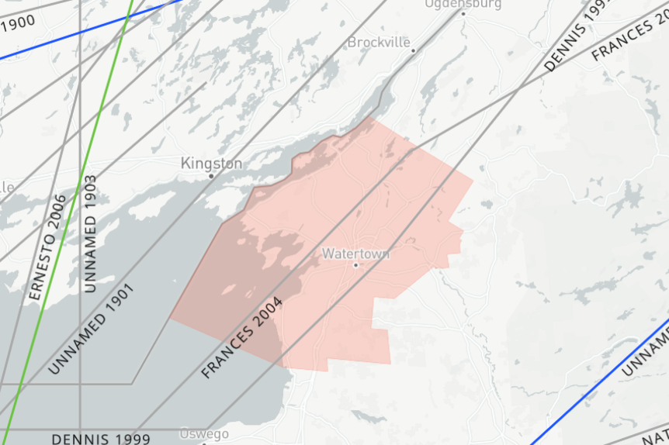
Source: NOAA NHC 2023

Extent

Hailstorms
The severity of hail is measured by duration, hail size, and geographic extent. Hail can exhibit a variety of sizes, though only the very largest hail stones pose serious risk to people, if exposed. It is often estimated by comparing it to a known object (Figure 11-2). Most hailstorms are made up of a mix of different sizes, and only the very largest hail stones pose serious risk to people caught in the open (NSSL 2021).
Figure 11-2. Hail Size Chart
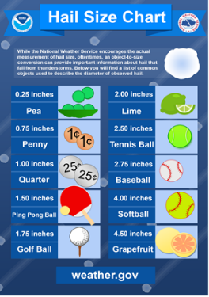

High Winds
The NWS issues advisories and warnings for winds. Issuance is normally site-specific. High wind advisories, watches and warnings are products issued by the NWS when wind speeds may pose a hazard or is life threatening. The criterion for each of these varies from state to state. Wind warnings and advisories for the State of New York are as follows:
- High Wind Warnings are issued when sustained wind speeds of 40 mph or greater lasting for one hour or longer or for winds of 58 mph or greater for any duration or widespread damage are possible.
- Wind Advisories are issues when sustained winds of 30 to 39 mph are forecast for one hour or longer, or wind gusts of 46 to 57 mph for any duration (NWS 2011).

Tornadoes
The Enhanced Fujita Scale (EF-Scale) is the standard used to measure the strength of a tornado. It is used to assign tornadoes a rating based on estimated wind speeds and related damage. When tornado-related damage is surveyed, it is compared to a list of Damage Indicators (DI) and Degree of Damage (DOD), which help better estimate the range of wind speeds produced by the tornado. From that, a rating is assigned, similar to that of the F-Scale, with six categories from EF0 to EF5, representing increasing degrees of damage. The EF-Scale was revised from the original F-Scale to reflect better examinations of tornado damage surveys. This new scale considers how most structures are designed (NWS n.d.). Figure 11-3 illustrates the relationship between EF ratings, wind speed, and expected tornado damage. Jefferson County typically experience tornadoes ranging from EF0 to EF1.
NOAA Storm Prediction Center issues watch and warning alerts for tornado activities. A tornado watch is when conditions are favorable for a tornado to form. A watch can cover parts of a state or span several states (NOAA-NSSL n.d.). A tornado warning is when a tornado is spotted by a radar and indicated action should we taken to ensure safety and shelter. Warnings can cover parts of counties or several counties, depending on the tornadoes path (NOAA-NSSL n.d.). The current average lead time for tornado warnings is 13 minutes. Occasionally, tornadoes develop so rapidly, that little, if any, advance warning is possible (NWS n.d.).
Figure 11-3. Explanation of EF-Scale Ratings
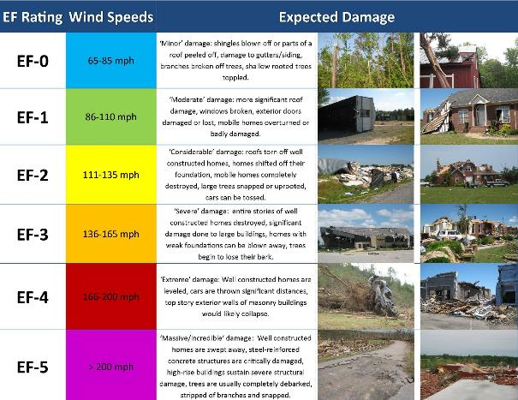
Source: NWS n.d.

Thunderstorms
Severe thunderstorm statements, watches, and warnings are issued by the local NWS office and the Storm Prediction Center (SPC). The NWS and SPC will update the watches and warnings and notify the public when they are no longer in effect. NWS issues statements, watches, and warnings for thunderstorms (NWS 2023).:
- Special Weather Statement: Issued for strong storms that are below severe levels but may have impacts. Usually reserved for the threat of wind gust of 40–57 mph or hail of 0.5-inches to 0.99-inches in diameter.
- Severe Thunderstorm Watches: A severe thunderstorm watch is issued when severe thunderstorms are possible in and near watch areas.
- Severe Thunderstorm Warning: A severe thunderstorm is imminent or occurring; it is either detected by weather radar or reported by storm spotters. A severe thunderstorm is one that produces winds 58 mph or stronger and/or hail 1 inch in diameter or larger. A warning means to take shelter.
The NWS has five risk categories for severe weather: marginal, slight, enhanced, moderate, and high. The probabilistic forecast directly expresses the best estimate of a severe weather event occurring within 25 miles of a point (NWS 2022). Figure 11-4 details the thunderstorm risk categories.
Figure 11-4. Thunderstorm Risk
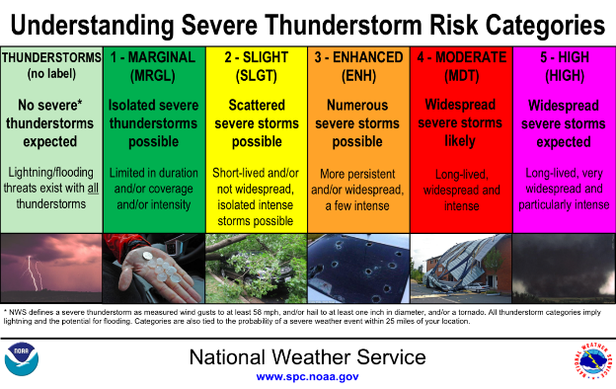
Source: NOAA

Nor’easters
Nor’easters have the potential to impact society to a greater extent than hurricanes and tornadoes. These storms often have a diameter three to four times larger than a hurricane and therefore, impact much larger areas. The severity of a Nor’easter depends on several factors including a region’s climatological susceptibility to snowstorms, snowfall amounts, snowfall rates, wind speeds, temperatures, visibility, storm duration, topography, time of occurrence during the day (e.g., weekday versus weekend), and season.
NOAA’s National Climatic Data Center (NCDC) is currently producing the Regional Snowfall Index (RSI) for significant snowstorms that impact the eastern two-thirds of the United States. The RSI ranks snowstorm impacts on a scale from 1 to 5 and is based on the spatial extent of the storm, the amount of snowfall, and the interaction of the extent and snowfall totals with population. The NCDC has analyzed and assigned RSI values to over 500 storms since 1900 (NOAA n.d.). Table 11-1 lists the five categories.
Table 11-1. Regional Snowfall Index Ranking Categories
Category | Description | RSI Value
1 | Notable | 1-3
2 | Significant | 3-6
3 | Major | 6-10
4 | Crippling | 10-18
5 | Extreme | 18+
Source: NOAA-NCDC 2011

Hurricanes/Tropical Storms
Hurricanes are classified according to the Saffir-Simpson Hurricane Wind Scale from a Category 1 to Category 5 by sustained wind intensity. Figure 11-5 shows the categories and the type of damage they produce.
Figure 11-5. Saffir-Simpson Hurricane Wind Scale
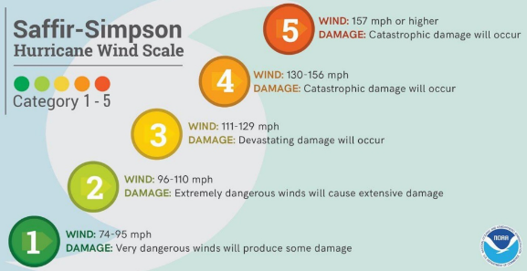
Source: NWS 2022
The NWS issues hurricane and tropical storm watches and warnings. These watches and warnings are issued or will remain in effect after a tropical cyclone becomes post-tropical, when such a storm poses a significant threat to life and property. The NWS allows the National Hurricane Center (NHC) to issue advisories during the post-tropical stage (NHC NOAA 2010):
- A Hurricane Watch is issued when hurricane force winds are possible within 48 hours. People can prepare by boarding up windows and moving loose items indoors and by having an emergency supply kit ready.
- A Hurricane Warning is issued when hurricane force winds are expected within 36 hours. People should seek shelter in a sturdy structure or evacuate if ordered.

Mean Return Period
In evaluating the potential for hazard events of a given magnitude, a mean return period (MRP) is often used. Figure 11-6 and Figure 11-7 show the estimated maximum three-second gust wind speeds that can be anticipated in the study area associated with the 100- and 500-year MRP events. These peak wind speed projections were generated using Hazards U.S. Multi-Hazard (HAZUS-MH) model runs for the 100- and 500-year event. The maximum 3-second gust wind speeds for Jefferson County are under 39 mph for the 100-year MRP event. The maximum 3-second gust wind speeds for Jefferson County range from 39 to 73 mph for the 500-year MRP event. The associated impacts and losses from these 100-year and 500-year MRP hurricane event model runs are reported in the Vulnerability Assessment.
Figure 11-6. 100-Year MRP Hurricane Event Impacts to Jefferson County
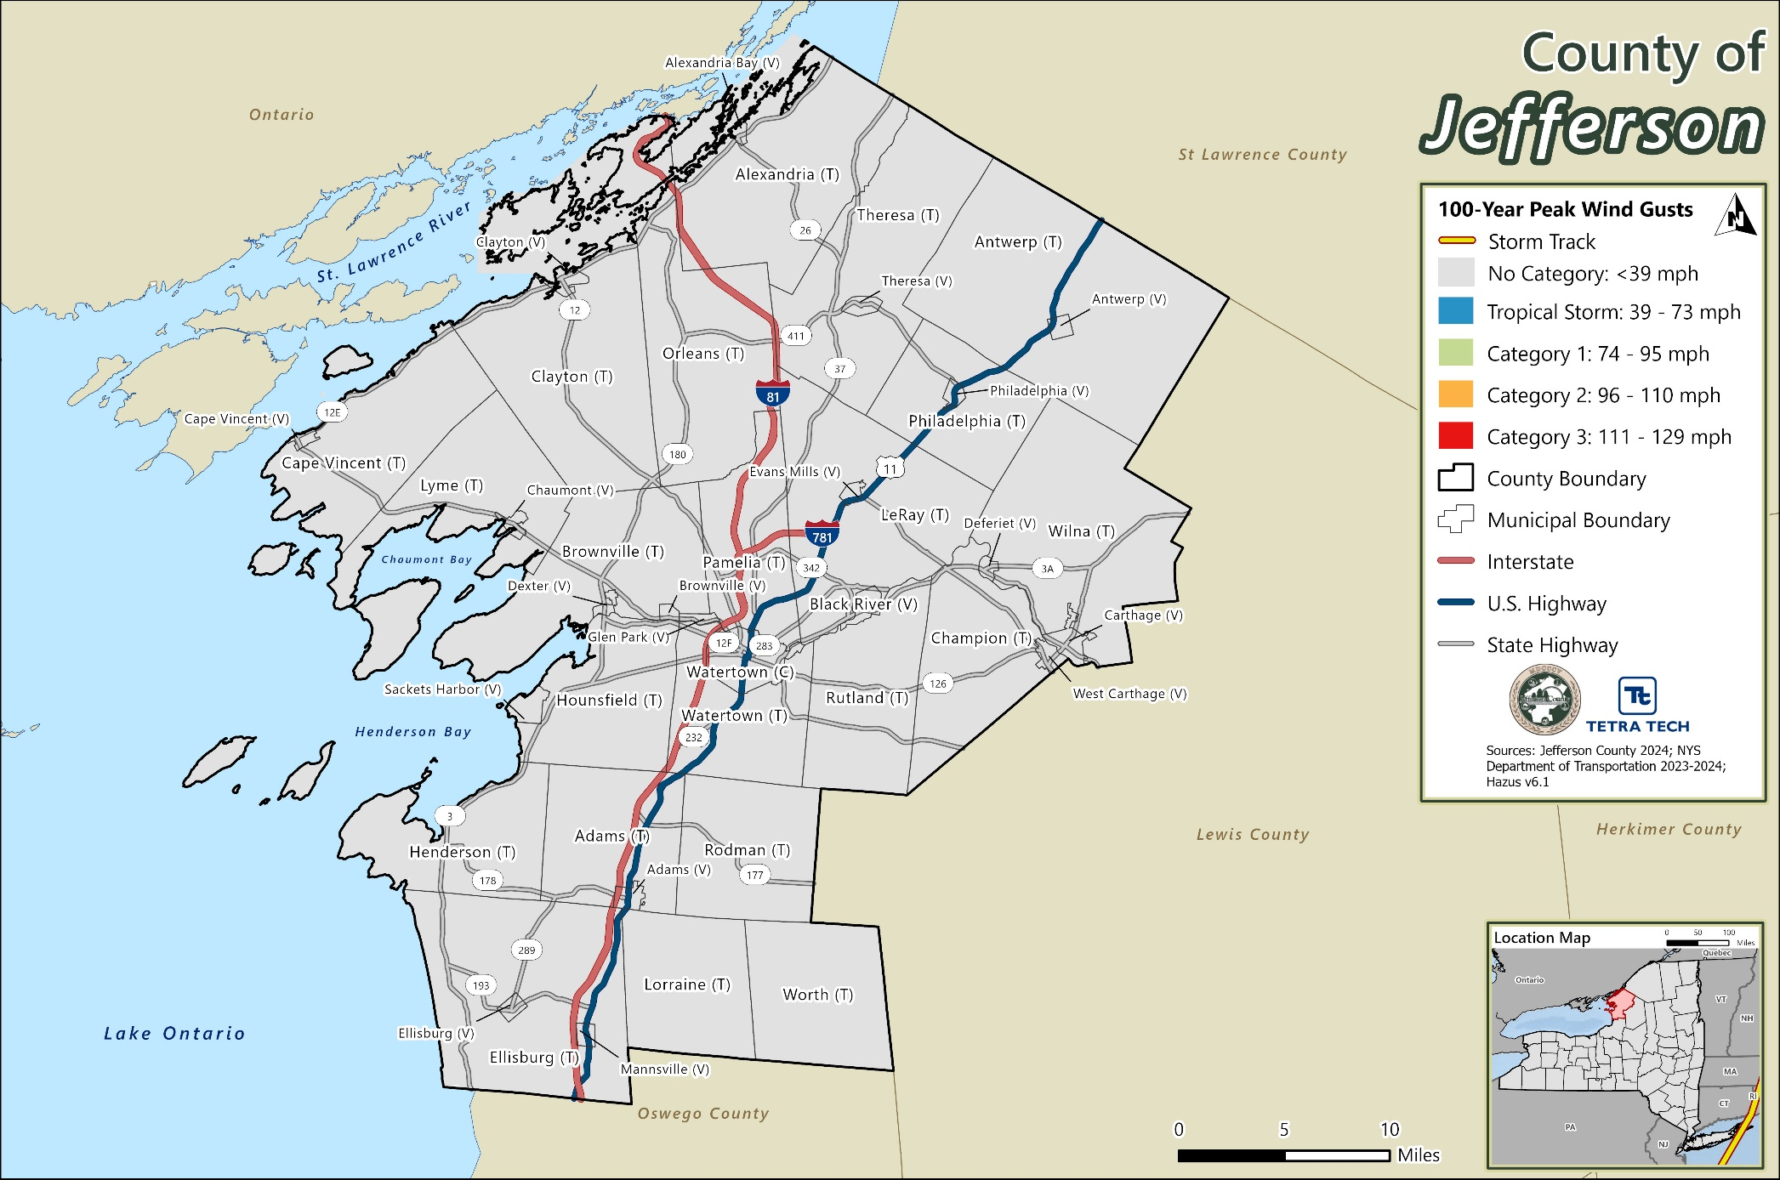
Figure 11-7. 500-Year MRP Hurricane Event Impacts to Jefferson County
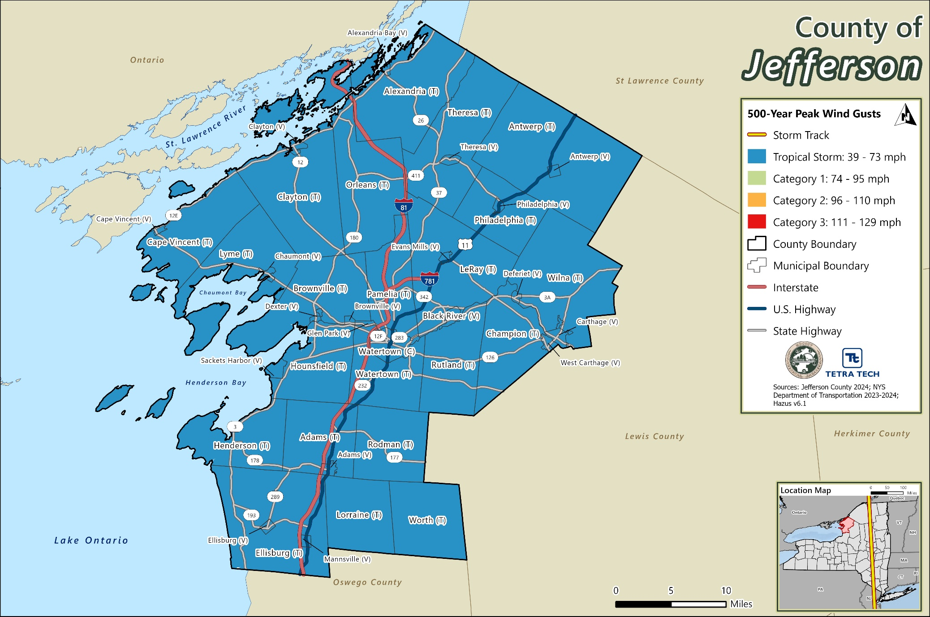

Previous Occurrences

FEMA Major Disaster and Emergency Declarations
Between 1954 and 2024, Jefferson County was included in five major disaster (DR) or emergency (EM) declarations for severe storm related events (FEMA 2024). Table 11-2 lists these declarations.
Table 11-2. FEMA Declarations for Severe Storm Events in Jefferson County (1954 to 2024)
Event Date | Declaration Date | Declaration Number | Description
May 13-June 17, 2004 | August 3, 2004 | DR-1534-NY | Severe Storms and Flooding
August 29-October 1, 2005 | September 30, 2005 | EM-3262-NY | Hurricane Katrina Evacuation
October 27-November 8, 2012 | October 28, 2012 | EM-3351-NY | Hurricane Sandy
October 31-November 1, 2019 | December 19, 2019 | DR-4472-NY | Severe Storms, Straight-Line Winds, and Flooding
August 8-10, 2024 | September 24, 2024 | DR-4825-NY | Remnants of Tropical Storm Debby
Source: FEMA 2024

USDA Declarations
The Secretary of Agriculture from the U.S. Department of Agriculture (USDA) is authorized to designate counties as disaster areas to make emergency loans to producers suffering losses in those counties and in contiguous counties. Between 2012 and 2024, Jefferson County was included in nine USDA severe storm-related agricultural disaster declarations. For declarations that occurred between 2012 and 2024, refer to Table 11-3.
Table 11-3. USDA Declarations for Severe Storm Events in Jefferson County (2012 to 2024)
Event Date | USDA Declaration Number | Description
May 1, 2013 | S3593 | Excessive Rain, Flash Flooding, Flooding, High Winds, and Hail
April 1-July 8, 2014 | S3747 | Excessive Rain, Flash Flooding, Flooding, High Winds, and Hail
May 1- July 14, 2015 | S3885 | Excessive Rain, High Winds, Hail, Lightning, and Tornado
July 23, 2018 | S4479 | Excessive Precipitation
April 1, 2019 | S4622 | Excessive Rain
April 15, 2019 | S4623 | Excessive Rain, Flash Flooding, and Flooding
August 8, 2023 | S5640 | Tornado and Excessive Rain
July 10-16, 2024 | S5739 | Tornado, Hurricane, High Wind, Flash Flood, Excessive Rain, Hail
August 5-10, 2024 | S5875 | Hurricane Debby
Source: USDA 2024

Previous Events below Declaration Thresholds
Known hazard events that impacted Jefferson County between January 2009 and December 2024 are discussed in Table 11-4. For events prior to 2009, refer to the 2011 Jefferson County HMP.
Table 11-4. Severe Storm Events in Jefferson County (2009 to 2024)
Event Date | Location Impacted | Description
August 4, 2009 | Philadelphia | Scattered thunderstorms resulted in intense thunderstorm wind that resulted in $53,000 in property damages and downed trees and power lines throughout the County.
December 9-10, 2009 | County-wide | High Wind resulted in $100,000,000 in property damages.
May 8, 2010 | County-wide | High Wind resulted in $100,000 in property damages.
July 21, 2010 | Grindstone, St. Lawrence, La Fargeville, Calcium | Thunderstorms produced large hail and damaging winds of up to 60 mph. Numerous trees were downed on Grindstone Island, and throughout the County. Documented property damages totaled to be $195,000
July 28, 2010 | Clayton, Brownville | Thunderstorms led to downed utility poles and trees throughout the County. Documented property damages totaled to be $75,000.
April 16, 2011 | County-wide | Strong winds led to $15,000 in documented property damages for the County.
June 8, 2011 | Westminster Park, Sackets Harbor, Carthage, Evans Mills. Ellisburg, Henderson, Lorraine | A thunderstorm led to some County residents without power. Documented property damages totaled to be $66,000.
January 17-18, 2012 | County-wide | Strong winds were reported in the area which led to $40,000 in documented property damages.
March 3, 2012 | County-wide | High winds were reported in the are which led to $20,000 in documented property damages.
July 31, 2012 | Dexter, Ellisburg | A band of showers and thunderstorms resulted in numerous reports of trees and wires that were downed. Reported property damages totaled to $20,000.
August 5, 2012 | Ellisburg, Adams | Showers and thunderstorms resulted in downed trees and wires. Reported property damages totaled to $20,000.
September 8, 2012 | Redman, Watertown | A line of thunderstorms led to numerous reports of downed trees and wires. Reported property damages totaled to $20,000.
September 22, 2012 | County-wide | A line of showers and thunderstorms produces strong winds that knocked down trees and wires. Reported property damages totaled to $20,000.
December 21, 2012 | County-wide | Strong winds resulted in downed trees and wires in Mannsville, Lorraine, and Watertown. Reported property damages totaled to $30,000.
January 20, 2013 | County-wide | A storm system brought strong winds to the area with trees and wires being reported down in Lowville. Reported property damages totaled to $30,000.
May 21-22, 2013 | Pierrepoint Manor, Watertown, Sackets Harbor, Herrings, Admas Center | A thunderstorm produced hail which led to wires and trees that were knocked over. Reported property damages totaled to $50,000.
November 1, 2013 | County-wide | A storm system brought strong winds to the area with reported property damages totaled to $20,000.
November 18, 2013 | County-wide | A storm system brought strong winds to the area with reported property damages totaled to $20,000.
January 6, 2014 | County-wide | A storm system brought strong winds to the area that knocked wires down. Reported property damages totaled to $15,000.
June 17, 2014 | Adams, Sackets Harbor, Ellisburg, Watertown, Black River | Scattered showers and thunderstorms resulted in wires and trees being knocked over, notably on Route 11. Reported property damages totaled to $65,000.
July 8, 2014 | Adams, Mannsville, Watertown, Great Bend, Antwerp | Severe thunderstorms came through the area which resulted in strong winds that knocked trees and wires down. Reported property damages totaled to $65,000.
April 10, 2015 | County-wide | Strong winds developed in the area which resulted in downed trees on Avery and Croghan Roads. Reported property damages totaled to $20,000.
October 28, 2015 | County-wide | Strong winds developed in the area which resulted in property damages that totaled to $20,000.
November 12-13, 2015 | County-wide | Strong winds developed in the area which resulted in property damages that totaled to $25,000.
January 10-11, 2016 | County-wide | Strong winds developed in the area which resulted in $25,000 in property damages.
June 11, 2016 | Adams Center | Showers and thunderstorms moved across the County resulting in downed trees. Reported property damages totaled to $20,000.
June 20, 2016 | Evans Mill, Watertown Center | Thunderstorms brought severe winds which resulted in wires downed across Route 11 and Waddington. A power pole was also reported downed on Fairmont Avenue. Reported property damages totaled to $95,000.
January 11, 2017 | County-wide | Strong winds led to downed trees and powerlines throughout the County. Reported property damages totaled to $75,000.
February 25, 2017 | Pamelia Four Corners, Theresa, Philadelphia | Thunderstorms brought damaging winds which resulted in a damaged mobile home, a roof, and a fence. Additionally, trees and wires were also reported to be downed. Property damages totaled to $80,000.
March 1-2, 2017 | County-wide | Strong winds led to downed trees and wires in Watertown. Reported property damages totaled to $25,000.
March 8, 2017 | County-wide | Strong winds resulted in $200,000 in property damages.
May 1, 2017 | Chaumont, Watertown, Westminister Park, West Carthage | Strong thunderstorms produced winds that knocked over trees and wires. Reported property damages totaled to $40,000.
August 4, 2017 | Carthage, Philadelphia, Redwood, Adams, Ellisburg | Strong thunderstorms produced hail which knocked over numerous trees and wires. Reported property damages totaled to $55,000.
August 22, 2017 | Watertown, Carthage | Severe storms resulted in strong winds that downed a large tree in the City of Watertown. Reported property damages totaled to $35,000.
October 30, 2017 | County-wide | Strong winds resulted in $25,000 in property damages.
April 4, 2018 | County-wide | Strong winds resulted in multiple trees and wires being reported down throughout the County. Reported property damages totaled to $15,000.
August 15, 2018 | Frontenac, Fineview | Hail slightly smaller than a golf ball was reported by the public, in addition to dented cars in the areas. Reported property damages totaled to $20,000.
February 24, 2019 | County-wide | Strong winds resulted in trees and wires down throughout the County which caused substantial damage to homes and businesses and resulted in power outages. Reported property damages totaled to $20,000.
November 15-16, 2020 | County-wide | A thunderstorm brought strong winds that blew down a barn on Route 78 in addition to wires and trees that were knocked over. Reported property damages totaled to $48,000.
December 11-12, 2021 | County-wide | Strong winds resulted in numerous reports of trees and powerlines that were knocked down. Reported property damages totaled to $50,000.
December 3, 2022 | County-wide | Strong winds resulted in downed trees. Reported property damages totaled to $20,000.
July 13, 2023 | Belleville | Severe thunderstorms resulted in over 600 acres of corn that was flattened along Route 289. Reported property damages totaled to $600,000 in crop damages.
January 9-10, 2024 | County-wide | Strong winds produced gusts above 60 mph and several trees were also reported down throughout the County. Reported property damages totaled to $25,000.
January 13-14, 2024 | County-wide | A powerful storm produced damaging winds that knocked trees down in Clayton and Mannsville. Reported property damaged totaled to $35,000.
July 16, 2024 | County-wide | Strong winds resulted in numerous reports of trees and powerlines that were knocked down as well as damages to infrastructure. Reported property damages totaled to $21,000.
Note: Events that incurred $15,000 or more of property damage are reported. Those that incurred less than$15,000 in damages are not reported in this table.

Cascading Impacts on Other Hazards
Severe weather events and severe wind events can escalate the impacts of flooding and utility failure. Severe winds can be destructive to the functionality of utilities by breaching power lines and disconnecting the utility systems. Severe weather may carry extreme rainfall that could exacerbate flooding. More information about flooding can be found in Chapter 9 of this HMP.

Vulnerability and Impact Assessment
To understand risk, a community must evaluate what assets are exposed or vulnerable in the hazard area identified. The entire County has been identified as exposed for severe storms. Therefore, all assets in the County (population, structures, critical facilities, and lifelines), as described in the County Profile (Section 3), are exposed and vulnerable to severe storm events.

Life, Health, and Safety

Overall Population
The entire population of Jefferson County (461,860) is exposed to this hazard; however, however, the impact of these events can have on life, health, and safety are dependent upon several factors, including the severity of the event and whether adequate warning time was provided to residents.
Outdoor workers are vulnerable to severe weather events. Employers should prepare for the hazards associated with adverse weather conditions that may require special facilities and safety equipment being provided to employees, or in some instances, work stoppage to ensure the safety and health of workers. Wet weather and high wind conditions can pose a greater threat to employees working in the construction, and shipbuilding industries. For instance, workers in the construction industry are bound to work in open spaces, at heights, with electrical equipment and metals, in excavation areas and trenches, and may handle hazardous materials as a work task, thereby causing exposure to a myriad of safety hazards (Hazwoper OSHA 2020).
As a result of a significant hurricane event, residents may be displaced or require temporary to long-term sheltering. The number of people requiring shelter is generally less than the number displaced as some displaced persons use hotels or stay with family or friends following a disaster event. Hazus estimates that there will not be any displaced households or persons seeking short-term shelter from the 100-year and 500-year MRP event.

Socially Vulnerable Population
Socially vulnerable populations are most susceptible due to their physical and financial ability to react and respond during extreme severe summer weathers. This population includes the elderly, young, and individuals with disabilities or access or functional needs who may be unable to evacuate in the event of an emergency. The elderly are considered most vulnerable because they require extra time or outside assistance during evacuations and are more likely to seek or need medical attention that might not be readily available due to isolation during a storm event. Section 3 (County Profile) provides statistics of these populations.
Economically disadvantaged people are at high risk for bracing severe summer weathers because of the potential inability to afford up-to-code homes and buildings that are deemed safe from storms passing through. They also may pose health issues, such as exposure to mold and other health issues that water seepage may cause. These populations may also lack access to vehicles for any necessary evacuations. The vulnerable population also includes those who would not have adequate warning from an emergency warning system (e.g., television or radio); this would include residents and visitors. The population adversely affected by severe summer weathers may also include those beyond the disaster area that rely on affected roads for transportation.
According to the 2022 five-year American Community Survey (ACS) population estimate, there are 14,310 total persons living below the poverty level, 16,667 persons over the age of 65 years, 8,759 persons under the age of five years, 1,511 non-English speakers, and 15,255 persons with a disability living in Jefferson County.

General Building Stock
All buildings are exposed to severe weather hazards such as hailstorms and lightning strikes. Refer to Section 3 (County Profile) for summaries of the building inventory in Jefferson County. An extreme hailstorm event can carry hail stones traveling at speeds greater than 100 miles per hour and all infrastructure is vulnerable to a lightning straight (NWS 2019). This could cause structural damage for the general building stock in the County.
Severe summer weather that causes lightning could be a threat to the County’s general building stock if the lightning starts a fire. Over 22,000 fires caused by lightning occurred annually throughout the U.S. between 2007 and 2011, which was valued at approximately $450 million of damages per year (NFPA 2013).
Potential building damage was evaluated by Hazus across the following damage categories: none, slight, moderate, extensive, and complete. Table 11-5 provides definitions of the categories of damage for a light wood-framed building. Definitions for other building types are included in the Hazus technical manual documentation. The results of potential damage states for buildings in Jefferson County categorized by general occupancy classes (i.e., residential, commercial, industrial, etc.) from Hazus are zero dollars in damages for the 100-year MRP event. Table 11-6 and Table 11-7 summarize the damage to structures for the 500-year MRP event. The analysis estimates that there will be $3,076,422 in total damage to structures, with the estimated residential damage being the most expensive at $ $2,050,800, with 18 dwellings expected to sustain minor damage. The Town of Alexandria is projected to sustain the most damage to buildings at $331,883 in damages for the 500-year MRP.
Table 11-5. Example of Structural Damage State Definitions for a Light Wood Framed Building
Damage Category | Description
Slight | Small plaster or gypsum-board cracks at corners of door and window openings and wall-ceiling intersections; small cracks in masonry chimneys and masonry veneer.
Moderate | Large plaster or gypsum-board cracks at corners of door and window openings; small diagonal cracks across shear wall panels exhibited by small cracks in stucco and gypsum wall panels; large cracks in brick chimneys; toppling of tall masonry chimneys.
Extensive | Large diagonal cracks across shear wall panels or large cracks at plywood joints; permanent lateral movement of floors and roof; toppling of most brick chimneys; cracks in foundations; splitting of wood sill plates and/or slippage of structure over foundations; partial collapse of room-over-garage or other soft-story configurations.
Complete | Structure may have large permanent lateral displacement, may collapse, or be in imminent danger of collapse due to cripple-wall failure or the failure of the lateral load resisting system; some structures may slip and fall off the foundations; large foundation cracks.
Source: FEMA 2022
Table 11-6. Building Loss for the 500-Year MRP Hurricane Event by Jurisdiction
Jurisdiction | Building Loss - 500-Year MRP Hurricane
 | Estimated Building Losses (All Occupancies) | Estimated Building Losses (Residential) | Estimated Building Losses (Commercial) | Estimated Building Losses (Industrial) | Estimated Damages  (All Other Occupancies)
Adams (T) | $33,464 | $33,464 | $0 | $0 | $0
Adams (V) | $14,150 | $14,150 | $0 | $0 | $0
Alexandria (T) | $331,883 | $233,213 | $68,265 | $11,951 | $18,454
Alexandria Bay (V) | $113,862 | $62,655 | $38,573 | $6,216 | $6,418
Antwerp (T) | $83,083 | $42,232 | $14,988 | $4,939 | $20,925
Antwerp (V) | $36,873 | $18,734 | $6,664 | $2,170 | $9,304
Black River (V) | $45,066 | $31,765 | $5,966 | $2,384 | $4,951
Brownville (T) | $52,895 | $52,895 | $0 | $0 | $0
Brownville (V) | $11,001 | $11,001 | $0 | $0 | $0
Cape Vincent (T) | $16,249 | $16,057 | $134 | $22 | $37
Cape Vincent (V) | $842 | $842 | $0 | $0 | $0
Carthage (V) | $231,947 | $121,792 | $84,169 | $15,534 | $10,452
Champion (T) | $180,812 | $80,548 | $52,156 | $16,337 | $31,771
Chaumont (V) | $23,997 | $16,213 | $5,428 | $875 | $1,480
Clayton (T) | $68,795 | $68,245 | $384 | $62 | $105
Clayton (V) | $28,493 | $28,493 | $0 | $0 | $0
Deferiet (V) | $27,650 | $12,256 | $12,061 | $2,024 | $1,309
Dexter (V) | $9,525 | $9,525 | $0 | $0 | $0
Ellisburg (T) | $20,273 | $20,273 | $0 | $0 | $0
Ellisburg (V) | $474 | $474 | $0 | $0 | $0
Evans Mills (V) | $28,413 | $16,406 | $4,727 | $2,011 | $5,270
Glen Park (V) | $5,678 | $5,678 | $0 | $0 | $0
Henderson (T) | $40,262 | $40,262 | $0 | $0 | $0
Hounsfield (T) | $36,178 | $36,178 | $0 | $0 | $0
LeRay (T) | $312,010 | $205,892 | $58,788 | $21,288 | $26,042
Lorraine (T) | $5,797 | $5,797 | $0 | $0 | $0
Lyme (T) | $175,813 | $118,827 | $39,743 | $6,405 | $10,838
Mannsville (V) | $726 | $726 | $0 | $0 | $0
Orleans (T) | $83,057 | $83,057 | $0 | $0 | $0
Pamelia (T) | $63,681 | $63,335 | $136 | $58 | $152
Philadelphia (T) | $76,961 | $31,911 | $17,731 | $7,537 | $19,781
Philadelphia (V) | $75,496 | $31,278 | $17,407 | $7,405 | $19,406
Rodman (T) | $14,530 | $14,530 | $0 | $0 | $0
Rutland (T) | $111,250 | $49,272 | $30,412 | $8,433 | $23,134
Sackets Harbor (V) | $17,815 | $17,815 | $0 | $0 | $0
Theresa (T) | $165,973 | $93,281 | $26,708 | $8,697 | $37,286
Theresa (V) | $49,728 | $25,266 | $8,988 | $2,927 | $12,548
Watertown (C) | $114,598 | $114,598 | $0 | $0 | $0
Watertown (T) | $52,338 | $52,338 | $0 | $0 | $0
West Carthage (V) | $106,748 | $48,746 | $30,824 | $9,989 | $17,190
Wilna (T) | $205,200 | $117,945 | $64,659 | $13,419 | $9,177
Worth (T) | $2,836 | $2,836 | $0 | $0 | $0
Jefferson County (Total) | $3,076,422 | $2,050,800 | $588,911 | $150,682 | $286,029
Source: Hazus v6.1; Jefferson County 2024; City of Watertown 2024; USACE 2022; RS Means 2024
Table 11-7. 500-Year Hurricane MRP Building Damages by Occupancy Class
Occupancy Class | Total Number of Buildings in Occupancy | Severity of Expected Damage | 500-Year MRP Hurricane
 |  |  | Building Count | Percent Buildings in Occupancy Class
Residential Exposure (Single and Multi-Family Dwellings) | 44,821 | NONE | 44,802 | 100.0%
 |  | MINOR | 18 | <0.1%
 |  | MODERATE | 1 | <0.1%
 |  | SEVERE | 0 | 0.0%
 |  | DESTRUCTION | 0 | 0.0%
Commercial Buildings | 2,462 | NONE | 2,457 | 99.8%
 |  | MINOR | 5 | 0.2%
 |  | MODERATE | 0 | 0.0%
 |  | SEVERE | 0 | 0.0%
 |  | DESTRUCTION | 0 | 0.0%
Industrial Buildings | 976 | NONE | 973 | 99.7%
 |  | MINOR | 3 | 0.3%
 |  | MODERATE | 0 | 0.0%
 |  | SEVERE | 0 | 0.0%
 |  | DESTRUCTION | 0 | 0.0%
Government, Religion, Agricultural, and Education Buildings | 1,926 | NONE | 1,923 | 99.8%
 |  | MINOR | 3 | 0.2%
 |  | MODERATE | 0 | 0.0%
 |  | SEVERE | 0 | 0.0%
 |  | DESTRUCTION | 0 | 0.0%
Source: Hazus v6.1; Jefferson County 2024; City of Watertown 2024; USACE 2022

Community Lifelines and Other Critical Facilities
All critical facilities in the County are exposed to the severe weather hazard with similar risks as discussed for the general building stock. It is essential that critical facilities remain operational during natural hazard events. Backup power is recommended for critical facilities and infrastructure. Where backup power is needed for critical facilities that provide essential services, municipalities identified mitigation actions in Section 9 (Jurisdictional Annexes).
Critical facilities are also at risk of being impacted by high winds associated with structural damage, or falling tree limbs/flying debris, which can result in the loss of power. Power loss can greatly impact households, business operations, public utilities, and emergency personnel. Emergency personnel such as police, fire, and emergency medical services (EMS) will not be able to effectively respond in a power loss event to maintain the safety of its citizens unless backup power and fuel sources are available. Loss of power can impact other public utilities, including potable water, wastewater treatment, and communications. In addition to public water services, property owners with private wells might not have access to potable water until power is restored.
The Hazus hurricane model was used to assign the range or average probability of each damage state category to the critical facilities and lifelines in Jefferson County for the 100-year and 500-year MRP events. For percent probability of sustaining damage, the minimum and maximum damage estimated value for that facility type is presented.
As a result of a 100-year MRP event, Hazus estimates that no structures will sustain any damages. As a result of a 500-year MRP event, Hazus estimates that communication facilities, facilities that contain hazardous materials, and water system facilities have the greatest chance of sustaining minor damage, at 0.4 percent of damages. No facilities are estimated to incur more than minor damages. Table 11-8 summarizes the damage state probabilities for critical facilities during the 500-year MRP event.
Table 11-8. 500-Year Hurricane MRP Damages
Name | Loss of Days | Average Percent Probability of Sustaining Damage  500-Year MRP Hurricane
 |  | Minor | Moderate | Severe | Complete
Communications | 0 | 0.4% | 0.0% | 0.0% | 0.0%
Energy | 0 | 0.3% | 0.0% | 0.0% | 0.0%
Food, Hydration, Shelter | 0 | 0.0% | 0.0% | 0.0% | 0.0%
Hazardous Materials | 0 | 0.4% | 0.0% | 0.0% | 0.0%
Health and Medical | 0 | 0.1% | 0.0% | 0.0% | 0.0%
Safety and Security | 0 | 0.3% | 0.0% | 0.0% | 0.0%
Transportation | 0 | 0.1% | 0.0% | 0.0% | 0.0%
Water Systems | 0 | 0.4% | 0.0% | 0.0% | 0.0%
Source: Hazus v6.1; Jefferson County 2024; New York State Department of Environmental Conservation 2023, 2024; Federal Communications Commission 2024; HIFLD 2023, 2024; NYS Department of Health 2024; National Plan and Provider Enumeration System 2023; USACE 2024; NYS Department of Transportation 2023

Economy
Severe weather events can have short- and long-lasting impacts on the economy. When a business is closed during storm recovery, there is lost economic activity in the form of day-to-day business and wages to employees. Overall, economic impacts include the loss of business function (e.g., tourism, recreation), damage to inventory, relocation costs, wage loss and rental loss due to the repair/replacement of buildings. Impacts to transportation lifelines affect both short-term (e.g., evacuation activities) and long-term (e.g., day-to-day commuting and goods transport) transportation needs. Utility infrastructure (power lines, gas lines, electrical systems) could suffer damage and impacts can result in the loss of power, which can impact business operations and can impact heating or cooling provision to the population.
Hazus also estimates the volume of debris that may be generated as a result of a hurricane event to enable the study region to prepare and rapidly and efficiently manage debris removal and disposal. For the 100-year MRP event, Hazus estimates that no debris will be generated. For the 500-year MRP event, Hazus estimates a total of 16,603 tons of debris will be generated county-wide, with the Town of Wilna producing the most estimated debris. Table 11-9 summarizes the estimated debris for the 500-Year MRP by municipality.
Table 11-9. Estimated Debris Created During the 500-Year MRP Hurricane Event
 | Estimated Debris Created During the 500-Year MRP Hurricane Wind Event
Jurisdiction | Brick and Wood (tons) | Concrete and Steel (tons) | Tree (tons)
Adams (T) | 1 | 0 | 0
Adams (V) | 1 | 0 | 0
Alexandria (T) | 30 | 0 | 1,586
Alexandria Bay (V) | 15 | 0 | 0
Antwerp (T) | 11 | 0 | 438
Antwerp (V) | 5 | 0 | 0
Black River (V) | 3 | 0 | 65
Brownville (T) | 1 | 0 | 0
Brownville (V) | 0 | 0 | 0
Cape Vincent (T) | 1 | 0 | 0
Cape Vincent (V) | 0 | 0 | 0
Carthage (V) | 17 | 0 | 454
Champion (T) | 22 | 0 | 4
Chaumont (V) | 1 | 0 | 0
Clayton (T) | 4 | 0 | 0
Clayton (V) | 2 | 0 | 0
Deferiet (V) | 2 | 0 | 27
Dexter (V) | 0 | 0 | 0
Ellisburg (T) | 0 | 0 | 0
Ellisburg (V) | 0 | 0 | 0
Evans Mills (V) | 3 | 0 | 119
Glen Park (V) | 0 | 0 | 0
Henderson (T) | 0 | 0 | 0
Hounsfield (T) | 2 | 0 | 0
LeRay (T) | 20 | 0 | 765
Lorraine (T) | 0 | 0 | 0
Lyme (T) | 9 | 0 | 0
Mannsville (V) | 0 | 0 | 0
Orleans (T) | 3 | 0 | 330
Pamelia (T) | 2 | 0 | 3
Philadelphia (T) | 10 | 0 | 446
Philadelphia (V) | 10 | 0 | 439
Rodman (T) | 0 | 0 | 0
Rutland (T) | 16 | 0 | 0
Sackets Harbor (V) | 1 | 0 | 0
Theresa (T) | 19 | 0 | 214
Theresa (V) | 6 | 0 | 0
Watertown (C) | 5 | 0 | 35
Watertown (T) | 2 | 0 | 0
West Carthage (V) | 12 | 0 | 0
Wilna (T) | 14 | 0 | 4,018
Worth (T) | 0 | 0 | 0
Jefferson County (Total) | 249 | 0 | 8,943
Source: Hazus v6.1; Jefferson County 2024; City of Watertown 2024; USACE 2022

Natural, Historic and Cultural Resources

Natural
The impact of severe weather events on the environment varies, but researchers are finding that the long-term impacts of more severe weather can be destructive to the natural and local environment. National organizations such as USGS and NOAA have been studying and monitoring the impacts of extreme weather phenomena as it impacts long-term climate change, streamflow, river levels, reservoir elevations, rainfall, floods, landslides, erosion, etc. For example, severe weather that creates longer periods of rainfall can erode natural banks along waterways and degrade soil stability for terrestrial species. Tornadoes can tear apart habitats causing fragmentation across ecosystems (US EPA 2023). Researchers also believe that a greater number of diseases will spread across ecosystems because of impacts that severe weather and climate change will have on water supplies (U.S. Climate Resilience Toolkit 2016). Overall, as the physical environment becomes more altered, species will begin to contract or migrate in response, which may cause additional stressors to the entire ecosystem within Jefferson County.

Historic
Winds associated with severe weather can cause damage or destruction to the County’s historical infrastructure. Many historical buildings and homes which may not be built to withstand such high winds and are more vulnerable than other infrastructure.

Cultural
Winds associated with severe weather can cause damage or destruction to the County’s cultural resources. Cultural resources may be located inside of historical buildings and homes, which may not be built to withstand such high winds and are more vulnerable.
Cultural heritage sites, particularly those exposed to the elements, are subject to weathering. Climate change is a potential threat to these sites as it exacerbates the expected rates of decay and contributes to the appearance of new decay. Climatic changes may aggravate the physical, chemical, and biological mechanisms causing degradation by affecting the structure or composition of building materials. Changes in temperature, precipitation, atmospheric moisture, and wind intensity, in addition to sea-level rise, desertification, and the interaction between climatic changes and air pollution, have been identified as concerns by the United Nations Educational, Scientific and Cultural Organization (Sesana, et al. 2021).

Future Occurrences and Projected Changes in Risk
Understanding future changes that affect vulnerability can assist in planning for future development and ensure establishment of appropriate mitigation, planning, and preparedness measures. The following sections examine potential conditions that may affect hazard vulnerability.

Probability of Future Events
Information on previous severe storm occurrences in the County was used to calculate the probability of future occurrence of such events, as summarized in Table 11-10. Based on historical records and input from the Steering Committee, the probability of occurrence for severe storm in the County is considered “frequent.”
Table 11-10. Probability of Future Severe Storm Events in Jefferson County
Hazard Type | Number of Occurrences Between 1996 and 2023 | Percent Chance of Occurring in Any Given Year
Hailstorms | 16 | 57.14%
High/Strong Wind | 58 | 100%
Tornado | 1 | 3.57%
Thunderstorm Wind | 93 | 100%
Hurricane/Tropical Storms | 0 | 0%
Total | 168 | 100%
Source: NOAA NCEI 2024
Note: Due to limitations in data, not all severe storm events occurring between 1954 and 1996 are accounted for in the tally of occurrences. As a result, the number of hazard occurrences is calculated using the number of occurrences between 1996 and 2023.

Climate Change Projections and Likely Impacts
As discussed in previous sections, most studies project that the County will see an increase in average annual temperatures and precipitation. As the climate warms and other changes in climate continue to unfold, the intensity of summer weather may change, producing more ideal conditions for severe storms to form. It is anticipated that the County will continue to experience direct and indirect impacts of severe weather events annually that may induce secondary hazards such as infrastructure deterioration or failure, utility failures, power outages, water quality and supply concerns, and transportation delays, accidents, and inconveniences.
In Jefferson County, and the Great Lakes region, temperatures are estimated to increase by 3.5 ºF to 7.4 ºF by the 2050s, 5.1 ºF to 12.4 ºF by the 2080s, and 5.6 ºF to 14.5 ºF by 2100, relative to the 1981-2010 base period. Precipitation totals are estimated to decrease by one or can increase by up to eleven the 2050s, increase by two to 17 percent by the 2080s, and decrease by four percent or increase by up to 23 percent by 2100, relative to the 1981-2010 base period (Stevens & Lamie 2024).
Projected changes in storm intensity and frequency depend on the type of storm. Heavy rainstorms are projected to happen more often and can become more intense as the climate continues to warm, a change which has the potential to affect drinking water; heighten the risk of riverine flooding; flood key rail lines, roadways, and transportation hubs; and increase delays and hazards related to extreme weather events. Hurricanes and tropical storms have become more intense since the mid 1990’s and their winds and associated flooding are expected to increase. The number of hurricanes and tropical storms in the Atlantic basin may not increase but storms that do form are projected to be stronger and shift farther north (Stevens & Lamie 2024). The length of hurricane season is also likely to expand due to rising water temperatures. Research also suggests that there is a greater risk of more off-season tornadoes in a warmer future climate, which suggests that more tornadic activity may occur when people are least expecting it (NOAA 2023).

Projected Changes in Development and Population
Jefferson County has experienced a decrease in its population since 2010. Cornell University’s Program on Applied Demographics produced populations projections by County from 2016 to 2040. According to these projections, Jefferson County is projected to have a population of 114,290 by 2030 and 115,693 by 2040 (Cornell University 2018). Changes in the density of the population can impact the number of persons exposed to severe storm events.
The ability of new development to withstand severe storm hazard impacts lies in sound land use practices, building design considerations (e.g., Leadership in Energy and Environmental Design [LEED]), and consistent enforcement of codes and regulations for new construction. New development will change the landscape where buildings, roads, and other infrastructure potentially replace open land and vegetation. Surfaces that were once permeable and moist are now impermeable and dry, potentially making them more susceptible to fires caused by lightning.
Chapter 3 identifies areas targeted for future growth and development across the County. Any areas of growth located in the County could be susceptible to severe storms. Specific areas of recent and new development are indicated in tabular form and/or on the hazard maps included in Volume II (Annexes) of this plan.

Severe Winter Storm

Hazard Profile

Hazard Description
A winter storm is a weather event in which the main types of precipitation are snow, sleet, or freezing rain. They can be a combination of heavy snow, blowing snow, and dangerous wind chills. According to the National Severe Storms Laboratory, the three basic components needed to make a winter storm include the following (NOAA 2021):
Below freezing temperatures (cold air) in the clouds and near the ground to make snow and ice.
Lift, something to raise the moist air to form clouds and cause precipitation, such as warm air colliding with cold air and being forced to rise over the cold dome or air flowing up a mountainside (orographic lifting).
Moisture to form clouds and precipitation, such as air blowing across a large lake or the ocean.
Some winter storms can immobilize an entire region, while others might only affect a single community. Winter storms typically are accompanied by low temperatures, high winds, freezing rain or sleet, and heavy snowfall. The aftermath of a winter storm can have an impact on a community or region for days, weeks, or even months; potentially causing cold temperatures, flooding, storm surge, closed and blocked roadways, downed utility lines, and power outages. Jefferson County’s winter storms include blizzards, snowstorms, and ice storms. Extreme cold temperatures and wind chills are associated with winter storms. For more information on extreme cold temperatures, refer to the Chapter 8 (Extreme Temperature).

Heavy Snow
According to the National Oceanic and Atmospheric Administration (NOAA), snow is precipitation in the form of ice crystals. It originates in clouds when temperatures are below the freezing point (32°F) and water vapor in the atmosphere condenses directly into ice without going through the liquid stage. Once an ice crystal has formed, it absorbs and freezes additional water vapor from the surrounding air, growing into snow crystals or a snow pellet, which then falls to the earth. Snow falls in different forms: snowflakes, snow pellets, or sleet. Snowflakes are clusters of ice crystals that form from a cloud (NOAA 2024). Figure 12-1 depicts snow creation.

Sleet
Sleet happens when snowflakes fall through a shallow layer of warm air and partially melt. The slushy drops refreeze as they hit a deeper layer of freezing air above the ground. The resulting frozen pellets bounce when they finally hit a surface, and they are usually smaller than 0.30 inches in diameter (NSSL 2021). Figure 12-2 depicts sleet creation.

Blizzards
A blizzard is a winter snowstorm with sustained or frequent wind gusts of 35 miles per hour (mph) or more, accompanied by falling or blowing snow reducing visibility to or below 0.25 mile, as the predominant conditions over a 3-hour period. Extremely cold temperatures often are associated with blizzard conditions but are not a formal part of the definition. The hazard, created by the combination of snow, wind, and low visibility, significantly increases when temperatures are below 20°F.
Figure 12-1. Snow Creation
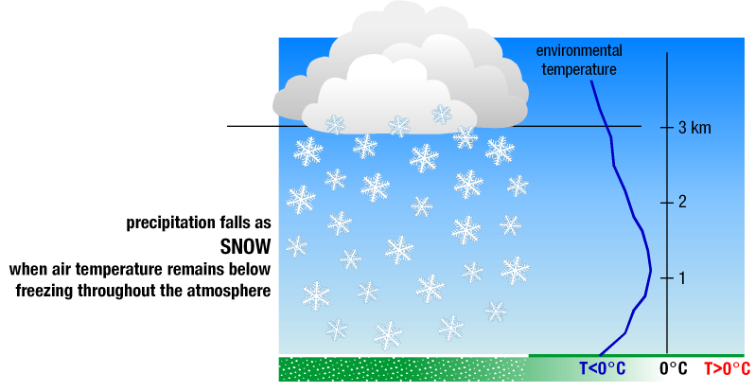
Source: NOAA-NSSL 2015
Figure 12-2. Sleet Creation
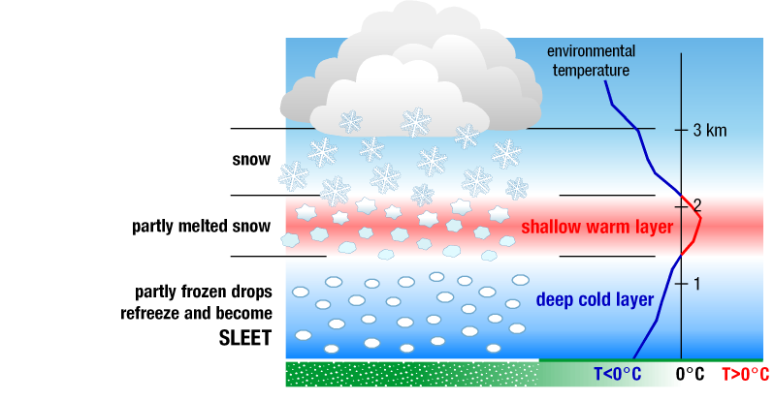
Source: NOAA-NSSL 2020
A severe blizzard is categorized as having temperatures near or below 10°F, winds exceeding 45 mph, and visibility reduced by snow to near zero. Storm systems powerful enough to cause blizzards usually form when the jet stream dips far to the south, allowing cold air from the north to clash with warm, moister air from the south. Blizzard conditions often develop on the northwest side of an intense storm system. The difference between the lower pressure in the storm and the higher pressure to the west creates a tight pressure gradient, resulting in strong winds and extreme conditions caused by the blowing snow (Lam 2019).

Ice Storms
An ice storm describes those events when damaging accumulations of ice are expected during freezing rain situations. Significant ice accumulations typically are accumulations of 0.25-inches or greater (NWS 2013). Heavy accumulations of ice can bring down trees, power lines, utility poles, and communication towers. Ice can disrupt communications and power for days. Even small accumulations of ice can be extremely dangerous to motorists and pedestrians (Dolce 2012). Figure 12-3 depicts freezing rain creation.
Figure 12-3. Freezing Rain Creation
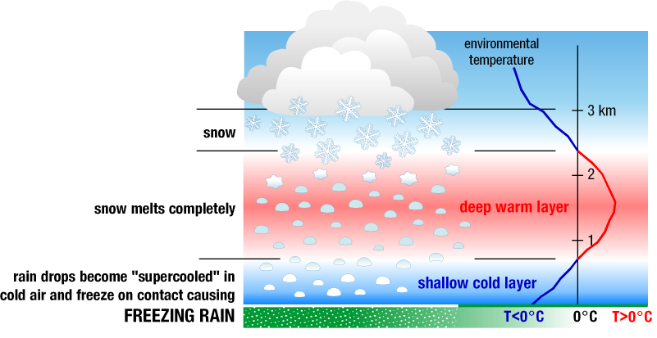
Source: NOAA-NSSL 2020

Location
The climate of New York State is marked by abundant snowfall. Winter weather can reach New York State as early as October and is usually in full force by late November with average winter temperatures between 20°F and 40°F. The inland regions of New York State receive more snow than most other communities in the nation. Although the entire State is subject to winter storms, the easternmost and west-central portions of the State are more likely to suffer under winter storm occurrences than any other location (NYS DHSES 2023). Average annual snowfall is 93 inches in Watertown but approaches 200 inches in the snow-belt areas in the southern section of the county (Jefferson County n.d.).
Figure 12-4 shows the Winter Weather Risk Index for Jefferson County on the census tract scale. This index helps to understand the susceptibility of the County to winter weather. According to the National Risk Index, on the county scale, the County has a relatively moderate risk to winter weather (FEMA 2019).
Figure 12-5 shows the Ice Storm Risk Index for Jefferson County on the census tract scale. This index helps to understand the susceptibility of the County to ice storms. According to the National Risk Index, on the county scale, the County has a relatively high risk to ice storms (FEMA 2019).
Figure 12-4. National Risk Index, Winter Weather Risk Index Score Using the Census Tract Scale
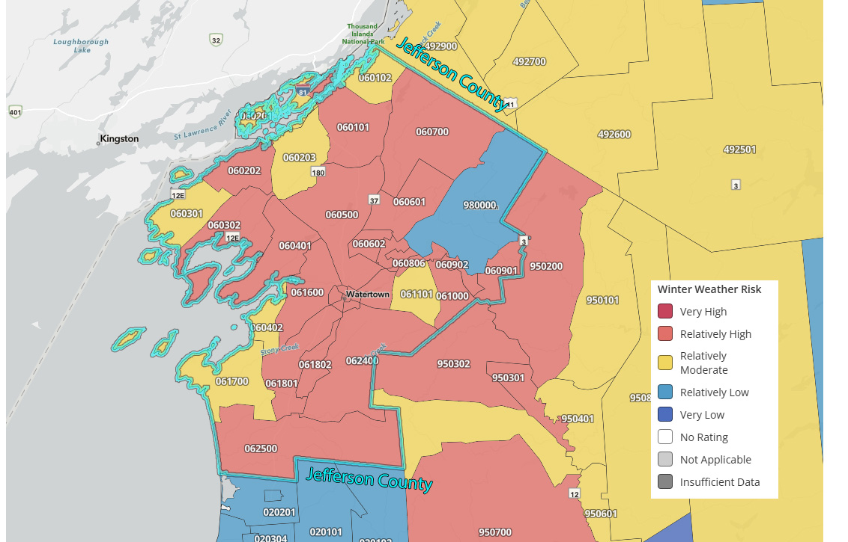
Source: FEMA 2019
Figure 12-5. National Risk Index, Ice Storm Risk Index Score Using the Census Tract Scale
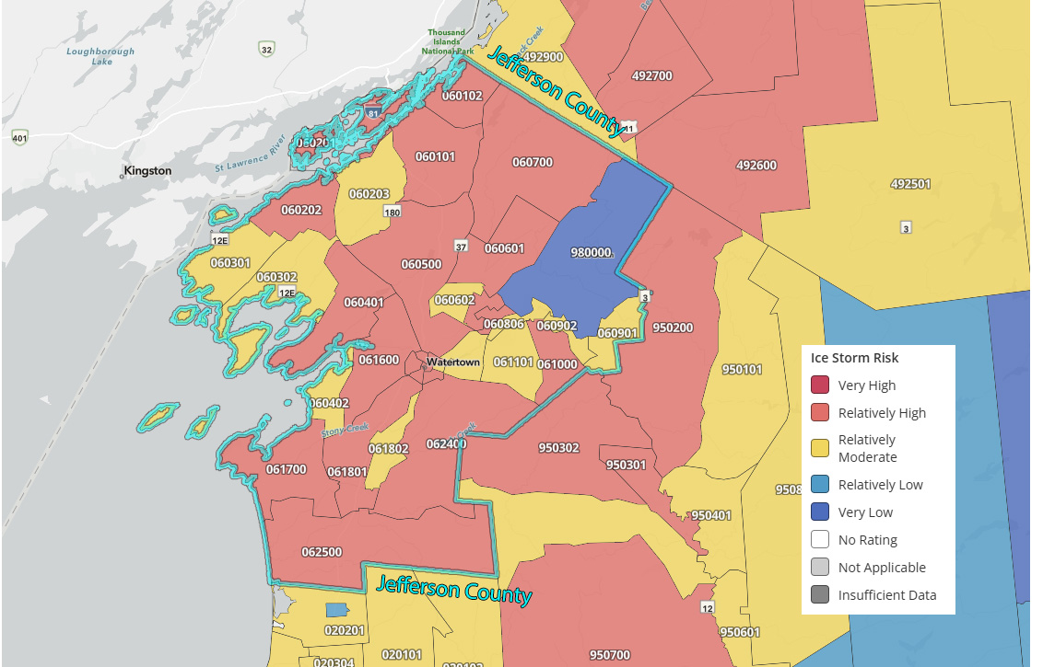
Source: FEMA 2019

Extent
The magnitude or severity of a severe winter storm depends on several factors, including snowfall rates, regional climatological susceptibility to snowstorms, snowfall amounts, wind speeds, temperatures, visibility, storm duration, topography, time of occurrence during the day and week (e.g., weekday versus weekend), and time of season.
The extent of a severe winter storm can be classified both by meteorological measurements and by evaluating societal impacts. The National Oceanic and Atmospheric Administration’s (NOAA’s) National Climatic Data Center (NCDC) produces the Regional Snowfall Index (RSI) for significant snowstorms that impact the eastern two-thirds of the US. The RSI ranks snowstorm impacts based on the spatial extent of the storm, the amount of snowfall, and the interaction of the extent and snowfall totals with population. The NCDC has analyzed and assigned RSI values to over 500 storms since 1900 (NOAA n.d.). Table 12-1 presents the five RSI ranking categories.
The National Weather Service (NWS) operates a widespread network of observing systems, such as geostationary satellites, Doppler radars, and automated surface observing systems that feed into the current state-of-the-art numerical computer models to provide a look into what will happen next, ranging from hours to days. The models are then analyzed by NWS meteorologists who then write and disseminate forecasts. According to NWS (NWS 2021), the magnitude of a severe winter storm can be classified into five main categories by event type, shown in Table 12-2.
Table 12-1. RSI Ranking Categories
Category | Description | RSI Value
1 | Notable | 1–3
2 | Significant | 3–6
3 | Major | 6–10
4 | Crippling | 10–18
5 | Extreme | 18.0+
Source: NOAA 2020
Note: RSI=Regional Snowfall Index
Table 12-2. Winter Storm Category Thresholds
Winter Storm Event | Threshold
Heavy Snowstorm | Accumulations of 4 inches or more of snow in a 6-hour period, or 6 inches of snow in a 12-hour period.
Sleet Storm | Significant accumulations of solid pellets that form from the freezing of raindrops or partially melted snowflakes causing slippery surfaces, posing a hazard to pedestrians and motorists.
Ice Storm | Significant accumulation of rain or drizzle freezing on objects (trees, power lines, roadways) as it strikes them, causing slippery surfaces and damage from sheer weight of ice accumulations.
Blizzard | Wind velocity of 35 mph or more, temperatures below freezing, considerable blowing snow with visibility frequently below one-quarter mile prevailing over an extended period.
Severe Blizzard | Wind velocity of 45 mph, temperatures of 10 °F or lower, a high density of blowing snow with visibility frequently measured in feet prevailing over an extended period.
Source: NWS 2021
Additionally, the NWS uses winter weather watches, warnings, and advisories to help people anticipate what to expect in the days and hours prior to an approaching storm (NWS 2021). Refer to Figure 12-6 for the warning thresholds.
Figure 12-6. Winter Storm Warning Thresholds
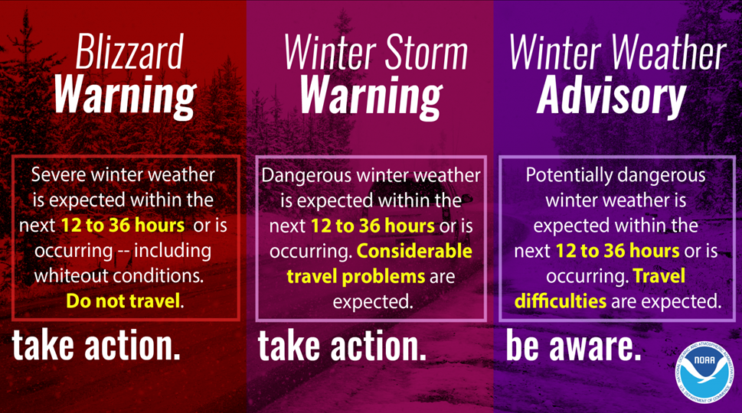
Source: NWS 2021

Previous Occurrences

FEMA Major Disaster and Emergency Declarations
Between 1954 and 2024, Jefferson County was included in eight major disaster (DR) or emergency (EM) declarations for winter storm-related events (FEMA 2023). Table 12-3 lists these declarations.
Table 12-3. FEMA Declarations for Winter Storm Events in Jefferson County (1954 to 2024)
Event Date | Declaration Date | Declaration Number | Description
January 29, 1977 | January 29, 1977 | EM-3027-NY | Snowstorm
February 5, 1977 | February 5, 1977 | DR-527-NY | Snowstorm
March 3-4, 1990 | March 21, 1991 | DR-898-NY | Severe Winter Storm
March 13-17, 1993 | March 17, 1993 | EM-3107-NY | Severe Blizzard
January 5-17, 1998 | January 6, 1998 | DR-1196-NY | Snowstorm
January 1-15, 1999 | January 15, 1999 | EM-3136-NY | Snow
November 17-26, 2014 | December 22, 2014 | DR-4204-NY | Severe Winter Storm, Snowstorm, and Floods
November 18-21, 2022 | November 20, 2022 | EM-3589-NY | Severe Winter Storm and Snowstorm
Source: FEMA 2024

USDA Declarations
The Secretary of Agriculture from the U.S. Department of Agriculture (USDA) is authorized to designate counties as disaster areas to make emergency loans to producers suffering losses in those counties and in contiguous counties. Between 2012 and 2024, Jefferson County was included in one USDA winter storm-related agricultural disaster declarations. For declarations that occurred between 2012 and 2024, refer to Table 12-4.
Table 12-4. USDA Declarations for Winter Storm Events in Jefferson County (2012 to 2024)
Event Date | USDA Declaration Number | Description
January 1-May 24, 2015 | S3886 | Frost, Freeze, Excessive Snow
Source: USDA 2024

Previous Events below Declaration Thresholds
Known hazard events that impacted Jefferson County between January 2009 and December 2024 are discussed in Table 12-5. For events prior to 2009, refer to the 2011 Jefferson County HMP.
Table 12-5. Winter Storm Events in Jefferson County (2009 to 2024)
Event Date | Location Impacted | Description
January 24-27, 2009 | County | Lake effect snow was produced off Lake Ontario and reported snowfall totals ranged from 12 to 24 inches in Jefferson County. Reported property damages totaled to be $20,000.
December 10-12, 2009 | County | Lake effect snow was produced off Lake Ontario and reported snowfall totals of 11 inches in Jefferson County. Reported property damages totaled to be $22,000.
December 28-29, 2009 | County | Lake effect snow was produced off Lake Ontario and there were reported snowfall totals of 11 inches in Watertown. Reported property damages totaled to be $20,000.
February 25-26, 2010 | County | A winter storm produced around eight inches of snow in the Watertown area. Reported property damages totaled to be $15,000.
December 1-3,2010 | County | Lake effect snow was produced off Lake Ontario and there were reported snowfall totals of eight inches in the Watertown area. Reported property damages totaled to be $20,000.
December 16-17, 2010 | County | Lake effect snow was produces off Lake Ontario and there were reported snowfall totals of over 18 inches. Reported property damages totaled to be $15,000.
February 9-10, 2011 | County | Lake effect snow was produced off Lake Ontario and there were reported snowfall totals of 20 inches in the Town of Theresa. Reported property damages totaled to be $40,000.
February 25, 2011 | County | A winter storm produced about six to 12 inches of snow and reported property damages totaled to be $20,000.
March 6, 2011 | County | A storm produced heavy, wet snow of about seven to ten inches across the eastern Lake Ontario region. Numerous vehicle accidents were also reported. Reported property damages totaled to be $15,000.
January 12, 2012 | County | An ice storm resulted in an extended period of freezing rain with maximum ice accumulations of one-half an inch in the County.
December 26-27, 2012 | County | A winter storm resulted in about a foot of snow in the region. Reported property damages totaled to be $15,000.
February 8-9, 2013 | County | A storm resulted in about 13 inches of snow at West Carthage. Reported property damages totaled to be $15,000.
March 18-21, 2013 | County | A lake effect storm resulted in seven to 13 inches of snow in the region. Reported property damages totaled to be $30,000.
November 26-27, 2013 | County | A winter storm brought snow, sleet and strong winds which led to travel advisories. Reported property damages totaled to be $15,000.
December 21-22, 2013 | County | An ice storm led to accumulations of a half to one inch of ice which knocked down trees and power lines which resulted in thousands without power in the County. Reported property damages totaled to be $250,000.
December 26-27, 2013 | County | A lake effect snowstorm produced 20 inches of snow in the Town of Lorraine. Reported property damages totaled to be $15,000.
January 6-8, 2014 | County | A lake effect snowstorm produced 48 inches in the Town of Adams and Watertown. Reported property damages totaled to be $20,000.
January 27-30, 2014 | County | A lake effect snowstorm produced snow at rates of two to three inches per hour and totaled to 27 inches in Watertown. Reported property damages totaled to be $40,000.
February 6-8, 2014 | County | A lake effect snowstorm created slick driving conditions over southern portions of the County. Snow accumulations ranged from 16-30 inches and reported property damaged totaled to be $35,000.
February 13-14, 2014 | County | A winter storm deposited between eight and 12 inches of heavy wet snow in the County. Reported property damages totaled to be $15,000.
February 27, 2014 | County | A lake effect snowstorm deposited upwards of 9 inches of snow in the County. Reported property damages totaled to be $15,000.
March 12, 2014 | County | A blizzard hit the area and produced 11 inches of snow at Watertown. Reported property damages totaled to be $24,000.
March 29-30, 2014 | County | A winter storm deposited four to seven inches of snow which covered the entire region. Reported property damages totaled to be $20,000.
November 13-14, 2014 | County | A lake effect snowstorm produced around 7 inches of snow in the Town of Adams. Reported property damages totaled to be $15,000.
December 10-11, 2014 | County | A winter storm produced 14 inches in Watertown and reported property damaged totaled to be $30,000.
December 31, 2014-January 2, 2015 | County | A lake effect storm produced one to two feet of snow across central and southern Jefferson County. Reported property damages totaled to be $95,000.
January 6-7, 2015 | County | A lake effect storm produced one to two feet of snow across northern Jefferson County. Reported property damages totaled to be $20,000.
January 9-11, 2015 | County | A lake effect storm produced 48 inches of snow in the Town of Adams and 23 inches in Watertown. Reported property damages totaled to be $30,000.
February 2, 2015 | County | A winter storm produced 9 inches of snow in Watertown. Reported property damages totaled to be $20,000.
February 6, 2015 | County | A lake effect storm produced snow at a rate of two inches per hour which led to a 35-car pile-up in southern Jefferson County. Reported property damages totaled to be $25,000.
January 1-2, 2016 | County | A lake effect storm produced 8 inches in Watertown. Reported property damages totaled to be $15,000.
January 10-13, 2016 | County | A lake effect storm produced 42 inches of snow in the Town of Lorraine and 8 inches in Watertown. Reported property damages totaled to be $55,000.
January 17, 2016 | County | A lake effect storm produced 12 inches of snow in the Town of Lorraine and 17 inches of snow in the Village of Mannsville. Reported property damages totaled to be $30,000.
February 12, 2016 | County | A lake effect storm produced nearly a foot of snow in northern Jefferson County, including 10 inches in Watertown. Reported property damages totaled to be $15,000.
February 15-16, 2016 | County | A winter storm produced a wide range of snow in the County. Reported property damages totaled to be $25,000.
November 20-22, 2016 | County | A lake effect storm produced 18 inches in Watertown and reported property damages totaled to be $35,000.
December 8-9, 2016 | County | A lake effect storm produced snowfall rates of two inches per hour in Watertown. Reported property damages totaled to be $15,000.
December 13-15, 2016 | County | A lake effect storm produced 13 inches of snow in Watertown and 16 inches in the Village of Mannsville. Reported property damages totaled to be $15,000.
January 4-7, 2017 | County | A lake effect storm produced snowfall rates of four inches per hour in Watertown and other areas in central Jefferson County. Reported snowfall amounts of 22 inches in West Carthage and 38 inches in the Village of Mannsville. Reported property damages totaled to be $16,000.
February 1-4, 2017 | County | A lake effect storm produced about a foot of snow in Mannsville. Reported property damages totaled to be $55,000.
February 12-13, 2017 | County | A storm produced heavy, wet snow, which totaled to 10 inches in Watertown. Reported property damages totaled to be $20,000.
March 14-15, 2017 | County | A storm produced snow throughout the County. Reported property damages totaled to be $50,000.
November 20, 2017 | County | A lake effect storm produced nine inches in Lorraine. Reported property damages totaled to be $15,000.
December 10-13, 2017 | County | A lake effect storm produced snow rates of three inches per hour east of Watertown. Reported property damages totaled to be $65,000.
December 24-27, 2017 | County | A lake effect storm produced 38 inches in Mannsfield and 17 inches in Watertown. Reported property damages totaled to be $70,000.
January 2-3, 2018 | County | A blizzard deposited one to two feet of snow throughout the County. Reported property damages totaled to be $35,000.
January 12-13, 2018 | County | A winter storm deposited 14 inches of snow in Watertown. Reported property damaged totaled to be $30,000.
February 3, 2018 | County | A lake effect storm deposited 10 inches of snow in Watertown. Reported property damages totaled to be $25,000.
February 8-9, 2018 | County | A lake effect storm produced about 21 inches in southern Jefferson County. Reported property damages totaled to be $20,000.
March 2, 2018 | County | A winter storm produced a range of snow accumulations. Reported property damages totaled to be 15,000.
March 13-15, 2018 | County | A winter storm produced 13.4 inches in Watertown. There were no reported property or crop damages.
January 19-20, 2019 | County | A winter storm produced snow totals of 12.9 inches in south Watertown. There were no reported property or crop damages.
January 25-26, 2019 | County | A lake effect storm produced 25.5 inches in Watertown. There were no reported property or crop damages.
January 28-31, 2019 | County | A winter storm produced strong winds and 37.6 inches of snow in Watertown. There were no reported property or crop damages.
March 22-23, 2019 | County | A winter storm produced 12 inches in the Town of Antwerp. There were no reported property or crop damages.
December 18, 2019 | County | A lake effect storm produced 12.4 inches in Watertown. There were no reported property or crop damages.
December 25-27, 2020 | County | A lake effect storm produced 17.4 inches in Watertown. There were no reported property or crop damages.
January 17-18, 2022 | County | A winter storm deposited 16 inches in the Town of Henderson. There were no reported property or crop damages.
January 23, 2022 | County | A lake effect storm deposited 14 inches in the Town of Henderson. There were no reported property or crop damages.
February 1-2, 2023 | County | A lake effect storm heavily impacted central Jefferson County which led to a four tractor trailers. There were no reported property or crop damages.
January 13-17, 2024 | County | A winter storm produced nearly 21.5 inches along parts of the Black River. There were no documented property or crop damages.
February 18, 2024 | County | Watertown reported 12.4 inches that was produced as a result of lake effect snow.
November 29-December 1, 2024 | County | A lake effect snow produced nearly 53 inches of snow in the Village of Black River. There were no reported property or crop damages.
Source: NOAA NCEI 2024
Note: Events included are only those that incurred $15,000 or more in damages or incurred over 12 inches of snow. Data from 2018-2023 is limited and not as location specific but is the best available data at the time of this update.

Cascading Impacts on Other Hazards
Severe winter weather events may exacerbate flooding. As discussed, the freezing and thawing of snow and ice associated with winter weather events can create major flooding issues in the County. Maintaining winter weather hazards through snow and ice removal could minimize the potential risk of flooding during a warming period. Refer to Chapter 9 (Flood) for more information about the flood hazard of concern. Winter storms are often accompanied by extreme cold. Refer to Chapter 8 (Extreme Temperatures) for more information about the extreme cold hazard of concern.

Vulnerability and Impact Assessment
To understand risk, a community must evaluate what assets are exposed or vulnerable in the identified hazard area. For the severe winter storm hazard, all of Jefferson County has been identified as the hazard area. Therefore, all assets in the County (population, structures, critical facilities, and lifelines), as described in the County Profile (Section 3), are vulnerable to a winter storm event.

Life, Health, and Safety

Overall Population
The entire population of Jefferson County (336,485) is exposed to severe winter storm events (US Census 2020). According to the NOAA National Severe Storms Laboratory (NSSL), every year, winter weather indirectly and deceptively kills hundreds of people in the U.S., primarily from automobile accidents, overexertion, and exposure. Winter storms are often accompanied by strong winds creating blizzard conditions with blinding wind-driven snow, drifting snow, extreme cold temperatures, and dangerous wind chills. They are considered deceptive killers because most deaths and other impacts or losses are indirectly related to the storm. People can die in traffic accidents on icy roads, by heart attacks while shoveling snow, or of hypothermia from prolonged exposure to cold (NSSL 2021).

Socially Vulnerable Population
People who experience homelessness, are over the age of 65, and under the age of 5 are considered to be the most susceptible to this hazard. Older adults are susceptible to this hazard due to their increased risk of injuries and death from falls and overexertion, and/or hypothermia from attempts to clear snow and ice. Young children are at risk from experiencing hypothermia or other cold related illnesses due to their inability to care for themselves and their dependency on others. Individuals who experience homelessness are at risk from hypothermia due to lack of a warming shelter from the cold temperatures that are associated with winter weather. Those that are at or around the poverty level in the County are dependent on their limited income and may not be able to afford staying at an alternative shelter, such as a hotel, and may not be able to afford to miss work, regardless of the weather conditions. People who are non-English speaking may not be able to interpret public emergency warnings and signage which puts them at an increased risk.
According to the 2022 five-year American Community Survey (ACS) population estimate, there are 14,310 total persons living below the poverty level, 16,667 persons over the age of 65 years, 8,759 persons under the age of five years, 1,511 non-English speakers, and 15,255 persons with a disability living in Jefferson County. Figure 3-14 shows SVI scores across Jefferson County.

General Building Stock
The County administers and enforces the New York State Uniform Fire Prevention and Building Code, which is the uniform code contained within Title 19 of the New York Codes, Rules and Regulations (New York State n.d.). The entire general building stock inventory is exposed and vulnerable to the severe winter storm hazard and could be more at risk from aging infrastructure. An extreme blizzard or snowstorm event can carry and deposit significant amounts of snow that are heavy enough to knock down power and telephone lines as well as damage roofs and aging buildings, some of which are critical facilities and community lifelines. In general, the structural impacts include partial damages to roofs and building frames, rather than an entire building.

Community Lifelines and Other Critical Facilities
Full functionality of critical facilities, such as police, fire, and medical facilities, is essential for response during and after a severe winter storm event. These critical facility structures are often constructed of concrete and masonry; therefore, they should only suffer minimal structural damage from severe winter storm events. Because power interruption can occur, backup power is recommended. Infrastructure at risk for this hazard includes roadways that could be damaged from the application of salt and intermittent freezing and warming conditions that can damage roads over time. Severe snowfall requires clearing of roadways and alerting of citizens to dangerous conditions; following the winter season, resources for road maintenance and repair are required.

Economy
Depending on the severity and duration of the severe winter weather event, damage to the general building stock, critical facilities, and community lifelines can include roof damage from heavy snow loads, structural damage from downed trees, and power outages.
The cost of snow and ice removal and repair of roads from the freeze/thaw process can drain local financial resources. In addition to snow removal costs, severe winter weather affects the ability of persons to commute into and out of the area for work or school. The loss of power and closure of roads prevents the commuter population traveling to work within and outside of the County and may cause a loss in economic productivity.

Natural, Historic and Cultural Resources

Natural
Severe winter weather can have a major impact on the environment. Not only does winter weather create changes in natural processes, the residual impacts of a community’s methods to maintain its infrastructure through winter weather maintenance may also have an impact on the environment. For example, an excess amount of snowfall and earlier warming periods may affect natural processes such as flow within water resources (NSIDC n.d.).
Rain-on-snow events can also exacerbate runoff rates with warming winter weather. Consequentially, these flow rates and excess volumes of water can erode banks, tear apart habitat along the banks and coastline, and disrupt terrestrial plants and animals. Road-salt runoff can cause groundwater salinization, modify the soil structure, and result in loss or reduction in lake turnover. Additionally, road salt can cause changes in the composition of aquatic invertebrate assemblages and pose threats to birds, roadside vegetation, and mammals (Tiwari and Rachlin 2018).

Historic
Historic sites are at risk from the extreme cold or freeze hazard. Historic buildings may be susceptible to damage from severe winter weather conditions. Proper strategies help safeguard buildings and their contents. Sudden and dramatic fluctuations in heating or cooling should be minimized. Slower heating and cooling give building materials and stored contents time to acclimate to new temperatures in the building and corresponding new humidity levels (CCAHA 2019).

Cultural
Cultural heritage sites, particularly those exposed to the elements, are subject to weathering. Climate change is a potential threat to these sites as it exacerbates the expected rates of decay and contributes to the appearance of new decay. Climatic changes may aggravate the physical, chemical, and biological mechanisms causing degradation by affecting the structure or composition of building materials. Changes in temperature, precipitation, atmospheric moisture, and wind intensity, in addition to the interaction between climatic changes and air pollution, have been identified as concerns by the United Nations Educational, Scientific and Cultural Organization (Sesana, et al. 2021).

Future Occurrences and Projected Changes in Risk
Understanding future changes that affect vulnerability can assist in planning for future development and ensure establishment of appropriate mitigation, planning, and preparedness measures. The following sections examine potential conditions that may affect hazard vulnerability.

Probability of Future Events
Information on previous winter storm occurrences in the County was used to calculate the probability of future occurrence of such events, as summarized in Table 12-6. Based on historical records and input from the Steering Committee, the probability of occurrence for winter storms in the County is considered “frequent.”
Table 12-6. Probability of Future Winter Storm Events in Jefferson County
Hazard Type | Number of Occurrences Between 1996 and 2023 | Percent Chance of Occurring in Any Given Year
Blizzard | 6 | 21.43%
Heavy Snow | 62 | 100%
Ice Storm | 4 | 14.29%
Lake-Effect Snow | 82 | 100%
Winter Storm | 43 | 100%
Winter Weather | 0 | 0%
Total | 197 | 100%
Note: Due to limitations in data, not all Winter Storm events occurring between 1954 and 1996 are accounted for in the tally of occurrences. As a result, the number of hazard occurrences is calculated using the number of occurrences between 1996 and 2023.

Climate Change Projections and Likely Impacts
The State of New York will see an increase in average annual temperatures and precipitation. Climate change has the ability to make winter weather events less frequent, but more severe when they do happen. Annual precipitation amounts in the region are projected to increase, primarily in the form of heavy rainfalls, which have the potential to freeze into heavy snowfall and icing. This increase in snow and ice could result in an increased risk to life and health, an increase in structural losses, a diversion of additional resources to response and recovery efforts, and an increase in business closures affected by severe winter events due to loss of service or access (The Climate Reality Project 2022).

Projected Changes in Development and Population
Jefferson County has experienced a decrease in its population since 2010. Cornell University’s Program on Applied Demographics produced populations projections by County from 2016 to 2040. According to these projections, Jefferson County is projected to have a population of 114,290 by 2030 and 115,693 by 2040 (Cornell University 2018). Changes in the density of the population can impact the number of persons exposed to severe winter storms and the draw upon water resources.
An increase in population may impact the ability of persons in the County to mobilize or receive essential services during severe winter storm events. Historically, winter weather events with associated snowfall and ice accumulation have severely impacted transportation corridors, making it difficult for emergency responders to get to specific areas of need that have people who may need medical attention. Winter weather events also negatively impact infrastructure, with aging infrastructure posing more of a risk. Infrastructure damage can lead to power outages and damaged pipes which may limit or prevent the circulation of water and heat in a facility, which poses a risk to people depending on that infrastructure.
As discussed in Chapter 3 (County Profile), areas targeted for future growth and development have been identified across the County. Any areas of growth located could be potentially impacted by severe winter storm events. Some local municipalities in the State have implemented the following activities to eliminate loss of life and property and infrastructure damages during winter storm events:
- Removing snow from roadways.
- Removing dead trees and trimming trees/brush from roadways to lessen falling limbs and trees.
- Posting proper road signs that are visible to all drivers.
- Burying electrical and telephone utility lines to minimize downed lines.
- Removing debris/obstructions in waterways and developing routine inspections/maintenance plans to reduce potential flooding.
- Replacing substandard roofs of critical facilities to reduce exposure to airborne germs resulting from leakage.
- Purchasing and installing backup generators in evacuation facilities and critical facilities to ensure essential services are available to residents.
Installing cell towers in areas where limited telecommunication is available to increase emergency response and cell phone coverage.

Wildfire

Hazard Profile

Hazard Description
According to the New York State Hazard Mitigation Plan, a wildfire is defined as any unplanned, uncontrolled, or unsupervised fire occurring in natural areas such as forests, grasslands, or prairies 1. These fires can escalate rapidly and become highly destructive, especially when they encroach upon developed areas. When wildfires threaten or impact buildings and infrastructure, they are classified as wildland-urban interface (WUI) fires.
According to the U.S. Fire Administration (USFA), wildfire risk in the United States varies by region due to factors such as climate, vegetation, socioeconomic conditions, and land use patterns 1. In New York State, wildfires are not as frequent or intense as in the western U.S., but they still pose a significant hazard, particularly in areas with dense forests, brush, and grasslands. The New York State Hazard Mitigation Plan identifies wildfire as a recurring hazard, especially in rural and forested regions 2.
Wildfires are most likely in open grasslands, shrublands, and forested areas, and the risk increases in wildland-urban interface (WUI) zones—areas where development meets undeveloped wildland. These fringe zones are particularly vulnerable because they combine flammable vegetation with human structures and activities.

Wildfire Causes
There are three different classes of wildfires: surface fires, ground fires, and crown fires. Surface fires are the most common type and burns along the forest floor, moving slowly and killing or damaging trees. Ground fires are usually started by lightning and burns on or below the forest floor. Crown fires spread rapidly by wind and move quickly by jumping along the tops of trees. It is important to distinguish wildfires from prescribed burns, which are intentionally ignited and carefully managed to achieve ecological or hazard reduction goals.
Wildfires often begin unnoticed and can spread rapidly under the right conditions. Three essential elements—heat, fuel, and oxygen—must be present for a fire to ignite and grow. While wildfires can occur year-round, they are most common during warmer, drier months, particularly in late spring through early fall.
Most wildfires in New York State are human caused, resulting from activities such as debris burning, campfires, equipment use, smoking and arson. Lightning is the second most common ignition source. The likelihood of a lightning strike starting a wildfire depends on the intensity of the strike and the type and dryness of the fuel it contacts. Once ignited, the spread of a wildfire is primarily influenced by fuel moisture content. Wildfires cause both short-term and long-term losses. Short-term losses can include destruction of timber, wildlife habitat, scenic vistas, and watersheds. Long-term effects include smaller timber harvests, reduced access to affected recreational areas, and the destruction of cultural and economic resources and community infrastructure.

Wildfire Behavior
Fire behavior is defined as the way fuel ignites, flame develops, and fire spreads, which depend on interactions among fuel, weather, and topography. Fire behavior is one of the most important aspects of wildfires because almost all actions in response to a fire depend on how it behaves. The extent to which fire manages can understand and predict fire behavior relies on success in pre-suppression planning and actual suppression of wildfires.
Potential for wildfire and its subsequent development (growth) and severity are controlled by the three principal factors of topography, fuel, and weather, described as follows:

Topography
Topography can powerfully influence wildfire behavior. Movement of air over the terrain tends to direct a fire’s course. A gulch or canyon can funnel air and act as a chimney, intensifying fire behavior and inducing faster spread. Saddles on ridgetops tend to offer lower resistance to passage of air and draw fires. Solar heating of drier, south-facing slopes produces upslope thermal winds that can complicate behavior. Slope is an important factor. If the percentage of uphill slope doubles, the rate the wildfire spreads will most likely double as well. Terrain can inhibit wildfires: fire travels downslope much more slowly than it does upslope, and ridgetops often mark the end of a wildfire’s rapid spread (FEMA 1997).

Fuel
Fuels are classified by weight or volume (fuel loading) and by type. Fuel loading is used to describe the amount of vegetative material available. If this amount doubles, energy released can also double. Each fuel type is given a burn index—an estimate of amount of potential energy that may be released, effort required to ignite a fire in a given fuel and expected flame length. Different fuels have different burn qualities, and some burn more easily than others. Grass fires release relatively little energy but can sustain very high rates of spread (FEMA 1997). According to the U.S. Forest Service (USFS), a forest stand may consist of several layers of live and dead vegetation in the understory (surface fuels), midstory (ladder fuels), and overstory (crown fuels) (USFS 2013):
- Surface fuels consist of grasses, shrubs, litter, and woody material lying on the ground. Surface fires burn low vegetation, woody debris, and litter. Under the right conditions, surface fires reduce likelihood that future wildfires will grow into crown fires.
- Ladder fuels consist of live and dead small trees and shrubs; live and dead lower branches from larger trees, needles, vines, lichens, mosses; and any other combustible biomass between the top of surface fuels and bottom of overstory tree crowns.
- Crown fuels are suspended above the ground in treetops or other vegetation and consist mostly of live and dead fine material. When historically low-density forests become overcrowded, tree crowns may merge and form a closed canopy. Tree canopies constitute the primary fuel layer in a forest crown fire.

Weather / Air Mass
Weather is the most important factor influencing fire behavior, but it is always changing. Air mass, defined by the National Weather Service (NWS) as a body of air covering a relatively wide area and exhibiting horizontally uniform properties, can affect wildfire through climatic factors that include temperature and relative humidity, local wind speed and direction, cloud cover, precipitation amount and duration, and stability of the atmosphere at the time of the fire (NWS 2009). Extreme weather leads to extreme events, and often a subsidence of severe weather marks the end of a wildfire’s growth and the beginning of successful containment. High temperatures and low humidity can produce vigorous fire activity. Fronts and thunderstorms can produce winds that radically and suddenly change in speed and direction, causing similar changes in fire activity. The rate of spread of a fire varies directly with wind velocity. Winds may play a dominant role in directing the course of a fire. The most damaging firestorms are typically marked by high winds (FEMA 1997).

Location
Jefferson County contains extensive forested areas, particularly in the eastern and southern parts of the county. These areas are popular for outdoor recreation, including hiking, camping, and hunting, which increases the potential for human-caused ignitions. While the county’s wildfire-prone areas tend to have low population densities, they still pose risks to public safety, infrastructure, and natural resources. Major transportation corridors such as Interstate 81 and U.S. Route 11 pass through or near forested areas and could be affected by wildfire smoke or closures during fire events 2. Land uses such as cultivated agricultural fields, pastureland, and managed open spaces (e.g., golf courses) are generally not considered high-risk for wildfire due to lower fuel loads and active land management 2.
New York State is divided into 10 Fire Danger Rating Areas (FDRAs), which are based on vegetation, climate, topography, and fire history. Jefferson County lies within the St. Lawrence and Lake Ontario Plains FDRA, which is monitored by the New York State Department of Environmental Conservation (DEC) and the Forest Ranger Division. These agencies issue daily fire danger ratings and warnings when conditions are elevated 2. The DEC also enforces seasonal burn bans, typically from March 16 to May 14, when wildfire risk is highest due to dry vegetation and windy conditions. These bans are critical in reducing the number of human-caused wildfires during the spring fire season.

Wildfire/Urban Interface
The WUI is divided into two categories: intermix and interface, as shown in Figure 13-1 and described below.
The interface is an area where human development meets or mixes with undeveloped natural environments such as forests, grasslands, or shrublands. This zone is a transition between unoccupied land and developed land. Interface areas have more than one house per 40 acres, have less than 50 percent vegetation, and are within 1.5 miles of an area over 1,235 acres that is more than 75 percent vegetated (Stewart, et al. 2006).Wildfires are of particular concern in the WUI because they bring humans—the primary cause for wildfire ignition in the United States—into greater contact with flammable wildlands. The WUI grows nationwide by approximately 2 million acres each year as communities continue to expand, often due to the pressures of high housing costs in more densely populated areas.
The intermix is an area where structures and wildlands intermingle, with no clear boundary between the two. In an intermix area, homes and other structures are scattered throughout a wildland area. These structures are often surrounded by trees and vegetation and are only accessible by narrow roads. This makes it difficult to reach these areas if a fire occurs. Intermix areas have more than one house per 40 acres and have more than 50 percent vegetation. Interface areas have more than one house per 40 acres, have less than 50 percent vegetation, and are within 1.5 miles of an area over 1,235 acres that is more than 75 percent vegetated (Stewart, et al. 2006).
In the State of New York, 27.2 percent (38,489 square miles) is located in the WUI; with 5.4 percent (7,599 square miles) is located in the WUI interface and 21.9 percent (30,890 square miles) is located in the WUI intermix (Radeloff, et al. 2020). Many property owners are unaware that a threat from a wildfire exists or that their homes are not defensible from it. Water supplies at the scene in the WUI are often inadequate. Access by firefighting equipment is often blocked or hindered by driveways that are narrow, winding, dead-ended, have tight turning radii, or have weight restrictions. Most wildland fire suppression personnel are inadequately prepared for fighting structural fires, and local fire departments are not usually fully trained or equipped for wildfire suppression. Furthermore, the mix of structures, ornamental vegetation, and wildland fuels may cause erratic fire behavior. These factors and others substantially increase risk to life, property, and economic welfare in the WUI.

Figure 13-1. Wildfire-Urban Interface Hazard Areas in Jefferson County
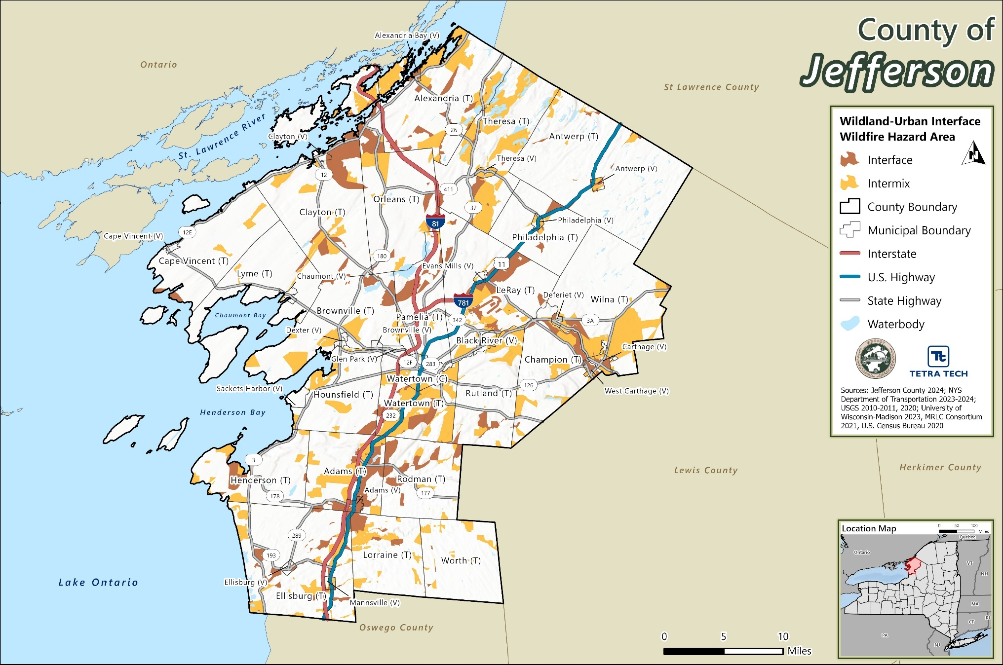

Extent
Wildfire events can range in size and intensity. The extent (that is, magnitude or severity) of wildfires depends on weather and human activity.

Wildfire Ratings and Classifications
There are several tools available to estimate fire potential, extent, danger, and growth, as described below.

Wildland Fire Assessment System
The Wildland Fire Assessment System (WFAS) is an internet-based information system that provides a national view of weather and fire potential, including national fires danger, weather maps and satellite-derived “greenness” maps. It was developed by the Fire Behavior unit at the Fire Sciences Laboratory in Missoula, Montana and is currently supported and maintained at the National Interagency Fire Center (NIFC) in Boise, Idaho (WFAS 2023).

National Fire Danger Rating System
Each day during the fire season, national maps of selected fire weather and fire danger components of the National Fire Danger Rating System are produced by the WFAS. Fire Danger Rating level considers current and antecedent weather, fuel types, and both live and dead fuel moisture. This information is provided by local station managers (WFAS 2023). Table 13-1 shows the fire danger rating and color code, which is also used by the NYSDEC to update their fire danger rating maps, which is identified later in this section.

Fire Potential Index
The Fire Potential Index (FPI) is a moisture-based vegetation flammability indicator. The FPI indicates the estimated proportion (percentage) of the vegetation that is dry enough to burn, thus the FPI is highest when dead fuel moistures and vegetation greenness are low. The FPI is calculated once daily for the continental US at a resolution of 1 square kilometer. Although these maps provide a relative measure of fuel flammability across the nation, they do not indicate the chance that a large fire will occur (USFS 2016) (USGS 2023).

Fuel Moisture
Fuel Moisture is a measure of the amount of water in a fuel (vegetation) available to a fire and is expressed as a percent of the dry weight of that specific fuel. When fuel moisture content is high, fires do not ignite readily, or at all, because heat energy must be used to evaporate and drive water from the plant before it can burn. When the fuel moisture content is low, fires start easily and will spread rapidly because all the heat energy goes directly into the burning flame itself. When the fuel moisture content is less than 30 percent, that fuel is essentially considered to be dead. Dead fuels respond solely to current environmental conditions and are critical in determining fire potential (NOAA 2023).
Fuels are classified into four categories which respond to changes in moisture. This response time is referred to as a time lag. A fuel’s time lag is based upon how long it would take for two-thirds of the dead fuel to respond to atmospheric moisture. Table 13-2 outlines these four fuel classifications.
Table 13-1. Description of Fire Danger Ratings in the State of New York
Rating Class and Color Code | Class Description
Red Flag | A short-term, temporary warning, indicating the presence of a dangerous combination of temperature, wind, relative humidity, fuel, or drought conditions which can contribute to new fires or rapid spread of existing fires. A Red Flag Warning can be issued at any Fire Danger level.
Extreme (Red) | Fires start quickly, spread furiously, and burn intensely. All fires are potentially serious. Development into high intensity burning will usually be faster and occur from smaller fires than in the very high fire danger class. Direct attack is rarely possible and may be dangerous except immediately after ignition. Fires that develop headway in heavy slash or in conifer stands may be unmanageable while the extreme burning condition lasts. Under these conditions the only effective and safe control action is on the flanks until the weather changes, or the fuel supply lessens.
Very High (orange) | Fires start easily from all causes and, immediately after ignition, spread rapidly and increase quickly in intensity. Spot fires are a constant danger. Fires burning in light fuels may quickly develop high intensity characteristics such as long-distance spotting and fire whirlwinds when they burn into heavier fuels.
High (yellow) | All fine dead fuels ignite readily, and fires start easily from most causes. Unattended brush and campfires are likely to escape. Fires spread rapidly and short-distance spotting is common. High intensity burning may develop on slopes or in concentrations of fine fuels. Fires may become serious and their control difficult unless they are attacked successfully while small.
Moderate (blue) | Fires can start from most accidental causes but, except for lightning fires in some areas, the number of starts is generally low. Fires in open cured grasslands will burn briskly and spread rapidly on windy days. Timber fires spread slowly to moderately fast. The average fire is of moderate intensity, although heavy concentrations of fuel, especially draped fuel, may burn hot. Short-distance spotting may occur but is not persistent. Fires are not likely to become serious and control is relatively easy.
Low (green) | Fuels do not ignite readily from small firebrands although a more intense heat source, such as lightning, may start fires in duff or punky wood. Fires in open cured grasslands may burn freely a few hours after rain, but woods fires spread slowly by creeping or smoldering, and burn in irregular fingers. There is little danger of spotting.
Source: USDA n.d.
Table 13-2. Fuel Moisture Classifications
1-hour fuels | 10-hour fuels | 100-hour fuels | 1000-hour fuels
Up to ¼-inch diameter – fine, flashy fuels that respond quickly to weather changes. Computed from observation time, temperature, humidity, and cloudiness. | ¼-inch to one-inch in diameter - computed from observation time, temperature, humidity, and cloudiness or can be an observed value. | One-inch to three-inch in diameter - computed from 24-hour average boundary condition composed of day length (daylight hours), hours of rain, and daily temperature/humidity ranges. | Three-inch to eight-inch in diameter - computed from a seven-day average boundary condition composed of day length, hours of rain, and daily temperature/humidity ranges.
Source: NPS 2023

Keetch-Byram Drought Index
The Keetch-Byram Drought Index (KBDI) assesses the risk of fire by representing the net effect of evapotranspiration and precipitation in producing cumulative moisture deficiency in deep duff and upper soil layers. The KBDI attempts to measure the amount of precipitation necessary to return the soil to full field capacity. The index ranges from zero, the point of no moisture deficiency, to 800, the maximum drought that is possible, and represents a moisture regime from zero to eight inches of water through the soil layer. At eight inches of water, the KBDI assumes saturation. At any point along the scale, the index number indicates the amount of net rainfall that is required to reduce the index to zero, or saturation (NIDIS 2023).

Haines Index
The Haines Index, also known as the Lower Atmosphere Stability Index, was developed for fire use. It is used to indicate the potential for wildfire growth by measuring the stability and dryness of the air over a fire. It is calculated by combining the stability and moisture content of the lower atmosphere into a number that correlates well with large fire growth. The stability term is determined by the temperature difference between two atmospheric layers; the moisture term is determined by the temperature and dew point difference. This index has been shown to be correlated with large fire growth on initiating and existing fires where surface winds do not dominate fire behavior. The drier and more unstable the lower atmosphere is, the higher the index. See Table 13-3.
Table 13-3. Haines Index
Haines Index | Potential for Large Fire Growth
2 or 3 | Very Low
4 | Low
5 | Moderate
6 | High
Source: NOAA n.d.

NYSDEC Fire Danger Rating Map
A current fire danger rating map is updated daily on the NYSDEC website (NYSDEC 2023). The map is developed by information obtained from the Division of Forest Protection and Division of Air Resources (impact assessment and meteorology section). Figure 13-2 shows the FDRAs in the State of New York and the current (as of June 12, 2024) fire danger risk for each of the areas. The figure is color coded and indicates where there are red flag warning areas. The figure is showing Jefferson County at low risk of fire danger, as of June 12, 2024.

Previous Occurrences

FEMA Major Disaster and Emergency Declarations
Between 1954 and 2024, Jefferson County was not included in any major disaster (DR) or emergency (EM) declarations for wildfire-related events (FEMA 2024).

USDA Declarations
The Secretary of Agriculture from the U.S. Department of Agriculture (USDA) is authorized to designate counties as disaster areas to make emergency loans to producers suffering losses in those counties and in contiguous counties. Between 2012 and 2024, Jefferson County was not included in any USDA wildfire-related agricultural disaster declarations.
Figure 13-2. The State of New York FDRAs
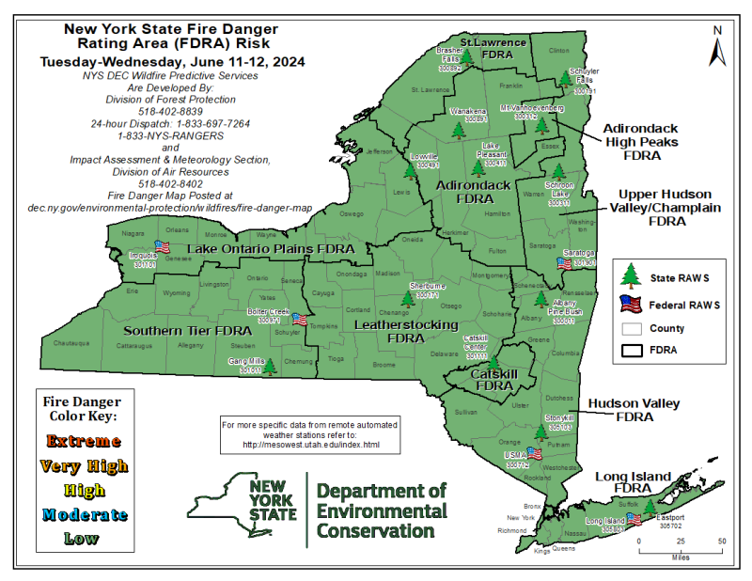
Source: NYSDEC 2024

Previous Events
Figure 13-3 shows the number of wildfires per square mile in New York from 2008 through 2024. Parts of Jefferson County saw as many as 1.5 fires per square mile over that period.
Known hazard events that impacted Jefferson County between January 2009 and December 2024 are listed in Table 13-4. For events prior to 2009, refer to the 2011 Jefferson County HMP.
Figure 13-3. Wildfire Events (2008 – 2024)
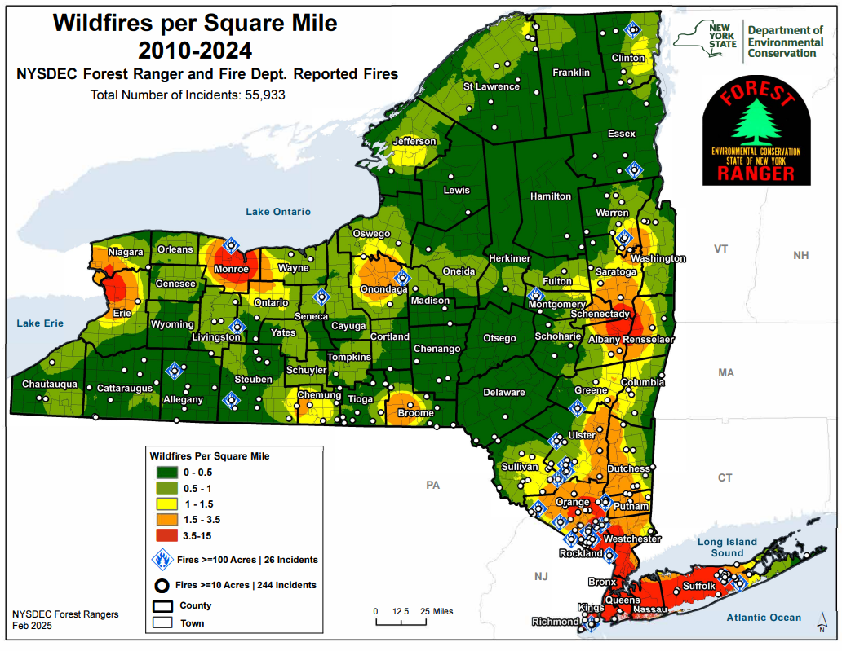
Source: NYSDEC Forest Rangers
Table 13-4. Wildfire Events in Jefferson County (2009 to 2024)
Event Date | Location Impacted | Description
November 15, 2009 | Town of Adams | Debris burning resulted in a fire damaging 7.0 acres.
July 31, 2012 | Town of Adams | A fire in the Town of Adams burned about 3,000 acres.
April 24, 2014 | Antwerp | Equipment caused a fire resulting in 26.0 acres damaged.
April 17, 2016 | Antwerp | Vrooming Hill Fire resulting in 6.8 damaged acres.
May 8, 2018 | Clayton | Debris burning resulted in a fire damaging 4.7 acres.
March 21, 2021 | Cape Vincent | Debris burning resulted in a fire damaging 3.4 acres.
May 20, 2021 | Lyme | Debris burning resulted in a fire damaging 0.5 acres.
July 27, 2023 | Town of Lyme | A large battery fire caused significant damage and emitted large amounts of smoke at a solar farm (CBS News 2023).
October 5, 2023 | Antwerp | A structure fire resulted in damage to 5.0 acres.
Source: NOAA 2024; NYS Forest Ranger Wildland Fire Database

Cascading Impacts on Other Hazards
While wildfires in Jefferson County are not as frequent or severe as in other parts of the country, their potential impacts are compounded by climate change and the cascading hazards that can follow a fire event.
Following a wildfire, the landscape is often left stripped of vegetation, which plays a critical role in stabilizing soil and regulating water flow. The loss of this vegetation can trigger a series of secondary hazards, including:
- Flooding and Debris Flows: Without vegetation to absorb rainfall and anchor soil, post-fire landscapes are highly susceptible to flash flooding and mudflows. Rainfall on burned areas can rapidly mobilize ash, sediment, and debris, creating fast-moving flows that damage infrastructure, contaminate waterways, and threaten downstream communities (NIDIS 2023). These risks are particularly acute in areas with steep slopes or near watercourses, such as those found in parts of Jefferson County. FEMA highlights that burned areas are particularly vulnerable to flooding and debris flows. Ash and debris left behind by wildfires can clog drainage systems and increase runoff, leading to severe downstream impacts.
- Landslides: Burned hillsides, especially those with shallow soils or steep gradients, may become unstable and prone to landsliding. While Jefferson County is not as mountainous as the Catskills or Adirondacks, localized slope failures can still occur, particularly in the eastern and southern parts of the county where forested hills are more common.
- Water System Impacts: Wildfires can degrade watershed health by introducing ash, sediment, and contaminants into streams and reservoirs. This can impair water quality, damage aquatic habitats, and disrupt water treatment operations, especially if facilities are damaged or lose power during a fire event.
- Invasive Species Proliferation: Intense wildfires can destroy native vegetation and disrupt ecosystems, creating opportunities for invasive plant and animal species to colonize the area. These species often outcompete native flora and fauna, leading to long-term ecological shifts and reduced biodiversity.
- Carbon Emissions and Climate Feedback Loops: Wildfires release large quantities of carbon dioxide and other greenhouse gases, contributing to global warming. This creates a feedback loop in which climate change increases wildfire risk, and wildfires in turn accelerate climate change (NOAA n.d.).
- Altered Ecosystems: The destruction of vegetation and habitat can lead to long-term changes in ecosystem structure and function, affecting wildlife populations, recreational opportunities, and the delivery of ecosystem services such as air and water purification.
In Jefferson County, these cascading impacts may be localized but significant, particularly in forested and rural areas where emergency response resources are limited, and ecological recovery may take years.

Vulnerability and Impact Assessment
To understand risk, a community must evaluate assets exposed to and vulnerable to the identified hazard. The entirety of Jefferson County is exposed and vulnerable to the wildfire hazard; however, assets located within the WUI areas (population, structures, critical facilities, and lifelines), as described in Section 3 (County Profile), are potentially more vulnerable to a wildfire event. The following text evaluates and estimates the potential impact of the wildfire hazard in the County.

Life, Health, and Safety

Overall Population
Wildfires have the potential to impact human health and life of residents and responders, structures, infrastructure, and natural resources. The most vulnerable populations include emergency responders and those within a short distance of the interface between the built environment and the wildland environment. First responders are exposed to the dangers from the initial incident and after-effects from smoke inhalation and heat stroke.
Wildfire smoke refers to smoke from wildland fires, both planned beneficial wildfire or unplanned hazardous wildfire. Planned burns, including prescribed burns, generate smoke, but such burns can be carried out in a way that mitigates adverse health impacts, such as by planning for days with specific weather patterns and by notifying the public in advance.
The duration of smoke impacts is set by a combination of the size and duration of the fires that create smoke and the duration of the weather pattern bringing the smoke into the state or moving it within the state. Major fires that create enough smoke to reach New York tend to have durations of weeks or longer.
Smoke generated by wildfire consists of visible and invisible emissions that contain particulate matter (soot, tar, water vapor, and minerals), gases (carbon monoxide, carbon dioxide, nitrogen oxides), and toxics (formaldehyde, benzene). Emissions from wildfires depend on the type of fuel, the moisture content of the fuel, the efficiency (or temperature) of combustion, and the weather. Public health impacts associated with wildfire include difficulty in breathing, odor, and reduction in visibility.
Table 13-5 summarizes the estimated population exposed to the WUI hazard areas by municipality. Based on the analysis, an estimated 20,668 residents, or 17.7 percent of the County’s population, are in the wildfire intermix hazard area. Overall, the Town of Watertown has the greatest number of individuals located in the wildfire intermix hazard area (3,112 persons). Similarly, an estimated 25,572 residents, or 21.9 percent of the County’s population, are in the wildfire interface hazard area. Overall, the Town of LeRay has the greatest number of individuals located in the wildfire interface hazard area (7,545 persons).
Table 13-5. Estimated Population in the WUI Hazard Areas in Jefferson County
 | Total Population (U.S. Census Bureau 2020 Decennial) | Population in the WUI Intermix Hazard Area |  | Population in the WUI Interface Hazard Area
Jurisdiction |  | Number of Persons | % of Jurisdiction Total | Number of Persons | % of Jurisdiction Total
Adams (T) | 3,340 | 1,040 | 31.1% | 1,690 | 50.6%
Adams (V) | 1,633 | 19 | 1.2% | 1,613 | 98.8%
Alexandria (T) | 2,817 | 1,211 | 43.0% | 708 | 25.1%
Alexandria Bay (V) | 924 | 29 | 3.1% | 879 | 95.1%
Antwerp (T) | 1,177 | 125 | 10.6% | 206 | 17.5%
Antwerp (V) | 506 | 175 | 34.6% | 330 | 65.2%
Black River (V) | 1,232 | 225 | 18.3% | 5 | 0.4%
Brownville (T) | 3,456 | 451 | 13.0% | 174 | 5.0%
Brownville (V) | 930 | 0 | 0.0% | 0 | 0.0%
Cape Vincent (T) | 2,066 | 61 | 3.0% | 220 | 10.6%
Cape Vincent (V) | 699 | 0 | 0.0% | 0 | 0.0%
Carthage (V) | 3,236 | 416 | 12.9% | 2,805 | 86.7%
Champion (T) | 2,537 | 842 | 33.2% | 534 | 21.0%
Chaumont (V) | 615 | 0 | 0.0% | 0 | 0.0%
Clayton (T) | 3,065 | 472 | 15.4% | 842 | 27.5%
Clayton (V) | 1,705 | 73 | 4.3% | 2 | 0.1%
Deferiet (V) | 245 | 77 | 31.4% | 165 | 67.3%
Dexter (V) | 1,004 | 0 | 0.0% | 0 | 0.0%
Ellisburg (T) | 2,869 | 1,060 | 36.9% | 612 | 21.3%
Ellisburg (V) | 186 | 0 | 0.0% | 25 | 13.4%
Evans Mills (V) | 678 | 55 | 8.1% | 37 | 5.5%
Glen Park (V) | 452 | 0 | 0.0% | 0 | 0.0%
Henderson (T) | 1,438 | 353 | 24.5% | 252 | 17.5%
Hounsfield (T) | 1,930 | 672 | 34.8% | 38 | 2.0%
LeRay (T) | 24,280 | 2,797 | 11.5% | 7,545 | 31.1%
Lorraine (T) | 924 | 290 | 31.4% | 286 | 31.0%
Lyme (T) | 1,684 | 49 | 2.9% | 23 | 1.4%
Mannsville (V) | 297 | 152 | 51.2% | 142 | 47.8%
Orleans (T) | 2,788 | 677 | 24.3% | 1,139 | 40.9%
Pamelia (T) | 3,343 | 326 | 9.8% | 266 | 8.0%
Philadelphia (T) | 877 | 88 | 10.0% | 123 | 14.0%
Philadelphia (V) | 1,098 | 338 | 30.8% | 86 | 7.8%
Rodman (T) | 1,197 | 193 | 16.1% | 591 | 49.4%
Rutland (T) | 2,422 | 896 | 37.0% | 270 | 11.1%
Sackets Harbor (V) | 1,351 | 19 | 1.4% | 0 | 0.0%
Theresa (T) | 1,896 | 1,215 | 64.1% | 202 | 10.7%
Theresa (V) | 752 | 371 | 49.3% | 373 | 49.6%
Watertown (C) | 24,685 | 775 | 3.1% | 301 | 1.2%
Watertown (T) | 5,913 | 3,112 | 52.6% | 1,153 | 19.5%
West Carthage (V) | 1,780 | 179 | 10.1% | 1,511 | 84.9%
Wilna (T) | 2,496 | 1,756 | 70.4% | 422 | 16.9%
Worth (T) | 198 | 79 | 39.9% | 2 | 1.0%
Jefferson County (Total) | 116,721 | 20,668 | 17.7% | 25,572 | 21.9%
Source: U.S. Census Bureau 2020; University of Wisconsin-Madison 2023, MRLC Consortium 2021

Socially Vulnerable Population
Social vulnerability is defined as the susceptibility of social groups to the adverse impacts of natural hazards, including disproportionate death, injury, loss, or disruption of livelihood. Social vulnerability considers the social, economic, demographic, and housing characteristics of a community that influence its ability to prepare for, respond to, cope with, recover from, and adapt to environmental hazards.
All persons exposed to the wildfire hazard are potentially vulnerable to wildfire impacts. Smoke and air pollution from wildfires can be a severe health hazard, especially for sensitive populations, including children, the elderly, and those with respiratory and cardiovascular diseases. In addition, wildfire may threaten the health and safety of those fighting the fires. First responders are exposed to dangers from the initial incident and after-effects from smoke inhalation and heat stroke.
Economically disadvantaged populations are more vulnerable because they are likely to evaluate their risk and make decisions to evacuate based on net economic impacts on their families. The population over age 65 is also more vulnerable because they are more likely to seek or need medical attention that may not be available due to isolation during a wildfire event, and they may have more difficulty evacuating.
Table 13-6 presents the estimated socially vulnerable populations located in the WUI intermix hazard area. Of the 20,668 persons located in the wildfire intermix hazard area, there are 3,026 persons over the age of 65 years, 1,326 persons under the age of five years, 171 non-English speakers, 2,535 persons with a disability, and 2,057 living in poverty.
Table 13-7 presents the estimated socially vulnerable populations located in the WUI interface hazard area. Of the 25,572 persons located in the wildfire interface hazard area, there are 3,489 persons over the age of 65 years, 2,082 persons under the age of five years, 344 non-English speakers, 3,247 persons with a disability, and 2,854 living in poverty.

General Building Stock
Buildings located within the wildfire intermix and interface hazard areas are exposed and considered vulnerable to the wildfire hazard. Buildings constructed of wood or vinyl siding are generally more likely to be impacted by the fire hazard than buildings constructed of brick or concrete.
The potential damage is the modeled loss that could occur to the exposed inventory measured by the structural and content replacement cost value. There are an estimated 9,600 buildings in the wildfire intermix hazard area, representing approximately 19.1 percent of the County’s total general building stock inventory replacement cost value. The Town of Wilna has the greatest number of its buildings located in the wildfire intermix hazard area (682 buildings or 69.0 percent of its total building stock). There are an estimated 10,122 buildings in the wildfire interface hazard area, representing approximately 20.2 percent of the County’s total general building stock inventory replacement cost value. The Village of Adams has the greatest number of its buildings located in the wildfire interface hazard area (647 buildings or 97.9 percent of its total building stock). Refer to Table 13-8 and Table 13-9 for the estimated exposure of the wildfire hazard areas by jurisdiction.

Table 13-6. Estimated Number of Vulnerable Persons in the WUI Intermix Hazard Area
 | Vulnerable Population Living in the WUI Intermix Hazard Area
 | Persons Over 65 |  | Persons Under 5 |  | Non-English Speakers |  | Persons with Disability |  | Persons in Poverty
Jurisdiction | Number | % of Total | Number | % of Total | Number | % of Total | Number | % of Total | Number | % of Total
Adams (T) | 152 | 31.0% | 17 | 30.4% | 3 | 30.0% | 141 | 31.0% | 77 | 30.8%
Adams (V) | 4 | 1.1% | 1 | 0.7% | 0 | 0.0% | 4 | 1.0% | 2 | 0.9%
Alexandria (T) | 207 | 42.9% | 78 | 42.9% | 0 | 0.0% | 135 | 42.7% | 65 | 42.8%
Alexandria Bay (V) | 12 | 3.2% | 1 | 3.1% | 0 | 0.0% | 7 | 3.1% | 3 | 2.9%
Antwerp (T) | 22 | 10.5% | 5 | 9.6% | 0 | 0.0% | 24 | 10.3% | 14 | 10.4%
Antwerp (V) | 44 | 34.1% | 19 | 33.3% | 0 | 0.0% | 61 | 34.3% | 29 | 34.1%
Black River (V) | 46 | 18.0% | 13 | 17.6% | 0 | 0.0% | 27 | 17.8% | 45 | 18.0%
Brownville (T) | 99 | 13.0% | 33 | 13.0% | 0 | 0.0% | 85 | 13.0% | 46 | 13.0%
Brownville (V) | 0 | 0.0% | 0 | 0.0% | 0 | 0.0% | 0 | 0.0% | 0 | 0.0%
Cape Vincent (T) | 16 | 2.9% | 1 | 1.7% | 0 | 0.0% | 6 | 2.7% | 3 | 2.3%
Cape Vincent (V) | 0 | 0.0% | 0 | 0.0% | 0 | 0.0% | 0 | 0.0% | 0 | 0.0%
Carthage (V) | 66 | 12.8% | 40 | 12.7% | 0 | 0.0% | 75 | 12.8% | 79 | 12.8%
Champion (T) | 102 | 32.9% | 25 | 32.1% | 13 | 31.7% | 190 | 33.2% | 168 | 33.1%
Chaumont (V) | 0 | 0.0% | 0 | 0.0% | 0 | 0.0% | 0 | 0.0% | 0 | 0.0%
Clayton (T) | 83 | 15.3% | 22 | 15.0% | 9 | 14.3% | 38 | 15.1% | 90 | 15.4%
Clayton (V) | 22 | 4.2% | 4 | 4.0% | 2 | 3.7% | 14 | 4.1% | 11 | 4.1%
Deferiet (V) | 4 | 28.6% | 15 | 31.3% | 0 | 0.0% | 6 | 30.0% | 13 | 31.0%
Dexter (V) | 0 | 0.0% | 0 | 0.0% | 0 | 0.0% | 0 | 0.0% | 0 | 0.0%
Ellisburg (T) | 190 | 36.9% | 55 | 36.9% | 0 | 0.0% | 80 | 36.9% | 79 | 36.7%
Ellisburg (V) | 0 | 0.0% | 0 | 0.0% | 0 | 0.0% | 0 | 0.0% | 0 | 0.0%
Evans Mills (V) | 8 | 7.5% | 2 | 5.7% | 0 | 0.0% | 13 | 7.8% | 7 | 7.3%
Glen Park (V) | 0 | 0.0% | 0 | 0.0% | 0 | 0.0% | 0 | 0.0% | 0 | 0.0%
Henderson (T) | 157 | 24.4% | 11 | 22.9% | 1 | 14.3% | 69 | 24.5% | 64 | 24.2%
Hounsfield (T) | 121 | 34.6% | 57 | 34.5% | 0 | 0.0% | 66 | 34.6% | 37 | 33.9%
LeRay (T) | 67 | 11.5% | 378 | 11.5% | 92 | 11.4% | 155 | 11.5% | 221 | 11.5%
Lorraine (T) | 49 | 31.4% | 6 | 28.6% | 0 | 0.0% | 43 | 30.9% | 39 | 31.0%
Lyme (T) | 13 | 2.9% | 1 | 2.2% | 0 | 0.0% | 6 | 2.7% | 3 | 2.4%
Mannsville (V) | 23 | 51.1% | 14 | 50.0% | 0 | 0.0% | 10 | 47.6% | 12 | 50.0%
Orleans (T) | 131 | 24.1% | 34 | 23.6% | 9 | 23.1% | 76 | 24.2% | 97 | 24.1%
Pamelia (T) | 47 | 9.7% | 13 | 9.4% | 0 | 0.0% | 35 | 9.6% | 12 | 9.2%
Philadelphia (T) | 8 | 9.1% | 13 | 10.1% | 0 | 0.0% | 5 | 9.8% | 1 | 6.7%
Philadelphia (V) | 38 | 30.6% | 19 | 30.6% | 0 | 0.0% | 46 | 30.7% | 82 | 30.6%
Rodman (T) | 25 | 15.8% | 7 | 15.2% | 0 | 0.0% | 27 | 15.7% | 29 | 15.7%
Rutland (T) | 156 | 36.9% | 35 | 36.5% | 29 | 35.8% | 112 | 37.0% | 98 | 36.7%
Sackets Harbor (V) | 4 | 1.3% | 0 | 0.0% | 0 | 0.0% | 2 | 1.3% | 2 | 1.4%
Theresa (T) | 114 | 63.7% | 99 | 63.9% | 0 | 0.0% | 134 | 63.8% | 150 | 63.8%
Theresa (V) | 35 | 49.3% | 13 | 46.4% | 0 | 0.0% | 43 | 48.9% | 52 | 49.1%
Watertown (C) | 110 | 3.1% | 56 | 3.1% | 11 | 3.1% | 133 | 3.1% | 148 | 3.1%
Watertown (T) | 596 | 52.6% | 167 | 52.5% | 0 | 0.0% | 426 | 52.5% | 130 | 52.6%
West Carthage (V) | 30 | 9.8% | 10 | 9.8% | 2 | 7.4% | 23 | 9.8% | 19 | 10.1%
Wilna (T) | 213 | 70.1% | 61 | 69.3% | 0 | 0.0% | 209 | 70.1% | 123 | 70.3%
Worth (T) | 12 | 38.7% | 1 | 25.0% | 0 | 0.0% | 9 | 37.5% | 7 | 35.0%
Jefferson County (Total) | 3,026 | 18.2% | 1,326 | 15.1% | 171 | 11.3% | 2,535 | 16.6% | 2,057 | 14.4%
Source: U.S. Census Bureau, American Community Survey 5-Year Estimates 2018-2022; University of Wisconsin-Madison 2023, MRLC Consortium 2021, U.S. Census Bureau 2020

Table 13-7. Estimated Number of Vulnerable Persons in the WUI Interface Hazard Area
 | Vulnerable Population Living in the WUI Interface Hazard Area
 | Persons Over 65 |  | Persons Under 5 |  | Non-English Speakers |  | Persons with Disability |  | Persons in Poverty
Jurisdiction | Number | % of Total | Number | % of Total | Number | % of Total | Number | % of Total | Number | % of Total
Adams (T) | 248 | 50.5% | 28 | 50.0% | 5 | 50.0% | 230 | 50.5% | 126 | 50.4%
Adams (V) | 353 | 98.6% | 134 | 98.5% | 4 | 80.0% | 398 | 98.8% | 215 | 98.6%
Alexandria (T) | 121 | 25.1% | 45 | 24.7% | 0 | 0.0% | 79 | 25.0% | 38 | 25.0%
Alexandria Bay (V) | 359 | 95.0% | 30 | 93.8% | 9 | 90.0% | 216 | 95.2% | 99 | 94.3%
Antwerp (T) | 36 | 17.2% | 9 | 17.3% | 0 | 0.0% | 40 | 17.1% | 23 | 17.0%
Antwerp (V) | 84 | 65.1% | 37 | 64.9% | 0 | 0.0% | 116 | 65.2% | 55 | 64.7%
Black River (V) | 1 | 0.4% | 0 | 0.0% | 0 | 0.0% | 0 | 0.0% | 1 | 0.4%
Brownville (T) | 38 | 5.0% | 12 | 4.7% | 0 | 0.0% | 32 | 4.9% | 17 | 4.8%
Brownville (V) | 0 | 0.0% | 0 | 0.0% | 0 | 0.0% | 0 | 0.0% | 0 | 0.0%
Cape Vincent (T) | 58 | 10.6% | 6 | 10.0% | 0 | 0.0% | 23 | 10.5% | 13 | 10.1%
Cape Vincent (V) | 0 | 0.0% | 0 | 0.0% | 0 | 0.0% | 0 | 0.0% | 0 | 0.0%
Carthage (V) | 445 | 86.6% | 272 | 86.6% | 0 | 0.0% | 509 | 86.6% | 534 | 86.7%
Champion (T) | 65 | 21.0% | 16 | 20.5% | 8 | 19.5% | 120 | 20.9% | 106 | 20.9%
Chaumont (V) | 0 | 0.0% | 0 | 0.0% | 0 | 0.0% | 0 | 0.0% | 0 | 0.0%
Clayton (T) | 148 | 27.4% | 40 | 27.2% | 17 | 27.0% | 68 | 27.1% | 160 | 27.4%
Clayton (V) | 0 | 0.0% | 0 | 0.0% | 0 | 0.0% | 0 | 0.0% | 0 | 0.0%
Deferiet (V) | 9 | 64.3% | 32 | 66.7% | 0 | 0.0% | 13 | 65.0% | 28 | 66.7%
Dexter (V) | 0 | 0.0% | 0 | 0.0% | 0 | 0.0% | 0 | 0.0% | 0 | 0.0%
Ellisburg (T) | 109 | 21.2% | 31 | 20.8% | 0 | 0.0% | 46 | 21.2% | 45 | 20.9%
Ellisburg (V) | 4 | 11.1% | 2 | 11.8% | 0 | 0.0% | 7 | 12.3% | 5 | 13.2%
Evans Mills (V) | 5 | 4.7% | 1 | 2.9% | 0 | 0.0% | 9 | 5.4% | 5 | 5.2%
Glen Park (V) | 0 | 0.0% | 0 | 0.0% | 0 | 0.0% | 0 | 0.0% | 0 | 0.0%
Henderson (T) | 112 | 17.4% | 8 | 16.7% | 1 | 14.3% | 49 | 17.4% | 46 | 17.4%
Hounsfield (T) | 6 | 1.7% | 3 | 1.8% | 0 | 0.0% | 3 | 1.6% | 2 | 1.8%
LeRay (T) | 181 | 30.9% | 1,022 | 31.1% | 250 | 31.1% | 418 | 31.1% | 597 | 31.1%
Lorraine (T) | 48 | 30.8% | 6 | 28.6% | 0 | 0.0% | 43 | 30.9% | 39 | 31.0%
Lyme (T) | 6 | 1.3% | 0 | 0.0% | 0 | 0.0% | 3 | 1.3% | 1 | 0.8%
Mannsville (V) | 21 | 46.7% | 13 | 46.4% | 0 | 0.0% | 10 | 47.6% | 11 | 45.8%
Orleans (T) | 222 | 40.9% | 58 | 40.3% | 15 | 38.5% | 128 | 40.8% | 164 | 40.7%
Pamelia (T) | 38 | 7.9% | 10 | 7.2% | 0 | 0.0% | 29 | 8.0% | 10 | 7.7%
Philadelphia (T) | 12 | 13.6% | 18 | 14.0% | 0 | 0.0% | 7 | 13.7% | 2 | 13.3%
Philadelphia (V) | 9 | 7.3% | 4 | 6.5% | 0 | 0.0% | 11 | 7.3% | 21 | 7.8%
Rodman (T) | 78 | 49.4% | 22 | 47.8% | 0 | 0.0% | 84 | 48.8% | 91 | 49.2%
Rutland (T) | 47 | 11.1% | 10 | 10.4% | 9 | 11.1% | 33 | 10.9% | 29 | 10.9%
Sackets Harbor (V) | 0 | 0.0% | 0 | 0.0% | 0 | 0.0% | 0 | 0.0% | 0 | 0.0%
Theresa (T) | 19 | 10.6% | 16 | 10.3% | 0 | 0.0% | 22 | 10.5% | 25 | 10.6%
Theresa (V) | 35 | 49.3% | 13 | 46.4% | 0 | 0.0% | 43 | 48.9% | 52 | 49.1%
Watertown (C) | 43 | 1.2% | 22 | 1.2% | 4 | 1.1% | 52 | 1.2% | 57 | 1.2%
Watertown (T) | 220 | 19.4% | 62 | 19.5% | 0 | 0.0% | 158 | 19.5% | 48 | 19.4%
West Carthage (V) | 258 | 84.6% | 86 | 84.3% | 22 | 81.5% | 198 | 84.6% | 160 | 84.7%
Wilna (T) | 51 | 16.8% | 14 | 15.9% | 0 | 0.0% | 50 | 16.8% | 29 | 16.6%
Worth (T) | 0 | 0.0% | 0 | 0.0% | 0 | 0.0% | 0 | 0.0% | 0 | 0.0%
Jefferson County (Total) | 3,489 | 20.9% | 2,082 | 23.8% | 344 | 22.8% | 3,247 | 21.3% | 2,854 | 19.9%
Source: U.S. Census Bureau, American Community Survey 5-Year Estimates 2018-2022; University of Wisconsin-Madison 2023, MRLC Consortium 2021, U.S. Census Bureau 2020
Table 13-8. Buildings in the WUI Intermix Hazard Area
Jurisdiction | Jurisdiction Total Buildings |  | Buildings in the WUI Intermix Hazard Area
 |  |  | Number of Buildings |  | Replacement Cost Value
 | Count | Replacement Cost Value | Count | % of Jurisdiction Total | Value | % of Jurisdiction Total
Adams (T) | 1,518 | $4,052,069,203 | 432 | 28.5% | $524,305,836 | 12.9%
Adams (V) | 661 | $1,774,388,625 | 7 | 1.1% | $2,830,191 | 0.2%
Alexandria (T) | 2,668 | $4,432,190,141 | 1,126 | 42.2% | $1,267,825,479 | 28.6%
Alexandria Bay (V) | 595 | $3,206,687,833 | 16 | 2.7% | $6,265,813 | 0.2%
Antwerp (T) | 588 | $1,789,914,615 | 51 | 8.7% | $70,968,867 | 4.0%
Antwerp (V) | 261 | $613,702,374 | 92 | 35.2% | $231,529,709 | 37.7%
Black River (V) | 500 | $1,046,580,838 | 90 | 18.0% | $161,384,977 | 15.4%
Brownville (T) | 2,040 | $1,775,095,498 | 262 | 12.8% | $227,548,267 | 12.8%
Brownville (V) | 403 | $982,068,271 | 0 | 0.0% | $0 | 0.0%
Cape Vincent (T) | 1,970 | $2,829,209,923 | 57 | 2.9% | $63,620,017 | 2.2%
Cape Vincent (V) | 475 | $1,727,996,587 | 0 | 0.0% | $0 | 0.0%
Carthage (V) | 1,119 | $3,720,102,915 | 140 | 12.5% | $608,466,135 | 16.4%
Champion (T) | 1,213 | $2,687,535,696 | 361 | 29.8% | $280,564,310 | 10.4%
Chaumont (V) | 283 | $842,494,250 | 0 | 0.0% | $0 | 0.0%
Clayton (T) | 2,359 | $5,439,296,759 | 355 | 15.0% | $499,428,034 | 9.2%
Clayton (V) | 948 | $4,190,396,460 | 42 | 4.4% | $199,580,191 | 4.8%
Deferiet (V) | 136 | $324,222,272 | 38 | 27.9% | $14,977,726 | 4.6%
Dexter (V) | 379 | $829,013,291 | 0 | 0.0% | $0 | 0.0%
Ellisburg (T) | 1,920 | $4,333,840,339 | 614 | 32.0% | $478,949,521 | 11.1%
Ellisburg (V) | 113 | $269,573,650 | 0 | 0.0% | $0 | 0.0%
Evans Mills (V) | 246 | $546,293,186 | 19 | 7.7% | $40,931,151 | 7.5%
Glen Park (V) | 208 | $407,146,663 | 0 | 0.0% | $0 | 0.0%
Henderson (T) | 1,669 | $2,093,822,742 | 384 | 23.0% | $160,878,885 | 7.7%
Hounsfield (T) | 1,313 | $2,771,230,753 | 427 | 32.5% | $451,204,366 | 16.3%
LeRay (T) | 3,255 | $7,914,338,817 | 371 | 11.4% | $1,189,101,068 | 15.0%
Lorraine (T) | 551 | $764,134,484 | 162 | 29.4% | $122,563,096 | 16.0%
Lyme (T) | 2,077 | $1,420,466,090 | 64 | 3.1% | $107,125,367 | 7.5%
Mannsville (V) | 173 | $366,229,053 | 84 | 48.6% | $154,149,863 | 42.1%
Orleans (T) | 2,073 | $5,479,758,595 | 491 | 23.7% | $1,095,229,888 | 20.0%
Pamelia (T) | 1,456 | $5,597,766,484 | 127 | 8.7% | $257,851,044 | 4.6%
Philadelphia (T) | 391 | $1,769,768,846 | 29 | 7.4% | $13,678,268 | 0.8%
Philadelphia (V) | 383 | $951,206,583 | 120 | 31.3% | $421,816,877 | 44.3%
Rodman (T) | 590 | $1,358,332,774 | 80 | 13.6% | $29,054,739 | 2.1%
Rutland (T) | 1,097 | $2,471,420,505 | 394 | 35.9% | $745,788,989 | 30.2%
Sackets Harbor (V) | 628 | $1,530,119,265 | 8 | 1.3% | $3,062,554 | 0.2%
Theresa (T) | 1,304 | $1,394,838,339 | 803 | 61.6% | $477,125,969 | 34.2%
Theresa (V) | 352 | $774,152,753 | 167 | 47.4% | $188,696,910 | 24.4%
Watertown (C) | 8,309 | $22,587,377,146 | 284 | 3.4% | $1,349,360,483 | 6.0%
Watertown (T) | 2,033 | $7,255,015,520 | 1,047 | 51.5% | $3,647,747,536 | 50.3%
West Carthage (V) | 652 | $1,693,926,280 | 62 | 9.5% | $108,027,387 | 6.4%
Wilna (T) | 989 | $1,191,104,535 | 682 | 69.0% | $736,859,288 | 61.9%
Worth (T) | 287 | $330,154,128 | 112 | 39.0% | $155,408,370 | 47.1%
Jefferson County (Total) | 50,185 | $117,534,983,081 | 9,600 | 19.1% | $16,093,907,174 | 13.7%
Source: Jefferson County 2024; City of Watertown 2024; USACE 2022; RS Means 2024; University of Wisconsin-Madison 2023, MRLC Consortium 2021, U.S. Census Bureau 2020
Table 13-9. Buildings in the WUI Interface Hazard Area
Jurisdiction | Jurisdiction Total Buildings |  | Buildings in the WUI Interface Hazard Area
 |  |  | Number of Buildings |  | Replacement Cost Value
 | Count | Replacement Cost Value | Count | % of Jurisdiction Total | Value | % of Jurisdiction Total
Adams (T) | 1,518 | $4,052,069,203 | 759 | 50.0% | $2,360,836,131 | 58.3%
Adams (V) | 661 | $1,774,388,625 | 647 | 97.9% | $1,624,828,913 | 91.6%
Alexandria (T) | 2,668 | $4,432,190,141 | 669 | 25.1% | $796,290,194 | 18.0%
Alexandria Bay (V) | 595 | $3,206,687,833 | 564 | 94.8% | $3,108,842,460 | 96.9%
Antwerp (T) | 588 | $1,789,914,615 | 84 | 14.3% | $98,257,892 | 5.5%
Antwerp (V) | 261 | $613,702,374 | 169 | 64.8% | $382,172,665 | 62.3%
Black River (V) | 500 | $1,046,580,838 | 2 | 0.4% | $1,279,231 | 0.1%
Brownville (T) | 2,040 | $1,775,095,498 | 114 | 5.6% | $200,750,041 | 11.3%
Brownville (V) | 403 | $982,068,271 | 0 | 0.0% | $0 | 0.0%
Cape Vincent (T) | 1,970 | $2,829,209,923 | 197 | 10.0% | $83,740,566 | 3.0%
Cape Vincent (V) | 475 | $1,727,996,587 | 0 | 0.0% | $0 | 0.0%
Carthage (V) | 1,119 | $3,720,102,915 | 960 | 85.8% | $2,725,267,171 | 73.3%
Champion (T) | 1,213 | $2,687,535,696 | 265 | 21.8% | $661,187,974 | 24.6%
Chaumont (V) | 283 | $842,494,250 | 0 | 0.0% | $0 | 0.0%
Clayton (T) | 2,359 | $5,439,296,759 | 644 | 27.3% | $2,363,523,945 | 43.5%
Clayton (V) | 948 | $4,190,396,460 | 1 | 0.1% | $395,192 | <0.1%
Deferiet (V) | 136 | $324,222,272 | 94 | 69.1% | $228,690,205 | 70.5%
Dexter (V) | 379 | $829,013,291 | 0 | 0.0% | $0 | 0.0%
Ellisburg (T) | 1,920 | $4,333,840,339 | 388 | 20.2% | $687,620,063 | 15.9%
Ellisburg (V) | 113 | $269,573,650 | 16 | 14.2% | $36,479,171 | 13.5%
Evans Mills (V) | 246 | $546,293,186 | 14 | 5.7% | $17,651,722 | 3.2%
Glen Park (V) | 208 | $407,146,663 | 0 | 0.0% | $0 | 0.0%
Henderson (T) | 1,669 | $2,093,822,742 | 300 | 18.0% | $429,700,188 | 20.5%
Hounsfield (T) | 1,313 | $2,771,230,753 | 34 | 2.6% | $121,518,994 | 4.4%
LeRay (T) | 3,255 | $7,914,338,817 | 942 | 28.9% | $1,429,608,265 | 18.1%
Lorraine (T) | 551 | $764,134,484 | 186 | 33.8% | $400,856,168 | 52.5%
Lyme (T) | 2,077 | $1,420,466,090 | 30 | 1.4% | $46,995,738 | 3.3%
Mannsville (V) | 173 | $366,229,053 | 88 | 50.9% | $211,683,998 | 57.8%
Orleans (T) | 2,073 | $5,479,758,595 | 810 | 39.1% | $1,767,965,699 | 32.3%
Pamelia (T) | 1,456 | $5,597,766,484 | 111 | 7.6% | $263,341,573 | 4.7%
Philadelphia (T) | 391 | $1,769,768,846 | 56 | 14.3% | $353,783,768 | 20.0%
Philadelphia (V) | 383 | $951,206,583 | 32 | 8.4% | $80,845,139 | 8.5%
Rodman (T) | 590 | $1,358,332,774 | 276 | 46.8% | $504,228,317 | 37.1%
Rutland (T) | 1,097 | $2,471,420,505 | 127 | 11.6% | $258,799,941 | 10.5%
Sackets Harbor (V) | 628 | $1,530,119,265 | 0 | 0.0% | $0 | 0.0%
Theresa (T) | 1,304 | $1,394,838,339 | 149 | 11.4% | $296,568,537 | 21.3%
Theresa (V) | 352 | $774,152,753 | 182 | 51.7% | $584,147,031 | 75.5%
Watertown (C) | 8,309 | $22,587,377,146 | 94 | 1.1% | $149,182,763 | 0.7%
Watertown (T) | 2,033 | $7,255,015,520 | 392 | 19.3% | $951,494,178 | 13.1%
West Carthage (V) | 652 | $1,693,926,280 | 555 | 85.1% | $1,412,643,295 | 83.4%
Wilna (T) | 989 | $1,191,104,535 | 167 | 16.9% | $216,858,764 | 18.2%
Worth (T) | 287 | $330,154,128 | 4 | 1.4% | $1,664,412 | 0.5%
Jefferson County (Total) | 50,185 | $117,534,983,081 | 10,122 | 20.2% | $24,859,700,300 | 21.2%
Source: Jefferson County 2024; City of Watertown 2024; USACE 2022; RS Means 2024; University of Wisconsin-Madison 2023, MRLC Consortium 2021, U.S. Census Bureau 2020

Community Lifelines and Other Critical Facilities
Wildfires can have an impact on the water supplies throughout the County because of residual pollutants like char or debris landing in water resources which can clog wastewater pipes, culverts, etc. Wildfires may also impact transportation routes, blocking residents and commuters from getting in and out of the County during a wildfire event because of char and debris polluting the air making it difficult to drive, or the flames having proximity to the roadways making the route an unsafe passageway. In general, roads and bridges surrounding the areas of fire risk are important because they provide ingress and egress to large areas and, in some cases, to isolated neighborhoods. Fires can create conditions that block or prevent access and can isolate residents and emergency service providers. If a wildfire reached the following critical facilities, their vulnerability could complicate response and recovery efforts during and following an event:
- Hazardous Materials and Fuel Storage—During a wildfire event, these materials could rupture due to excessive heat and act as fuel for the fire, causing rapid spreading and escalating the fire to unmanageable levels. In addition, they could leak into surrounding areas, saturating soils, and seeping into surface waters, and have a disastrous effect on the environment.
- Communication Facilities—If these facilities are damaged and become inoperable, it would exacerbate already difficult communication in the planning area.
- Fire Stations—If fire stations were compromised during a wildfire event, it would make fire suppression and support services even more challenging.
Table 13-10 and Table 13-11 summarize the number of community lifelines exposed to the wildfire hazard areas. Of the 304 community lifelines located in the wildfire intermix hazard area, Water Systems has the majority of facilities (154). Of the 302 community lifelines located in the wildfire interface hazard area, Water Systems has the majority of facilities (98). Refer to Section 3 (County Profile) for more information about the critical facilities and lifelines in Jefferson County.

Economy
Wildfire events can have major economic impacts on a community from the initial loss of structures and the subsequent loss of revenue from destroyed business. These events may cost thousands of taxpayer dollars to suppress and control; hundreds of operating hours on fire apparatus; and thousands of volunteer man hours from the volunteer firefighters.

Table 13-10. Critical Facilities in the WUI Interface Hazard Area
Jurisdiction | Number of Facilities in the WUI Interface Hazard Area, by Lifeline Category |  |  |  |  |  |  |  |  | Total Facilities in Hazard Area
 | Communications | Energy | Food, Hydration, Shelter | Hazardous Materials | Health & Medical | Safety & Security | Transportation | Water Systems | Other Critical Facilities | Count | % of Jurisdction Total
Adams (T) | 0 | 0 | 0 | 0 | 1 | 2 | 1 | 7 | 5 | 16 | 29.6%
Adams (V) | 0 | 0 | 0 | 1 | 1 | 6 | 4 | 0 | 7 | 19 | 70.4%
Alexandria (T) | 1 | 0 | 0 | 0 | 0 | 1 | 3 | 7 | 3 | 15 | 16.0%
Alexandria Bay (V) | 1 | 0 | 0 | 0 | 2 | 9 | 0 | 0 | 6 | 18 | 94.7%
Antwerp (T) | 0 | 0 | 0 | 0 | 0 | 0 | 0 | 2 | 1 | 3 | 5.4%
Antwerp (V) | 0 | 0 | 0 | 0 | 0 | 5 | 0 | 0 | 3 | 8 | 72.7%
Black River (V) | 0 | 0 | 0 | 0 | 0 | 0 | 0 | 0 | 0 | 0 | 0.0%
Brownville (T) | 0 | 0 | 0 | 0 | 0 | 0 | 0 | 3 | 0 | 3 | 6.0%
Brownville (V) | 0 | 0 | 0 | 0 | 0 | 0 | 0 | 0 | 0 | 0 | 0.0%
Cape Vincent (T) | 0 | 0 | 0 | 0 | 0 | 0 | 0 | 0 | 0 | 0 | 0.0%
Cape Vincent (V) | 0 | 0 | 0 | 0 | 0 | 0 | 0 | 0 | 0 | 0 | 0.0%
Carthage (V) | 0 | 1 | 0 | 2 | 2 | 7 | 1 | 0 | 9 | 22 | 75.9%
Champion (T) | 0 | 0 | 0 | 0 | 0 | 2 | 0 | 1 | 2 | 5 | 9.3%
Chaumont (V) | 0 | 0 | 0 | 0 | 0 | 0 | 0 | 0 | 0 | 0 | 0.0%
Clayton (T) | 1 | 4 | 0 | 0 | 0 | 3 | 4 | 10 | 3 | 25 | 28.7%
Clayton (V) | 0 | 0 | 0 | 0 | 0 | 0 | 0 | 0 | 0 | 0 | 0.0%
Deferiet (V) | 0 | 1 | 0 | 0 | 0 | 1 | 0 | 0 | 2 | 4 | 50.0%
Dexter (V) | 0 | 0 | 0 | 0 | 0 | 0 | 0 | 0 | 0 | 0 | 0.0%
Ellisburg (T) | 2 | 0 | 0 | 0 | 0 | 0 | 10 | 3 | 1 | 16 | 18.0%
Ellisburg (V) | 0 | 0 | 0 | 0 | 0 | 0 | 0 | 0 | 0 | 0 | 0.0%
Evans Mills (V) | 0 | 0 | 0 | 0 | 0 | 2 | 0 | 0 | 0 | 2 | 13.3%
Glen Park (V) | 0 | 0 | 0 | 0 | 0 | 0 | 0 | 0 | 0 | 0 | 0.0%
Henderson (T) | 0 | 0 | 0 | 0 | 0 | 0 | 0 | 4 | 0 | 4 | 12.1%
Hounsfield (T) | 0 | 0 | 0 | 0 | 0 | 0 | 1 | 0 | 0 | 1 | 2.5%
LeRay (T) | 0 | 0 | 0 | 0 | 0 | 0 | 1 | 8 | 0 | 9 | 9.4%
Lorraine (T) | 1 | 0 | 0 | 0 | 0 | 3 | 2 | 7 | 2 | 15 | 62.5%
Lyme (T) | 0 | 0 | 0 | 0 | 0 | 0 | 0 | 0 | 0 | 0 | 0.0%
Mannsville (V) | 0 | 0 | 0 | 0 | 0 | 1 | 1 | 0 | 3 | 5 | 62.5%
Orleans (T) | 0 | 0 | 0 | 0 | 0 | 0 | 4 | 11 | 3 | 18 | 19.6%
Pamelia (T) | 0 | 0 | 0 | 0 | 0 | 1 | 0 | 6 | 0 | 7 | 10.8%
Philadelphia (T) | 0 | 0 | 0 | 0 | 0 | 1 | 1 | 3 | 0 | 5 | 19.2%
Philadelphia (V) | 0 | 0 | 0 | 0 | 0 | 0 | 1 | 0 | 0 | 1 | 5.0%
Rodman (T) | 1 | 0 | 0 | 0 | 0 | 3 | 10 | 7 | 3 | 24 | 54.5%
Rutland (T) | 0 | 0 | 0 | 0 | 0 | 1 | 4 | 2 | 2 | 9 | 18.4%
Sackets Harbor (V) | 0 | 0 | 0 | 0 | 0 | 0 | 0 | 0 | 0 | 0 | 0.0%
Theresa (T) | 0 | 0 | 0 | 0 | 0 | 0 | 0 | 14 | 0 | 14 | 16.7%
Theresa (V) | 0 | 1 | 0 | 0 | 0 | 5 | 1 | 0 | 4 | 11 | 55.0%
Watertown (C) | 0 | 0 | 0 | 0 | 0 | 0 | 0 | 0 | 0 | 0 | 0.0%
Watertown (T) | 3 | 0 | 0 | 1 | 0 | 1 | 4 | 3 | 0 | 12 | 19.4%
West Carthage (V) | 0 | 1 | 0 | 2 | 1 | 3 | 0 | 0 | 2 | 9 | 81.8%
Wilna (T) | 0 | 0 | 0 | 0 | 0 | 0 | 0 | 0 | 2 | 2 | 5.6%
Worth (T) | 0 | 0 | 0 | 0 | 0 | 0 | 0 | 0 | 0 | 0 | 0.0%
Jefferson County (Total) | 10 | 8 | 0 | 6 | 7 | 57 | 53 | 98 | 63 | 302 | 18.4%
Source: Jefferson County 2024; New York State Department of Environmental Conservation 2023, 2024; Federal Communications Commission 2024; HIFLD 2023, 2024; NYS Department of Health 2024; National Plan and Provider Enumeration System 2023; USACE 2024; NYS Department of Transportation 2023; University of Wisconsin-Madison 2023, MRLC Consortium 2021, U.S. Census Bureau 2020
Table 13-11. Critical Facilities in the WUI Intermix Hazard Area
Jurisdiction | Number of Facilities in the WUI Intermix Hazard Area, by Lifeline Category |  |  |  |  |  |  |  |  | Total Facilities in Hazard Area
 | Communications | Energy | Food, Hydration, Shelter | Hazardous Materials | Health & Medical | Safety & Security | Transportation | Water Systems | Other Critical Facilities | Count | % of Jurisdction Total
Adams (T) | 1 | 0 | 0 | 0 | 0 | 2 | 3 | 6 | 0 | 12 | 22.2%
Adams (V) | 0 | 0 | 0 | 0 | 0 | 0 | 2 | 0 | 0 | 2 | 7.4%
Alexandria (T) | 2 | 0 | 0 | 0 | 1 | 2 | 3 | 19 | 4 | 31 | 33.0%
Alexandria Bay (V) | 0 | 0 | 0 | 0 | 0 | 0 | 0 | 0 | 0 | 0 | 0.0%
Antwerp (T) | 0 | 0 | 0 | 0 | 0 | 1 | 1 | 4 | 1 | 7 | 12.5%
Antwerp (V) | 0 | 0 | 0 | 0 | 0 | 2 | 1 | 0 | 0 | 3 | 27.3%
Black River (V) | 0 | 0 | 0 | 0 | 0 | 0 | 0 | 0 | 1 | 1 | 6.3%
Brownville (T) | 1 | 0 | 0 | 0 | 0 | 2 | 0 | 5 | 0 | 8 | 16.0%
Brownville (V) | 0 | 0 | 0 | 0 | 0 | 0 | 0 | 0 | 0 | 0 | 0.0%
Cape Vincent (T) | 0 | 0 | 0 | 0 | 0 | 0 | 0 | 1 | 1 | 2 | 8.7%
Cape Vincent (V) | 0 | 0 | 0 | 0 | 0 | 0 | 0 | 0 | 0 | 0 | 0.0%
Carthage (V) | 0 | 0 | 0 | 0 | 2 | 0 | 1 | 0 | 0 | 3 | 10.3%
Champion (T) | 1 | 0 | 0 | 0 | 0 | 1 | 1 | 8 | 2 | 13 | 24.1%
Chaumont (V) | 0 | 0 | 0 | 0 | 0 | 0 | 0 | 0 | 0 | 0 | 0.0%
Clayton (T) | 1 | 0 | 0 | 0 | 0 | 0 | 1 | 5 | 2 | 9 | 10.3%
Clayton (V) | 0 | 0 | 0 | 0 | 0 | 1 | 0 | 0 | 0 | 1 | 6.3%
Deferiet (V) | 0 | 0 | 0 | 0 | 0 | 2 | 1 | 0 | 0 | 3 | 37.5%
Dexter (V) | 0 | 0 | 0 | 0 | 0 | 0 | 0 | 0 | 0 | 0 | 0.0%
Ellisburg (T) | 1 | 0 | 0 | 0 | 0 | 0 | 5 | 5 | 2 | 13 | 14.6%
Ellisburg (V) | 0 | 0 | 0 | 0 | 0 | 0 | 0 | 0 | 0 | 0 | 0.0%
Evans Mills (V) | 0 | 0 | 0 | 0 | 0 | 0 | 0 | 0 | 0 | 0 | 0.0%
Glen Park (V) | 0 | 0 | 0 | 0 | 0 | 0 | 0 | 0 | 0 | 0 | 0.0%
Henderson (T) | 0 | 0 | 0 | 0 | 0 | 0 | 2 | 3 | 0 | 5 | 15.2%
Hounsfield (T) | 0 | 0 | 0 | 0 | 0 | 0 | 2 | 1 | 3 | 6 | 15.0%
LeRay (T) | 0 | 0 | 0 | 0 | 1 | 1 | 1 | 0 | 0 | 3 | 3.1%
Lorraine (T) | 0 | 0 | 0 | 0 | 0 | 0 | 2 | 1 | 0 | 3 | 12.5%
Lyme (T) | 0 | 0 | 0 | 0 | 0 | 0 | 0 | 4 | 0 | 4 | 8.0%
Mannsville (V) | 0 | 0 | 0 | 0 | 0 | 2 | 0 | 0 | 1 | 3 | 37.5%
Orleans (T) | 0 | 0 | 0 | 0 | 0 | 1 | 1 | 20 | 5 | 27 | 29.3%
Pamelia (T) | 0 | 0 | 0 | 0 | 0 | 0 | 1 | 5 | 0 | 6 | 9.2%
Philadelphia (T) | 0 | 0 | 0 | 0 | 0 | 0 | 1 | 0 | 0 | 1 | 3.8%
Philadelphia (V) | 0 | 1 | 0 | 0 | 0 | 3 | 4 | 0 | 1 | 9 | 45.0%
Rodman (T) | 1 | 0 | 0 | 0 | 0 | 0 | 2 | 3 | 0 | 6 | 13.6%
Rutland (T) | 0 | 0 | 0 | 0 | 0 | 0 | 2 | 1 | 0 | 3 | 6.1%
Sackets Harbor (V) | 0 | 0 | 0 | 0 | 0 | 0 | 1 | 0 | 0 | 1 | 7.7%
Theresa (T) | 3 | 0 | 0 | 0 | 0 | 0 | 1 | 42 | 0 | 46 | 54.8%
Theresa (V) | 1 | 0 | 0 | 0 | 0 | 2 | 1 | 0 | 2 | 6 | 30.0%
Watertown (C) | 1 | 0 | 0 | 0 | 2 | 3 | 1 | 0 | 3 | 10 | 7.1%
Watertown (T) | 1 | 1 | 0 | 0 | 5 | 3 | 4 | 8 | 4 | 26 | 41.9%
West Carthage (V) | 0 | 0 | 0 | 0 | 0 | 0 | 0 | 0 | 0 | 0 | 0.0%
Wilna (T) | 3 | 0 | 0 | 1 | 1 | 2 | 5 | 13 | 2 | 27 | 75.0%
Worth (T) | 0 | 0 | 0 | 0 | 0 | 1 | 2 | 0 | 1 | 4 | 50.0%
Jefferson County (Total) | 17 | 2 | 0 | 1 | 12 | 31 | 52 | 154 | 35 | 304 | 18.5%
Source: Jefferson County 2024; New York State Department of Environmental Conservation 2023, 2024; Federal Communications Commission 2024; HIFLD 2023, 2024; NYS Department of Health 2024; National Plan and Provider Enumeration System 2023; USACE 2024; NYS Department of Transportation 2023; University of Wisconsin-Madison 2023, MRLC Consortium 2021, U.S. Census Bureau 2020

Natural, Historic and Cultural Resources

Natural
While wildfire is a necessary part of ecosystem health in Jefferson County, intense wildfire that burns too hot can result in severe damage to the environment, including burning and killing of plant and animal life. Intense fire can also heat narrow and shallow waterways, resulting in damage to aquatic systems.
Surface fuels are defined by fire behavior fuel models. A fuel model contains the parameters required by the surface fire spread model to compute surface fire behavior characteristics, including rate of spread, flame length, fire line intensity, and other fire behavior metrics. As the name might suggest, surface fuels account only for surface fire potential and surface fuels are generally defined to be less than six feet in height off the ground. Surface fuels typically are categorized into one of six primary fuel types based on the primary carrier of the surface fire: 1) Grass, 2) Grass/Shrub, 3) Shrub, 4) Timber/Understory, 5) Timber Litter and 6) Slash. These surface fuel models provide the input parameters needed to compute surface fire behavior.
According to the USGS, post-fire runoff polluted with debris and contaminates can be extremely harmful to terrestrial ecosystems and aquatic life (USGS 2023). Studies show that urban fires in particular are more harmful to the environment compared to forest fires (Harvard University 2022). The age and density of infrastructure within Jefferson County can exacerbate consequences of fires on the environment because of the increased amount of chemicals and contaminates that would be released from burning infrastructure. These chemicals, such as iron lead, and zinc, may leach into the stormwater, contaminate nearby streams, and impair aquatic life.
Intense wildfire events that destroy existing ecosystems can result in an increase in invasive species that may be able to move into an area with a lack of natural competitors (U.S. Department of the Interior 2012).

Historic
Wildfires are a major threat to historic resources, with the potential to cause extensive damage, and in some cases, complete destruction. The potential impacts on historic resources, particularly infrastructure, from wildfire depend heavily on the materials used for construction. Many historic structures are made of wood, which is a highly flammable material.

Cultural
Wildfires are a major threat to cultural resources, with the potential to cause extensive damage, and in some cases, complete destruction. The potential impacts on cultural resources from wildfire depend heavily on the materials used to construct the facility in which cultural resources are located. In many instances, historic structures house cultural resources and artifacts; many historic structures are made of wood, which is a highly flammable material.

Future Occurrences and Projected Changes In Risk
Understanding future changes that affect vulnerability can assist in planning for future development and ensure establishment of appropriate mitigation, planning, and preparedness measures. The following sections examine potential conditions that may affect hazard vulnerability.

Probability of Future Events
Information on previous wildfire occurrences in the County was used to calculate the probability of future occurrence of such events, as summarized in Table 13-12. Based on historical records and input from the Steering Committee, the probability of occurrence for wildfire in the County is considered “occasional.”
Table 13-12. Probability of Future Wildfire Events in Jefferson County
Hazard Type | Occurrences Between 1996 and 2023 | Percent Chance of Occurring in Any Given Year
Wildfire | 14 | 50%
Source: NOAA 2024; NYS Forest Ranger Wildland Fire Database

Climate Change Projections and Likely Impacts
According to the USDA Forest Service, climate change will likely alter the atmospheric patterns that affect fire weather. Changes in fire patterns will, in turn, impact carbon cycling, forest structure, and species composition. Climate change associated with warmer temperatures, changes in rainfall, and increased periods of drought may create an atmospheric and fuel environment that is more conductive to large, severe fires (United Nations 2021).
Understanding the climate/fire/vegetation interactions is essential for addressing issues associated with climate change that include (USFS 2011):
- Effects on regional circulation and other atmospheric patterns that affect fire weather
- Effects of changing fire regimes on the carbon cycle, forest structure, and species composition, and
- Complications from land use change, invasive species and an increasing WUI.
Average temperatures are anticipated to increase in New York, therefore, suitability of habitats for specific types of trees potentially changes, altering the fire regime and resulting in more frequent fire events and changes in intensity. Prolonged and more frequent heat waves and droughts have the potential to increase the likelihood of a wildfire. The increased potential combined with stronger winds may make it harder to contain fires and thus increase the County’s vulnerability to this hazard.
Wildfires are increasingly influenced by the effects of climate change, which is altering weather patterns, vegetation conditions, and fire behavior across the United States. While the most dramatic increases in wildfire activity have occurred in the western U.S., New York State is not immune to these changes.
According to the Fourth National Climate Assessment, climate change is contributing to longer fire seasons, increased drought frequency, and more extreme heat events, all of which can elevate wildfire risk 1. Warmer temperatures and reduced soil moisture can dry out vegetation, making it more flammable and increasing the likelihood of ignition and rapid fire spread.
In New York, climate models project:
- Warmer average temperatures, especially in spring and summer
- More frequent and intense heatwaves
- Earlier snowmelt and longer dry periods
- Increased variability in precipitation, including both droughts and heavy rainfall events (NOAA n.d.)
These changes may lead to a longer and earlier wildfire season, particularly in areas with dense vegetation and limited moisture retention. While New York is not expected to experience the same scale of wildfire activity as western states, the frequency and intensity of wildfires are projected to increase modestly (NOAA n.d.).
The New York State Hazard Mitigation Plan (2023) acknowledges that while wildfires are not currently a top-tier hazard in the state, climate change may shift this risk profile, especially in rural and forested counties like Jefferson. Jefferson County contains large tracts of deciduous and mixed forest, particularly in the southern and eastern parts of the county. These areas are already identified as having moderate wildfire risk, and climate change could exacerbate this by drying out forest fuels earlier in the season; increasing the number of high fire danger days; and raising the likelihood of human-caused ignitions during recreational use. Although wildfire exposure in Jefferson County is currently limited due to low population density in high-risk areas, the potential for smoke-related health impacts, transportation disruptions, and ecological damage may increase under future climate scenarios.
Additionally, warmer winters may reduce snowpack and allow for earlier vegetation growth, which can dry out and become fuel for spring wildfires. The spring burn ban (March 16–May 14) enforced by the New York State Department of Environmental Conservation (DEC) is likely to remain a critical tool in managing this risk.

Projected Changes in Development and Population
As discussed, and illustrated in Chapter 3 (County Profile), areas targeted for future growth and development have been identified across the County. Any changes in development can impact the County’s risk to the wildfire hazard of concern. Therefore, the County should implement wildfire management strategies in existing building code to protect structures against the residual impacts from wildfire such as heat, debris, and char. Furthermore, development should be built with access to transit routes that will enable easier evacuation during a wildfire event.
Half of the currently vacant parcels in Jefferson County are located in delineated wildfire hazard areas - a total of 65,207 acres of potentially developable land. The severity of the hazard is greatest in areas of high fuel loading and steep slopes. Areas that are typically considered to be safe from wildfires include highly urbanized, developed areas that are not contiguous with vast areas of wild lands. Areas typically considered to be prone to wildfires include large tracts of wild lands containing heavier fuels with high continuity such as those forested areas in many parts of the study region. Pressure to develop some forested areas and open land adjacent to forested areas, especially for residential use, will generally result in increases to the wildland-urban interface and the value of improved property within these areas in most jurisdictions, and hence an increased risk of future property damage and public danger due to wildfires.
Jefferson County has experienced a steady population since 2010. According to the U.S. Census Bureau, the County’s population increased by approximately 0.04 percent between 2010 and 2020 (116,721 persons in 2020). Even though the population has remained steady, any changes in the density of population can impact the number of persons exposed to the wildfire hazard. Fire suppression capabilities are high at the State and local levels. However, new development and changes in population with a mix of additional structures, ornamental vegetation, and wildland fuels will require continued assessment of the hazard and mitigation risk.

Hazard Ranking
As part of the hazard mitigation planning process, each jurisdiction within Jefferson County actively participated in evaluating the hazards of concern identified by the County and the Steering Committee at the outset of this plan update. This collaborative evaluation was conducted by local hazard mitigation planning teams representing each municipality. These teams assessed the potential impacts of each hazard on a wide range of community elements, including:
- Buildings and critical facilities
- Transportation and utility infrastructure
- Community assets and essential services
- Local populations, including vulnerable groups
- The local economy and continuity of operations
- Geospatial risk assessment outputs conducted by GIS specialists using best-available-data specific to Jefferson County and its municipalities
In addition to reviewing historical data on past hazard events, jurisdictions considered the frequency, severity, and consequences of previous occurrences. They also incorporated climate change projections and emerging hazard trends to better understand how risks may evolve over time.
Each jurisdiction also conducted a self-assessment of its capabilities and capacity to prepare for, respond to, and recover from hazard events. This included evaluating local emergency response resources, planning and regulatory tools, public outreach programs, and mitigation investments.
Based on this comprehensive analysis, each community assigned a hazard ranking—Low, Medium, or High—to each hazard of concern for their specific community. This ranking is detailed in Section X.4.5 Hazard Ranking in each Jurisdictional Annex (Volume II). Hazards ranked as High are addressed with specific mitigation actions in accordance with State and Federal guidelines and are detailed in the community’s annex in Section X.8.4: Proposed Hazard Mitigation Actions for the HMP Update.
In a small number of cases, jurisdictions rated all hazards as Low. These determinations were based on a combination of quantitative GIS-based risk assessment data and local knowledge and experience. A low ranking does not imply immunity from hazard impacts; rather, it reflects that past events have had minimal consequences, and that the community perceives a low likelihood of significant future impacts. For example, in some cases these communities are less than one square mile in size, with only a few hundred residents and contain no floodplain. These rankings also suggest that the jurisdiction has strong and proactive capabilities in place to manage risk and enhance resilience. Importantly, the participation of these communities remains a valuable contribution to the planning process. Their insights help ensure that the County’s HMP reflects a comprehensive understanding of risk, capacity, and vulnerability across the more than 40 jurisdictions that make up Jefferson County, New York.

Part 3: Capability Assessment

Capability Assessment
A capability assessment is an inventory of a community’s missions, programs, and policies and an analysis of its capacity to carry them out (FEMA 2003). This assessment is an integral part of the planning process. It enables identification, review, and analysis of current local and state programs, policies, regulations, funding, and practices that could either facilitate or hinder mitigation. Through assessing its capabilities, a jurisdiction learns how or whether it can implement certain mitigation actions by determining the following:
- Limitations that may exist on undertaking actions
- The range of local and/or state administrative, programmatic, regulatory, financial, and technical resources available to assist in implementing their mitigation actions
- Actions that are infeasible because they are outside the scope of current capabilities
- Types of mitigation actions that may be technically, legally, administratively, politically, or fiscally challenging or infeasible
- Opportunities to enhance local capabilities to support long-term mitigation and risk reduction
This chapter presents a summary and description of the existing plans, programs, and regulatory mechanisms at all levels of government (federal, state, county, local) that reduce hazard risks and support hazard mitigation within the planning area. These capabilities are presented in three categories:
- Planning and regulatory capabilities
- Administrative and technical capabilities
- Fiscal capabilities
Each Planning Partner’s annex in Volume II also includes a capability assessment specific to those jurisdictions. In addition to the above categories, the annexes review capabilities in the more localized categories of adaptive capacity and education and outreach.

Capability Assessment Process
Jurisdiction specific capabilities are assessed in each jurisdictional annex in Volume II. All participating jurisdictions were tasked with developing or updating their capability assessment for this update, evaluating the effectiveness of their capabilities in supporting hazard mitigation and identifying opportunities to enhance local capabilities. Each jurisdiction identified how it has integrated hazard mitigation into its existing planning, regulatory, and operational/administrative framework and how it intends to promote ongoing integration.
The contracted consultant met with Jefferson County and each participating jurisdiction virtually to review the capability assessment from the 2011 HMP and update accordingly. The consultant also reviewed plans, codes, and ordinances to enhance the information provided by the jurisdictions.

Planning and Regulatory Capabilities
Planning and regulatory capabilities are based on ordinances, policies, local laws, state statutes, plans, and programs that relate to managing growth and development. Planning and regulatory capabilities refer not only to current plans and regulations, but also to the jurisdiction’s ability to change and improve those plans and regulations as needed. This section summarizes planning and regulatory capabilities for Jefferson County. Further information is provided in the jurisdictional annexes in Volume II.

State and Federal

National Flood Insurance Program
The U.S. Congress established the National Flood Insurance Program (NFIP) with the passage of the National Flood Insurance Act of 1968 (FEMA’s 2002 NFIP: Program Description). The NFIP is a Federal program enabling property owners in participating communities to purchase insurance as a protection against flood losses in exchange for State and community floodplain management regulations that reduce future flood damages. The flood hazard profile in Chapter 9 provides further information on the NFIP as implemented in Jefferson County.
There are three components to the NFIP: flood insurance, floodplain management and flood hazard mapping. Communities participate in the NFIP by adopting and enforcing floodplain management ordinances to reduce future flood damage. In exchange, the NFIP makes federally backed flood insurance available to homeowners, renters, and business owners in these communities. Community participation in the NFIP is voluntary. Flood insurance is designed to provide an alternative to disaster assistance to reduce the escalating costs of repairing damage to buildings and their contents caused by floods. Flood damage in the U.S. is reduced by nearly $1 billion each year through communities implementing sound floodplain management requirements and property owners purchasing flood insurance. Additionally, buildings constructed in compliance with NFIP building standards suffer approximately 80 percent less damage annually than those not built in compliance (FEMA, 2008).
The state and municipalities within it may adopt higher regulatory standards when implementing the provisions of the NFIP. Specifically identified are the following:
- Base Flood Elevation (BFE)—The elevation of surface water due to flooding that has a 1 percent chance of being equaled or exceeded in any given year.
- Freeboard—By law, NYS requires Base Flood Elevation plus 2 feet (BFE+2) for all construction. When there is a base flood elevation available, the lowest floor, including any basement, must be at or above the base flood elevation (plus two feet beginning in 2007). Elevation may be by means of properly compacted fill, a solid slab foundation, or a “crawl space” foundation, which contains permanent openings to let flood waters in and out. Non-residential structures may be flood-proofed in lieu of elevation. Where a local floodplain administrator has information to estimate a base flood elevation, such as historical flood records or a hydraulic study, that elevation must be used. If the development consists of more than 5 acres or more than 50 lots, the permit applicant must develop a base flood elevation and build accordingly (NYSDEC 2018). Communities may go beyond this requirement, providing for additional freeboard.
- Cumulative Substantial Improvements/Damages—The NFIP allows improvements valued at up to 50 percent of the building’s pre-improvement value to be permitted without meeting the flood protection requirements. Over the years, a community may issue a succession of permits for different repairs or improvement to the same structures. This can greatly increase the overall flood damage potential for structures within a community. The community may wish to deem “substantial improvement” cumulatively so that once a threshold of improvement within a certain length of time is reached, the structure is considered to be substantially improved and must meet flood protection requirements.
40 of the 42 municipalities in Jefferson County actively participate in the NFIP. As of 2024, there were 190 NFIP policies in Jefferson County. There have been 272 claims made, totaling over $2 million for damages to structures and contents. There are 15 NFIP Repetitive Loss (RL) properties in the County. Further details on the County’s flood vulnerability may be found in the flood hazard profile in Chapter 9.
Municipal compliance with the NFIP is described in each of the jurisdictional annex in Volume II (Jurisdictional Annexes). The County’s municipalities have been compliant with the NFIP. To enhance their flood damage prevention programs and enhance compliance with the NFIP in the future, several municipalities propose actions in their mitigation strategies to ensure that their floodplain administrators complete training on floodplain management and the NFIP or update their flood damage prevention ordinance.

NFIP Community Rating System
As an additional component of the NFIP, the Community Rating System (CRS) is a voluntary incentive program that recognizes and encourages community floodplain management activities that exceed the minimum NFIP requirements. As a result, flood insurance premium rates are discounted to reflect the reduced flood risk resulting from the community actions meeting the three goals of the CRS (FEMA, 2012):
- Reduce flood losses,
- Facilitate accurate insurance rating, and
- Promote the awareness of flood insurance.
As of October 2023, 41 of the 42 communities within Jefferson County participate in the CRS program. Jefferson County is exploring the program requirements of the Community Rating System (CRS) through technical expertise and assistance to help communities maintain and enhance their participation in the program.

U.S. Army Corps of Engineers
Under Section 404(e) of the Clean Water Act, the U.S. Army Corps of Engineers (USACE) can issue general permits to authorize activities that have only minimal individual and cumulative adverse environmental effects. A nationwide permit (NWP) is a general permit that authorizes activities across the country unless a district or division commander revokes the nationwide permit in a state or other geographic region. There are 54 nationwide permits, and they authorize a wide variety of activities, including linear transportation projects, bank stabilization activities, residential development, commercial and industrial developments, aids to navigation and certain maintenance activities (USACE 2017).
There are three types of USACE permits: standard, nationwide (described above), and regional. Standard permits are individual permits that involve full public interest review of an individual permit application and includes the issuance of a public notice for any project that does not meet the terms and conditions of an NWP or a Letter of Permission (LOP). Regional general permits are for small, specialized projects.

New York State Floodplain Management
There are two departments that have statutory authorities and programs that affect floodplain management at the local jurisdiction level in New York State: the NYSDEC and the Department of State’s Division of Code Enforcement and Administration.
The NYSDEC is charged with conserving, improving, and protecting the state’s natural resources and environment, and preventing, abating, and controlling water, land, and air pollution. Programs that have bearing on floodplain management are managed by the Bureau of Flood Protection and Dam Safety, which cooperates with federal, state, regional, and local partners to protect lives and property from floods, coastal erosion, and dam failures. These objectives are accomplished through floodplain management and both structural and nonstructural means.
The Dam Safety Section is responsible for “reviewing repairs and modifications to dams and assuring [sic] that dam owners operate and maintain dams in a safe condition through inspections, technical reviews, enforcement, and emergency planning.” The Flood Control Projects Section is responsible for reducing flood risk to life and property through construction, operation, and maintenance of flood control facilities.
The Floodplain Management Section is responsible for reducing flood risk to life and property through management of activities, such as development in flood hazard areas, and for reviewing and developing revised flood maps. The Section serves as the NFIP State Coordinating Agency and, in this capacity, is the liaison between FEMA and New York communities that elect to participate in the NFIP. The Section provides a wide range of technical assistance.

Climate Leadership and Community Protection Act
New York State’s Climate Leadership and Community Protection (the Climate Act), (bill S6599) was signed into law in 2019. This Act requires New York to reduce economy-wide greenhouse gas emissions 40 percent by 2030, and no less than 85 percent by 2050 from 1990 levels. In addition, the Climate Act includes requirements for renewable energy generation and end-use energy savings and calls for 100 percent zero-emission electricity by 2040 for New York State, with 70 percent renewable energy by 2030. The statute creates a Climate Action Council charged with developing a scoping plan of recommendations to meet these directives and place New York on a path toward carbon neutrality. The Climate Act includes improving community adaptation and resilience to climate change by having a strong focus on a just transition to a low-carbon economy for disadvantaged communities. The Climate Act has created:
- New York’s Scoping Plan—The Climate Act formed a Climate Action Council (Council) tasked with developing a framework for how the State will achieve the objectives of the Climate Act. The Council released a draft scoping plan in December 2021 with a public comment period that included 11 public hearings held throughout the state. On December 19, 2022, the Council released a final Scoping Plan which outlines recommended policies and actions to help New York meet the directives of the Climate Act. As required under the Climate Act, the Council will update the Scoping Plan every five years to ensure the plan continues to meet the State’s climate directives.
- Disadvantaged Communities Barriers and Opportunities Report and Disadvantaged Communities Criteria—The Disadvantaged Communities Barriers and Opportunities Report (PDF), required by the Climate Act, analyzes why some communities are disproportionately impacted by climate change and air pollution and have unequal access to clean energy. The report recommends actions for New York State agencies to design climate protection and clean energy programs through a lens of justice. The recommendations are incorporated into New York’s Scoping Plan. The Climate Act charged the Climate Justice Working Group (CJWG) with the development of criteria (leaves DEC website) to identify disadvantaged communities to ensure that frontline and otherwise underserved communities benefit from the state’s historic transition to cleaner, greener sources of energy, reduced pollution, and cleaner air, and economic opportunities.

New York State Climate Impact Assessment
The New York State Energy Research and Development Authority (NYSERDA) assembled more than 250 New York–based, national, and Indigenous climate science experts and representatives from diverse communities and industries across the state to contribute to this assessment. The assessment provides a credible, science-based analysis of what to expect from climate change in New York State. The findings are intended to help residents, businesses, and decision-makers across the state plan and prepare for climate change impacts.
The assessment also strives to show how addressing climate change provides opportunities to enhance equity and reduce the vulnerability of those most at risk. The assessment details information on the impacts of climate change on eight sectors across the state, through in-depth technical chapters, summary information, and case studies, and provides projections and information on current and future climate conditions in New York State, incorporating and reflecting the latest data, models, and scientific understanding of climate change.

New York State Hazard Mitigation Plan
The NYS Hazard Mitigation Plan, updated by New York State Division of Emergency Management and Emergency Services (NYS DHSES) Disaster Recovery Section was approved by FEMA on December 14, 2023. The plan serves as the framework for statewide efforts to reduce risk from natural hazards and assesses risks from natural hazards, including flooding, severe storms, and extreme temperatures, by analyzing historical data and future projections. It identifies mitigation projects and initiatives to reduce the long-term risk to people, property, and infrastructure from natural hazards. The plan emphasizes building resilience in local communities and achieving greater resilience in the face of future changes. The NYSHMP is a digital, web-based platform called MitigateNY and is meant to serve as a foundation to multi-jurisdictional multi-hazard plans across the state.

Stormwater Management Planning
When proper controls are not in place, research studies show a clear link between urbanization and increased flooding and pollutant export. The goal of stormwater management is to ensure that the quantity and quality of stormwater runoff from a site that is undergoing construction or development should not be substantially altered from its pre-development conditions (NYSDEC 2015).
According to the federal law commonly known as Stormwater Phase II, permits are required for stormwater discharges from Municipal Separate Storm Sewer Systems (MS4s) in urbanized areas and those additionally designated by the New York State Department of Environmental Conservation (NYSDEC). Owners or operators of such MS4s must be authorized in accordance with the State Pollutant Discharge Elimination System General Permit for Stormwater Discharges from Municipal Separate Storm Sewer Systems. The permit requires development of a Stormwater Management Program (SWMP).

County and Local

Ordinances

Building Codes
Jefferson County enforces the 2020 Building Code of New York State (19 NYCRR) through the Jefferson County Fire Prevention and Building Code Department. The County enforces the New York State Uniform Fire Prevention and Building Code in 30 municipalities that chose not to enforce the Code at the local level. The Department employs NYS certified Building Code Enforcement Officers and clerical staff to ensure that new construction and areas of public assembly conform to the provisions of the State Uniform Code, making this an effective measure for hazard impact reduction with adequate administration and enforcement.

Emergency Management Ordinance
Jefferson County has an Emergency Management Ordinance in place through Article 2-B NY State Executive Law, overseen by Fire & Emergency Management. The County is charged under Article 2-B to keep and maintain an updated Comprehensive Emergency Management plan as a framework to minimize the effect of disasters by identifying appropriate local preparedness, mitigation, response, and recovery measures. The intent of the CEMP is to identify local measures that may prevent disasters, develop local mechanisms to coordinate resources and personnel during and after disasters, support the facilitation of service delivery to aid citizens, reduce human suffering resulting from disasters, and provide for short- and long-term recovery and redevelopment after disasters.

Real Estate Disclosure Requirements
Jefferson County follows the Property Condition Disclosure Act, NY Code - Article 14 §460-467, which is administered by the NYS Department of State and real estate agents. Under this Act, home sellers must either complete a standardized disclosure statement and deliver it to the buyer before signing the final purchase contract or pay a credit of $500 to the buyer at closing. In practice, most home sellers in New York opt to pay the credit rather than complete the statement. This requirement exists in addition to potential liability for failing to disclose under the exceptions to “caveat emptor.”

Site Plan Code
Jefferson County has a Site Plan Code in place through New York General Municipal Law (GML), Article 12-B, §239, which is administered by the County Planning Board. The GML §239 m and l requires that site plan applications within a certain distance from County interests be referred to County Planning for review to promote coordination of land use decisions and local/county impacts.

Stormwater Management Code
Jefferson County has a Stormwater Management Code in place, implemented under USEPA Phase II Stormwater regulations (CFR 40 Sections 9, 122, 123, and 124) and NYSDEC SPDES General Permit for Stormwater Discharges from MS4s. This code is administered by Jefferson County Soil & Water Conservation District and the Jefferson County Planning & Highway Departments.

Subdivision Code
Jefferson County has a Subdivision Code in place, with the County Planning Board responsible for its administration. The GML §239n requires that subdivision applications within a certain distance from County interests are referred to County Planning for review to promote coordination of land use decisions and local/county impacts.

Zoning/Land Use Code
Jefferson County has a Zoning/Land Use Code in place through New York General Municipal Law (GML), Article 12-B, §239, which is administered by the County Planning Board. The GML requires that certain types of municipal planning, zoning, and subdivision projects be referred to County Planning for review prior to local action. This requirement promotes coordination of land use decision-making and enhances consideration of potential inter-municipal and county-wide impacts. In Jefferson County, the responsibility for Section 239m reviews has been given to the Jefferson County Planning Board. This provision applies to development within 500 feet from municipal boundaries, existing or proposed County or State parks or recreation areas, County or State road rights-of-ways, existing or proposed rights-of-way of streams or drainage channels owned by the County, existing or proposed boundaries of County or State land with public buildings or institutions, and boundaries of farm operations in agricultural districts.

Planning Mechanisms

Agriculture Plan
Jefferson County has an Agriculture Plan in place through the Jefferson County Agricultural and Farmland Protection Plan (2016), which is administered by the Department of Planning. In 2002, the Jefferson County Agricultural and Farmland Protection Board prepared an Agricultural and Farmland Protection Plan that has been used over the years as the basis for implementing many programs and projects benefiting and enhancing agriculture in the County. The updated 2016 plan addresses demographic, economic, technological, and land use changes that influence agriculture. This plan provides the County with a long-term vision and direction to guide policies and programs that enhance agriculture; strategies to maintain agriculture as a critical land use and economic driver; a framework for organization and collaboration to promote existing and new farm operations; identification of potential project partners and sources of funding; and data, maps, and other information that can support agricultural economic development, public relations, marketing, grant writing, and other agriculture-related programs.

Climate Adaptation/Resilience Plan
Jefferson County participates in the North Country Regional Sustainability Plan (2013), which is administered by the North Country Planning Consortium. This plan was developed under the Cleaner, Greener Communities (CGC) Sustainability Planning Program, a statewide initiative to develop sustainability strategies through regional planning. The plan is regional in scope and provides guidance rather than being prescriptive or regulatory. It offers a framework for a long-term sustainability vision for the North Country region of New York State, which encompasses seven northern counties including Jefferson, Clinton, Essex, Franklin, Hamilton, Lewis, and St. Lawrence. The plan was created to bring the region together, create the basis for broader action through increased funding for projects, and formalize a process to actively promote sustainability within the region.

Continuity of Operations Plan
Jefferson County has two Continuity of Operations Plans in place: the Jefferson County Plan for Operations in the Event of a Public Health Emergency Involving a Communicable Disease (2021) and the County Government COOP-COG Plan (2023). The Public Health plan is administered by Human Resources and Public Health, while the County Government plan is administered by Fire & Emergency Management and County Administration. The Public Health plan addresses declared public health emergencies involving communicable diseases that may impact government operations. It was developed based on best practices and guidance resulting from the Coronavirus pandemic and is intended to provide guidance for future public health emergencies. The County COOP/COG plan was developed in two volumes (overall County plan and annexes for each participating County Department) to ensure that essential functions of each participating Department can continue to support their vital services and public interfaces.

Capital Improvement Plan
Jefferson County has a Capital Improvement Plan in place through the Annual Budget, which is administered by the Board of Legislators. Under this plan, county entities submit desired capital projects to the Board of Legislators with project titles, descriptions, and anticipated costs. The submitted projects may include those with relevance to hazard mitigation, including stormwater management or making facilities more sustainable.

County Emergency Preparedness Assessment (CEPA)
Jefferson County participates in the NY State County Emergency Preparedness Assessment (CEPA) when called upon, which supports the State THIRA. This assessment is administered by Fire & Emergency Management and NY State Office of Emergency Management. The CEPA is managed and facilitated by NY State OEM, with stakeholders from all applicable local, county, and community partners. The intent of the CEPA is to inform the State on their Statewide THIRA. Identified hazards and the applicable preparedness, mitigation, response, and recovery capabilities are evaluated and rated, with improvement metrics identified.

Disaster Debris Management Plan
Jefferson County does not have a formal Disaster Debris Management Plan. However, the County does have an agreement in place with an on-call sub-contractor to support disaster-level debris management.

Economic Development Plan
Jefferson County has an Economic Development Plan in place through the Comprehensive Economic Development Strategy (2021), which is administered by the Comprehensive Economic Development Strategy Committee. This plan is intended to help direct integrated economic development programming and leverage funding for local economic and community development initiatives. Based on data analysis, stakeholder engagement, market analysis, and an understanding of Jefferson County’s capacity in economic and workforce development, the CEDS identifies several economic development imperatives: growing from within to support existing industries and entrepreneurial culture; developing downtowns into destinations with food/retail/entertainment/housing options; supporting business retention, expansion, and innovation of existing major employers; addressing workforce needs through partnerships and innovative solutions; and working in partnership with surrounding counties to deliver key economic development functions.

Emergency Operations Plan
Jefferson County has an Emergency Operations Plan in place through the Comprehensive Emergency Management Plan (2003, under review) and applicable annexes, which are administered by Fire & Emergency Management and Public Health. Under Article 2-B, the County is charged with maintaining an updated CEMP as a framework to minimize disaster effects by identifying appropriate local preparedness, mitigation, response, and recovery measures. The intent of the CEMP is to identify local measures that may prevent disasters, develop mechanisms to coordinate resources and personnel during and after disasters, support service delivery to aid citizens, reduce human suffering resulting from disasters, and provide for short- and long-term recovery and redevelopment.

Floodplain Management or Watershed Plan
Jefferson County participates in the Sandy Creeks 9E Watershed Management Plan (in development), which is administered by the Tug Hill Commission. This plan is being developed by the Jefferson, Oswego, and Lewis County Soil and Water Conservation Districts in collaboration with Upstate Freshwater Institute and the Tug Hill Commission. As climate and land use changes affect the Sandy Creeks Watershed, the plan aims to discover potential water quality impacts, inform management decisions, improve grant funding opportunities, and protect water quality to avoid regulatory actions such as implementing a Total Maximum Daily Load. The extensive testing for this plan will highlight any E. coli, nutrient, or sediment load issues, allowing water quality goals to be set and identifying the best management practices to achieve these goals.

Habitat Conservation/Wildlife Management Plan
Jefferson County has multiple Habitat Conservation/Wildlife Management Plans in place for various locations within the county, administered by the New York State Department of Environmental Conservation. These plans guide habitat management decision-making to benefit wildlife and facilitate wildlife-dependent recreation over a ten-year timeframe, after which they are assessed and modified as needed. Each plan identifies specific target species and habitat goals. Habitat Management Plans exist for Ashland Flats (2016), Black Pond (2019), Collins Landing (2019), Cranberry Creek (2017), Dexter Marsh (2022), French Creek (2022), Honeyville (2017), Lakeview (2018), Indian River (2017), Perch River (2021), and Point Peninsula (2022).

North Sandy Pond Management Plan
This Lake Management Plan for North Sandy Pond focuses on the history of the embayment and its watershed, trends in water quality, and an evaluation of sources of nutrients based on best available information. Recommended actions include a continued focus on water quality monitoring to determine nutrient input sources and reduce external nutrient inputs, community education to implement best management practices for the overall benefit of the lake, and documenting HABs and their potential toxins during blooms to protect public health and wildlife.

Open Space Plan
Jefferson County participates in the New York State Open Space Conservation Plan (2016), which is administered by New York State. This comprehensive statewide plan describes current open space conservation goals, actions, tools, resources, and programs administered by state and federal agencies and conservation nonprofits. Since 1992, the Open Space Conservation Plan has served as the blueprint for the State’s Open Space Program, guiding the investment of land protection funds from the Environmental Protection Fund. The plan is updated periodically and includes recommendations on how state and local governments can protect and enhance riparian areas, coastal areas, floodplains, and forests as part of climate change adaptation while improving wildlife habitat and creating recreational opportunities.

Public Health Plan
Jefferson County has a Public Health Plan in place through the Community Health Assessment and Community Health Improvement Plan (2022), which is administered by the Public Health Service. The Community Health Assessment identifies key health needs and issues through systematic, comprehensive data collection and analysis. The Community Health Improvement Plan utilizes these results to develop a long-term plan to address public health concerns in the community.

Jefferson County Public Health Service Strategic Plan 2023-2027
This strategic plan, administered by the Public Health Service, serves as a working document for the agency to achieve its vision and mission. From these foundations, specific priority areas, goals, objectives, and activities were developed. Annual review and revisions to the plan are made and communicated to staff, the community and partners, and the County Legislature to illustrate how the JCPHS is achieving its commitments. Unless otherwise noted, each measurable strategy is evaluated quarterly by the Strategic Planning Team and through monitoring by use of the Vision, Mission, Services, Goals (VMSG) Performance Management System.

Stormwater Management Plan
Jefferson County has a Stormwater Management Plan in place through the USEPA Phase II Stormwater regulations (CFR 40 Sections 9, 122, 123, and 124) and NYSDEC SPDES General Permit for Stormwater Discharges from MS4s, administered by the JC Soil & Water Conservation District and JC Planning & Highway Departments. Established in 2014, the Jefferson County Stormwater Coalition comprises the City of Watertown, seven surrounding communities, and Jefferson County. The coalition works collaboratively to meet stormwater management regulations, achieve water quality goals, and promote awareness and stewardship of water resources in urban areas.

Tourism Plan
Jefferson County has a Tourism Plan in place through the 2021 Jefferson County Comprehensive Economic Development Strategy, which is administered by the Comprehensive Economic Development Strategy Committee. The 1000 Islands International Tourism Council developed recommendations to support tourism businesses across the region, attract investment in tourism assets, and contribute to Jefferson County’s overall economic development goals. This work directly feeds into the county’s CEDS. Components completed to inform findings and recommendations include business intelligence calls to various tourism businesses, a lodging and short-term rental market snapshot, research on tourism market trends applicable to the North Country, and a labor market analysis on tourism jobs and occupations.

Transportation Plan
Jefferson County has a Transportation Plan in place through the Jefferson County Coordinated Transportation Plan for Mobility Services (2021), which is administered by the Planning Department. This plan identifies cost-effective approaches to address public transportation gaps, minimize duplication of transportation services, and help improve the coordination of transportation services for persons with disabilities, older residents, college students, and residents seeking access to employment, education, medical appointments, food sources, recreation, and social destinations. The plan also prioritizes how federal and state public transportation resources will be utilized by the Metropolitan Planning Organization, City of Watertown, Jefferson County, and third-party vendors. It includes adjustment to the CitiBus fixed route system to extend services, allowing for a County-Wide Public Transportation System to be developed, with additional services such as FMLM and Rides to Recovery to enhance access to essential life needs.

Administrative and Technical Capabilities
This section summarizes administrative and technical capabilities in Jefferson County. Further information is provided in the jurisdictional annexes in Volume II.

State and Federal

New York State Division of Homeland Security and Emergency Services
The New York State Division of Homeland Security and Emergency Services (NYS DHSES) is responsible for coordinating the activities of all State agencies to protect New York’s communities, the State’s economic well-being, and the environment from natural and human-caused disasters and emergencies. NYS DHSES routinely assists local governments, voluntary organizations, and private industry through a variety of emergency management programs, including hazard identification, loss prevention, planning, training, operational response to emergencies, technical support, and disaster recovery assistance.
NYS DHSES administers the FEMA mitigation grant programs in the state and supports local mitigation planning in addition to developing and routinely updating the state hazard mitigation plan. NYS DHSES prepared the current state hazard mitigation plan working with input from other State agencies, authorities, and organizations. It was approved by FEMA in 2023, and it keeps New York eligible for recovery assistance in Public Assistance (Categories A through G) and Hazard Mitigation assistance in each of the Unified Hazard Mitigation Assistance Program’s five grant programs. The 2023 New York State HMP was used as guidance in completing the Jefferson County HMP Update (NYS DHSES 2019).
For the purpose of this HMP, representatives from NY DHSES completed stakeholder surveys, provided technical assistance and data, and attended planning partnership meetings.

New York State Department of Environmental Conservation Region 6—Central New York
NYSDEC Region 6 is located in western New York and includes Herkimer, Jefferson, Lewis, Oneida, and St. Lawrence counties. The main Department of Environmental Conservation (DEC) office is located in Watertown with sub-offices in Utica, Herkimer, Lowville, and Potsdam. DEC staff have two main areas of responsibility: natural resource management and environmental quality protection. As part of natural resource management, staff oversee state fish and wildlife resources as well as state forests (NYSDEC Region 6 2019).

New York State Department of Environmental Conservation Division of Water—Bureau of Flood Protection and Dam Safety
Within the NYSDEC Division of Water, the Bureau of Flood Protection and Dam Safety cooperates with federal, state, regional, and local partners to protect lives and property from floods, coastal erosion and dam failures through floodplain management and both structural and nonstructural means; and provides support for information technology needs in the division (NYS DEC n.d.). The bureau consists of the following sections:
- Coastal Management—Works to reduce coastal erosion and storm damage to protect lives, natural resources, and properties through structural and nonstructural means.
- Dam Safety—Is responsible for reviewing repairs and modifications to dams and assuring that dam owners operate and maintain dams in a safe condition through inspections, technical reviews, enforcement, and emergency planning.
- Flood Control Projects—Is responsible for reducing flood risk to life and property through construction, operation, and maintenance of flood control facilities.
- Floodplain Management—Is responsible for reducing flood risk to life and property through proper management of activities including, development in flood hazard areas and review and development of revised flood maps (NYSDEC Bureau of Flood Protection and Dam Safety 2019).
The NYSDEC’s Mission is “To conserve, improve and protect New York’s natural resources and environment and to prevent, abate and control water, land and air pollution, in order to enhance the health, safety and welfare of the people of the state and their overall economic and social well-being.”
NYSDEC’s goal is to achieve this mission through the simultaneous pursuit of environmental quality, public health, economic prosperity, and social well-being, including environmental justice and the empowerment of individuals to participate in environmental decisions that affect their lives.

Northeast Regional Climate Center
The Northeast Regional Climate Center (NRCC) partnered with the New York State Energy Research and Development Authority (NYSERDA) to compare various methods of downscaling global climate model (GCM) output and create extreme precipitation projections for New York State. These projections will ultimately be incorporated into climate change adaptation planning. These products are designed for use by municipal officials, researchers, planners, highway departments, and other decision-makers who need to take storm events into account (NRCC 2015).
For example, the NRCC provides intensity-duration-frequency curves that show the probability of heavy rainfall events and incorporate climate projections for officials to plan for future conditions. These curves display how precipitation events are being affected by New York State’s rapidly changing climate (NRCC 2015). NRCC also maintains the “Extreme Precipitation in New York & New England” website, an interactive tool for extreme precipitation analysis (NRCC 2018). This tool can be used by municipalities to assist them in the design and feasibility assessment of future projects and allow them to see the future intensity and frequency of rain events.

Department of State’s Division of Building Standards and Codes
The New York State Department of State’s Division of Building Standards and Codes provides a variety of services related to the development, administration, and enforcement of the Uniform Fire Prevention and Building Code (Uniform Code) and Energy Conservation Construction Code (Energy Code). These codes provide for the construction of safe, resilient, and energy-efficient buildings throughout New York State.
The statutory responsibility for developing and maintaining the Uniform Code and the Energy Code is vested in the State Fire Prevention and Building Code Council (Code Council). If the Code Council decides to amend either code, it commences a process for rulemaking set forth in the State Administrative Procedure Act. The Code Development Unit administers statutory functions and evaluates proposed changes to the codes.
Executive Law §379 authorizes the legislative body of a local government to enact or adopt local laws and ordinances that impose standards for construction that are more restrictive than the corresponding standards imposed by the Uniform Code. Energy Law §11-109 allows counties, cities, towns, villages, school districts, or district corporations to promulgate local energy conservation construction codes that are more stringent than the state Energy Code. The Code Council is empowered to approve these more restrictive standards and codes when they comply with Executive Law §379 and Energy Law §11-109. The Code Development Unit assists with reviewing the technical aspects of these local laws and ordinances and reporting its findings to the Code Council.
The Division of Building Standards and Codes’ Code Enforcement Disaster Assistance Response (CEDAR) Program provides requesting communities with post-disaster assistance under the leadership of the DHSES Office of Emergency Management and in accordance with Executive Law 2-B. The program’s initial disaster response focuses on performing rapid evaluation safety assessments of damaged structures in affected communities for use as part of the application process to request federal disaster assistance through FEMA. The CEDAR program’s long-term disaster response provides a unified method for communities to access the range of resources available within and beyond the Department of State.

New York State Department of Transportation
It is the mission of the New York State Department of Transportation (NYSDOT) to provide a safe, reliable, equitable, and resilient transportation system that connects communities, enhances quality of life, and supports the economic well-being of New York State. Jefferson County is served by the North Country, Region 7 NYSDOT office, which is based out of the Watertown.
NYSDOT offers a variety of grant, education, and training opportunities; has several environmental initiatives and programs; issues permits for traffic signals, driveways, advertisements, and other permitting needs; provides statistical roadway information; and provides information on community resources, such as scenic highways and fishing access sites.

County and Local

Jefferson County Administrator’s Office
The Jefferson County Administrator’s Office oversees the day-to-day operations of County government and the County Departments. We work directly with the Board of Legislators to develop policies, procedures and programming decisions then implement same as directed by the Board.
Responsibilities associated with Clerk of the Board include but are not limited to preparing agendas, including resolutions and local laws for action by the Board of Legislators, and any other duties prescribed by law. The Clerk of the Board also serves as the Records Access Officer for Jefferson County.
The Office is also responsible for developing the annual County Budget and ensuring that the departments remain within those confines established by the Board.

Jefferson County Board of Legislators
Jefferson County is governed by a 15-member Board of Legislators. The members of the Board of Legislators organize the Board and select a Chairman and Vice Chairman (from among the serving legislators). The Chairman of the Board is the presiding officer and the ex-officio member of all Standing and Special committees. The Chairman of the Board appoints the members and designates the Chairman to each Standing and Special Committee.
The Board of Legislators develops policy and legislation for the administration and operation of the County, while the administrative staff and operating departments implement the legislature’s directives. Policy and legislative development is facilitated through three standing committees: Health and Human Services, General Services, and Finance and Rules.

Jefferson County Building and Grounds Department
The Buildings & Grounds Department is responsible for the general maintenance, overall upkeep and security of County owned buildings totaling over 537,000 square feet. Established by Local Law #2 of 1993, the department has evolved into a full service, nearly self-sufficient department performing all HVAC repairs and mid-size renovation projects as well as preventive and general maintenance. Security is provided to our buildings seven days a week via fixed post guards during the day and roving watchmen at night. The unique roll of our department is unlike any other. In addition to everyday general maintenance, we work very closely with every other county department to determine their needs, make necessary repairs and renovations which often results in increasing efficiency within these departments. The department also serves as the custodian of the Capital Plan as it pertains to the improvement of County owned buildings and grounds.

Jefferson County Department of Community Services
Jefferson County Community Services seeks to determine the needs of people with mental illness, chemical dependency, or developmental disabilities; develop the program of local mental hygiene services; direct and administer the development of a local annual comprehensive plan for all services for mentally disabled residents of the county which shall be submitted to the department and used in part to formulate a statewide comprehensive plan for services; ensure that there is coordination, cooperation, and integration among local providers of mental hygiene services; provide fiscal oversight of the state and local monies used in the provision of mental hygiene services; oversee the preschool program for children with disabilities; and administer the Early Intervention program for infants and toddlers with disabilities or delays for Jefferson County.

Jefferson County Department of Public Health
The public health department offers a range of essential services aimed at promoting community well-being. Preventive services include immunizations, health screenings, and educational initiatives designed to reduce the risk of disease. In collaboration with the New York State Department of Health, the department also addresses local environmental health concerns to ensure a safe and healthy environment. For individuals requiring medical assistance at home, in-home nursing and support services are available through the home healthcare program. The department coordinates emergency medical services (EMS) systems and preparedness efforts to ensure timely and effective responses to medical emergencies. Additionally, the Medical Examiner’s Office investigates deaths that occur under specific circumstances to determine causes and ensure public safety. Finally, community health planning efforts focus on developing health improvement plans and tracking public health data to guide future initiatives and measure progress.

Emergency Medical Services
The Emergency Medical Services (EMS) unit coordinates education programs, systems response planning, support services, quality improvement, and public health preparedness with other emergency and public safety providers, hospitals, agencies and committees. Lewis, St. Lawrence, Oswego, and Onondaga County interactions are maintained. The unit sponsors 25 courses annually.

Jefferson County Department of Social Services
The Jefferson County Department of Social Services (DSS) provides social services and benefits to residents of the county. The Department of Social Services (DSS) provides a comprehensive array of programs and services designed to support individuals and families in need and empower them to achieve greater independence and stability through a wide range of self-sufficiency programs. These include essential assistance programs such as the Supplemental Nutrition Assistance Program (SNAP), the Home Energy Assistance Program (HEAP), temporary financial aid, and child support services. To protect the most vulnerable, the DSS operates both Child Protective Services, which investigates reports of child abuse and neglect, and Adult Protective Services, which safeguards at-risk adults. The department also supports family stability through foster care, adoption services, and initiatives aimed at helping families achieve long-term self-sufficiency. In addition, the DSS contributes to workforce development through employment and training programs, including the Welfare to Work initiative. For those facing urgent hardships, the department offers emergency assistance to prevent crises like eviction or utility shut-offs.

Jefferson County Fire Prevention and Building Code Department
The objective of the Code Office is to provide adequate enforcement of the International Building Code with New York State Enhancements to meet health and safety goals. Proper enforcement of the Code protects property and encourages quality development that enhances public safety and the economy of the County.
The County currently enforces the New York State Uniform Fire Prevention and Building Code in 27 municipalities that chose not to enforce the Code at the local level. The Department employs Code Enforcement Officers and clerical staff to ensure that new construction and areas of public assembly conform to the provisions of the State Uniform Code. Proper enforcement of the Code protects property and encourages quality development that enhances public safety and the economy of the County. The office’s two major program responsibilities include existing and new building permit administration (i.e.: plan review, issuing permits, construction inspections and issuing certificates of occupancy) and mandated fire safety inspections.

Jefferson County Highway Department
The Highway Department maintains the roads and bridges within the County Highway system, which includes 555 miles of road and 450 drainage structures. The Department offers additional services to Towns and Villages, including equipment rentals, survey work, and technical assistance (highway and bridge design, permit applications, drainage calculations, traffic engineering, and construction practices).

Jefferson County Office of Aging
The general mission of the Office of Aging is to enhance maximum independence and dignity for all individuals 60 and older capable of self-care in their own home. The Office’s programs and services remove barriers to economic and personal independence by providing a continuum of care for the lower income/frail elderly in Jefferson County. As New York’s elder population has grown more diverse, our services also continue to evolve to better serve people of diverse cultures. This also means providing equal access to services groups historically affected by discrimination and other social and economic factors, including those who have limited English proficiency (LEP).

Jefferson County Office of Fire and Emergency Management
The Jefferson County Office of Fire & Emergency Management serves to enhance the safety and security of the citizens and visitors of Jefferson County by serving as the lead coordinating agency for regional preparedness and emergency management efforts. By partnering with local leaders in business, government, and the public, we build sustainable communities and programs. The office supports the efforts of local emergency service providers by coordinating training programs, facilitating interagency operational planning, and providing operational support via various specialized response teams.
The Office is responsible for all Emergency Management functions, Fire Coordinator duties as well as overseeing the Jefferson County 911 Center. The Office’s 911 Dispatch Center provides state-of-the art, county-wide radio communications and computer-aided dispatch services to all emergency service agencies and receives and manages 911 telephone calls and informational calls in a prompt, courteous and professional manner.

Jefferson County Planning Department
The Planning Department serves as technical staff to the County and its municipalities primarily in four major program categories:
- County Planning and Economic Development
- Community Planning and Development
- Resource and Environmental Management
- Information, Demographic and Data Services
In support of a multitude of specific County programs, staff provides project development and administration, grant writing, and research and analysis services. Specific program areas include Community Development Block Grants, North Country HOME Consortium, County Planning Board administration, Comprehensive Economic Development Strategy (CEDS) Committee, Geographic Information System (GIS) Services, Fort Drum-related growth and development technical services, Agriculture and Farmland Protection Board administration, and Demographic and Census services. Many other County-wide project and program areas are also administered.
The Planning Department provides local government technical assistance to various town and village boards in the development and implementation of comprehensive plans, land use regulations, and community and economic development plans and strategies.
These services are intended to assist and guide efforts at both the County and local levels, to develop and implement planning and development programs which will have positive impacts on the area’s economy, environment, rural character, and land uses.

County Planning and Economic Development

Community Development Block Grant Housing Program (CDBG)
The Department administers the County’s CDBG housing program. Staff undertakes program planning, application development, and State administration and reporting requirements. Through the NYS Office of Community Renewal, Jefferson County applies for owner-occupied housing rehabilitation funds for qualifying low to moderate income home owners. The County works with Avalon Associates to administer the program and Neighbors of Watertown to process the applications and work with the contractors. The County has received $11,250,000 since 2005.

HOME Consortium
The North Country HOME Consortium consists of three counties - Jefferson, St. Lawrence, and Lewis. It operates under authorization established by the U.S. Department of Housing and Urban Development. The Consortium was created in order for the counties to qualify as an entitlement community thereby receiving federal funding annually for housing projects. The Department of Planning has an administrative role in support of Jefferson County’s status as the lead county. Since its inception in 1994, the Consortium has distributed over $33 million in local housing assistance to local not-for-profit housing providers. This has resulted in the purchase and/or rehabilitation of over 1,900 units in the three-county area.

County Planning Board
The County Planning Board performs comprehensive planning, site plan review, special use permits, and subdivision review. The Planning Department provides staff assistance on a monthly basis in support of the County Planning Board’s authorized functions. In addition to monthly meeting administration, most of the Department’s assistance is dedicated to NYS General Municipal Law, section 239-m project reviews for development projects and local zoning actions referred by municipalities.

Fort Drum Growth Management Assistance
The Department is active in a number of technical assistance projects related to land use and encroachment management, housing, and force structure initiatives occurring at Fort Drum. The Fort Drum Regional Liaison Organization (FDRLO) sponsored a Growth Management Project with the assistance of the Department and other local agencies to inventory, analyze and model tri-county growth impacts resulting from the addition of brigade elements and soldiers at Fort Drum. The Department also assisted development of a Fort Drum Region Transit Needs Assessment.

Comprehensive Economic Development Strategy (CEDS) Committee
The Department provides staff assistance to the CEDS Committee, which develops and maintains the Jefferson County CEDS Plan for use by various agencies in their economic development programs. The Committee’s work includes partnerships with the Jefferson County Industrial Development Agency (JCIDA), and other local economic development interests to identify and promote local economic development strategies. The Department also coordinates with the Federal Economic Development Administration (EDA) on behalf of the CEDS Committee to profile and endorse local capital projects that might be eligible for funding assistance.

Community Planning and Development

Development Site Research and Analysis
The Department often coordinates with local and state development organizations to aid with research and assessment of potential development sites. The Department utilizes maps and GIS resources to help identify sites meeting specific criteria such as conditions related to utilities, location/zoning characteristics and natural resource features as requested by development prospects.

Resource and Environmental Management

Agriculture
The Department manages administration of the County Agriculture Districts Program, which includes over 190,000 acres of land in three separate Districts in the County. These Districts offer a number of benefits to agricultural landowners to encourage continued agriculture production and activities. Under NYS Department of Agriculture and Markets guidelines, the Department is responsible for undertaking periodic comprehensive reviews of the viability of each District. In addition, local landowners have a 30-day period during the month of June each year to request addition of viable agricultural property to any of the County’s three consolidated Districts.
Through administrative support to the County’s Agricultural and Farmland Protection Board, the Department also assists with maintenance and implementation of the County’s Agriculture and Farmland Protection Plan.

Information, Demographic and Data Services

Geographic Information Systems (GIS) Management and Implementation
The Planning Department’s GIS staff provides a wide variety of mapping and data services to the County. The Department collects, develops, and maintains digital spatial data pertaining to the County, and presents that data to Jefferson County’s municipalities, government offices, citizenry, and New York State. Common projects for municipalities include mapping zoning, comprehensive plans, school districts, economic development projects, land use, and aerial imagery. County projects include mapping housing and demographic trends, tracking and presenting New York Certified Agricultural Districts, land use mapping, flood area mapping, natural resource mapping, snowmobile trails mapping, service locator mapping, infrastructure mapping, and Census support effort. Special projects include election district and polling place mapping at the direction of the Board of Elections, maps related to planning efforts in the Fort Drum vicinity, and tourism mapping. The office also posts maps for general use or interest on the Planning Department’s Resource maps page.

U. S. Census
The Planning Department works with the U.S. Census Bureau every ten years to prepare for the Official Census. Staff reviews and updates the Census Master Address File, reviews municipal boundaries for changes, updates the address file with new construction data, and reviews census tracts and block groups to ensure they are within the required population criteria.

General Technical Assistance
Each year, staff responds to hundreds of technical assistance and informational inquiries from the general public, local businesses, the development community, and other governmental agencies. These requests typically cover a broad range of topics, such as Census information, environmental and development requirements, economic demographics, and grant opportunities.

Jefferson County Recycling and Waste Management
The Department provides County-wide solid waste planning, technical assistance, recycling, and solid waste management services as directed by the County Board of Legislators to the residents, businesses, and municipalities of Jefferson County.

Jefferson County Soil and Water Conservation District
The Jefferson County Soil and Water Conservation District is a municipal subdivision that partners with state, local and federal agencies, as well as watershed groups to educate and assist landowners and municipalities in planning and implementing best management practices that stabilize soil, improve water quality, manage stormwater runoff, preserve open space, and manage fish and wildlife habitat. The District provides technical assistance in the preservation and restoration of streams, wetlands, woodlots, agricultural land and low impact development to landowners, farmers, engineers, contractors, developers, and municipalities.

Jefferson County Veterans Services
Jefferson County Veterans Services provides information and help veterans, family members, and active military members obtain assistance and benefits from the Veterans Administration (VA).

Thousand Islands Regional Tourism Development Corporation
The mission of the TI Council is development, promotion, enhancement and retention of the tourism industry and its associated employment base within the territory encompassing generally Jefferson County in the state of New York – an area of approximately the same size in the southeastern portion of Ontario, Canada. These two areas lay on opposite sides of the St. Lawrence River. The TI Council is a nonprofit corporation, whose largest financial supporters are the County of Jefferson, New York, USA, and the Thousand Islands Bridge Authority and its operating partner, the Federal Bridge Corporation Limited. The Thousand Islands Regional Tourism Development Corporation (doing business as the 1000 Islands International Tourism Council) is a United States 501c3 nonprofit organization.

Tug Hill Commission
The NYS Tug Hill Commission is a small, non-regulatory state agency affiliated with the NYS Department of State, dedicated to helping local governments and citizens shape the future of the Tug Hill region—an area encompassing 41 towns and 18 villages across Jefferson, Lewis, Oneida, and Oswego counties. Established in 1972 in recognition of the region’s unique natural resources, the commission’s importance was further affirmed through the Tug Hill Reserve Act of 1992 and subsequent legislation in 1998 promoting conservation easements on key working forest lands. The commission offers technical assistance in land use planning, community development, and natural resource management to local governments and organizations. When requested, the commission helps communities in efforts to upgrade their zoning, subdivision regulations, or other local land use controls. It supports local officials through workshops and issue papers and operates a “circuit rider” program that provides shared staff to the region’s five Councils of Government. Additionally, the commission’s Watertown office houses a geographic information system (GIS) that enhances local mapping and planning capabilities while reducing costs using GIS and emerging technologies.

Watertown International Airport
Watertown International Airport is owned and operated by Jefferson County, New York. It is a public use, FAA Part 139 certificated airport serving Northern New York, Southern Ontario and the Fort Drum region. Watertown International Airport proudly serves the men and women of our neighbor Fort Drum and the 10th Mountain Division and actively seeks to provide connections soldiers with family and friends throughout the country and the world. The Northern New York region - “North Country” - was in 2019 named a Great American Defense Community for service to our Army residents.

Fiscal Capabilities
This section summarizes fiscal capabilities in Jefferson County. Further information is provided in the jurisdictional annexes in Volume II. The State Capabilities section of the 2023 New York State Hazard Mitigation Plan features a section on mitigation-related funding administered by state agencies that eligible jurisdictions can use to fund mitigation actions.

State and Federal

Federal Hazard Mitigation Funding Opportunities
As noted on the FEMA hazard mitigation assistance website (FEMA n.d.), FEMA administers five programs that provide funding for eligible mitigation planning and projects that reduces disaster losses and protect life and property from future disaster damages. The programs are the Hazard Mitigation Grant Program (HMGP), and the HMGP Post Fire Grant, the Flood Mitigation Assistance (FMA) Program, the Pre-Disaster Mitigation (PDM) Program, and the new Building Resilient Infrastructure & Communities (BRIC) Program. Table 15-1 provides an overview of program funding eligibility and cost share.
HMGP assists in implementing long-term hazard mitigation planning and projects following a Presidential major disaster declaration. PDM provides funds for hazard mitigation planning and projects on an annual basis. FMA provides funds for planning and projects to reduce or eliminate risk of flood damage to buildings that are insured under the National Flood Insurance Program (NFIP) on an annual basis. BRIC supports jurisdictions in hazard mitigation projects, reducing the risks they face from disasters and natural hazards. The BRIC program will replace the existing Pre-Disaster Mitigation (PDM) program. The BRIC program guiding principles are supporting communities through capability- and capacity-building; encouraging and enabling innovation; promoting partnerships; enabling large projects; maintaining flexibility; and providing consistency (FEMA 2023).
Table 15-1. FEMA HMA Grant Cost Share Requirements
Programs | Cost Share(Percent of Federal / Non-Federal Share)
Hazard Mitigation Grant Program | 75 / 25
Hazard Mitigation Grant Program—Post-Fire | 75 / 25
Flood Mitigation Assistance—Localized Flood Risk Reduction, Project Scoping, individual mitigation of insured properties, and planning grants | 75 / 25
Flood Mitigation Assistance – Repetitive Loss (RL) Property | 90 / 10
Flood Mitigation Assistance – Severe Repetitive Loss (SRL) Property | 100 / 0
Pre-Disaster Mitigation | 75 / 25
Pre-Disaster Mitigation —small and impoverished community | Up to 90 / 10
Building Resilient Infrastructure and Communities | 75 / 25
Building Resilient Infrastructure and Communities—Economically Disadvantaged Rural Communities | Up to 90 / 10
Source: FEMA 2023; FEMA 2023
Sub-applicants should consult their State Hazard Mitigation Officer (SHMO) for the amount of percentage of HMGP subrecipient management cost funding their State has determined to be passed through subrecipients.
To be eligible for an increased federal cost share, a FEMA-approved state or tribal (standard or enhanced) mitigation plan that addressed repetitive loss properties must be in effect at the time of award, and the property is being submitted for consideration must be a repetitive loss property.
HMGP funding is generally 15 percent of the total amount of Federal assistance provided to a State, Territory, or federally recognized tribe following a major disaster declaration. PDM and FMA funding depends on the amount congress appropriates each year for those programs. BRIC is funded by a 6 percent ($500 million) set-aside from federal post-disaster grant funding.
Individual homeowners and business owners may not apply directly to FEMA. Eligible local governments may apply on their behalf (FEMA 2023).
Federal mitigation grant funding is available to all communities with a current hazard mitigation plan (this plan); however, most of these grants require a “local share” in the range of 10-25 percent of the total grant amount. The FEMA mitigation grant programs are described below.

FEMA

Hazard Mitigation Grant Program
The Hazard Mitigation Grant Program (HMGP) is a post-disaster mitigation program. It is made available to states by FEMA after each Federal disaster declaration. The HMGP can provide up to 75 percent funding for hazard mitigation measures. The HMGP can be used to fund cost-effective projects that will protect public or private property in an area covered by a federal disaster declaration or that will reduce the likely damage from future disasters. Examples of projects include acquisition and demolition of structures in hazard-prone areas, flood-proofing or elevation to reduce future damage, minor structural improvements, and development of state or local standards. Projects must fit into an overall mitigation strategy for the area identified as part of a local planning effort. All applicants must have a FEMA-approved hazard mitigation plan (this plan).
Applicants who are eligible for the HMGP are state and local governments, certain nonprofit organizations or institutions that perform essential government services, and Indian tribes and authorized tribal organizations. Individuals or homeowners cannot apply directly for the HMGP; a local government must apply on their behalf. Applications are submitted to NYS DHSES and placed in rank order for available funding and submitted to FEMA for final approval. Eligible projects not selected for funding are placed in an inactive status and may be considered as additional HMGP funding becomes available.

Flood Mitigation Assistance Program
The Flood Mitigation Assistance (FMA) program combines the previous Repetitive Flood Claims and Severe Repetitive Loss Grants into one grant program. The FMA provides funding to assist states and communities in implementing measures to reduce or eliminate the long-term risk of flood damage to buildings, manufactured homes, and other structures insurable under the NFIP. The FMA is funded annually; no federal disaster declaration is required. Only NFIP insured homes and businesses are eligible for mitigation in this program. Funding for FMA is very limited and, as with the HMGP, individuals cannot apply directly for the program. Applications must come from local governments or other eligible organizations. The federal cost share for an FMA project is at least 75 percent. At most, 25 percent of the total eligible costs must be provided by a non-federal source. Of this 25 percent, no more than half can be provided as in-kind contributions from third parties. At minimum, a FEMA-approved local flood mitigation plan is required before a project can be approved. The FMA funds are distributed from FEMA to the state. The NYS DHSES serves as the grantee and program administrator for the FMA program.

Rehabilitation of High Hazard Potential Dams Program
The Rehabilitation of High Hazard Potential Dams (HHPD) grant program provides technical, planning, design, and construction assistance for eligible rehabilitation activities that reduce dam risk and increase community preparedness.
The HHPD Grant Program will provide assistance for technical, planning, design, and construction activities toward:
- Repair
- Removal
- Structural/nonstructural rehabilitation of eligible high hazard potential dams

Extraordinary Circumstances
For BRIC and FMA project subawards, the FEMA Region may apply extraordinary circumstances when justification is provided and with concurrence from FEMA Headquarters (Risk Reduction and Risk Analysis Divisions) prior to granting an exception. If this exception is granted, a local mitigation plan must be approved by FEMA within 12 months of the award of the project subaward to that community.
For HMGP, BRIC, and FMA, extraordinary circumstances exist when a determination is made by the Applicant and FEMA that the proposed project is consistent with the priorities and strategies identified in the State (Standard or Enhanced) Mitigation Plan and that the jurisdiction meets at least one of the criteria below. If the jurisdiction does not meet at least one of these criteria, the Region must coordinate with FEMA Headquarters (Risk Reduction and Risk Analysis Divisions) for HMGP; however, for BRIC and FMA the Region must coordinate and seek concurrence prior to granting an exception:
- The jurisdiction meets the small, impoverished community criteria (see Part VIII, B.2).
- The jurisdiction has been determined to have had insufficient capacity due to lack of available funding, staffing, or other necessary expertise to satisfy the mitigation planning requirement prior to the current disaster or application deadline.
- The jurisdiction has been determined to have been at low risk from hazards because of low frequency of occurrence or minimal damage from previous occurrences as a result of sparse development.
- The jurisdiction experienced significant disruption from a declared disaster or another event that impacts its ability to complete the mitigation planning process prior to award or final approval of a project award.
- The jurisdiction does not have a mitigation plan for reasons beyond the control of the State, federally recognized tribe, or local community, such as Disaster Relief Fund restrictions that delay FEMA from granting a subaward prior to the expiration of the local or Tribal Mitigation Plan.
For HMGP, BRIC, and FMA, the Applicant must provide written justification that identifies the specific criteria or circumstance listed above, explains why there is no longer an impediment to satisfying the mitigation planning requirement and identifies the specific actions or circumstances that eliminated the deficiency.
When an HMGP project funding is awarded under extraordinary circumstances, the Recipient shall acknowledge in writing to the Regional Administrator that a plan will be completed within 12 months of the subaward. The Recipient must provide a work plan for completing the local or Tribal Mitigation Plan, including milestones and a timetable, to ensure that the jurisdiction will complete the plan in the required time. This requirement shall be incorporated into the award (both the planning and project subaward agreements if a planning subaward is also awarded).

Assistance to Firefighters Grant Program
The goal of the Assistance to Firefighters Grants is to enhance the safety of the public and firefighters with respect to fire-related hazards by providing direct financial assistance to eligible fire departments, nonaffiliated emergency medical services organizations, and state fire training academies. This funding is for critically needed resources to equip and train emergency personnel to recognized standards, enhance operations efficiencies, foster interoperability, and support community resilience.

Emergency Management Performance Grants Program
The Emergency Management Performance Grant (EMPG) provides state, local, tribal, and territorial emergency management agencies with the resources required for implementation of the National Preparedness System and works toward the national preparedness goal of a secure and resilient nation. The EMPG’s allowable costs support efforts to build and sustain core capabilities across the prevention, protection, mitigation, response, and recovery mission areas.

Homeland Security Grant Program
The Homeland Security Grant Program (HSGP) plays an important role in the implementation of the National Preparedness System by supporting the building, sustainment, and delivery of core capabilities essential to achieving the National Preparedness Goal of a secure and resilient nation. The program supports efforts to build and sustain core capabilities across the Prevention, Protection, Mitigation, Response, and Recovery mission areas. This includes two priorities: building and sustaining law enforcement terrorism prevention capabilities and maturation and enhancement of state and major urban area fusion centers. HSGP is composed of three interconnected grant programs including the State Homeland Security Program (SHSP), Urban Areas Security Initiative (UASI), and the Operation Stonegarden (OPSG). Together, these grant programs fund a range of preparedness activities, including planning, organization, equipment purchase, training, exercises, and management and administration.

U.S. Department of Health and Human Services Social Services Block Grant Program
The Social Services Block Grant (SSBG) is a flexible funding source that allows states and territories to tailor social service programming to their population’s needs. Through the SSBG, states provide essential social services that help achieve a myriad of goals to reduce dependency and promote self-sufficiency; protect children and adults from neglect, abuse, and exploitation; and help individuals who are unable to take care of themselves to stay in their homes or to find the best institutional arrangements.

U.S. Department of Housing and Urban Development

Community Development Block Grants
Community Development Block Grants (CDBG) are federal funds intended to provide low and moderate-income households with viable communities, including decent housing, as suitable living environment, and expanded economic opportunities. Eligible activities include community facilities and improvements, roads and infrastructure, housing rehabilitation and preservation, development activities, public services, economic development, planning, and administration. Public improvements may include flood and drainage improvements. In limited instances, and during the times of “urgent need” (e.g., post-disaster) as defined by the CDBG National Objectives, CDBG funding may be used to acquire a property located in a floodplain that was severely damaged by a recent flood, demolish a structure severely damaged by an earthquake, or repair a public facility severely damaged by a hazard event.
Community Development Block Grant Disaster Recovery (CDBG-DR) grant funds are appropriated by Congress and allocated by HUD to rebuild disaster-impacted areas and provide crucial seed money to start the long-term recovery process. These flexible grants help cities, counties, Indian tribes, and States recover from presidentially declared disasters, especially in low-income areas, subject to the availability of supplemental appropriations. Since CDBG-DR assistance may fund a broad range of recovery activities, HUD can help communities and neighborhoods that otherwise might not recover due to limited resources.

Disaster Housing Assistance Program
The Disaster Housing Assistance Program provides emergency assistance for housing, including minor repairs of the home to establish livable conditions, mortgage, and rental assistance.

HOME Investment Partnerships Program
The HOME Investment Partnerships Program (HOME) provides grants to states and localities that communities use—often in partnership with local nonprofit groups—to fund a wide range of activities, including building, buying, and/or rehabilitating affordable housing for rent or homeownership or providing direct rental assistance to low-income people. HOME is the largest federal block grant to state and local governments designed exclusively to create affordable housing for low-income households. HOME funds are awarded annually as grants to participating jurisdictions. The program’s flexibility allows states and local governments to use HOME funds for grants, direct loans, loan guarantees or other forms of credit enhancements, or rental assistance or security deposits.
The program’s requirement that participating jurisdictions match 25 cents of every dollar in program funds mobilizes community resources in support of affordable housing.

Section 108 Loan Guarantee Program
The Section 108 Loan Guarantee Program (Section 108) provides communities with a source of low-cost, long-term financing for economic and community development projects. Section 108 financing provides an avenue for communities to undertake larger, more costly projects, where they may have limited resources to invest upfront.
Section 108 can fund economic development, housing, public facilities, infrastructure, and other physical development projects, including improvements to increase resilience against natural disasters. This flexibility of use makes it one of the most potent and important public investment tools that HUD offers to states and local governments.
Section 108 assistance can be deployed in two ways:
- Directly by the community or its governmental or non-profit partner to carry out an eligible project
- Indirectly with a community or its partner re-lending (or, in limited circumstances, granting) the funds to a developer or business to undertake an eligible project

U.S. Economic Development Administration
The U.S. Economic Development Administration (USEDA) is an agency of the U.S. Department of Commerce that supports regional economic development in communities around the country. It provides funding to support comprehensive planning and makes strategic investments that foster employment creation and attract private investment in economically distressed areas of the United States. Through its Public Works Program, USEDA invests in key public infrastructure, such as in traditional public works projects, including water and sewer systems improvements, expansion of port and harbor facilities, brownfields, multitenant manufacturing and other facilities, business and industrial parks, business incubator facilities, redevelopment technology-based facilities, telecommunications, and development facilities. Through its Economic Adjustment Program, USEDA administers its Revolving Loan Fund (RLF) Program, which supplies small businesses and entrepreneurs with the gap financing needed to start or expand their business, in areas that have experienced or are under threat of serious structural damage to the underlying economic base.

U.S. Department of Transportation

Federal Highway Administration Emergency Relief
Federal Highway Administration (FHWA) Emergency Relief is a grant program that can be used for the repair or reconstruction of federal-aid highways and roads on federal lands that have suffered serious damage as a result of a disaster. New York State serves as the liaison between local municipalities and FHWA, making the municipalities sub-applicants of New York State. The program is appropriated $100 million annually.

Federal Transit Administration Emergency Relief
Federal Transit Authority (FTA) Emergency Relief is a grant program that funds capital projects to protect, repair, reconstruct, or replace equipment and facilities of public transportation systems. Administered by the FTA and directly allocated to mass transit and port authorities, this transportation-specific fund was created as an alternative to FEMA’s PA.

Federal Highway Administration Recreational Trails
The Recreational Trails Program is an assistance program of the FHWA that provides funds to states to develop and maintain recreational trails and trail-related facilities for both nonmotorized and motorized recreational trail uses. The program requires that states use 30 percent of funds for non-motorized recreation, 30 percent for motorized recreation, and 40 percent for diverse recreational trail use.
In New York State, the Recreational Trails Program is administered by the Office of Parks, Recreation, and Historic Preservation.

Rebuilding American Infrastructure with Sustainability and Equity Grant Program
The Rebuilding American Infrastructure with Sustainability and Equity (RAISE) grant program provides an opportunity for the U.S. Department of Transportation (USDOT) to invest in road, rail, transit, and port projects that promise to achieve national objectives. The RAISE program enables USDOT to examine these projects on their merits to help ensure that taxpayers are getting the highest value for every dollar invested.
The eligibility requirements of RAISE allow project sponsors at the state and local levels to obtain funding for multi-modal, multi-jurisdictional projects that are more difficult to support through traditional USDOT programs. RAISE can provide funding directly to any public entity, including municipalities, counties, port authorities, tribal governments, or others, in contrast to traditional federal programs that provide funding to very specific groups of applicants (mostly state departments of transportation and transit agencies). This flexibility allows RAISE and USDOT partners at the state and local levels to work directly with a host of entities that own, operate, and maintain much of that nation’s transportation infrastructure but otherwise cannot turn to the federal government for support.

U.S. Department of Agriculture

Community Facilities Direct Loan and Grant Program
This program provides affordable funding to develop essential community facilities in rural areas. An essential community facility is defined as a facility that provides an essential service to the local community for the orderly development of the community in a primarily rural area and does not include private, commercial, or business undertakings. Funds can be used to purchase, construct, and/or improve essential community facilities, purchase equipment, and pay related project expenses. Rural areas including cities, villages, townships, towns, and federally recognized tribal lands, with no more than 20,000 residents according to the latest U.S. Census, are eligible for this program.

Emergency Loan Program
The Emergency loan program is triggered when a natural disaster is designated by the Secretary of Agriculture, or a natural disaster or emergency is declared by the President under the Stafford Act. These loans help producers who suffer qualifying farm-related losses directly caused by the disaster in a county declared or designated as a primary disaster or quarantine area. Also, farmers located in counties that are contiguous to the declared, designated, or quarantined area may qualify for emergency loans.
For production losses, a 30 percent reduction in a primary crop in a designated or contiguous county is required. Losses to quality, such as receiving a 30 percent reduced price for flood-damaged crops, may be eligible for assistance, too.

Emergency Watershed Protection Program
The Emergency Watershed Protection (EWP) Program, a federal emergency recovery program, helps local communities recover after a natural disaster. The EWP program offers technical and financial assistance to help local communities relieve imminent threats to life and property caused by floods, fires, windstorms, and other natural disasters that impair a watershed. EWP does not require a disaster declaration by federal or state government officials for program assistance to begin. The Natural Resources Conservation Service (NRCS) state conservationist can declare a local watershed emergency and initiate EWP program assistance in cooperation with an eligible sponsor. The sponsor must sign a cooperative agreement with NRCS. The EWP program offers financial and technical assistance for various activities, including the following:
- Remove debris from stream channels, road culverts, and bridges
- Reshape and protect eroded streambanks
- Correct damaged or destroyed drainage facilities
- Establish vegetative cover on critically eroding lands
- Repair levees and structures
- Repair certain conservation practices
- Buyouts
Additional information regarding the EWP is detailed below.

EWP – Recovery
The EWP – Recovery program is aimed at relieving imminent hazards to life and property caused by floods, fires, windstorms, and other natural occurrences. Public and private landowners are eligible for assistance but must be represented by a project sponsor that must be a legal subdivision of the state, such as a city, county, township, or conservation district, and Native American Tribes or Tribal governments. NRCS will pay up to 75 percent of the construction cost of emergency measures. The remaining 25 percent must come from local sources and can be in the form of cash or in-kind services.
EWP – Recovery work is not limited to any one set of measures. The program is designed for the installation of recovery measures to safeguard lives and property as a result of a natural disaster. NRCS completes a Damage Survey Report, which provides a case-by-case investigation of the work necessary to repair or protect a site. Watershed impairments that the EWP Program addresses are debris-clogged stream channels, undermined and unstable streambanks, jeopardized water control structures and public infrastructures, wind-borne debris removal, and damaged upland sites stripped of protective vegetation by fire or drought.

EWP – Floodplain Easement
Privately owned lands or lands owned by local and state governments might be eligible for participation in the EWP – Floodplain Easement program. To be eligible, lands must meet one of the following criteria:
- Lands that have been damaged by flooding at least once within the previous calendar year or have been subject to flood damage at least twice within the previous 10 years
- Other lands within the floodplain that would contribute to the restoration of flood storage and flow, provide for control of erosion, or improve the practical management of the floodplain easement
- Lands that would be inundated or adversely impacted as a result of a dam breach
Through this program, easements are restored to the natural environment to the extent practicable. Work can include both structural and nonstructural practices to restore flood storage and flow, control erosion, and improve the practical management of the easement.
Structures, including buildings, within the floodplain easement must be demolished and removed or relocated outside the 100-year floodplain or dam breach inundation area.

Regional Conservation Partnership Program
The Regional Conservation Partnership Program promotes coordination of NRCS conservation activities with partners that offer value-added contributions to expand the collective ability to address on-farm, watershed, and regional natural resource concerns. Through this program, NRCS seeks to co-invest with partners to implement projects that demonstrate innovative solutions to conservation challenges and provide measurable improvements and outcomes tied to the resource concerns they seek to address.

U.S. Fish and Wildlife Service, Partners for Fish and Wildlife
The Partners for Fish and Wildlife Program provides free technical and financial assistance to landowners, managers, tribes, corporations, schools, and nonprofits interested in improving wildlife habitat on their land. These projects range in size from a wetland of a few acres to a grassland restoration covering several hundred thousand acres.
Many Partners for Fish and Wildlife projects take place on working landscapes such as forests, farms, and ranches. Efforts are focused on areas of conservation concern, such as upland forests, wetlands, native prairies, marshes, rivers, and streams. Projects are designed to benefit federal trust species including migratory birds and endangered, threatened, or at-risk species.

U.S. Environmental Protection Agency

Smart Growth Implementation Assistance Program
The Smart Growth Implementation Assistance program focuses on complex issues such as stormwater management, code revision, transit-oriented development, affordable housing, infill development, corridor planning, green building, and climate change. Applicants can submit proposals under four categories: community resilience to disasters, job creation, the role of manufactured homes in sustainable neighborhood design, or medical and social service facilities siting.

Clean Water Act Section 604(b) Water Quality Planning Grants
Water Quality Planning Grants provide funding to implement regional comprehensive water quality management planning activities as described in Section 604(b) of the federal Clean Water Act. Funds are to be used for water quality management planning activities, including tasks to determine the nature, extent, and causes of point and nonpoint source water pollution problems, and to develop plans to resolve these problems.

U.S. Economic Development Administration
The U.S. Economic Development Administration (USEDA) is an agency of the U.S. Department of Commerce that supports regional economic development in communities around the country. It provides funding to support comprehensive planning and makes strategic investments that foster employment creation and attract private investment in economically distressed areas of the United States.

Public Works Program
Through its Public Works Program, USEDA invests in key public infrastructure, such as traditional public works projects, including water and sewer system improvements, expansion of port and harbor facilities, brownfields, multitenant manufacturing and other facilities, business and industrial parks, business incubator facilities, redevelopment technology-based facilities, telecommunications facilities, and development facilities.

Economic Adjustment Program
Through its Economic Adjustment Program, USEDA administers its Revolving Loan Fund Program, which supplies small businesses and entrepreneurs with the gap financing needed to start or expand their business in areas that have experienced or are under threat of serious structural damage to the underlying economic base.

National Park Service Land and Water Conservation Fund
The Land and Water Conservation Fund (LWCF) was established by Congress in 1964 to fulfill a bipartisan commitment to safeguard natural areas, water resources, and cultural heritage, and to provide recreation opportunities. Using no taxpayer dollars, the LWCF invests earnings from offshore oil and gas leasing to help strengthen communities, preserve history, and protect the national endowment of lands and waters. The LWCF program is divided into the “State Side,” which provides grants to State and local governments, and the “Federal Side,” which is used to acquire lands, waters, and interests therein necessary to achieve the natural, cultural, wildlife, and recreation management objectives of federal land management agencies. The LWCF was permanently reauthorized in 2019 and permanently funded in August 2020.

Restore America’s Estuaries, Coastal Watersheds Grant Program
Restore America’s Estuaries, in close coordination with and financial support from EPA, administers the National Estuary Program (NEP) Coastal Watersheds Grant Program. This grant program funds projects within the geographic areas shown here and supports the following Congressionally set priorities:
- Loss of key habitats resulting in significant impacts on fisheries and water quality such as seagrass, mangroves, tidal and freshwater wetlands, forested wetlands, kelp beds, shellfish beds, and coral reefs.
- Recurring harmful algae blooms.
- Unusual or unexplained marine mammal mortalities.
- Proliferation or invasion of species that limit recreational uses, threaten wastewater systems, or cause other ecosystem damage.
- Flooding and coastal erosion that may be related to sea-level rise, changing precipitation, or salt marsh, seagrass, or wetland degradation or loss.
- Impacts of nutrients and warmer water temperatures on aquatic life and coastal ecosystems, including low dissolved oxygen conditions in estuarine waters.
- Contaminants of emerging concern found in coastal and estuarine waters such as pharmaceuticals, personal care products, and microplastics.

State Hazard Mitigation Funding Opportunities

Empire State Development
Empire State Development offers a wide range of financing, grants, and incentives to promote business and employment growth, and real estate development throughout the State. Several programs address infrastructure construction associated with project development, acquisition, and demolition associated with project development and brownfield remediation and redevelopment.

New York State Office of Planning and Development Local Waterfront Revitalization Program
The Waterfront Revitalization of Coastal Areas and Inland Waterways Act offers local governments the opportunity to participate in the State’s Coastal Management Program (CMP) (pdf) on a voluntary basis by preparing and adopting a LWRP, providing more detailed implementation of the State’s CMP through use of such existing broad powers as zoning and site plan review. When an LWRP is approved by the New York State Secretary of State, State agency actions are required to be consistent with the approved LWRP to the maximum extent practicable. When the federal government concurs with the incorporation of an LWRP into the CMP, federal agency actions must be consistent with the approved addition to the CMP.
An approved LWRP reflects community consensus and provides a clear direction for appropriate future development. It establishes a long-term partnership among local government, community-based organizations, and the State. Also, funding to advance preparation, refinement, or implementation of Local Waterfront Revitalization Programs is available under Title 11 of the New York State EPF LWRP, among other sources.
In addition, State permitting, funding, and direct actions must be consistent, to the maximum extent practicable, with an approved LWRP. Within the federally defined coastal area, federal agency activities are also required to be consistent with an approved LWRP. This “consistency” provision is a strong tool that helps ensure all government levels work in unison to build a stronger economy and a healthier environment.

New York State Department of Transportation, BRIDGE NY
The BRIDGE NY program, administered by the NYSDOT, is open to all municipal owners of bridges and culverts. Projects are awarded through a competitive process and support all phases of project development. Projects selected for funding under the BRIDGE NY Initiative are evaluated based on the resiliency of the structure, including such factors as hydraulic vulnerability and structural resiliency; the significance and importance of the bridge, including traffic volumes, detour considerations, number and types of businesses served, and impacts on commerce; and the current bridge and culvert structural conditions. Information regarding the program can be found on the following website: https://www.dot.ny.gov/BRIDGENY.

New York State Department of Environmental Conservation

Climate Smart Communities Grant Program
Climate Smart Community (CSC) grants support mitigation and adaptation projects to reduce greenhouse gas emissions and prepare for the effects of climate change. The CSC program enables high-performing registered communities to achieve recognition for their leadership. Designed around 10 pledge elements, the certification program recognizes communities achieving any of over 130 total possible actions through a rating system leading to four levels of award: Certified, Bronze, Silver, and Gold. Recertification of completed actions is required every five years.
Competitive grants ranging from $25,000 to $100,000 provide support for local governments to become certified CSCs. All counties, cities, towns, and villages of New York State are eligible to receive funding. The CSC grant program will provide 50/50 matching grants for eligible projects. It offers free technical support on energy and climate and guidance tailored to New York State communities. Funding is available for the following:
- Implementation projects that advance climate adaptation and mitigation actions, including the following:
  - Construction of natural resiliency measures
  - Relocation or retrofit of climate-vulnerable facilities
  - Conservation or restoration of riparian areas and tidal marsh migration areas
  - Reduction of flood risk
  - Clean transportation
  - Reduction or recycling of food waste
- Certification projects that advance actions aligned with CSC certification requirements, including the following:
  - Right-sizing government fleets
  - Developing natural resource inventories
  - Conducting vulnerability assessments
  - Developing climate adaptation strategies
  - Updating hazard mitigation plans to address changing conditions and reduce climate vulnerability
As of April 2024, 408 communities have committed to acting on climate through the CSC program. In Jefferson County, three communities participate in the program:
- Village of West Carthage – No current rating
- Village of Clayton – No current rating
- City of Watertown – No current rating

Volunteer Fire Assistance Grants
This 50/50 matching funds program makes funds available to rural fire companies for the purchase of wildland firefighting equipment such as portable backpack pumps, Nomex protective clothing, hand tools, hard hats, hoses, portable radios, and dry hydrants.

Environmental Protection Fund
New York State’s Environmental Protection Fund (EPF) is a source of funding for capital projects that protect the environment and enhance communities. Capital projects are usually large projects that purchase land or construct facilities. Most projects that receive grants of EPF money combine it with other funding sources that require matching funds.
The EPF also supports the stewardship of public lands, including state parks and millions of acres of public lands throughout the state. Through partnerships with volunteer organizations, state agencies use stewardship funding to manage trails and lands, protect natural resources, preserve wildlife habitats, make critical capital improvements at parks and campgrounds, educate students about conservation, and provide access to persons with disabilities.

Clean Water State Revolving Fund
The Clean Water State Revolving Fund (CWSRF) provides interest-free or low-interest rate financing for wastewater and sewer infrastructure projects to municipalities throughout New York State. Projects eligible for financing include construction or restoration of sewers and wastewater treatment facilities, stormwater management, landfill closures, and habitat restoration and protection projects.
The New York State Environmental Facilities Corporation (EFC) provides both short- and long-term financing—interest-free or low-interest—to accommodate municipalities of all population sizes with varying financial needs. When communities repay their financings, it allows EFC to finance new projects, and the funds “revolve” over time.

Water Quality Improvement Project Program
The Water Quality Improvement Project (WQIP) program is a competitive reimbursement grant program that funds projects that directly address documented water quality impairments. The competitive, statewide grant program is open to local governments and not-for-profit corporations. Grant recipients may receive up to 75 percent of the project costs for high priority wastewater treatment improvement, non-agricultural nonpoint source abatement and control, land acquisition for source water protection, aquatic habitat restoration, and municipal separate storm sewer system projects; up to 50 percent for salt storage projects; and up to 40 percent for general wastewater infrastructure improvement projects. Eligible activities include (NYS DEC n.d.):
- Wastewater treatment improvement
- Non-agricultural nonpoint source abatement and control
- Land acquisition for source water protection
- Salt storage
- Aquatic habitat restoration
- Municipal separate storm sewer systems (MS4)

Wastewater Infrastructure Engineering Planning Grant
The Wastewater Infrastructure Engineering Planning Grant assists municipalities with the engineering and planning costs of CWSRF-eligible water quality projects. Eligibility for municipalities is based on median household income as follows:
- Median household income of $65,000 or less in the Regional Economic Development Council (REDC) regions of Capital District, Southern Tier, North Country, Mohawk Valley, Central New York, Finger Lakes, or Western New York (Jefferson County is located in the North Country region)
- Median household income of $85,000 or less in REDC regions of Long Island, New York City, or Mid-Hudson;
Grants with a 20 percent required local match could finance activities, including engineering and consultant fees for engineering and planning services to produce an engineering report. Funding priorities go to projects that have one of the following qualities:
- Required by an executed order on consent
- Required by a draft or final State Pollutant Discharge Elimination System permit
- Upgrading or replacing an existing wastewater system
- Constructing a wastewater treatment and/or collection system for an area with failing onsite septic systems
- Identified in a total maximum daily load implementation plan
The goal of the Engineering Planning Grant program is to advance water quality projects to construction, so successful applicants can use the engineering report funded by the grant to seek financing through the CWSRF program, Water Quality Improvement Project program, or other funding entities to further pursue the identified solution. Details regarding this program can be found on the website: https://www.dec.ny.gov/pubs/81196.html.

New York State Division of Homeland Security and Emergency Services, The New York State Emergency Services Revolving Loan
The New York State Emergency Services Revolving Loan Account was established under the State Finance Law to make loans to cities, villages, fire districts, counties, towns, and not-for-profit fire/ambulance corporations at an annual fixed interest rate of 2.5 percent. The loan supports the repair of firefighting apparatus, ambulances, or rescue vehicles and the renovation, rehabilitation, or repair of facilities that house firefighting equipment, ambulances, rescue vehicles, and related equipment. Principal and interest payments made by recipients are deposited in the revolving loan account and loaned once again to new applicants. Therefore, funding levels in the account vary throughout the year depending upon the amount of repayment money, interest accrued, and number of new loans made.

New York State Department of Archives, Local Government Records Management Improvement Fund
The Local Government Records Management Improvement Fund provides grants to assist local governments in establishing records management programs or developing new program components. Funds come from fees collected by county clerks and the New York City Office of the City Register. These fees are collected during the recording of certain documents and when county clerks assign index numbers for certain court cases. The amount of grant funding available each year depends on the number of documents recorded and index numbers assigned that year. Project categories include the following:
- Disaster management
- Document conversion and access
- Files management
- Historical records
- Inactive records
Application types include:
- Individual (up to $75,000)
- Shared services (up to $150,000)
- New York City Department of Records

New York State Office of Parks, Recreation, and Historic Preservation, Recreational Trails Grant Program
The Recreational Trails Program (RTP) provides funds to the States to develop and maintain recreational trails and trail-related facilities for both nonmotorized and motorized recreational trail uses. The RTP is an assistance program of the U.S. Department of Transportation’s Federal Highway Administration (FHWA). In New York State, the RTP is administered by the Office of Parks, Recreation and Historic Preservation (OPRHP).
The RTP legislation requires that States use 30 percent of funds for non-motorized recreation, 30 percent for motorized recreation, and 40 percent for diverse recreational trail use.

Federal and State Disaster and Recovery Assistance Programs
Following a disaster, various types of assistance may be made available by local, state, and federal governments. The types and levels of disaster assistance depend on the severity of the damage and the declarations that result from the disaster event. Among the general types of assistance that may be provided should the President of the United States declare the event a major disaster includes the following:

Individual Assistance
Individual Assistance (IA) provides help for homeowners, renters, businesses, and some nonprofit entities after disasters occur. This program is largely funded by the U.S. Small Business Administration. For homeowners and renters, those who suffered uninsured or underinsured losses may be eligible for a Home Disaster Loan to repair or replace damaged real estate or personal property. Renters are eligible for loans to cover personal property losses. Individuals may borrow up to $200,000 to repair or replace real estate, $40,000 to cover losses to personal property, and an additional 20 percent for mitigation. For businesses, loans may be made to repair or replace disaster damages to property owned by the business, including real estate, machinery and equipment, inventory, and supplies. Businesses of any size are eligible. Nonprofit organizations such as charities, churches, private universities, etc. are also eligible. An Economic Injury Disaster Loan provides necessary working capital until normal operations resume after a physical disaster. These loans are restricted, by law, to small businesses only.

Public Assistance
Public Assistance (PA) provides cost reimbursement aid to local governments (state, county, local, municipal authorities, and school districts) and certain nonprofit agencies that were involved in disaster response and recovery programs or that suffered loss or damage to facilities or property used to deliver government-like services. This program is largely funded by FEMA with both local and state matching contributions required.

Small Business Administration Loans
The Small Business Administration (SBA) provides low-interest disaster loans to homeowners, renters, business of all sizes, and most private nonprofit organizations. SBA disaster loans can be used to repair or replace the following items damaged or destroyed in a declared disaster: real estate, personal property, machinery and equipment, and inventory and business assets.
Homeowners may apply for up to $200,000 to replace or repair their primary residence. Renters and homeowners may borrow up to $40,000 to replace or repair personal property (such as clothing, furniture, cars, and appliances) damaged or destroyed in a disaster. Physical disaster loans of up to $2 million are available to qualified businesses or most private nonprofit organizations.

County and Local
Jefferson County and individual jurisdictions are (legally, not necessarily practically) able to fund mitigation projects though existing local budgets, local appropriations (including referendums and bonding), and a variety of federal and state loan and grant programs. Many jurisdictions noted throughout the planning process that they are faced with increasing fiscal constraints, including decreasing revenues, budget constraints, and tax caps. In an effort to overcome these fiscal challenges, jurisdictions have continued to leverage the sharing of resources and combining available funding with grants and other sources and note that plans and interjurisdictional cooperation are beneficial in obtaining grants.

Septic System Replacement Program
Jefferson County is participating in the NYS Septic System Replacement Program. The purpose of this fund is to replace existing cesspools and septic systems that are having significant and quantifiable environmental and/or public health impacts to groundwater used for drinking water, or a threatened or impaired waterbody.
In Jefferson County, Priority Geographic Areas identified for this program include Moon Lake, Red Lake, Indian River, St. Lawrence River, and Guffin Bay.

Transportation Initiative Program
Jefferson County has received new grant funding for this initiative and will again work in collaboration with Watertown Urban Mission (WUM) to administer this program. The program objective is to assist eligible households who have independently secured a vehicle for employment but whose vehicle requires repair, maintenance, or start-up costs (insurance and registration).
Households receiving or eligible to receive TANF in Jefferson County will be considered for this program if they are currently employed or have a bona-fide job offer and transportation is necessary to obtain the employment. Non-TA families currently employed and with income under 200 percent of FPL will also be considered for the program if they are in danger of losing employment due to lack of a vehicle.

Home Energy Assistance Program
Assistance is provided to income eligible persons in applying for the Home Energy Assistance Program (HEAP) for the payment of heating bills. Assistance is based on monthly gross income, the number of persons living in the household and the heating situation.

Temporary Assistance
Temporary Assistance is a financial assistance program that offers temporary help to individuals and families on a short-termed basis until the household is able to achieve self-sufficiency.

Family Assistance
Family Assistance (FA) is for families with minor children. It provides cash assistance to eligible families in need that have minor children living with a parent or caretaker. Non-parent caregivers, who are caring for children living in their home without their parent, may be eligible for financial assistance or other supports. Additional information is provided here: Know Your Resources: Nonparent Caregiver Benefits(Pub. 5194). Family Assistance operates under the TANF guidelines with time limits of five years.

Safety Net Assistance
Safety Net Assistance (SN) is for individuals, childless couples, and families who have met their 60-month time limit. Cash benefits are limited to two-year time limits. After two years, non-cash assistance vouchers are issued. Learn more about ACEs – Understanding Adverse Childhood Experiences (ACEs) by clicking on the following link https://ocfs.ny.gov/programs/cwcs/aces.php.

Emergency Assistance
Emergency Assistance to Families (EAF) and Emergency Safety Net Assistance (ESNA) provide assistance to families with crisis situations that are threatening the family such as: evictions, utility shut offs, and diversion payments to prevent the household from applying for ongoing assistance. Some examples of an emergency are:
- Experiencing homelessness.
- Having little or no food.
- Receiving a written eviction.
- Having little to no fuel for heating during cold weather.
- Having utilities shut-off or are about to be shut-off, or a 72-hour disconnect notice has been issued.
- You or someone in your family has been beaten, abused, or threatened with violence by a husband, wife, partner, or other member of the household.

Homeless Program
Reducing the rates of homelessness of veterans is a very high priority of the VA. Progress has been made to reduce the number of homeless veterans, but efforts continue to reduce the rate to zero. The local VA Homeless Program helps veteran find and keep safe, affordable housing and may be able to help keep veterans in their home by providing limited financial assistance.
Besides housing, the program helps veterans enroll in the VA Health Care Network, reviews, and assists with VA education applications, assists with seeking employment and more. To be eligible for the services, a veteran must:
- Be eligible to enroll in VA Health Care
- Be homeless or at risk of homelessness (i.e., eviction notice)
- Have income at 50 percent of the Area Medium Income (AMI), or lower

Other State and Federal Grant Funding
In addition to the grant funds mentioned above, and others received and administered by the County departments described above, the County reported open grants with the following grant programs administered by FEMA:
- Public Assistance Program—Provides aid to state, local, tribal, and territorial governments and certain nonprofits for response and recovery from major disasters.
- State Homeland Security Program (SHSP)—Supports the implementation of risk-driven, capabilities-based State Homeland Security Strategies to address identified capability targets 1.
- Emergency Management Performance Grant (EMPG)—Assists state and local governments in enhancing and sustaining all-hazards emergency management capabilities.
- State Law Enforcement Terrorism Prevention Program (SLETPP)—Supports law enforcement terrorism prevention activities, often as a component of SHSP or Urban Area Security Initiative (UASI) funding.
- Operation Stonegarden (OPSG)—Enhances cooperation and coordination among local, tribal, territorial, state, and federal law enforcement agencies to secure U.S. borders.
- Hazard Mitigation Grant Program (HMGP)—Provides funding to reduce the risk of loss of life and property from future disasters during the recovery phase of a declared disaster.

Other Federal grant funds received by the County include:
- Creating Helpful Incentives to Produce Semiconductors and Science Act of 2022 (CHIPS)
  - Administering Agencies: U.S. Department of Commerce (via the CHIPS Program Office and CHIPS R&D Office), U.S. Department of Defense (for defense-related microelectronics initiatives)
  - Purpose: To revitalize the U.S. semiconductor industry by investing $52.7 billion over five years.
- American Rescue Plan Act of 2021 (ARPA)
  - Administering Agency: U.S. Economic Development Administration (EDA), part of the U.S. Department of Commerce
  - Purpose: To help the U.S. recover from the economic impacts of the COVID-19 pandemic. This program provided $3 billion in supplemental funding for six major grant programs, including:
    - Build Back Better Regional Challenge – economic transformation through industry growth.
    - Good Jobs Challenge – workforce development and job creation.
    - Economic Adjustment Assistance – infrastructure and business support.
    - Indigenous Communities Program – economic development in tribal areas.
    - Travel, Tourism & Outdoor Recreation – support for hard-hit tourism sectors.
    - Statewide Planning, Research & Networks – planning and research grants.
In addition to the Federal grant funds mentioned above, and others received and administered by the County departments described above, the County reported open grants with the following grant programs administered by New York State agencies:
- BridgeNY
  - Administered by: New York State Department of Transportation (NYSDOT)
  - Purpose: Provides funding to local governments to rehabilitate and replace bridges and culverts, with a focus on improving infrastructure resiliency, safety, and sustainability, especially in the face of climate change.
- Formula Grants for Rural Areas
  - Administered by: Federal Transit Administration (FTA), administered in NY by NYSDOT
  - Purpose: Supports public transportation in rural areas (populations under 50,000), enhancing access to healthcare, employment, and other services.
- Focused Attraction of Shovel-Ready Tracts New York (FAST NY)
  - Administered by: Empire State Development (ESD)
  - Purpose: Provides grants to prepare and develop shovel-ready sites to attract large employers, especially in high-tech and advanced manufacturing sectors.
- PSAP (Public Safety Answering Point)
  - Administered by: NYS Division of Homeland Security and Emergency Services (DHSES)
  - Purpose: Supports counties in upgrading 911 call centers, improving emergency response capabilities, and implementing Next Generation 911 technologies.
- SICG (State Interoperable Communications Grant)
  - Administered by: NYS Division of Homeland Security and Emergency Services (DHSES)
  - Purpose: Enhances emergency communications infrastructure and promotes regional interoperability among public safety agencies.
- GIVE (Gun Involved Violence Elimination)
  - Administered by: NYS Division of Criminal Justice Services (DCJS)
  - Purpose: Provides funding and technical assistance to law enforcement agencies to reduce gun violence through evidence-based strategies and community engagement.
- STRIVE (Statewide Targeted Reductions in Violence Initiative)
  - Administered by: NYS Office for the Prevention of Domestic Violence (OPDV)
  - Purpose: Supports law enforcement and service providers in improving responses to domestic violence and enhancing victim services across 20 counties.
- Domestic Terrorism Prevention Program
  - Administered by: NYS Division of Homeland Security and Emergency Services (DHSES)
  - Purpose: Funds the development of Threat Assessment and Management (TAM) teams and community training to prevent acts of targeted violence and domestic terrorism.

Part 4: Mitigation Strategy

Mitigation Strategy
This chapter presents mitigation strategies for Jefferson County to reduce potential vulnerability and losses identified as concerns in the risk assessment portion of this plan. The Steering Committee reviewed the risk assessment and capability assessment to identify and develop these mitigation strategies.
Hazard mitigation reduces the potential impacts of, and costs associated with, emergency and disaster-related events. Mitigation actions address a range of impacts, including impacts on the population, property, the economy, and the environment.
Mitigation actions can include activities such as revisions to land-use planning, training and education, and structural and nonstructural safety measures.

Past Mitigation Accomplishments
The County, through previous and ongoing hazard mitigation activities, has demonstrated that it is proactive in protecting its physical assets and citizens against losses from natural hazards. Examples of previous and ongoing actions and projects include the following:
- The County facilitated the development of the original Jefferson County HMP. The current planning process represents the regulatory five-year plan update process, which includes the participation of 43 jurisdictions in the County, along with key County and regional stakeholders.
- Each municipality participating in this HMP update participate in the National Flood Insurance Program (NFIP), which requires the adoption of FEMA floodplain mapping and certain minimum standards for building within the floodplain.
- Reports, plans, and studies relating to or including information on natural hazards or natural hazard policies affecting Jefferson County have been reviewed and incorporated into this plan update as appropriate, as discussed in Chapter 2 (Planning Process) and References.

Review and Update of Mitigation Goals and Objectives
This section documents describes the process of updating hazard mitigation goals and objectives for reducing or avoiding long-term vulnerabilities to identified hazards. For the purposes of this plan, goals and objectives are defined as follows:
“The hazard mitigation strategy shall include a description of mitigation goals to reduce or avoid long-term vulnerabilities to the identified hazards.”
44 CFR 201.6(c)(3)(i)
- Goals are general guidelines that explain what is to be achieved. They are usually broad, long-term, policy-type statements and represent global visions. Goals help define the benefits that the plan is trying to achieve. The success of the plan, once implemented, should be measured by the degree to which its goals have been met (that is, by the actual benefits in terms of hazard mitigation).
- Objectives are short-term aims that form a strategy or course of action to meet a goal. Unlike goals, objectives are stand-alone measurements of the effectiveness of a mitigation action. The objectives also are used to help establish priorities. Broadly defined mitigation objectives were eliminated from the updated strategy unless accompanied by discrete actions.
The Steering Committee reviewed the 2011 goals and objectives and made revisions for the 2025 update based on the following considerations:
- Hazard events and losses since the 2011 plan
- The updated hazard profiles and risk assessment
- The goals and objectives established in the New York State 2023 SHMP
- The Planning Partnership’s interests in integrating this plan with other planning mechanisms, including Jefferson County and local risk management plans
- Direct input from the Steering Committee, stakeholders, and the public on how the County and jurisdictions need to move forward to best manage their hazard risk
- Discussions and research on existing authorities, policies, programs, resources
- Support for mitigation through the protection of natural systems
As a result of this review process, the goals for the 2025 update were updated to the following:
- Goal 1: Protect Life
- Goal 2: Protect Property
- Goal 3: Increase Public Preparedness and Whole Community Awareness
- Goal 4: Develop and Maintain an Understanding of Risks from Hazards
- Goal 5: Enhance County and Local Mitigation Capabilities to Reduce Hazard Vulnerability
- Goal 6: Support Continuity of Operations Pre-, During, and Post-Hazard Events
- Goal 7: Reduce the Risk of Natural Hazards for Socially Vulnerable Populations and Underserved Communities
The 2025 goals are supported by the following objectives:
- Objective 1: Improve warning and emergency communications systems
- Objective 2. Reduce the impacts of hazards on people, property, and vulnerable
- Objective 3. Maintain and strengthen local regulatory standards including full and effective building code enforcement, floodplain management, and other vulnerability-reducing
- Objective 4. Protect and increase resilience of critical facilities and lifelines
- Objective 5. Reduce repetitive and severe repetitive losses
- Objective 6. Protect environmental resources that serve a natural hazard mitigation function
- Objective 7. Encourage cost-effective and environmentally-sound development and land use
- Objective 8. Facilitate development and timely submittal of project applications meeting state and federal guidelines for funding for repetitive and severe repetitive loss properties and hardening/retrofitting infrastructure and critical facilities with highest vulnerability rankings
- Objective 9. Encourage the use of green stormwater
- Objective 10. Improve education and outreach efforts regarding risk, the potential impacts of hazards, and the identification of specific measures that can be taken to reduce their impact
- Objective 11. Improve data collection, use, and sharing to reduce the impacts of hazards
- Objective 12. Provide for user-friendly hazard data accessibility for mitigation and other planning efforts and for private citizens
- Objective 13. Acquire and maintain detailed critical facilities and lifelines such that these sites can be prioritized and risk-assessed for possible mitigation actions
- Objective 14. Improve hazard data available to the county and participating communities for use in future planning efforts
- Objective 15. Incorporate new state and FEMA guidance, rules, and regulations into the HMP
- Objective 16. Strengthen understanding of, and adaptation to, a changing climate
- Objective 17. Increase local government official awareness regarding mitigation planning, project identification and funding opportunities for mitigation
- Objective 18. Provide government officials and local practitioners with educational opportunities and information regarding best practices for hazard mitigation planning, project identification, and implementation
- Objective 19. Improve capabilities, coordination, and opportunities at municipal and county levels to plan and implement hazard mitigation projects, programs, and activities
- Objective 20. Support increased integration of municipal/county hazard mitigation planning and floodplain management with effective municipal/county zoning regulation, subdivision regulation, and comprehensive planning implementation
- Objective 21. Ensure continuity of operations of essential county and municipal government services
- Objective 22. Increase resiliency by facilitating rapid disaster recovery
- Objective 23. Support and encourage the implementation of alternative energy
- Objective 24. Identify, and provide additional resources to, vulnerable and marginalized populations that have reduced capacity to respond to hazards compared with the general population.
- Objective 25. Ensure dam infrastructure is maintained
- Objective 26. Support the identification and access to funding to repair/replace dams.
- Objective 27. Ensure Emergency Action Plans are developed and updated
- Objective 28. Acquire and maintain detailed data regarding critical facilities and lifelines such that these sites can be prioritized and risk-assessed for possible mitigation actions.
- Objective 29. Support increased participation in the National Flood Insurance Program and Community Rating System.
- Objective 30. Promote sustainable and equitable land development practices that direct future development away from vulnerable areas.
- Objective 31. Encourage and support multi-jurisdictional mitigation projects that leverage funding and support from multiple levels of government and community organizations.
- Objective 32. Strengthen inter-jurisdiction and inter-agency communication, coordination, and partnerships to foster hazard mitigation actions and/or projects
- Objective 33. Encourage the establishment of policies to help ensure the prioritization and implementation of mitigation actions and/or projects designed to benefit essential facilities, services, and infrastructure

Mitigation Strategy Development and Update

Update of Local Jurisdiction Mitigation Strategies

Review of Previous Actions
FEMA defines Mitigation Actions as specific actions that help to achieve the mitigation goals and objectives.
To evaluate progress on local mitigation actions, each planning partner was provided with a Mitigation Action Plan Review Worksheet, pre-populated with the actions identified for their jurisdiction in the prior (2011) plan. The Planning Partners were asked to indicate the status of each action (“No Progress/Unknown,” “In Progress/Not Yet Complete,” “Continuous,” “Completed,” “Discontinued”). They were requested to provide comments to quantify the extent of progress and provide reasons for the level of progress or why actions were discontinued. This information is included in the jurisdictional annexes.
Mitigation actions identified as “Complete” or “Discontinued” have been removed from the Planning Partners’ updated mitigation strategies. Actions identified as “No Progress/Unknown” or “In Progress/Not Yet Complete” have been carried forward in their local updated mitigation strategies. Planning partners were asked to provide further details on these projects to help better define the projects, identify benefits and costs, and improve implementation.
Certain continuous or ongoing actions (Ongoing Capabilities) from the previous plan that represent programs that are now fully integrated into the normal operational and administrative framework of the community are identified in the capabilities assessment of each annex and removed from the updated mitigation strategy (marked as “Discontinued”).

Identifying New Actions
At the kickoff and during subsequent local level planning meetings, all participating jurisdictions were further surveyed to identify completed mitigation actions, in progress actions, or ongoing capabilities, as well as potential new actions. Communities also were made aware of potential new mitigation actions as such actions became evident during the plan update process (e.g., through the capability assessment, risk assessment, or the public and stakeholder outreach process).

Developing the Overall Strategy
Members of the Steering Committee and contract consultants worked directly with each jurisdiction (by phone, email, or virtual meetings) to update their annex with mitigation strategies that focus on well-defined, implementable projects that meet the definition or characteristics of mitigation. Mitigation actions were selected with a careful consideration of benefits (risk reduction, losses avoided), costs, and possible funding sources (including mitigation grant programs).

Addressing Known Vulnerabilities
To help support the selection of an appropriate risk-based mitigation strategy, each annex includes a summary of hazard vulnerabilities. These were identified during the plan update process by planning partner representatives, through review of available plans and reports, or through the hazard profiling and risk assessment process.
A mitigation strategy workshop was conducted on in February 2025 for all participating jurisdictions to support the development of focused problem statements based on the impacts of natural hazards in the County and their communities. These problem statements provide a detailed description of a problem area, including its impacts on the jurisdiction; past damage; loss of service; etc. An effort was made to include the street address of the problem location, adjacent streets, water bodies, and well-known structures as well as a brief description of existing conditions (topography, terrain, hydrology) of the site. These problem statements form a bridge between the hazard risk assessment, which quantifies impacts on each community, and the development of actionable mitigation strategies.

Incorporating a Range of Action Types
Concerted efforts were made to ensure that Planning Partners develop updated mitigation strategies that cover the range of mitigation action types described in recent FEMA planning guidance (FEMA “Local Mitigation Planning Handbook” March 2013):
- Local Plans and Regulations—These actions include government authorities, policies or codes that influence the way land and buildings are developed and built.
- Structure and Infrastructure Project—These actions involve modifying existing structures and infrastructure to protect them from a hazard or remove them from a hazard area. This could apply to public or private structures as well as community lifelines and other critical facilities. This type of action also involves projects to construct structures to reduce the impact of hazards.
- Natural Systems Protection—These are actions that minimize damage and losses to natural systems and preserve or restore their functions.
- Education and Awareness Programs—These are actions to inform and educate citizens, elected officials, and property owners about hazards and potential ways to mitigate them. These actions may also include participation in national programs, such as the National Flood Insurance Program, Community Rating System, StormReady (NOAA), and Firewise (NFPA) Communities.

Efforts were also made to develop mitigation strategies that cover the range of mitigation action types described in recent CRS guidance (FEMA 2018):
- Preventative Measures—Government, administrative or regulatory actions, or processes that influence the way land and buildings are developed and built. Examples include planning and zoning, floodplain local laws, capital improvement programs, open space preservation, and storm water management regulations.
- Property Protection—These actions include public activities to reduce hazard losses or actions that involve (1) modification of existing buildings or structures to protect them from a hazard or (2) removal of the structures from the hazard area. Examples include acquisition, elevation, relocation, structural retrofits, storm shutters, and shatter-resistant glass.
- Public Information—Actions to inform and educate citizens, elected officials, and property owners about hazards and potential ways to mitigate them. Such actions include outreach projects, real estate disclosure, hazard information centers, and educational programs for school-age children and adults.
- Natural Resource Protection—Actions that minimize hazard loss and also preserve or restore the functions of natural systems. These actions include sediment and erosion control, stream corridor restoration, watershed management, forest and vegetation management, and wetland restoration and preservation.
- Structural Flood Control Projects—Actions that involve the construction of structures to reduce the impact of a hazard. Such structures include dams, setback levees, floodwalls, retaining walls, and safe rooms.
- Emergency Services—Actions that protect people and property during and immediately following a disaster or hazard event. Services include warning systems, emergency response services, and the protection of essential facilities

Protecting Critical Facilities
Planning partner mitigation actions that address vulnerable critical facilities have been proposed in consideration of protection against 500-year events or worst-case scenarios. However, in the case of projects funded through federal mitigation programs, the level of protection may be influenced by cost-effectiveness as determined through a formal benefit-cost analysis. In the case of “self-funded” projects, local jurisdiction discretion must be recognized. Further, it must be recognized that the County and jurisdictions have limited authority with regard to mitigation at any level of protection over privately owned critical facilities.

Accounting for Climate Change
As discussed in the hazard profiles in this HMP, the long-term effects of climate change are anticipated to exacerbate the impacts of weather-related hazards (e.g., flood, severe storm, severe winter storm, and wildfire). Communities are working to evaluate and recognize these long-term implications and to incorporate their mitigation strategies into planning and capital improvement updates.

Update of County Mitigation Strategy
The update of the County-level mitigation strategies included a review of progress on the actions/initiatives identified in the 2011 HMP using a process similar to that used to review local jurisdiction mitigation strategy progress. The County, through their various department representatives, was provided with a Mitigation Action Plan Review Worksheet identifying all County-level actions and initiatives from the 2011 plan. The County reviewed each action and provided progress. For each action, relevant County representatives were asked to indicate the status of each action (No Progress/Unknown, In Progress/Not Yet Complete, Ongoing, Completed, or Discontinued), and provide review comments on each.
Projects/initiatives identified as “Complete”, as well as those actions identified as Discontinued, have been removed from this plan update. Those actions the County has identified as No Progress/Unknown, In Progress/Not Yet Complete, or Ongoing have been carried forward in the County’s updated mitigation strategy. Actions considered ongoing capabilities were marked as Discontinued and included in the plan as ongoing capabilities.
Throughout the course of the plan update process, additional regional and County-level mitigation actions were identified by the following processes:
- Review of the results and findings of the updated risk assessment
- Review of available regional and County plans, reports, and studies
- Direct input from County departments and other regional agencies, including:
  - Community Action Planning Council (CAPC)
  - Cornell Cooperative Extension
  - Development Authority of the North Country (DANC)
  - Disabled Persons Assistance Organization (DPAO)
  - Fort Drum Regional Health Planning Organization
  - Fort Drum Regional Liaison Organization
  - Jefferson County Highway Department
  - Jefferson County Economic Development
  - Jefferson County Information Technology
  - Jefferson County Planning
  - Jefferson County Public Health
  - Jefferson County Real Property Tax Services
  - Jefferson County Social Services
  - Jefferson County Soil & Water Conservation District
  - Jefferson County Administration
  - Jefferson County Code Enforcement
  - Jefferson County Economic Development
  - Jefferson County Office of Fire & Emergency Management
  - North Country Regional Economic Development Council
  - TI Bridge Authority
  - Tug Hill Commission
  - US Army at Fort Drum Emergency Management
  - Watertown Jefferson County Transportation Council (MPO)
- Input received through the public and stakeholder outreach process
As discussed within the hazard profiles in this HMP, the long-term effects of climate change are anticipated to exacerbate the impacts of weather-related hazards including drought, flood, severe storm, and severe winter storm. The County has included mitigation actions, including continuing and long-term planning and emergency management support, to address these long-term implications and potential impacts.
Various County departments and agencies included mitigation actions to address vulnerable critical facilities. These actions were proposed in consideration of protection against 0.2-percent annual chance (500-year) events, or worst-case scenarios. It is recognized, however, that in the case of projects being funded through federal mitigation programs, the level of protection can be influenced by cost-effectiveness, as determined through a formal benefit-cost analysis. In the case of “self-funded” projects, local government authority can affect the ability to implement. Further, the County has limited authority over privately-owned critical facility owners regarding mitigation at any level of protection.

Mitigation Strategy Evaluation and Prioritization
Section 201.c.3.iii of 44 CFR establishes how mitigation strategies are to be prioritized, implemented, and administered by local jurisdictions. For this plan update, each mitigation strategy was prioritized using criteria suitable for evaluating hazard mitigation strategies. This method provided a systematic approach that considered the opportunities and constraints of implementing each mitigation action. The Steering Committee chose the following evaluation criteria for this process:
- Life Safety—How effective will the action be at protecting lives and preventing injuries? Will the proposed action adversely affect one segment of the population?
- Property Protection—How significant will the action be at eliminating or reducing damage to structures and infrastructure? For example: development in the floodplain or high-risk areas?
- Cost-Effectiveness—Are the costs to implement the action commensurate with the benefits achieved?
- Political—Is there overall public support for the action? Is there the political will to support it? Is the action at odds with development pressures?
- Legal—Does the jurisdiction have the authority to implement the action?
- Fiscal—Can the action be funded under existing program budgets (i.e., is this action currently budgeted for)? Or would it require a new budget authorization or funding from another source such as grants?
- Environmental—What are the potential environmental impacts of the action? Will it comply with environmental regulations? Are there co-benefits of this action?
- Social Vulnerability—Does the action benefit socially vulnerable populations and underserved communities? Additional considerations can include appropriate numerical measures of social vulnerability.
- Administrative—Does the jurisdiction have the personnel and administrative capabilities to implement the action and maintain it or will outside help be necessary? Does the scale and scope of the action align with the jurisdiction’s capabilities?
- Hazards of Concern—Does the action address one or more of the jurisdiction’s high-ranked hazards?
- Climate Change—Does the action incorporate climate change projections? Is the action designed to withstand/address long-term conditions?
- Timeline—Can the action be completed in less than five years?
- Community Lifelines—Does this action benefit community lifelines?
- Other Local Objectives—Does the action advance other local objectives, such as capital improvements, economic development, environmental quality, or open space preservation? Does it support the policies of other plans and programs?
Participating jurisdictions were asked to use these criteria to prioritize their identified mitigation actions. For each mitigation action, the jurisdictions assigned a numeric score for each of the 14 evaluation criteria:
- 1 = Highly effective or feasible
- 0 = Neutral
- -1 = Ineffective or not feasible
Jurisdictions were asked to provide a brief summary of the rationale behind the numeric rankings assigned. The numerical results were totaled and then used by each jurisdiction to help prioritize the action or strategy as low, medium, or high. Actions that had a numerical value between 0 and 6 were categorized as low priority; actions with numerical values between 7 and 10 were categorized as medium priority; and actions with numerical values between 11 and 14 were categorized as high priority. While this provided a consistent, systematic methodology to support the evaluation and prioritization of mitigation actions, jurisdictions may have additional considerations that could influence their overall prioritization of mitigation actions.
It is noted that jurisdictions may be carrying forward mitigation actions from prior mitigation strategies that were prioritized using a different, but not inherently contrary, approach. Mitigation actions in the prior (2011) Jefferson County HMP were “qualitatively evaluated against the mitigation goals and objectives and other evaluation criteria. They were then prioritized into three categories: high, medium, and low.” At their discretion, jurisdictions carrying forward prior actions were encouraged to re-evaluate their priority, particularly if conditions that would affect the prioritization criteria had changed.
For the plan update there has been an effort to develop more clearly defined and action-oriented mitigation strategies. These local strategies include actions that are seen by the community as the most effective approaches to advance their local mitigation goals and objectives within their capabilities. In addition, each planning partner was asked to develop problem statements. With active support from NYS DHSES planning staff, the partners were able to develop action-oriented and achievable mitigation strategies. For that reason, many of the actions in the updated mitigation strategy were ranked as high or medium priority, as reflective of the community’s clear intent to implement them, available resources not-withstanding. In general, actions that would have had low priority rankings were appropriately screened out during the local action evaluation process.

Benefit/Cost Review
Section 201.6.c.3iii of 44 CFR requires the prioritization of the mitigation strategy to emphasize the extent to which benefits are maximized according to a benefit/cost review of the proposed projects. For all actions identified in the local strategies, jurisdictions identified the associated costs and benefits as follows:
- Costs presented include the total project estimation. This can include administrative, construction (engineering, design, and permitting), and maintenance costs.
- Benefits are the savings from losses avoided attributed to project implementation. These can include life safety, structure and infrastructure damages, loss of service or function, and economic and environmental damage and losses.
When possible, jurisdictions were asked to identify the actual or estimated dollar costs and associated benefits. Where estimates of costs and benefits were available, the ratings were defined follows:
Low < = $10,000 | Medium = $10,000 to $100,000 | High > = $100,000
Often numerical costs and/or benefits were not identified and may be impossible to quantify. In this case, jurisdictions were asked to evaluate project cost-effectiveness using qualitative high, medium, and low ratings based on the definitions in Table 16-1.
Table 16-1 Qualitative Cost and Benefit Ratings
Costs
High | Existing funding levels are not adequate to cover the costs of the proposed project, and implementation would require an increase in revenue through an alternative source (e.g., bonds, grants, and fee increases).
Medium | The project could be implemented with existing funding but would require a re-apportionment of the budget or a budget amendment, or the cost of the project would have to be spread over multiple years.
Low | The project could be funded under the existing budget. The project is part of or can be part of an existing, ongoing program.
Benefits
High | Project will have an immediate impact on the reduction of risk exposure to life and property.
Medium | Project will have a long-term impact on the reduction of risk exposure to life and property or will provide an immediate reduction in the risk exposure to property.
Low | Long-term benefits of the project are difficult to quantify in the short-term.
Using this approach, projects with positive benefit versus cost ratios (such as high over high, high over medium, medium over low, etc.) are considered cost-effective.
For some of the Jefferson County actions identified, the Planning Partnership may seek financial assistance under FEMA’s Hazard Mitigation Assistance (HMA) programs. These programs require detailed benefit/cost analysis as part of the application process. The benefit/cost review applied for the prioritization of actions in this update did not include the level of detail required by FEMA for project grant eligibility under HMA grant programs. These analyses will be performed when funding applications are prepared, using FEMA’s Benefit-Cost Analysis model.
The Planning Partnership is committed to implementing mitigation strategies with benefits that exceed costs. For projects not seeking financial assistance from grant programs that require this sort of analysis, the Planning Partnership reserves the right to define benefits according to parameters that meet its needs and the goals and objectives of this plan.

Part 5: Plan Maintenance

Plan Maintenance and Implementation Procedures
This chapter details the formal process that will ensure that the Hazard Mitigation Plan remains an active and relevant document and that the Planning Partnership maintains its eligibility for applicable funding sources. The plan maintenance process includes a schedule for monitoring and evaluating the plan annually and producing an updated plan every five years. In addition, this chapter describes how public participation will be integrated throughout the plan maintenance and implementation process. It explains how the mitigation strategies outlined in this plan update will be incorporated into existing planning mechanisms and programs, such as comprehensive land use planning processes, capital improvement planning, and building code enforcement and implementation.

HMP Coordinator and Jurisdiction Points of Contact
The HMP Coordinator is assigned to manage the maintenance and update of the plan during its approval period (the five-year period between FEMA’s approval of the plan and its expiration), with the following responsibilities:
- Convene the Planning Partnership
- Be the prime point of contact for questions regarding the plan and its implementation
- Coordinate the incorporation of additional information into the plan.
- Manage the monitoring, evaluation, and updating responsibilities identified in this section.
Currently, the Jefferson County HMP Coordinator is designated as:
Niel S. Rivenburgh, Deputy Director
Office of Fire & Emergency Management
753 Waterman Dr
Watertown, NY 13601
(315) 786-2765
Email: nrivenburgh@co.jefferson.ny.us
As of the date of this plan, primary and secondary mitigation planning representatives (points of contact) are identified in each jurisdictional annex in Volume II. It will be the responsibility of each jurisdiction and its representatives to inform the HMP Coordinator of any changes in representation.

Maintenance and Implementation Tasks
The procedures for monitoring, evaluating, and updating the plan are provided below. The plan maintenance matrix shown in Table 17-1 provides a synopsis of responsibilities for plan monitoring, integration, evaluation, and update, which are discussed in further detail in the sections below.
Table 17-1. Plan Maintenance Matrix
Task | Approach | Timeline | Lead Responsibility | Support Responsibility
Monitoring | Planning partners to recommend update of mitigation strategies, progress toward implementation of actions, identification of new actions, and update of information on funding opportunities. | Each September or after the occurrence of a presidentially declared disaster | Jurisdictional points of contact identified in Volume II | Jurisdictional implementation lead identified in Volume II
Integrating | Distribute the safe growth worksheet (see Table 17-2) for annual review and update by all participating jurisdictions. | Each September with interim email reminders to address integration in county and municipal activities | HMP Coordinator and jurisdictional points of contact identified in Volume II | HMP Coordinator
Evaluating | Review the status of previous actions, as submitted by the monitoring task lead, and assess the effectiveness of the plan; compile and finalize update of mitigation strategy. | Updated progress report completed by September 30 of each year | Jurisdictional points of contact identified in Volume II | Alternate jurisdictional points of contact
Updating | Reconvene the Planning Partners to guide a comprehensive update to review and revise the plan. | Every 5 years or upon major update to Comprehensive Plan or after the occurrence of a major disaster | HMP Coordinator | Jurisdictional points of contacts identified in Volume II
Grant Monitoring | Notify Planning Partners about grant opportunities, maintain a list of eligible jurisdiction-specific projects for funding consideration, and notify Planning Partners of fiscal year mitigation priorities. | Continuously and as grant opportunities are identified | HMP Coordinator | Jurisdictional points of contacts identified in Volume II
Public Involvement | Maintain the HMP, inform the public of hazard events via social media outlets, promote educational workshops on hazard topics, and track and file public comments received regarding the HMP. | Continuously | HMP Coordinator and jurisdictional points of contact identified in Volume II | Alternate jurisdictional points of contact

Monitoring
The Planning Partnership will be responsible for monitoring and documenting annual progress on the plan. Each year, beginning one year after plan development, Jefferson County and local Planning Partnership representatives will collect and process information from the persons responsible for initiating or overseeing the mitigation projects in each department, agency, and organization involved in implementing mitigation actions identified in their jurisdictional annexes. In the first year of the approval period, this will be accomplished using an online performance progress reporting system (the BAToolSM), which will enable each planning partner to:
- Directly access mitigation actions
- Easily update the status of each project
- Document successes or obstacles to implementation
- Add or delete projects to maintain mitigation strategy implementation
Participating partners will be prompted by the tool to update progress on a quarterly basis, providing an incentive for them to refresh their mitigation strategies and to continue implementation of actions. This reporting system facilitates the sorting and prioritization of projects and will support the submittal of an increased number of project grant fund applications. Planning Partnership representatives will be expected to document the following:
- Progress on the implementation of mitigation actions
- Obstacles or impediments to implementation of actions
- Any grant applications filed on behalf of any of the participating jurisdictions
- Hazard events and losses occurring in their jurisdiction
- Additional mitigation actions believed to be appropriate and feasible
- Public and stakeholder input.
Plan monitoring for years 2 through 4 of the approval period will be addressed via the BAToolSM or manually.

Integrating the HMP into Municipal Planning Mechanisms
Hazard mitigation is sustained action taken to reduce or eliminate the long-term risk to human life and property from natural hazards. Integrating hazard mitigation into a community’s existing plans, policies, codes, and programs leads to development patterns or redevelopment that reduce risk from known hazards. The Planning Partnership was tasked with identifying how hazard mitigation is integrated into existing planning mechanisms. The jurisdictional annexes in Volume II describe how this is done for each planning partner. During this process, many partners recognized the importance and benefits of incorporating hazard mitigation into future local planning and regulatory processes.
Effective mitigation is achieved when hazard awareness and risk management approaches and strategies become an integral part of public activities and decision-making. Within the County, there are many existing plans and programs that support hazard risk management, and it is critical that this HMP integrate and coordinate with and complement those existing plans and programs.
The Capability Assessment (Chapter 15) provides a summary and description of the existing plans, programs, and regulatory mechanisms at all levels of government (federal, state, county, and local) that support hazard mitigation within the County. In the jurisdictional annexes in Volume II, each planning partner identified how it has integrated hazard risk management into its existing planning, regulatory, and administrative framework (“existing integration”) and how they intend to promote this integration further (“opportunities for future integration”).
It is the intention of Planning Partnership representatives to incorporate mitigation planning as an integral component of daily government operations. Planning Partnership representatives will work with local government officials to integrate the newly adopted hazard mitigation goals and actions into the general operations of government and partner organizations. The sample adoption resolution (Appendix A – Adoption Resolution) includes a resolution item stating the intent of the local governing body to incorporate mitigation planning as an integral component of government and partner operations. By doing so, the Planning Partnership anticipates that:
- Hazard mitigation planning will be formally recognized as an integral part of overall emergency management efforts.
- The HMP, comprehensive plans, emergency management plans and other relevant planning mechanisms will become mutually supportive documents that work in concert to meet the goals and needs of county residents.
Other planning processes and programs to be coordinated with the recommendations of the HMP include the following:
- Emergency response plans
- Training and exercise of emergency response plans
- Debris management plans
- Recovery plans
- Capital improvement programs
- Municipal codes
- Community design guidelines
- Water-efficient landscape design guidelines
- Stormwater management programs
- Water system vulnerability assessments
- Community wildfire protection plans
- Comprehensive flood hazard management plans
- Resiliency plans
- Community Development Block Grant Disaster Recovery action plans
- Public information and improved public participation
- Educational programs
- Continued interagency coordination
During the HMP annual review process, each participating jurisdiction will be asked to document how they are utilizing and incorporating the HMP into their day-to-day operations and planning and regulatory processes. Each municipality will also identify additional policies, programs, practices, and procedures that could be modified to accommodate hazard mitigation actions and include these findings and recommendations in the annual HMP progress report. The checklist present in Table 17-2, adapted from FEMA’s 2013 Local Mitigation Handbook, will help a community analyze how hazard mitigation is integrated into local plans, ordinances, regulations, and policies. Completing the checklist will help jurisdictions identify areas that currently integrate hazard mitigation and where to make improvements and reduce vulnerability to future development.
Table 17-2. Safe Growth Check List
Planning Mechanisms | Yes | No | How is it being done or how will this be utilized in the future?
Operating, Municipal, and Capital Improvement Program Budgets
When constructing upcoming budgets, are hazard mitigation actions funded as budget allows?
Are construction projects evaluated to see if they meet the hazard mitigation goals?
Does the municipality review mitigation actions when allocating funding during annual budget adoption processes?
Do budgets limit expenditures on projects that would encourage development in areas vulnerable to natural hazards?
Do infrastructure policies limit extension of existing facilities and services that would encourage development in areas vulnerable to natural hazards?
Do budgets provide funding for hazard mitigation projects identified in the HMP?
Human Resource Manual
Do any job descriptions specifically include identifying and/or implementing mitigation projects/actions or other efforts to reduce natural hazard risk?
Building and Zoning Ordinances
Prior to zoning changes or development permitting, does the municipality review the HMP and other hazard analyses to ensure consistent and compatible land use?
Does the zoning ordinance discourage development or redevelopment within natural areas, including wetlands, floodways, and floodplains?
Does the zoning ordinance contain natural overlay zones that set conditions
Does the zoning ordinance require developers to take additional actions to mitigate natural hazard risk?
Do rezoning procedures recognize natural hazard areas as limits on zoning changes that allow greater intensity or density of use?
Does the zoning ordinance prohibit development within or filling of wetlands, floodways, and floodplains?
Subdivision Regulations
Do the subdivision regulations restrict the subdivision of land within or adjacent to natural hazard areas?
Do the regulations provide for conservation subdivisions or cluster subdivisions in order to conserve environmental resources?
Do the regulations allow density transfers where hazard areas exist?
Comprehensive Plan
Are the goals and policies of the plan related to those of the HMP?
Does the future land use map clearly identify natural hazard areas?
Does the plan provide adequate space for expected future growth in areas located outside natural hazard areas?
Land Use
Does the future land use map clearly identify natural hazard areas?
Do the land use policies discourage development or redevelopment in natural hazard areas?
Transportation Plan
Does the transportation plan limit access to hazard areas?
Is transportation policy used to guide growth to safe locations?
Are transportation systems designed to function under disaster conditions (e.g., evacuation)?
Environmental Management
Are environmental systems that protect development from hazards identified and mapped?
Do environmental policies maintain and restore protective ecosystems?
Do environmental policies provide incentives to development located outside protective ecosystems?
Grant Applications
Are data and maps used as supporting documentation in grant applications?
Municipal Ordinances
Is hazard mitigation a priority when updating municipal ordinances?
Economic Development
Does the local economic development group take into account information regarding identified hazard areas when assisting new businesses in finding a location?
Public Education and Outreach
Does the municipality have any public outreach mechanisms/ programs in place to inform citizens on natural hazards, risk, and ways to protect themselves during such events?

Evaluating
Evaluation of the mitigation plan is an assessment of whether the planning process and actions have been effective, whether the HMP goals are being achieved, and whether changes are needed. The HMP Coordinator will consult with the Planning Partnership members to evaluate the effectiveness of the plan implementation and to reflect changes that could affect mitigation priorities or available funding.
The status of the HMP will be discussed and documented at an annual plan review meeting of the Planning Partnership to be held either in person or via teleconference approximately one year from the date of local adoption of this update and successively thereafter. The HMP Coordinator will be responsible for calling participants and coordinating the annual plan review meeting and soliciting input regarding progress toward meeting plan goals and objectives. At least two weeks before the annual plan review meeting, the HMP Coordinator will advise Planning Partnership members of the meeting date, agenda, and expectations of the members. These evaluations will assess whether:
- Goals and objectives address current and expected conditions
- The nature or magnitude of the risks has changed
- Current resources are appropriate for implementing the HMP and if different or additional resources are now available
- Actions were cost effective
- Schedules and budgets are feasible
- Implementation problems are present, such as technical, political, legal, or coordination issues with other agencies
- Outcomes have occurred as expected
- Changes in local resources impacted plan implementation (e.g., funding, personnel, and equipment)
- New agencies, departments, and staff are included, involving other local governments as defined under 44 CFR 201.6.
Specifically, the Planning Partnership will review the mitigation goals, objectives, and activities using performance-based indicators, including:
- New agencies/departments
- Project completion
- Underspending/overspending
- Achievement of the goals and objectives
- Resource allocation
- Timeframes
- Budgets
- Lead/support agency commitment
- Resources
- Feasibility
Finally, the Planning Partnership will evaluate how other programs and policies have conflicted with or augmented planned or implemented mitigation actions and will identify policies, programs, practices, and procedures that could be modified to accommodate hazard mitigation actions (“Implementation of Mitigation Plan through Existing Programs” subsection below discusses this process). Other programs and policies can include those that address:
- Economic development
- Environmental preservation
- Historic preservation
- Redevelopment
- Health and safety
- Recreation
- Land use and zoning
- Public education and outreach
- Transportation
The Planning Partnership should refer to evaluation forms in the FEMA 386-4 guidance document to assist in the evaluation process (Worksheets #2 and #4; see Appendix D – Plan Maintenance Tools). Further, the Planning Partnership should refer to any process and plan review deliverables developed by the County or participating jurisdictions as a part of the plan review processes established for prior or existing local HMPs within the county.
The HMP Coordinator will be responsible for preparing an annual HMP progress report for each year of the approval period based on the information provided by the Planning Partners and other information as appropriate. These annual reports will provide data for the five-year update of this HMP and will assist in pinpointing any implementation challenges. By monitoring the implementation of the HMP, the Planning Partnership will be able to assess which actions are completed, which are no longer feasible, and which require additional funding.
Following any major disasters, the HMP will be evaluated and revised to determine if the recommended actions remain relevant and appropriate. The risk assessment will also be revisited to see if any changes are necessary based on the pattern of disaster damage or if data listed in the hazard profiles of this plan has been collected to facilitate the risk assessment. This is an opportunity to increase the community’s disaster resistance and build a better and stronger community.

Updating
44 CFR 201.6.d.3 requires that local hazard mitigation plans be reviewed, revised as appropriate, and resubmitted for approval to remain eligible for benefits awarded under DMA 2000. It is the intent of the Jefferson County HMP Planning Partnership to update this plan on a five-year cycle from the date of initial plan adoption.
To facilitate the update process, the HMP Coordinator, with support of the Planning Partnership, will use the second annual Planning Partnership meeting to develop and commence the implementation of a detailed plan update program. Prior to the five-year update, the HMP Coordinator will invite representatives from the New York State Division of Homeland Security and Emergency Services to provide guidance on plan update procedures. At a minimum, this will establish who will be responsible for managing and completing the plan update effort, items that need to be included in the updated plan, and a detailed timeline with milestones to ensure that the update is completed according to regulatory requirements. At this meeting, the project team will determine what resources will be needed to complete the update and seek to secure these resources.
Following each 5-year update of the HMP, the updated plan will be distributed for public comment. After all comments are addressed, the HMP will be revised and distributed to all Planning Partners.

Grant Monitoring and Coordination
Jefferson County intends to be a resource to the Planning Partnership in the support of project grant writing and development. The degree of this support will depend on the level of assistance requested by the Planning Partners during openings for grant applications. As part of grant monitoring and coordination, Jefferson County intends to provide the following:
- Notification to Planning Partners about impending grant opportunities
- A current list of eligible, jurisdiction-specific projects for funding pursuit consideration
- Notification about mitigation priorities for the fiscal year to assist the Planning Partners in the selection of appropriate projects.

Continued Public Involvement
The Planning Partners are committed to the continued involvement of the public in the hazard mitigation process. This HMP update will continue to be posted online at the following link: https://www.jeffersoncountynyhmp.com/. In addition, public outreach and dissemination of the HMP will include the following:
- Links to the plan on local websites of each jurisdiction with capability
- Continued utilization of existing social media outlets (Facebook, Twitter) to inform the public of natural hazard events, such as floods and severe storms; the public can be educated via the jurisdictional websites on how these applications can be used in an emergency situation
- Promotion of articles or workshops on hazards to educate the public and keep them aware of the dangers of hazards
The HMP Coordinator will be responsible for receiving, tracking, and filing public comments regarding this HMP. The public will have an opportunity to comment on the plan via the hazard mitigation website at any time. The HMP Coordinator will ensure that:
- Public and stakeholder comments and input on the plan, and hazard mitigation in general, are collected, recorded, and addressed as appropriate.
- The Jefferson County HMP website is maintained and updated as appropriate.
- Copies of the latest approved plan are available for review at appropriate county facilities, along with instructions to facilitate public input and comment on the plan.
Public notices, including media releases, are made (as appropriate) to inform the public of the availability of the plan, particularly during plan update cycles.

References

Appendix A: Resolultions
The Jefferson County and municipal adoption resolutions will be included in this appendix upon receipt of the Federal Emergency Management Agency (FEMA) Approval Pending Adoption (APA) status. Please refer to Chapter 2 (Planning Process) for additional information on plan adoption procedures.
This appendix also includes an example resolution to be submitted by Jefferson County and participating jurisdictions authorizing adoption of the 2025 Jefferson County Hazard Mitigation Plan Update.

Appendix B: Outreach, Participation and Meeting Documentation
Appendix B provides comprehensive documentation of the public and stakeholder engagement efforts conducted during the development of the 2025 Jefferson County Hazard Mitigation Plan (HMP) Update. This appendix includes meeting agendas, presentation slides, and minutes (where available) from planning meetings held throughout the process. These materials reflect the County’s commitment to transparency and inclusive participation, and they support the broader planning framework outlined in Chapter 2 (Planning Process).
The multi-jurisdictional nature of this hazard mitigation planning effort required extensive coordination across various levels of government, agencies, and community sectors. Stakeholder involvement was both broad and productive, with input integrated throughout the HMP, including in the jurisdiction-specific mitigation strategies found in Volume II (Jurisdictional Annexes). All outreach and meeting materials have been provided to Jefferson County, NYSDHSES and FEMA.

Public Survey Results
To ensure community voices were heard, Jefferson County conducted a public survey aimed at assessing residents’ awareness of local hazard vulnerabilities and mitigation strategies. The survey was accessible for four months via the County’s official website and the HMP project site (https://www.jeffersoncountynyhmp.com/), and it garnered over 300 responses. The results, which are summarized in the following pages, helped inform the planning process and highlight public perceptions and priorities. All personally identifiable information has been redacted from the public version of this document; however, unredacted data may be made available upon request in accordance with applicable privacy and data-sharing policies.

Stakeholder Surveys
In addition to public outreach, targeted surveys were distributed to key stakeholders across Jefferson County. These included representatives from law enforcement, fire departments, emergency medical services, public works, utilities, healthcare providers, and the business community. While these stakeholders may not have participated in every phase of the planning process, their input was essential in identifying sector-specific vulnerabilities and capabilities.

Neighboring Community Survey
Recognizing the interconnected nature of hazard impacts, a survey was also distributed to neighboring jurisdictions. These communities, due to their geographic proximity, often experience similar hazard events and share mutual aid responsibilities. The feedback collected from these neighboring entities provided valuable regional context and helped align Jefferson County’s mitigation strategies with broader regional resilience goals. A summary of these results is included in this appendix.

Digital Outreach: Website and Social Media
To further enhance public awareness and engagement, Jefferson County utilized digital platforms including the county website, web application and social media channels. Screenshots of relevant posts, articles, and announcements are included in this appendix to demonstrate the County’s outreach efforts and to document the timeline and content of public communications.

Appendix C: Action Worksheet Template and Instructions
This appendix includes the instructions and template provided for the development of Mitigation Strategy Action Worksheets. These worksheets are included in each jurisdictional annex of the plan in compliance with NYS DHSES Mitigation Guidance.

Action Worksheet
Project Name:
Project Number:
Risk / Vulnerability
Hazard(s) of Concern:
Description of the Problem:
Action or Project Intended for Implementation
Description of the Solution:
Is this project related to a Critical Facility or Lifeline? |  |  |  | Yes |  |  | No
Is this project related to a Critical Facility located within the 100-year floodplain? |  |  |  | Yes |  |  | No
(If yes, this project must intend to protect the 500-year flood event or the actual worse case damage scenario, whichever is greater)
Level of Protection: |  |  |  |  |  | Estimated Benefits  (losses avoided):
Useful Life: |  |  |  |  |  | Goals Met:
Estimated Cost: |  |  |  |  |  | Mitigation Action Type:
Plan for Implementation
Prioritization: |  |  |  |  |  | Desired Timeframe for Implementation:
Estimated Time Required for Project Implementation: |  |  |  |  |  | Potential Funding Sources:
Responsible Organization: |  |  |  |  |  | Local Planning Mechanisms to be Used in Implementation if any:
Three Alternatives Considered (including No Action)
Alternatives: |  | Action |  |  |  | Estimated Cost |  |  |  | Evaluation
 |  | No Action |  |  |  | $0 |  |  |  | Current problem continues
Progress Report (for plan maintenance)
Date of Status Report:
Report of Progress:
Update Evaluation of the Problem and/or Solution:
Action Worksheet
Project Name:
Project Number:
Criteria |  |  | Numeric Rank  (-1, 0, 1) |  | Provide brief rationale for numeric rank when appropriate
Life Safety
Property Protection
Cost-Effectiveness
Technical
Political
Legal
Fiscal
Environmental
Social
Administrative
Multi-Hazard
Timeline
Agency Champion
Other Community Objectives
Total
Priority
(High/Med/Low)

Guidance to Complete the Mitigation Action Worksheet
The following provides additional guidance on how to complete the Mitigation Action Worksheet. Please note that NYS DHSES requires a minimum of two proposed mitigation activities.

Action Worksheet
Project Name: Each action must have a unique project number referenced here and in the Action Tables.
Project Number: Each action must have a unique project name referenced here and in the Action Tables.

Assessing the Risk and Vulnereability
Hazard(s) of Concern: Please identify the hazard(s) being addressed with this action. The Hazards of Concern included in the Jefferson County Hazard Mitigation Plan include:
- Dam Failure
- Drought
- Geologic Hazards
- Extreme Temperature
- Flood
- Severe Storm
- Severe Winter Storm
- Wildfire
Description of the Problem: Provide a detailed narrative of the problem. Describe the natural hazard you wish to mitigate, its impacts to the jurisdiction, past damages, and loss of service, etc. Include the street address of the property/project location (if applicable), adjacent streets, and easily identified landmarks such as water bodies and well-known structures, and end with a brief description of existing conditions (topography, terrain, hydrology) of the site.

Action/Project Intended for Implementation
Description of the Solution: Provide a detailed narrative of the solution. Describe the physical area (project limits) to be affected, both by direct work and by the project's effects; how the action would address the existing conditions previously identified; proposed construction methods, including any excavation and earth-moving activities; where you are in the development process (e.g., are studies and/or drawings complete), etc., the extent of any analyses or studies performed (attach any reports or studies).
Critical Facility: Please indicate whether or not the identified project is related to a critical facility in your community. If a critical facility, indicate whether or not it is located in the 1% annual chance flood area.
Level of Protection: Please identify the level of protection the proposed project will provide. For example, 100-year (1%) flood.
Useful Life: Identify the number of years the project will provide protection against the hazard.
Estimated Cost: Provide an estimated cost for implementation; rough dollar figures are preferred, but if unknown, a specified range is acceptable. Consider all costs associated with implementation. (Low <$10,000, Medium $10,000-$100,000, High >$100,000).
Estimated Benefits: Identify the benefits that implementation of this project will provide. If dollar amounts are known, include them. If dollar amounts are unknown or are unquantifiable, describe the losses that will be avoided.
Mitigation Action Type:
- Local Plans and Regulations (LPR) – These actions include government authorities, policies or codes that influence the way land and buildings are being developed and built.
- Structure and Infrastructure Project (SIP) - These actions involve modifying existing structures and infrastructure to protect them from a hazard or remove them from a hazard area. This could apply to public or private structures as well as critical facilities and infrastructure. This type of action also involves projects to construct manmade structures to reduce the impact of hazards.
- Natural Systems Protection (NSP) – These are actions that minimize damage and losses, and also preserve or restore the functions of natural systems.
- Education and Awareness Programs (EAP) – These are actions to inform and educate citizens, elected officials, and property owners about hazards and potential ways to mitigate them. These actions may also include participation in national programs, such as StormReady and Firewise Communities.
Goals Met

Plan for Implementation
Prioritization: Please enter High/Medium/Low. Refer to the prioritization exercise and table.
Estimated Time Required for Project Implementation: Provide the estimated time required to complete the project from start to end. (Short-term, Long-term, or On-going/Continuous)
Responsible Organization: Identify the name of a department or agency responsible for implementation, not the jurisdiction.
Desired Timeline for Implementation: Identify the desired start time for this project. For example, within six months.
Potential Funding Source(s): Multiple sources of potential funding should be listed when appropriate.
Local Planning Mechanism to be Used in Implementation (if any): Consider the use of local planning mechanisms that will be used to implement the project.

Evauation of Potential Actions/Projects
Actions/Projects Considered: Please consider three different options to mitigate the problem identified. One alternative is always to accept the current level or risk (tolerate the vulnerability/problem) by deciding to take no action at this time. If you choose to take no action, please complete the worksheet up to and including this section and this will be noted in the Plan.
Please include the name of the action considered and a brief reason as to why the action was not selected. The reasoning documents the consideration of these alternatives.

Reporting on Progress (for Plan Maintenance)
Date of Status Report: This section should be completed during yearly plan maintenance/evaluation.
Report of Progress: Describe what progress, if any, has been made on this project. If it has been determined the jurisdiction no longer wishes to pursue implementation, state that here and indicate why.
Update Evaluation of the Problem and/or Solution: Provide an updated description of the problem and solution, and what has happened since initial consideration/development.
Actions which are not complete may be dropped with a rational provided (e.g., project deemed unfeasible…). Other incomplete actions should clearly be indicated as continuing; indicate percent complete and identify any hurdles/obstacles/reasons for change in schedule. Even actions that have had no progress to date can be identified as continuing. For any action that is not yet complete and will continue, always consider modifying the action to promote implementation.
Please note this report on progress should be done, at minimum, each year prior to the annual Planning Committee update outlined in the plan maintenance procedures in Chapter 21 (Plan Maintenance).

Guidance to Complete the Prioritization Table
Complete this table to help evaluate and prioritize each mitigation action being considered by your municipality. Please use these 14 criteria to assist in evaluating and prioritizing new mitigation actions identified. Specifically, for each new mitigation action, assign a numeric rank (-1, 0, or 1) for each of the 14 evaluation criteria in the provided table, defined as follows:
1 = Highly effective or feasible
0 = Neutral
-1 = Ineffective or not feasible

Use the numerical results of this exercise to help prioritize your actions as “Low”, “Medium” or “High” priority. Your municipality may recognize other factors or considerations that affect your overall prioritization; these should be identified in narrative in the Priority field of the worksheet. The 14 evaluation/prioritization criteria are:
Life Safety – How effective will the action be at protecting lives and preventing injuries?
Property Protection – How significant will the action be at eliminating or reducing damage to structures and infrastructure?
Cost-Effectiveness – Are the costs to implement the project or initiative commensurate with the benefits achieved?
Technical – Is the mitigation action technically feasible? Is it a long-term solution? Eliminate actions that, from a technical standpoint, will not meet the goals.
Political – Is there overall public support for the mitigation action? Is there the political will to support it?
Legal – Does the jurisdiction have the authority to implement the action?
Fiscal - Can the project be funded under existing program budgets (i.e., is this initiative currently budgeted for)? Or would it require a new budget authorization or funding from another source such as grants?
Environmental – What are the potential environmental impacts of the action? Will it comply with environmental regulations?
Social – Will the proposed action adversely affect one segment of the population? Will the action disrupt established neighborhoods, break up voting districts, or cause the relocation of lower income people?
Administrative – Does the jurisdiction have the personnel and administrative capabilities to implement the action and maintain it or will outside help be necessary?
Multi-hazard – Does the action reduce the risk to multiple hazards?
Timeline – Can the action be completed in less than 5 years (within our planning horizon)?
Local Champion – Is there a strong advocate for the action or project among the jurisdiction’s staff, governing body, or committees that will support the action’s implementation?
Other Local Objectives – Does the action advance other local objectives, such as capital improvements, economic development, environmental quality, or open space preservation? Does it support the policies of other plans and programs?

Appendix D: Plan Maintenance Tools
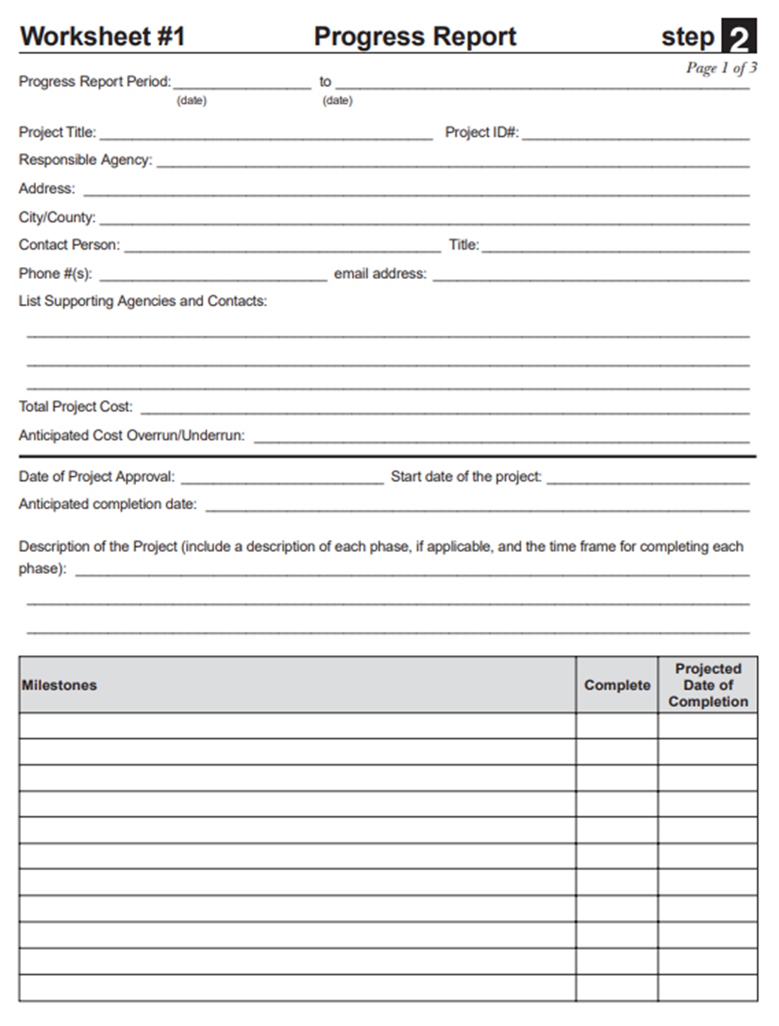
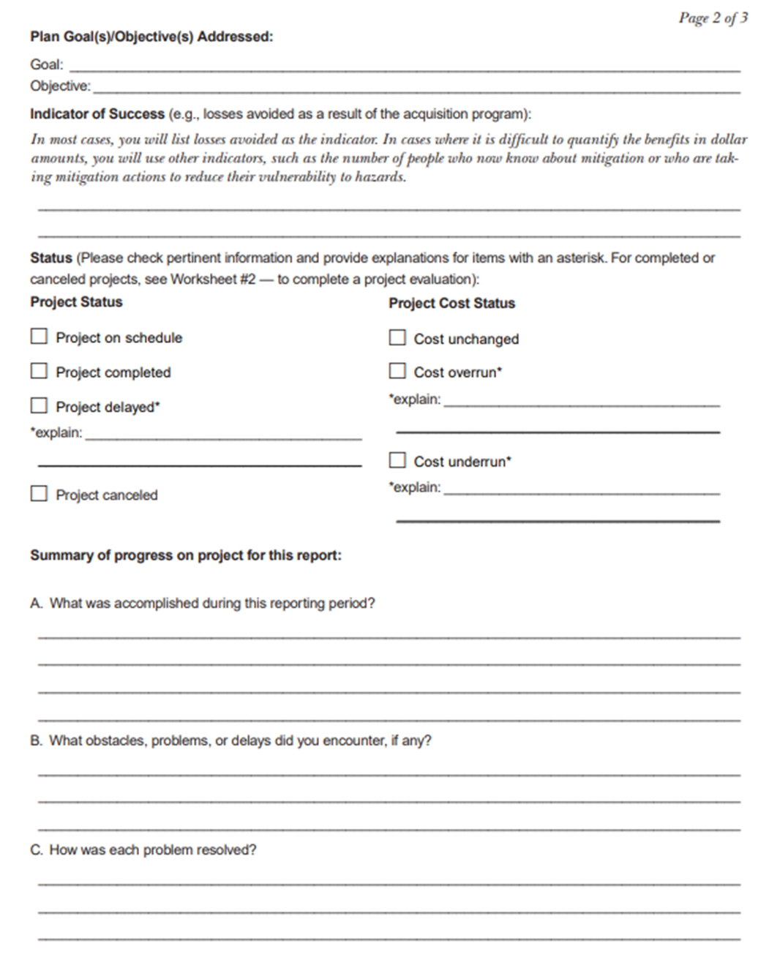
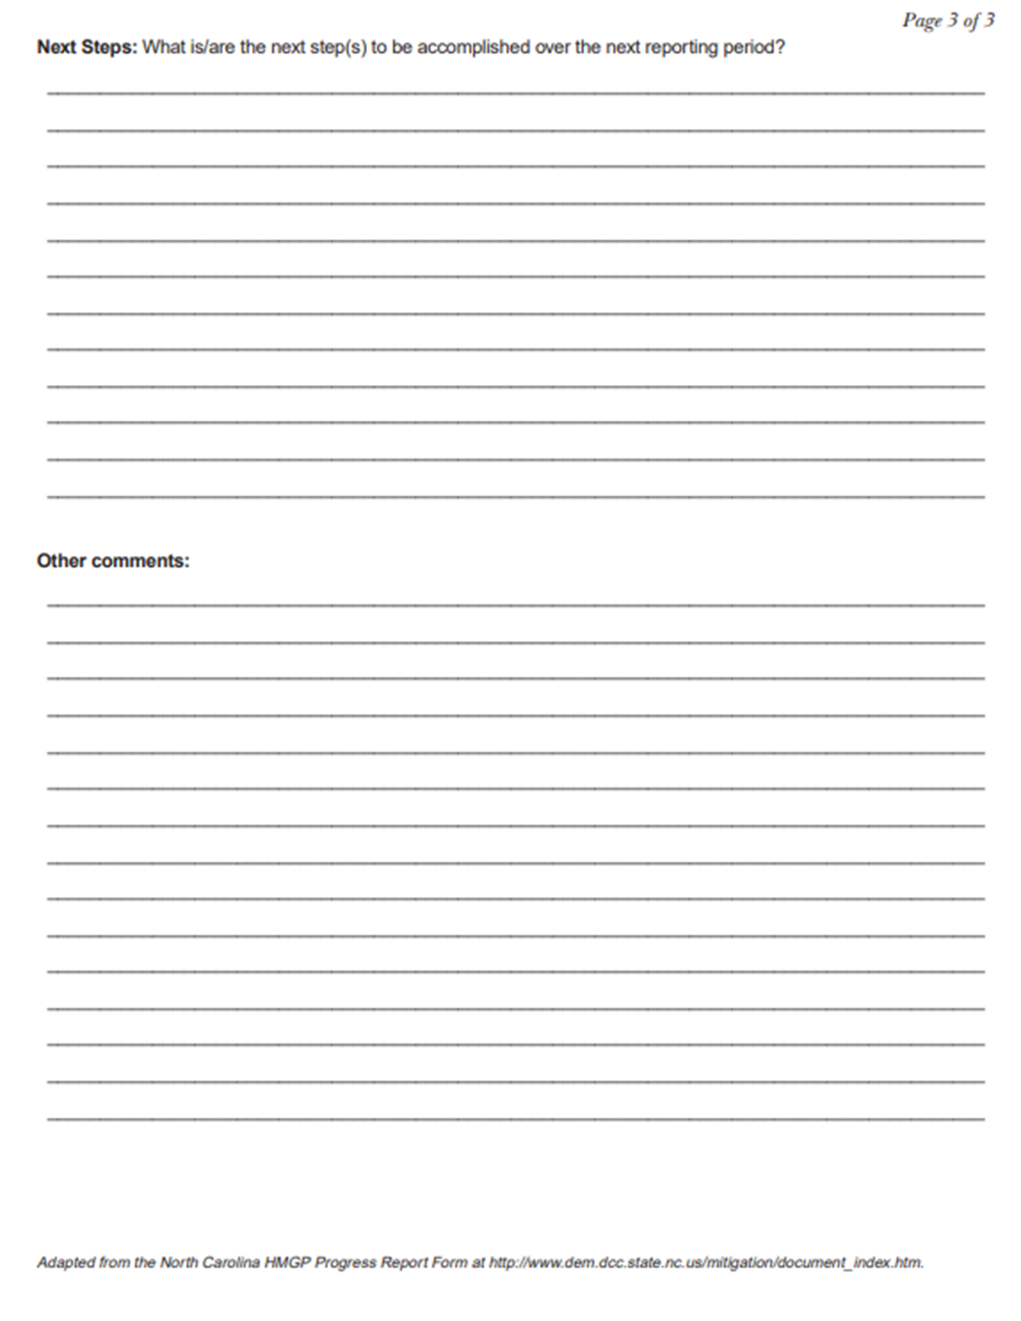
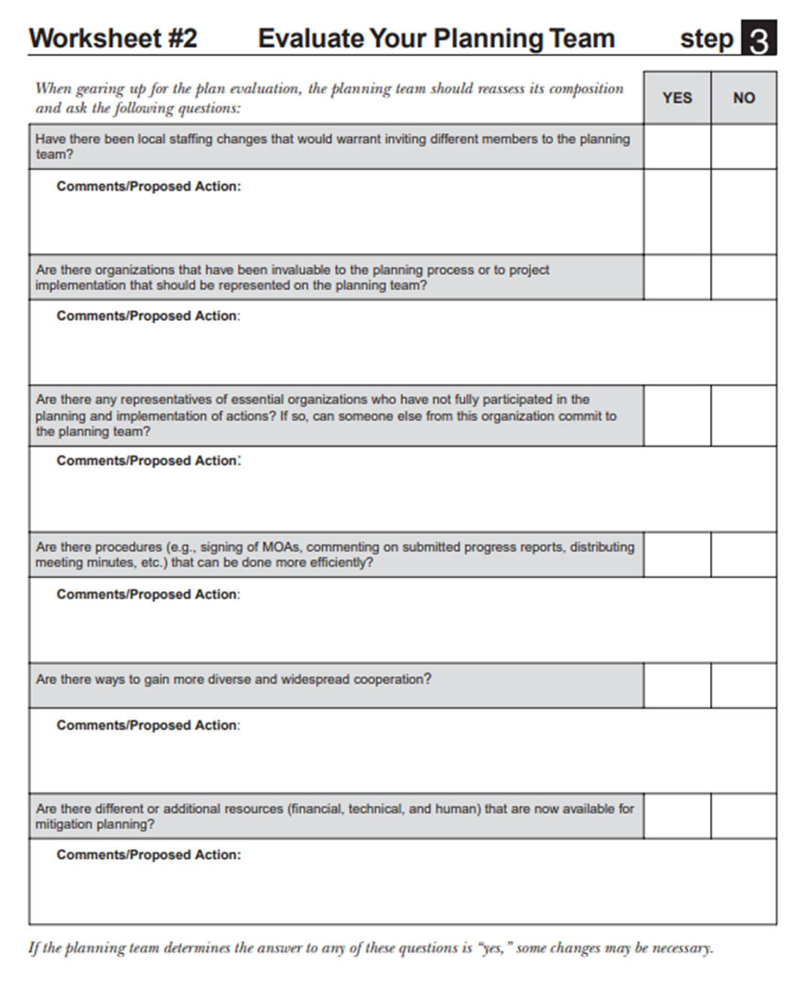
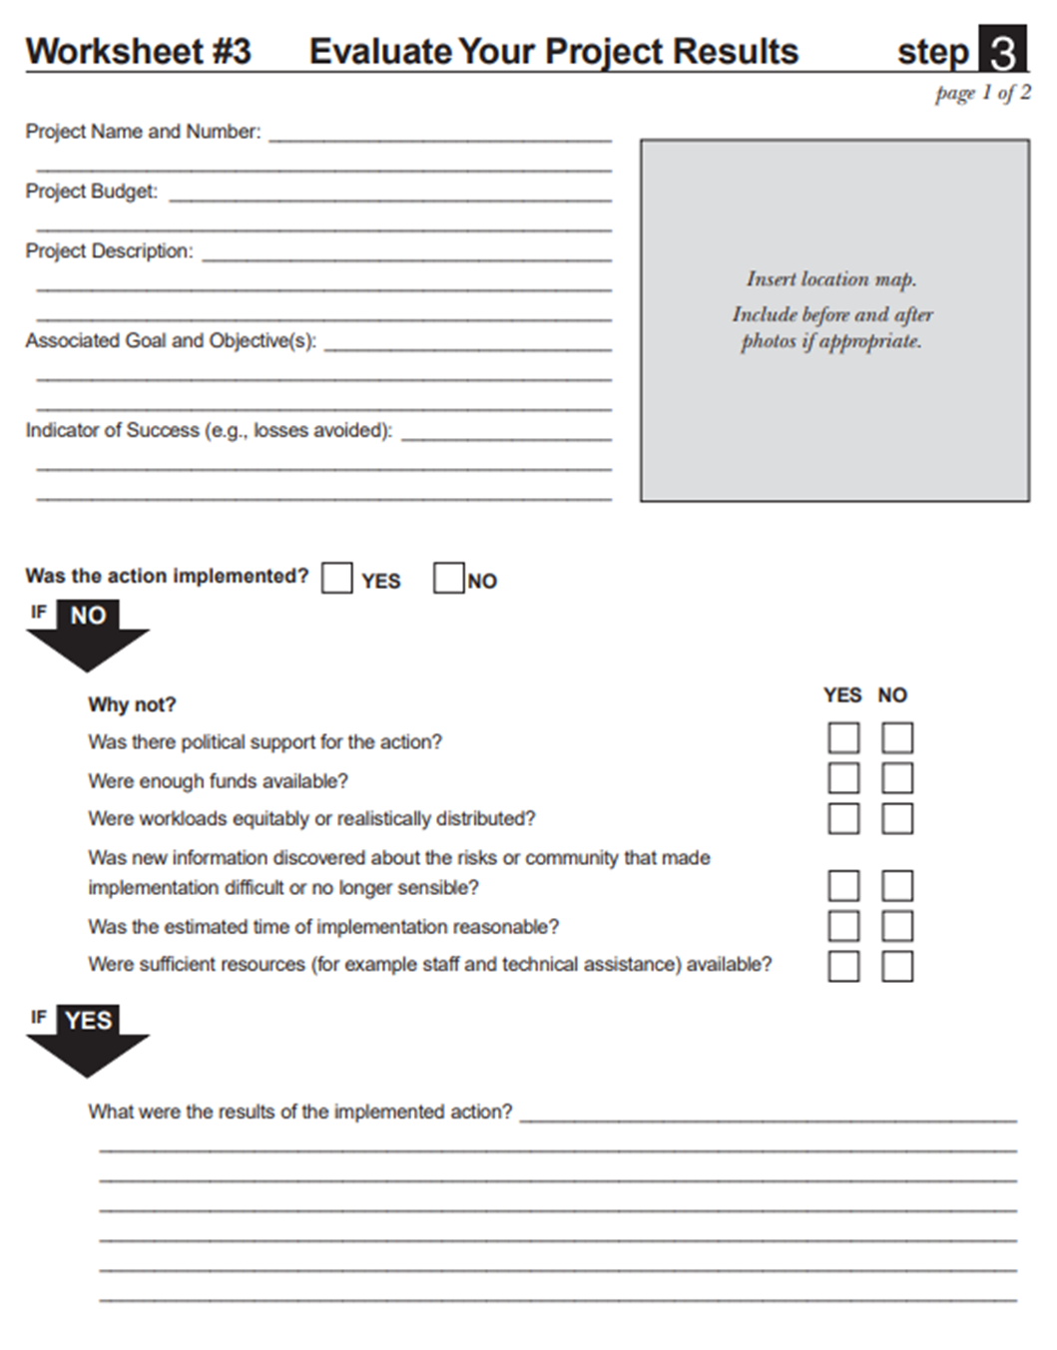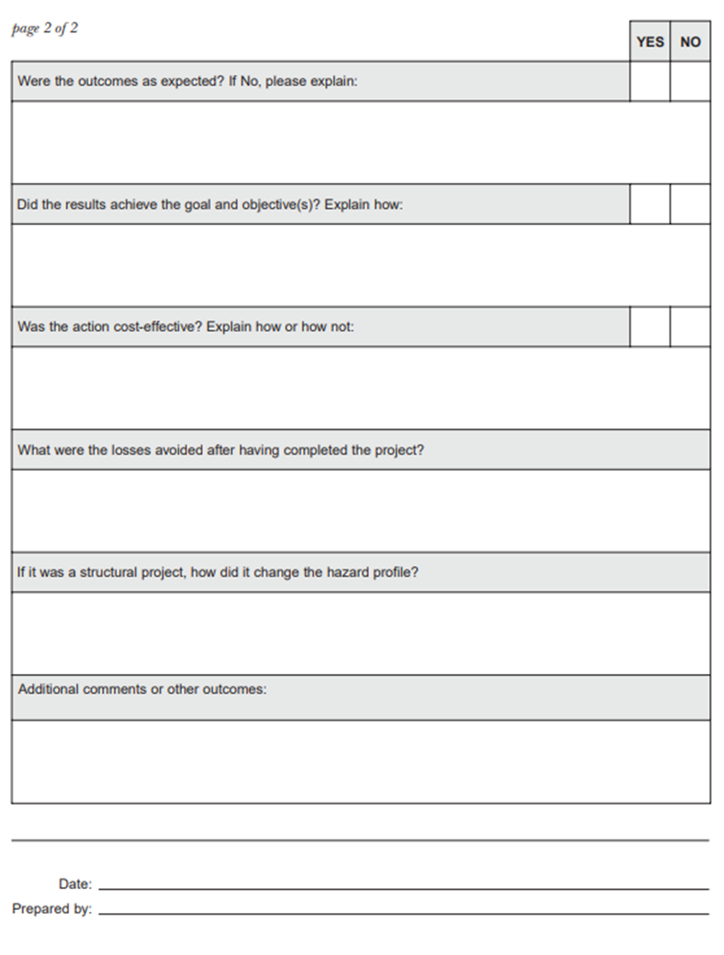
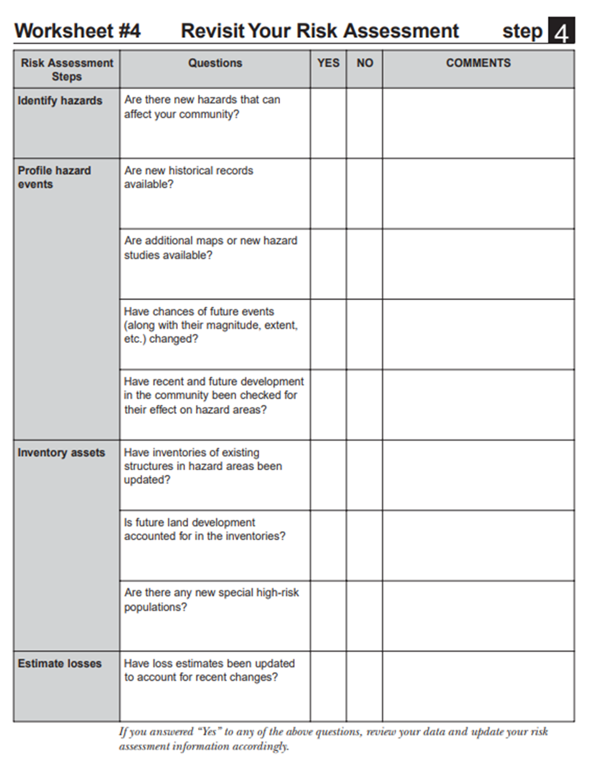
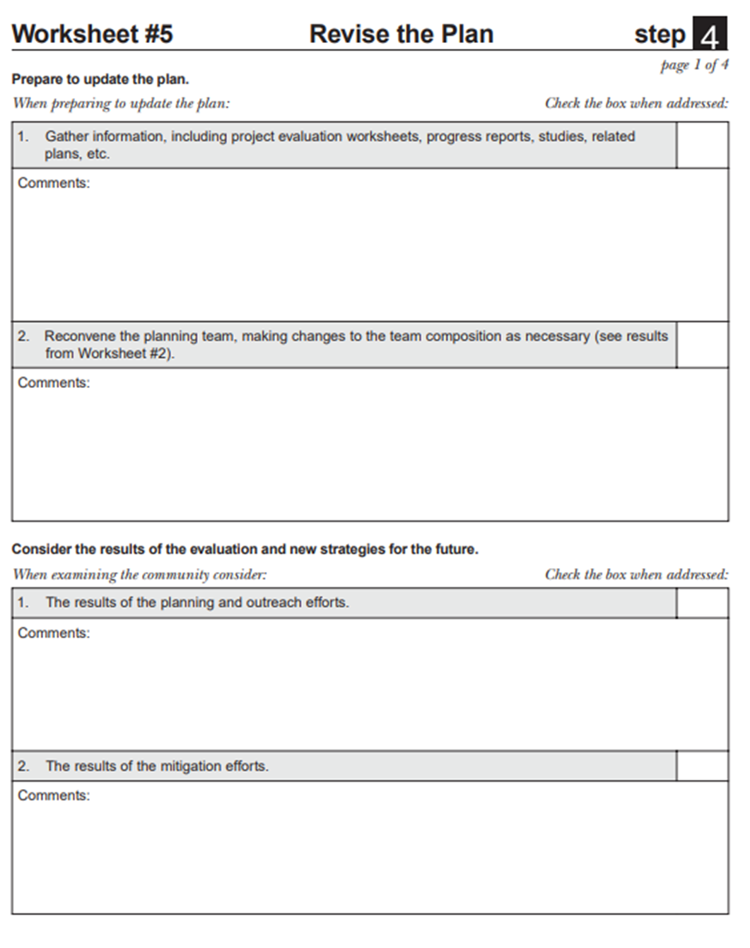
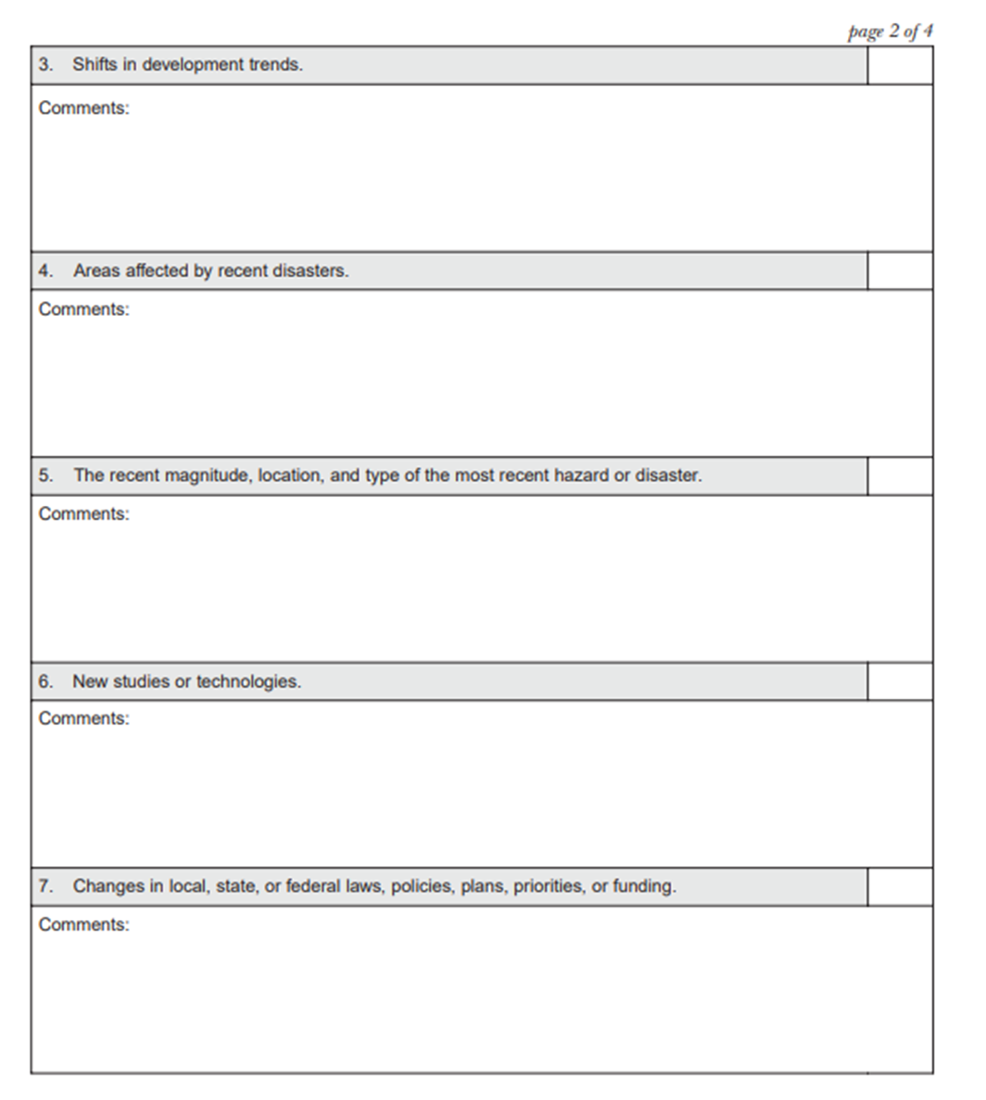
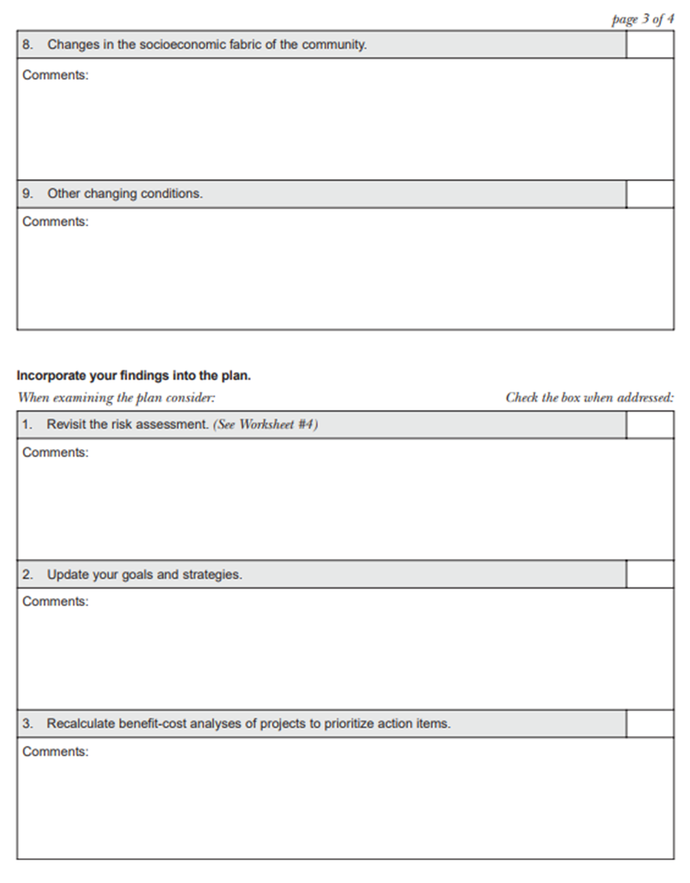

Appendix E: Critical Facility and Community Lifeline Inventory
This appendix contains information and details to support the information provided in Chapter 3 County Profile and Chapters 6 through 13. It provides the address and hazard exposure of critical facilities and community lifelines located within Jefferson County and its jurisdictions. Due to the sensitive nature of this information, this appendix is considered confidential and has been redacted from the public plan.

Appendix F: Linkage Procedures

Administrative Process For “Linkage” to The Jefferson County Hazard Mitigation Plan
The development of the Jefferson County Hazard Mitigation Plan 2024 Update (the Plan) included the County and all eligible local governments within the defined planning area are included in this plan. Completed jurisdictional annexes are presented in Volume II. Any non-participating local jurisdictions such as Fire Districts, Utility Districts, School Districts, and any other eligible local government as defined in 44 CFR 201.2 within the Jefferson County planning area can join this plan as a participating jurisdiction and to ultimately achieve approved status by following the linkage procedures defined in this appendix.
It is assumed that some or all these local jurisdictions may choose to "link" to the Plan at some point in time to gain eligibility for programs under the DMA. In addition, some of the current partnership may not continue to meet eligibility requirements due to the lack of active participation as prescribed by the plan. These "linkage" procedures will define the requirements established by the Jefferson County HMP Steering Committee and all planning partners for dealing with the increase or decrease in planning partners linked to this plan. It should be noted that currently non-participating jurisdictions within the defined planning area are not obligated to link to this plan. These jurisdictions can choose to do their own “complete" plan that addresses all required elements of section 201.6 of 44CFR.

Increasing the Partnership Through Linkage

Eligibility
Eligible jurisdictions located in the planning area may link to this plan at any point during the plan’s performance period. Eligible jurisdictions located in the planning area may link to this plan at any point during the plan’s performance period (5 years after final approval). Eligibility will be determined by the following factors:
- The linking jurisdiction is a local government as defined by the Disaster Mitigation Act.
- The boundaries or service area of the linking jurisdiction is completely contained within the boundaries of the planning area established during the 2025 hazard mitigation plan development process.
- The linking jurisdiction’s critical facilities were included in the critical facility and infrastructure risk assessment completed during the 2025 plan development process.

Requirements
It is expected that linking jurisdictions will complete the requirements outlined below and submit their completed template to the lead agency Jefferson County Office of Fire & Emergency Management for review within six months of beginning the linkage process:
- The Jefferson County Hazard HMP Steering Committee has established an annual window for which linkage to the plan can occur. Linking jurisdictions are instructed to complete the following procedures during this time frame.
- The current non-participating jurisdiction contacts the Jefferson County HMP Coordinator for the Plan and requests a "Linkage Package". The Jefferson County HMP Coordinator is:
Niel S. Rivenburgh, Deputy Director
Office of Fire & Emergency Management
753 Waterman Dr
Watertown, NY 13601
(315) 786-2765
Email: nrivenburgh@co.jefferson.ny.us

- The Jefferson County HMP Coordinator will provide a linkage package that includes:
- Copy of Volume I and II of the Plan (CDROM).
- Planning Partner's Expectations Sheet.
- A Sample "Letter of Intent" to Link to the Plan.
- A Jurisdictional Template and Instructions.
- Catalog of Hazard Mitigation Alternatives or the Mitigation Catalog.
- A copy of Section 201.6 of Chapter 44, the Code of Federal Regulations (44CFR), which defines the federal requirements for a local hazard mitigation plan.
- The new jurisdiction will be required to review both volumes of the Plan which includes the following key components for the planning area:
- The Jefferson County risk assessment;
- The plan’s goals and objectives;
- Plan implementation and maintenance procedures;
- Catalog of potential mitigation actions; and
- County-wide initiatives.
Once this review is complete, the jurisdiction will complete its specific jurisdictional annex by following the template and its instructions for completion provided by the Jefferson County HMP Coordinator. Technical assistance can be provided upon request by completing the request for technical assistance (TA) form provided in the linkage package. This TA may be provided by the Jefferson County HMP Coordinator or any other resource within the Planning Partnership such as a member of the HMP Steering Committee or a currently participating jurisdiction. The Jefferson County HMP Coordinator will determine who will provide the TA and the possible level of TA based on resources available at the time of the request.
- The new jurisdiction will also be required to develop a public involvement strategy that ensures their public's ability to participate in the plan development process. At a minimum, the new jurisdiction must make an attempt to solicit public opinion on hazard mitigation at the onset of this linkage process and a minimum of one public meeting to present their draft jurisdiction specific annex for comment, prior to adoption by the governing body. The Planning Partnership will have available resources to aid in the public involvement strategy such as the Plan website. However, it will be the new jurisdiction’s responsibility to implement and document this strategy for incorporation into their annex.
It should be noted that the Jurisdictional Annex templates do not include a section for the description of the public process. This is because the original partnership was covered under a uniform public involvement strategy that covered the operational area that is described in Volume I of the plan. Since the new partner was not addressed by that strategy, they will have to initiate a new strategy, and add a description of that strategy to their annex. For consistency, new partners are encouraged to follow the public involvement format utilized by the initial planning effort as described in Volume I of the Plan.
- Once their public involvement strategy is completed and they have completed their template, the new jurisdiction will submit the completed package to the Jefferson County HMP Coordinator for a pre-adoption review to ensure conformance with the regional plan format.
- The Jefferson County HMP Coordinator will review for the following:
- Documentation of public involvement and mitigation action development strategies;
- Conformance of template entries with guidelines outlined in instructions;
- Chosen actions are consistent with goals, objectives, and mitigation catalog of Jefferson County Hazard Mitigation Plan; and
- Designated point of contact.
The Jefferson County HMP Coordinator may utilize members of the HMP Steering Committee or other resources to complete this review. All proposed linked annexes will be submitted to the HMP Planning Committee for their review and comment prior to submittal to the New York State Division of Homeland Security and Emergency Services (NYS DHSES).
- Plans approved and accepted by the HMP Steering Committee will then be forwarded to NYS DHSES for review with cover letter stating the forwarded plan meets local approved plan standards and whether the plan is submitted with local adoption or for criteria met/plan not adopted review.
- NYS DHSES will review plans for state and federal compliance. Non-compliant plans are returned to the jurisdiction for correction. Compliant plans are forwarded to FEMA Region II office for review with annotation as to the adoption status.
- FEMA Region II reviews the new jurisdiction's plan in association with the approved plan to ensure DMA compliance. Region II notifies new jurisdiction of results of review with copies to NYS DHSES and approved planning authority.
- New jurisdiction corrects plan’s shortfalls (if necessary) and resubmits to NYS DHSES through the approved plan lead agency.
- For plans with no shortfalls that have not been adopted from the Region II review or outstanding corrected shortfalls, the new jurisdiction governing authority adopts the plan (if not already accomplished) and forwards adoption resolution to Region II with copies to lead agency and NYS DHSES.
- Region II Director notifies new jurisdiction governing authority of plan approval.
The new jurisdiction plan is then included with the Jefferson County HMP and the linking jurisdiction is committed to participate in the ongoing plan implementation and maintenance identified in Volume I of the HMP.

