Jurisdictional Annexes

Town of Brownville
This jurisdictional annex to the Jefferson County Hazard Mitigation Plan (HMP) provides information to assist public and private sectors in the Town of Brownville with reducing losses from future hazard events. This annex is not guidance of what to do when a disaster occurs; its focus is on actions that can be implemented prior to a disaster to reduce or eliminate damage to property and people. The annex presents a general overview of Brownville, describes who participated in the planning process, assesses Brownville’s risk, vulnerability, and capabilities, and outlines a strategy for achieving a more resilient community.

Hazard Mitigation Planning Team
The Town of Brownville identified primary and alternate HMP points of contact and developed this plan over the course of several months, with input from many Town departments.
Table A summarizes local officials who participated in the development of the annex. Additional documentation of the Town’s planning activities through Planning Partnership meetings is included in Volume I.
Table A. Hazard Mitigation Planning Team
Primary Point of Contact | Alternate Point of Contact
Name/Title: Richard Lane, Town Supervisor  Address:16431 Star School House Rd, Dexter NY 13634  Phone Number:315-639-6266 Ext. 5  Email: townbr@yahoo.com | Name/Title: Novina Green, Town Clerk  Address:16431 Star School House Road, Dexter NY  Phone Number: 315-639-6266 Ext. 2  Email: townbr@yahoo.com
National Flood Insurance Program Floodplain Administrator
Name/Title: Ron McGregor, Floodplain Administrator
Address:16431 Star School House Rd. Dexter NY 13634
Phone Number: 315-639-6266 Ext. 5
Email: townbr@yahoo.com

Community Profile

Community Classifications
Table B summarizes classifications for community programs available to Brownville.
Table B. Community Classifications
Program | Participating? (Yes/No) | Classification | Date Classified
Building Code Effectiveness Grading Schedule (BCEGS) | Yes | 3 | 6/27/22
Community Rating System (CRS) | No | - | -
Firewise Communities classification | No | - | -
National Weather Service StormReady Certification | No | - | -
Public Protection (ISO Fire Protection Classes 1 to 10) | Yes | 6/6Y
NYSDEC Climate Smart Community | No | - | -
Other: Organizations with mitigation focus (advocacy group, non-government)
N/A = Not applicable

Community Profile
The Town of Brownville has an area of 57 square miles and is located in the center part of the County. The Town is bordered by the Town of Clayton and the Town of Orleans to the north, the Town of Pamelia to the east, the Town of Watertown, Town of Hounsfield, Village of Dexter, and Village of Brownville to the south, and the Town of Lyme and Henderson Bay to the west. Numerous state highways run directly through the Town of Brownville.
According to the U.S. Census, the 2020 population for the Town of Brownville was 3,456which makes up three percent of the county population. Data from the 2022 American Community Survey indicates that 7.3 percent of the population is 5 years of age or younger, 22.1 percent is 65 years of age or older, zero percent is non-English speaking, 10.3 percent is below the poverty threshold, and 18.9 percent is considered disabled.

Jurisdictional Risk Assessment
The hazard profiles in Volume I provide detailed information regarding each planning partner’s vulnerability to the identified hazards, including summaries of Brownville’s risk assessment results and data used to determine the hazard ranking. Key local risk assessment information is presented below.
Each jurisdiction has unique assets, vulnerabilities and overall risk. A multi-jurisdictional plan needs to identify every hazard (from the whole planning area). In hazard mitigation planning, risk is the potential for damage or loss when natural hazards interact with people or assets. These assets may be buildings, infrastructure or natural and cultural resources. A risk assessment is a robust, data-driven analysis. It explains what might happen. It also finds where the local jurisdiction is vulnerable to hazards.
Each community must describe how the selected hazards affect its jurisdiction. Some hazards will have similar effects across the area: extreme temperatures, windstorms, winter weather, drought, heavy rain, etc. Some have a smaller location and will vary based on geography. Multi-jurisdictional plans must explain these differences.
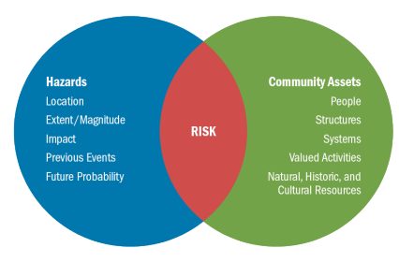
Risk is the relationship, or overlap, between hazards and community assets. The smaller the overlap, the lower the risk.

Hazard Area
Hazard area maps provided below illustrate the probable hazard areas impacted within the Town are shown in Figure 1 through Figure 2. These maps are based on the best available data at the time of the preparation of this plan and are adequate for planning purposes. Maps are provided only for hazards that can be identified clearly using mapping techniques and technologies and for which Brownville has significant exposure. The maps show the location of potential new development, where available.
Figure 1. Brownville Flood and Coastal Erosion Hazard Area Extent and Location
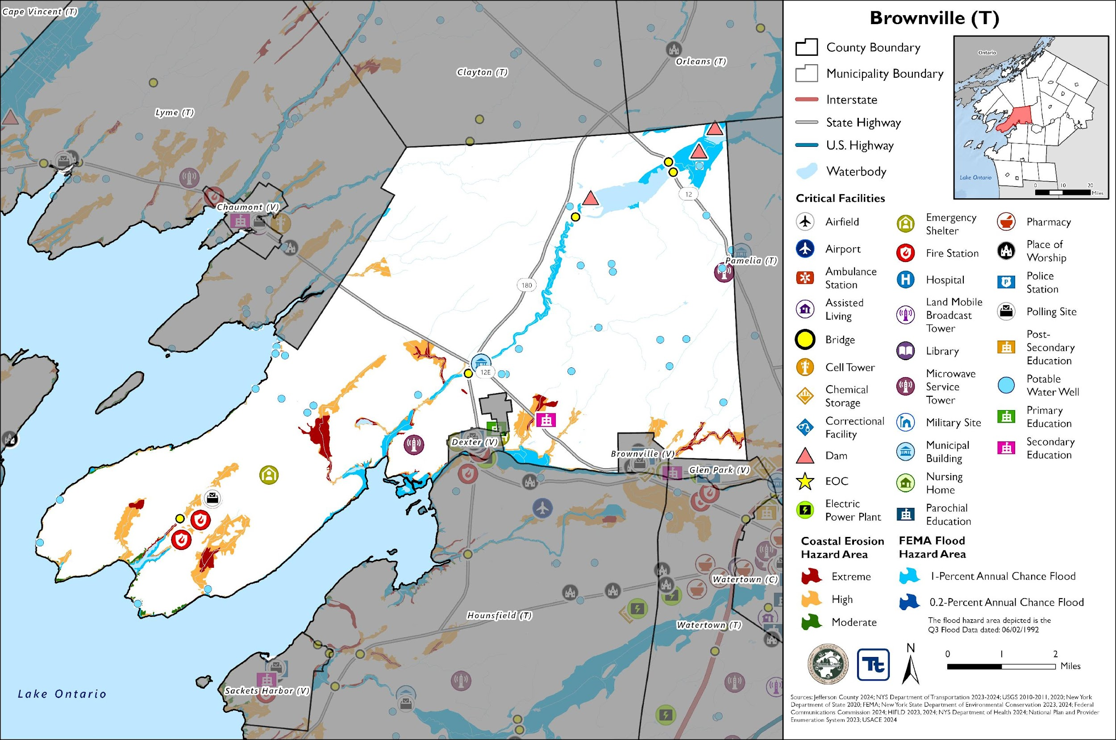
Figure 2. Brownville Landslide and WUI Hazard Area Extent and Location Map
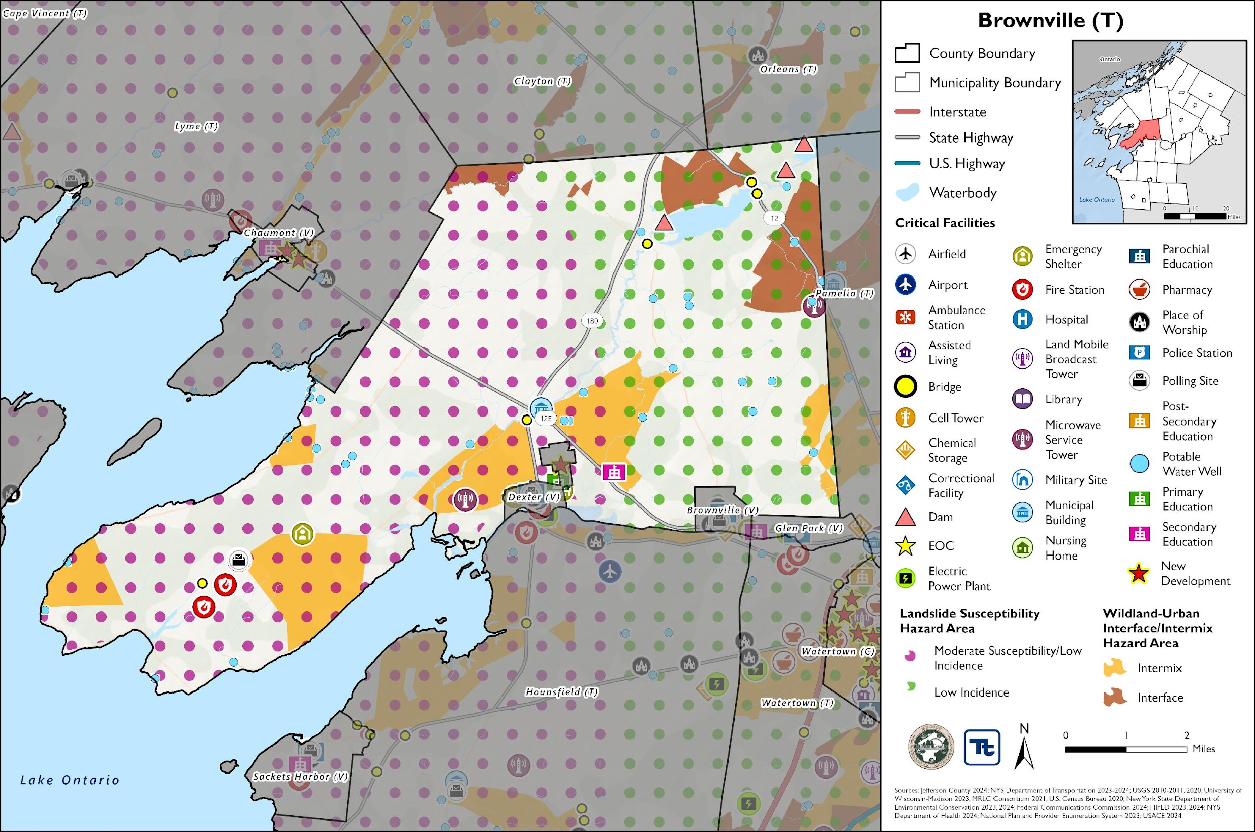

Previous Event History
The history of natural and non-natural hazard events in Brownville is detailed in Volume I, where each hazard profile includes a chronology of historical events that have affected the County and its municipalities. Table C provides details on loss and damage in Brownville during hazard events since the last hazard mitigation plan update.
Table C. Presidential Disaster Declaration History in Brownville
Dates of Event | Event Type (Disaster Declaration) | Summary of Event | Summary of Damage and Losses in Brownville
November 18-22, 2022 | Severe Winter Storm (EM-3589) | A winter storm caused more than six feet of snow to accumulate in Jefferson County. This intense snowfall has created extremely dangerous travel conditions, and as a result, numerous road closures and travel bans. | The Town did not incur any documented damage or losses.
October 31 – November 1, 2019 | Severe Storm, Flood (DR-4472) | A storm system brought record breaking rains, damaging wind gusts (45 to 50 mph), a small Lake Ontario seiche, and river flooding to the region. Thousands of power outages occurred across the area, and wind-related damage closed hundreds of roads and did countless tree damage. High winds and lakeshore flooding continued into November 1. | The Town did not incur any documented damage or losses.
May 2 – August 6, 2017 | Flood (DR-4348) | Six months of wet weather led to an over-accumulation of waters in Lake Ontario. Flooding from the lake began impacting areas in May and continued until early autumn. Waves destroyed public and private break walls all along the lake shore. Thousands of homes and buildings were affected flood waters. Several homes dropped off bluffs. In some areas shoreline erosion of 50 to 100 feet deep occurred. Sanitary sewer systems in lakeside communities were affected. Beaches, marinas, and state parks were closed all summer long with unknown economic losses to mainly seasonal businesses. In late May, the Governor imposed a 5-mph speed limit within 600 feet of the Lake Ontario and St. Lawrence River shore. By summer’s end, damage estimates reached $10 Million in Jefferson County. | The Town did not incur any documented damage or losses.
November 17-26, 2014 | Severe Winter Storm, Flood (DR-4204) | A winter storm moved into the region, causing temperatures to drop tremendously. Lake effect snow impacted counties bordering Lake Ontario and Lake Erie. Travel restrictions were instituted due to whiteout conditions. The storm produced heavy snowfall, high winds, and blizzard-like conditions, resulting in road closures, travel disruptions, power outages, and damage to public and private property. | The Town did not incur any documented damage or losses.
October 27 – November 8, 2012 | Severe Storm (EM-3351) | Remnants of Hurricane Sandy brought strong winds and heavy rains. Rainfall amounts of two to five inches were measured across the area with some area creeks reaching bankful. High winds downed trees and power lines. Wind gusts were measured to 60 mph. Utilities reported tens of thousands of customers without power across the entire region. | The Town did not incur any documented damage or losses.
EM = Emergency Declaration (FEMA)
FEMA = Federal Emergency Management Agency
DR = Major Disaster Declaration (FEMA)
N/A = Not applicable

Local Hazard Impacts Assessment
In the table below representatives from the Town of Brownville Hazard Mitigation Planning Team assessed impacts of hazards on buildings, structures, facilities, infrastructure, community assets and systems, people and the local economy.
Table D. Local Hazard Impacts Assessment
Hazard Name | Local Impacts
Dam Failure | N/A
Drought | No known impacts
Extreme Temperature | No known impacts
Flood | No known impacts
Geological Hazards | No known impacts
Severe Storm | No known impacts
Severe Winter Storm | No known impacts
Wildfire | No known impacts

Vulnerable Community Assets
In the table below representatives from the Town of Brownville Hazard Mitigation Planning team assessed specific impacts to the assets included in the table below. If a community asset is not present in the municipality the Planning Team stated, ‘Not Applicable.’
Table E. Vulnerable Community Assets
Community Asset | Hazard Impacts and Asset Vulnerabilities | Community Asset | Hazard Impacts and Asset Vulnerabilities
Agriculture | N/A | Local Roads | High winds could cause trees to fall and block roads.
Airports | N/A | Major Employers | No known impacts
Area: Concentration of Businesses | N/A | Medical Centers (non-hospital) | N/A
Area: Concentration of Residences | No known impacts | Natural Resources | No known impacts
Bridges | N/A | Neighborhoods | No known impacts
City Hall/Courthouse | N/A | Parks and Recreational Sites | N/A
College/University | N/A | Place of Worship | N/A
Community Centers/Hubs | N/A | Private Property | No known issues
Community Activities: major local events including festivals and economic drivers such as beaches, skiing, farming, fishing, etc. | N/A | Public Transportation | N/A
Cultural/Historic Buildings/Sites | N/A | Schools (K-12) | N/A
Culverts | No known impacts | Small Businesses | No known issues
Elder-care Facilities | N/A | Supermarkets/Grocery Stores | N/A
Fire/Police Stations | Three fire stations. Two have fixed generators (1 with no transfer switch). One station has a portable generator. | Transportation - Mobile Asset Storage | N/A
Gas Stations | N/A | Utilities | Severe storms and winds could cause damage to street lights and utility poles
Highways | N/A | Wastewater Treatment Plants | N/A
Hospitals | N/A | Waterfront | Severe wet weather storms could cause damage to waterfront properties.
Other | No known impacts | Drinking Water Resources | No known issues

Hazard Ranking
The participating jurisdictions have differing degrees of vulnerability to the hazards of concern, so each jurisdiction ranked its own degree of risk to each hazard. The community-specific hazard ranking is based on problems and impacts identified by the risk assessment presented in Volume I.
The ranking process involves an assessment of the likelihood of occurrence for each hazard; the potential impacts of the hazard on people, property, and the economy; community capabilities to address the hazard; and changing future climate conditions. Impacts from a particular hazard may have decreased due to an implemented project or relocation of an asset that was previously at risk. Alternatively, risk may have increased because population has increased in a hazard prone area.
Table F. Hazard Ranking
Hazard Name | Frequency (2011 – present):  Increased, Decreased, Stayed the Same | Impacts (2011 – present):  Increased, Decreased, Stayed the Same | Description of frequency and impacts (2011 – present): | Future Events (present – 2030):  Will Increase, Decrease, Stay the Same | 2025 Ranking
Dam Failure | Same | - | - | Same | Low
Drought | Same | - | - | Same | Low
Extreme Temperature | Same | - | - | Same | Low
Flood | Same | - | - | Same | Medium
Geologic Hazards | Same | - | - | Same | Low
Severe Weather | Same | - | - | Same | Low
Severe Winter Weather | Same | - | - | Same | Medium
Wildfire | None | - | - | None | Low

Critical Facilities
Table G. Critical Facilities Flood Vulnerability
Name | Type | Vulnerability
 |  | 1% Annual Chance Event | 0.2% Annual Chance Event
Brownville Highway Garage/Office Building | Municipal Building | X | X
Source: Jefferson County 2024; New York State Department of Environmental Conservation 2023, 2024; Federal Communications Commission 2024; HIFLD 2023, 2024; NYS Department of Health 2024; National Plan and Provider Enumeration System 2023; USACE 2024; NYS Department of Transportation 2023

The municipality does not have any identified high hazard potential dams within the jurisdiction.

Growth/Development Trends
Understanding how past, current, and projected development patterns have or are likely to increase or decrease risk in hazard areas is a key component to appreciating a jurisdiction’s overall risk to its hazards of concern. Recent and expected future development trends, including major residential/commercial development and major infrastructure development, are summarized in Table H through Table L.

Development and Permitting
Table H. Development and Permitting Capability
Question | Answer
Does your municipality or the county issue building permits for development in your community? | Jefferson County
What is your process for tracking building permits? | Zoning officer keeps copy which are then filed by year and date
Are permits tracked by hazard area? (For example, floodplain development permits.) | No
Does your community have a buildable land inventory? If yes, please describe. | No
Table I. Number of Building Permits for New Construction Issued Since the Previous HMP
 | New Construction Permits Issued
 | Single Family | Multi-Family | Other (commercial, mixed-use, etc.) | Total
2019
Total Permits | 8 | 0 | 0 | 8
Permits within SFHA | 0 | 0 | 0 | 0
2020
Total Permits | 16 | 0 | 1 | 17
Permits within SFHA | 0 | 0 | 0 | 0
2021
Total Permits | 7 | 0 | 0 | 7
Permits within SFHA | 0 | 0 | 0 | 0
2022
Total Permits | 4 | 0 | 0 | 4
Permits within SFHA | 0 | 0 | 0 | 0
2023
Total Permits | 15 | 0 | 0 | 15
Permits within SFHA | 0 | 0 | 0 | 0
2024
Total Permits | 15 | 0 | 2 | 17
Permits within SFHA | 0 | 0 | 0 | 0
SFHA = Special Flood Hazard Area (1% flood event)
Table J. Recent Major Development and Infrastructure from 2011 to 2018
Property or Development Name | Type of Development | # of Units / Structures | Location (address and/or block and lot) | Known Hazard Zones | Description / Status of Development
Water Capital Project | Capital Project | - | North Shore Rd., 12E. Star School House Rd., Cemetery Rd. | No | Install water line - WD1
Table K. Recent Major Development and Infrastructure from 2019 to Present
Property or Development Name | Type of Development | # of Units / Structures | Location (address and/or block and lot) | Known Hazard Zones | Description / Status of Development
Water Capital Project | Capital Project | - | County Route 59, Middle Rd., South Shore Rd. | No | Install water line - WD2
Table L. Known of Anticipated Major Development and Infrastructure in the Next Five Years
Property or Development Name | Type of Development | # of Units / Structures | Location (address and/or block and lot) | Known Hazard Zones* | Description / Status of Development
NEXAMP | Solar Panels | - | 26422 Weaver Rd | No | Single axel sun tracking system.

National Flood Insurance Program Compliance
This section provides specific information on the management and regulation of the regulatory floodplain, including current and future compliance with the National Flood Insurance Program (NFIP). The floodplain administrator listed in Table A is responsible for maintaining this information.

NFIP Statistics
Table M summarizes the NFIP policy and claim statistics for Brownville.
Table M. Brownville NFIP Summary of Policy and Claim Statistics
# Policies | 14
# Claims (Losses) | 22
Total Loss Payments | $442,993.98
# Repetitive Loss Properties (NFIP definition) | 2
# Repetitive Loss Properties (FMA definition) | 0
# Severe Repetitive Loss Properties | 0
NFIP Definition of Repetitive Loss: The NFIP defines a repetitive loss property as any insurable building for which two or more claims of more than $1,000 were paid by the NFIP within any rolling 10-year period since 1978.
FMA Definition of Repetitive Loss: FEMA’s Flood Mitigation Assistance (FMA) program defines a repetitive loss property as any insurable building that has incurred flood-related damage on two occasions, in which the cost of the repair, on average, equaled or exceeded 25 percent of the market value of the structure at the time of each such flood event.
Definition of Severe Repetitive Loss: A residential property covered under an NFIP flood insurance policy and: (a) That has at least four NFIP claim payments over $5,000 each, and the cumulative amount of such claims payments exceeds $20,000; or (b) For which at least two separate claims payments have been made with the cumulative amount of the building portion of such claims exceeding the market value of the building. At least two of the claims must have occurred within any 10-year period, more than 10 days apart.
Source: FEMA 2024

National Flood Insurance Program (NFIP) Flood Vulnerability Summary
The HMP Team provided information on participation in and continued compliance with the NFIP in the table below.
Table N. NFIP Summary
NFIP Topic | Comments
Describe areas prone to flooding in your jurisdiction. | Zone A
Who is the Community Floodplain Administrator (FPA)? Do they serve any roles other than FPA? Do they have adequate training and capacity for this role? | Ron McGregor, Floodplain Administrator
What local department is responsible for floodplain management? | Code Enforcement
Are any certified floodplain managers on staff in your jurisdiction? | No
What is the local law number or municipal code of your flood damage prevention ordinance? | L.L. No 3-1994
When was the latest effective Flood Insurance Rate Map (FIRM) adopted, if applicable? | June 2, 1992
Explain NFIP administration services (e.g., permit review, inspections, engineering capability, GIS, etc.) | N/A
What are the barriers to running an effective NFIP program in your community, if any? | N/A
Does your floodplain management staff need any assistance or training to support its floodplain management program? If yes, what type of assistance/training is needed? | No
How do you make Substantial Damage determinations? What is the process to make sure these structures are brought into compliance? | N/A
How do you determine if proposed development on an existing structure would qualify as a substantial improvement? | N/A
How many Substantial Damage determinations were declared for recent flood events in your jurisdiction? | N/A
Does the community track the number of buildings in the floodplain? If so, how many structures are in special flood hazard area (SFHA)? | N/A
How many structures (residential and non-residential) are exposed to flood risk within the community outside of the regulatory maps? | N/A
Does the community maintain elevation records? If yes, please describe. | N/A
Are there any repetitive loss (RL) or severe repetitive loss (SRL) structures in the community? If yes, how many of each category? | Two Repetitive Loss Properties
Describe any areas of flood risk with limited NFIP policy coverage. | N/A
How does the community teach property owners or other stakeholders about the importance flood insurance? | N/A
What digital sources (like the FEMA Map Service Center,  National Flood Hazard Layer) or non-regulatory tools does your community use? | None
Are there other local ordinances, plans or programs (e.g., site plan review) that support floodplain management and meeting the NFIP requirements? For instance, does the planning board or zoning board consider efforts to reduce flood risk when reviewing variances such as height restrictions? | N/A
When was the most recent Community Assistance Visit (CAV) or Community Assistance Contact (CAC)? | CAC: March 25, 1996  CAV: March 11, 2020
Does your community plan to join the CRS program or is your community interested in improving your CRS classification? | N/A

Jurisdictional Capability INVENTORY and ASSESSMENT
Brownville performed an inventory and analysis of existing capabilities, plans, programs, and policies that enhance its ability to implement mitigation strategies. Volume I describes the components included in the capability assessment and their significance for hazard mitigation planning. The jurisdictional assessment for this annex includes analyses of the following:
- Planning and regulatory capabilities
- Development and permitting capabilities
- Administrative and technical capabilities
- Fiscal capabilities
- Education and outreach capabilities
- Classification under various community mitigation programs
- Adaptive capacity to withstand hazard events
For a community to succeed in reducing long-term risk, hazard mitigation must be integrated into day-to-day local government operations. As part of the hazard mitigation analysis, planning and /policy documents were reviewed and each jurisdiction was surveyed to obtain a better understanding of their progress toward plan integration. Development of an updated mitigation strategy provided an opportunity for Brownville to identify opportunities for integrating mitigation concepts into ongoing Town procedures.

Planning and Regulatory Capability and Integration
Planning and regulatory capabilities are the plans, policies, codes, and ordinances that prevent and reduce the impacts of hazards.

Ordinances
Jefferson County has an Emergency Management Ordinance which charges the County with maintaining a Comprehensive Emergency Management Plan to identify local measures that may prevent disasters, to develop local mechanisms to coordinate local resources and personnel for service during and after disasters, support the facilitation of delivery of services to aid citizens and reduce human suffering resulting from disaster, and to provide for short- and long-term recovery and redevelopment after disasters.
Jefferson County has Site Plan and Subdivision Codes that are relevant to development within a certain distance of County interests. Development applications in the areas across the County are sent to County Planning for review to promote coordination of land use decisions and local/county impacts. These County capabilities are inclusive of Brownville and the jurisdiction often partners with the County. To learn more about these capabilities please see Jefferson County’s Jurisdictional Annex.
The HMP Team inventoried its existing ordinances against the full capability list of hazard mitigation-related capabilities. The absence of other kinds of ordinances was not considered a gap in local capabilities. The table below summarizes the ordinances currently in place.
Table O. Ordinances
Capability Type | In Place in Municipality | Comments | Responsible Department / Agency / Organization
Building Codes | Yes | All of the communities in Jefferson County regulate construction through the use of a building code. The Town of Brownville adhere to a building code through County authority. Building codes regulate construction standards and are developed for specific geographic areas of the country. They consider the type, frequency, and intensity of hazards present in the region. Structures built to applicable building codes are inherently resistant to many hazards such as strong winds, floods, and earthquakes. Due to the location specific nature of the building codes, these are very valuable tools for mitigation. | Planning Board
Flood Damage Prevention Ordinance | Yes, L.L. No 3-1994 | This ordinance is designed to protect communities from flood hazards by implementing regulations that ensures the land use and development practices account for the flood risks, requires vulnerable structures to be constructed to withstand flood damage, and to control changes to the natural floodplain and stream channels to prevent increased flood hazards. | Floodplain Administrator
Real Estate Disclosure Requirements | Yes | In addition to facing potential liability for failing to disclose under the exceptions to “caveat emptor,” a home seller must make certain disclosures under the law or pay a credit of $500 to the buyer at closing. While the PCDA requires a seller to complete a standardized disclosure statement and deliver it to the buyer before the buyer signs the final purchase contract, in practice, most home sellers in New York opt not to complete the statement and instead pay the credit. | NYS Department of State, Real Estate Agent
Subdivision Code | Yes | Subdivision ordinances offer an opportunity to account for natural hazards prior to the development of land as they formulate regulations when the land is subdivided. Subdivision design that incorporates mitigation principles can reduce the exposure of future development to hazard events. | Planning Board
Zoning/Land Use Code | Yes | Zoning is a useful tool to consider when developing a mitigation strategy. It can be used to restrict new development, require low-density development, and designate specific uses (e.g. recreational) in the hazard prone areas. Private property rights must be considered but enacting a zoning ordinance can reduce or potentially eliminate damages from future hazard events. | Planning Board

Plans
Jefferson County has an Agriculture Plan (Jefferson County Agricultural and Farmland Protection Plan, 2016); Climate Adaptation / Resilience Plan (North Country Regional Sustainability Plan, 2013); Comprehensive Emergency Management Plan; County Emergency Preparedness Assessment (CEPA); Continuity of Operations Plan (Jefferson County Government COOP – COG Plan, 2023); Economic Development Plan (Jefferson County Comprehensive Economic Development Strategy, 2021); Public Health Plan (Jefferson County Public Health Service Strategic Plan 2023-2027); Threat and Hazard Identification and Assessment (THIRA); Tourism Plan; Transportation Plan (Jefferson County Coordinated Transportation Plan for Mobility Services, 2021); and other recent plans that are all countywide in scope and implementation and are applicable to the Town of Brownville. To learn more about these capabilities please see Jefferson County’s Jurisdictional Annex.
The HMP Team inventoried its existing plans against the full capability list of hazard mitigation-related capabilities. The absence of other kinds of plans was not considered a gap in local capabilities. The table below summarizes the plans currently in place.
Table P. Plans
Capability Type | In Place in Municipality | Comments | Responsible Department / Agency / Organization
Comprehensive Plan | Yes | A comprehensive plan is a document which illustrates the overall vision and goals of a community. It serves as a guide for the community’s future and often includes anticipated demographics, land use, transportation, and actions to achieve desired goals. Integrating mitigation concepts and policies into a comprehensive plan provides a means for implementing initiatives through legal frameworks and enhances the opportunity to reduce the risk posed by hazard events. | Town Administration
Floodplain Management or Watershed Plan | Yes | The Floodplain Management Plan (FMP) is intended to:  - Identify Town's known flood problem areas.  - Establish goals, objectives, and policies and implementation programs to reduce flooding and flood related hazards.  - Identify the natural and beneficial functions of our floodplains.  - Support a reduction in flood insurance costs for those required to have flood insurance. | Town Administration

Administrative and Technical Capability
Jefferson County Code, Fire Prevention and Building Code department currently enforces the New York State Uniform Fire Prevention and Building Code in 31 municipalities that chose not to enforce the Code at the local level, including the Town of Brownville. The Department employs Code Enforcement Officers and clerical staff to ensure that new construction and areas of public assembly conform to the provisions of the State Uniform Code. Proper enforcement of the Code protects property and encourages quality development that enhances public safety and the economy of the County. The office's two major program responsibilities include existing and new building permit administration (i.e.: plan review, issuing permits, construction inspections and issuing certificates of occupancy) and mandated fire safety inspections.
Jefferson County has an Economic Development Commission (Jefferson County Comprehensive Economic Development Strategy); Emergency Management (Jefferson County Office of Fire & Emergency Management), County Department of Planning; County Public Health Department (including Administration and Finance, Home Healthcare Services, Medical Examiner’s Office, Emergency Medical Services); County Highway Department, among others, whose programs and services serve the entire County, including the Town of Brownville. To learn more about these capabilities please see Jefferson County’s Jurisdictional Annex.
The HMP Team inventoried its existing Administrative and Technical Capabilities against the full capability list of hazard mitigation-related capabilities. The absence of other staff was not considered a gap in local capabilities. The table below summarizes staff and personnel resources.
Table Q. Administrative and Technical Capabilities
Capability Type | In Place in Municipality | Comments
Planning Board | Yes | The Planning Board consists of seven members.
Public Works/Highway Department | Yes | The Highway Department consists of seven members.
Zoning Board of Appeals | Yes | The Zoning Board consists of five members.

Fiscal Capability
The table below summarizes financial resources available to Brownville.
Table R. Fiscal Capabilities
Capability Type | Has this funding capability been used since the last plan (2011)? If yes, please describe.
Community Development Block Grants (CDBG, CDBG-DR) | No
Capital improvement project funding | No
Authority to levy taxes for specific purposes | Yes
User fees for water, sewer, gas, or electric service | Yes
Impact fees for homebuyers or developers of new development/homes | No
Stormwater utility fee | No
Incur debt through general obligation bonds | No
Incur debt through special tax bonds | No
Incur debt through private activity bonds | No
Withhold public expenditures in hazard-prone areas | No
Other Federal (non-FEMA) funding programs | No
FEMA funding programs | No
Other State funding programs | No
Open Space Acquisition funding programs | No
Other (for example, Clean Water Act 319 Grants [Nonpoint Source Pollution]) | No

Education and Outreach Capability
The table below includes education and outreach programs and methods already in place that could be used to carry out mitigation activities and communicate information about hazards.
Table S. Education and Outreach Capabilities
Capability Type | Is this education and outreach capability currently in use in the Municipality? If yes, please describe.
Community Newsletter | Yes - all community updates posted on website
Hazard awareness campaigns (such as Firewise, Storm Ready, Severe Weather Awareness Week, school programs, public events) | No
Hazard mitigation information available on your website | No
Local News | No
Natural disaster/safety programs in place for schools | No
Organizations that conduct outreach to socially vulnerable populations and underserved populations | No
Public information officer or communications office | No
Social media for hazard mitigation education and outreach | No
Warning systems for hazard events | No
Other | No

Hazard Capability Assessment
Each jurisdiction has a unique combination of capabilities to adjust to, protect from, and withstand a future hazard event, future conditions, and changing risk. The HMP Team ranked the local government’s capability to address risks and impacts of each hazard based on the risk and capability assessments performed above.
- Strong: Capacity exists and effectively manages the impacts of this hazard.
- Moderate: Capacity exists but is not used or needs some improvement.
- Weak: Capacity exists and needs substantial improvement
- None: Capacity does not exist.

Table T. Adaptive Capacity
Hazard | Strong, Moderate, Weak, None
Dam Failure | Moderate
Drought | Weak
Extreme Temperature | Weak
Flood | Moderate
Geological Hazards | Weak
Severe Storm | Strong
Severe Winter Storm | Strong
Wildfire | Weak

Mitigation Strategy and Prioritization
This section discusses the status of mitigation actions from the previous HMP, describes proposed hazard mitigation actions, and prioritizes actions to address over the next five years.

Past Mitigation Action Status
The Town did not participate in the last plan.

Additional Mitigation Efforts
In addition to the mitigation actions completed in Table 2-1, Brownville identified the following mitigation efforts completed since the last HMP:
- None identified.

Identified Issues
The Town of Brownville has identified the following vulnerabilities within their community for mitigation strategy development:
- The Town’s Highway Garage and Office Building is located in the floodplain and this facility is considered to be a critical facility that provides critical services before, during, and after a hazard event.
- Frequent flooding events have resulted in damage to residential properties. These properties have been repetitively flooded as documented by paid NFIP claims.

Proposed Hazard Mitigation Actions for the HMP Update
Brownville participated in the mitigation strategy workshop and identified hazard mitigation actions to reduce the risks and impacts of hazards the community ranked as high-risk. Hazard risk ranking was specific to each community in the County and was based on quantitative (i.e, analysis of the best available data) and qualitative risk assessment processes (i.e., evaluation of previous occurrences, likelihood of future occurrences and vulnerabilities to people and community services; buildings and critical infrastructure; the natural environment and other local priorities.
Implementation of these actions are dependent upon available funding (grants and local match availability) and local capacity and may be modified or omitted at any time based on the occurrence of new hazard events and changes in local priorities.
Volume I identifies fourteen evaluation criteria for prioritizing the mitigation actions. Below, Table U provides the prioritization criteria score for each proposed mitigation action.

Action 2025-BrownvilleT-01. Brownville Highway Garage/Office Building
Lead Agency: | Highway Department
Supporting Agencies: | Planning Board
Hazards of Concern: | Flood, Severe Weather, Severe Winter Weather
Description of the Problem: | The Town’s Highway Garage and Office Building is located in the floodplain and this facility is considered to be a critical facility that provides critical services before, during, and after a hazard event.
Description of the Solution: | The Town will conduct a feasibility assessment to determine what additional floodproofing measures are needed at the Highway Garage and Office Building to protect this facility to the 500-year flood level. Options include:  - Elevation of facility  - Floodproofing of facility  - Mobile flood barriers  - Relocation  Once the most cost-effective option is identified, the Town will carry out the option.
Estimated Cost: | TBD based on cost effective solution
Potential Funding Sources: | HMGP, PDM, FMA Town Budget
Implementation Timeline: | Within 5 Years
Goals Met: | 1, 2, 4, 5, 6, 7
Benefits: | Ensures continuity of operations of the Highway Garage and Town offices.
Impact on Socially Vulnerable Populations: | Protection of critical facilities provides an opportunity for first responders and emergency managers to maintain critical services that socially vulnerable populations rely on.
Impact on Future Development: | The risk of significant damage occurring to the structure will be reduced, which will allow critical operations to be maintained or only briefly interrupted in severe events. This provides continued support to both current and future development in the service area.
Impact on Critical Facilities/Lifelines: | This action will protect the highway garage/office building, which is a critical facility, maintaining the critical services that it provides.
Impact on Capabilities: | This action improves continuity of operations during a flood event, allows for a more rapid return to pre-disaster capabilities after a flood event, and faster deployment of post disaster capabilities.
Climate Change Considerations: | This action addresses anticipated increases in flooding frequency and severity through protection to the 500-year (0.2-percent annual chance) flood level.
Mitigation Category | Structure and Infrastructure Projects
CRS Category | Emergency Services, Property Protection
Priority | High
Alternative | Action | Evaluation
 | No action | -
 | Rebuild Structure with flood protection | Not a cost-effective solution
 | Establish plans to enter into MOU with neighboring critical facilities to provide service during flood events | Reduction in response times and delay of critical services in the immediate area.

Action 2025-BrownvilleT-02. Repetitive Loss Properties Mitigation
Lead Agency: | Floodplain Administrator
Supporting Agencies: | Town Administration
Hazards of Concern: | Flood, Severe Storm
Description of the Problem: | Frequent flooding events have resulted in damage to residential properties. These properties have been repetitively flooded as documented by paid NFIP claims. The Town has two repetitive loss properties, but other properties may be impacted by flooding as well.
Description of the Solution: | Conduct outreach to two RL property owners and provide information on mitigation alternatives. After preferred mitigation measures are identified, collect required property-owner information, and develop a FEMA grant application and BCA to obtain funding to implement acquisition/purchase/moving/elevating residential homes in the flood prone areas that experience frequent flooding (high risk areas).
Estimated Cost: | TBD based on property
Potential Funding Sources: | FMA, HMGP, match from property owners
Implementation Timeline: | Within 5 Years
Goals Met: | 2, 5, 6, 7
Benefits: | Eliminates flood damage to homes and residences, which creates an open space for the municipality and increasing flood storage.
Impact on Socially Vulnerable Populations: | Removing homes from the floodplain immediately removes the risk to life and property. Socially vulnerable populations may be able to have houses elevated or acquired when it would otherwise be unaffordable.
Impact on Future Development: | Increased outreach to homeowners within a flood prone area will limit construction in areas that are prone to hazard events. Homes may be acquired, which will remove those structures from the floodplain and prevent future development on those sites.
Impact on Critical Facilities/Lifelines: | Removing structures from the floodplain decreases the demand on utilities and emergency services including health and medical, law enforcement, and search and rescue.
Impact on Capabilities: | Removing the risk from the immediate floodplain via acquisition of properties will free up resources for search and rescue and other emergency operations as needed.
Climate Change Considerations: | Climate change is likely to increase the frequency and severity of severe rainfall, flash flooding, riverine flooding, and coastal flooding from sea level rise and storm surge events. Removing structures from the floodplain will reduce the response and recovery costs as a result of these events and decrease the loss of human life as a result of these events. Elevating structures will reduce the recovery costs as a result of these events.
Mitigation Category | Structure and Infrastructure Project
CRS Category | Property Protection
Priority | High
Alternative | Action | Evaluation
 | No action | -
 | Levee around floodplain | Costly, not enough room
 | Deployable flood barriers | Requires deployment. Residents may not have adequate time to deploy, especially those who are elderly or disabled.

Table U. Summary of Prioritization of Actions
 |  | Scores for Evaluation Criteria
Project Number | Project Name | Life Safety | Property Protection | Cost-Effectiveness | Political | Legal | Fiscal | Environmental | Social Vulnerability | Administrative | Hazards of Concern | Climate Change | Timeline | Community Lifelines | Other Local Objectives | Total |  | High / Medium / Low
Action 2025-BrownvilleT-01 | Brownville Highway Garage/Office Building | 1 | 1 | 1 | 1 | 1 | 0 | 1 | 1 | 1 | 1 | 1 | 1 | 1 | 1 | 13 |  | High
Action 2025-BrownvilleT-02. | Repetitive Loss Properties Mitigation | 1 | 1 | 1 | 1 | 1 | 0 | 1 | 1 | 1 | 1 | 1 | 1 | 1 | 1 | 13 |  | High
Note: Volume I, Section 6 (Mitigation Strategy) conveys guidance on prioritizing mitigation actions. Low (0-6), Medium (7-10), High (11-14)

