Jurisdictional Annexes

Town of Antwerp
This jurisdictional annex to the Jefferson County Hazard Mitigation Plan (HMP) provides information to assist public and private sectors in the Town of Antwerp with reducing losses from future hazard events. This annex is not guidance of what to do when a disaster occurs; its focus is on actions that can be implemented prior to a disaster to reduce or eliminate damage to property and people. The annex presents a general overview of Antwerp, describes who participated in the planning process, assesses Antwerp’s risk, vulnerability, and capabilities, and outlines a strategy for achieving a more resilient community.

Hazard Mitigation Planning Team
The Town of Antwerp identified primary and alternate HMP points of contact and developed this plan over the course of several months, with input from many Town departments.
Table A summarizes local officials who participated in the development of the annex. Additional documentation of the Town’s planning activities through Planning Partnership meetings is included in Volume I.
Table A. Hazard Mitigation Planning Team
Primary Point of Contact | Alternate Point of Contact
Name/Title: Elizabeth Lynch, Town Supervisor  Address: 45 Main St, P.O. Box 658, Antwerp NY 13608  Phone Number: (315) 659-2419  Email: toaliz22@hotmail.com | Name/Title: Barbara Mitchell, Town Clerk  Address: 45 Main St, P.O. Box 658, Antwerp NY 13608  Phone Number: (315) 659-2419  Email: townclerk@nnymail.com
National Flood Insurance Program Floodplain Administrator
Name/Title:
Address: 45 Main St, P.O. Box 658, Antwerp NY 13608
Phone Number:
Email:
Additional Contributors
Name/Title: Scott Canfield - Highway Superintendent
Method of Participation: scanfield67@outlook.com

Community Profile

Community Classifications
Table B summarizes classifications for community programs available to Antwerp.
Table B. Community Classifications
Program | Participating? (Yes/No) | Classification | Date Classified
Building Code Effectiveness Grading Schedule (BCEGS) | Yes | 3 | June 27, 2022
Community Rating System (CRS) | No | - | -
Firewise Communities classification | No | - | -
National Weather Service StormReady Certification | No | - | -
Public Protection (ISO Fire Protection Classes 1 to 10) | Yes | 4/4Y | February 2024
NYSDEC Climate Smart Community | No | - | -
Other: Organizations with mitigation focus (advocacy group, non-government)
N/A = Not applicable

Community Profile
The Town of Antwerp has an area of 105 square miles and is located in the northern part of the County. The Town is bordered by St. Lawrence County to the north, Lewis County to the east, the Town of Wilna and the Town of Philadelphia to the south, and the Town of Theresa to the west. U.S. Highway 11 runs directly through the Town of Antwerp.
According to the U.S. Census, the 2020 population for the Town of Antwerp was 1,177 which makes up one percent of the county population. Data from the 2022 American Community Survey indicates that 4.4 percent of the population is 5 years of age or younger, 17.8 percent is 65 years of age or older, zero percent is non-English speaking, 11.5 percent is below the poverty threshold, and 19.9 percent is considered disabled.

Jurisdictional Risk Assessment
The hazard profiles in Volume I provide detailed information regarding each planning partner’s vulnerability to the identified hazards, including summaries of Antwerp’s risk assessment results and data used to determine the hazard ranking. Key local risk assessment information is presented below.
Each jurisdiction has unique assets, vulnerabilities and overall risk. A multi-jurisdictional plan needs to identify every hazard (from the whole planning area). In hazard mitigation planning, risk is the potential for damage or loss when natural hazards interact with people or assets. These assets may be buildings, infrastructure or natural and cultural resources. A risk assessment is a robust, data-driven analysis. It explains what might happen. It also finds where the local jurisdiction is vulnerable to hazards.
Each community must describe how the selected hazards affect its jurisdiction. Some hazards will have similar effects across the area: extreme temperatures, windstorms, winter weather, drought, heavy rain, etc. Some have a smaller location and will vary based on geography. Multi-jurisdictional plans must explain these differences.
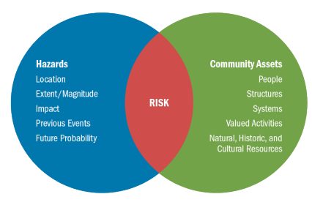
Risk is the relationship, or overlap, between hazards and community assets. The smaller the overlap, the lower the risk.

Hazard Area
Hazard area maps provided below illustrate the probable hazard areas impacted within the Town are shown in Figure 1 through Figure 2. These maps are based on the best available data at the time of the preparation of this plan and are adequate for planning purposes. Maps are provided only for hazards that can be identified clearly using mapping techniques and technologies and for which Antwerp has significant exposure. The maps show the location of potential new development, where available.
Figure 1. Antwerp Flood and Coastal Erosion Hazard Area Extent and Location Map
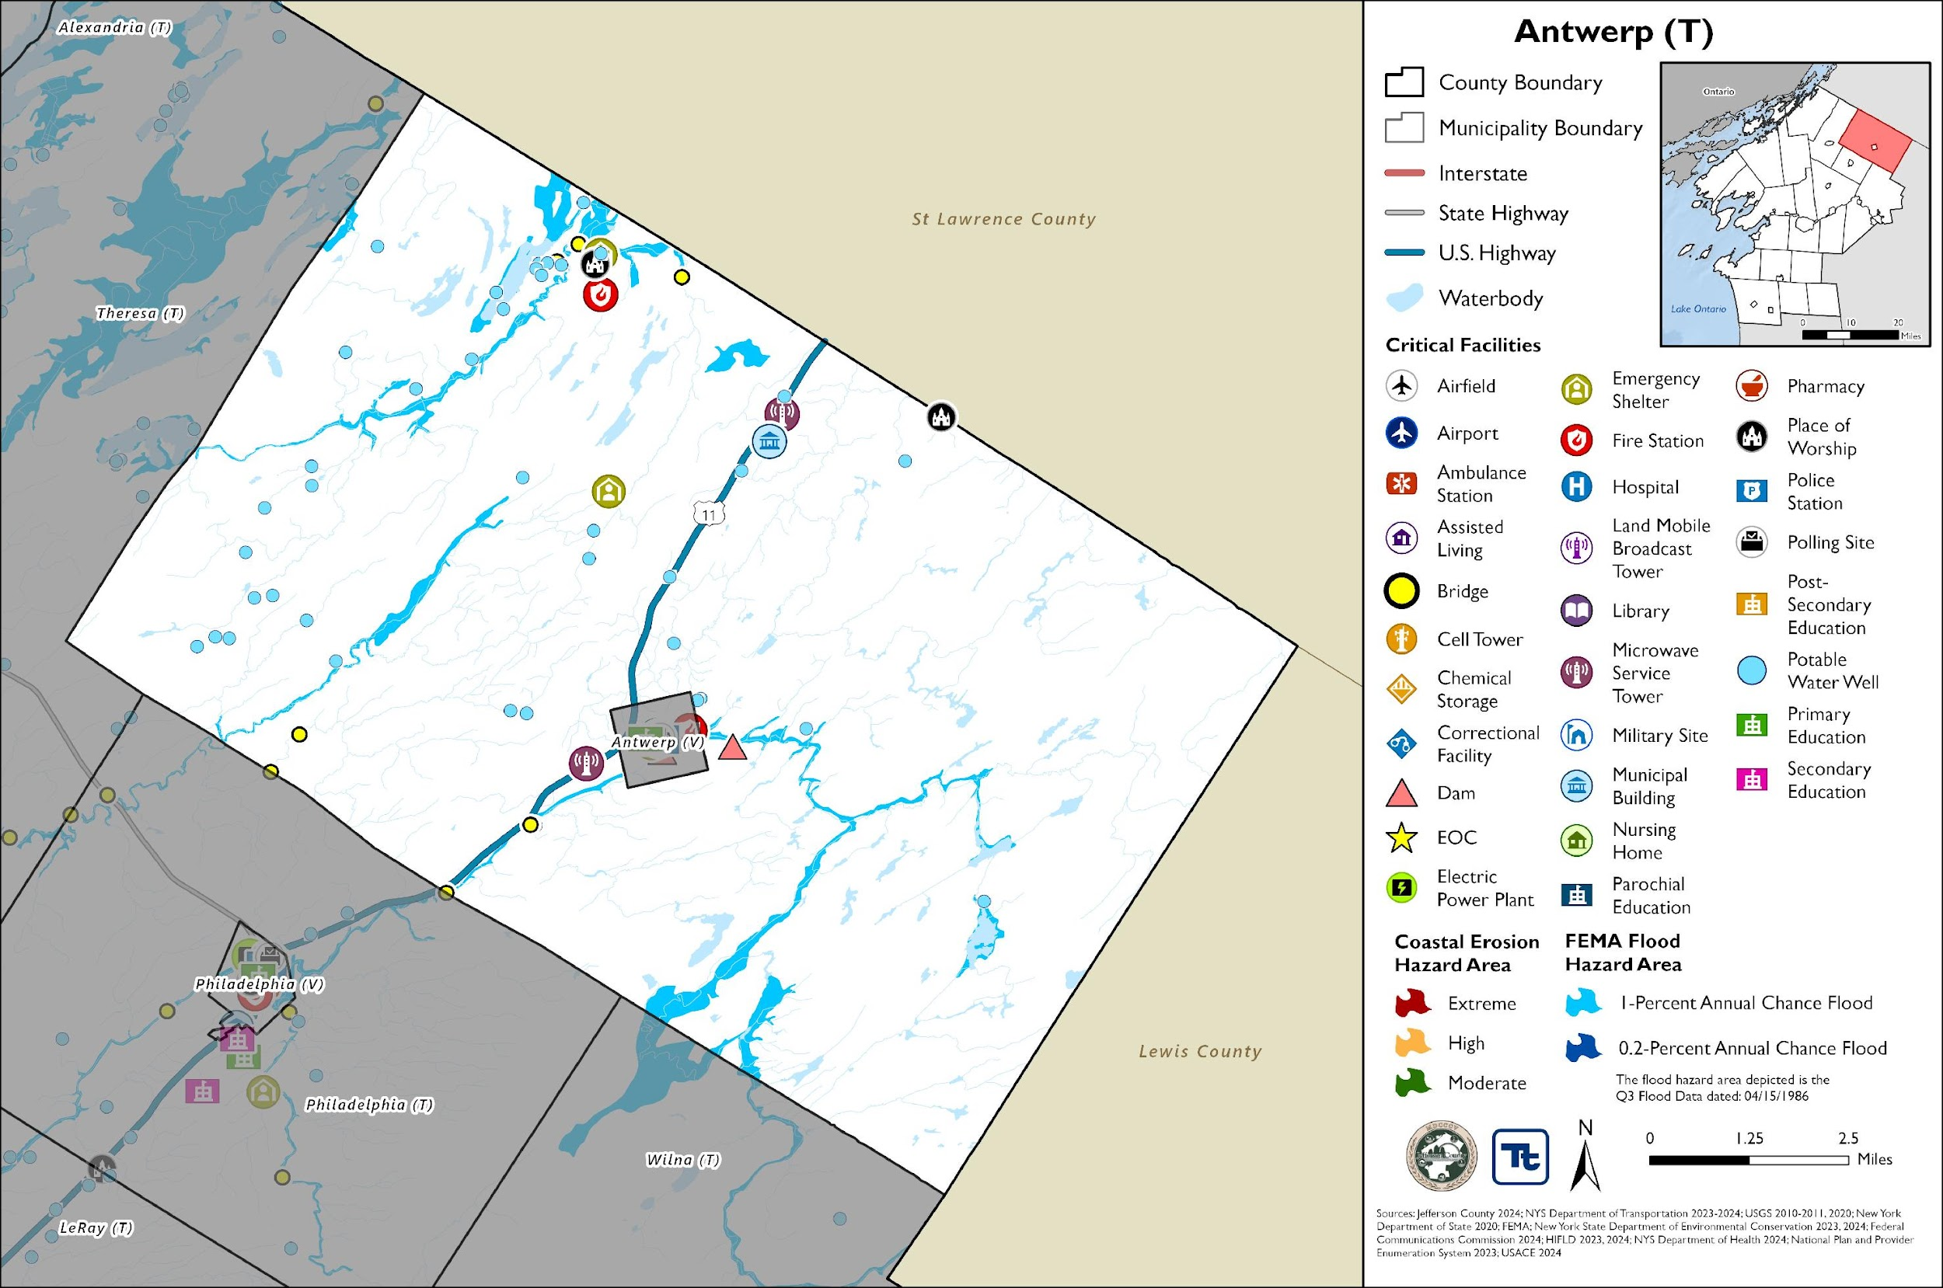
Figure 2. Antwerp Landslide and WUI Hazard Area Extent and Location Map
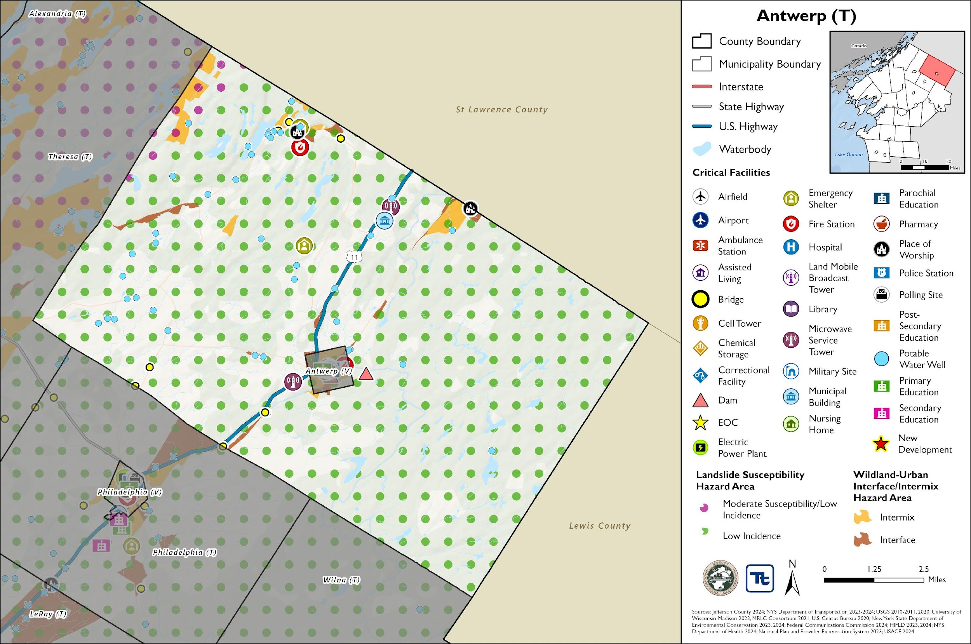

Previous Event History
The history of natural and non-natural hazard events in Antwerp is detailed in Volume I, where each hazard profile includes a chronology of historical events that have affected the County and its municipalities. Table C provides details on the loss and damage in Antwerp during hazard events since the last hazard mitigation plan update.
Table C. Presidential Disaster Declaration History in Antwerp
Dates of Event | Event Type (Disaster Declaration) | Summary of Event | Summary of Damage and Losses in Antwerp
November 18-22, 2022 | Severe Winter Storm (EM-3589) | A winter storm caused more than six feet of snow to accumulate in Jefferson County. This intense snowfall has created extremely dangerous travel conditions, and as a result, numerous road closures and travel bans.
October 31 – November 1, 2019 | Severe Storm, Flood (DR-4472) | A storm system brought record breaking rains, damaging wind gusts (45 to 50 mph), a small Lake Ontario seiche, and river flooding to the region. Thousands of power outages occurred across the area, and wind-related damage closed hundreds of roads and did countless tree damage. High winds and lakeshore flooding continued into November 1.
May 2 – August 6, 2017 | Flood (DR-4348) | Six months of wet weather led to an over-accumulation of waters in Lake Ontario. Flooding from the lake began impacting areas in May and continued until early autumn. Waves destroyed public and private break walls all along the lake shore. Thousands of homes and buildings were affected flood waters. Several homes dropped off bluffs. In some areas shoreline erosion of 50 to 100 feet deep occurred. Sanitary sewer systems in lakeside communities were affected. Beaches, marinas, and state parks were closed all summer long with unknown economic losses to mainly seasonal businesses. In late May, the Governor imposed a 5-mph speed limit within 600 feet of the Lake Ontario and St. Lawrence River shore. By summer’s end, damage estimates reached $10 Million in Jefferson County.
November 17-26, 2014 | Severe Winter Storm, Flood (DR-4204) | A winter storm moved into the region, causing temperatures to drop tremendously. Lake effect snow impacted counties bordering Lake Ontario and Lake Erie. Travel restrictions were instituted due to whiteout conditions. The storm produced heavy snowfall, high winds, and blizzard-like conditions, resulting in road closures, travel disruptions, power outages, and damage to public and private property.
October 27 – November 8, 2012 | Severe Storm (EM-3351) | Remnants of Hurricane Sandy brought strong winds and heavy rains. Rainfall amounts of two to five inches were measured across the area with some area creeks reaching bankful. High winds downed trees and power lines. Wind gusts were measured to 60 mph. Utilities reported tens of thousands of customers without power across the entire region.
EM = Emergency Declaration (FEMA)
FEMA = Federal Emergency Management Agency
DR = Major Disaster Declaration (FEMA)
N/A = Not applicable

Local Hazard Impacts Assessment
In the table below representatives from the Town of Antwerp Hazard Mitigation Planning Team assessed impacts of hazards on buildings, structures, facilities, infrastructure, community assets and systems, people and the local economy.
Table D. Local Hazard Impacts Assessment
Hazard Name | Local Impacts
Dam Failure | No known impacts
Drought | No known impacts
Extreme Temperature | No known impacts
Flood | County Route 25 in the Hamlet of Oxbow last flooded in 1990.
Geological Hazards | No known impacts
Severe Storm | Basements have been flooded.
Severe Winter Storm | No known impacts
Wildfire | No known impacts

Vulnerable Community Assets
In the table below representatives from the Town of Antwerp Hazard Mitigation Planning team assessed specific impacts to the assets included in the table below. If a community asset is not present in the municipality the Planning Team stated, ‘Not Applicable.’
Table E. Vulnerable Community Assets
Community Asset | Hazard Impacts and Asset Vulnerabilities | Community Asset | Hazard Impacts and Asset Vulnerabilities
Agriculture | No known impacts | Local Roads | In storm events trees have periodically fallen across roads and are cleared by the Town.
Airports | Not applicable | Major Employers | No known impacts
Area: Concentration of Businesses | No known impacts | Medical Centers (non-hospital) | Not applicable
Area: Concentration of Residences | No known impacts | Natural Resources | No known impacts
Bridges | No known impacts | Neighborhoods | The Town has experienced power outages related to storms and wind.
City Hall/Courthouse | No known impacts | Parks and Recreational Sites | No known impacts
College/University | Not applicable | Place of Worship | No known impacts
Community Centers/Hubs | Not applicable | Private Property | No known impacts
Community Activities: major local events including festivals and economic drivers such as beaches, skiing, farming, fishing, etc. | No known impacts | Public Transportation | Not applicable
Cultural/Historic Buildings/Sites | No known impacts | Schools (K-12) | No known impacts
Culverts | Culverts occasionally get plugged with debris and can cause localized flooding. | Small Businesses | There are flood concerns for the store in the hamlet of Oxbow.
Elder-care Facilities | Not applicable | Supermarkets/Grocery Stores | Not applicable
Fire/Police Stations | Oxbow fire station flooded in the 1990s. | Transportation - Mobile Asset Storage | Not applicable
Gas Stations | Not applicable | Utilities | National grid substation on NYS Rt 11/Old Rt. 11. No known impacts.
Highways | NYS Route 11 runs through the Town of Antwerp. No known impacts. | Wastewater Treatment Plants | Not applicable
Hospitals | Not applicable | Waterfront | There is waterfront property on Paynes Lake, Muskelunge Lake, Oswegatchie River, Indian River, but there are no known impacts.
Other | Not applicable | Drinking Water Resources | Private wells

Hazard Ranking
The participating jurisdictions have differing degrees of vulnerability to the hazards of concern, so each jurisdiction ranked its own degree of risk to each hazard. The community-specific hazard ranking is based on problems and impacts identified by the risk assessment presented in Volume I.
The ranking process involves an assessment of the likelihood of occurrence for each hazard; the potential impacts of the hazard on people, property, and the economy; community capabilities to address the hazard; and changing future climate conditions. Impacts from a particular hazard may have decreased due to an implemented project or relocation of an asset that was previously at risk. Alternatively, risk may have increased because population has increased in a hazard prone area.

Table F. Hazard Ranking
Hazard Name | Frequency (2011 – present):  Increased, Decreased, Stayed the Same | Impacts (2011 – present):  Increased, Decreased, Stayed the Same | Description of frequency and impacts (2011 – present): | Future Events (present – 2030):  Will Increase, Decrease, Stay the Same | 2025 Ranking
Dam Failure | Stayed the same | Stayed the same | - | Stayed the same | Low
Drought | Stayed the same | Stayed the same | - | Stayed the same | Low
Extreme Temperature | Stayed the same | Stayed the same | - | Stayed the same | Low
Flood | Stayed the same | Stayed the same | Flooding is possible but there hasn’t been a flood in Town since 1990. | Stayed the same | Medium
Geologic Hazards | Stayed the same | Stayed the same | - | Stayed the same | Low
Severe Weather | Increased | Increased | [DR4825] Hurricane Debby August 9th2025 caused multiple culverts and road shoulders to washout that have not previously flooded. | Increase | High
Severe Winter Weather | Stayed the same | Stayed the same | - | Stayed the same | Medium
Wildfire | Stayed the same | Stayed the same | - | Stayed the same | Low

Critical Facilities
The table below identifies the critical facilities that are located in the flood hazard area.
Table G. Critical Facilities Flood Vulnerability
Name | Type | Vulnerability
 |  | 1% Annual Chance Event | 0.2% Annual Chance Event
None Identified
Source: Jefferson County 2024; New York State Department of Environmental Conservation 2023, 2024; Federal Communications Commission 2024; HIFLD 2023, 2024; NYS Department of Health 2024; National Plan and Provider Enumeration System 2023; USACE 2024; NYS Department of Transportation 2023

The municipality does not have any identified high hazard potential dams within the jurisdiction.

Growth/Development Trends
Understanding how past, current, and projected development patterns have or are likely to increase or decrease risk in hazard areas is a key component to appreciating a jurisdiction’s overall risk to its hazards of concern. Recent and expected future development trends, including major residential/commercial development and major infrastructure development, are summarized in Table H through Table L.

Development and Permitting
Table H. Development and Permitting Capability
Question | Answer
Does your municipality or the county issue building permits for development in your community? | Jefferson County
What is your process for tracking building permits? | N/A
Are permits tracked by hazard area? (For example, floodplain development permits.) | No, Town of Antwerp is not a floodplain
Does your community have a buildable land inventory? If yes, please describe. | No

Table I. Number of Building Permits for New Construction Issues Since the Previous HMP
 | New Construction Permits Issued
 | Single Family | Multi-Family | Other (commercial, mixed-use, etc.) | Total
2019
Total Permits | 2 | 0 | 0 | 2
Permits within SFHA | 0 | 0 | 0 | 0
2020
Total Permits | 16 | 0 | 6 | 22
Permits within SFHA | 0 | 0 | 0 | 0
2021
Total Permits | 2 | 0 | 0 | 2
Permits within SFHA | 0 | 0 | 0 | 0
2022
Total Permits | 3 | 0 | 0 | 3
Permits within SFHA | 0 | 0 | 0 | 0
2023
Total Permits | 3 | 0 | 1 | 4
Permits within SFHA | 0 | 0 | 0 | 0
2024
Total Permits | 16 | 0 | 0 | 16
Permits within SFHA | 0 | 0 | 0 | 0
SFHA = Special Flood Hazard Area (1% flood event)
Table J. Recent Major Development and Infrastructure from 2011 to 2018
Property or Development Name | Type of Development | # of Units / Structures | Location (address and/or block and lot) | Known Hazard Zones | Description / Status of Development
None Identified
Table K. Recent Major Development and Infrastructure from 2019 to Present
Property or Development Name | Type of Development | # of Units / Structures | Location (address and/or block and lot) | Known Hazard Zones | Description / Status of Development
None Identified
Table L. Known or Anticipated Major Development and Infrastructure in the Next Five Years
Property or Development Name | Type of Development | # of Units / Structures | Location (address and/or block and lot) | Known Hazard Zones* | Description / Status of Development
None Identified

National Flood Insurance Program Compliance
This section provides specific information on the management and regulation of the regulatory floodplain, including current and future compliance with the National Flood Insurance Program (NFIP). The floodplain administrator listed in Table A is responsible for maintaining this information.

NFIP Statistics
Table M summarizes the NFIP policy and claim statistics for Antwerp.
Table M. Antwerp NFIP Summary of Policy and Claim Statistics
# Policies | 0
# Claims (Losses) | 6
Total Loss Payments | $33,327.54
# Repetitive Loss Properties (NFIP definition) | 1
# Repetitive Loss Properties (FMA definition) | 0
# Severe Repetitive Loss Properties | 0
NFIP Definition of Repetitive Loss: The NFIP defines a repetitive loss property as any insurable building for which two or more claims of more than $1,000 were paid by the NFIP within any rolling 10-year period since 1978.
FMA Definition of Repetitive Loss: FEMA’s Flood Mitigation Assistance (FMA) program defines a repetitive loss property as any insurable building that has incurred flood-related damage on two occasions, in which the cost of the repair, on average, equaled or exceeded 25 percent of the market value of the structure at the time of each such flood event.
Definition of Severe Repetitive Loss: A residential property covered under an NFIP flood insurance policy and: (a) That has at least four NFIP claim payments over $5,000 each, and the cumulative amount of such claims payments exceeds $20,000; or (b) For which at least two separate claims payments have been made with the cumulative amount of the building portion of such claims exceeding the market value of the building. At least two of the claims must have occurred within any 10-year period, more than 10 days apart.
Source: FEMA 2024

National Flood Insurance Program (NFIP) Flood Vulnerability Summary
The HMP Team provided information on participation in and continued compliance with the NFIP in the table below.
Table N. NFIP Summary
NFIP Topic | Comments
Describe areas prone to flooding in your jurisdiction. | No
Who is the Community Floodplain Administrator (FPA)? Do they serve any roles other than FPA? Do they have adequate training and capacity for this role? | Jefferson County Code, Fire Prevention and Building Code department
What local department is responsible for floodplain management? | Jefferson County Code, Fire Prevention and Building Code department
Are any certified floodplain managers on staff in your jurisdiction? | No
What is the local law number or municipal code of your flood damage prevention ordinance? | The Town, County and NYSDEC did not have record of this law number/municipal code.
When was the latest effective Flood Insurance Rate Map (FIRM) adopted, if applicable? | 4/15/86
Explain NFIP administration services (e.g., permit review, inspections, engineering capability, GIS, etc.) | N/A
What are the barriers to running an effective NFIP program in your community, if any? | None
Does your floodplain management staff need any assistance or training to support its floodplain management program? If yes, what type of assistance/training is needed? | None
How do you make Substantial Damage determinations? What is the process to make sure these structures are brought into compliance? | N/A
How do you determine if proposed development on an existing structure would qualify as a substantial improvement? | N/A
How many Substantial Damage determinations were declared for recent flood events in your jurisdiction? | None
Does the community track the number of buildings in the floodplain? If so, how many structures are in special flood hazard area (SFHA)? | No
How many structures (residential and non-residential) are exposed to flood risk within the community outside of the regulatory maps? | None
Does the community maintain elevation records? If yes, please describe. | No
Are there any repetitive loss (RL) or severe repetitive loss (SRL) structures in the community? If yes, how many of each category? | The Town has one repetitive loss property
Describe any areas of flood risk with limited NFIP policy coverage. | None
How does the community teach property owners or other stakeholders about the importance flood insurance? | N/A
What digital sources (like the FEMA Map Service Center,  National Flood Hazard Layer) or non-regulatory tools does your community use? | N/A
Are there other local ordinances, plans or programs (e.g., site plan review) that support floodplain management and meeting the NFIP requirements? For instance, does the planning board or zoning board consider efforts to reduce flood risk when reviewing variances such as height restrictions? | No
When was the most recent Community Assistance Visit (CAV) or Community Assistance Contact (CAC)? | CAC: June 2, 2022  CAV: September 10, 1990
Does your community plan to join the CRS program or is your community interested in improving your CRS classification? | N/A

Jurisdictional Capability INVENTORY and ASSESSMENT
Antwerp performed an inventory and analysis of existing capabilities, plans, programs, and policies that enhance its ability to implement mitigation strategies. Volume I describes the components included in the capability assessment and their significance for hazard mitigation planning. The jurisdictional assessment for this annex includes analyses of the following:
- Planning and regulatory capabilities
- Development and permitting capabilities
- Administrative and technical capabilities
- Fiscal capabilities
- Education and outreach capabilities
- Classification under various community mitigation programs
- Adaptive capacity to withstand hazard events
For a community to succeed in reducing long-term risk, hazard mitigation must be integrated into day-to-day local government operations. As part of the hazard mitigation analysis, planning and /policy documents were reviewed, and each jurisdiction was surveyed to obtain a better understanding of their progress toward plan integration. Development of an updated mitigation strategy provided an opportunity for Antwerp to identify opportunities for integrating mitigation concepts into ongoing Town procedures.

Planning and Regulatory Capability and Integration
Planning and regulatory capabilities are the plans, policies, codes, and ordinances that prevent and reduce the impacts of hazards.
Jefferson County has an Emergency Management Ordinance which charges the County with maintaining a Comprehensive Emergency Management Plan to identify local measures that may prevent disasters, to develop local mechanisms to coordinate local resources and personnel for service during and after disasters, support the facilitation of delivery of services to aid citizens and reduce human suffering resulting from disaster, and to provide for short- and long-term recovery and redevelopment after disasters.
Jefferson County has Site Plan and Subdivision Codes that are relevant to development within a certain distance of County interests. Development applications in the areas across the County are sent to County Planning for review to promote coordination of land use decisions and local/county impacts. These County capabilities are inclusive of Antwerp and the jurisdiction often partners with the County. To learn more about these capabilities please see Jefferson County’s Jurisdictional Annex.
The HMP Team inventoried its existing ordinances against the full capability list of hazard mitigation-related capabilities. The absence of other kinds of ordinances was not considered a gap in local capabilities. The table below summarizes the ordinances currently in place.
Table O. Ordinances
Capability Name | In Place in Municipality | Comments | Responsible Department / Agency / Organization
Building Codes | Yes | All of the communities in Jefferson County regulate construction through the use of a building code. The Town of Antwerp adheres to a building code through County authority. Building codes regulate construction standards and are developed for specific geographic areas of the country. They consider the type, frequency, and intensity of hazards present in the region. Structures built to applicable building codes are inherently resistant to many hazards such as strong winds, floods, and earthquakes. Due to the location specific nature of the building codes, these are very valuable tools for mitigation. | Planning Board
Flood Damage Prevention Ordinance | Yes | This ordinance is designed to protect communities from flood hazards by implementing regulations that ensures the land use and development practices account for the flood risks, requires vulnerable structures to be constructed to withstand flood damage, and to control changes to the natural floodplain and stream channels to prevent increased flood hazards. | Floodplain Administrator
Real Estate Disclosure Requirements | Yes | In addition to facing potential liability for failing to disclose under the exceptions to “caveat emptor,” a home seller must make certain disclosures under the law or pay a credit of $500 to the buyer at closing. While the PCDA requires a seller to complete a standardized disclosure statement and deliver it to the buyer before the buyer signs the final purchase contract, in practice, most home sellers in New York opt not to complete the statement and instead pay the credit. | NYS Department of State, Real Estate Agent
Subdivision Code | Yes | Subdivision ordinances offer an opportunity to account for natural hazards prior to the development of land as they formulate regulations when the land is subdivided. Subdivision designs that incorporates mitigation principles can reduce the exposure of future development to hazard events. | Planning Board
Zoning/Land Use Code | Yes | Zoning is a useful tool to consider when developing a mitigation strategy. It can be used to restrict new development, require low-density development, and designate specific uses (e.g. recreational) in the hazard prone areas. Private property rights must be considered, but enacting a zoning ordinance can reduce or potentially eliminate damages from future hazard events. | Planning Board

Plans
Jefferson County has an Agriculture Plan (Jefferson County Agricultural and Farmland Protection Plan, 2016); Climate Adaptation / Resilience Plan (North Country Regional Sustainability Plan, 2013); Comprehensive Emergency Management Plan; County Emergency Preparedness Assessment (CEPA); Continuity of Operations Plan (Jefferson County Government COOP – COG Plan, 2023); Economic Development Plan (Jefferson County Comprehensive Economic Development Strategy, 2021); Public Health Plan (Jefferson County Public Health Service Strategic Plan 2023-2027); Threat and Hazard Identification and Assessment (THIRA); Tourism Plan; Transportation Plan (Jefferson County Coordinated Transportation Plan for Mobility Services, 2021); and other recent plans that are all countywide in scope and implementation and are applicable to the Town of Antwerp. To learn more about these capabilities please see Jefferson County’s Jurisdictional Annex.
The HMP Team inventoried its existing plans against the full capability list of hazard mitigation-related capabilities. The absence of other kinds of plans was not considered a gap in local capabilities.

Administrative and Technical Capability
Jefferson County Code, Fire Prevention and Building Code department currently enforces the New York State Uniform Fire Prevention and Building Code in 31 municipalities that chose not to enforce the Code at the local level, including the Town of Antwerp. The Department employs Code Enforcement Officers and clerical staff to ensure that new construction and areas of public assembly conform to the provisions of the State Uniform Code. Proper enforcement of the Code protects property and encourages quality development that enhances public safety and the economy of the County. The office's two major program responsibilities include existing and new building permit administration (i.e.: plan review, issuing permits, construction inspections and issuing certificates of occupancy) and mandated fire safety inspections.
Jefferson County has an Economic Development Commission (Jefferson County Comprehensive Economic Development Strategy); Emergency Management (Jefferson County Office of Fire & Emergency Management), County Department of Planning; County Public Health Department (including Administration and Finance, Home Healthcare Services, Medical Examiner’s Office, Emergency Medical Services); County Highway Department, among others, whose programs and services serve the entire County, including the Town of Antwerp. To learn more about these capabilities please see Jefferson County’s Jurisdictional Annex.
The HMP Team inventoried its existing Administrative and Technical Capabilities against the full capability list of hazard mitigation-related capabilities. The absence of other staff was not considered a gap in local capabilities. The table below summarizes staff and personnel resources.
Table Q. Administrative and Technical Capabilities
Capability Type | In Place in Municipality | Comments
Maintenance Programs | Yes | Highway Department
Mutual Aid Agreements | Yes | Village of Antwerp and Jefferson County
Public Works/Highway Department | Yes | The Highway Department has six employees.

Fiscal Capability
The table below summarizes financial resources available to Antwerp.
Table R. Fiscal Capabilities
Capability Type | Has this funding capability been used since the last plan (2011)? If yes, please describe.
Community Development Block Grants (CDBG, CDBG-DR) | No
Capital improvement project funding | Yes - CHIPS funding
Authority to levy taxes for specific purposes | Yes
User fees for water, sewer, gas, or electric service | No
Impact fees for homebuyers or developers of new development/homes | No
Stormwater utility fee | No
Incur debt through general obligation bonds | No
Incur debt through special tax bonds | No
Incur debt through private activity bonds | No
Withhold public expenditures in hazard-prone areas | No
Other Federal (non-FEMA) funding programs | No
FEMA funding programs | Yes, DR-4825
Other State funding programs | Yes, CHIPS program
Open Space Acquisition funding programs | No
Other (for example, Clean Water Act 319 Grants [Nonpoint Source Pollution]) | No

Education and Outreach Capability
The table below includes education and outreach programs and methods already in place that could be used to carry out mitigation activities and communicate information about hazards.
Table S. Education and Outreach Capabilities
Capability Type | Is this education and outreach capability currently in use in the Municipality? If yes, please describe.
Community Newsletter | No
Hazard awareness campaigns (such as Firewise, Storm Ready, Severe Weather Awareness Week, school programs, public events) | No
Hazard mitigation information available on your website | No
Local News | No
Natural disaster/safety programs in place for schools | No
Organizations that conduct outreach to socially vulnerable populations and underserved populations | No
Public information officer or communications office | No
Social media for hazard mitigation education and outreach | No
Warning systems for hazard events | No

Hazard Capability Assessment
Each jurisdiction has a unique combination of capabilities to adjust to, protect from, and withstand a future hazard event, future conditions, and changing risk. The HMP Team ranked the local government’s capability to address risks and impacts of each hazard based on the risk and capability assessments performed above.
- Strong: Capacity exists and effectively manages the impacts of this hazard.
- Moderate: Capacity exists but is not used or needs some improvement.
- Weak: Capacity exists and needs substantial improvement
- None: Capacity does not exist.

Table T. Adaptive Capacity
Hazard | Strong, Moderate, Weak, None
Dam Failure | None
Drought | Weak
Extreme Temperature | Weak
Flood | Weak
Geological Hazards | Weak
Severe Storm | Moderate
Severe Winter Storm | Moderate
Wildfire | Weak

Mitigation Strategy and Prioritization
This section discusses the status of mitigation actions from the previous HMP, describes proposed hazard mitigation actions, and prioritizes actions to address over the next five years.

Past Mitigation Action Status
The Town did not participate in the last plan.

Additional Mitigation Efforts
Since the adoption of the County’s first HMP, Antwerp has made significant mitigation progress in the following areas:
- None identified.

Identified Issues
The Town of Antwerp has identified the following vulnerabilities within their community for mitigation strategy development:
- Flooding events have resulted in damage to residential properties. These properties have been repetitively flooded as documented by paid NFIP claims. The Town has one repetitive loss property, but other properties may be impacted by flooding as well.

Proposed Hazard Mitigation Actions for the HMP Update
Antwerp participated in the mitigation strategy workshop and identified hazard mitigation actions to reduce the risks and impacts of hazards the community ranked as high-risk. Hazard risk ranking was specific to each community in the County and was based on quantitative (i.e, analysis of the best available data) and qualitative risk assessment processes (i.e., evaluation of previous occurrences, likelihood of future occurrences and vulnerabilities to people and community services; buildings and critical infrastructure; the natural environment and other local priorities.
Implementation of these actions are dependent upon available funding (grants and local match availability) and local capacity and may be modified or omitted at any time based on the occurrence of new hazard events and changes in local priorities.
Volume I identifies fourteen evaluation criteria for prioritizing the mitigation actions. Below, Table U provides the prioritization criteria score for each proposed mitigation action.

Action 2025-AntwerpT-01. Repetitive Loss Properties Mitigation
Lead Agency: | Floodplain Administrator
Supporting Agencies: | Town Administration
Hazards of Concern: | Flood, Severe Storm
Description of the Problem: | Frequent flooding events have resulted in damage to residential properties. These properties have been repetitively flooded as documented by paid NFIP claims. The Town has one repetitive loss property, but other properties may be impacted by flooding as well.
Description of the Solution: | Conduct outreach to 10 flood-prone property owners, including one RL property, and provide information on mitigation alternatives. After preferred mitigation measures are identified, collect required property-owner information, and develop a FEMA grant application and BCA to obtain funding to implement acquisition/purchase/moving/elevating residential homes in the flood prone areas that experience frequent flooding (high risk areas).
Estimated Cost: | TBD based on property
Potential Funding Sources: | FMA, HMGP, match from property owners
Implementation Timeline: | Within 5 Years
Goals Met: | 2, 5, 6, 7
Benefits: | Eliminates flood damage to homes and residences, which creating an open space for the municipality and increasing flood storage.
Impact on Socially Vulnerable Populations: | Removing homes from the floodplain immediately removes the risk to life and property. Socially vulnerable populations may be able to have houses elevated or acquired when it would otherwise be unaffordable.
Impact on Future Development: | Increased outreach to homeowners within a flood prone area will limit construction in areas that are prone to hazard events. Homes may be acquired, which will remove those structures from the floodplain and prevent future development on those sites.
Impact on Critical Facilities/Lifelines: | Removing structures from the floodplain decreases the demand on utilities and emergency services including health and medical, law enforcement, and search and rescue.
Impact on Capabilities: | Removing the risk from the immediate floodplain via acquisition of properties will free up resources for search and rescue and other emergency operations as needed.
Climate Change Considerations: | Climate change is likely to increase the frequency and severity of severe rainfall, flash flooding, riverine flooding, and coastal flooding from sea level rise and storm surge events. Removing structures from the floodplain will reduce the response and recovery costs as a result of these events and decrease the loss of human life as a result of these events. Elevating structures will reduce the recovery costs as a result of these events.
Mitigation Category | Structure and Infrastructure Project
CRS Category | Property Protection
Priority | High
Alternative | Action | Evaluation
 | No action | -
 | Levee around floodplain | Costly, not enough room
 | Deployable flood barriers | Requires deployment. Residents may not have adequate time to deploy, especially those who are elderly or disabled.

Table U. Summary of Prioritization of Actions
 | Scores for Evaluation Criteria
Project Number | Project Name | Life Safety | Property Protection | Cost-Effectiveness | Political | Legal | Fiscal | Environmental | Social Vulnerability | Administrative | Hazards of Concern | Climate Change | Timeline | Community Lifelines | Other Local Objectives | Total | High / Medium / Low
Action 2025-AntwerpT-01. | Repetitive Loss Properties Mitigation | 1 | 1 | 1 | 1 | 1 | 0 | 1 | 1 | 1 | 1 | 1 | 1 | 1 | 1 | 13 | High
Note: Volume I, Section 6 (Mitigation Strategy) conveys guidance on prioritizing mitigation actions. Low (0-6), Medium (7-10), High (11-14)

