Jurisdictional Annexes

Town of Adams
This jurisdictional annex to the Jefferson County Hazard Mitigation Plan (HMP) provides information to assist public and private sectors in the Town of Adams with reducing losses from future hazard events. This annex is not guidance of what to do when a disaster occurs; its focus is on actions that can be implemented prior to a disaster to reduce or eliminate damage to property and people. The annex presents a general overview of Adams, describes who participated in the planning process, assesses Adams’s risk, vulnerability, and capabilities, and outlines a strategy for achieving a more resilient community.

Hazard Mitigation Planning Team
The Town of Adams identified primary and alternate HMP points of contact and developed this plan over the course of several months, with input from many Town departments.
Table A summarizes local officials who participated in the development of the annex. Additional documentation of the Town’s planning activities through Planning Partnership meetings is included in Volume I.
Table 1-1. Hazard Mitigation Planning Team
Primary Point of Contact | Alternate Point of Contact
Name/Title: David Kellogg, Town Supervisor  Address:3 S. Main Street, Adams, NY 13605  Phone Number:315-232-2467  Email: adamshighway@frontiernet.net or dkellog2@twcny.rr.com | Name/Title: Jennifer Burt, Town Clerk  Address:3 S. Main Street, Adams, NY 13605  Phone Number:315-232-2467. Ext 1030  Email: adamstownclerk@frontier.net
National Flood Insurance Program Floodplain Administrator
Name/Title: David Ross, Floodplain Administrator
Address:3 S. Main Street, Adams, NY 13605
Phone Number:(315) 232-2749
Email: dhross@twcny.rr.com
Additional Contributors
Name/Title: David Kellogg, Town Supervisor
Method of Participation: Provided key input in the planning process.
Name/Title: Jennifer Burt, Town Clerk
Method of Participation: Provided key input in the planning process.
Name/Title: David Ross, Floodplain Administrator
Method of Participation: Provided key input in the planning process.
Name/Title: Rick Walden, Highway Superintendent
Method of Participation: Provided key input in the planning process.

Community Profile

Community Classifications
Table B summarizes classifications for community programs available to Adams.
Table 1-2. Community Classifications
Program | Participating? (Yes/No) | Classification | Date Classified
Building Code Effectiveness Grading Schedule (BCEGS) | Yes | 3 | 6/27/22
Community Rating System (CRS) | No
Firewise Communities classification | No
National Weather Service StormReady Certification | No
Public Protection (ISO Fire Protection Classes 1 to 10) | Yes | Adams Fire: 3/7.  Adams Center: 4/4Y.  Smithville: 7/9.
NYSDEC Climate Smart Community | No
Other: Organizations with mitigation focus (advocacy group, non-government) | No
N/A = Not applicable

Community Profile
The Town of Adams has an area of 41 square miles and is bordered by the Town of Hounsfield and Town of Watertown to the north, the Town of Rodman to the east, the Town of Lorraine and the Town of Ellisburg to the south, and the Town of Henderson to the west. Interstate 81, U.S. Highway 11 and numerous state highways run directly through the Town of Adams.

According to the U.S. Census, the 2020 population for the Town of Adams was 3,340 which makes up 2.9 percent of the county. Data from the 2022 American Community Survey indicates that 1.7 percent of the population is 5 years of age or younger, 14.7 percent is 65 years of age or older, 0.3 percent is non-English speaking, 7.5 percent is below the poverty threshold, and 13.6 percent is considered disabled.

Jurisdictional Risk Assessment
The hazard profiles in Volume I provide detailed information regarding each planning partner’s vulnerability to the identified hazards, including summaries of Adams’ risk assessment results and data used to determine the hazard ranking. Key local risk assessment information is presented below.
Each jurisdiction has unique assets, vulnerabilities and overall risk. A multi-jurisdictional plan needs to identify every hazard (from the whole planning area). In hazard mitigation planning, risk is the potential for damage or loss when natural hazards interact with people or assets. These assets may be buildings, infrastructure or natural and cultural resources. A risk assessment is a robust, data-driven analysis. It explains what might happen. It also finds where the local jurisdiction is vulnerable to hazards.
Each community must describe how the selected hazards affect its jurisdiction. Some hazards will have similar effects across the area: extreme temperatures, windstorms, winter weather, drought, heavy rain, etc. Some have a smaller location and will vary based on geography. Multi-jurisdictional plans must explain these differences.
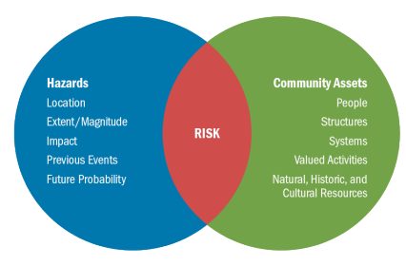
Risk is the relationship, or overlap, between hazards and community assets. The smaller the overlap, the lower the risk.

Hazard Area
Hazard area maps provided below illustrate the probable hazard areas impacted within the Town are shown in Figure 1through Figure 2. These maps are based on the best available data at the time of the preparation of this plan and are adequate for planning purposes. Maps are provided only for hazards that can be identified clearly using mapping techniques and technologies and for which Adams has significant exposure. The maps show the location of potential new development, where available.
Figure 1. Adams Flood and Coastal Erosion Hazard Area Extent and Location
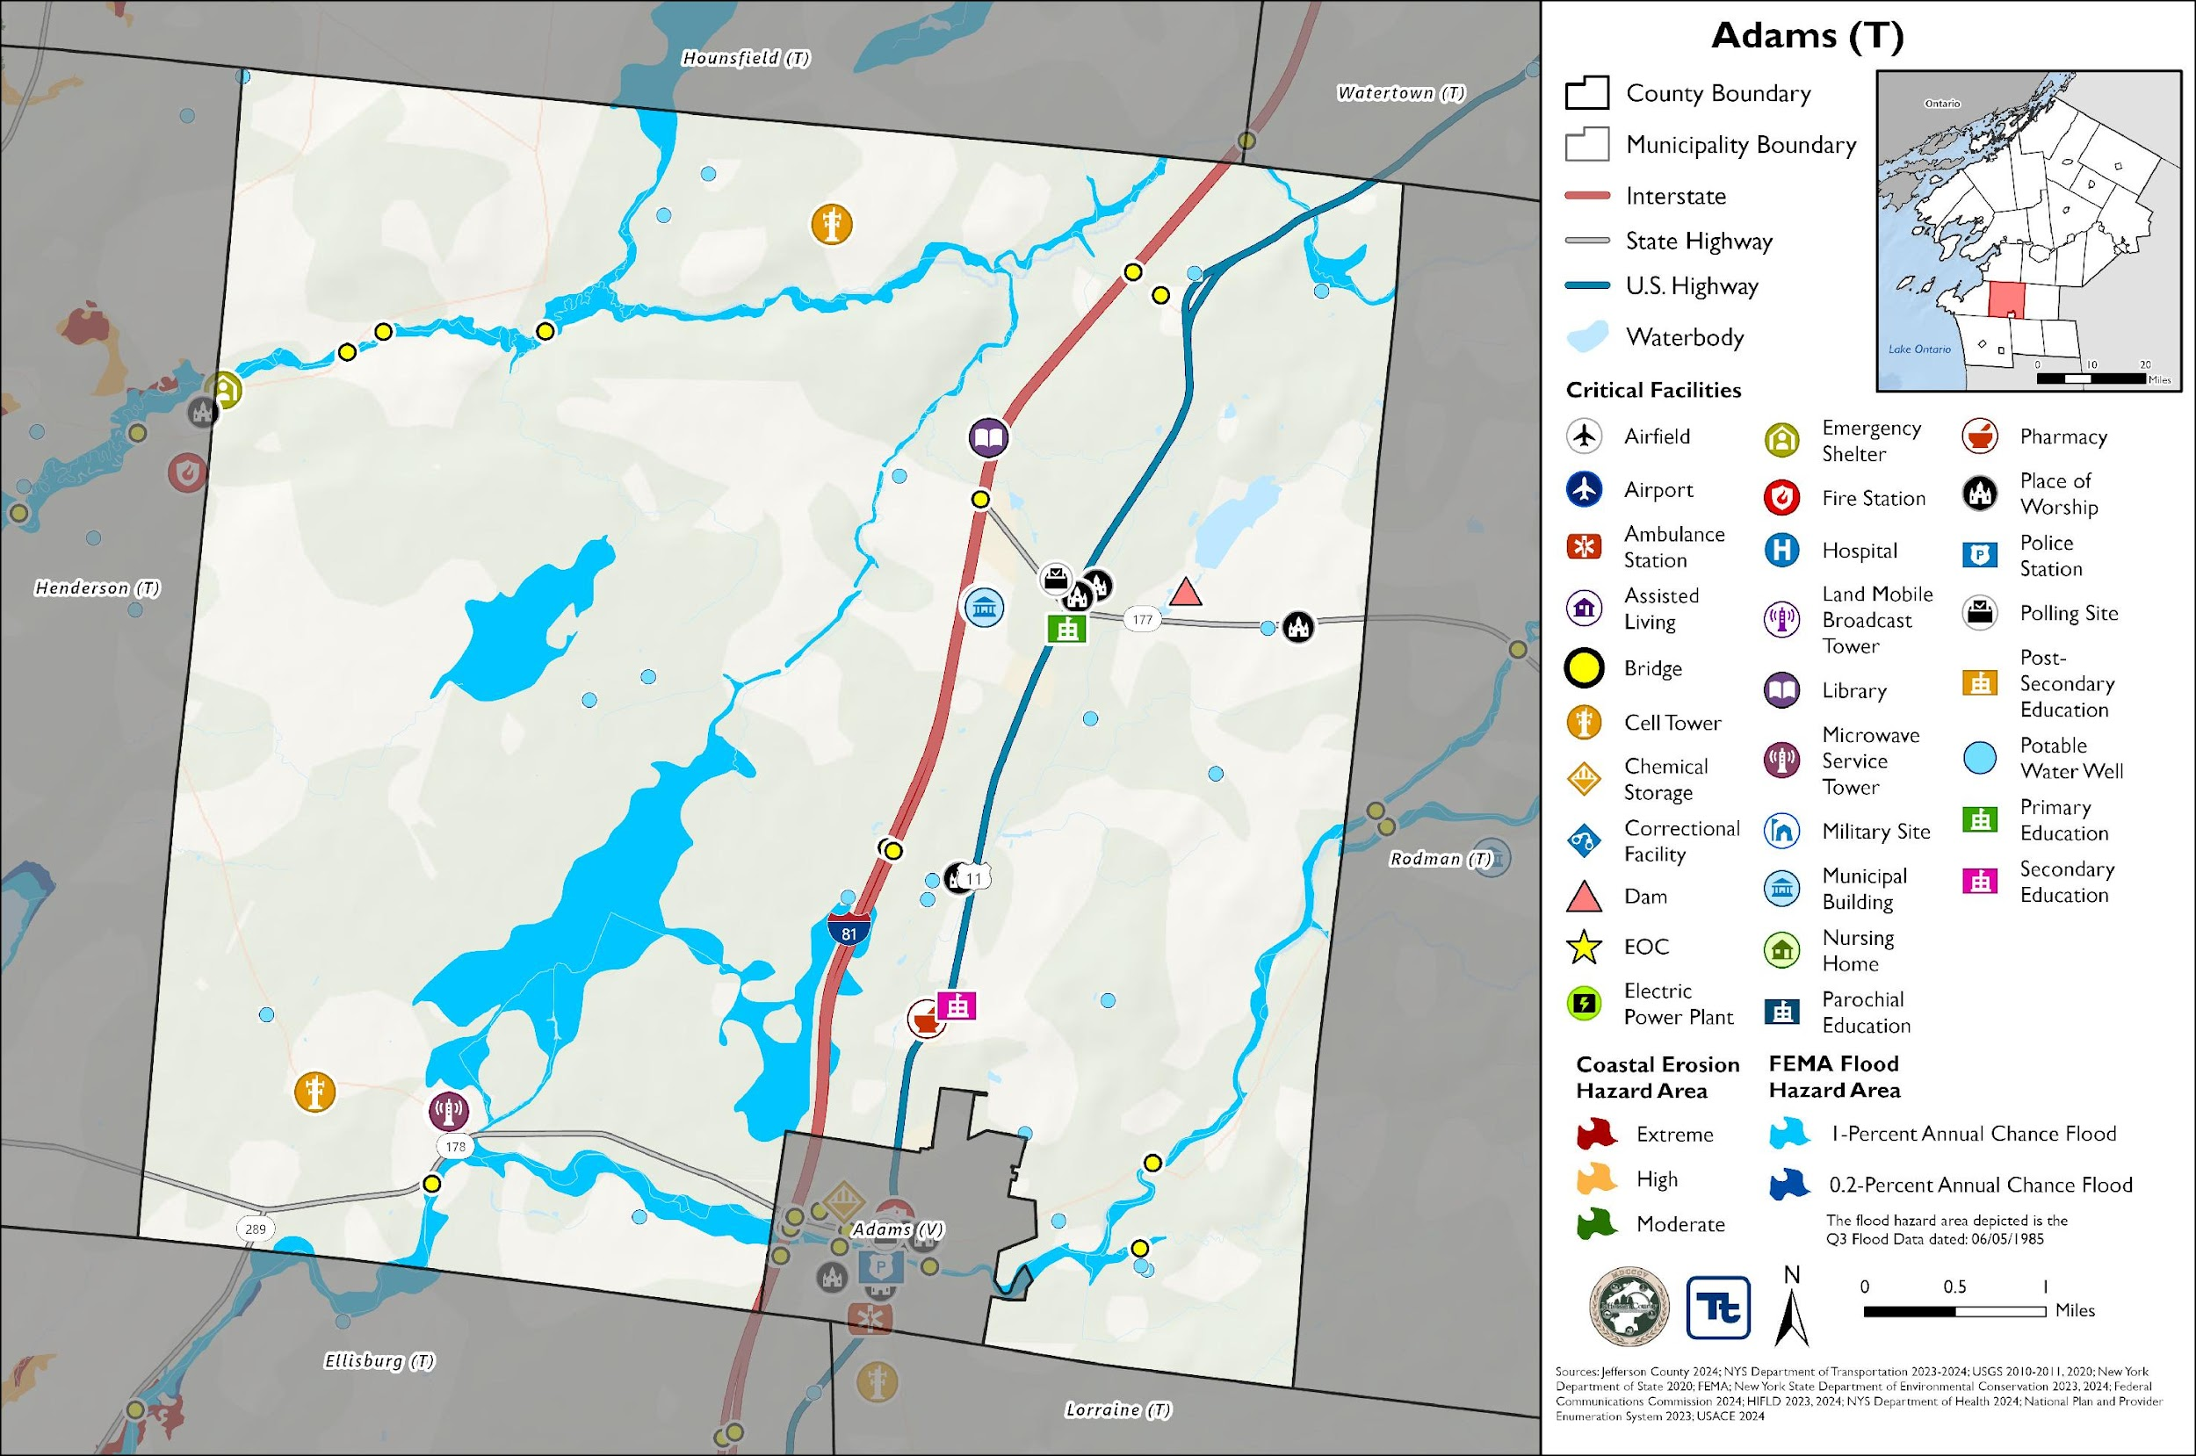

Figure 2. Adams Landslide and WUI Hazard Area Extent and Location
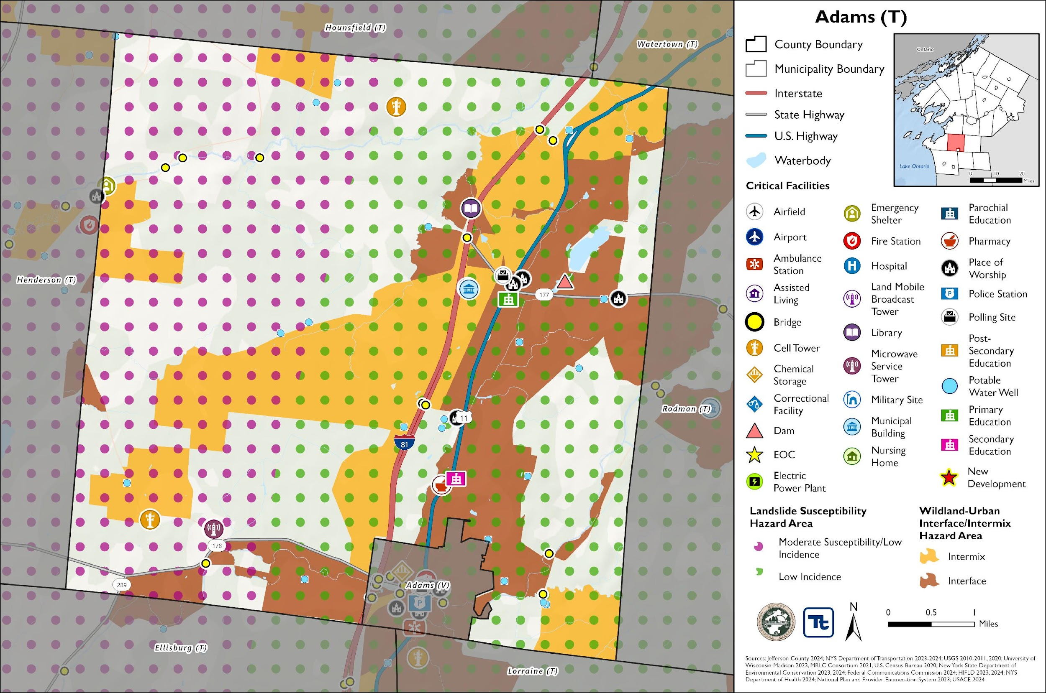

Previous Event History
The history of natural and non-natural hazard events in Adams is detailed in Volume I, where each hazard profile includes a chronology of historical events that have affected the County and its municipalities. Table C provides details on loss and damage in Adams during hazard events since the last hazard mitigation plan update.
Table C. Presidential Disaster Declaration History is Adams
Dates of Event | Event Type (Disaster Declaration) | Summary of Event | Summary of Damage and Losses in Adams
November 18-22, 2022 | Severe Winter Storm (EM-3589) | A winter storm caused more than six feet of snow to accumulate in Jefferson County. This intense snowfall has created extremely dangerous travel conditions, and as a result, numerous road closures and travel bans. | The Town did not incur any documented damages and losses.
October 31 – November 1, 2019 | Severe Storm, Flood (DR-4472) | A storm system brought record breaking rains, damaging wind gusts (45 to 50 mph), a small Lake Ontario seiche, and river flooding to the region. Thousands of power outages occurred across the area, and wind-related damage closed hundreds of roads and did countless tree damage. High winds and lakeshore flooding continued into November 1. | The Town noted downed trees.
May 2 – August 6, 2017 | Flood (DR-4348) | Six months of wet weather led to an over-accumulation of waters in Lake Ontario. Flooding from the lake began impacting areas in May and continued until early autumn. Waves destroyed public and private break walls all along the lake shore. Thousands of homes and buildings were affected flood waters. Several homes dropped off bluffs. In some areas shoreline erosion of 50 to 100 feet deep occurred. Sanitary sewer systems in lakeside communities were affected. Beaches, marinas, and state parks were closed all summer long with unknown economic losses to mainly seasonal businesses. In late May, the Governor imposed a 5-mph speed limit within 600 feet of the Lake Ontario and St. Lawrence River shore. By summer’s end, damage estimates reached $10 Million in Jefferson County. | The Town did not incur any documented damages and losses.
November 17-26, 2014 | Severe Winter Storm, Flood (DR-4204) | A winter storm moved into the region, causing temperatures to drop tremendously. Lake effect snow impacted counties bordering Lake Ontario and Lake Erie. Travel restrictions were instituted due to whiteout conditions. The storm produced heavy snowfall, high winds, and blizzard-like conditions, resulting in road closures, travel disruptions, power outages, and damage to public and private property. | The Town did not incur any documented damages and losses.
October 27 – November 8, 2012 | Severe Storm (EM-3351) | Remnants of Hurricane Sandy brought strong winds and heavy rains. Rainfall amounts of two to five inches were measured across the area with some area creeks reaching bankful. High winds downed trees and power lines. Wind gusts were measured to 60 mph. Utilities reported tens of thousands of customers without power across the entire region. | The Town reported some downed trees and some areas of localized flooding.
FEMA = Federal Emergency Management Agency
DR = Major Disaster Declaration (FEMA)
N/A = Not applicable

Local Hazard Impacts Assessment
In the table below representatives from the Town of Adams Hazard Mitigation Planning team assessed impacts of hazards on buildings, structures, facilities, infrastructure, community assets and systems, people and the local economy.
Table D. Local Hazard Impacts Assessment
Hazard Name | Local Impacts
Dam Failure | No known impacts
Drought | Water comes from well water from the Village of Adams and there are no known impacts.
Extreme Temperature | The Town Barn is set up where it could be an emergency shelter as needed. Some homeowners have reported pipes that are frozen, but the Town has a water thawing machine to reduce impacts. Some property owners have rerouted their pipes and there have been no known issues.
Flood | Two County roads sometimes flood out and the Town puts cones around and there are no known issues. The County is possibly looking to rebuild one of the roads.
Geological Hazards | There are more earthquakes, but no damages have been reported. One earthquake started in the Town.
Severe Storm | No known impacts
Severe Winter Storm | No known impacts
Wildfire | No known impacts

Vulnerable Community Assets
In the table below representatives from the Town of Adams Hazard Mitigation Planning team assessed specific impacts to the assets included in the table below. If an exist is not present in the municipality the Planning Team stated, ‘Not Applicable.’
Table E. Vulnerable Community Assets
Community Asset | Hazard Impacts and Asset Vulnerabilities | Community Asset | Hazard Impacts and Asset Vulnerabilities
Agriculture | No known impacts | Local Roads | County Route 63 has flood issues and the Town is looking into working with the County to rebuild part of the road. The field next to it is the same height which contributes to the flood issues.  State Route 178 and County Route 84 experience flooding because a creek floods over the road during flashflood events.
Airports | Not applicable | Major Employers | No known impacts
Area: Concentration of Businesses | No known impacts | Medical Centers  (non-hospital) | Not applicable
Area: Concentration of Residences | No known impacts | Natural Resources | No known impacts
Bridges | No known impacts | Neighborhoods | No known impacts
Municipal Buildings | No known impacts | Parks and Recreational Sites | Not applicable
College  University | Not applicable | Place of Worship | No known impacts
Community Centers/Hubs | Not applicable | Private Property | No known impacts
Community Activities: major local events including festivals and economic drivers such as beaches, skiing, farming, fishing, etc. | No known impacts | Public Transportation | Not applicable
Cultural/Historic Buildings/Sites | No known impacts | Schools (K-12) | No known impacts
Culverts | No known impacts | Small Businesses | No known impacts
Elder-care Facilities | No known impacts | Supermarkets  Grocery Stores | No known impacts
Fire/Police Stations | The Town has three fire departments, and all have fixed generators. | Mobile Asset Storage | The Highway Barn is used as temporary shelter.
Gas Stations | No known impacts | Utilities | No known impacts
Highways | No known impacts | Wastewater Treatment Plants | Not applicable
Hospitals | Not applicable | Waterfront | Not applicable
Other | Railroad washout. | Drinking Water Resources | No known impacts

Hazard Ranking and Vulnerabilities
The participating jurisdictions have differing degrees of vulnerability to the hazards of concern, so each jurisdiction ranked its own degree of risk to each hazard. The community-specific hazard ranking is based on problems and impacts identified by the risk assessment presented in Volume I.
The ranking process involves an assessment of the likelihood of occurrence for each hazard; the potential impacts of the hazard on people, property, and the economy; community capabilities to address the hazard; and changing future climate conditions. Impacts from a particular hazard may have decreased due to an implemented project or relocation of an asset that was previously at risk. Alternatively, risk may have increased because population has increased in a hazard prone area.
Table F. Hazard Ranking
Hazard Name | Frequency (2011 – present):  Increased, Decreased, Stayed the Same | Impacts (2011 – present):  Increased, Decreased, Stayed the Same | Description of frequency and impacts (2011 – present): | Future Events (present – 2030):  Will Increase, Decrease, Stay the Same | 2025 Ranking
Dam Failure | Same | Same | - | Same | Low
Drought | Same | Same | - | Same | Low
Extreme Temperature | Same | Same | - | Same | Low
Flood | Increased | Increased | - | Increase | High
Geologic Hazards | Same | Same | - | Same | Low
Severe Weather | Increased | Increased | - | Increase | High
Severe Winter Weather | Increased | Increased | - | Increase | High
Wildfire | Same | Same | - | Same | Low

Critical Facilities
Table G. Critical Facilities Flood Vulnerability
Name | Type | Vulnerability
 |  | 1% Annual Chance Event | 0.2% Annual Chance Event
None Identified
Source: Jefferson County 2024; New York State Department of Environmental Conservation 2023, 2024; Federal Communications Commission 2024; HIFLD 2023, 2024; NYS Department of Health 2024; National Plan and Provider Enumeration System 2023; USACE 2024; NYS Department of Transportation 2023

The municipality does not have any identified high hazard potential dams within the jurisdiction.

Growth/Development Trends
Understanding how past, current, and projected development patterns have or are likely to increase or decrease risk in hazard areas is a key component to appreciating a jurisdiction’s overall risk to its hazards of concern. Recent and expected future development trends, including major residential/commercial development and major infrastructure development, are summarized in Table H through Table L.

Development and Permitting
Table H. Development and Permitting Capability
Question | Answer
Does your municipality or the county issue building permits for development in your community? | Jefferson County
What is your process for tracking building permits? | The Town issues and tracks zoning permits.
Are permits tracked by hazard area? (For example, floodplain development permits.) | Yes
Does your community have a buildable land inventory? If yes, please describe. | No
Table I. Number of Building Permits for New Construction Issued Since the Previous HMP
 | New Construction Permits Issued
 | Single Family | Multi-Family | Other (commercial, mixed-use, etc.) | Total
2019
Total Permits | 6 | 0 | 2 | 8
Permits within SFHA | 0 | 0 | 0 | 0
2020
Total Permits | 3 | 0 | 2 | 5
Permits within SFHA | 0 | 0 | 0 | 0
2021
Total Permits | 4 | 0 | 0 | 4
Permits within SFHA | 0 | 0 | 0 | 0
2022
Total Permits | 5 | 0 | 0 | 5
Permits within SFHA | 0 | 0 | 0 | 0
2023
Total Permits | 6 | 0 | 1 | 7
Permits within SFHA | 0 | 0 | 0 | 0
2024 | 3 | 0 | 0 | 3
Total Permits
Permits within SFHA
SFHA = Special Flood Hazard Area (1% flood event)
Table J. Recent Major Development and Infrastructure from 2011 to 2018
Property or Development Name | Type of Development | # of Units / Structures | Location (address and/or block and lot) | Known Hazard Zones | Description / Status of Development
None Identified
Table K. Recent Major Development and Infrastructure from 2019 to Present
Property or Development Name | Type of Development | # of Units / Structures | Location (address and/or block and lot) | Known Hazard Zones | Description / Status of Development
None Identified
Table L. Known or Anticipated Major Development and Infrastructure in the Next Five Years
Property or Development Name | Type of Development | # of Units / Structures | Location (address and/or block and lot) | Known Hazard Zones* | Description / Status of Development
Family Dollar | Commercial | 1 | Route 11 | None Identified | In Planning Stages; not enough square footage

National Flood Insurance Program Compliance
This section provides specific information on the management and regulation of the regulatory floodplain, including current and future compliance with the National Flood Insurance Program (NFIP). The floodplain administrator listed in Table A is responsible for maintaining this information.

NFIP Statistics
Table M summarizes the NFIP policy and claim statistics for Adams.
Table M. Adams NFIP Summary of Policy and Claim Statistics
# Policies | 1
# Claims (Losses) | 0
Total Loss Payments | $737
# Repetitive Loss Properties (NFIP definition) | 0
# Repetitive Loss Properties (FMA definition) | 0
# Severe Repetitive Loss Properties | 0
NFIP Definition of Repetitive Loss: The NFIP defines a repetitive loss property as any insurable building for which two or more claims of more than $1,000 were paid by the NFIP within any rolling 10-year period since 1978.
FMA Definition of Repetitive Loss: FEMA’s Flood Mitigation Assistance (FMA) program defines a repetitive loss property as any insurable building that has incurred flood-related damage on two occasions, in which the cost of the repair, on average, equaled or exceeded 25 percent of the market value of the structure at the time of each such flood event.
Definition of Severe Repetitive Loss: A residential property covered under an NFIP flood insurance policy and: (a) That has at least four NFIP claim payments over $5,000 each, and the cumulative amount of such claims payments exceeds $20,000; or (b) For which at least two separate claims payments have been made with the cumulative amount of the building portion of such claims exceeding the market value of the building. At least two of the claims must have occurred within any 10-year period, more than 10 days apart.
Source: FEMA 2024

National Flood Insurance Program (NFIP) Flood Vulnerability Summary
The HMP Team provided information on participation in and continued compliance with the NFIP in the table below.
Table N. NFIP Summary
NFIP Topic | Comments
Describe areas prone to flooding in your jurisdiction. | Areas along North Sandy Creek
Who is the Community Floodplain Administrator (FPA)? Do they serve any roles other than FPA? Do they have adequate training and capacity for this role? | David Ross, Floodplain Administrator
What local department is responsible for floodplain management? | Zoning
Are any certified floodplain managers on staff in your jurisdiction? | No
What is the local law number or municipal code of your flood damage prevention ordinance? | Local Law 1 of 1996
When was the latest effective Flood Insurance Rate Map (FIRM) adopted, if applicable? | 06/05/85
Explain NFIP administration services (e.g., permit review, inspections, engineering capability, GIS, etc.) | Permit review
What are the barriers to running an effective NFIP program in your community, if any? | None
Does your floodplain management staff need any assistance or training to support its floodplain management program? If yes, what type of assistance/training is needed? | No
How do you make Substantial Damage determinations? What is the process to make sure these structures are brought into compliance? | County Codes for structure
How do you determine if proposed development on an existing structure would qualify as a substantial improvement? | N/A
How many Substantial Damage determinations were declared for recent flood events in your jurisdiction? | None
Does the community track the number of buildings in the floodplain? If so, how many structures are in special flood hazard area (SFHA)? | Unsure
How many structures (residential and non-residential) are exposed to flood risk within the community outside of the regulatory maps? | No
Does the community maintain elevation records? If yes, please describe. | No
Describe any areas of flood risk with limited NFIP policy coverage. | None
How does the community teach property owners or other stakeholders about the importance of flood insurance? | Individual property owners reach out to banks
What digital sources (like the FEMA Map Service Center,  National Flood Hazard Layer) or non-regulatory tools does your community use? | None
Are there other local ordinances, plans or programs (e.g., site plan review) that support floodplain management and meeting the NFIP requirements? For instance, does the planning board or zoning board consider efforts to reduce flood risk when reviewing variances such as height restrictions? | Yes
When was the most recent Community Assistance Visit (CAV) or Community Assistance Contact (CAC)? | CAC: December 16, 2016  CAV: None to date
Does your community plan to join the CRS program or is your community interested in improving your CRS classification? | No

Jurisdictional Capability INVENTORY and ASSESSMENT
Adams performed an inventory and analysis of existing capabilities, plans, programs, and policies that enhance its ability to implement mitigation strategies. Volume I describes the components included in the capability assessment and their significance for hazard mitigation planning. The jurisdictional assessment for this annex includes analyses of the following:
- Planning and regulatory capabilities
- Development and permitting capabilities
- Administrative and technical capabilities
- Fiscal capabilities
- Education and outreach capabilities
- Classification under various community mitigation programs
- Adaptive capacity to withstand hazard events
For a community to succeed in reducing long-term risk, hazard mitigation must be integrated into day-to-day local government operations. As part of the hazard mitigation analysis, planning and /policy documents were reviewed and each jurisdiction was surveyed to obtain a better understanding of their progress toward plan integration. Development of an updated mitigation strategy provided an opportunity for Adams to identify opportunities for integrating mitigation concepts into ongoing Town procedures.

Planning and Regulatory Capability and Integration
Planning and regulatory capabilities are the plans, policies, codes, and ordinances that prevent and reduce the impacts of hazards.

Ordinances
Jefferson County has an Emergency Management Ordinance which charges the County with maintaining a Comprehensive Emergency Management Plan to identify local measures that may prevent disasters, to develop local mechanisms to coordinate local resources and personnel for service during and after disasters, support the facilitation of delivery of services to aid citizens and reduce human suffering resulting from disaster, and to provide for short- and long-term recovery and redevelopment after disasters.
Jefferson County has Site Plan and Subdivision Codes that are relevant to development within a certain distance of County interests. Development applications in the areas across the County are sent to County Planning for review to promote coordination of land use decisions and local/county impacts. These County capabilities are inclusive of Adams and the jurisdiction often partners with the County. To learn more about these capabilities please see Jefferson County’s Jurisdictional Annex.
The HMP Team inventoried its existing ordinances against the full capability list of hazard mitigation-related capabilities. The absence of other kinds of ordinances was not considered a gap in local capabilities. The table below summarizes the ordinances currently in place.
Table O. Ordinances
Capability Name | In Place in Municipality | Comments | Responsible Department / Agency / Organization
Building Codes | Yes, Uniform Fire Prevention and Building Code, 2021 | In New York State, building codes reduce hazard risks and impacts by enforcing regulations that enhance structural safety, fire resistance, and resilience to natural disasters.  Structural Integrity – Buildings must be designed to withstand environmental stresses such as high winds, heavy snow loads, and seismic activity. The New York State Building Code includes specific requirements for foundations, framing, and load-bearing capacities.  Fire Safety – Codes mandate fire-resistant materials, sprinkler systems, smoke alarms, and fire escapes to reduce the risk of fire spreading and to allow occupants safe evacuation.  Flood and Storm Resilience – In flood-prone areas, buildings must be elevated above base flood elevation, use flood-resistant materials, and include proper drainage systems to minimize water damage.  Energy Efficiency and Ventilation – The code includes standards for insulation, windows, and HVAC systems, which improve indoor air quality and reduce risks from extreme temperatures.  Accessibility and Emergency Egress – Buildings must have clear exit routes, emergency lighting, and accessible designs for individuals with disabilities to ensure safe evacuation during emergencies.  Hazardous Material Regulations – Codes control the use of materials like lead, asbestos, and toxic chemicals to minimize health risks.  By enforcing these standards, New York State building codes help protect lives, reduce property damage, and improve community resilience against various hazards. | NYS Division of Building Standards and Codes, Jefferson County Building Codes Enforcement
Flood Damage Prevention Ordinance | Yes, Local Law 1 of 1996 | This ordinance is designed to protect communities from flood hazards by implementing regulations that ensures the land use and development practices account for the flood risks, requires vulnerable structures to be constructed to withstand flood damage, and to control changes to the natural floodplain and stream channels to prevent increased flood hazards. | Floodplain Administrator
Real Estate Disclosure Requirements | Yes, Property Condition Disclosure Act, NY Code - Article 14 §460-467 | In addition to facing potential liability for failing to disclose under the exceptions to “caveat emptor,” a home seller must make certain disclosures under the law or pay a credit of $500 to the buyer at closing. While the PCDA requires a seller to complete a standardized disclosure statement and deliver it to the buyer before the buyer signs the final purchase contract, in practice, most home sellers in New York opt not to complete the statement and instead pay the credit. | NYS Department of State, Real Estate Agent
Zoning/Land Use Code | Yes, Town of Adams Zoning Ordinance,  1989 | Zoning is a useful tool to consider when developing a mitigation strategy. It can be used to restrict new development, require low-density development, and designate specific uses (e.g. recreational) in the hazard prone areas. Private property rights must be considered, but enacting a zoning ordinance can reduce or potentially eliminate damages from future hazard events. | Zoning Board

Plans
Jefferson County has an Agriculture Plan (Jefferson County Agricultural and Farmland Protection Plan, 2016); Climate Adaptation / Resilience Plan (North Country Regional Sustainability Plan, 2013); Comprehensive Emergency Management Plan; County Emergency Preparedness Assessment (CEPA); Continuity of Operations Plan (Jefferson County Government COOP – COG Plan, 2023); Economic Development Plan (Jefferson County Comprehensive Economic Development Strategy, 2021); Public Health Plan (Jefferson County Public Health Service Strategic Plan 2023-2027); Threat and Hazard Identification and Assessment (THIRA); Tourism Plan; Transportation Plan (Jefferson County Coordinated Transportation Plan for Mobility Services, 2021); and other recent plans that are all countywide in scope and implementation and are applicable to the Town of Adams. To learn more about these capabilities please see Jefferson County’s Jurisdictional Annex.
The HMP Team inventoried its existing plans against the full capability list of hazard mitigation-related capabilities. The absence of other kinds of plans was not considered a gap in local capabilities.

Administrative and Technical Capability
Jefferson County Code, Fire Prevention and Building Code department currently enforces the New York State Uniform Fire Prevention and Building Code in 31 municipalities that chose not to enforce the Code at the local level, including the Town of Adams. The Department employs Code Enforcement Officers and clerical staff to ensure that new construction and areas of public assembly conform to the provisions of the State Uniform Code. Proper enforcement of the Code protects property and encourages quality development that enhances public safety and the economy of the County. The office's two major program responsibilities include existing and new building permit administration (i.e.: plan review, issuing permits, construction inspections and issuing certificates of occupancy) and mandated fire safety inspections.
Jefferson County has an Economic Development Commission (Jefferson County Comprehensive Economic Development Strategy); Emergency Management (Jefferson County Office of Fire & Emergency Management), County Department of Planning; County Public Health Department (including Administration and Finance, Home Healthcare Services, Medical Examiner’s Office, Emergency Medical Services); County Highway Department, among others, whose programs and services serve the entire County, including the Town of Adams. To learn more about these capabilities please see Jefferson County’s Jurisdictional Annex.
The HMP Team inventoried its existing Administrative and Technical Capabilities against the full capability list of hazard mitigation-related capabilities. The absence of other staff was not considered a gap in local capabilities. The table below summarizes staff and personnel resources.
Table Q. Administrative and Technical Capabilities
Capability Type | In Place in Municipality | Comments
Maintenance Programs | Yes | The Highway Department performs snow removal and tree maintenance as needed.
Mutual Aid Agreements | Yes | The Town works with the County and the Village.
Planning Board | Yes | Five Board Members
Planning Department | Yes
Public Works/Highway Department | Yes | Highway Department
Zoning Board of Appeals | Yes | Five Board Members
Other | Yes | Water Department

Fiscal Capability
The table below summarizes financial resources available to Adams.
Table R. Fiscal Capabilities
Capability Type | Has this funding capability been used since the last plan (2011)? If yes, please describe.
Community Development Block Grants (CDBG, CDBG-DR) | No
Capital improvement project funding | Yes, Sidewalks in the Village, Water District (added District 3)
Authority to levy taxes for specific purposes | Yes, water
User fees for water, sewer, gas, or electric service | Yes, Water
Impact fees for homebuyers or developers of new development/homes | No
Stormwater utility fee | No
Incur debt through general obligation bonds | Yes
Incur debt through special tax bonds | Yes
Incur debt through private activity bonds | No
Withhold public expenditures in hazard-prone areas | No
Other Federal (non-FEMA) funding programs | No
FEMA funding programs | Yes, HMP
Other State funding programs | Yes, ARPA and CHIPS
Open Space Acquisition funding programs | No
Other (for example, Clean Water Act 319 Grants [Nonpoint Source Pollution]) | No

Education and Outreach Capability
The table below summarizes education and outreach programs and methods already in place that could be used to carry out mitigation activities and communicate information about hazards.
Table S. Education and Outreach Capabilities
Capability Type | Is this education and outreach capability currently in use in the Municipality? If yes, please describe.
Community Newsletter | No, the Town used to, but they may have gone out of business .
Hazard awareness campaigns (such as Firewise, Storm Ready, Severe Weather Awareness Week, school programs, public events) | No
Hazard mitigation information available on your website | No
Local News | Yes, Town communicates with the News for hazard events.
Natural disaster/safety programs in place for schools | Yes, Fire Drills
Organizations that conduct outreach to socially vulnerable populations and underserved populations | No
Public information officer or communications office | Yes, ZEO and Town Supervisor
Social media for hazard mitigation education and outreach | No
Warning systems for hazard events | No

Hazard Capability Assessment
Each jurisdiction has a unique combination of capabilities to adjust to, protect from, and withstand a future hazard event, future conditions, and changing risk. The HMP Team ranked the local government’s capability to address risks and impacts of each hazard based on the risk and capability assessments performed above.
- Strong: Capacity exists and effectively manages the impacts of this hazard.
- Moderate: Capacity exists but is not used or needs some improvement.
- Weak: Capacity exists and needs substantial improvement
- None: Capacity does not exist.
Table T. Community Capability
Hazard | Strong, Moderate, Weak, None
Dam Failure | None
Drought | None
Extreme Temperature | None
Flood | Strong
Geological Hazards | Strong
Severe Storm | Strong
Severe Winter Storm | Strong
Wildfire | None

Mitigation Strategy and Prioritization
This section discusses the status of mitigation actions from the previous HMP, describes proposed hazard mitigation actions, and prioritizes actions to address over the next five years.

Past Mitigation Action Status
The Town did not participate in the last plan.

Additional Mitigation Efforts
Since the adoption of the County’s first HMP, Adams has made significant mitigation progress in the following areas:
- None identified.

Identified Issues
The Town of Adams has identified the following vulnerabilities within their community for mitigation strategy development:
- Flood prone roads not only interrupt the movement of persons and goods but can lead to isolation issues where first responders are unable to reach their destination and cause evacuation routes to be inaccessible. Flooded roadways may be caused by debris in culverts from severe storms and severe winter storms. There are multiple roads in Town which may benefit from flood mitigation strategies, such as the elevation of the roadways or the hardening of the infrastructure surrounding them to reduce likelihood of flooding including State Route 178, County Route 84 and 63.
- The Adams Central Fire Department is looking at attaching a facility to Highway Barn because the roof is leaking, the building is difficult to heat due to no insulation and they are running out of room. The Fire Department facility was originally used as the old Town Barn.

Proposed Hazard Mitigation Actions for the HMP Update
Adams participated in the mitigation strategy workshop and identified hazard mitigation actions to reduce the risks and impacts of hazards the community ranked as high-risk. Hazard risk ranking was specific to each community in the County and was based on quantitative (i.e, analysis of the best available data) and qualitative risk assessment processes (i.e., evaluation of previous occurrences, likelihood of future occurrences and vulnerabilities to people and community services; buildings and critical infrastructure; the natural environment and other local priorities.
Implementation of these actions are dependent upon available funding (grants and local match availability) and local capacity and may be modified or omitted at any time based on the occurrence of new hazard events and changes in local priorities.
Volume I identifies fourteen evaluation criteria for prioritizing the mitigation actions. Below, Table U provides the prioritization criteria score for each proposed mitigation action.

Action 2025-AdamsT-01. Floodprone Roads
Lead Agency: | Town Highway Department
Supporting Agencies: | Town Administration, County, NYSDOT
Hazards of Concern: | Flood, Severe Storm, Severe Winter Storm
Description of the Problem: | Flood prone roads not only interrupt the movement of persons and goods but can lead to isolation issues where first responders are unable to reach their destination and cause evacuation routes to be inaccessible. Flooded roadways may be caused by debris in culverts from severe storms and severe winter storms. There are multiple roads in Town which may benefit from flood mitigation strategies, such as the elevation of the roadways or the hardening of the infrastructure surrounding them to reduce likelihood of flooding including:  - State Route 178  - County Route 84  - County Route 63
Description of the Solution: | The Town will develop specific mitigation solutions for flood-prone road systems after conducting a flood study. Possible solutions may include:  - Elevation of roadways  - Installation or improvement of drainage systems  - Regrading of roadway and soils  - Resurfacing or reshaping roadways
Estimated Cost: | TBD after mitigation technique is chosen
Potential Funding Sources: | FEMA HMA, Town Budget, CHIPS
Implementation Timeline: | Within 5 years
Goals Met: | 1, 2, 3, 4, 6, 7
Benefits: | Overall flooding will be reduced, which will result in less frequency of road closures and reduced damage occurring to culverts and roadways during severe events. Businesses are likely to remain in place if they are able to remain open, or re-open sooner following a flood.
Impact on Socially Vulnerable Populations: | Areas that were previously vulnerable to frequency or severe flooding events will be less likely to be impacted by flooding events.
Impact on Future Development: | Future development in the impacted area will be less likely to be flooded.
Impact on Critical Facilities/Lifelines: | - Transportation routes are more likely to remain open  - Evacuation routes will remain intact.  - Access to health and medical facilities will be maintained, both for healthcare workers and the population who require treatment for injuries and illness.
Impact on Capabilities: | This action improves the Town’s reliability in terms of transportation.
Climate Change Considerations: | A warmer atmosphere means storms have the potential to be more intense and occur more often, including increased periods of intense rain events.
Mitigation Category | Structure and Infrastructure Project
CRS Category | Preventative Measures, Property Protection, Structural Flood Control Projects
Priority | High
Alternative | Action | Evaluation
 | No action | -
 | Relocate all flood-prone road system | Not feasible
 | Raise all flood prone roads | Cost prohibitive

Action 2025-AdamsT-02. Adams Central Fire Department
Lead Agency: | Town Highway Department, Adams Central Fire Department
Supporting Agencies: | Town Administration
Hazards of Concern: | Wildfire
Description of the Problem: | The Adams Central Fire Department is looking at attaching a facility to Highway Barn because the roof is leaking, the building is difficult to heat due to no insulation and they are running out of room. The Fire Department facility was originally used as the old Town Barn.
Description of the Solution: | The Town will investigate the feasibility of attaching the Adams Central Fire Department to the Highway Barn. The Town will also investigate the feasibility of repairing the current building and making necessary upgrades, as well as evaluate the feasibility of building a new facility that can house larger equipment.
Estimated Cost: | TBD after mitigation technique is chosen
Potential Funding Sources: | Town Budget
Implementation Timeline: | Within 5 years
Goals Met: | 1, 2
Benefits: | The Fire Department will be more efficient and useful with a new facility that can house larger equipment.
Impact on Socially Vulnerable Populations: | The populations that rely on the Central Fire Department will be better protected because the Department will have a fully operational building that can house all of their equipment.
Impact on Future Development: | Future development will be better protected by the Central Fire Department due to facility and storage upgrades.
Impact on Critical Facilities/Lifelines: | The Fire Department is a critical facility and upgrading or building a new facility would improve the critical facility functions and capabilities.
Impact on Capabilities: | This action improves the Town’s fire fighting capabilities which aims to protect the Town population.
Climate Change Considerations: | A warmer atmosphere means storms have the potential to be more intense and occur more often, including increased periods of intense rain events.
Mitigation Category | Structure and Infrastructure Project
CRS Category | Property Protection, Emergency Services
Priority | High
Alternative | Action | Evaluation
 | No action | -
 | Elevate Building | Does not fix leaking issues.
 | Build New Fire Department and keep current one operational | Not Cost Effective

Table U. Summary of Prioritization of Actions
 |  | Scores for Evaluation Criteria
Project Number | Project Name | Life Safety | Property Protection | Cost-Effectiveness |  | Political |  | Legal |  | Fiscal |  | Environmental |  | Social Vulnerability |  | Administrative |  | Hazards of Concern |  | Climate Change |  | Timeline |  | Community Lifelines |  | Other Local Objectives |  | Total |  |  | High / Medium / Low
Action 2025-AdamsT-01 | Floodprone Roads | 1 | 1 |  | 1 |  | 1 |  | 1 |  | 0 |  | 1 |  | 1 |  | 1 |  | 1 |  | 1 |  | 1 |  | 1 |  | 0 |  | 12 |  |  | High
Action 2025-AdamsT-02 | Adams Central Fire Department | 1 | 1 |  | 1 |  | 1 |  | 1 |  | 0 |  | 0 |  | 0 |  | 1 |  | 1 |  | 1 |  | 1 |  | 1 |  | 1 |  | 11 |  |  | High
Note: Volume I, Section 6 (Mitigation Strategy) conveys guidance on prioritizing mitigation actions. Low (0-6), Medium (7-10), High (11-14)

